Student number: ST10493814

Demo video link: <https://youtu.be/8Z2HDRFnVqM?si=JC40nzBL5vMbaMgP>

**Section A:**

Project name: PracticalAssignment

We were required to create an application that allows a user to enter details about a series and for them to be stored.

Junit test:

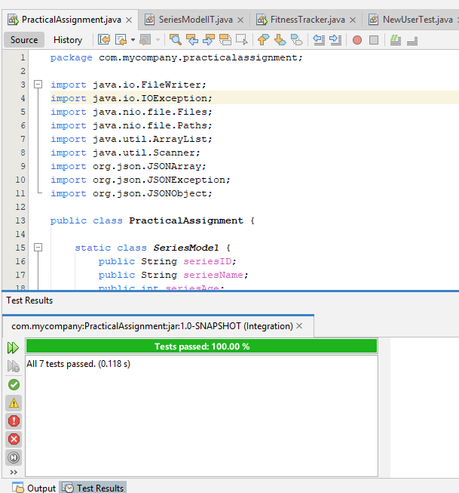

**Section B:**

Project name: FitnessTracker

I decide to make a fitness tracker application where a user can enter their information and their workout goals. The user can update their weight and view their workout history as the date is manually logged in as well.

Junit test:

