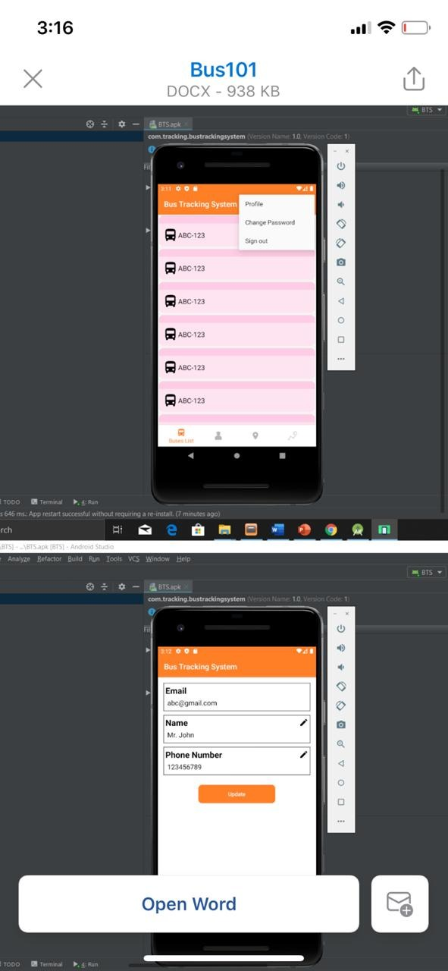



~~First here , when user click profile , the data it’s not the same that he enter when he sign up~~

~~But may be it will change after . —~~

~~Also the app now , when user open the app There is a page for all drivers. We think that driver should not see all drivers page ..~~

~~This page should not appear to user , and also now user can enter and edit there information~~

~~User can’t do this, only admin~~

User can see the route and the schedule.