**Bus Tracking System**

**Graduation Project (1 or 2)**

**by**

Students Names & Number with single line space

**A project submitted in partial fulfilment of the requirements for the degree of Bachelor of Science (Computer Science or Information System)**

**Supervised by**

Supervisor Name

Semester and Academic Year

# Abstract

This project aims to serve as good tool for users of Taibah University (students and stuff of Taibah University) to get useful information University Bus Schedule, Route and Tracking info. Bus Tracking System will be developed as mobile application for Android operating system. It will have admin area for managing Bus Schedules and Bus Routes as well as tracking Buses and resolving Problems reported by Bus Drivers. Application will be also used by Bus Drivers which can View Route info, Select destination and Check Availability of Bus. We already mentioned that Bus Driver can Report a problem to Admin (in case of Bus malfunction), and Admin will remove Schedule of that Bus.

In order to achieve efficient tracking system, we will use popular technology which combines using of smartphones with microcontrollers. This will not be hard to implement and cost will be not so expensive (comparing to other approaches). All Buses will have mobile phones with GPS/GPRS (Global Positioning System / General Packet Radio Service). These technologies are one of most common used technologies for vehicle tracking. The phone will be positioned inside Bus and it enables real time tracking. It sends geographical coordinates (longitude and latitude) in specified time intervals. We will use Google Maps to show position of Bus on map. This way, users of Taibah University will be enabled to continuously track Bus position using their smartphones and our Bus Tracking Application.

We plan to use Android Studio as development tool and Java programming language. We will use Firebase as background database for storing all data. Later, when application is tested in real environment we plan to develop iOS version of application.

**Keywords**: **Tracking System, smartphone, GPS, GPRS, Google Map, Android**

# Acknowledgement

In the Name of Allah, the Beneficent and the Merciful. First and foremost, we thank God the Most Beneficial and the Most Merciful for His endless help and unlimited Grace. We would also like to thanks to all our professors for their help and especially **Dr. Akaber Junid** for being an extraordinary supervisor. Also, we want to thank our families for their help and our friends for their encouraging and support. And last, but not the least, we have special thanks Taibah University for support and cooperation.

Table of Content

Abstract ii

Acknowledgement iii

List of Figures vi

List of Tables vii

List of Abbreviations viii

1 Chapter 1: Introduction 1

1.1 Introduction 1

1.2 Problem Definition 1

1.3 Project Objectives 2

1.4 Project Scope and Constraint 2

1.5 Project Timeline 3

1.6 Document Organization 3

2 Chapter 2: Literature Review 5

2.1 Introduction 5

2.2 Background 5

2.3 Related work 5

2.3.1 Chalo application 7

2.3.2 Puzzle Bus Tracking‏ 8

2.3.3 NeoTrack - School Bus Tracking‏ 9

2.3.4 eMushrif app: 10

2.3.5 Review of Relevant Work 11

2.4 Summary 12

3 Chapter 3: System Analysis 13

3.1 Introduction 13

3.2 Requirements Elicitation 13

3.2.1 Functional Requirements 13

3.2.2 Non Functional Requirements 14

3.2.3 User Requirements or Domain requirements 14

3.3 Requirements Specification 15

3.3.1 Detailed Use Case 17

3.4 Developmental Methodology 23

3.5 Summary 25

4 Chapter 4: System Design 26

4.1 Introduction 26

4.2 Architectural design 26

4.3 Class Diagram 27

4.4 ER Diagram 28

4.5 Sequence Diagram 29

4.6 Database Tables 31

4.6.1 Admin Table 31

4.6.2 Users Table 32

4.6.3 Driver Table 33

4.6.4 Problem Table 34

4.6.5 Route Table 35

4.6.6 Bus Table 36

4.6.7 Schedule table 37

4.7 User Interface Design 39

4.8 Summary 41

5 References 42

# List of Figures

Figure 1: gantt chart 3

Figure 2.1: Chalo app screen shot 7

Figure 2.2: puzzle bus tracking app screen images 9

Figure 2.3: NeoTrack bus tracking system screen 10

Figure 2.4: mushrif app login screen 11

Figure 2.5: mushrif app bus tracking screen 11

Figure 3-1: user use case of the bus tracking system 15

Figure 3.2: waterfall model process flow diagram source [10] 24

Figure 4- 1: Architectural design diagram 26

Figure 4- 2: Class diagram 27

Figure 4- 3: ER diagram 28

Figure 4- 4: : Sequence Diagram Report Problem 29

Figure 4- 5: : Sequence Diagram View Bus Route and View Bus Schedule 30

Figure 4- 6: User Interface 39

Figure 4- 7: User Interface 1 40

Figure 4- 8: User Interface 2 41

# List of Tables

Table 2-1: review of related work table 12

Table 3-1: register user use case table 16

Table 3-2: login use case table 16

Table 3-3: edit profile use case table 17

Table 3-4: use as a guest use case table 17

Table 3-5: view bus route use case table 17

Table 3-6: track bus use case table 18

Table 3-7: view bus schedule use case table 18

Table 3-8: admin login use case table 19

Table 3-9: manage bus route use case table 19

Table 3-10: bus schedule use case table 20

Table 3-11: view reported problem use case table 20

Table 3-12: report a problem use case table 21

Table 3-13: driver login use case table 21

Table 3-14: view rout details use case table 21

Table 3-15: select destination use case table 22

Table 3-16: check for availability use case table 22

Table 3-17: System development tools and language 24

Table 4- 1: Admin Table 31

Table 4- 2: Users Table 32

Table 4- 3: Driver Table 33

Table 4- 4: Problem Table 34

Table 4- 5: Route Table 35

Table 4- 6: Bus Table 36

Table 4- 7: Schedule Table 37

Table 4- 8: Place Table 38

# List of Abbreviations

ID Identification

UML Unified Modeling Language

GPS Global Positioning System

GPRS General Packet Radio Service

IDE Integrated Development Environment

# Chapter 1: Introduction

## Introduction

Public transportation systems in the university play an increasingly important role in the way student move around their addresses and different branches of the university. Buses helping students move from address to the university or to any other branch inside the city or outside.

Taibah University is keen to provide all the amenities for its students. The buses are there which students of the university uses for the movement. The buses timings information is a very critical point because not every student has access to it. Also it is tough to remember the timings every time and sometime there is a change in the schedule of buses which create more disturbance. This app is designed to lead the students and take them out from such difficult situation and they will have all the information related to buses on their hands with just a touch away.

## Problem Definition

At present, Taibah University is still using the traditional way of using paper and files to keep a record of the bus route and schedule as well as provide information through notices which is not effective.

Therefore, there is a need for a systematic way of keeping records as well as providing information as per the need.

The application is developed basically for the smartphone users and it will be operational on the android operating system. There will be GPS tracking and it will have pickup locations where the student can get the bus by requesting from it.

In addition, students usually do not know the proper schedule of the buses, where some students wait for the bus to arrive unaware that the bus had already been left and consequently, they miss their classes at the university.

Buses to other university campuses outside the city Students face the problem that they must queue up and leave their homes long time before the trip in order to ensure a seat on the bus.

Therefore, the smart system is necessary to provide real-time information on buses to remote users. For this reason, we proposed a new system that overcomes the drawbacks of the university's transportation system.

## Project Objectives

The main purpose of this project is to automate manual bus registration procedures for any journey, its trip line and all driver information in addition to periodic follow-up, each conducted through a proposed system. The objectives of this project will consist of:

* To make the university transport system more efficient.
* To increase service speed with the use of technology.
* To eliminate paperwork and increase the level of accuracy.
* To track bus way through application.
* To determine the bus number and if the desired bus near to student station, application send to student notification that desired bus arrived.
* To determine and send location to maintenance unit if bus get crashes.

## Project Scope and Constraint

Taibah University bus system is an android application, in addition the application restricted to two types of users: students, staff inside the university and for drivers of buses in cooperation with the Operation and Maintenance unit.

The constraint we are facing in this project is dealing with some of the following functions such that registration by students and reservation buss by determining the bus number .in addition the Students do not know the bus locations and arrival and departure times, with this application the students can track bus routes on the map.

The second user is a driver with the main functions, the first is the possibility of sending coordinates and locate bus at any time to the system administrator and also use the application to communicate directly with the maintenance unit at the University of Thebes if the bus crashes.

With application also students will receive automatic notifications when the bus is close to the arrival station so that the users don’t get delayed or do not arrive at the stop too early.

## Project Timeline

The project timeline for the bus tracking system is given below

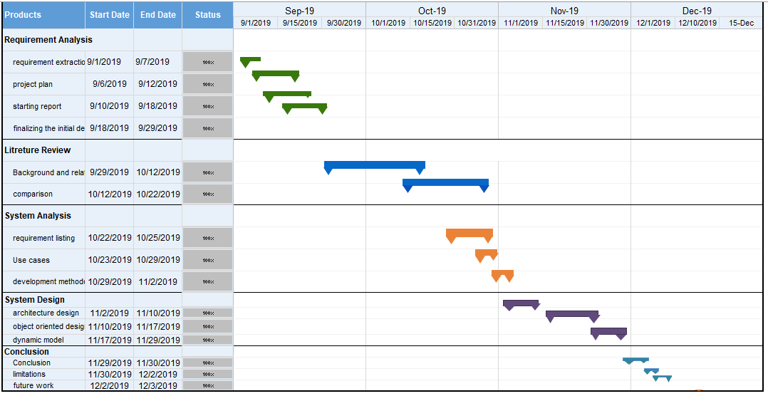

Figure 1: gantt chart

## Document Organization

This project consists of five chapters. We were organized these chapters to follow steps according to main objective. Following are brief descriptions about the contents in each chapter:

**Chapter 1 "Introduction**": The problem definition, project objectives, and project timeline are presented.

**Chapter 2 "Literature Review":** Related work will be discussed in this chapter as well as a comparison between the related work and our suggested system.

**Chapter 3 "System Analysis":** The analysis of the proposed system through UML diagrams will be presented in this chapter.

**Chapter 4 "System Design":** The design of the system (database, interfaces) will be presented in this chapter.

**Chapter 5 "Conclusion and Future Work**": Final Summary of the document will be presented.

# Chapter 2: Literature Review

## 2.1 Introduction

In this chapter we will present a summary study of some project that have same idea as our project also we going to do comparison between our project with the similar ones and we will show some advantages and disadvantages for both.

## 2.2 Background

Smartphone use has become very popular and it has become a primary need for everyone. The smartphone mainly has two types of operating systems in which one in Android and the other is IOS. From both of these android has been widely used throughout the world due to its open source availability and easy upgradation. Time is everything in today’s world hence waiting for the bus at the stop is very time consuming.

So to reduce this issue we have developed an application which will be responsible for the tracking of buses and it is called bus tracker. The developed application is capable of finding the current bus location and will forward it to the user awaiting for the bus to reach at a station. As android is most widely used platform therefore we have opted it to develop the application and its client side is android based. The main design purpose of the application is for the students and staff of college who wait for the bus at bus station for long hours.

## 2.3 Related work

A. Ahmed et.al [1] proposed a model of related to development of an application to expand bus transport services for university students. This reduces the time for bus waiting students, thus enabling drivers and students to exchange updated bus information. This remarkable system changed the bus waiting into the modern concept of providing the bus location. It would give the students the exact time of bus arrival and departure on the route. The change of the bus time table would also be modified in the app and it will help to better manage the application.

Dalip, V. Kumar.et.al [2] introduce in this paper how to develop app to aid locating passengers. System is able to tracks the passengers and make reservation of ticket in addition to able to report history of trip as well as the number of tickets. The Google map location display is another important feature of the application which will make it more flexible to use and efficient to track. There is another important feature of the app which allows the passengers to save the history of the travel. By entering the ticket number which is valid the tracking comes very easy.

Bläsing et. al. [3] Presented a Sandbox application proposal which performed dynamic analysis and it was an android based application. There was another important feature of the application was detection of the features which were suspicious through automatic detection. Hence in an isolated environment application was executed and then it intervenes and logs low- level interactions with the system for further analysis.

M. Rauf et al [4] introduce a different approach in this paper via using neural network and some of algorithms that investigates the GPS based Bus monitoring system using Radial basis function Neural network for the enhanced navigational performance and error reduction in monitoring and station reporting system Meanwhile. The proposed model would increase the overall reliability of GPS signal transmission at the bus station, resulting in people either waiting for the bus or not making a decision.

JISHA, R. C., et al [5] presented an application proposal and his proposal was based on the school bus tracking application. This application involves that location show up and monitoring the children of the school. In their application GPRS and GPS wireless technologies were used. They have also used Firebase in their application but the efficiency of the application was not 100% because of the dependency of the mobile speed and GPS connectivity. The app was a great initiative to relax the parents with and cater for their worries. Their paper discusses that in future they will enhance their work and introduce more significant enhancements.

Sangavi, K. et al. [6] have implemented web site techniques for the college bus tracking system. They want to save time and quality of service to the college bus. In this system. They introduced used technology and optimized algorithm at a moderate cost. They introduce to the college management and information about the current location of the bus to students and staffs and it is user-friendly to use this website. This website available from various device such as laptops, mobile phones, tablet, and personal computers.

B.M Vidyavathi et al. [7] proposed model in this paper enable User to catch the bus on time, provides by using short path algorithm technique able to alternate bus and the shortest route till the bus. Also keeping track of the number of students registered and the current location of the bus at regular time intervals. Also enables the driver to select which bus he is driving, the technique used is unique.

There’s also some of web service that provide GPS tracking in middle east and Arab country as ***trackware*** [8] web service provider that helps school administrators monitor and track the movements of their bus fleet to ensure the safety of students as they travel to and from school. Also allow parents to connect to the school tour by sending notices before the bus arrives at home, and when boarding and disembarking with a quick and instant communication mechanism with the parents. In addition to Parents can send their location coordinates through the application, which helps the school to organize school tours with ease.

### Chalo application

This is a free application which is responsible for the tracking of buses and will provide the live location details. It will guide you that when to reach on bus station to catch the bus hence your bus stop wait can be avoided.

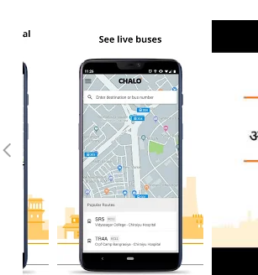

Figure 2.1: Chalo app screen shot

#### 2.3.1.1 The application has some advantages

* Track Bus Live

In the application GPS devices are used for the tracking live location and then stream the location on the user screen. The location checking is very simple process as it need just one click and you have the location as well as the time that which it will reach to the stop.

* Find ‍‍‍‍‍‍Live Arrival Time of Bus

The live arrival bus time will be calculated and it will processed through tons of data processing where it represent the live arrival time of the bus along with the bus location. This is also just on one click of the user and here is the bus arrival time.

* Find the Cheapest and Fastest Trips

The system can show the cheapest and fastest trips rides for that need user have to add destination to the trip planner and then it will automatically show all the available slots. This will show the cheapest and also the fastest rides to the users which will make it easier for them to understand the actual fashion and what to consider for the order. In the planner different vehicle modes will be used and it includes buses, trains, metro, ferry, auto rickshaws, taxis and more!

* Mobile Bus Pass

The main feature of the application is payment through the mobile which has made it very easy for the users as they do not have to take cash amount with themselves. The app allows freedom from buying the tickets to travel and allows you to enjoy a smooth ride.

#### 2.3.1.2 Disadvantages

* Absence of interaction between the bus drivers who uses the application.

### 2.3.2 Puzzle Bus Tracking‏

Another bus tracking app named as puzzle bus tracking app also offer the facility of tracking the bus and the frontend display of the application is given below:

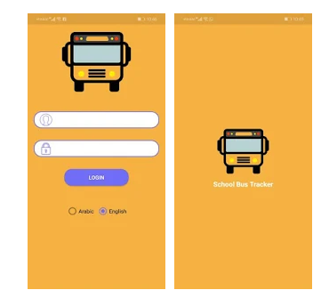

Figure 2.2: puzzle bus tracking app screen images

#### 2.3.2.1 Advantages

* This app allows parents to track the route of the bus in Real – time.
* Parents will be informed about expected arrival time of the bus so the child wouldn't have to wait outside in harsh weather.
* The parents can inform the bus supervisor if their child isn't taking the bus for a day or a longer period of time.
* It also allows parents to spot real-time location of the bus and expected arrival time to avoid waiting and wasting time.
* The parent will be notified in case the bus has been waiting in front of the house and the student didn't board.

#### Disadvantages

* The feature of find ‍‍‍‍‍‍live arrival time of bus is not available

### 2.3.3 NeoTrack - School Bus Tracking‏

NeoTrack is an application which is based on the tracking of school buses and it is facilitated with artificial intelligence to track the location of bus. This is very convenient setup for the parent to get tracking of their children’s school bus and it will provide a real time data.

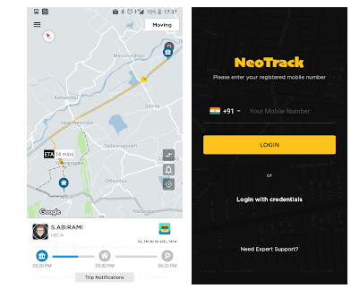

Figure 2.3: NeoTrack bus tracking system screen

#### 2.3.3.1 Advantages

* Real time tracking of your child school bus location.
* Get Notification alerts of the bus location and expected time of arrival to your pickup / drop point.
* You can see you child's school bus route.
* You can track your children studying on multiple schools.
* App will work only if your child's school is registered with NeoTrack.

#### 2.3.3.2 Disadvantages

* Absence of interaction between the bus drivers who use the application.

### 2.3.4 eMushrif app:

This app as they stated on their website, is considered to be the case with the transformation of ordinary school buses into smart and safe buses using smart technology to ensure the safety of children.

|  |  |
| --- | --- |
| Figure 2.4: mushrif app login screen | Figure 2.5: mushrif app bus tracking screen |

#### 2.3.4.1 Advantage:

* Keep track of your children buses
* Receive notifications when they get on or off the bus
* Receive notifications when bus is approaching home
* Track all buses belonging to your school
* Know how many students are on board of any bus

#### 2.3.4.2 Disadvantage:

* Absence of interaction between the bus drivers who use the application
* Large size it takes a lot of space in phone

### 2.3.5 Review of Relevant Work

All the related work in the field are collected and presented into the following table.

|  |  |  |  |  |  |  |
| --- | --- | --- | --- | --- | --- | --- |
| **Programs**  **Features** | **Chalo** | **Puzzle Bus** | **NeoTrack** | **A. Al-Mazloum et. al** **study** | **Shin et al. study** | **Bus tracking** |
| Support Arabic language | - | - | - | - | - | √ |
| Driver screen | - | - | - | - | - | √ |
| Searching bar | √ | √ | √ | - | √ | √ |
| Arrival time | √ | √ | √ | **-** | **-** | √ |
| Easy interface | √ | √ | √ | √ | √ | √ |
| Provide different info about app | √ | √ | √ | √ | √ | √ |

Table 2-1: review of related work table

## 2.4 Summary

After reading many previous ideas and works we can say that the possibility of designing an application for the operating systems of smartphone i.e. android mobile is a tricky but convenient option. It is obviously from Table 1 that none of existing application on market satisfies all Features we want. Our Bus Tracking application will support all these features. It will be handy solution to clearly identify the location of the bus along with the arrival time. The application major goal is to ease bus location accessibility for the students. Bus current location will be displayed to you and without the help of other you have the exact location. It will easier and a lot of time will be saved.

# Chapter 3: System Analysis

## 3.1 Introduction

This chapter will be based on the system analysis and it will contains different functional and non-functional requirements of the project. The chapter will represent a picture of the under development system through eliciting system requirements. It discusses all the insights and significant matters that will lead the foundation of entire development processes and clear the understanding of the under discussion product.

## 3.2 Requirements Elicitation

There are different requirement elicitation methods used for the bus tracking system before finalizing the requirements. Different interviews were conducted from the students, professors and bus drivers to elicit requirements. After interviews brainstorming was used to take out the real requirements of the system and the use cases were developed that depicts the complete system scenarios for clear understating.

The requirement elicited through the different process used for the project requirement evaluation are explained below:

### 3.2.1 Functional Requirements

The system will have different modules and mainly it includes the user module, system module and bus module. The functional requirements of the system are given below:

1. The bus tracking system will have a database that will store all the record of buses.
2. The system will have unique identification number for each bus.
3. The system will have details of each bus along with the time of departure to each campus.
4. The system shall allow user to track any bus through the unique identification number of the bus.
5. The system shall be able to enable GPS to locate the bus location.
6. The system shall be able to handle multiple requests at the same time.
7. The user shall be able to request bus information from the system.
8. The system will have user accounts for each user of the system.
9. The system allow the user to log in with user name and passwords by mapping it with the database details of the user.
10. The user will be able to manage the profile of user.
11. The user will be able to request the bus for a particular destination.
12. The admin of the system will be able to edit the bus number.
13. The admin will be able to edit users.
14. The system will be able to keep record of all the buses.
15. The system will be able to have bus timings for the system.
16. The system will be able to have bus routes for each bus.
17. The system will be able to display the bus arrival time at each destination.

### 3.2.2 Non Functional Requirements

Non-functional requirements for bus tracking system are focus on providing the real time and user friendly system. Following are the main non-functional requirements for the system.

1. Accessibility: The system will be accessible to every student of the university.
2. Ease of use: The system will be easy to use and every user can operate it with basic understanding of the apps.
3. Performance: The system performance will be optimal at the peak hours of the university timings.

### 3.2.3 User Requirements or Domain requirements

The expected users of the system are students and stuff of Taibah University. All users must have installed our application on their android phone. Users will have information about Bus Route and Bus Schedule all the time. Also, they will have option to track some bus in real time. System offers users to register and choose favourite bus so next time they can select bus for tracking much faster.

## 3.3 Requirements Specification

The use case of the system explaining the complete flow of the system is given and it shows two actors of the system with interactions.

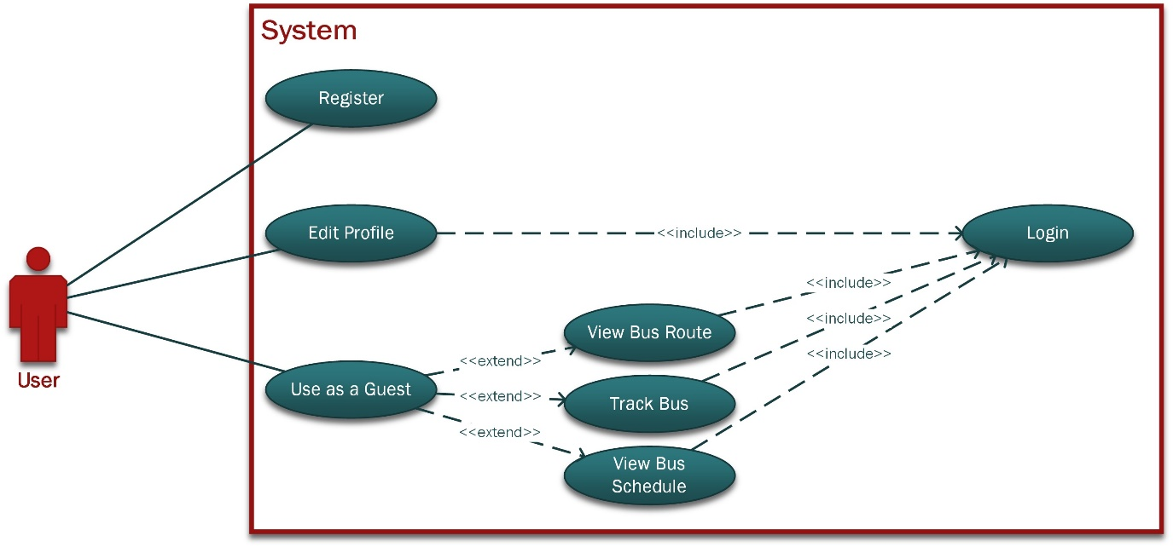

Figure 3-1: user use case of the bus tracking system

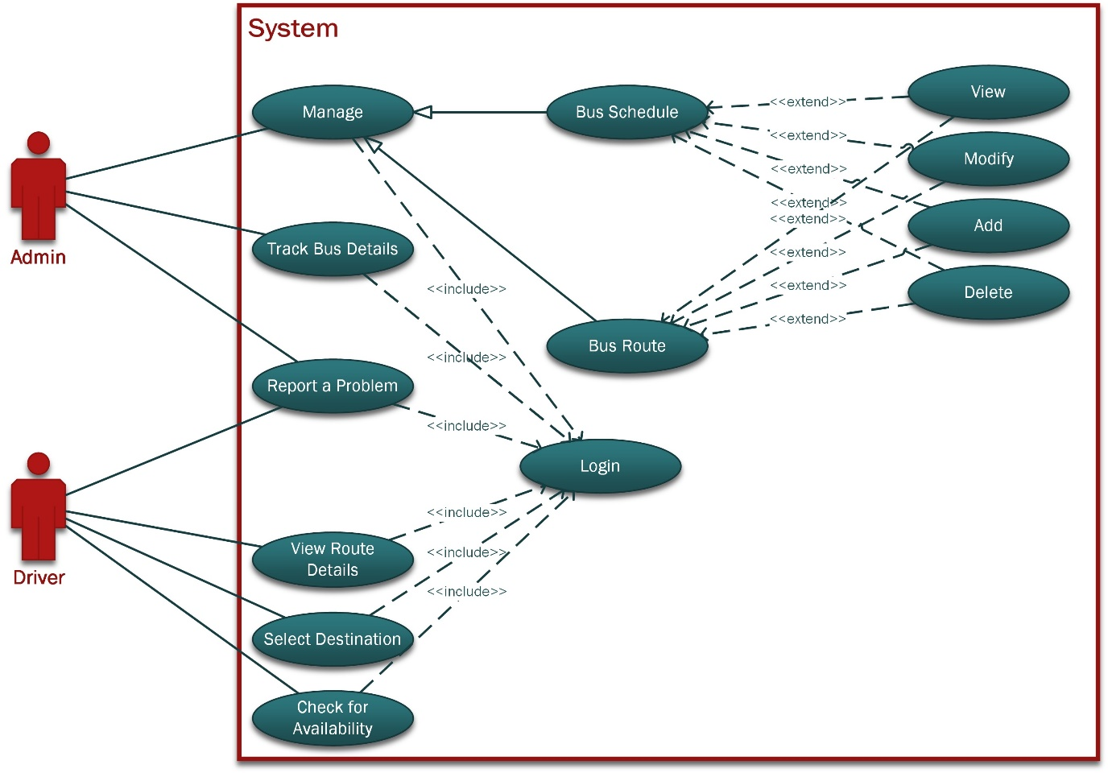

Figure 3-2: system and driver use case of the bus tracking system

### 3.3.1 Detailed Use Case

|  |  |
| --- | --- |
| Use case ID | 001 |
| Use case name | Register user |
| Actors | Users |
| Description | The user of the system register to the system. |
| Trigger | Sign up page opened |
| Pre-condition | The user has no registered account |
| Normal flow | The user of the system register to the system. |
| Post condition | User is register to the system |

Table 3-1: register user use case table

|  |  |
| --- | --- |
| Use case ID | 002 |
| Use case name | Login use case |
| Actors | Users |
| Description | The user of the system login to the system. |
| Trigger | Login page opened |
| Pre-condition | The user already have an account signup. |
| Normal flow | The user of the system login to the system. |
| Post condition | User is able to log in. |

Table 3-2: login use case table

|  |  |
| --- | --- |
| Use case ID | 003 |
| Use case name | Edit profile use case |
| Actors | Users |
| Description | The user of the system login to the system and then edit the profile. |
| Trigger | User is login to the system |
| Pre-condition | The user already have an account signup and is logged in to the system. |
| Normal flow | The user will login and edit the profile. |
| Post condition | User is able to edit the profile. |

Table 3-3: edit profile use case table

|  |  |
| --- | --- |
| Use case ID | 004 |
| Use case name | Use as a guest use case |
| Actors | Users |
| Description | The user of the system uses the system as a guest without registering to the system |
| Trigger | User start using the system as a guest |
| Pre-condition | The user have app in her system |
| Normal flow | The user will request for bus by viewing the bus details. |
| Post condition | User is able to request for bus. |

Table 3-4: use as a guest use case table

|  |  |
| --- | --- |
| Use case ID | 005 |
| Use case name | View bus route use case table |
| Actors | Users |
| Description | The user of the system uses the system to view bus route |
| Trigger | User is logged in to the system or using it as a guest |
| Pre-condition | The user have app in her system |
| Normal flow | The user will be log in to the system or use as a guest to view the bus route. |
| Post condition | User is able to see the bus route. |

Table 3-5: view bus route use case table

|  |  |
| --- | --- |
| Use case ID | 006 |
| Use case name | Track bus use case table |
| Actors | Users |
| Description | The user of the system uses the system to track bus |
| Trigger | User is logged in to the system or using it as a guest |
| Pre-condition | The user have app in her system |
| Normal flow | The user will be log in to the system or use as a guest to track the bus |
| Post condition | User is able to track the bus. |

Table 3-6: track bus use case table

|  |  |
| --- | --- |
| Use case ID | 007 |
| Use case name | View bus schedule use case table |
| Actors | Users |
| Description | The user of the system uses the system to view bus schedule |
| Trigger | User is logged in to the system or using it as a guest |
| Pre-condition | The user have app in her system |
| Normal flow | The user will be log in to the system or use as a guest to view bus schedule |
| Post condition | User is able to view bus schedule. |

Table 3-7: view bus schedule use case table

|  |  |
| --- | --- |
| Use case ID | 008 |
| Use case name | Admin login use case |
| Actors | Admin |
| Description | The user of the system login to the system as admin. |
| Trigger | Login page opened |
| Pre-condition | The user already have an account. |
| Normal flow | The user of the system login to the system. |
| Post condition | User is able to log in. |

Table 3-8: admin login use case table

|  |  |
| --- | --- |
| Use case ID | 009 |
| Use case name | Manage bus route use case |
| Actors | Admin |
| Description | The user of the system login to the system as admin and manage bus route. |
| Trigger | Admin is logged into to the system |
| Pre-condition | The user already have an account is logged in to the system. |
| Normal flow | The user of the system login to the system as admin and manage bus route. |
| Post condition | User is able to manage the bus route. |

Table 3-9: manage bus route use case

|  |  |
| --- | --- |
| Use case ID | 010 |
| Use case name | Bus schedule use case |
| Actors | Admin |
| Description | The user of the system login to the system as admin and manage bus schedule. |
| Trigger | Admin is logged into to the system |
| Pre-condition | The user already have an account is logged in to the system. |
| Normal flow | The user of the system login to the system as admin and manage bus schedule add, update, delete and edit. |
| Post condition | User is able to manage the bus schedule. |

Table 3-10: bus schedule use case table

|  |  |
| --- | --- |
| Use case ID | 011 |
| Use case name | View reported problem use case |
| Actors | Admin |
| Description | The user of the system login to the system as admin and view reported problem by driver. |
| Trigger | Admin is logged into to the system |
| Pre-condition | The user already have an account is logged in to the system. |
| Normal flow | The user of the system login to the system as admin and manage bus schedule add, update, delete and edit. |
| Post condition | User is able to manage the bus schedule. |

Table 3-11: view reported problem use case table

|  |  |
| --- | --- |
| Use case ID | 012 |
| Use case name | Report a problem use case |
| Actors | Driver |
| Description | The user of the system login to the system as driver and is able to report a problem to the system. |
| Trigger | Driver is logged into to the system |
| Pre-condition | The user already has an account is logged in to the system. |
| Normal flow | The user of the system login to the system as driver and is able to report a problem to the system. |
| Post condition | User is able to report the problem. |

Table 3-12: report a problem use case table

|  |  |
| --- | --- |
| Use case ID | 013 |
| Use case ID | 013 |
| Use case name | Driver login use case |
| Actors | Driver |
| Description | The user of the system login to the system as driver. |
| Trigger | Login page opened |
| Pre-condition | The user already have an account. |
| Normal flow | The user of the system login to the system. |
| Post condition | User is able to log in. |

Table 3-13: driver login use case table

|  |  |
| --- | --- |
| Use case ID | 014 |
| Use case name | View rout details use case |
| Actors | Driver |
| Description | The user of the system login to the system as driver and is able to view rout details. |
| Trigger | Driver is logged into to the system |
| Pre-condition | The user already have an account is logged in to the system. |
| Normal flow | The user of the system login to the system as driver and is able to view rout details. |
| Post condition | User is able to view route details. |

Table 3-14: view rout details use case table

|  |  |
| --- | --- |
| Use case ID | 015 |
| Use case name | Select destination use case |
| Actors | Driver |
| Description | The user of the system login to the system as driver and is able to select destination. |
| Trigger | Driver is logged into to the system |
| Pre-condition | The user already has an account is logged in to the system. |
| Normal flow | The user of the system login to the system as driver and is able to select destination. |
| Post condition | User is able to select destination. |

Table 3-15: select destination use case table

|  |  |
| --- | --- |
| Use case ID | 016 |
| Use case name | Check for availability use case |
| Actors | Driver |
| Description | The user of the system login to the system as driver and is able to check for availability. |
| Trigger | Driver is logged into to the system |
| Pre-condition | The user already have an account is logged in to the system. |
| Normal flow | The user of the system login to the system as driver and is able to check for availability. |
| Post condition | User is able to check for availability. |

Table 3-16: check for availability use case table

## 3.4 Developmental Methodology

The system will be developed by using waterfall model and this methodology of software development lifecycle uses freeze requirements. There are seven stages of waterfall and for this task and during the system the process will start by requirement analysis. The requirements for this project have been made frozen by collecting all the details of the system.

Bus tracking system is a smaller project with very less chances of scope creep as the scope of project is already fixed therefore it is most highly suitable system for this strategy. The waterfall model do not allow to move in between different stages and can only to switch from previous stage to next stage so this will wipe out all the confusion in the project. The waterfall model is not very complex approach therefor for easy understanding this will be used for the development of bus tracking system.

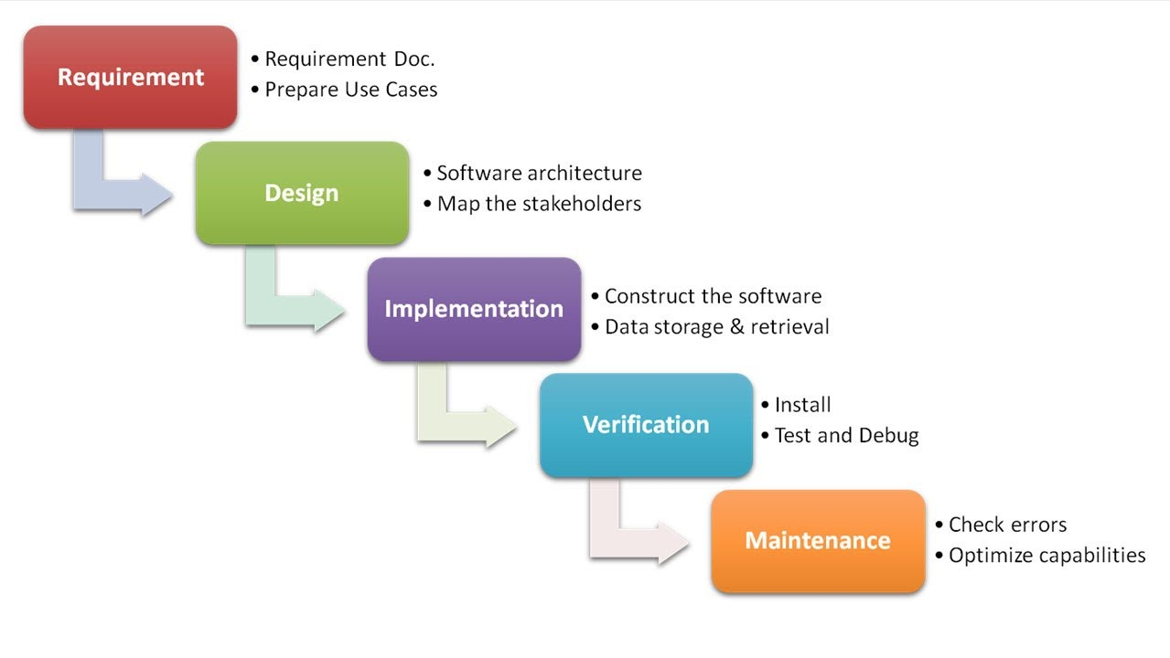

Figure 3.2: waterfall model process flow diagram source [10]

* During the development each phase will proceed to next step only after accomplishing the first stage.
* There will be documentation in each stage that will guide to the next stage.
* The data will be collected through the interviews, discussion, literature surveys and through mind mapping.
* The project is subjected for the students enrolled in the university only.
* The tools and language that will used the development bus tracking system are different for different phases of software development life cycle. The complete process involves requirement analysis and listing that will use word document, UML diagram design for the clear understanding of the project, design the front end of the project and developing with project as well database. The following table describe complete requirements:

|  |  |
| --- | --- |
| **System development language** | **Java programming language** |
| Tool for the development | Android |
| Tool for the database | XAMPP |
| Tool for the UML diagrams | Microsoft Visio |
| Tool for the requirement writing and system report | Word document |
| Tool for the system presentation | Power Point |

**Table 3-17: System development tools and language**

## 3.5 Summary

This chapter is representation of all the requirements collected through the user interviews and different other collection methods. Functional requirements and non-functional attributes of the projects are also discussed in this chapter and the next chapter will discuss the design details of the project with different diagram depictions.

# Chapter 4: System Design

## 4.1 Introduction

The (Bus Tracking Application) project will be developed as an android application to help students, drivers and staff in university. In this chapter will focuses on the design of the system. The design phase will be explained using the entity relationship diagram, class diagram and the database tables. Additionally, the architectural design and the user interface.

## 4.2 Architectural design

The system architecture is the conceptual model focuses on system component, object and connections between them. Defines the structure, behavior and more views of a system. Figure 4-1 shows the system architecture design of the application.

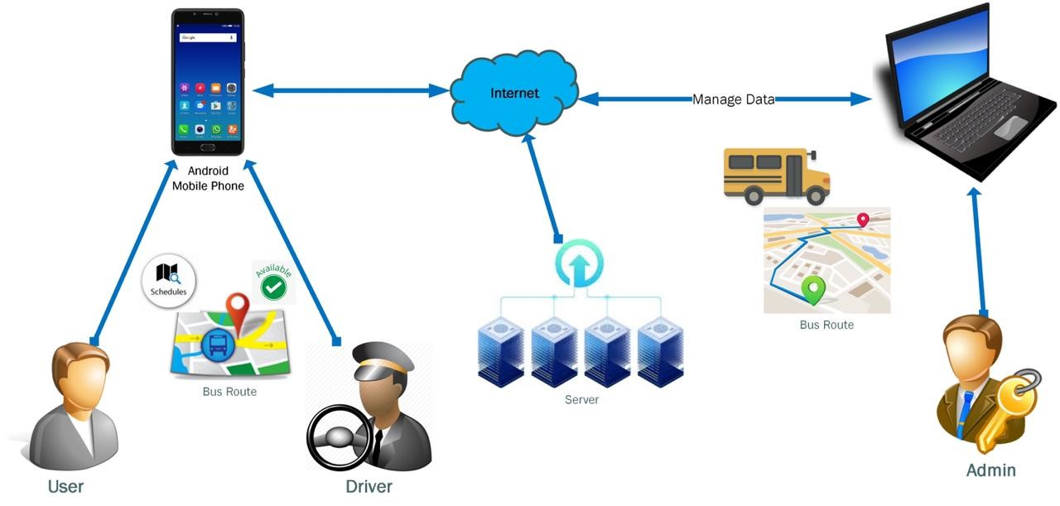

Figure 4- 1: Architectural design diagram

## 4.3 Class Diagram

The class diagram defines the system structure by describing the classes of the system and its attributes, methods and relationships between the various objects. Figure 4-2 show the class diagram of system.

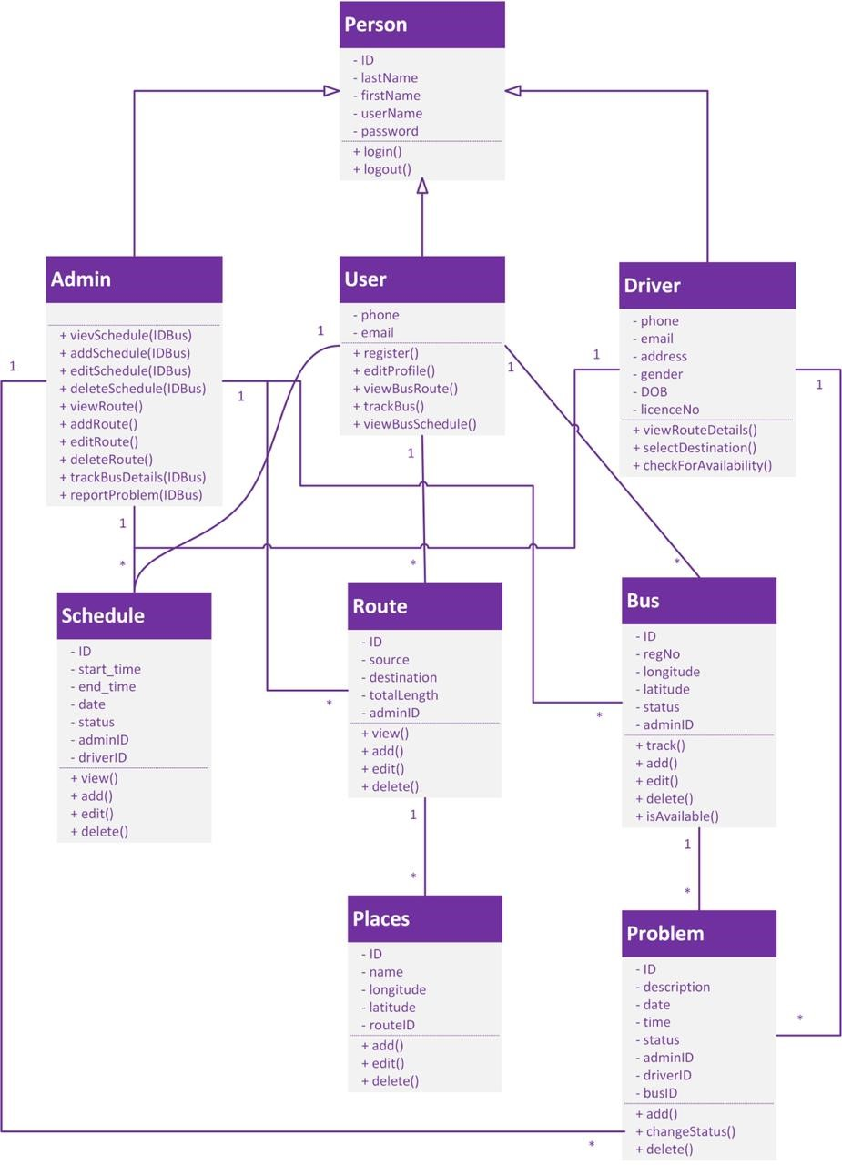

Figure 4- 2: Class diagram

## 4.4 ER Diagram

Entity Relationship Diagram (ERD) is a data modeling technique that display the relationship between entities such as objects, people, or concepts within a system. This model contains everything including the logical and physical configuration decisions to produce a design in a data definition, which can then be utilized to develop a database. Figure 4-3 show the ER diagram of the system.

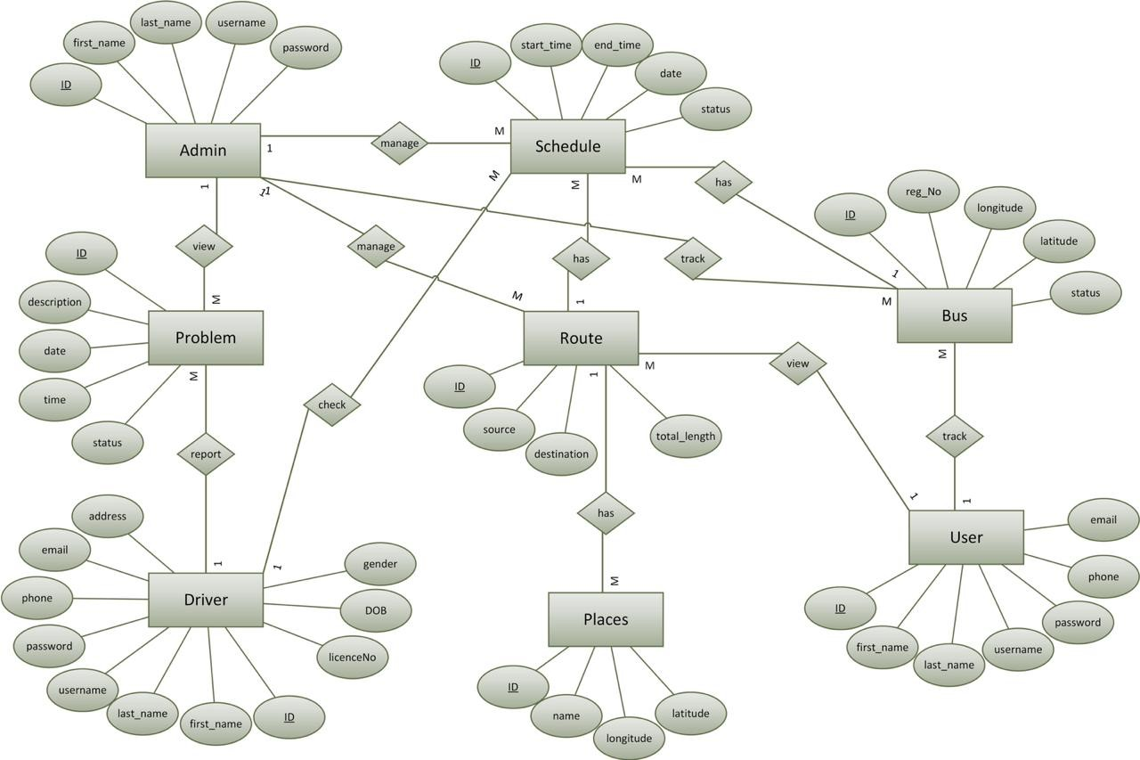

Figure 4- 3: ER diagram

## 4.5 Sequence Diagram

Sequence Diagram is used to show interaction between objects during some activity. It is very useful to visualize some of use cases. Usually, they show one scenario which is consisted of several objects and messages (exchanged between these objects). Sequence diagrams can be used for specification of time requests and description of complex scenarios. Sequence diagrams are part of Interaction diagrams and their main concern is description and order of messages between objects. Figure 4-4 show the Sequence Diagram Report Problem

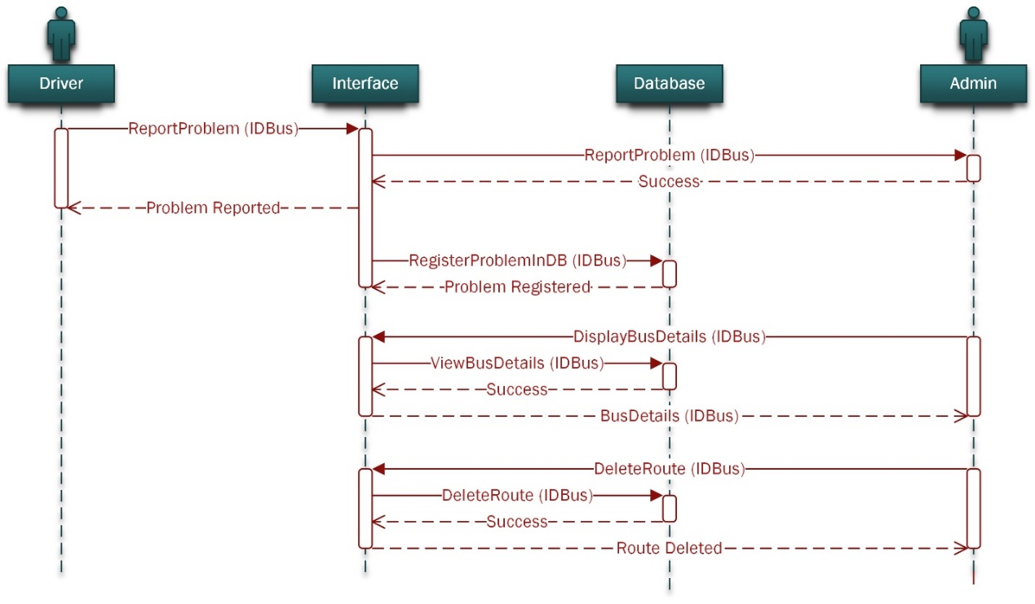

Figure 4- 4: Sequence Diagram Report Problem

In Diagram above we can see Driver Report Problem use case. First of all, Driver send message to the Admin via system (Interface) about problem with some bus, identified by IDBus attribute. System informs Driver about Problem is reported. Also, system store problem in Database for later usage. After that, Admin ask from System to displays bus details (based on IDBus attribute). System returns bus details from database. Finally, Admin delete Route from system (database). Information about successful deletion is shown to Admin.

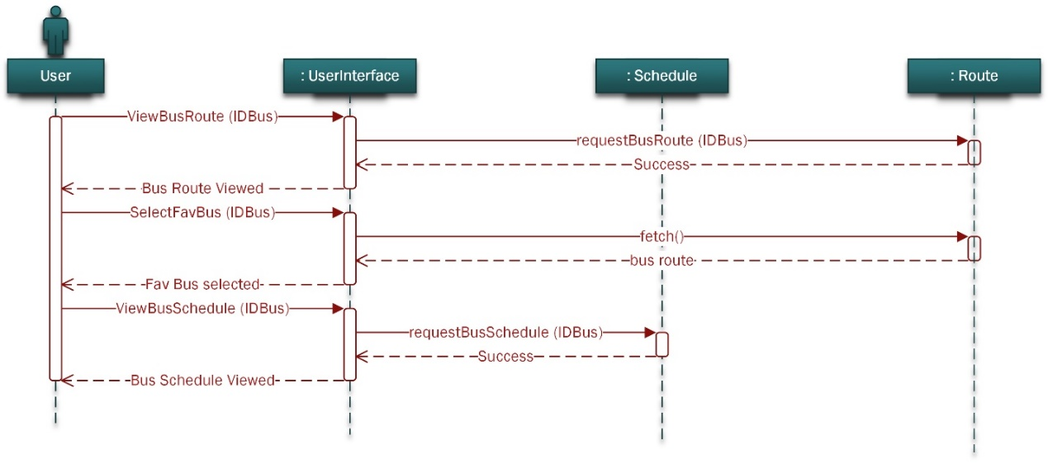

Figure 4- 5: Sequence Diagram View Bus Route and View Bus Schedule

Diagram above (figure 4-5) shows interaction between User during his choosing of favorite bus and bus schedule. At the start User ask from system information about Bus Route. System returns message with Route info to the User. After that User choose favorite Bus. System responds by showing Bus Route. Finally, User request from System information about Bus Schedule. System responds by showing Bus Schedule.

## 4.6 Database Tables

### 4.6.1 Admin Table

|  |  |  |  |  |  |
| --- | --- | --- | --- | --- | --- |
| Admin Table | | | | | |
|  |  | |  | **Primary/foreign key** | |
| attribute | **Description** | **Type** | | **Primary key(pk)** | **Foreign key (FK)** |
| Admin_ID | **Unique id of admin** | **Int** | | **PK** |  |
| First_name | **First name of the admin** | **Varchar** | |  |  |
| Last_name | **Last name of the admin** | **Varchar** | |  |  |
| Username | **username for the admin** | **Varchar** | |  |  |
| Password | **Password for the admin** | **Password** | |  |  |

Table 4- 1: Admin Table

### 4.6.2 Users Table

|  |  |  |  |  |
| --- | --- | --- | --- | --- |
| Users Table | | | | |
|  |  |  | **Primary/foreign key** | |
| attribute | **Description** | **Type** | **Primary key(pk)** | **Foreign key (FK)** |
| User_id | **Unique id for each user** | **Int** | **PK** |  |
| First_name | **First name of the user** | **Varchar** |  |  |
| Last_name | **Last name of the user** | **Varchar** |  |  |
| Username | **The username of the user** | **Varchar** |  |  |
| Password | **User's password** | **Password** |  |  |
| phone | **The phone number of user** | **Varchar(10)** |  |  |
| Email | **The user's e-mail** | **Email** |  |  |

Table 4- 2: Users Table

### 4.6.3 Driver Table

|  |  |  |  |  |
| --- | --- | --- | --- | --- |
| **Driver Table** | | | | |
| **Foreign Key (FK)** | **Primary Key (PK)** | **Type** | **Description** | **Attribute** |
|  | **PK** | **Int** | **Unique Id for each Driver** | **Driver_ID** |
|  |  | **Varchar** | **The first name of driver** | **First_Name** |
|  |  | **Varchar** | **The last name of driver** | **Last_Name** |
|  |  | **Varchar** | **The user name of driver** | **UserName** |
|  |  | **Password** | **The driver password** | **Password** |
|  |  | **Varchar** | **The driver gender (F,M)** | **Gender** |
|  |  | **Date** | **The driver birth of date** | **DOB** |
|  |  | **Int** | **The licence number of Drivers** | **LicenceNO** |

Table 4- 3: Driver Table

### 4.6.4 Problem Table

|  |  |  |  |  |
| --- | --- | --- | --- | --- |
| Problem Table | | | | |
|  |  |  | **Primary/foreign key** | |
| attribute | **Description** | **Type** | **Primary key(pk)** | **Foreign key (FK)** |
| Problem_ID | **Unique Id for the problem** | **Int** | **PK** |  |
| Description | **Description of the problem** | **Varchar** |  |  |
| Date | **The date of the problem** | **Date** |  |  |
| Time | **The time of the Problem** | **Time** |  |  |
| Status | **The statue of the problem** | **bool** |  |  |
| Admin_ID | **The id of admin** |  |  | **FK** |

Table 4- 4: Problem Table

### 4.6.5 Route Table

|  |  |  |  |  |
| --- | --- | --- | --- | --- |
| **Route Table** | | | | |
| Foreign Key (FK) | **Primary Key (PK)** | **Type** | **Description** | **Attribute** |
|  | **PK** | **Int** | **Id for each route** | **Route_ID** |
|  |  | **Varchar** | **Source of direction** | **Source** |
|  |  | **Varchar** | **The destination for each bus** | **Destination** |
|  |  | **Int** | **Total road length** | **Total_length** |
| FK |  | **Int** | **Unique Id for each user** | **User_ID** |
| FK |  | **Int** | **Unique Id for each admin** | **Admin_ID** |

Table 4- 5: Route Table

### 4.6.6 Bus Table

|  |  |  |  |  |
| --- | --- | --- | --- | --- |
| Bus Table | | | | |
| Foreign Key (FK) | Primary Key (PK) | Type | Description | Attribute |
|  | **PK** | **Int** | **Unique ID for each Bus** | **Bus_ID** |
|  |  | **Decimal** | **Find a location using GPS coordinates for latitude and longitude** | **longitude** |
|  |  | **Decimal** | **Find a location using GPS coordinates for latitude and longitude** | **latitude** |
|  |  | **Int** | **Registrations number for buses** | **Reg_NO** |
|  |  | **Tinyint** | **Status updates of bus** | **Status** |
| **FK** |  | **Int** | **Unique Id for each user** | **User_ID** |
| **FK** |  | **Int** | **Unique Id for each admin** | **Admin_ID** |

Table 4- 6: Bus Table

### 4.6.7 Schedule table

|  |  |  |  |  |
| --- | --- | --- | --- | --- |
| **Schedule Table** | | | | |
| Foreign Key (FK) | **Primary Key (PK)** | **Type** | **Description** | **Attribute** |
|  | **PK** | **Int** | **Id for each schedule** | **Schedule_ID** |
|  |  | **Time** | **Bus start time** | **Start_Time** |
|  |  | **Time** | **Bus end time** | **End_Time** |
|  |  | **Date** | **The date when the bus was registered** | **Date** |
|  |  | **Tinyint** | **Status updates of schedule** | **Status** |
| FK |  | **Int** | **Id for each bus** | **Bus_ID** |
| FK |  | **Int** | **Unique Id for each driver** | **Driver_ID** |
| FK |  | **Int** | **Id for each route** | **Route_ID** |
| Fk |  | **Int** | **Unique Id for each admin** | **Admin_ID** |

Table 4- 7: Schedule Table

**4.6.8 Place Table**

|  |  |  |  |  |
| --- | --- | --- | --- | --- |
| **Place Table** | | | | |
| Foreign Key (FK) | **Primary Key (PK)** | **Type** | **Description** | **Attribute** |
|  | **PK** | **Int** | **Unique ID for each place** | **Place_ID** |
|  |  | **varchar** | **The name of place** | **Name** |
|  |  | **Decimal** | **Find a location using GPS coordinates for latitude and longitude** | **longitude** |
|  |  | **Decimal** | **Find a location using GPS coordinates for latitude and longitude** | **latitude** |
| FK |  | **Int** | **Id for each route** | **Route_ID** |

Table 4- 8: Place Table

## 4.7 User Interface Design

This UI screen for the Tracking Bus application include admin interface, user interface and driver interface. The design of UI simple and easy to use. Figure 4-6, figure 4-7 and figure 4-8 show the UI design.

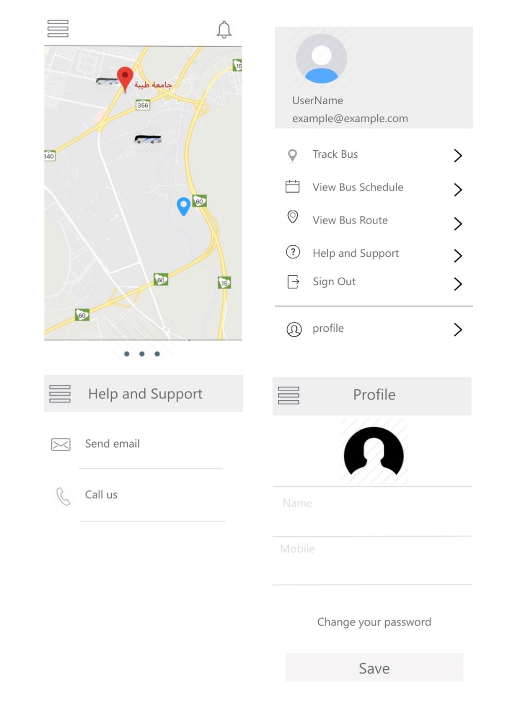

Figure 4- 6: User Interface

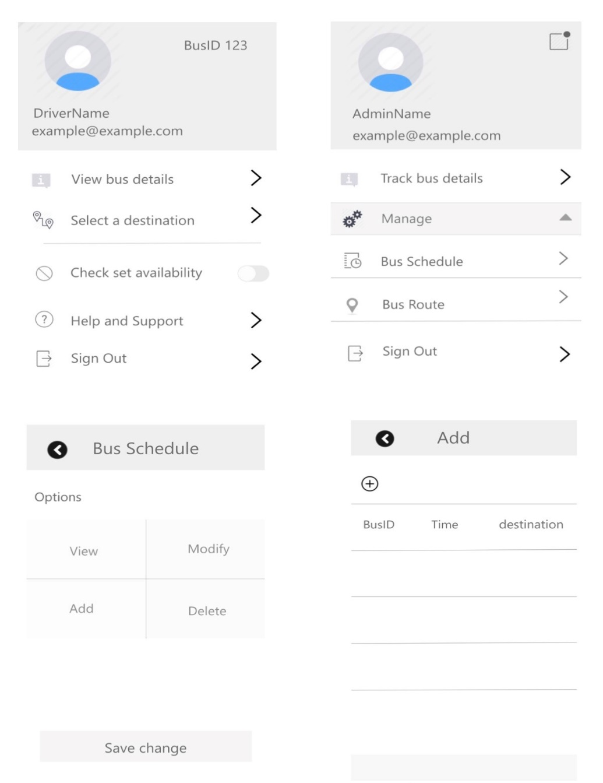

Figure 4-7: User Interface 2

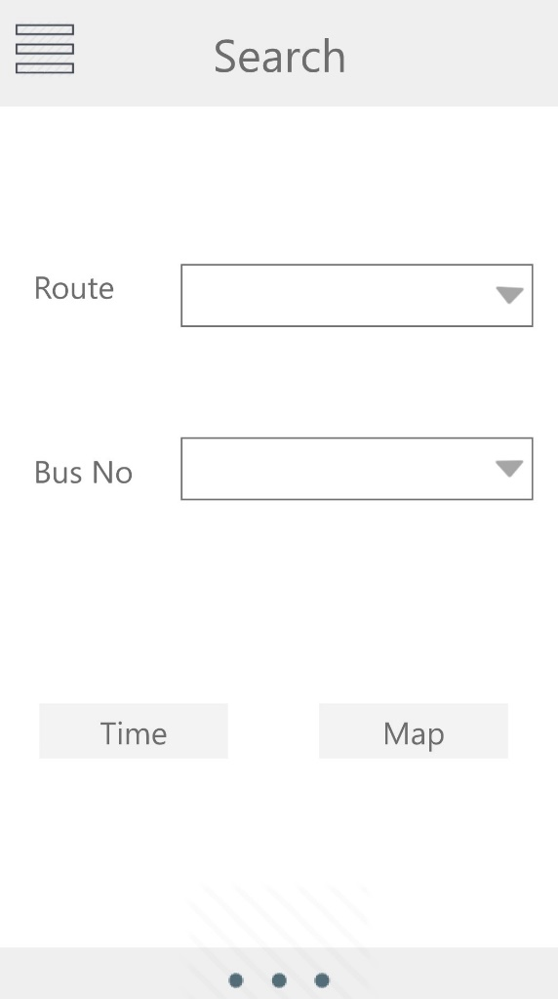

Figure 4-8: User Interface 3

## 4.8 Summary

This chapter contains design of the system architecture, ER diagram, class diagram and sequence diagram to represents the interaction between objects in the system. Also, contains the UI design to show the interface of the system and how the user interacts with the system. Additionally, the database tables will also be included in this chapter.

# References

1. Ahmed Ahmed, Elshaimaa Nada and Wafaa Al-Mutiri,” University Buses Routing And Tracking system”, International Journal of Computer Science & Information Technology (IJCSIT) Vol 9, No 1, February 2017. System”, International Journal of Advances.
2. Dalip, Vijay Kumar, ”GPS and GSM based Passenger Tracking System”, International Journal of Computer Applications (0975 –8887)Volume 100– No.2, August 2014 Comprehensive Security Assessment”, IEEE Security
3. T. Bläsing, L. Batyuk, A.-D. Schmidt, S.A. Camtepe, Sandbox system for suspicious software detection”, Proc. of 5th International Conference on Malicious and Unwanted Software (MALWARE 2010). and S. Albayrak, (2010), “An Android Application
4. H.Niu, “Research and Implementation of Bus Monitoring System Based on GIS”, Bachelor dissertation, Beijing Jiaotong University, Beijing, China, 2008.
5. JISHA, R. C., et al. An Android Application for School Bus Tracking and Student Monitoring System. In: 2018 IEEE International Conference on Computational Intelligence and Computing Research (ICCIC). IEEE, 2018. ‏
6. Sangavi, K. A., Vinitha, N., Vimala, R., & Ramesh, A. College bus tracking system.‏ (2019).
7. VIDYAVATHI, B. M., et al. COLLEGE BUS TRACKING SYSTEM (TRAVELINE). International Journal of Advanced Research in Computer Science, 2018.
8. URL : [https://trackware.com/ar/school-bus-tracker/#](https://trackware.com/ar/school-bus-tracker/) access. at 4/11/2019
9. Balaji, S., and M. Sundararajan Murugaiyan. "Waterfall vs. V-Model vs. Agile: A comparative study on SDLC." International Journal of Information Technology and Business Management 2, no. 1 (2012): 26-30.
10. Reinhard Gotzhein, Rick Reed " System Analysis and Modelling "ed, Germany in May/June 2006