**All about me!**

My name is ……………………………

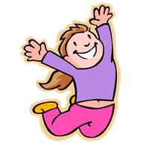I am ………. years old.

I live in …………………….

I have ……… brothers and ………. sisters.

My favourite food is …………………….

My favorite colour is …………………….

My best friend’s name is ………………….

*I like to / don’t like to*

|  |  |  |
| --- | --- | --- |
|  | I like to | I don’t like to |
| read |  |  |
| listen to music |  |  |
| play with my friends |  |  |
| watch movies |  |  |
| draw |  |  |
| dance |  |  |
| play computer games |  |  |
| catch spiders |  |  |