**Instructions: Please read carefully**

* Please rename this file as only your ID number **(e.g. 18-*****-1.doc or 18-*****-1.pdf).**
* Submit the file before **11:59pm on 23/10/2020** in the Portal Lab Performance section labeled **Lab task 2. If you cannot complete the full task, do not worry. Just upload what you have completed.**

|  |
| --- |
| 1. Initialize TWO integer arrays of different sizes. Merge the input arrays and create a new array. Then print the new array in reverse order.   For example,  Array_1 = **{10,20,30,40,50}**  Array_2 = **{1,2,3,4,5,6,7,8}**  Output: **8 7 6 5 4 3 2 1 50 40 30 20 10** |
| **Your code here:**  #include <iostream>  using namespace std;  int main()  {  int a1[]={10,20,30,40,50};  int s1=sizeof(a1)/sizeof(a1[0]);  int a2[]={1,2,3,4,5,6,7,8};  int s2=sizeof(a2)/sizeof(a2[0]);  int c[20] ,temp,i,j,k;  for(i=0;i<s1;i++)  {  c[i]=a1[i];  }  for(i=0,j=s1;j<s1+s2; i++,j++)  {  c[j]=a2[i];  }  cout<<"After merge:\n";  for(i=0; i<s1+s2; i++)  {  cout<<c[i]<<" ";  }  k=i-1;  for(i=0;i<k;i++)  {  temp=c[i];  c[i]=c[k];  c[k]=temp;  k--;  }  cout<<"\nAfter Reverse:\n";  for(i=0;i<s1+s2;i++)  {  cout<<c[i]<<" ";  }  return 0;  } |
| **Your whole Screenshot here: (Console Output):** |

|  |
| --- |
| 1. Initialize TWO integer arrays **A** and **B** of different sizes. Make a new array with the common elements between **A** and **B**. Print the new array element(s). If there is no common element, output “No common element!”.   For example,  Scenario 1:  Array_1 = **{1,4,6,3,6,9}**  Array_2 = **{5,3,7,1,2,6}**  Output: **1 6 3**  Scenario 2:  Array_1 = **{1,4,6,3,6,9}**  Array_2 = **{5,8,7,12,21,63}**  Output: **No common element!** |
| **Your code here:**  **#include <iostream>**  **using namespace std;**  **int main()**  **{**  **int b1[]={1,4,8,3,6,9};**  **int si1=sizeof(b1)/sizeof(b1[0]);**  **int b2[]={5,3,7,1,2,6};**  **int si2=sizeof(b2)/sizeof(b2[0]);**  **for(int i=0;i<si1;++i)**  **{**  **for(int j=0;j<si2;++j)**  **{**  **if(b1[i]==b2[j])**  **{**  **cout<<b1[i]<<" ";**  **}**  **}**  **}**  **return 0;**  **}**  #include <iostream>  using namespace std;  int main()  {  int b1[]={1,4,6,3,6,9};  int si1=sizeof(b1)/sizeof(b1[0]);  int b2[]={5,8,7,12,21,63};  int si2=sizeof(b2)/sizeof(b2[0]);  for(int i=0;i<si1;++i)  {  for(int j=0;j<si2;++j)  {  if(b1[i]==b2[j])  {  cout<<b1[i]<<" ";  }  else  {  goto jump;  }  }  }  jump:  cout<<"no common elements";  return 0;  } |
| **Your whole Screenshot here: (Console Output):** |

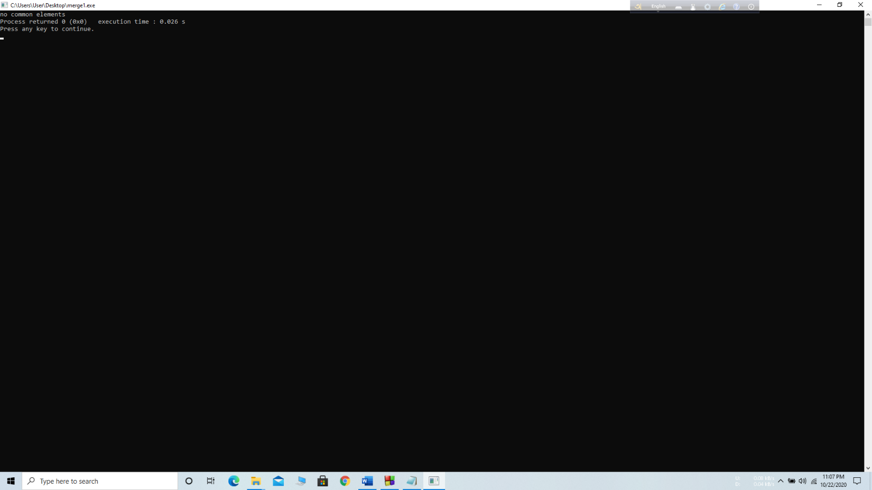

|  |
| --- |
| 1. Initialize an array. Size should be more than FIVE. Write you program to change the array in such a way so that there cannot be any duplicate element in the array anymore. Print the changed array. If the initialized array already had no duplicate elements from the beginning, output a message saying “Array already unique!”;   For example,  Scenario 1:  Array_1 = **{1,4,6,3,6,9,1}**  Output: **1 4 6 3 9**  Scenario 2:  Array_1 = **{1,4,5,3,6,9}**  Output: **Array already unique!** |
| **Your code here:**  #include <iostream>  using namespace std;  int main()  {  int a1[] = {1,4,6,3,6,9,1};  int s1 = sizeof(a1)/sizeof(a1[0]);  cout <<"Output: ";  for (int i=0; i<s1; i++)  {  int j;  for (j=0; j<i; j++)  if (a1[i] == a1[j])  break;  if (i == j)  cout << a1[i] << " ";  }  return 0;  } |
| **Your whole Screenshot here: (Console Output):** |

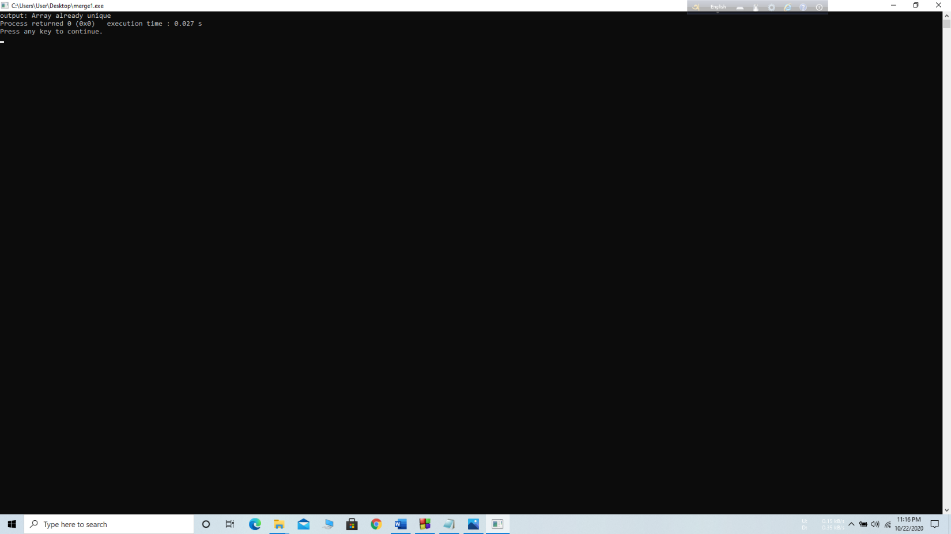

|  |
| --- |
| 1. Initialize an integer array **A** of size 10. Take an integer as input and print how many times that integer occurs in **A**.   For example,  Array_1 = **{8,4,6,1,6,9,6,1,9,8}**  Output:  **Input a number to search: 6**  **The number occurs 3 times in the array** |
| **Your code here:**  **#include <iostream>**  **using namespace std;**  **int main()**  **{**  **int i, num, j=0,f[10];**  **int a1[]={8,4,6,1,6,9,6,1,9,8};**  **int s1 = sizeof(a1)/sizeof(a1[0]);**  **cout<<"Enter Element to be Searched : ";**  **cin>>num;**  **for(i=0; i<s1; i++)**  **{**  **if(a1[i]==num)**  **{**  **f[j]=i;**  **j++;**  **}**  **}**  **cout<<”The number occurs " <<j<<" times in the array"<<"\n";**  **return 0;**  **}** |
| **Your whole Screenshot here: (Console Output):** |

|  |
| --- |
| 1. Initialize an integer array of size 10. Print the number of time each element occurs in the array.   For example,  Array_1 = **{8,4,6,1,6,9,6,1,9,8}**  Output:  **8 occurs = 2 times**  **4 occurs = 1 time**  **6 occurs = 3 times**  **1 occurs = 2 times**  **9 occurs = 2 times** |
| **Your code here:**  #include <iostream>  using namespace std;  int main()  {  int a1[]={8,4,6,1,6,9,6,1,9,8};  int s1 = sizeof(a1)/sizeof(a1[0]);  for(int i=0;i<9;i++)  {  int count=1;  for(int j=i+1;j<10;j++)  {  if (a1[i]==a1[j])  count++;  }  cout<<a1[i]<<" occurs = "<<count<<" times"<<"\n";  }  return 0;  } |
| **Your whole Screenshot here: (Console Output):** |

|  |
| --- |
| 1. Initialize a matrix of minimum 3x4 (row x column) size. Output its transpose matrix.   For example,  Matrix_1:  **1 6 7 9**  **2 4 8 5**  **3 1 9 4**  Output:  **1 2 3**  **6 4 1**  **7 8 9**  **9 5 4** |
| **Your code here:**  #include <iostream>  using namespace std;  int main()  {  int a[10][10],transpose[10][10],row,column,i,j;  cout << "Enter rows of matrix: ";  cin>>row;  cout<<"Enter columns of matrix: ";  cin >>column;  cout<<"\nEnter numbers of matrix: " <<endl;  for (int i=0;i<row;++i)  {  for (int j=0;j<column;++j)  {  cout<<"Enter number a" <<i+1<<j+1<< ": ";  cin >>a[i][j];  }  }  cout<<"\nMatrix_1: "<<endl;  for(int i=0;i<row;++i)  {  for(int j=0;j<column;++j)  {  cout<<" "<<a[i][j];  if(j==column-1)  cout<<endl<<endl;  }  }  for (int i=0;i<row;++i)  for (int j=0;j<column;++j)  {  transpose[j][i]=a[i][j];  }  cout<<"\nOutput:" << endl;  for (int i=0;i<column; ++i)  for (int j=0;j<row;++j)  {  cout<<" "<<transpose[i][j];  if(j==row-1)  cout<<endl<<endl;  }  return 0;  } |
| **Your whole Screenshot here: (Console Output):** |