Book Proposal

Proposed Book Title:
REST API Development
Proposed Book Subtitle:
A Complete Guide To Building usable, scalable, and secure RESTful Systems
Author(s):
Ray Sinnema
Author title(s) and affiliation(s):
API and Security Architect @ EMC
Preferred mailing address(es):
Pronkmos 117, 3994LN Houten, Netherlands
Preferred phone number:
+31-639429001
Preferred Email address(es):
remon.sinnema@emc.com
rssinnema@yahoo.com
Author Platform details:
Author biography and LinkedIn profile: https://www.linkedin.com/in/remonsinnema

Author Web site/blog/Twitter:
http://securesoftwaredev.com
https://twitter.com/ApiSecRay

Author public speaking samples (YouTube, etc.):
http://www.xmlamsterdam.com/pdf/2013/2013-remonsinnema-radl-xmlamsterdam2013/01-agenda.html (click the title to advance to the next slide)
http://www.slideshare.net/sinnema313/

Why are you the best person to write this book?
- I’m co-creator or REST API Description Language (RADL) and author of RADL tooling.
- I serve on the REST Governance Board for the ECD division in EMC where I reviewed several REST APIs.
- I’m responsible for the REST API of EMC’s public cloud Content & Collaboration Platform.
- I’m author of the XACML REST Profile.
- I’ve written a bunch of well-received blog posts on REST.

Book Summary:
In one sentence, tell us why the audience will want to buy your book.
This book provides readers with actionable advice for all phases of REST development, from concept to design to implementation to operations and maintenance, with an emphasis on security.
Summarize what the book is about, like you would pitch it to a potential reader on the back cover. What makes your book unique in the marketplace?
The rise of the API Economy has led to a surge in almost-RESTful APIs that don’t reap all of the benefits of the Web’s architecture. This hands-on guide will teach you everything you need to know to design and implement usable, scalable, and secure REST APIs that can painlessly evolve over time.
- Analyze the problem domain and design the most usable API for it by following established patterns
- Build security in from the start and keep an eye on it in production
- Use the REST API Description Language and associated tooling to automate tedious tasks so you can focus on the creative part
- Evolve your API without breaking clients

Technology Summary:
How would you characterize the technology’s stage of development? (Put an X in the column next to the stage that best applies.)
Answer | Stage | Description
 | Emerging | This is a new and cutting-edge technology that is still in the experimental/lab stage.
X | Developing | A technology that is gaining momentum and has a lot of activity but is not a clear standard. High growth, but multiple competitors on the horizon.
 | Mature | An established technology with leading market/mind share. Strong or moderate growth.
 | Declining | An old titan that may still be important and useful, but there is no further expected development work or growth. Alternative approaches threaten to make it obsolete.

Briefly explain the technology and why it is important.
APIs powering machine-to-machine (M2M) interactions make up an increasing percentage of all interactions on the Internet, driven by the large trends of mobile, cloud, and Internet of Things. REST is an architectural style modeled after the human Web that offers many advantages for M2M scenarios, like scalability and evolvability.

Audience:
Explain who the primary audience is for your book. What professional positions does this audience hold? What knowledge do you assume of this audience? What books can you assume they have read? What skills can you assume they have mastered?
Software developers and architects. They know the basics of HTTP and APIs, but don’t necessarily know the finer details of REST. They have read some articles and blogs and maybe one book on the topic (hopefully one of RESTful Web APIs, Hypermedia APIs with HTML5 and Node, or REST In Practice). They know about software development and the problems of evolving software over time.
Please estimate as best you can how many people will use this technology? Please state any applicable statistics (e.g., web searches, web site traffic, blogs) indicating market use or market growth.
The number of people using REST is hard to quantify, but Google Trends shows that an ever increasing number of people are searching for it:
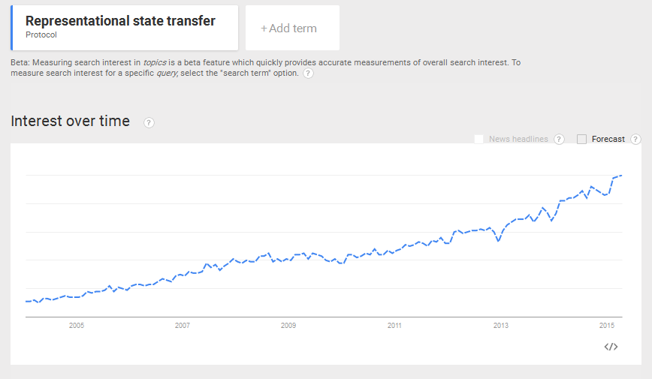
Likewise, Programmable Web counts an exponentially increasing number of REST APIs:
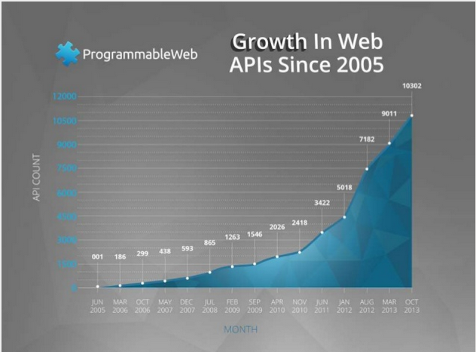
Please provide some scenarios that indicate how the audience will use your book. For example, will readers refer to it daily as a reference? Will they read it once to learn the concepts and then refer to it occasionally?
People will most likely read the book front to cover once and then refer back to it whenever they’re dealing with a particular topic.
Use the following table to describe how the audience for your book typically gets information and where it looks for guidance and leadership (list top five choices).
What web sites or blogs do they read? | 1) StackOverflow  2) InfoQ  3) DZone  4) SlashDot  5) IBM DeveloperWorks
What publications do they read (e.g., magazines, journals, newspapers)? | 1) Dr. Dobbs  2) Communications of the ACM  3) Java Magazine  4) IEEE Software Magazine  5)
What conferences do they attend? | 1) Velocity  2) GOTO  3) QCon  4)  5)
Who are the leaders and key influencers in the field who would review or endorse your book? | 1) Mike Amundsen  2) Leonard Richardson  3) Markus Lanthaler  4) Olivier Goetschke  5)

Key Topic Coverage:
What are the top five topics that will be covered in the book? Why are they the top five?
- API design – Applying the REST principles is largely a design problem.
- Security – Any economy is based on trust and so is the API Economy. Trust follows from proper security.
- Analysis – You can’t design a system well if you don’t understand it.
- Implementation – This is where the design is realized.
- REST-specific tooling – Developers want to focus on developing, not on being REST-compliant. Tooling takes away the drudgery and makes it easy to do the right thing.

What problems does this book solve for its users?
How to apply the principles of the REST architectural style to everyday software development.
List the four or five topics covered or features included that will provide the greatest benefit to readers or will be the most likely to excite them?
- Clear step-by-step procedures for analyzing, designing, implementing, and evolving RESTful systems.
- REST-specific tooling that guides developers into making the right choices and automates the tedious tasks.
- Guidance on how to secure REST APIs.
- A catalog of REST design patterns.

Other Book Features and Video Offerings:
Is there a companion web site? If so, what do you plan to include on the site? Would you be willing to participate in video offerings as well as workshops and training seminars?
There should be a companion web site that includes errata, code examples, and a forum for readers to ask and answer questions.
I’m very interested in video offerings, workshops, seminars, speaking at conferences, consulting engagements, and any other activities that promote the use of the REST architectural style of software development.

Competition:
What books or online resources compete with this book? Please list the title and author. In each case, how will your book be different or better in timing, content, coverage, approach, or tone?
Easily the best book on the market today is RESTful Web Services, by Mike Amundsen, Leonard Richardson, and Sam Ruby. The authors do a wonderful job of explaining hypermedia and REST API design.
The proposed book will make the treatment more concrete by providing step-by-step procedures, design patterns, and all the other details needed to build and evolve a RESTful system that is usable, scalable, and secure.
Hypermedia APIs with HTML5 and Node by Mike Amundsen and REST In Practice by Jim Webber, Savas Parastatidis and Ian Robinson are good books too.
The proposed book will use code samples more effectively and cover more of the development lifecycle.
There are a couple of older books as well.
The proposed book will be much more in line with current thinking.
There are many, many online resources about REST.
The proposed book will cover the subject in much more detail.

Book Outline:
Until we can envision your book in exceedingly concrete terms, we cannot know whether to sign it.
I. Getting Started

1. Introduction
1.1. Application Programming Interfaces (APIs)
1.2. Representational State Transfer (REST)
1.2.1. What is REST?
1.2.2. The Essence of REST: Hypermedia
1.2.3. REST Maturity
1.3. Introducing RESTBucks
1.3.1. The RESTBucks Domain
1.3.2. Software Development At RESTBucks
1.4. Summary

2. Analysis
2.1. Functional Requirements
2.1.1. Capturing Requirements With State Diagrams
2.1.2. State Diagrams for RESTBucks
2.1.3. Capturing Requirements With Examples
2.1.4. Automating Examples With Behavior-Driven Development (BDD)
2.1.5. Deriving State Diagrams From BDD Scenarios
2.2. Non-Functional Requirements
2.2.1. The qualities
2.2.2. Developer eXperience
2.3. Summary

II. Design

3. Design Methodology
3.1. Document Requirements With State Diagrams
3.2. Discover Resources and Methods From State Transitions
3.3. Name Resources With URIs
3.4. Name State Transitions With Link Relations
3.5. Design Messages
3.6. Document Application Semantics
3.7. Select a Media Type To Serialize Messages
3.7.1. HAL
3.7.2. Mason
3.7.3. Siren
3.7.4. UBER
3.7.5. JSON-LD & Hydra
3.7.6. Making a Choice
3.8. The Design In Action
3.9. Summary

4. Design Patterns
4.1. Home
4.2. Collection
4.3. Create
4.4. Polling
4.5. Notification
4.6. Asynchronous Processing
4.7. Workflow
4.8. Lifecycle
4.9. Processor
4.10. Concurrency
4.11. Correlation
4.12. Transaction
4.13. Batch
4.14. Summary

5. Error Handling
5.1. HTTP Status Codes
5.2. Problem Details
5.3. Serializing Error Messages
5.4. Security
5.5. Summary

6. Performance and Scalability
6.1. Conditional GETs
6.2. Statelessness
6.3. Caching
6.4. Granularity
6.5. Paging
6.6. Content Ranges
6.7. Load Balancing
6.8. Summary

7. Security
7.1. Threat Modeling REST APIs
7.2. Authentication
7.3. Authorization
7.4. Auditing
7.5. Summary

8. REST API Description Language (RADL)
8.1. Purpose
8.2. Structure
8.3. Designing With RADL
8.4. Tooling
8.5. Summary

III. Implementation

9. Implementation
9.1. Model-View-Controller (MVC)
9.2. DRY
9.3. Generating Code From RADL
9.4. Extracting RADL From Code
9.5. Security
9.5.1. Input Validation
9.5.2. Output Encoding
9.6. Calling external services
9.7. Providing Client Libraries
9.8. Summary

10. Test
10.1. Automated Regression Testing
10.2. Generating Stubs From RADL
10.3. Security
10.4. Summary

11. Documentation
11.1. Client Documentation
11.1.1. Design-Time Documentation
11.1.2. Run-Time Documentation
11.2. Server Documentation
11.3. Summary

12. Operations
12.1. Separating Configuration From Code
12.2. Logging and Monitoring
12.3. Security
12.3.1. Alerting
12.3.2. Vulnerability Disclosure
12.4. Support
12.5. Summary

13. Maintenance
13.1. Backwards Compatibility
13.2. Breaking Changes
13.3. Extensibility
13.4. Summary

IV. Usage

14. Developing REST Clients
14.1. Human-Driven Clients
14.2. Autonomous Clients
14.3. Resolving URIs
14.4. Summary

Specs and Schedule:
How many pages do you expect the book to be?
Around 300.
What use you will make of illustrations or screenshots?
There will be diagrams and some illustrations.
What special considerations apply to your plans for the book, including unusual format, use of color, hard-to-get illustrations, or anything else calling for unusual resources?
None.
When do you anticipate delivering a complete draft of the manuscript or technical review?
In 5 months.

