

Republic of Tunisia
Ministry of Higher Education and Scientific Research General Directorate of Technological Studies
Higher Institute of Technological Studies of Sfax

Department: Computer Technologies Department

End of studies Internship

In order to obtain the diploma of

Degree in Computer Technology
Option: Development of Information Systems (DSI)

Entitled
Online presence management
Developed by

Ahmed Khlif

Presented on 19/06/2024 in front of the jury commission

Mr. | FAIEZ CHARFI | President
Mr. | NISSEN MASMOUDI | Rapporteur
Mr. | MOHAMED ELLEUCH | Supervisor (ISET)
Mr. | SLIM FEKI | Supervisor (ISET)
Mr. | HEDI TMAR | Supervisor (Company)

Code :

Academic Year 2023/2024

Dedication
With overflowing joy and a profoundly touched heart I dedicate this work to my beloved parents, Maher and Faiza, and my cherished siblings, Rihab, and Mariem. Your love, encouragement, and sacrifices have been my guiding light and source of strength throughout this journey. Your belief in me has fuelled my determination to continuously improve and move forward, and for that I am eternally grateful.
I would also like to express my gratitude to all my friends especially for their support, encouragement, throughout this journey.


One last thing

Acknowledgment
I thank God Almighty for giving me the health and the will to start and finish this project.
I would first like to express my warm thanks to Mr. Kamel Abouchaala, the Director at Fab Lab, for the time he shared with me and his advice during the period of this end-of-study project.
This work would not have been as enriching and would not have been possible without the help and supervision of my supervisors, Mr. Mohamed Elleuch and Mr. Slim Feki. They agreed to accompany me, answered my questions with kindness, and provided me with all the information required and necessary for the creation of my application.
In particular, I thank the co-founder of Fondation Djagora, Mr. Hedi Tmar, who agreed to welcome me into his company.
Our most sincere thanks to everyone who helped, encouraged, and supported me in this project.
We would like to thank all the members of the jury Mr. Nissen Masmoudi and Mr. Faiez Charfi who gave me the privilege of appreciating this work.

Summary
Chapter 1: Preliminary Study 2
Introduction 3
1. Presentation of the host company 3
1.1. Overview of the host company 3
1.2. Activities and segments 3
1.2.1. Djagora Academy: 3
1.2.2. Djagora FabLab: 4
1.2.3. Djagora Juniors: 4
1.2.4. Djagora Home Digital: 4
1.3. Technical sheet: 4
2. Project overview 5
2.1. Objectives to be achieved: 5
2.2. Study of the existing 5
2.3. Critical analysis of the existing 6
2.4. Proposed solution 7
3. Requirements specification 7
3.1. Functional Requirements Specifications 7
3.1.1. User needs : 7
3.2. Non-functional requirements specifications 7
3.2.1. Graphical Charter: 7
3.2.2. Usability requirements: 8
3.2.3. Performance requirements: 8
4. Methodology and Modeling language: 8
4.1. Adapted Methodology 8
4.2. SCRUM 9
4.3. Use case diagram 10
5. Project Structure 11
5.1. SCRUM Team Identification 11
5.2. Team and member roles 11
5.3. Product Backlog 11
6. Software Architecture for web Application 13
6.1. Software Architecture MVC 13
6.2. MVC Architecture in .NET Web Applications 14
6.3. Web Services 14
6.4. Consuming RESTful APIs with Axios 15
6.5. full-stack application architecture 16
6.6. Web Development Techniques 16
6.7. Backend Development Techniques 18
7. Analysis of NFC and QR Code Integration 19
7.1. What is NFC? 19
7.2. How to activate NFC on smartphone and use it 20
7.3. Concept of iDigix business card NFC 21
7.4. Advantages of using NFC-enabled Cards in iDigix 22
Conclusion 23
Chapter 2: Sprint 1“Software and Framework Configuration and Authentication System” 24
1. Objective 25
2. Backlog sprint 1 25
3. Development Tools 25
3.1. Hardware Environment: 25
3.2. Software Environment: 26
4. Conception 28
4.1. “Sprint 1” class Diagram 28
4.2. Registration Conception 29
4.3.1. Registration use case diagram 29
4.3.2. Registration sequence diagram: 31
4.3. Authentication Conception 32
4.4.1. Authentication use case diagram 32
4.4.2. Authentication sequence diagram 34
5. Realizations 35
5.4. Realization of the "Rgistration" 35
5.5. Realization of the “Authentication” 36
5.5.1. Development and integration of web services 36
6. Security & Performance 38
6.1. Security Improvements: 38
6.2. Performance Enhancements: 40
7. API Testing 41
Conclusion 42
Chapter 3: Sprint 2“Profile Customization, and Link Management 43
1. Objective 44
2. Backlog sprint 2 44
3. Conception 44
3.1. “Sprint 2” Class Diagram 44
3.2. Appearance Management Conception. 45
3.2.1. Appearance Management use case diagram 45
3.2.2. Appearance Management Sequence diagram 47
3.3. Links Management Conception. 47
3.3.1. Links Management use case diagram 47
3.3.2. Links Management sequence diagram 50
4. Realizations 51
4.1. Appearance Management. 51
4.2. Save Confirmation Alert 51
4.3. Links Creation. 52
4.4. Responsive. 53
4.5. Create Link. 53
4.6. Links Editing. 54
4.7. Integration profile 54
5. API Testing 55
Conclusion 56
Chapter 4: Sprint 3“Subscription Plans and invoicing system.” 57
1. Objective 58
2. Backlog sprint 3 58
3. Conception 58
3.1. “Sprint 3” Class Diagram 58
3.2. “Deposits” Conception 59
3.2.1. Deposits and puchase history use case diagram 59
3.2.2. budget management diagram. 60
3.3. “Purchasing” Conception 60
3.3.3. Purchasing of Use Cases 60
3.3.4. Purchasing sequence diagram. 62
4. Realizations 63
4.1. Purchasing Bundles. 63
4.2. Confirmation Alert 64
4.3. Budget Section In Settings 64
5. API Testing 66
Conclusion 68
Chapter 5: Sprint 4“Analytic Implementation and Search Functionality” 69
1. Objective 70
2. Backlog sprint 4 70
3. Conception 70
3.1. “Sprint 4” class Diagram 70
3.2. “Analytic” Conception. 71
3.2.1. Analytic use case diagram 71
3.2.2. Collect insight sequence diagram. 73
3.2.3. analytic sequence diagram. 74
3.3. Search Conception. 74
3.3.1. Search Use case diagram 74
3.3.2. Search sequence diagram: 76
4. Realizations 77
4.1. Search. 77
4.2. Dashbord analytic. 78
5. API Testing 79
Conclusion 80
Chapter 6: Sprint 5“Rating System and Deployment” 81
1. Objective 82
2. Backlog sprint 5 82
3. Conception 83
3.1. “Sprint 5” Class Diagram 83
3.2. “Managing Reserved Coupons” Conception. 83
3.2.1. Managing Reserved coupons use case diagram 83
3.2.2. apply for reserved coupons sequence diagram 86
3.2.3. Used a reserved coupons sequence diagram 87
3.3. “Manage available coupons” Conception. 88
3.3.1. “Manage available coupons” use case diagram 88
4. Realzations. 89
4.1. Rating section. 89
4.2. Apply for reserved coupon. 90
4.3. Use a reserved coupon to Rate the service provider of it. 91
5. API Testing 92
6. Application Deployment and Configuration 93
5.1. Choosing OVH for Deployment 93
5.2. Understanding VPS 94
5.3. Server Configuration 95
5.4. deployment diagram 95
5.5. Deploying iDigix on a OVH VPS Using Nginx: 96
Conclusion 101
General Conclusion 102
Abbreviations 103
Bibliography and Netography 104

List of figures
Figure 1: Djagora's foundation. 3
Figure 2:Agile methodology 8
Figure 3:SCRUM Process 9
Figure 4: Use case diagram 10
Figure 5:MVC Architecture 13
Figure 6:Consuming RESTful APIs with Axios 16
Figure 7:Chart of stack overflow questions that month. 17
Figure 8:NFC technology 19
Figure 9:Prototype of iDigix NFC Card 20
Figure 10:Activation de la NFC 20
Figure 11:Where to place your NFC business card 21
Figure 12:one card shares evrything. 22
Figure 13:PC PORTABLE GAMER ASUS FX506HCB-HN161 25
Figure 15:sprint 1 class Diagram 28
Figure 16:Use Case Diagram " Registration " 29
Figure 17:Registration sequence diagram 31
Figure 18:“Authentication” sequence diagram 34
Figure 19:Inscription porcess steps interfaces 35
Figure 20:interface email sent 36
Figure 21:login service api methode 37
Figure 22:Authentication page. 38
Figure 23:JWT Authentication Process 38
Figure 24:API Rate Limiting Process 39
Figure 25:lazy loading process. 40
Figure 26:Postman POST login API call in case of successful. 41
Figure 27:POST login API call in case of error. 41
Figure 28:Sprint 2 Class Diagram 45
Figure 29:“Appearance Management” use case diagram 45
Figure 30:User Appearance Settings Management sequence diagram. 47
Figure 31:Links Management use case 47
Figure 32:User Link Management. 50
Figure 33:interface of profile Appearance 51
Figure 34:alert save confirmation. 52
Figure 35:interface of profile links management 52
Figure 36:Custom Link Creation Process in a Mobile view 53
Figure 37:process of edit a link 54
Figure 38:Public porfile view 54
Figure 39:Postman Api user get Profile successful response. 55
Figure 40:Sprint 3 Class Diagram 59
Figure 41:“Deposit and purchase history” use case diagram 59
Figure 42:deposit sequence diagram 60
Figure 43:“Purchases” use case diagram 61
Figure 44:purchasing process sequence diagram 62
Figure 45:Purchasing bundles page. 63
Figure 46:purchasing the premium Bundel dialog. 63
Figure 47:confirmation message after complete purchase 64
Figure 48:Budget section (1/2) 64
Figure 49:budget section (2/2) 65
Figure 50:Postman Api user get Deposits successful response. 66
Figure 51:Postman Api user get Purchases successful response. 67
Figure 52:sprint 4 Class diagram 71
Figure 53:analytic use case diagram. 71
Figure 54:process of collect analytic data sequence 73
Figure 55:access process of view analytic page sequence 74
Figure 56: Search use case diagram 74
Figure 57:process of search of public profile 76
Figure 58:Search with filtering Option in a Mobile view 77
Figure 59:analytics page with charts(1/2) 78
Figure 60:analytics page with charts(2/2) 78
Figure 61Postman Api user get Clicks successful response. 79
Figure 62:sprint 5 Class Diagram 83
Figure 63:managing reserved coupons use case 83
Figure 64:apply for reserved coupon sequence diagram 86
Figure 65:Used a reserved coupon use case 87
Figure 66:manage available coupons use case 88
Figure 67:interface of rating management 89
Figure 68:interface of apply for reserved coupon. (1/2) 90
Figure 69::interface of apply for reserved coupon. (2/2) 90
Figure 70:interfraces of process to rate service provider. 91
Figure 71:Postman Api user reserve coupon successful response. 92
Figure 72: about OVHcloud. 93
Figure 73:Overview of VPS Hosting 94
Figure 74:deployment diagram. 95
Figure 75:Connect via SSH snapshot 96
Figure 76:Update and Install Packages commande lines. 97
Figure 77:Build the ASP.NET Core application commande lines 97
Figure 78:Transferring files to my vps. 98
Figure 79:nano comande line confguring Nginx 98
Figure 80:configured Nginx 98
Figure 81:nano comande line confguring systemd service. 99
Figure 82:configured application service 99
Figure 83:comnade line of starting and enabling and view status of the service 99
Figure 84:www.idigix.site 100

List of tables
Table 1: Djagora Foundation technical sheet 4
Table 2:Comparative Analytic of Linktree and iDigix 6
Table 3:Team and member roles 11
Table 4:Product Backlog 11
Table 5:Difference between SOAP and REST 15
Table 6:Difference between Angular and React 16
Table 7:Backlog du Sprint 1 25
Table 8:Software Environment 26
Table 9:Textual description of the Registration 30
Table 10:Textual Description of Authentication 33
Table 11:backlog sprint 2 45
Table 12:Text description of “Appearance Management” use cases 46
Table 13:Text description of “Links Management” use cases 48
Table 14: Sprint 3 Backlog 58
Table 15:Text description of “Deposits” use cases 59
Table 16:Text description of “Purchases” use cases 60
Table 17: Sprint 4 Backlog 69
Table 18:Text description of “Analytic” use cases 71
Table 19:Text description of Search System use cases 74
Table 20: Sprint 5 Backlog 81
Table 21:Text description of “Reserved Coupons” use cases 83
Table 22:Text description of “Managing Coupons” use cases. 87
Table 23:server Configuration 94

General introduction
In the current age of digital technology, it is vital for both individuals and businesses to manage their online presence intelligently to achieve success in a highly competitive environment. However, with the abundance of digital platforms and sharing links, promoting online content consistently and effectively has become a significant challenge. It is in this context that I have been tasked with designing and developing a platform for online presence management, named iDigix, Within the Djagora Association Sfax.
At iDigix, we've developed a platform with essential components to optimize users' online presence. Profile Management offers personalized customization of public profiles, including aggregating various content types onto a single page. Our advanced Search System facilitates effortless discovery and networking. With an integrated Rating System, Analytics Dashboard, search system, iDigix empowers users to enhance their online presence, foster connections, and achieve digital goals with confidence. This report is structured into these chapters:
The first chapter is called "Preliminary Study" and it outlines the objectives and methodology adopted during the project implementation. It also presents the host establishment and describes the existing situation and delves into the application's functional and non-functional requirements, exploring the software architecture and the technologies employed during development.
Chapters 2-6 provide a detailed account of each sprint, outlining the development of key features, including authentication, profile customization, link management, subscription plans, payment integration, analytic implementation, search functionality, rating system and deployment.
This report offers a comprehensive understanding of the iDigix platform, its development process, and its potential to revolutionize online presence management.

Chapter 1: Preliminary Study

Introduction
The development of an application requires an initial study phase. In this chapter, I will discuss the presentation of the organization hosting the project, the project itself, followed by a detailed project overview, objectives, analysis of existing solutions, proposed solutions, requirements specification, and concludes with the adopted methodology and project structure.
- Presentation of the host company
- Overview of the host company
the Djagora Foundation is a non-profit organization based in Sfax, Tunisia, dedicated to supporting startups. It aims to foster entrepreneurship and leadership in Sfax and southern Tunisia, creating a vast network of talented individuals, entrepreneurs, and startups.
- Activities and segments

The Djagora Foundation follows a plan whose aim is to put into practice the philosophical aspects linked to leadership and entrepreneurship. It has four main activities:
Figure 1: Djagora's foundation.
- Djagora Academy:
A program for final-year students and young graduates to create high economic value businesses in the ICT sector and promote employability in Sfax, Tunisia.

- Djagora FabLab:
An open workshop equipped with digital fabrication tools, offering training and prototyping services to bring ideas to life
- Djagora Juniors:
A program for youth aged 12-17 to learn new technologies, coding, and personal development through various workshops.
- Djagora Home Digital:
A space for Tunisian women to enhance their skills and receive training in digital home culture, leading to certification and comprehensive development opportunities.
- Technical sheet:
Table 1: Djagora Foundation technical sheet

Social reason | Djagora foundation
Legal status | foundation
Adress | Village de l'entrepreneuriat, technopole de Sfax, cite el Ons km10, Sfax, Sakiet Ezzit, Tunisie
Phone Number | (+216) 74 861 993
Fax | (+216) 74 861 991
Web site | http://djagora.factorycampus.net/
E-mail | djagora@factorycampus.net

- Project overview
The project aims to create a platform for online presence management, addressing the need for effective digital promotion.
- Objectives to be achieved:
- Centralize online presence management.
- Streamline profile customization and updating.
- Provide users with insights into their profile performance.
- Offer an innovative rating system that allows users to collect authentic feedback via coupons.
- Implement a robust search system with advanced filters.
- Integrate NFC and QR code technology for enhanced accessibility and interaction.
- Offer a secure purchasing and deposits system, including a detailed history of transactions and various bundles and products for users.
- Study of the existing
To ensure that iDigix is a game-changer, it's crucial to undertake a comprehensive analysis of similar platforms, with a particular focus on Linktree. Our study aims to identify Linktree's strengths and weaknesses, so we can find opportunities for improvement and differentiation. By closely examining Linktree's features, user experience, and market positioning, we aim to leverage its successes and address any shortcomings in our iDigix project. This analysis will enable us to gain a better understanding of the online presence management landscape and refine our strategy, with the ultimate goal of creating a platform that stands out in the market.

- Critical analysis of the existing
Table 2:Comparative Analytic of Linktree and iDigix
Aspect | Linktree | iDigix
Online Presence | Rich content integration and extensive customization. | Focuses on simplicity and effective management
Profile Customization | Wide free customization with advanced options in Pro plan | Basic customization for free, more options in Premium plan
Links Management | Unlimited number of links, Pro feature allows users to add thumbnails/icons. | Unlimited number of links, Thumbnails/icons can be added
Content Integration | Extensive, includes social media feeds, videos, Mailchimp, forms, Google Sheets | Limited to links
Analytics | Basic analytics for free, advanced in Pro plan | Detailed analytics focusing on engagement available in Premium
Rating and Feedback | Lacks an integrated rating system allowing users to provide feedback on profiles | Features an integrated rating system based on service
User Base | Influencers, brands, and creators | Diverse, including students, influencers and enterprises
Interface | Modern, intuitive | Simple, clean, user-friendly

- Proposed solution
iDigix offers a streamlined approach to managing online presence, empowering individuals, and businesses to enhance their digital footprint effectively. The platform serves as a centralized hub for controlling and improving online visibility, addressing the challenges of promoting content in a fragmented digital landscape through a comprehensive set of features. It includes a high-performance, scalable application that ensures a smooth user experience, intuitive profile customization for easy aggregation and adjustment of content, and a range of subscription plans tailored to various needs and budgets.
iDigix also provides comprehensive budget management, efficient search and filtering capabilities, NFC card integration for convenient profile interactions, data-driven insights for optimizing online strategies, and a unique coupon-based rating system for collecting authentic feedback. By combining these features, iDigix offers a powerful, user-friendly solution for managing online presence and achieving digital goals with confidence.
- Requirements specification
- Functional Requirements Specifications
Following the talks with the iDigix team, we were able to establish the company's needs and the primary functionalities of the system:
- User needs :
The system must assure those functionalities for the User:
- The system must allow the User to authenticate.
- The system must allow the User to customize their public profile appearance.
- The system must allow the User to manage their links effectively.
- The system mus allow the User to an intuitive search function with advanced filters.
- The system must allow the User to explore and select different subscription plans.
- The system must allow the User to track their deposits and past purchases.
- The system must allow the Premium user to have access to a unique rating system.
- The system must allow the Premium user to access detailed analytic and insights about their profile performance and user interactions.
- Non-functional requirements specifications
- Graphical Charter:
- The graphic interfaces need to be exceptionally clear.
- The graphic interface is expected to be well-organized and easily navigable.
- The interfaces are expected to be ergonomic and user-friendly.
- The buttons must be significant and well placed.
- Usability requirements:
- The system should incorporate contextual aids in specific interfaces.
- The system should ensure efficient and quick data entry.
- The system should maintain consistent interface design.
- The system should offer clear error handling and feedback.
- The system should ensure responsive design.
- Performance requirements:
- The server needs to be capable of managing various data validation and input procedures.
- The server needs to be capable of managing several connections at once.
- The system needs to react quickly.
- The system should implement lazy loading to optimize performance.
- Methodology and Modeling language:
- Adapted Methodology
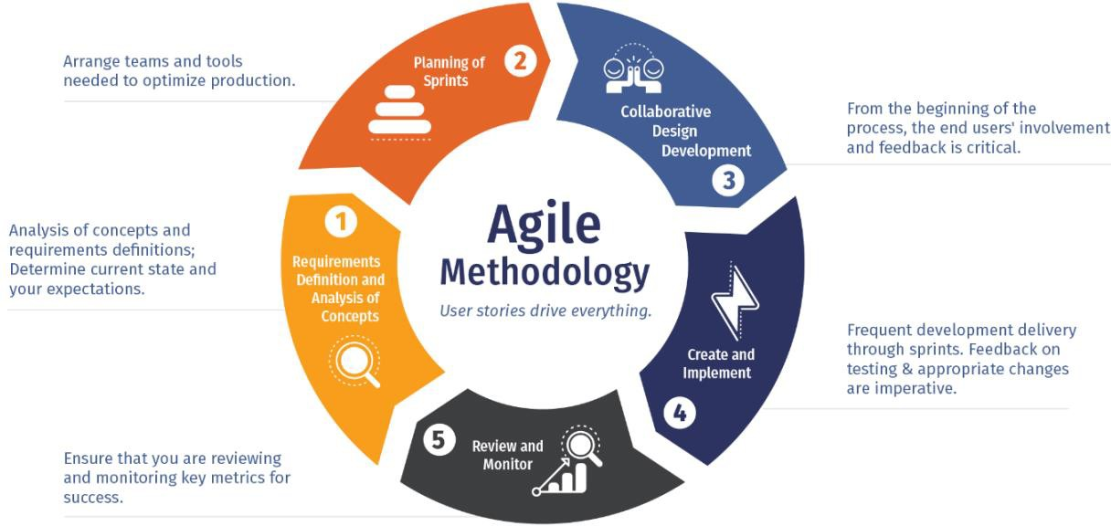
The choice of a software development methodology is a critical step in the life cycle of a development project. It is the planning and control structure for the process of creating an information system. The choice depends on the nature of the project itself and its size and complexity.
Figure 2:Agile methodology
the study of several methodologies and their suitability for our project, we have opted for the use of the SCRUM method.
- SCRUM
Scrum is an agile development methodology used in the development of Software based on iterative and incremental processes.
Scrum is an adaptable, fast, flexible, and effective agile framework that is designed to deliver value to the customer throughout the development of the project.
The primary objective of Scrum is to satisfy the customer’s needs through an environment of transparency in communication, collective responsibility, and continuous progress.
The development starts from a general idea of what needs to be built, elaborating on a list of characteristics ordered by priority (product backlog) that the owner of the product wants to obtain.
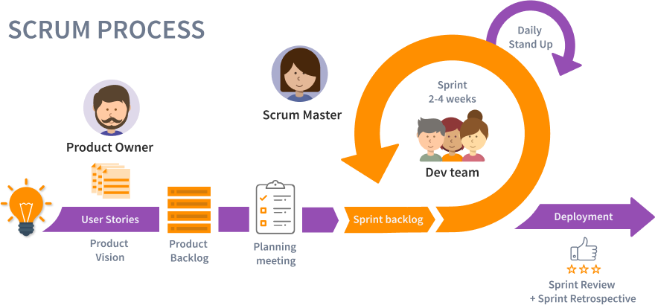
The figure below illustrates the process on which SCRUM is based:
Figure 3:SCRUM Process
Scrum has many advantages over other agile development methodologies. It is currently the most used and trusted framework of reference in the software industry. Below are some of the known benefits of Scrum:
Easily Scalable: Scrum processes are iterative and are handled within specific work periods, which makes it easier for the team to focus on definite functionalities for each period. This not only has the benefit of achieving better deliverables in line with the needs of the user but also gives the ability to the teams to scale the modules in terms of functionality, design, scope, and characteristics in an orderly, transparent, and simple manner.
Flexible to changes: Quick reaction to changes in requirements generated by customer needs or market developments. The methodology is designed to adapt to the changing requirements that complex projects entail.
Time to Market reduction: The Client can start using the most important functionalities of the project before the product is completely ready.
Timely Prediction: Using this methodology, we know the average speed of the team by a sprint (story points), with which, consequently, it is possible to estimate when a certain functionality that is still in the backlog will be available.
Reduction of risks: The fact of carrying out the most valuable functionalities in the first place and knowing the speed with which the team advances in the project, allows to clear risks effectively in advance.
- Use case diagram
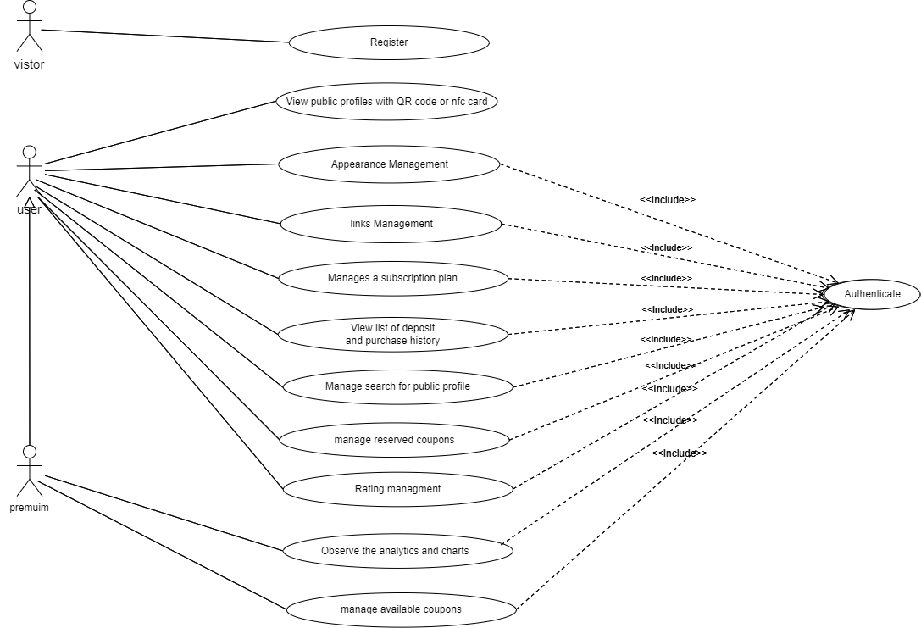
The use case diagrams describe the general functions and scope of a system. These diagrams also identify the interactions between the system and its actors.
Figure 4: Use case diagram
- Project Structure
- SCRUM Team Identification
In the context of our project, the team plays a pivotal role in Scrum: it serves to optimize productivity and flexibility. To achieve these goals, it must self-organize and be multi-skilled. Additionally, it should have sufficient autonomy to support its work. In the context of our project, we find:
- Team and member roles
Table 3:Team and member roles
Role | Missions | Actors
Product Owner | Prioritizes work at sprint planning meetings, inspires team members with clear goals, and deals with any questions. | Hedi Tmar
Scrum Master | A Scrum Master facilitates and enforces the agreed-upon practices for the Scrum team. | Kamel Abouchaala
Development Team | The team in charge of developing the product increment and achieving the sprint target. | Ahmed Khlif, workmate
- Product Backlog
A product backlog is a list of the new features, changes to existing features, bug fixes, infrastructure changes, or other activities that a team may deliver to achieve a specific outcome.
Table 4:Product Backlog
Sprint | Description | Actors | Priority | Starting  date | Ending  date
Sprint 1  Software and Framework Configuration and Authentication System | - Software configuration  - Authentication and authorization.  - Implement email verification.  - Security & Performance | Ahmed  And  Workmate | High | 05/02/2024 | 28/02/2024
Sprint 2  Profile Customization and Link Management | - Create user-friendly UI components.  - Implement profile customization and link management across devices. | Ahmed  And  Workmate | High | 29/02/2024 | 21/03/2024
Sprint 3 Subscription Plans and invoicing system. | - Define subscription tiers and features.  - Enable user subscription management. | Ahmed  And  Workmate | Medium | 22/03/2024 | 11/04/2024
Sprint 4  Analytic Implementation  and Search Functionality | - Develop backend algorithms to collect and process user data efficiently.  - Generate insightful charts.  - Implement search functionality | Ahmed  And  Workmate | Medium | 12/04/2024 | 06/05/2024
Sprint 5  Rating System, and Deployment | - Brainstorm a new system to get valuable feedback based on service.  - Create Coupons managing functionalities.  - Develop backend logic to process and store ratings using coupons.  - Implement frontend display of ratings on user profiles and rating section  - Application Deployment and configuration | Ahmed  And  Workmate | High | 07/05/2024 | 14/06/2024
- Software Architecture for web Application
In web application architecture, the structural framework organizes frontend, backend, and database components for seamless interaction. The primary goal is a unified, scalable system meeting functional requirements while considering performance, security, and maintenance.
In this scenario, we used the Model-View-Controller (MVC) architecture, which separates data (Model), presentation (View), and logic (Controller) for efficient.
- Software Architecture MVC
The Model-View-Controller (MVC) framework is an architectural/design pattern that separates an application into three main logical components Model, View, and Controller. Each architectural component is built to handle specific development aspects of an application. It isolates the business logic and presentation layer from each other. It was traditionally used for desktop graphical user interfaces (GUIs). Nowadays, MVC is one of the most frequently used industry-standard web development frameworks to create scalable and extensible projects.
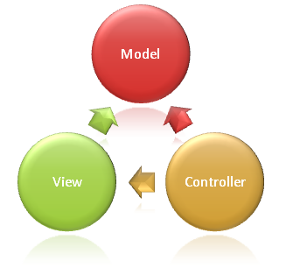
The MVC framework includes the following 3 components:
Figure 5:MVC Architecture
The Model Manages all data-related logic, including database interactions and business logic. Responds to controller requests by providing or updating data. Serves as the backbone for data operations in the application.
The View Responsible for all UI-related tasks, such as generating the user interface and presenting data to the user. Receives data from the Model through the Controller and displays it to the user in a visually appealing .
The controller Acts as a bridge between the Model and View components, facilitating communication between them. Processes business logic, handles incoming requests, and manipulates data as necessary. Coordinates the flow of data between the model and view, ensuring a smooth interaction and rendering of the final output.
- MVC Architecture in .NET Web Applications
MVC pattern in .NET provides a robust, scalable, and maintainable way of building web applications. It offers clear separation of concerns, integration with modern technologies, and a supportive ecosystem, which can lead to the creation of high-quality web applications. However, it's important to note that while MVC is powerful, it's not necessarily the best choice for every project. The complexity of the application, team expertise, and specific project requirements should always be considered when choosing an architectural pattern.
I spent many days looking for an effective implementation framework before i started working on my apps.
- Web Services
Web services are software systems designed to support interoperable machine-to-machine interaction over a network. They provide a standardized way for different applications to communicate and exchange data, regardless of the underlying platform or programming language.
There are several types of web services, but two of the most common are:
SOAP (Simple Object Access Protocol): SOAP is a protocol that defines a standard for exchanging structured information in the implementation of web services. It relies heavily on XML for message format and is known for its robustness and adherence to standards.
REST (Representational State Transfer): REST is an architectural style for designing networked applications. It uses standard HTTP methods (GET, POST, PUT, DELETE) to perform CRUD operations on resources. RESTful APIs are lightweight, scalable, and widely adopted for building modern web applications.

Table 5:Difference between SOAP and REST
Criteria | SOAP | REST
Advantage | More advanced, with strong standards | Simple to use, easy to implement
Data Format | All data passed in XML format | Permits multiple data formats, with JSON being the most preferred
Protocol | Independent of HTTP | Based on HTTP
State Management | Stateful, maintains session state between requests | Stateless, each request contains all necessary information
Ease of Integration | Requires more effort for integration due to complex standards | Easier integration with simple HTTP methods
RESTful web services have several advantages over SOAP and other alternatives.
- To summarize, for our web application, REST proves to be the best option because it completely fits its needs for simple CRUD operations and effective data interchange via HTTP methods and JSON.
- Consuming RESTful APIs with Axios
To interact with RESTful APIs in our iDigix project, we chose Axios as our HTTP client library.
Axios serves as the bridge between frontend and backend. It provides a simple and elegant interface for making HTTP requests from the frontend to the backend API endpoints.
With Axios, we can easily send GET, POST, PUT, and DELETE requests to retrieve data from the server, submit form data, update resources, and perform other CRUD operations.
The response data received from the backend can then be processed and displayed in the React components, providing users with real-time updates and feedback.
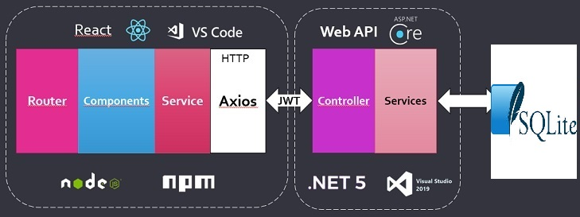
- full-stack application architecture
Figure 6:Consuming RESTful APIs with Axios
The image is a high-level diagram showcasing a full-stack application architecture. It illustrates the interaction between a front-end developed with React, including elements such as Router, Components, Service, and Axios for HTTP requests, with a back-end using ASP.NET Core Web API, involving Controller and Services. The data storage is handled by entity Framework using a SQLite database. The diagram also includes related technologies such as Node.js, npm, .NET, It suggests the use of JWT (JSON Web Tokens) for secure communication between the front and back ends.
- Web Development Techniques
Table 6:Difference between Angular and React
 |   Angular |   React
Advantages | - Full-fledged framework with comprehensive features.  - Built with TypeScript, enabling strong typing and improved code maintainability.  - Built-in support for dependency injection, facilitating modular and testable code.  - Automatic synchronization between model and view, | - Simple design and clear documentation  - Component-based architecture for code reuse.  - High performance with virtual DOM  - JavaScript with JSX syntax for easy HTML integration.  - Large and active community for resources  - Hot reloading for faster development cycles
Disadvantages | - Limited Flexibility: Angular's fixed structure limits adaptability.  - Complex Setup: Steeper learning curve and setup compared to React.  - More Boilerplate: Requires more code, which can be cumbersome.  - Risk of Abandonment: Updates may render features obsolete | - Less Built-in: Lacks some features found in Angular.  - Fragmented Ecosystem: More options can lead to confusion.  - UI Fragility: Components can break more easily.  - Learning JSX: New syntax may be challenging for some.

Before deciding on which framework to use, it’s wise to look at its popularity. The bigger and active a community is, the quicker it gets to find a solution for any unexpected problem that comes in our project. In this case According to the data I was able to gather at the time of the working.
On Github, while React’s repository has 207k stars, Angular had nearly 88.1k stars. This shows that both have a very large community behind them, as they stay on the top of the most starred repositories.
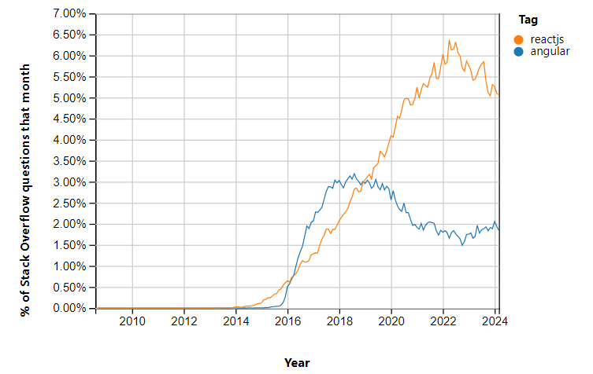
As we can see in the above chart, according to the Stack Overflow trend diagram, we can see the evolution of the popularity of Angular and ReactJS technologies through the percentage of queries tagged with these terms each month. It is worth noting that, despite ReactJS's rapid and sustained rise in popularity since 2015, surpassing Angular in terms of percentage of talks, the graph shows some stabilization for ReactJS and a slight rise for Angular in 2024.
Figure 7:Chart of stack overflow questions that month.
 in this case for our web application, we've opted for React as the preferred framework for web development.
- Backend Development Techniques
ASP.NET Core is a robust web application framework developed by Microsoft, designed for creating dynamic websites, web applications, and web services. As part of the broader .NET framework, it offers a comprehensive suite of tools and libraries tailored for backend development, including handling HTTP requests, managing sessions, and interacting with databases.
When paired with React for frontend development, ASP.NET Core presents numerous advantages. React's efficient rendering system, component-based architecture, and seamless user experience complement ASP.NET Core's backend capabilities seamlessly.
This combination facilitates the creation of high-performance web applications equipped with features like asynchronous data fetching, state management, and single-page application behavior. React components seamlessly interact with ASP.NET Core's Web API, which processes requests, interacts with databases as necessary, and returns responses in JSON format.
This pairing proves effective for full-stack development, harnessing JavaScript for dynamic client-side interactions and C# on the server side for managing business logic, ensuring security, and handling database operations. It leverages the rich ecosystem of React and the scalability, security features, and robust community support offered by ASP.NET Core.
- In summary, utilizing React with ASP.NET Core streamlines development processes, enhances performance, and facilitates the creation of modern, scalable web applications.

- Analysis of NFC and QR Code Integration
To make it easy for everyone to use, iDigix will use both NFC (Near Field Communication) and QR code technology. This way, users can share their profiles and access content easily, no matter what kind of device they have.
- What is NFC?
NFC technology, which stands for Near Field Communication, allows for easy data exchange over short distances.
It works similarly to Bluetooth or contactless credit cards, but only for a few millimeters.
In other words, it lets two devices interact: you just need to place your NFC business card close to the phone you want to interact with.
This technology enables quick and wireless information transfer between them.

Figure 8:NFC technology
In the context of iDigix, NFC will be integrated to enable a seamless and intuitive way for users to share their profiles. Users can simply tap their NFC-enabled smartphones together to instantly exchange their profile links, making it easier to connect and share their online presence with others
First, NFC technology is compatible on more than 98% of smartphones in circulation today.
To help users with devices that don't support NFC, iDigix will also integrate QR code functionality. This ensures that all users can easily share and access profiles, regardless of their device's capabilities.

I will now show a prototype of how the card will look in two phases: the front and back of the NFC card.
Figure 9:Prototype of iDigix NFC Card
- How to activate NFC on smartphone and use it
iPhone:
NFC is automatically enabled on IOS from iPhone XR.
Android:
To exchange information with an Android phone, your interlocutor must activate the NFC
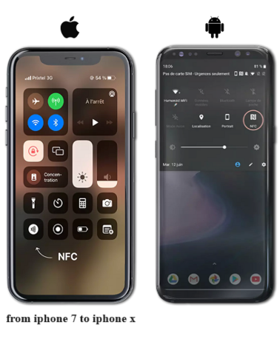
Figure 10:Activation de la NFC
If the person you're with has an iPhone, just hold your card near the top of their phone to show your digital profile.
If they have an Android phone, hold your card near the center back of their phone.
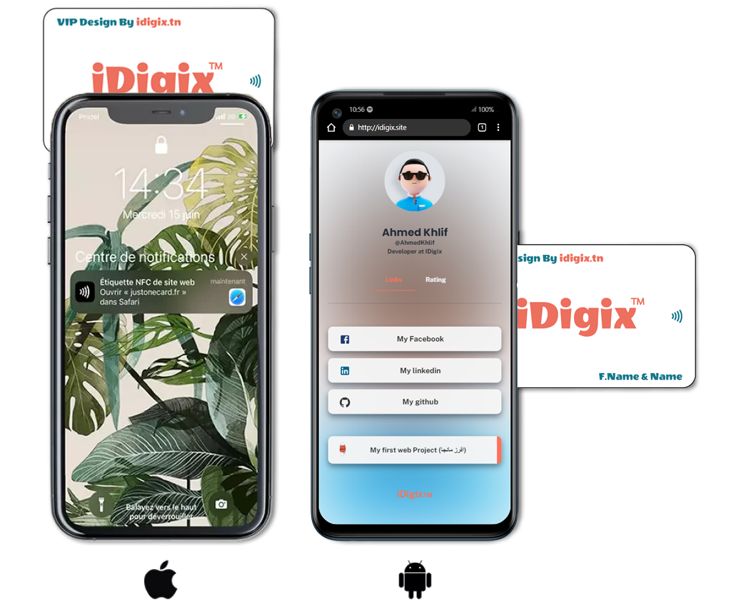
Each Android phone has its NFC reader in a slightly different spot, but it's usually near the center.
Figure 11:Where to place your NFC business card
You can see the figure above to help improve understanding of how this works.
- Concept of iDigix business card NFC
to integrate NFC with iDigix! Here's a detailed explanation of how the concept would work:
- Card Purchase: Clients on the iDigix platform would be able to purchase NFC-enabled cards. These cards wouldn't be standard business cards; they'd be specifically designed for iDigix and integrate seamlessly with the platform.
- Card Creation: When a client purchases an NFC card, they'd be guided through a simple card creation process within their iDigix profile. This process would involve:
  - Design Customization: Clients could personalize the design of their NFC card, selecting a template, adding their logo, and choosing colors.
  - Link Association: The client's unique iDigix profile link would be automatically linked to the NFC card. This would typically take the form of a URL like http://idigix.site/Profile/username.
- Advantages of using NFC-enabled Cards in iDigix
Enhanced Networking: NFC cards make it incredibly easy for users to share their iDigix profiles, accelerating networking opportunities. This can be particularly valuable for individuals and businesses looking to connect with potential clients, collaborators, or investors.
Seamless Integration: NFC card integration creates a seamless experience for users, encouraging them to share their iDigix profiles more frequently.
Unique Branding: The ability to customize the design of the NFC cards allows clients to create a unique and professional brand identity, enhancing their online presence.
Direct Access: NFC cards provide instant access to user profiles, making it easier for potential clients or collaborators to learn more about the individual or business.
Enhanced User Experience: NFC cards contribute to a more engaging and interactive experience for users, providing a seamless way to connect and share information. 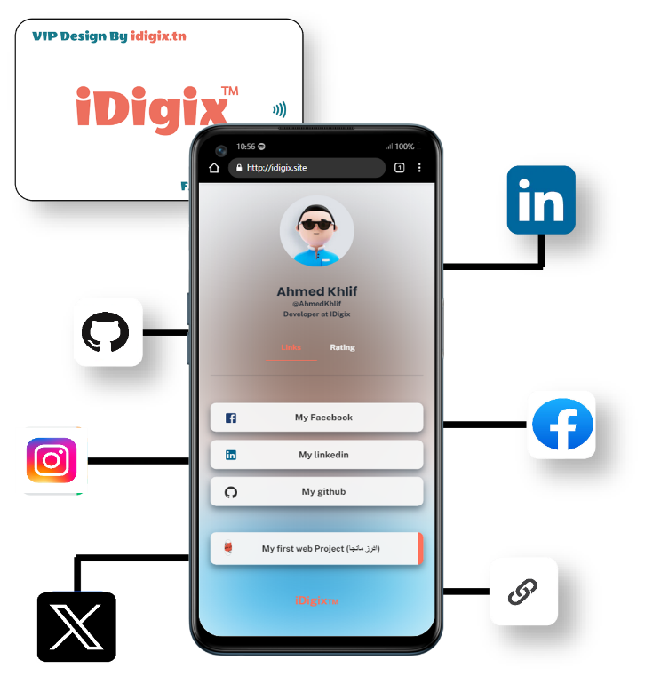
Figure 12:one card shares evrything.

Conclusion
This chapter establishes a solid foundation for iDigix's development through clear objectives, rigorous analysis, and innovative proposals. Defined functional and non-functional requirements ensure clarity, while SCRUM methodology guarantees agility and efficiency. Integration of NFC and QR code technologies enhances accessibility and usability, fostering seamless profile sharing. Our robust software architecture ensures scalability and performance, paving the way for iterative improvements aligned with user needs and technological advancements.
In the next chapter, we will introduce the first sprint of our project which will address software configurations and Authentication System

Chapter 2: Sprint 1“Software and Framework Configuration and Authentication System”

- Objective
This chapter focuses on the tasks required to produce the first sprint, which is centered on handling authentication through the development of web services.
We will also design and implement user registration functionality, ensuring that our system is secure and user data is protected.
To achieve this, we emphasize client confidentiality and robust information security measures.
- Backlog sprint 1
Task planning is an important phase for defining the number of sprints needed to complete a project and specifying each sprint’s duration.
Table 7:Backlog du Sprint 1
Tasks | Actors | Days
Software configuration | Ahmed & Workmate | 3
Authentication and authorization. | Ahmed &Workmate | 5
Implement email verification. | Ahmed & Workmate | 5
Security & Performance | Ahmed & Workmate | 5

- Development Tools
This section will list the primary hardware and software tools we'll utilize to complete the project.
- Hardware Environment:

Throughout the entire stage, I used my PC, which had the following characteristics:

Figure 13:PC PORTABLE GAMER ASUS FX506HCB-HN161
- Processor: Intel® i5-11400H Hexa-Core (2.70 GHz à 4.50 GHz)
- RAM: 32 Go (2 x 16 GB)
- Resolution: Ecran 15.6" Full HD 144Hz.
- Principal of stockage: 512 Go SSD
- Carte Graphique : NVIDIA GeForce RTX 3050 4Go GDDR6
- Operating system: Windows 11, Edition Familiale 64 bits

- Software Environment:
Table 8:Software Environment
Logo | Name | Description
 | React | React is a free and open-source front-end JavaScript library for building user interfaces based on components. It is maintained by Meta and a community of individual developers and companies. React can be used to develop single-page, mobile, or server-rendered applications with frameworks like Next.js.
 | .NET | .NET Core is a free, open-source toolkit for building various applications. Unlike its older sibling .NET Framework, it runs on Windows, macOS, and Linux. This makes it flexible for developers to create apps for many platforms.
 | C# | C# is a modern, innovative, open-source, cross-platform object-oriented programming language and one of the top 5 programming languages on GitHub.
 | SQLite | SQLite is a lightweight, self-contained relational database management system (RDBMS) library written in C. Unlike traditional client-server databases, it doesn't require a separate server process, making it popular for mobile apps and embedded systems.
 | DB Browser | DB Browser for SQLite is a free, open-source graphical interface for SQLite databases. It allows you to visually manage your SQLite databases through a spreadsheet-like interface and lets you write and execute SQL queries.
 | JSON | JSON stands for JavaScript Object Notation — it is usually a text-based format that represents structured data on JavaScript object syntax. It is used in cases like when a server needs to send some data to the Client, and it can be  displayed on the web page and vice versa.
 | Postman | Postman is an API (application programming interface) development tool that helps to build, test, and modify APIs. Almost any functionality that could be needed by any  developer is encapsulated in this tool
 | Material-UI for React (MUI) | MUI is a popular open-source library that offers a collection of pre-built React components implementing Google's Material Design guidelines. These components provide a consistent, visually appealing, and responsive user interface (UI) foundation for your React applications
 | Axios | Axios is a popular promise-based HTTP client library for JavaScript. It simplifies the process of making asynchronous HTTP requests (GET, POST, PUT, DELETE, etc.) from both the browser and Node.js environments.
 | Git | Git is a powerful tool for tracking changes in files over time, like a version control system for your projects. Imagine it as a time machine for your code, letting you see past versions and revert to them if needed
 | Visual Studio Code | Visual Studio Code is a lightweight but powerful source code editor which runs on your desktop and is available for Windows, macOS and Linux. It comes with built-in support for JavaScript, TypeScript and Node.js and has a rich ecosystem of extensions for other languages and runtimes (such as C++, C#, Java, Python, PHP, Go, .NET)
 | GitHub | GitHub, a cloud-based platform built upon the open-source software Git, facilitates code storage, sharing, and collaboration. By hosting code in repositories, users can showcase their work, track changes, and collaborate seamlessly. It enables easy code review and suggestions, fostering efficient collaborative development.
 | TypeScript | TypeScript is a strongly typed programming language that builds on JavaScript, giving you better tooling at any scale.
 | Entity Framework Core | Entity Framework Core (EF Core) is a modern object-database mapper that lets you build a clean, portable, and high-level data access layer with .NET (C#) across a variety of databases, including SQL Server (on-premises and Azure), SQLite, MySQL, PostgreSQL, Oracle, and Azure Cosmos DB. It supports LINQ queries, change tracking, updates, and schema migrations
- Conception
- “Sprint 1” class Diagram
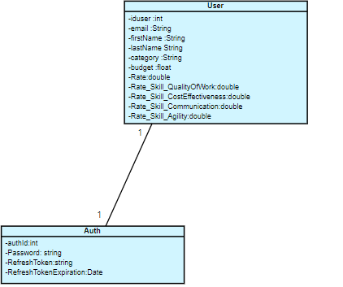
Figure 15:sprint 1 class Diagram

- Registration Conception
- Registration use case diagram
In this section, we will present the diagram of use cases related to the Registration page with its textual description
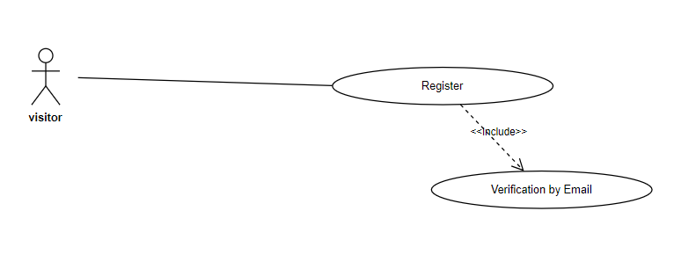
Figure 16:Use Case Diagram " Registration "
This table provides a textual description of the « Inscription » use case diagram.

Table 9:Textual description of the Registration
Use Case | Registration
Actor | Visitor
Precondition | Need for access
Post-condition | Registration validated: New user added to the database.
Normal Scenario | - The system displays the login page.  - The user clicks on "Sign Up."  - The system displays the first step of the registration form.  - The user fills out the first step of the form (first and last name, username, gender).  - The system validates the provided information.  - If the information is valid, the system enables the second step.  - The user fills out the second step of the form (phone number).  - The system validates the provided information.  - If the information is valid, the system enables the final step.  - The user fills out the final step of the form (email address, password).  - The system checks the password strength.  - If the password is strong enough, the user submits the final step.  - The system sends a verification email.  - The user validates the registration by clicking on the link sent in the email.  - The system records the new user's data in the database.  - The system informs the user that they have been successfully verified.  - The system redirects the user to the login page.
Exceptions | E1: Access credentials are incorrect.  - The email is invalid.  - The email already exists.  - The system displays an error message.

- Registration sequence diagram:
This diagram shows how users sign up for a website. It checks their details, like name and password strength, sends a verification email, and confirms their registration.
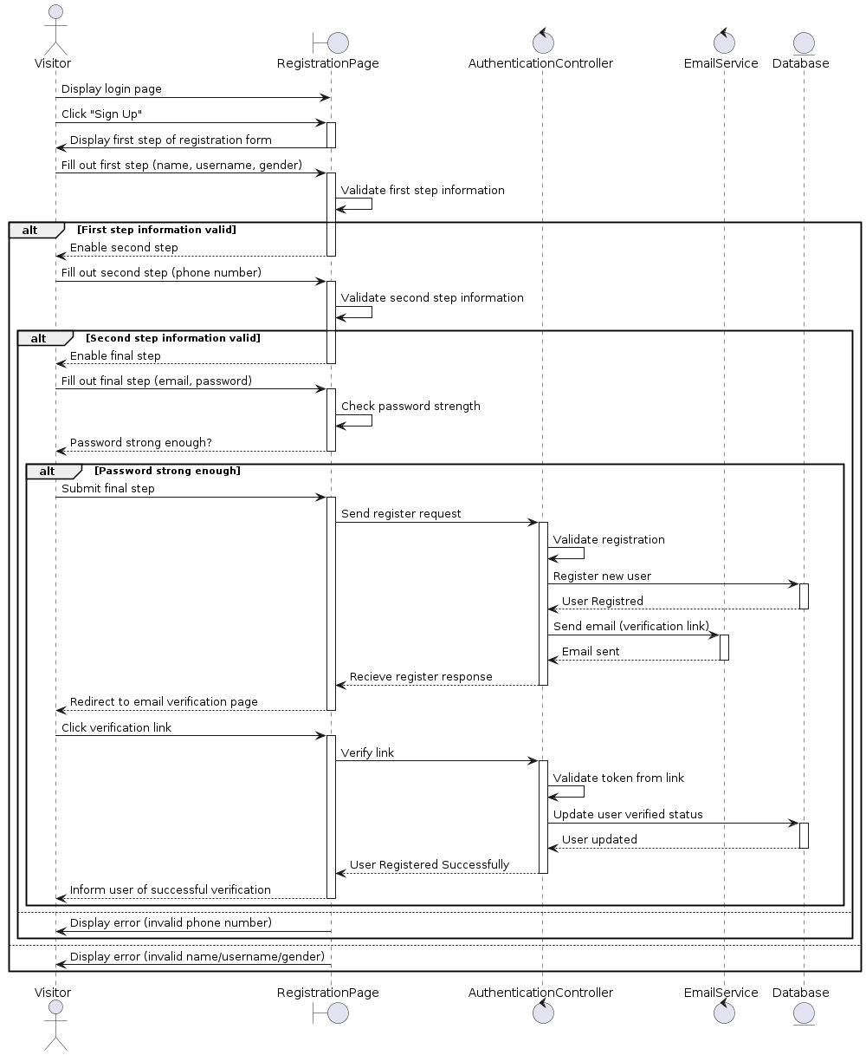
Figure 17:Registration sequence diagram

- Authentication Conception
- Authentication use case diagram
In this section, we will present the diagram of use cases related to the Authentication page with its textual description
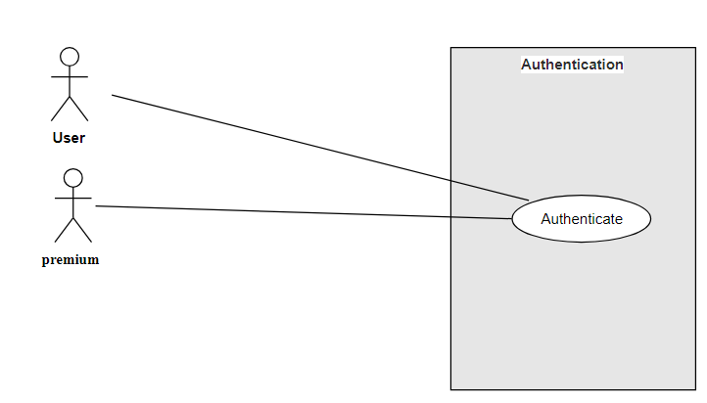
Table 10:Textual Description of Authentication
Use case | Authentication
Actor | (User/ Premium)
Precondition | User requires access to the system.
Post-condition | User is successfully authenticated and granted access.
Normal Scenario | - The system displays the login page.  - The user enters his Email and password.  - The system verifies the provided credentials.  - If the credentials are valid,  the system generates a JWT access token containing user claims and a refresh token for long-term authentication.  - The system stores the JWT token securely and the user is granted access
Exception | Error: If the credentials are incorrect.  - The system displays pop-up error message indicating that the access credentials are incorrect in the login page.  - The user is prompted to re-enter their credentials.
Additional Scenarios | Token Expiration:  - If the JWT token expires, the system uses the refresh token to generate a new JWT access token.  - The user can continue their session without needing to re-authenticate.  Token Storage:  - The JWT token is stored securely on the client-side.  - The refresh token is stored securely on the server-side to prevent misuse

- Authentication sequence diagram
This diagram shows user authentication and token management, including successful and unsuccessful login scenarios, and token expiration handling.
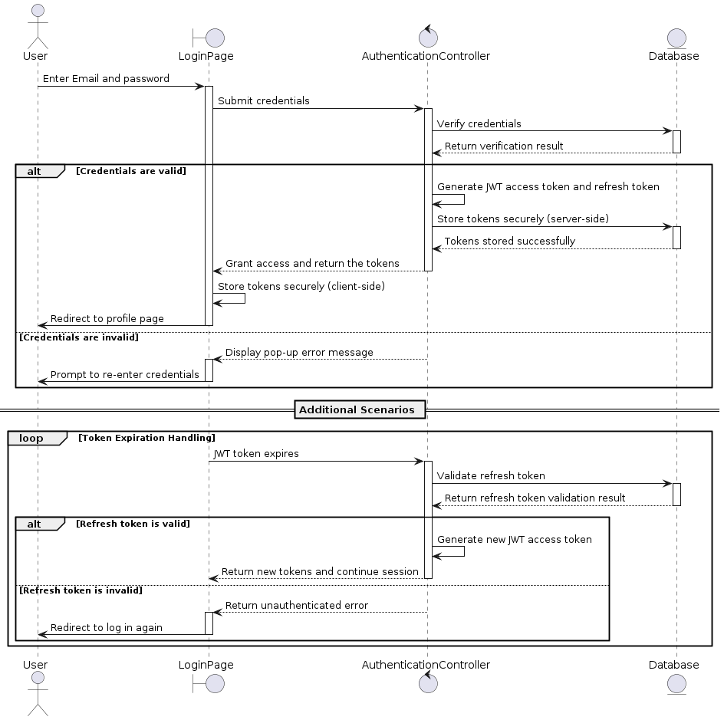
Figure 18:“Authentication” sequence diagram

- Realizations
In this section, we will demonstrate these interfaces using Material-UI. This powerful library enhances our ability to design and implement intuitive and visually appealing user experiences.
- Realization of the "Rgistration"
registration process starts with the user clicking "Sign Up" on the login page. They are then prompted to fill out the three steps of the registration form. The system validates this information, and if it is correct, the user can proceed to the next step.
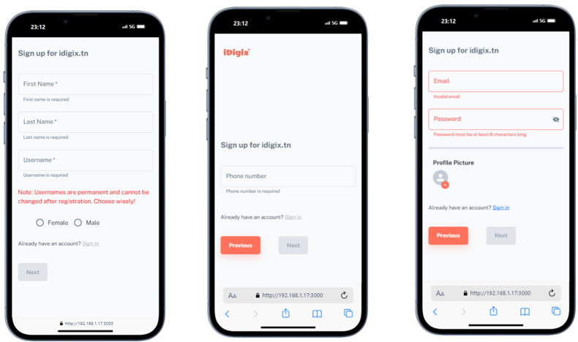
1
2
3
Figure 19:Inscription porcess steps interfaces
Finally, the system sends a verification email to the user. The user clicks the link in the email to confirm their registration. The system then records the new user's data in the database and informs them of their successful verification. If there are issues such as an invalid or existing email, the system displays an error message.

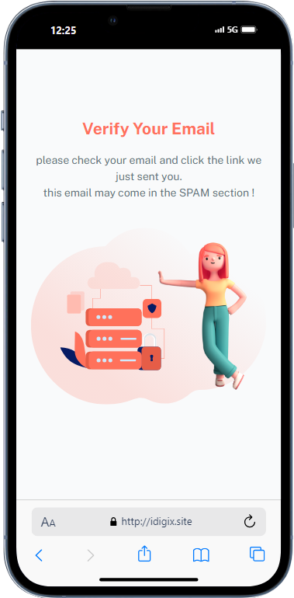
Figure 20:interface email sent
- Realization of the “Authentication”
- Development and integration of web services
The development and integration of web services entails constructing and linking the API with the front-end application. This involves defining the endpoints and methods for communication with the API, as well as implementing necessary authentication and authorization mechanisms. In our project's context, we manage the development and integration of web services by utilizing the Axios library for making HTTP requests to the API.
In this figure, the Login function initiates a POST request to the /Main/Login endpoint, passing the user's email and password in the request body. Subsequently, the Login function receives a response from the API containing the JWT access token, refresh token, and expiration time. These tokens are then stored in the application's state using the setAuthTokens function, and the response object is returned.
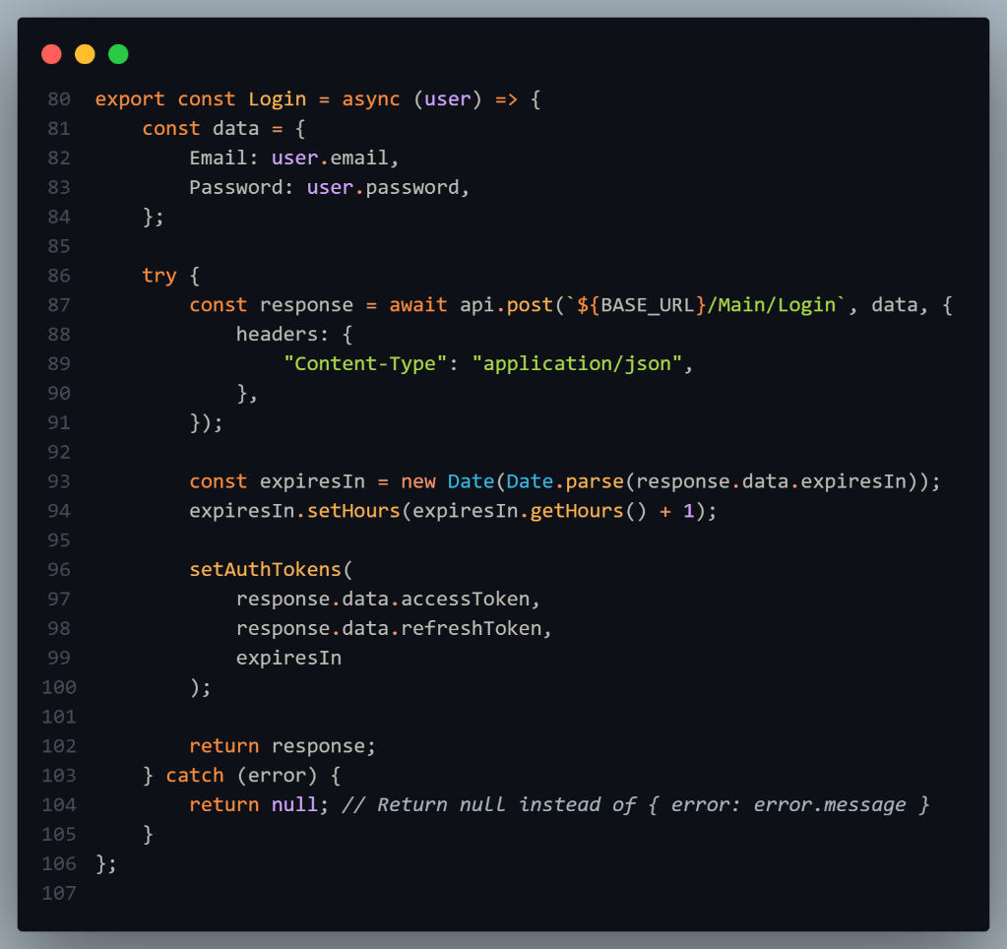
Figure 21:login service api methode
After creating web services that are used to authenticate users at the frontend level. We now proceed to integrate them at the level of our application.
The web service is integrated into steps:
- Step 1: Creating the "LoginPage" Component: This is where a change is triggered when clicking on the "Login" button.
- Step 2: Input control functions: before sending the login information the must be a primary verification of the input’s values.
- Step 3: Send Authorization API request: the actual action you want to take.
- Step 4: Receive response: in case of a valid request all user data will as well as the x- token will be stored at the shared references (local storage) to be used after that.
the Authentication page is user-friendly, with easy fields for your email/username and password, and simple registration for new accounts. It also has a welcoming illustration of a connected global community.

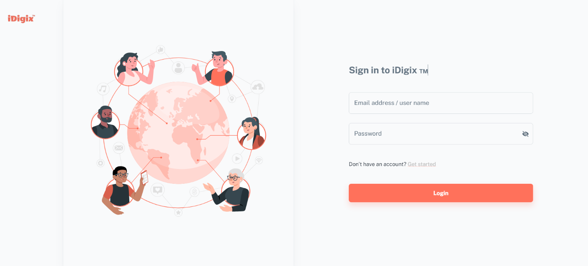
- Security & Performance
Figure 22:Authentication page.
Ensuring the security and performance of our APIs is crucial for providing a safe experience to users. Here's how we've improved both aspects:
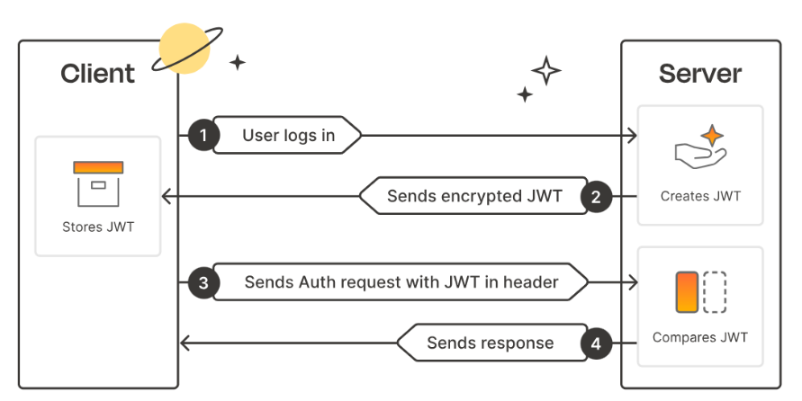
- Security Improvements:
Figure 23:JWT Authentication Process
• JWT authentication: At this level, we need to securely transmit authentication information using JSON Web Token (JWT) When a user logs into an application, the API server creates a digitally signed and encrypted JWT that includes the user's identity. The client then includes the JWT in every subsequent request, which the server deserializes and validates. The user's data is therefore not stored on the server's side, which improves scalability.
- In the context for securing the API for my project is handled using JWT for authentication. The JWT is generated using a secret key, which ensures that the token cannot be tampered with by an attacker. The JWT is then stored in the user's Auth object along with a new refresh token and an expiration date for the refresh token. This ensures that only authorized users can access the API and its data.
• Rate Limiting: We've implemented rate limiting to prevent excessive requests and potential abuse of our API. This helps maintain system stability and protects against malicious attacks.
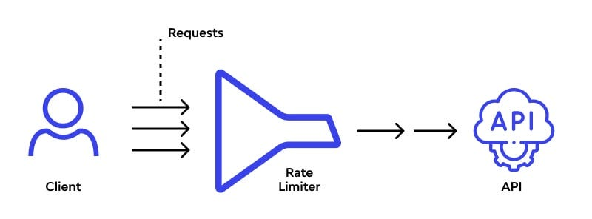
Figure 24:API Rate Limiting Process
• Data Encryption: To safeguard sensitive user information like passwords and personal data, we implemented encryption. This ensures that even if unauthorized access occurs, the data remains protected and unreadable.
We built this encryption service using the Advanced Encryption Standard (AES) to keep data safe. We set up a key and an initialization vector for encryption and decryption.
To encrypt, we used the key and initialization vector to encode the data into a secure Base64 string. For decryption, we reversed the process to get the original text back.
We also added functions to check if a text matches its encrypted form and to see if a string is already encrypted. This service ensures data stays private and intact in various applications.
• Route Guarding: Route guarding functions as a virtual gatekeeper. It ensures that users can only interact with what they're authorized to. Our client-side application uses route guarding to control access to different features based on user categories (free, student, premium).
- Performance Enhancements:
• Lazy Loading: To reduce initial loading times and improve overall performance. We used lazy loading. This means that only essential resources are loaded initially.
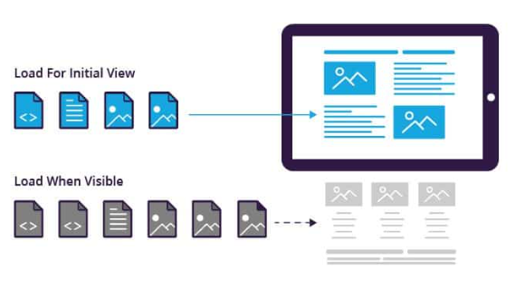
Figure 25:lazy loading process.
• Caching: We utilize caching mechanisms to store frequently accessed data locally, reducing the need for repeated server requests. This not only speeds up response times but also alleviates server load, leading to a more responsive and efficient API.
With these security and performance enhancements, we strive to provide users with a secure, fast, and reliable experience.

- API Testing
To ensure the reliability of the developed functionalities, it is unthinkable to pass the sprints without having them tested.
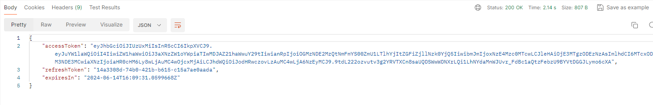
Figure 26:Postman POST login API call in case of successful.
This figure above shows a successful login request using Postman. The client sends user credentials (email / password) to the /Auth/Login endpoint and receives an access token, refresh token, and expiration timestamp in response. These tokens are used for secure and authenticated future API requests.
in case of error the server returned a 401 Unauthorized status, indicating the email or password provided is incorrect.
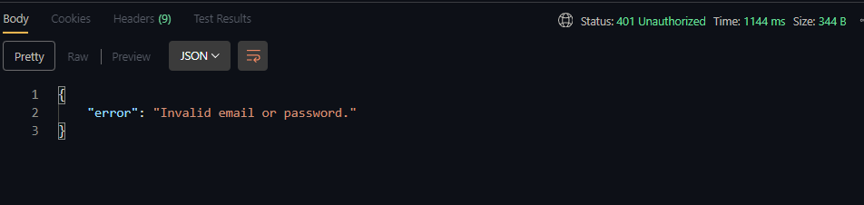
Figure 27:POST login API call in case of error.

Conclusion
This sprint has emphasized the importance of security and performance by establishing a robust authentication system. By implementing JWT authentication, including token refresh features, we have ensured that user information is protected, and that the platform can handle a high volume of traffic seamlessly. With the foundational elements of software and framework configuration in place, the next sprint focuses on enhancing the user experience through profile customization and link management.

Chapter 3: Sprint 2“Profile Customization, and Link Management
- Objective
In this chapter, we'll explore the development cycle of our second sprint, focusing on profile customization and link management. We'll start by analyzing and modeling this sprint using use case diagrams. Then, we'll delve into the main use case through sequence diagrams and construct class diagrams to outline the system's structure. Finally, we'll showcase the interfaces developed for profile customization and link management. Our aim is to improve user experience by providing intuitive tools for personalizing profiles and managing links efficiently.

- Backlog sprint 2
Task planning is an important phase for defining the number of sprints needed to complete a project and for specifying the duration of each sprint.
Table 11:backlog sprint 2
Task | Actor | Days
Appearance Management | Ahmed & Workmate | 7
Links Management | Ahmed & Workmate | 5
Research user preferences and industry trends | Ahmed & Workmate | 3
document project requirements | Ahmed & Workmate | 2
Attending sprint meeting | Ahmed & Workmate | 1

- Conception
- “Sprint 2” Class Diagram
This class diagram illustrates the actions for Sprint 2. Users can, manage their appearance, and manage their links.
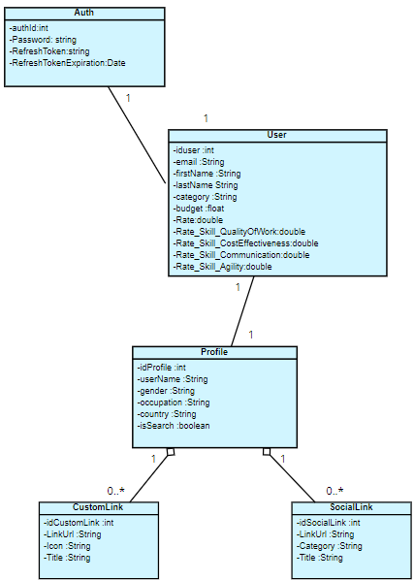
Figure 28:Sprint 2 Class Diagram
- Appearance Management Conception.
- Appearance Management use case diagram
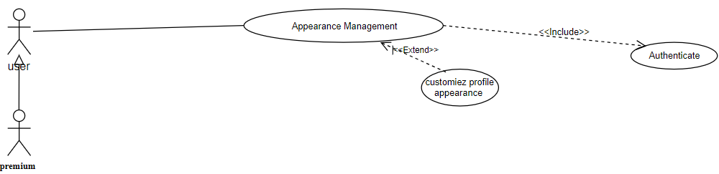
In this section, we will present the diagram of use cases related to the Appearance section in profile page with its textual description
Figure 29:“Appearance Management” use case diagram

Table 12:Text description of “Appearance Management” use cases
Use case | Manage Appearance
Actor | User / Premium
Precondition | The user must be authenticated and have access to appearance management options.
Post-condition | Changes to appearance settings are saved and reflected in the user's public profile.
Nominal Scenario | - The user navigates to the appearance management section.  - The system displays options to adjust appearance settings.  - The user selects the desired setting to modify.  - The system provides intuitive controls for the user to adjust.  - The user makes the desired changes.  - The system saves the changes and updates the user's public profile accordingly.
Exception | If the user does not save, changes will not be applied to the profile.
- Appearance Management Sequence diagram
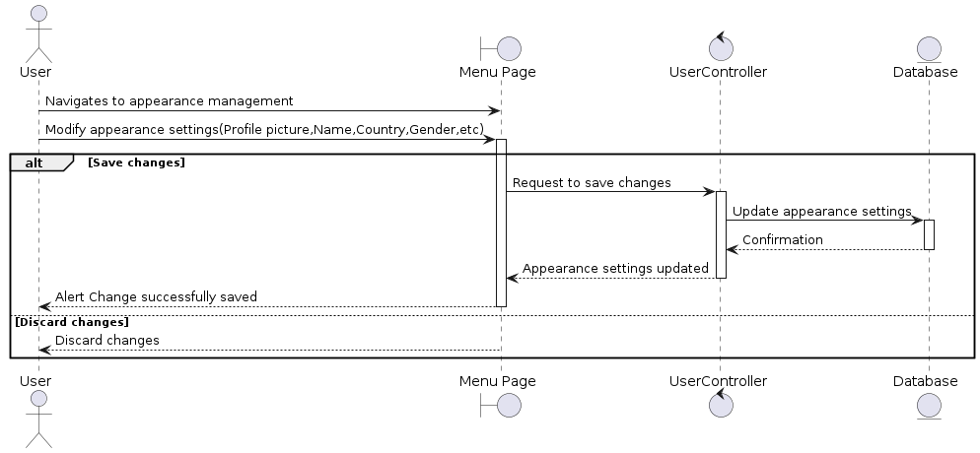
Figure 30:User Appearance Settings Management sequence diagram.
This diagram illustrates appearance settings modification. User alters settings on Menu Page. If saved, Controller updates Database, confirms, and notifies user. If discarded, no action taken.
- Links Management Conception.
- Links Management use case diagram
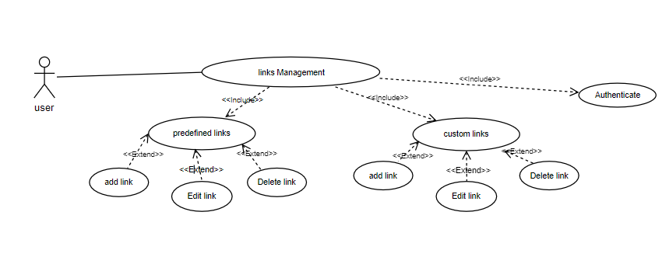
In this section, we will present the diagram of use cases related to the Links section in profile page with its textual description
Figure 31:Links Management use case

Table 13:Text description of “Links Management” use cases
Use Case | Manage Links
Actor | User
Precondition | The user must be authenticated and have access to the links management section.
Post-condition | Changes to the user's predefined and custom links are saved and reflected in the user's public profile.
Nominal Scenario | - The system displays the Profile page.  - The user navigates to the links management section.  - The system displays the existing predefined and custom links associated with the user's profile.  - The user can add predefined or custom links by providing the URL, a title for the link, and optionally uploads an image related to the link.  - The user saves the changes.
Exception | E1: Invalid Fields  - The system displays a pop-up alert dialog if any of the fields are invalid.  E2: Cancellation  - The user cancels the adding
Alternative Scenario (Edit Link) | - The user selects the link to edit from the list.  - The system displays the details of the selected link.  - The user modifies the URL, title, or image of the link.  - The user saves the changes.
Exception | E1: Invalid Fields  - The System displays Pop-up Alert Dialog  E2: Cancellation  - The user cancels the modification process.
Alternative Scenario (Delete Link) | - The user selects the link to delete from the list.  - The system prompts the user to confirm the deletion.  - The user confirms the deletion.  - The system removes the link from the list.
E1: Invalid Fields
- The system displays a pop-up alert dialog.
E2: Cancellation
The user cancels the deletion process.
- Links Management sequence diagram
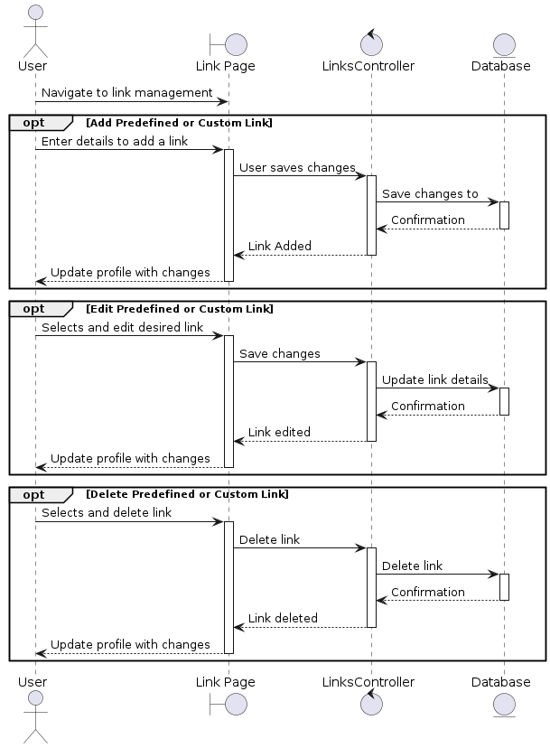
Figure 32:User Link Management.
This diagram showcases user-managed links on a Profile Page. Users can add, edit, or delete links and handle errors. They access existing links, make changes, and save them, with updates reflected in the database. The Link Management Controller facilitates communication between the interface and the database, allowing users to cancel modifications.
- Realizations
After analyzing and designing this sprint, we've created interfaces that perfectly match our planned functionalities. Now, let's focus on the Appearance Management interface. Then, we'll move on to explore the link management implementation interface.
- Appearance Management.
This interface simplifies profile customization. Users can upload or change profile pictures, edit personal info like name, occupation, and Country. They can select gender and toggle profile visibility for searching. A "Save Profile" button ensures changes are stored. The layout is user-friendly, providing instant feedback for ease of use.
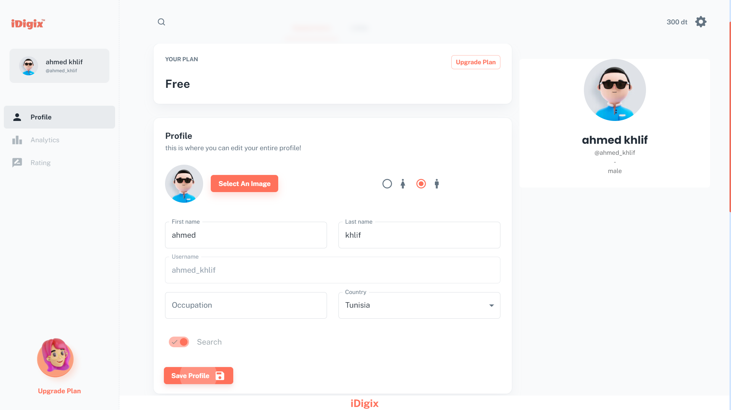
Figure 33:interface of profile Appearance
- Save Confirmation Alert
After successfully saving profile changes, users receive a confirmation alert, providing reassurance that their updates have been applied and reflecting the latest information on their public profile.

Figure 34:alert save confirmation.
- Links Creation.
The "Manage Links" interface on iDigix is a user-friendly and intuitive section of the user's profile where they can manage their predefined and custom links. Currently, there are no links added for this user, and the interface clearly indicates this with an illustration.

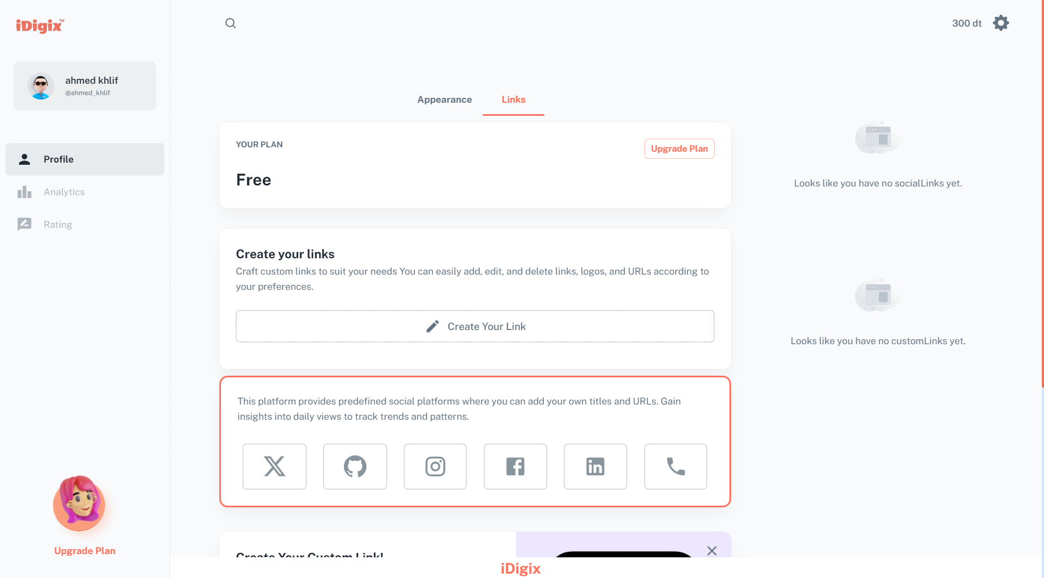
Figure 35:interface of profile links management

- Responsive.
Our site is designed to be responsive, meaning that it can adapt to any device,
When using a phone device, the user will see a simplified version of the interface. The user can still access all the same features and functionality as they would on a desktop computer.
In our exploration of link creation within the iDigix platform, we'll navigate through the process of generating links, whether predefined or custom.
- Create Link.
The user can create a link by clicking the 'Create Your Link' button, which opens a phone-friendly dialog with details like URL, title, and image. They can also choose a predefined link from popular social platforms. Once added, the link is saved and saved to the user's profile. The user can review the link by clicking on the phone icon in the bottom-right corner. The "Review" window displays a list of links, including both custom and predefined links, and users can manage them by clicking on the "Edit" or "Delete" buttons.
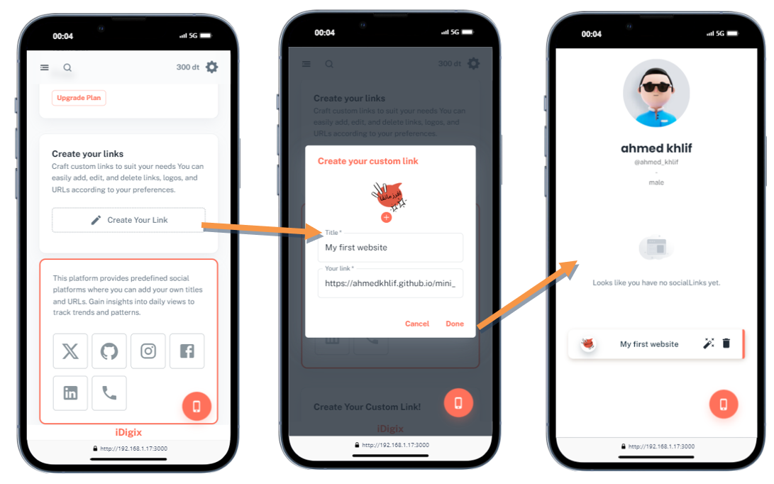
The following figures explain how this process works:
Figure 36:Custom Link Creation Process in a Mobile view

- Links Editing.
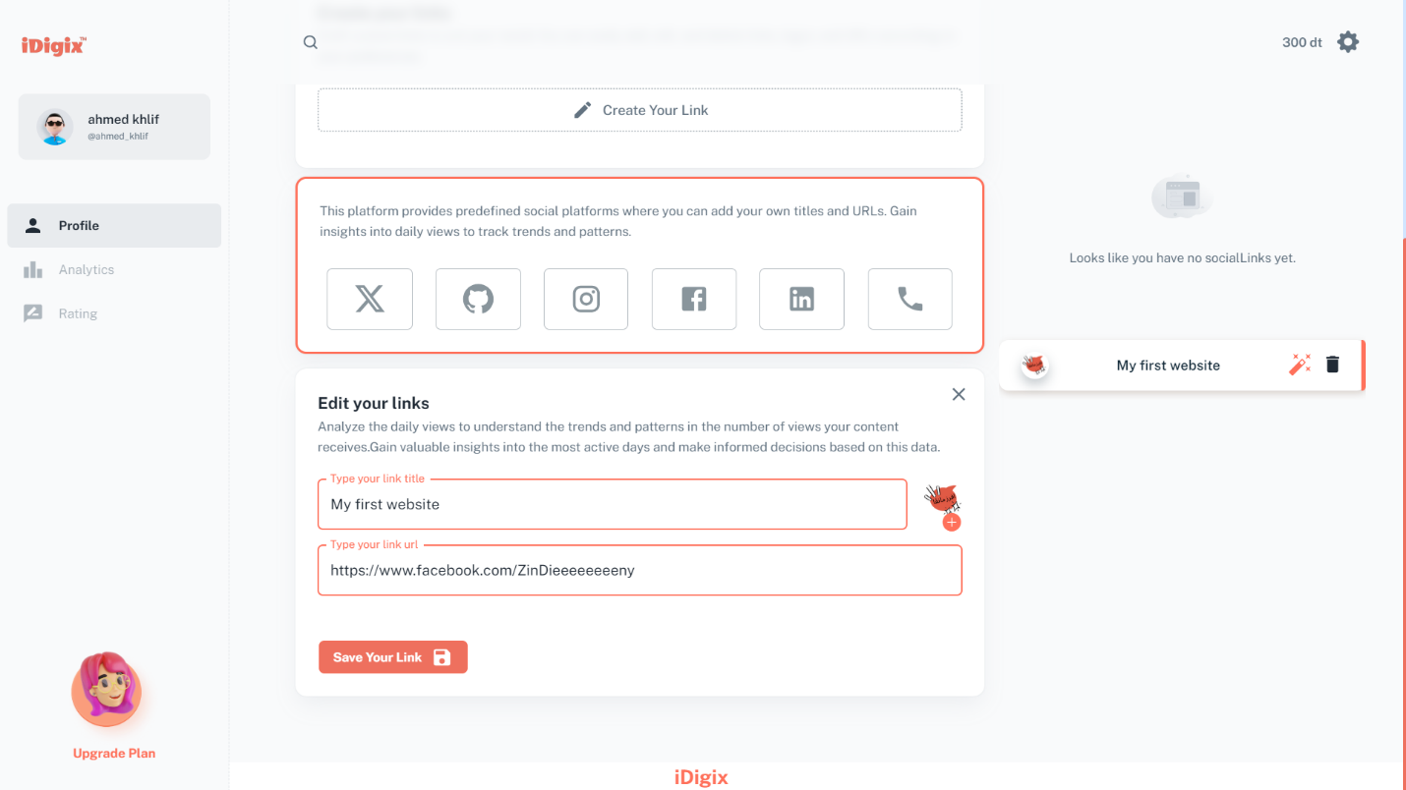
In this figure, the user clicks on the "Edit"Icon After selecting the desired link for editing, a form appears in the lower section of the main area. This form enables the modification of the information associated with the chosen link.
Figure 37:process of edit a link

- Integration profile
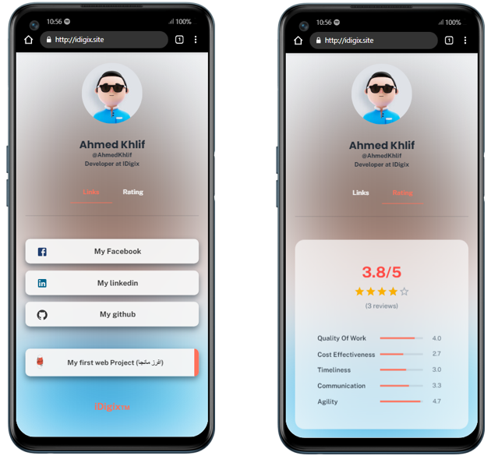
Figure 38:Public porfile view

The provided figure above depicts a mobile interface for a user profile on the IDigix platform, showcasing two main views: "Links" and "Rating." The profile summary includes a personalized avatar, the user's name and username, job title, and company affiliation. The "Links" tab is the default active tab and includes large buttons for Facebook, LinkedIn, GitHub, and a project link. The "Rating" tab shows an overall rating with stars and the number of reviews, as well as detailed scores for Quality of Work, Cost Effectiveness, Timeliness, Communication, and Agility. The interface is straightforward with a clean design, essential information prominently displayed, and clear differentiation between sections. Social media and project links are easily accessible, and detailed ratings provide a comprehensive view of the user’s performance across various metrics.
- API Testing
The following figure represents the “user” Get Profile API Call in case of a successful response.
This is a request to get a user profile from the /Profile/GetProfile endpoint. It uses a Bearer token for authentication. When it's successful the response provides detailed user information, including their ID, email, name, category, budget, and various skill ratings.
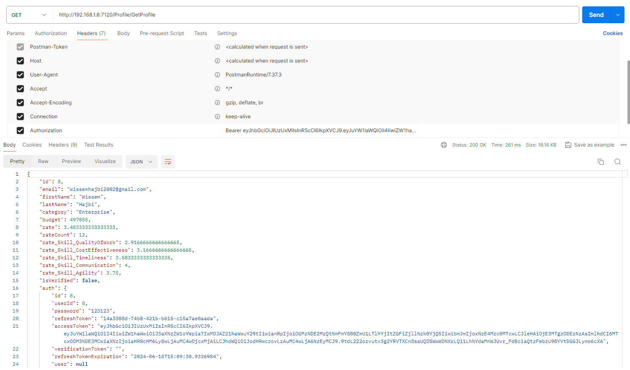
Figure 39:Postman Api user get Profile successful response.

Conclusion
In this chapter, we delved into the development cycle of our second sprint, which focused on profile customization and link management. Beginning with the analysis and modeling of this sprint using use case diagrams, we outlined the functionalities through sequence and class diagrams. Subsequently, we showcased the interfaces developed for profile customization and link management, aiming to enhance user experience by providing intuitive tools for personalizing profiles and managing links efficiently.

Chapter 4: Sprint 3“Subscription Plans and invoicing system.”

- Objective
This chapter focuses on Sprint 3, which involves implementing subscription plans and integrating payment systems. In Sprint 3, we will define subscription tiers, enable user subscription management, and develop a billing and invoicing system. These steps are crucial for ensuring a smooth and secure user experience and effective monetization of our application.
- Backlog sprint 3
Starting our chapter with the Sprint3 backlog is an important step in defining the number of sprints required to complete a project and deliver it and specifying how much time each sprint will take.
Table 14: Sprint 3 Backlog
Task | Actor | Days
Define subscription tiers and features | Ahmed & Workmate | 5
User Interface Development | Ahmed & Workmate | 5
invoice management system. | Ahmed & Workmate | 6
- Conception
- “Sprint 3” Class Diagram
This use case diagram illustrates the actions for Sprint 3. Users or premium users can manage a subscription plan and view a list of deposit and purchase history.
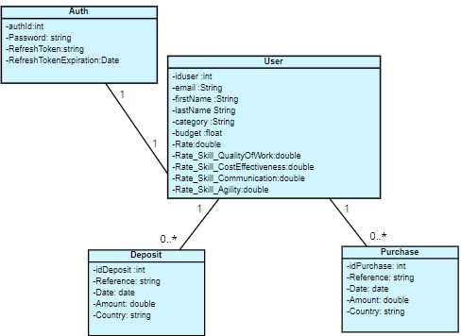
Figure 40:Sprint 3 Class Diagram
- “Deposits” Conception
- Deposits and puchase history use case diagram
In this section, we will present the diagram of use cases related to the financial activities section in setings page with its textual description
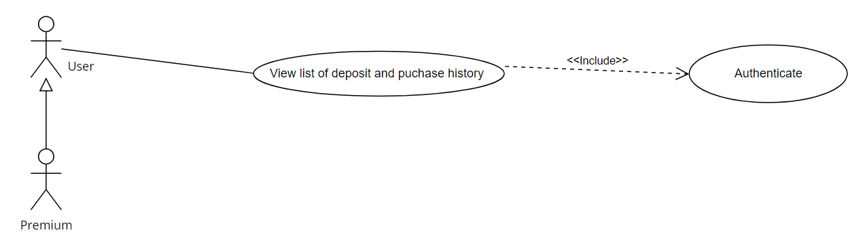
Figure 41:“Deposit and purchase history” use case diagram
Table 15:Text description of “Deposits” use cases
Use case | Deposits and puchase history
Actor | User / Premium
Precondition | The user must be authenticated.
Post-condition | All purchases and Deposits are saved and reflected in the budget management section in settings.
Nominal Scenario | User navigates to the Settings Page.  - Settings Page sends a request to the Purchases Controller to retrieve deposits and purchases data.  - Purchases Controller provides the deposits and purchases data back to the Settings Page.  - User interacts with the displayed financial data (views transactions, searches ).
Exception | - If no transactions exist,  The it displays a message "No rows".

- budget management diagram.
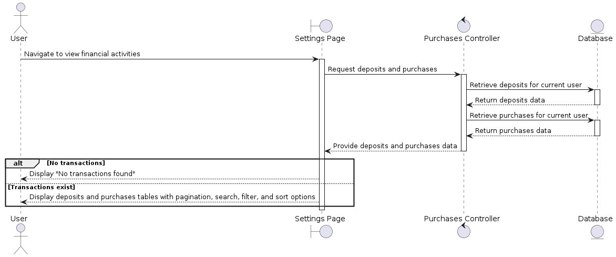
Figure 42:deposit sequence diagram
- “Purchasing” Conception
- Purchasing of Use Cases
In this section, we will present the diagram of use cases related to the Purchases section in bundles page with its textual description

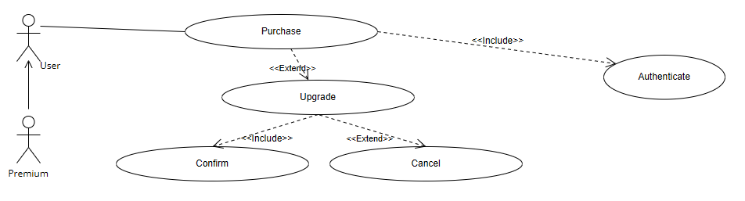
Figure 43:“Purchases” use case diagram
Table 16:Text description of “Purchases” use cases
Use case | Purchases
Actor | User / Premium
Precondition | The user must be authenticated and have enough budget and access to products.
Post-condition | All purchases are saved and reflected in the budget management section in settings.
Nominal Scenario | - The user navigates to the bundles page.  - The system displays different bundles and features to the user.  - The user selects the desired bundle and proceeds to purchase it.  - The system verifies if the user has enough funds in their account.  - On successful verification, the system saves the changes, grants access to new features, and updates the user’s plan.
Exception | If the user does not have sufficient funds  The system notifies the user and cancels the purchase.

- Purchasing sequence diagram.
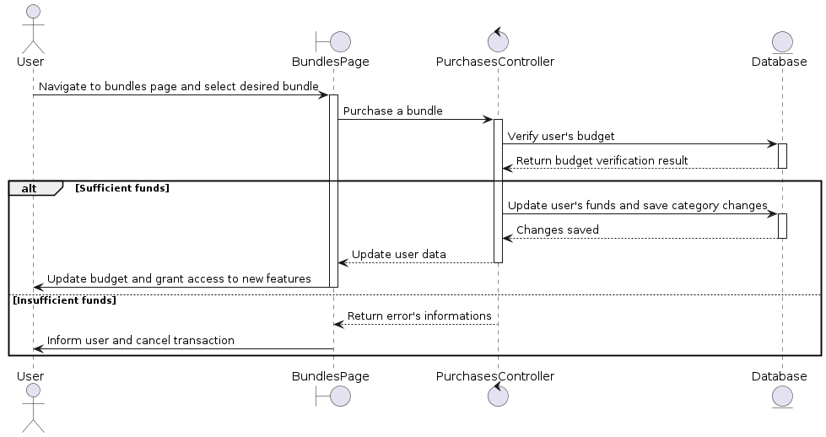
Figure 44:purchasing process sequence diagram
This diagram shows how a user buys a bundle. First, they pick a bundle. Then, the system checks if they have enough money. If they do, their budget is updated, letting them access new features. If not, the purchase is cancelled, and they're informed about the problem.

- Realizations
Based on the analysis and conception of the current sprint. We will present the most important interfaces.
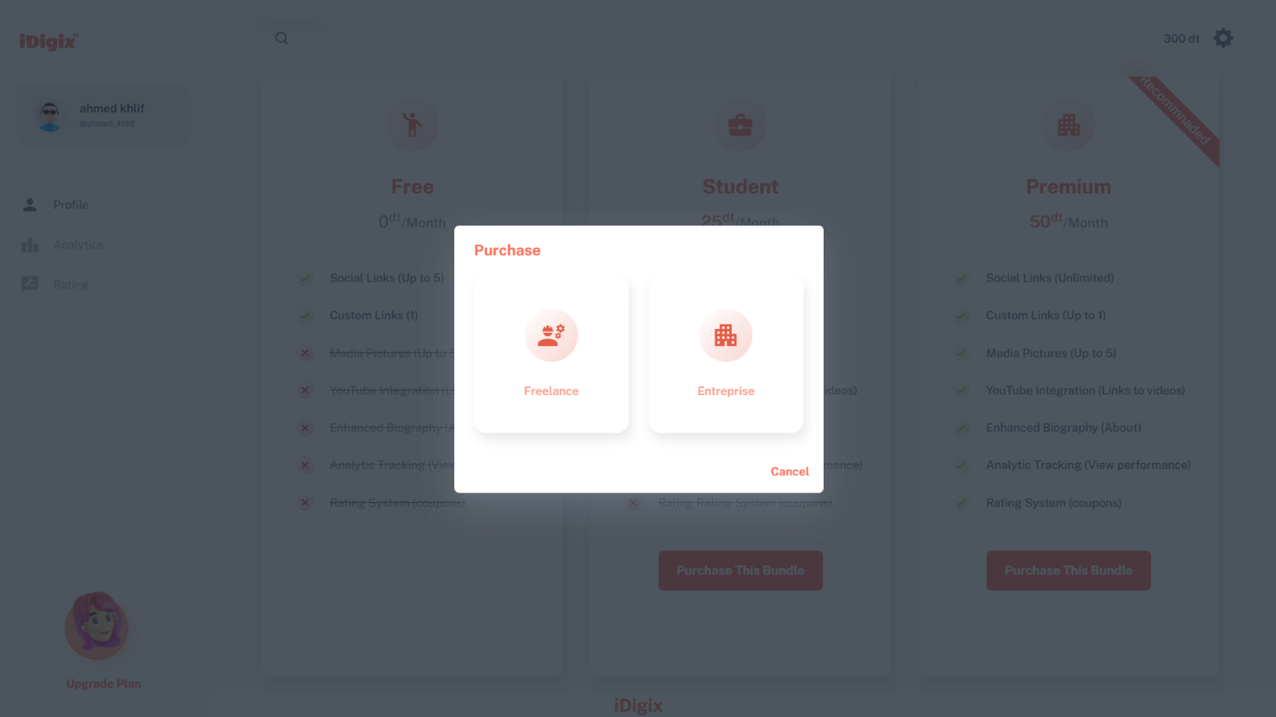
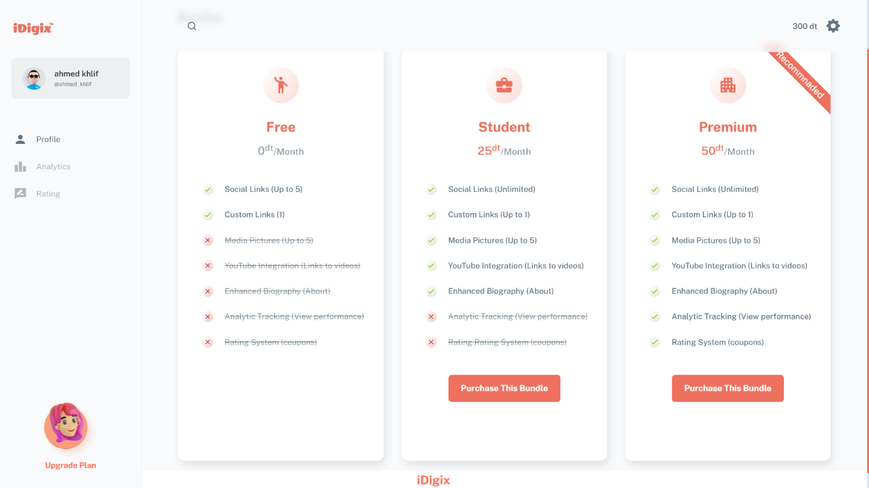
- Purchasing Bundles.

Figure 45:Purchasing bundles page.
Figure 46:purchasing the premium Bundel dialog.

This interface represents the "Bundle Management" section, enabling users to view and select from various subscription bundles offered on the platform. Key features include options for the user to explore the details and benefits of each bundle, compare features, and choose the most suitable plan. The available bundles are the Free User, Student Bundle, and Premium Bundle.
- Confirmation Alert
This confirmation message appears after a user completes the purchase
Of a subscription on the platform.

Figure 47:confirmation message after complete purchase
- Budget Section In Settings
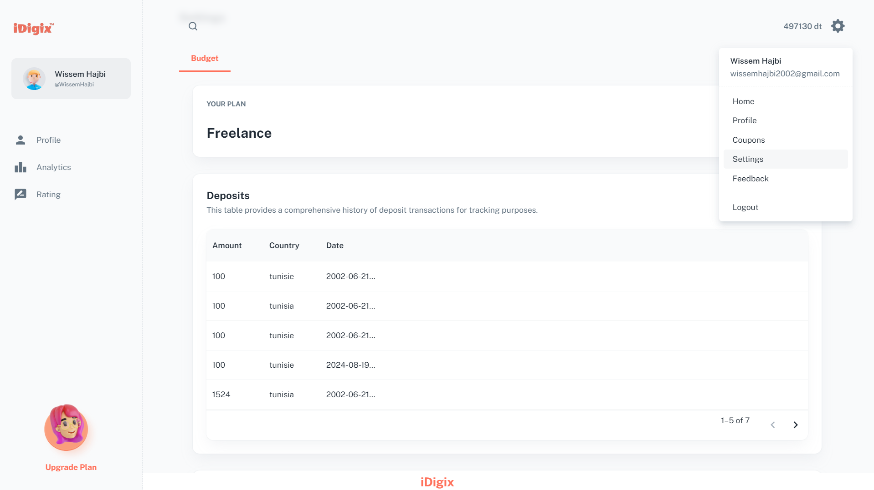
Figure 48:Budget section (1/2)
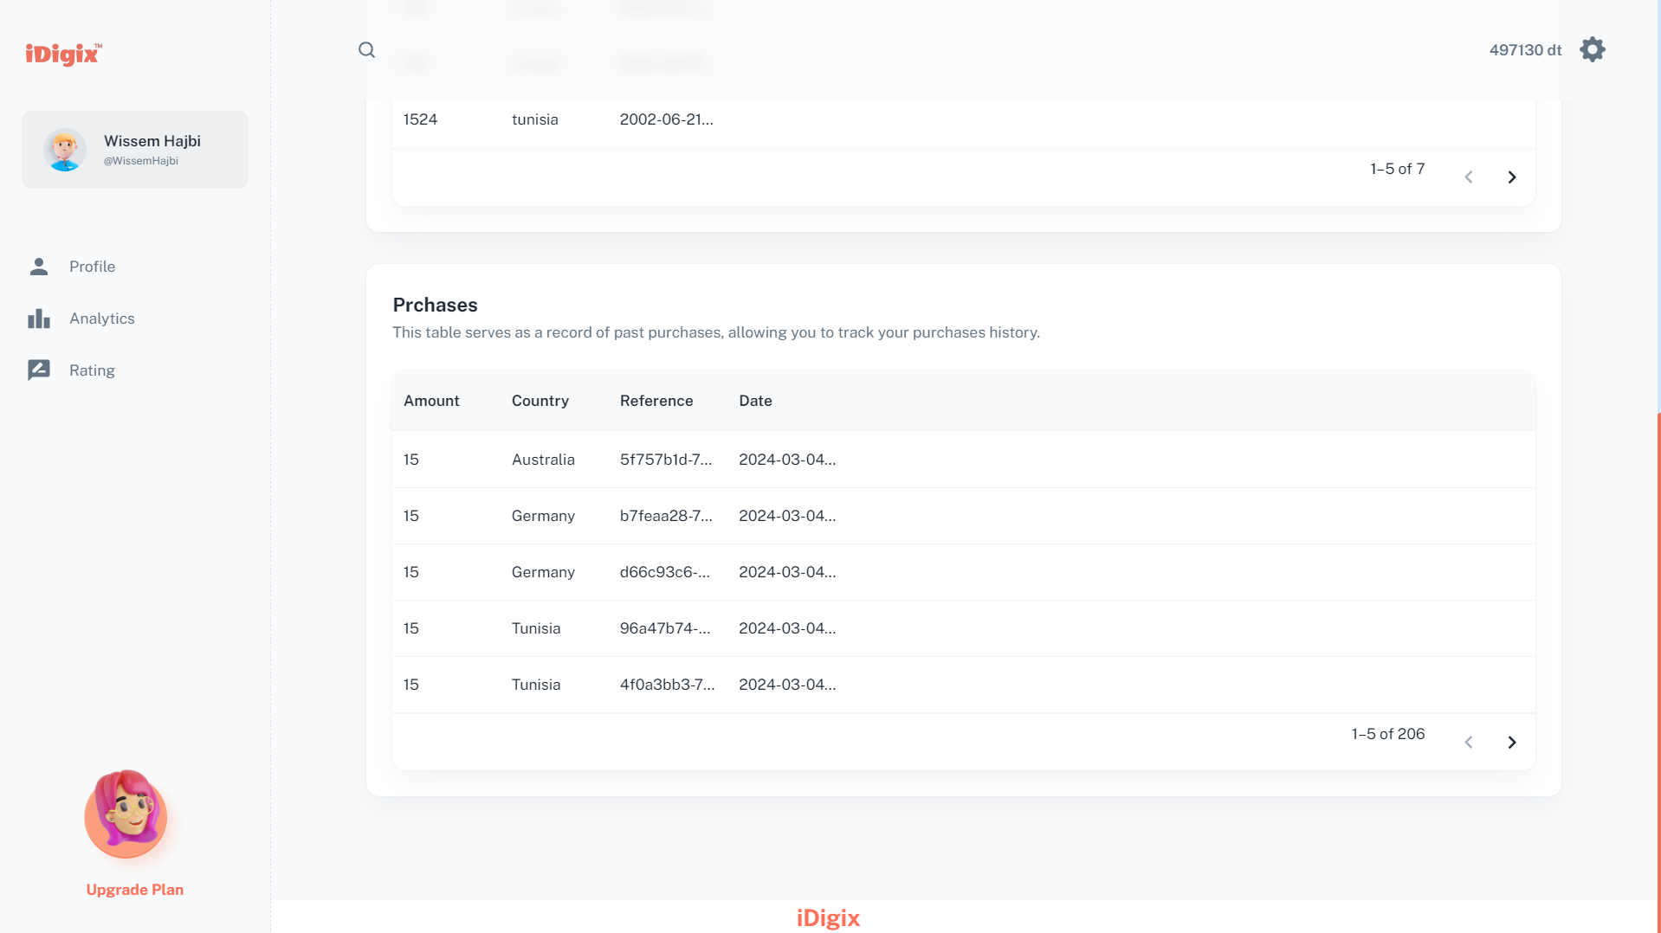
Figure 49:budget section (2/2)
The interfaces is clean and intuitive, making it easy for users to navigate. The purchases table is well-designed, with clear column headers and a clean layout, displaying important details such as date, country, and reference. Additionally, the deposit table provides a clear record of deposits, allowing users to track their financial history.
The pagination control is user-friendly, allowing users to easily navigate between pages of both tables. The interface appears to be responsive, adapting well to different screen sizes and devices, ensuring a seamless experience. To enhance the experience, consider adding search, filtering, and sorting options to both tables, making it even easier for users to manage their financial data.

- API Testing
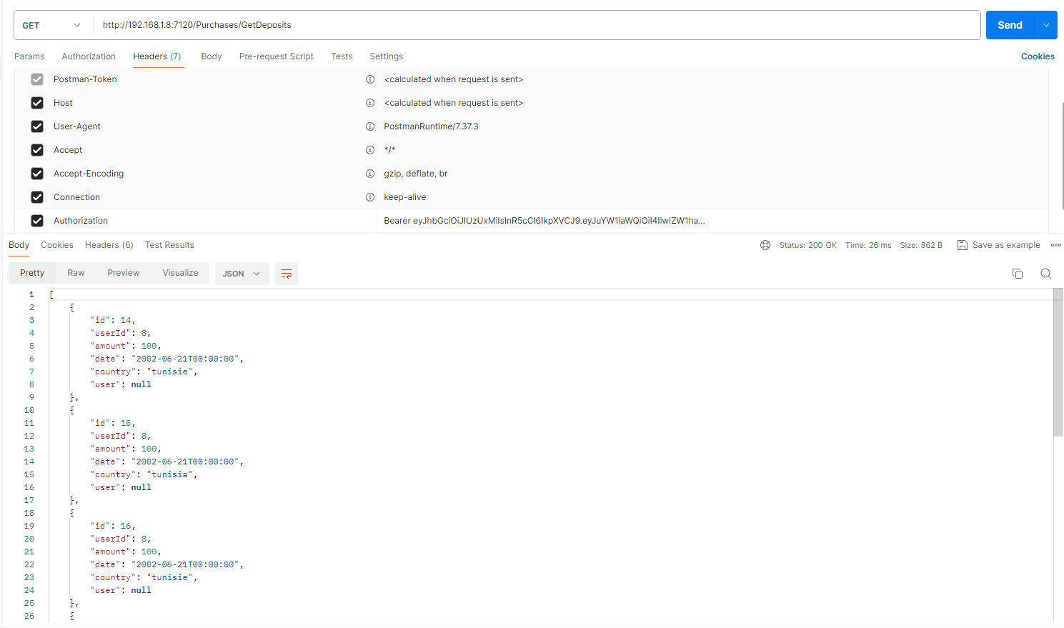
The following figure represents Retrieving Purchases and Deposits Data Using API Requests in Postman Call in case of a successful response
Figure 50:Postman Api user get Deposits successful response.
This is a request to get the list of deposits from the /Purchases/GetDeposits endpoint. It uses a Bearer token for authentication. When successful, the response provides detailed deposit information, including deposit ID, user ID, amount, date, and country.
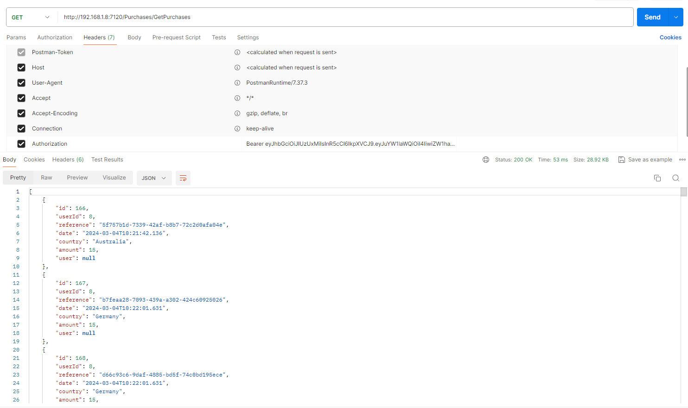
This is a request to get the list of purchases from the /Purchases/GetPurchases endpoint. It uses a Bearer token for authentication. When successful, the response provides detailed purchase information, including purchase ID, user ID, reference number, date, country, and amount.
Figure 51:Postman Api user get Purchases successful response.
Both figures illustrate the process of fetching data for purchases and deposits through API GET requests authenticated with JWT. The responses provide structured JSON data that can be used to populate tables, helping to manage and display user financial transactions effectively. This approach ensures secure and efficient data retrieval for user-specific information.

Conclusion
In this chapter, we successfully implemented Sprint 3, focusing on subscription plans and payment integration. We defined subscription tiers, enabled user subscription management, integrated a payment gateway, and developed a billing and invoicing system. Detailed analysis of use cases for purchases and deposits guided our design and implementation. Key interfaces, such as Bundle Management and Budget Settings, were developed to enhance user experience and ensure seamless transactions. This sprint has laid a solid foundation for monetizing our application while ensuring a smooth and secure user experience. Moving forward, we'll build upon this work to continue improving our platform.

Chapter 5: Sprint 4“Analytic Implementation and Search Functionality”

- Objective
This sprint focuses on significantly improving the analytic capabilities and user experience of our platform. Our primary goals are to design an intuitive search interface, develop robust backend algorithms for data collection and processing, integrate data visualization libraries, and implement comprehensive user access controls for analytic features.
- Backlog sprint 4
This table presents the fourth sprint backlog:
Table 17: Sprint 4 Backlog
Task | Actor | Days
Develop backend algorithms to collect and process user data. | Ahmed & Workmate | 5
Integrate data visualization libraries for generating charts and graphs. | Ahmed & Workmate | 3
Implement user access controls for analytic features. | Ahmed & Workmate | 4
Design intuitive search functionality | Ahmed & Workmate | 5

- Conception
- “Sprint 4” class Diagram
This clas case diagram illustrates the actions for Sprint 4. Users can interact with other profiles and search for users. Premium users can view analytics. All these actions include an authentication process.
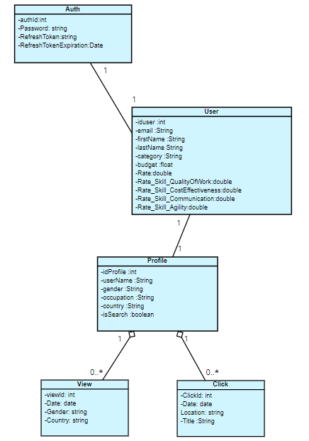
Figure 52:sprint 4 Class diagram
- “Analytic” Conception.
- Analytic use case diagram
In this part, we will present the diagram of the use case related to the Analytic page with its textual description
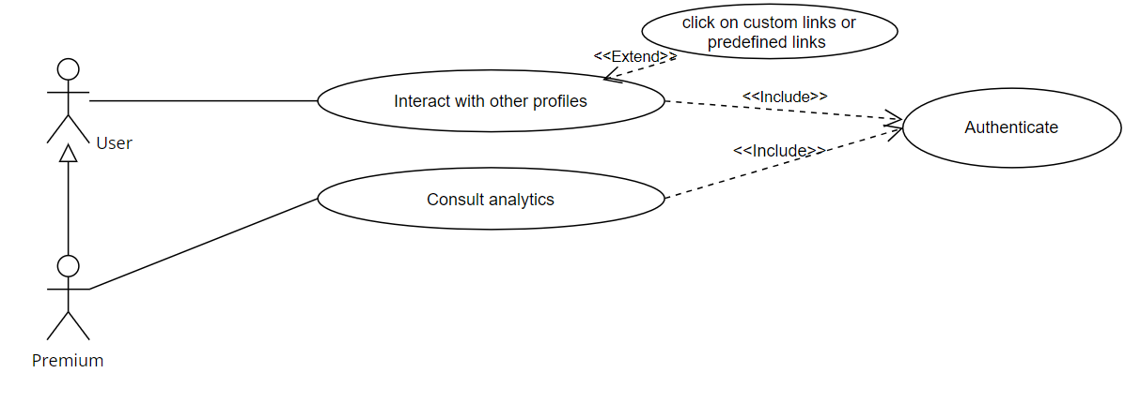
Figure 53:analytic use case diagram.
Table 18:Text description of “Analytic” use cases
Use case | Interactions Analytic
Actor | User / premium
Precondition | The user must be authenticated.
Post-condition | All interactions are recorded and displayed on the analytic page.
Nominal Scenario | - The user views a profile, or their own profile is viewed.  - The system records the view.  - The user clicks on another profile's link, or their profile's link is clicked.  - The system records the click.  - The user navigates to the analytic page to check their insights.  - The system calculates and displays various charts.
Exception | If the user is a premium member but doesn't have enough data :  the system displays empty charts.  If the user is non-premium :  users cannot access their insights.

- Collect insight sequence diagram.
When a user clicks on another user's profile link, the system verifies that it's not the user's own profile, then saves the click for future analytics.
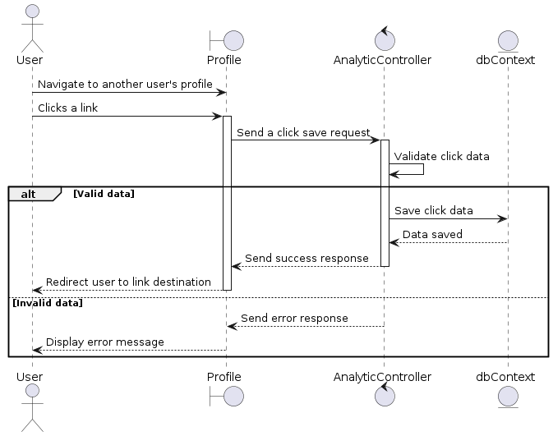
Figure 54:process of collect analytic data sequence
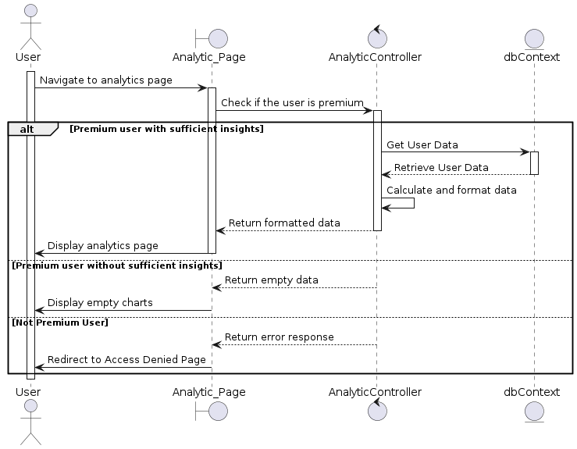
- analytic sequence diagram.
Figure 55:access process of view analytic page sequence
- Search Conception.
- Search Use case diagram
In this part, we will present the diagram of the use case related to the Search page with its textual description

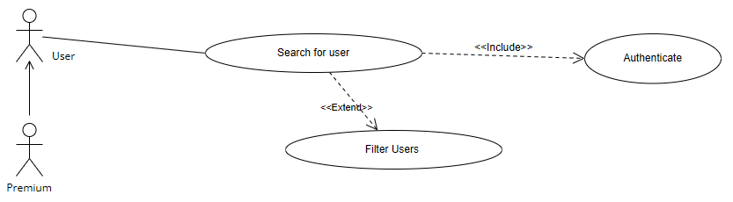
Figure 56: Search use case diagram
Table 19:Text description of Search System use cases
Use case | Search System with Filtering Options
Actor | User / Premium / Student
Precondition | - All search queries and interactions are saved and reflected in the user's search history.
Post-condition | All search queries and interactions are saved and reflected in the user's search history.
Nominal Scenario | - The user enters a search query into the platform's search bar.  - The system processes the search query.  - The system checks if it has already processed a similar query and cached the results.  - If cached results are available, the system retrieves the cached results.  - If cached results are not available, the system processes the search query.  - The system displays search results to the user.  - The user can filter the results  - The user clicks on the "Load More" button to view additional results.  - The system retrieves and displays more search results based on the original query and filters.  - The user interacts with the search results
Exception | If there is an issue with the search query or filters :  The system displays error message
- Search sequence diagram:
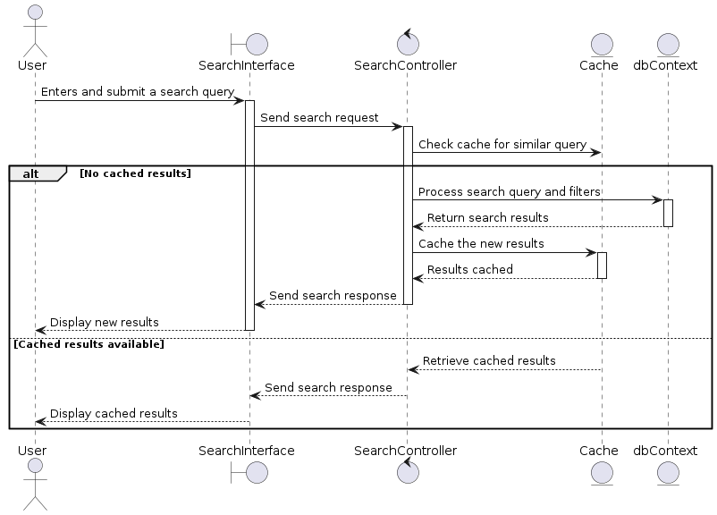
This sequence diagram shows the process when a user submits a search query. The user enters and submits a query, which is sent to the search controller. The controller checks the cache for similar queries. If no cached results are found, the query is processed, results are cached, and then displayed to the user. If cached results are available, they are retrieved and displayed to the user.
Figure 57:process of search of public profile

- Realizations
Based on the analysis and conception of the current sprint. We will present the most important interfaces.
- Search.
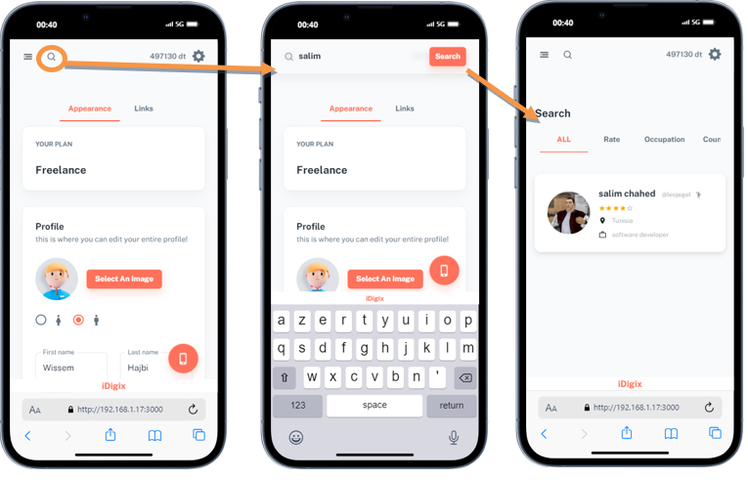
Figure 58:Search with filtering Option in a Mobile view
The "Search System with Filtering Options" interface offers a user-friendly experience with a responsive search bar for easy query input. It dynamically displays results, checking for cached data or processing new queries, and allows users to refine results using various filters.
In scenarios where the search query yields a single result, the "Load More" button may indeed be unnecessary. This optimization streamlines the user experience, eliminating unnecessary elements and simplifying the interface. Therefore, in the case where a user searches for "Salim" and finds only one result, the "Load More" button would not be displayed, ensuring a clean and efficient search interface.

- Dashbord analytic.
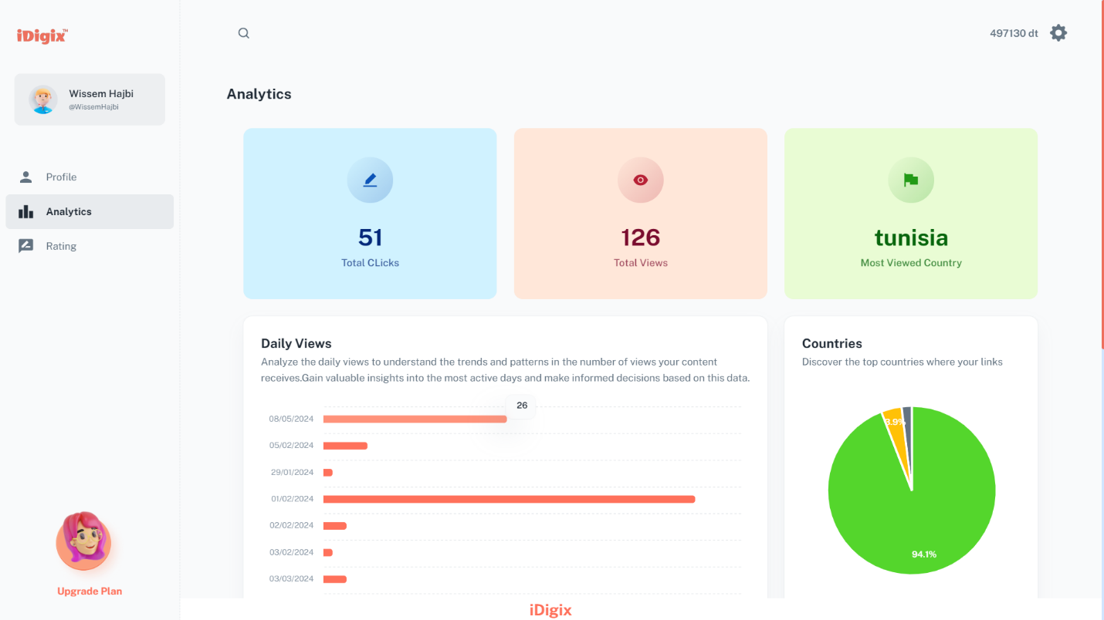
Figure 59:analytics page with charts(1/2)
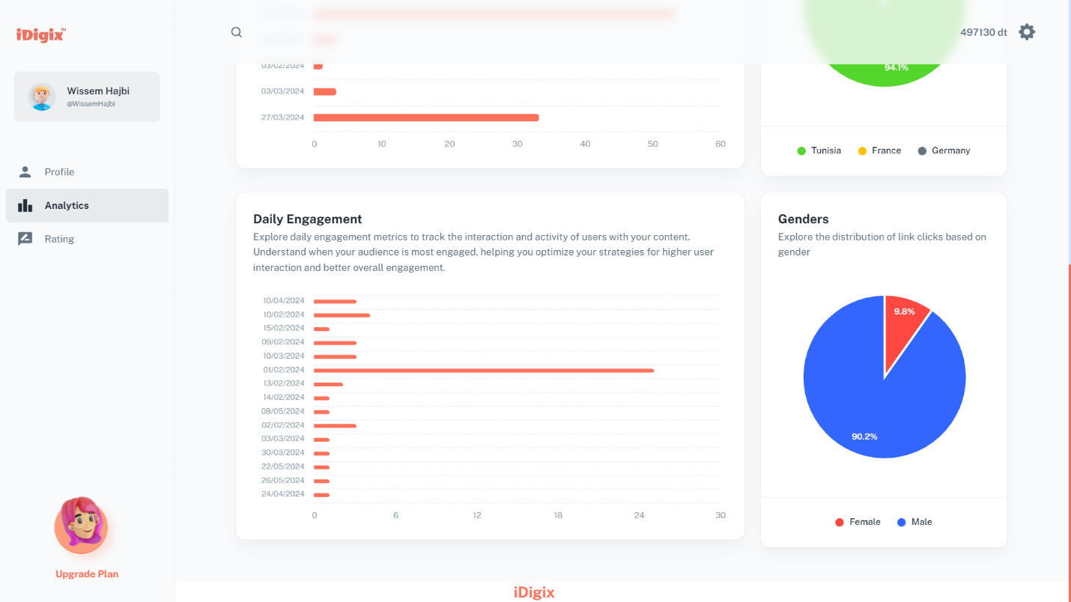
Figure 60:analytics page with charts(2/2)
In the Analytics section of the iDigix platform, premuim users can delve into comprehensive insights tailored to their engagement and content performance. Key features include summary cards that highlight essential metrics such as total clicks, total views, and the primary viewing country. A detailed "Daily Engagement" bar chart allows users to track user interactions over specific dates, facilitating trend identification and strategy optimization. Additionally, a "Countries" pie chart illustrates the geographical distribution of views, aiding users in understanding their audience reach. The interface also includes a gender distribution pie chart, providing insights into the demographics of link clicks. Designed for user convenience.
This intuitive design ensures users can effortlessly analyze their content's performance and audience demographics, empowering them to make data-driven decisions to enhance engagement and reach.
- API Testing
The following figure represents the “user” Get Clicks API Call in case of a successful response.
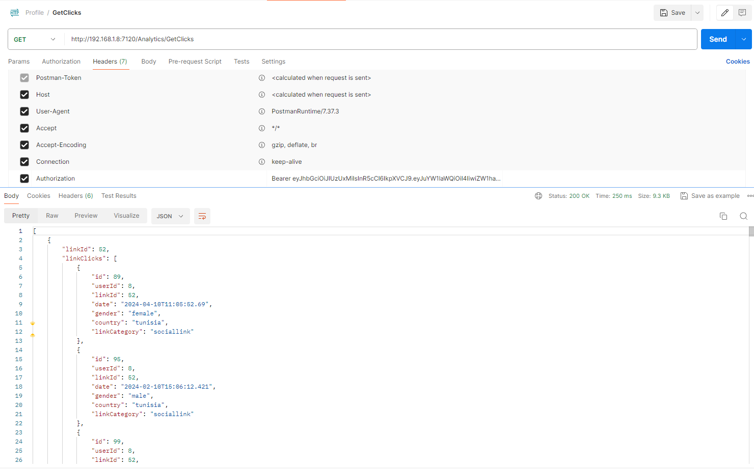
Figure 61Postman Api user get Clicks successful response.
This request retrieves data on link clicks. It presents information about individual clicks, such as the click ID, user ID, date, gender, country, and link category. Additionally, it includes click counts by gender and country, offering insights into the distribution of clicks based on demographics. This response offers an overview of link engagement, facilitating clicks analytics.

Conclusion
In this chapter, we focused on Sprint 4, aiming to enhance the analytic capabilities and search functionality of our platform. We developed backend algorithms for data collection and processing, integrated data visualization libraries, implemented user access controls, and designed an intuitive search interface. Detailed use case analysis guided the development of key interfaces like the 'Search System with Filtering Options' and the 'Analytics' section, ensuring a robust and user-friendly experience. This sprint has significantly improved our platform's user experience and analytic capabilities, laying a foundation for more advanced features in the future.

Chapter 6: Sprint 5“Rating System and Deployment”

- Objective
IDigix introduces a dynamic Rating System. This innovative feature allows service providers to distribute coupons to their customers, who can then rate the services they received. This process enhances feedback, provides valuable insights into service performance, and helps us continually refine our platform based on client input. The Rating System represents a significant step forward in our commitment to delivering a seamless and rewarding user experience, empowering both service providers and customers alike. However, the implementation of a robust rating system isn't complete without considering its impact on deployment and configuration. Deploying a feature that integrates with other platform elements requires careful attention to ensure seamless integration and optimal performance.
- Backlog sprint 5
Task planning is an important phase for defining the number of sprints needed to complete a project and for specifying the duration of each sprint.
Table 20: Sprint 5 Backlog
Task | Actor | Days
Develop backend functionalities for rating system data collection and processing. | Ahmed & Workmate | 6
Integrate rating visualization components for displaying user feedback. | Ahmed & Workmate | 6
Implement user access controls for rating system features. | Ahmed & Workmate | 5
Application Deployment and Configuration | Ahmed & Workmate | 10

- Conception
Once we've defined our sprint backlog, we'll move on to functionality. So, we'll assemble several "user stories" under a well-defined functionality.
- “Sprint 5” Class Diagram
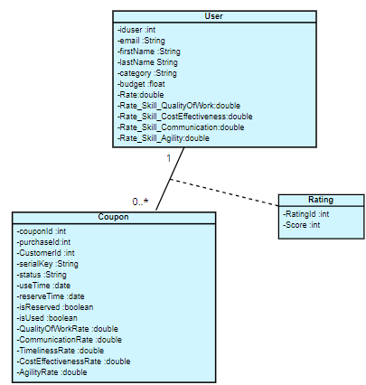
Figure 62:sprint 5 Class Diagram

- “Managing Reserved Coupons” Conception.
- Managing Reserved coupons use case diagram
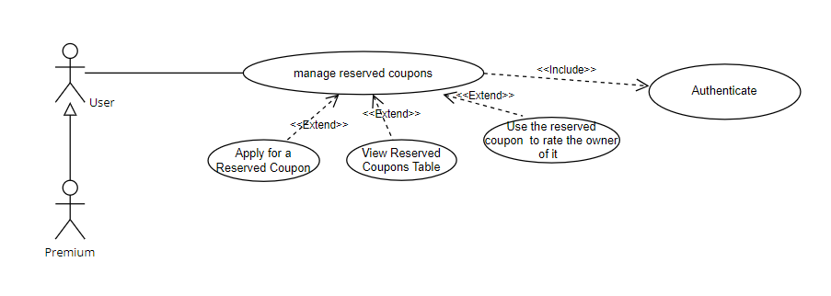
Figure 63:managing reserved coupons use case
Table 21:Text description of “Reserved Coupons” use cases
Use case | Managing Reserved Coupons
Actor | User / premium
Precondition | The user must be authenticated and have access to available reserved coupons.
Post-condition | The user successfully applies for a reserved coupon and can view their reserved coupons table.
Main Scenario (Apply for a Reserved Coupon) | - On the coupon page, the user navigates to the "Order Reserved Coupon" section.  - The client user selects or enters the coupon code and clicks "Apply".  - The system confirms the coupon application and updates the user's reserved coupons table.
Exception | E1: Invalid Coupon Selection  - The system displays a pop-up alert if the entered coupon code is invalid.  E2: Cancellation  - The client user cancels the coupon application process. The system does not reserve the coupon.
Alternative Scenario (View Reserved Coupons Table) | - The client user navigates to the "Your Reserved Coupons" section directly from the coupon page.  - This section displays a table of Owner, Reference, and Serial Key of reserved coupons.
Exception | E1: No Reserved Coupons  - The system displays a message indicating there are no reserved coupons to view.
Alternative Scenario (Using Reserved Coupon): | - The client user navigates to the "Your Reserved Coupons " section directly from the coupon page.  - The user selects a reserved coupon from the table.  - The system redirects the user to the profile page of the owner of the selected coupon.  - On the profile page, a dialog box appears, prompting the user to provide a rating and feedback for the owner.  - The dialog box allows the user to rate the owner on a scale of 1 to 5 for each skill category.
Exception | E1: No Reserved Coupons Available  - The system displays a message indicating there are no reserved coupons to use.  E2: Invalid Coupon Usage  - The system displays an alert if the selected coupon is no longer valid.  E3: Rating Submission Failure  -If the rating fails, the system displays an error message.

- apply for reserved coupons sequence diagram
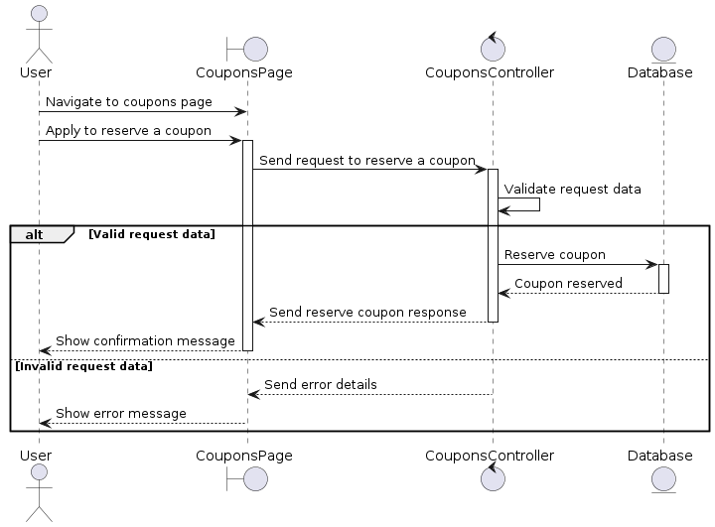
Figure 64:apply for reserved coupon sequence diagram
This sequence diagram shows a user reserving a coupon. The user navigates to the coupons page and applies. The controller validates the request. If valid, the coupon is reserved, and a confirmation is shown. If invalid, an error message is displayed.

- Used a reserved coupons sequence diagram
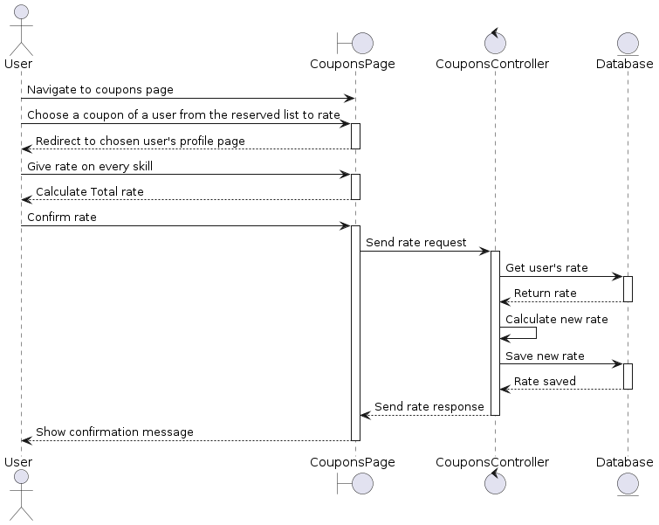
Figure 65:Used a reserved coupon use case
This sequence diagram shows a user rating another user. The user navigates to the coupons page, selects a coupon to rate, and is redirected to the user's profile. After rating each skill and confirming, the rating is sent to the controller, which updates the database and shows a confirmation message to the user.

- “Manage available coupons” Conception.
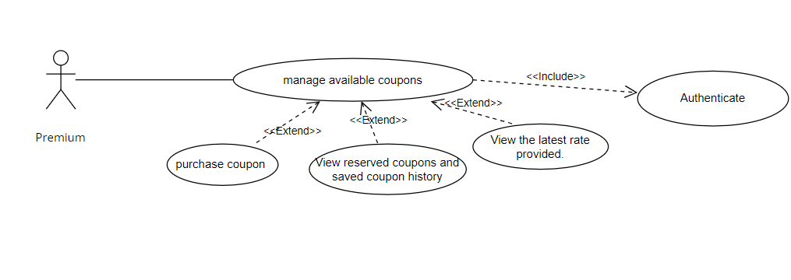
- “Manage available coupons” use case diagram
Figure 66:manage available coupons use case
Table 22:Text description of “Managing Coupons” use cases.
Use case | Managing Coupons
Actor | Premium User
Precondition | The premium user must be authenticated and have access to coupon management.
Post-condition | The premium user can purchase, view, and manage available, reserved, and used coupons.
Main Scenario (Purchase Coupons) | - The premium user access to the "Manage Coupons" section.  - The premium user clicks "Get Coupons".  - The system displays available coupons for purchase.  - The premium user selects the desired coupons number and confirms the purchase.  - The system checks the user’s budget.  - If the user has sufficient funds, the system processes the purchase and updates the user's coupon list.
Exception | E1: Insufficient Funds  The system displays a message indicating insufficient funds for the purchase.  E2: Cancellation of Processing  The premium user cancels the purchase process. The system does not process the coupon purchase.
- Realzations.
Based on the analysis and conception of the current sprint. We will present the most important interfaces.
- Rating section.
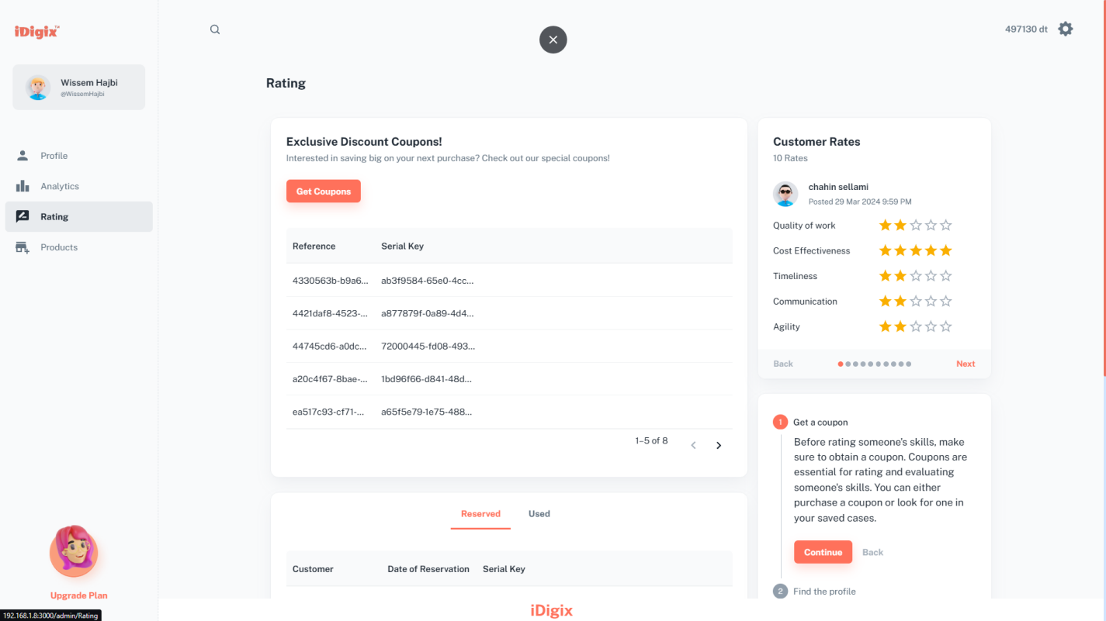
Figure 67:interface of rating management
This window offers a seamless and intuitive user experience. The "Exclusive Discount Coupons" section streamlines access to and management of your coupons. In our 'Customer Ratings' section, you can conveniently view past reviews and ratings provided by your clients. Navigate through them by swiping left or right, empowering users to make informed decisions. Additionally, the informative panel guides users on how to obtain and use coupons effectively, while the organized tabs ensure that reserved and used coupons are easily accessible. My goal is to create a functional and user-friendly interface that meets all needs
- Apply for reserved coupon.
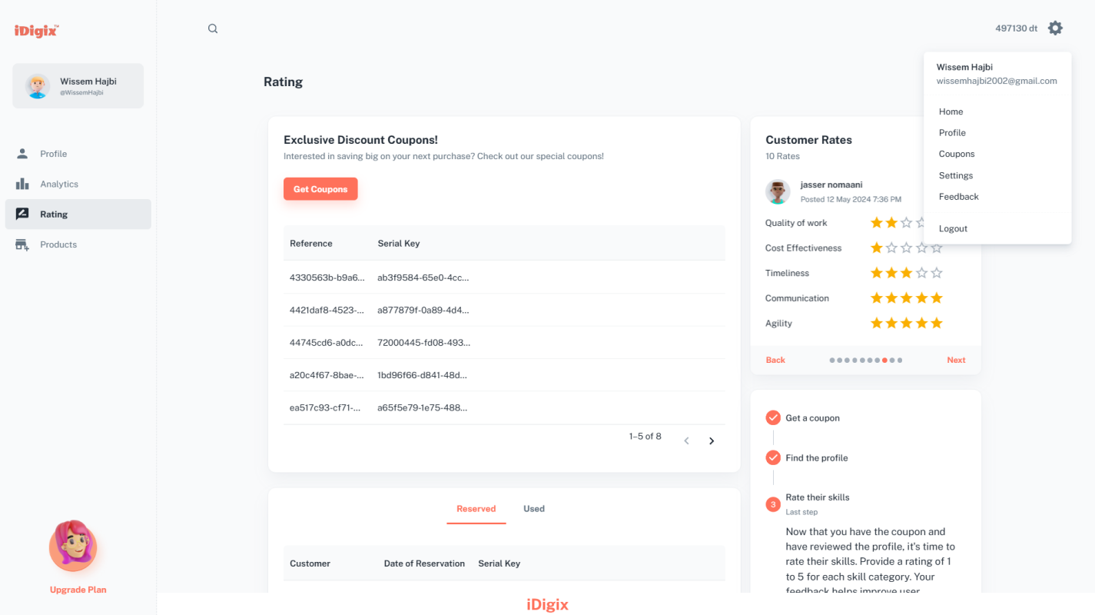

Figure 68:interface of apply for reserved coupon. (1/2)
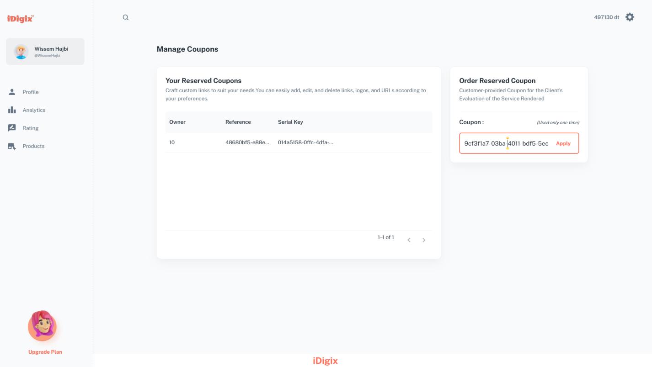
Figure 69::interface of apply for reserved coupon. (2/2)
The "Managing Reserved Coupons" interface lets any authenticated user view and apply reserved coupons. In the "Order Reserved Coupon" section on the right, users can enter a coupon code and click "Apply". The reserved coupons table on the left updates to display coupons you reserved before, showing details like the owner, reference, and serial key.
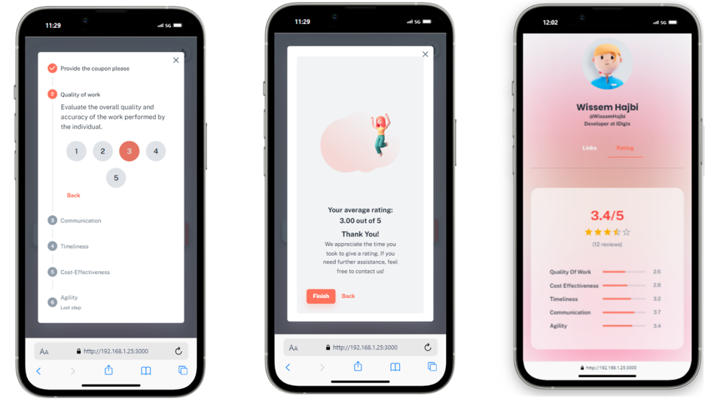
- Use a reserved coupon to Rate the service provider of it.
Figure 70:interfraces of process to rate service provider.
The process begins with the client navigating to the "Your Reserved Coupons" section directly from the coupon page. The user then selects a reserved coupon from the table, Redirecting the user to the owner’s profile page.
A dialog box appears, prompting the user to provide a rating and feedback for the owner. The dialog box is designed to be user-friendly, allowing the user to rate the owner on a scale of 1 to 5 across various skill categories. Such as Quality of Work, Communication, Timeliness, Cost-Effectiveness, and Agility. The interface is well-organized, with each category clearly defined and easy to navigate. Then, the user is presented with an average rating based on their selections.
The final interface showcases the ratings on the profile, visible to other users. This display not only informs potential customers about the provider's abilities and reliability but also incentivizes providers to maintain and improve their service quality.

- API Testing
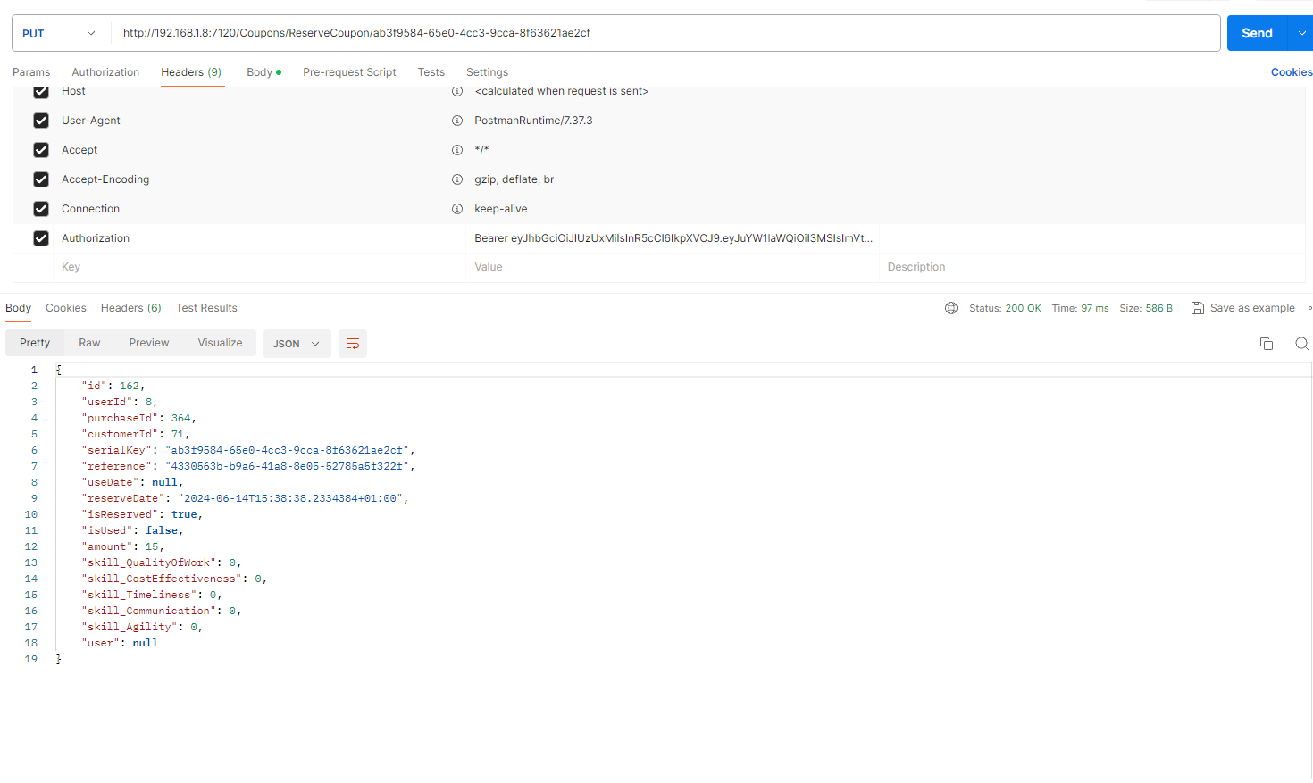
The following figure represents the “user” user reserve coupon to rate a service provider API Call in case of a successful response.
Figure 71:Postman Api user reserve coupon successful response.
This is a request to reserve a coupon from the /Coupons/ReserveCoupon/{couponId} endpoint. It uses a Bearer token for authentication. When successful, the response provides detailed coupon information, including coupon ID, user ID, purchase ID, customer ID, serial key, reference, reserve date, amount, and various skill ratings. This API is used to mark a coupon as reserved, which can then be utilized and rated.
- Application Deployment and Configuration
In this section, we'll explore the deployment and configuration process of the iDigix application. Before we delve into the technical details, let's take a moment to understand the infrastructure that supports our deployment,
- Choosing OVH for Deployment
For deploying iDigix to a production environment, a reliable and scalable hosting solution is crucial. OVH, a reputable provider of web hosting and cloud services, stands out as an excellent choice. They are renowned for:
- Robust infrastructure: OVH boasts a vast network of data centers with cutting-edge technology, ensuring optimal performance and uptime for your application
- Excellent customer support: Their dedicated support team is available to assist you with any issues you may encounter during deployment or ongoing operation
- VPS offerings: OVH's Virtual Private Server (VPS) plans offer the perfect balance of control, scalability, and affordability
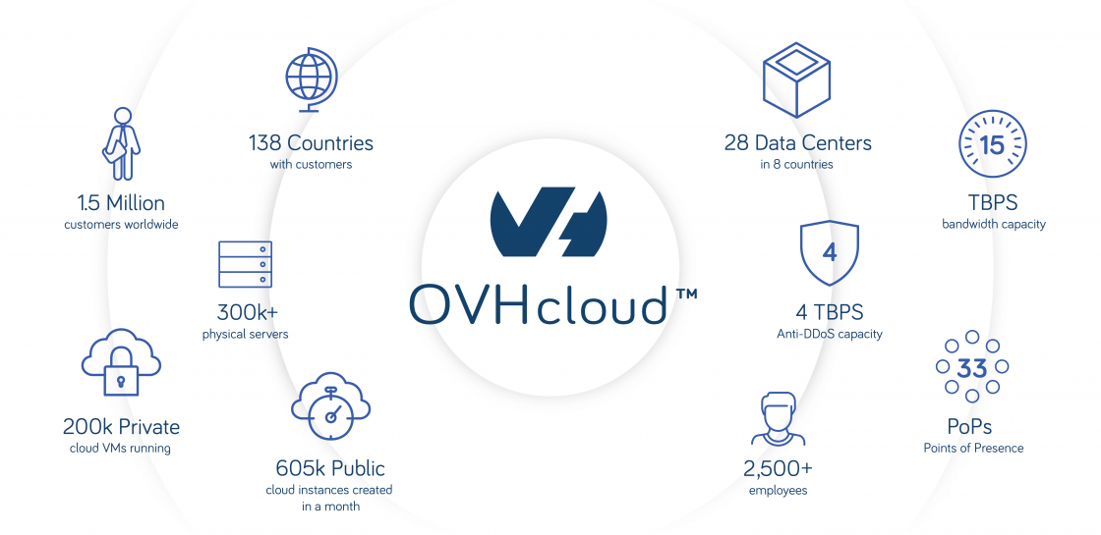
By choosing OVH for iDigix deployment, gain a dependable foundation for the application to thrive.
Figure 72: about OVHcloud.

- Understanding VPS
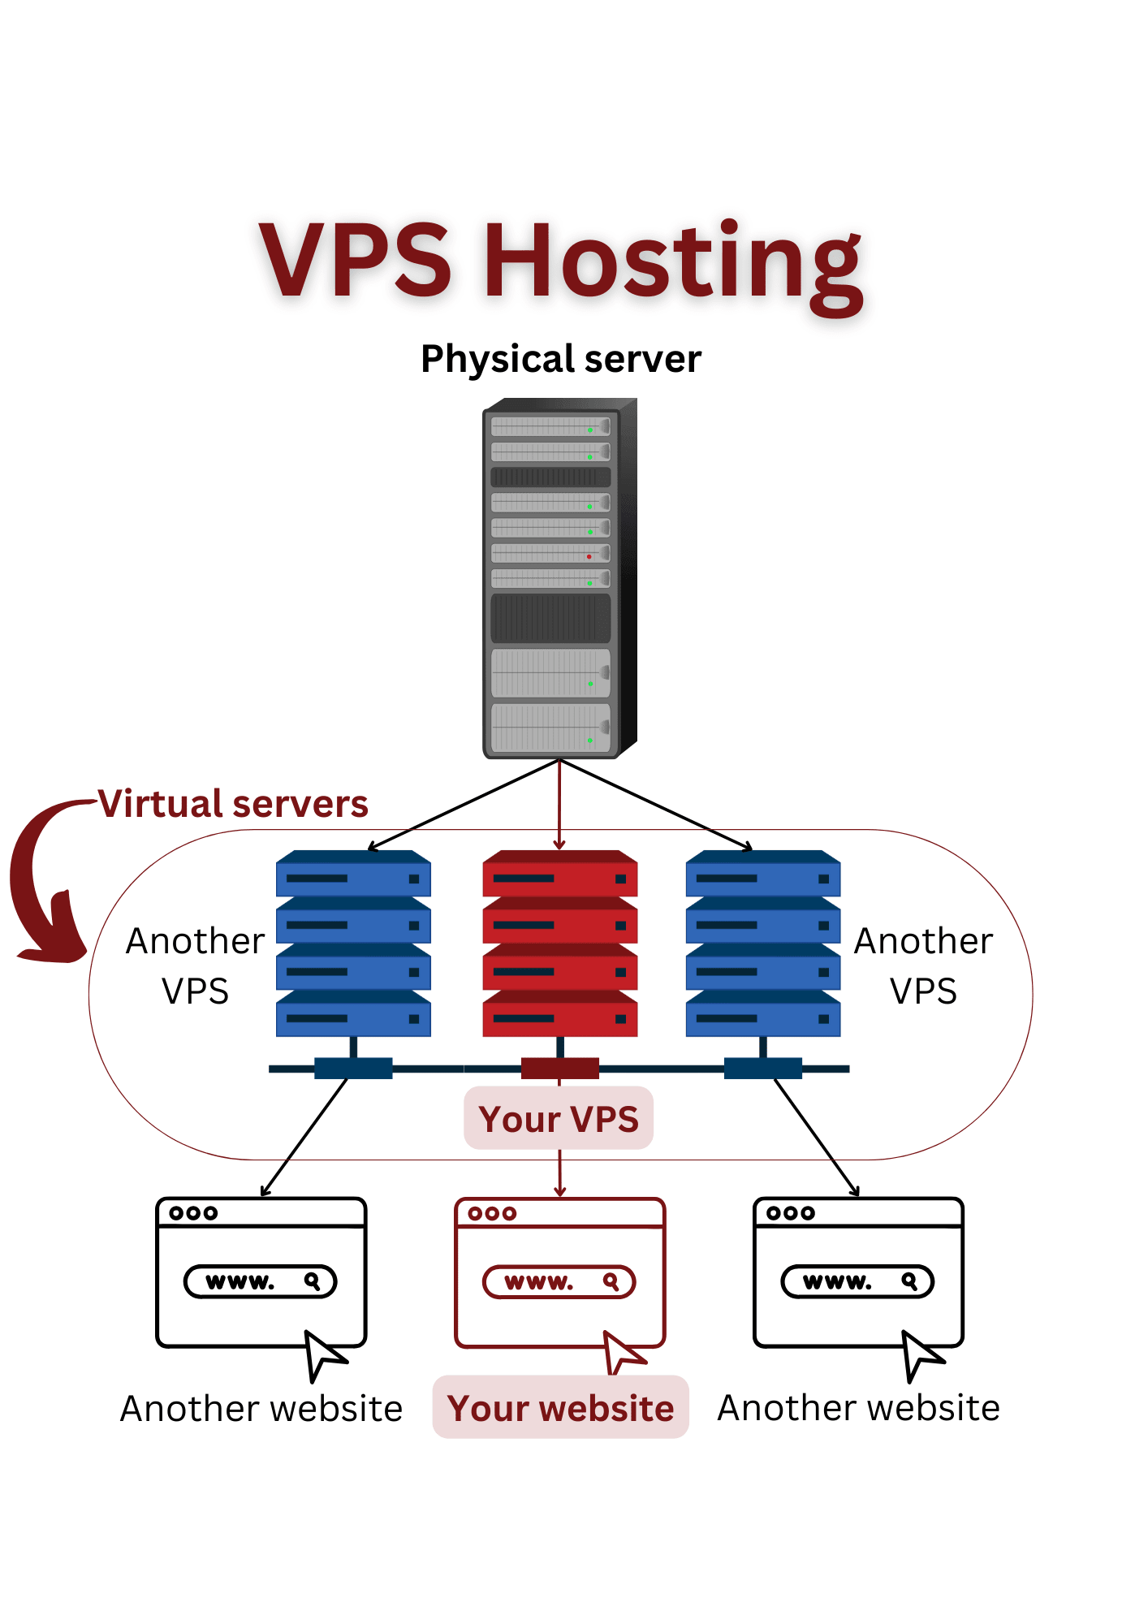
A Virtual Private Server (VPS) is a virtualized server that provides dedicated resources within a larger physical server. It offers more control and flexibility compared to shared hosting.
Figure 73:Overview of VPS Hosting
Key Benefits of Using a VPS:
- Performance : Dedicated resources ensure consistent performance.
- Control: Full root access for complete control over the server.
- Scalability: Easily adjust resources as needed.
- Security: Isolation from other users enhances security.
- Cost-Effectiveness: Offers dedicated server benefits at a lower cost.
With its dedicated resources and increased control, a VPS from OVH provides the perfect platform for deploying and scaling the iDigix application effectively.

- Server Configuration
Table 23:server Configuration
Hardware | Configuration
Processor | Proc 1 vCore
Memory | 2 GB RAM
Storage | 20 GB SSD SATA
- deployment diagram
The deployment diagram illustrates the architectural setup of iDigix, showcasing how the platform is hosted on an OVH VPS and served by Nginx. Testing this deployment ensures that iDigix functions smoothly and reliably in a production environment. Key areas to focus on during testing include:
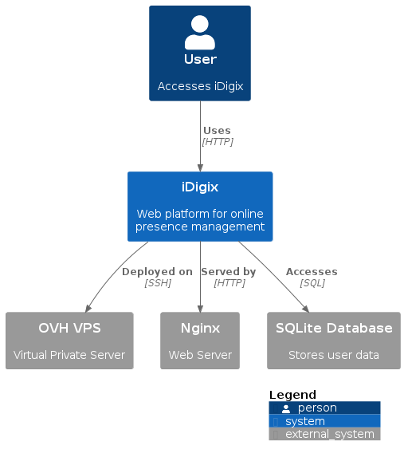
Figure 74:deployment diagram.

- Deploying iDigix on a OVH VPS Using Nginx:
Now, let's dive into the practical aspect of deploying iDigix on an OVH VPS.that I Follow to ensure a smooth and efficient setup process
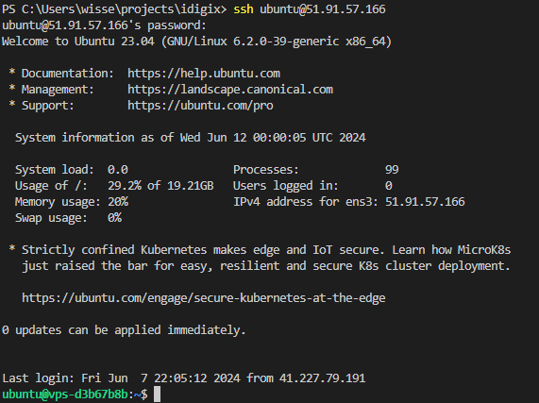
Step 1 Connect via SSH: To begin, I connected to my VPS using SSH. This allowed me to remotely manage the server from my local machine.
Figure 75:Connect via SSH snapshot
the command above connects to the VPS using the IP address 51.91.57.166 and the username ubuntu.
Step 2 Update and Install Packages: To ensure the VPS is equipped with the necessary tools and updates, several steps are taken. Firstly, the system undergoes an update to ensure it possesses the latest security patches and features. Following this, essential packages such as Nginx, .NET SDK, and Node.js are installed to provide a robust environment for hosting applications. The .NET SDK is acquired by adding the Microsoft repository and installing the appropriate package, while Node.js and npm are installed to support the development of React applications. These commands are executed on the VPS, configuring it with the requisite software components and laying the foundation for hosting and running applications smoothly.
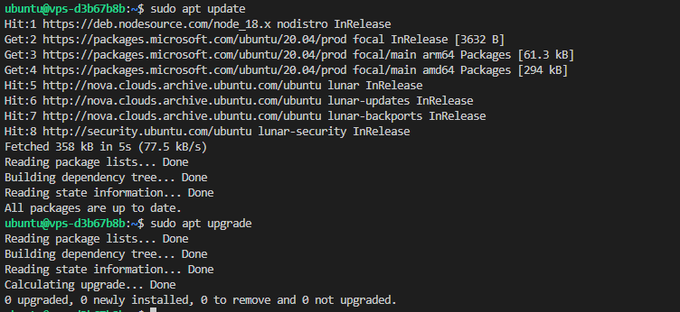
Figure 76:Update and Install Packages commande lines.
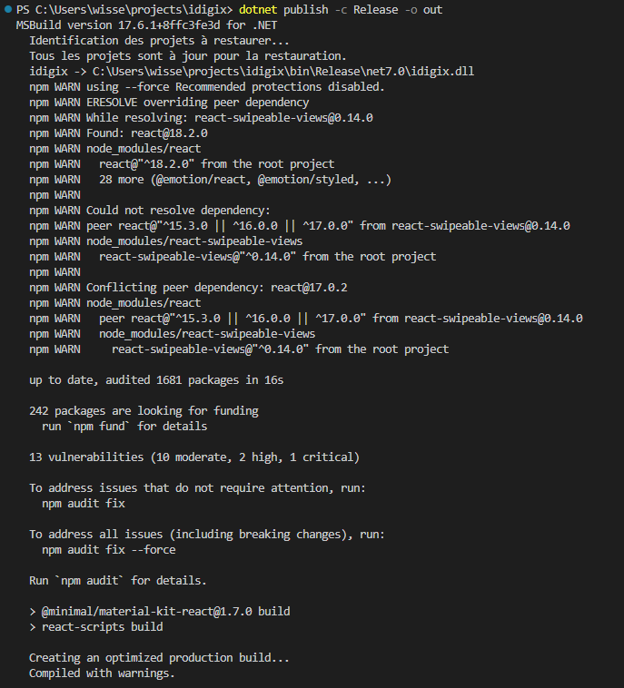
Step 3 Build the ASP.NET Core application: On my local machine, I navigated to my project directory and published the ASP.NET Core application to a release folder.
Figure 77:Build the ASP.NET Core application commande lines
Step 4 Transferring Files to My VPS: Using SCP, I securely copied the published files from my local machine to the VPS.
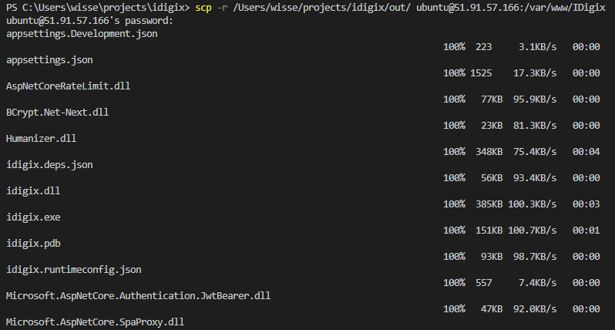
Figure 78:Transferring files to my vps.
Step 5 Configuring Nginx: Opens the Nano text editor to edit the configuration file.
Figure 79:nano comande line confguring Nginx
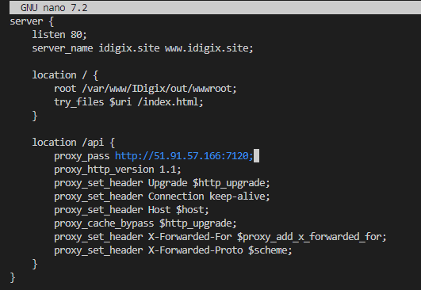
I configured Nginx to serve my application, specifying the necessary proxy settings and static file locations.
Figure 80:configured Nginx
Step 6 Setting Up systemd for Service Management:
To ensure my application runs continuously, I created a systemd service.
Figure 81:nano comande line confguring systemd service.
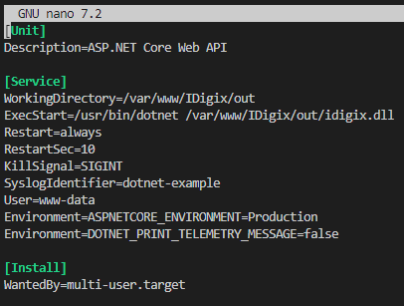
I added the following configuration to manage the application as a service.
Figure 82:configured application service
Step7 Starting and Enabling the Service:
I enabled and started the systemd service to keep my application running.
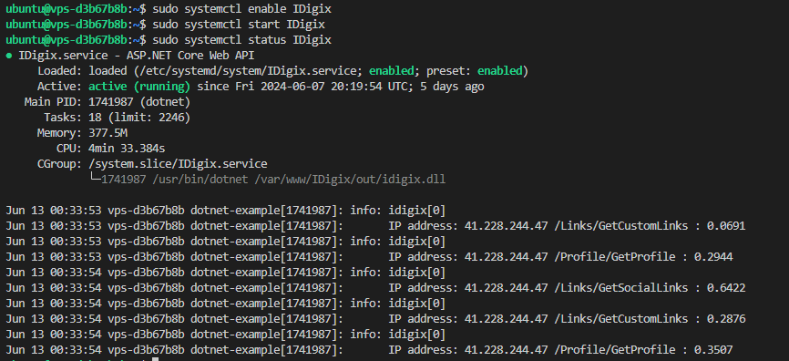
Figure 83:comnade line of starting and enabling and view status of the service

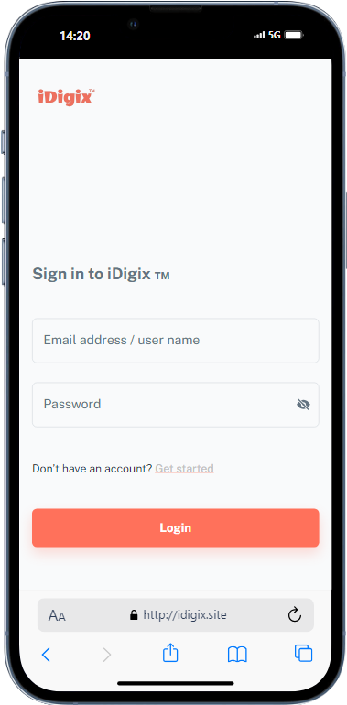
By following these necessary steps, the iDigix application is successfully deployed on an OVH VPS using Nginx. This setup ensures a robust and scalable environment for the application, ready to handle production traffic.
Figure 84:www.idigix.site

Conclusion
Following the successful deployment, the final phase of this sprint involved crucial feedback gathering from the Djagora Association team. This collaborative effort aimed to assess the functionality and usability of the deployed platform and gather insights for potential improvements. Their feedback, combined with our observations and data analysis, will help us refine iDigix, ensuring a truly user-centric and robust platform for managing online presence.
.

General Conclusion
This report is the result of an end-of-studies internship at the Djagora Association Sfax, aimed at obtaining a degree in Computer Technology. During this internship, we designed and developed iDigix, a web platform to help people and businesses manage their online presence.
Throughout the project, we applied the theoretical knowledge we gained over three years of study. We faced the challenge of building a web platform, which included both frontend and backend development. This required understanding different technologies and methods. In the end, we successfully completed iDigix.
iDigix has two main parts:
Frontend: Built with React, it offers a user-friendly interface for accessing and managing the platform's features.
Backend: Built with ASP.NET Core, it handles data processing, security, and database interactions (using SQLite).
These parts work together to ensure a smooth user experience.
Developing iDigix also helped the Djagora Association by:
Providing a tool for managing online presence: Users can centralize their online profiles, customize their profiles, manage links, see analytics, and use a rating system.
Encouraging online engagement: The platform helps users’ network and engage with its search and rating features.
Supporting businesses: iDigix helps service providers promote their services, get feedback, and build trust with customers.
In conclusion, this internship was a valuable experience that allowed me to apply my academic knowledge to a real-world project. The successful development of iDigix highlights the importance of combining theoretical learning with practical implementation.

Abbreviations

Abbreviations | Acronyms
API | Application Programming Interface
URL | Uniform Resource Locator
UI | User Interface
GUI | Graphical User Interface
NFC | Near Field Communication
RAM | Random Access Memory
SSD | Solid State Drive
JSON | JavaScript Object Notation
MVP | Minimum Viable Product
CRUD | Create, Read, Update, Delete
MVC | Model-View-Controller
REST | REpresentational State Transfer
SOAP | Simple Object Access Protocol
XML | Extensible Markup Language
JWT | JSON Web Token
SQL | Structured Query Language
HTTP | Hypertext Transfer Protocol
QR CODE | Quick Response Code
VPS | Virtual Private Server
SSH | Secure Shell
AES | Advanced Encryption Standard

Bibliography and Netography

- Axios,2024 https://axios-http.com/docs/intro
- * Richardson, L., & Ruby, S. (2013). *RESTful web APIs*. O'Reilly Media.
- SQLite, 2024 https://builtin.com/data-science/sqlite
- Entity Framework Core, 2024 https://learn.microsoft.com/en-us/ef/core/
- GitHub,2024https://docs.github.com/en/get-started/start-your-journey/about-github-and-git
- Material-UI,2024 https://mui.com/
- Microsoft .NET,2024https://learn.microsoft.com/en-us/dotnet/
- OVHcloud,2024 https://www.ovhcloud.com/en-gb/about-us/history/
- Postman2024, https://www.postman.com/
- React,2024 https://reactjs.org/
- SQLiteBrowser,2024 https://github.com/sqlitebrowser/sqlitebrowser
- Stack, 2024 https://stackoverflow.com/
- TypeScript,2024 https://www.typescriptlang.org/
- Visual Studio Code,2024 https://code.visualstudio.com/docs
- Angular vs react,2024 https://www.imaginarycloud.com/blog/angular-vs-react/
- Mvc framework,2024 https://www.geeksforgeeks.org/mvc-framework-introduction/
- JSON,2024 https://www.json.org/json-en.html
- Postman,2024 https://learning.postman.com/docs/introduction/overview/
- DB Browser,2024 https://sqlitebrowser.org/

Abstract:
This report outlines the development of iDigix, a web-based platform for efficient online presence management. Developed as part of an end-of-studies internship, iDigix empowers users to enhance their online presence through personalized profile management, advanced search functionality, integrated analytics, and a unique rating system. Utilizing modern technologies such as React for frontend, ASP.NET Core for backend, and SQLite for database management, iDigix provides individuals and businesses with comprehensive tools to improve their digital footprint. Furthermore, the project details the successful deployment of iDigix to a production environment.
KEYWORD: online presence management, web platform, React, ASP.NET Core, SQLite, profile customization, link management, analytics, rating system, deployment.
Resumé:
Ce rapport décrit le développement d'iDigix, une plateforme web pour la gestion efficace de la présence en ligne. Développé dans le cadre d'un stage de fin d'études, iDigix permet aux utilisateurs d'améliorer leur présence en ligne grâce à la gestion de profil personnalisée, à des fonctions de recherche avancées, à des analyses intégrées et à un système de notation unique. En utilisant des technologies modernes telles que React pour le frontend, ASP.NET Core pour le backend, et SQLite pour la gestion de la base de données, iDigix fournit aux particuliers et aux entreprises des outils complets pour améliorer leur empreinte numérique. De plus, le projet détaille le déploiement réussi d'iDigix dans un environnement de production.
Mots Clés : gestion de la présence en ligne, plateforme web, React, ASP.NET Core, SQLite, personnalisation de profil, gestion de liens, analyses, système de notation, déploiement.
الخلاصة:
يستعرض هذا التقرير تطوير منصة آي ديجكس، وهي منصة ويب لإدارة الحضور الإلكتروني بكفاءة. تم تطويرها كجزء من تدريب نهاية الدراسة، حيث تُمكن آي ديجكس المستخدمين من تحسين حضورهم الإلكتروني من خلال إدارة الملف الشخصي المُخصصة، ووظائف البحث المتقدمة، والتحليلات المُدمجة، ونظام التقييم الفريد. باستخدام تقنيات حديثة مثل ريأكت للواجهة الأمامية وآسب. نت كور للواجهة الخلفية، وإس كيو لايت لإدارة قاعدة البيانات، تقدم آي ديجكس للأفراد والشركات أدوات شاملة لتحسين بصمتهم الرقمية. بالإضافة إلى ذلك، يوضح المشروع نشر آي ديجكس بنجاح في بيئة إنتاج.
كلمات مفاتيح: إدارة الحضور الإلكتروني، منصة ويب، ريأكت، آسب. نت كور، إس كيو لايت، تخصيص الملف الشخصي، إدارة الروابط، التحليلات، نظام التقييم، النشر

