Tunisian Republic
Ministry of Higher Education and Scientific Research
General Directorate of Technological Studies
Higher Institute of Technological Studies of Sfax
IT Département

Academic year 2024 /2025
END OF STUDIES INTERNSHIP
In order to obtain the diploma in Information Technology
Option: Development of Information Systems (DSI)
Entitled
DESIGN AND IMPLEMENTATION OF A VIHECLE MANAGEMENT

Developed by:
Ahmed Jrad
Presented on 19/06/2025 in front of the jury commission
Code :
Mr. | Mouhamed ELLEUCH | President
Mr. | Sonia Lahiani | Rapporteur
Mr. | Ahmed Ben Younes | Supervisor (ISET)
Mrs. | Sondes Titi | Supervisor (Company)

Dedication

I, Ahmed Jrad, humbly dedicate this project to my family and mentors, whose continuous support, guidance, and encouragement have been invaluable throughout this academic journey.

Their belief in my abilities has inspired me to persevere through challenges and strive for excellence.

This work stands as a reflection of their unwavering faith and my commitment to growth and professional development.
Ahmed Jrad

Acknowledgment

First of all, I would like to express my sincere gratitude to my supervisor at the Higher Institute of Technological Studies of Sfax, and Mr. Ahmed Ben Younes, for his valuable support and guidance throughout my internship.
I would also like to thank Mrs. Sondes titi, my company supervisor, for entrusting me with the realization of this project and for the time and effort she dedicated to guide me through the entire project .
My thanks also go to the faculty of ISET, especially the computer technologies department, for the knowledge and expertise shared during My academic journey.
Finally, I extend our most sincere and respectful thanks to the members of the jury for taking the time to evaluate My humble work.

Liste of figures
Figure 1 : A simplified diagram of phosphate fertilizer production is shown in the following figure 5
Figure 2: Organization chart of GCT 5
Figure 3:Scrum Method 9
Figure 4: Software Architecture 20
Figure 5: Use Case Diagram 23
Figure 6: Class Diagram of Sprint 1 26
Figure 7;sequence diagram 30
Figure 8 : login interface 31
Figure 9 :Signe up interface 32
Figure 10 ;Admin Index interface 33
Figure 11 : Manger Index interface 33
Figure 12;Employee Index interface 34
Figure 13 ;User Management interface 34
Figure 14 ; Success change user role interface: 34
Figure 15 ; Case Diagram 38
Figure 16 ;Class Diagrams of Sprint 2 40
Figure 17 ;sequence diagram “Vehicle Management 41
Figure 18 : sequence diagram “Driver Management 42
Figure 19 ; sequence diagram “Fuel Card Management 43
Figure 20 ;Use Case Diagram 47
Figure 21 :Class Diagrams 53
Figure 22 : Employee submits a mission order 54
Figure 23 ; sequence diagram “Employee submits a service order 55
Figure 24 : order Service review 56
Figure 25 :Sequence diagram “order mission for Manager 57
Figure 26 ;Use Case Diagram: 61
Figure 27 ; Class Diagram of Sprint 1 62
Figure 28 ; Sequence diagram (Report summation): 63
Figure 29 ; Sequence diagram (manage reports) 64
Figure 30 :Use Case Diagram 67
Figure 31 : Class Diagram of Sprint 1 69
Figure 32 : Sequence diagram (track periodic maintenance) 70
Figure 33:Sequence diagram (Notifications for Periodic Maintenance) 70

Liste of tables
Table 1: Product Backlog: 16
Table 2: Sprint Planning 17
Table 3:Hardware Environment 18
Table 4:Languages and Frameworks Used 18
Table 5: Sprint 1 Backlog 22
Table 6: Textual description of the use case 23
Table 7: Textual description of the use case 24
Table 8 :: Textual description of the use case 24
Table 9: Textual description of the use case 25
Table 10 : Department management 25
Table 11 ;Sprint2 Back Log 37
Table 12 :Textual description 38
Table 13 : Textual description 39
Table 14 :Textual description of the use case 39
Table 15 ;Sprint2 Back Log 46
Table 16 : order mission for employee 48
Table 17 : order Service for employee 48
Table 18 : order Service for Manager 49
Table 19 ; mission Order Review 50
Table 20 ; Service Order Review 51
Table 21 ; Service Order Review 52
Table 22:Sprint 1 Backlog 60
Table 23 : textual description: Textual description of the use case” submit report 61
Table 24:Textual description of the use case” Registration 62
Table 25 : Sprint 1 Backlog 66
Table 26 : Track Periodic Maintenance 67
Table 27 : Receive Notifications for Periodic Maintenance 68
Table 28 : Manage Accidental Maintenance 68

Table of contents

Table of contents 6
General Introduction 1
Chapiter 1: Primary Study 2
Introduction: 3
I. Company Description: 3
1. Presentation of GCT: 3
2. Project Presentation 6
3. Analyze of the existent: 6
3.1. . Study of the existing: 6
3.2. . Criticism of the existing: 7
3.3. Proposed Solution: 7
II. Methodology and Adopted Approach 8
1. Design Methodology 8
2. Agile Principles 8
3. Scrum Method 8
4. Principle and Phases of SCRUM 9
5. Project Planning with SCRUM 9
6. Team and Roles 10
Chapter 2: Planning and Architecture: 11
Introduction: 12
I. Needs Analysis: 12
II. User Overview: 12
III. Functional Requirements 13
IV. Non-Functional Requirements: 15
V. Product Backlog: 16
VI. Sprint Planning: 17
VII. Work environment: 18
1. Hardware Environment: 18
2. Software Environment: 18
3. Languages and Frameworks Used 18
3.1. Software Used: 19
4. Software Architecture: 19
Conclusion: 20
Chapiter 3: Sprint 1: User Management 21
Introduction: 22
I. Sprint 1 Backlog: 22
II. Analysis and Requirements Specifications: 23
1. Use Case Diagram: 23
2. textual description: 23
2.1. Textual description of the use case” Authentication” 23
2.2. Textual description of the use case” Registration” 24
2.3. Textual description of the use case” Role-Based Dashboard Display” 24
2.4. Textual description of the use case” Role Update” 25
2.5. Textual description of the use case” Department management” 25
3. Class Diagram of Sprint 1: 26
4. Squance Diagrame: 26
4.1. Sequence diagram(authentication): 27
4.2. Sequence diagram (Registration): 27
4.3. Sequence diagram (Role-Based Dashboard Display): 28
4.4. Sequence diagram (Role Update): 29
4.5. Sequence diagram (Department management): 30
5. Realization: 30
5.1. Login interface: 31
5.2. Signe up interface: 32
5.3. Admin Index interface: 33
5.4. Manger Index interface: 33
5.5. Employee Index interface: 34
5.6. User Management interface: 34
5.7. Success change user role interface: 34
Conclusion: 35
Chapiter 4: Sprint 2: 36
Vehicle & Driver Management 36
Introduction: 37
I. Sprint2 Back Log: 37
II. Analysis and Requirements Specifications: 38
1. Use Case Diagram: 38
2. textual description: 38
2.1. Textual description of the use case” Manage Drivers” 38
2.2. Textual description of the use case” Manage Fuel Cards” 39
2.3. Textual description of the use case” Vehicle management”: 39
3. Class Diagrams of Sprint 2: 40
3.1. Class Diagram: 40
4. Sequance Diagrame: 40
4.1. sequence diagram “Vehicle Management” 41
4.2. . sequence diagram “Driver Management”: 42
4.3. sequence diagram “Fuel Card Management”: 43
Conclusion: 44
Chapiter 5: Sprint 3: Order management 45
Introduction: 46
I. Sprint2 Back Log: 46
II. Analysis and Requirements Specifications: 47
1. Use Case Diagram: 47
2. textual description: 48
2.1. Textual description of the use case” order mission for employee”: 48
2.2. Textual description of the use case” order Service for employee”: 48
2.3. Textual description of the use case” order Service for Manager”: 49
2.4. Textual description of the use case” mission Order Review”: 50
2.5. Textual description of the use case” Service Order Review”: 51
2.6. Textual description of the use case” Service Order Review”: 52
3. Class Diagrams: 53
4. Sequance Diagrame: 53
4.1. sequence diagram “Employee submits a mission order”: 54
4.2. sequence diagram “Employee submits a service order”: 55
4.3. Sequence diagram “order Service review”: 56
4.4. Sequence diagram “order mission for Manager”: 57
Conclusion: 58
Chapiter 3: Sprint 1: User Management 59
Introduction: 60
I. Sprint 1 Backlog: 60
II. Analysis and Requirements Specifications: 61
1. Use Case Diagram: 61
2. textual description: Textual description of the use case” submit report” 61
2.1. Textual description of the use case” Registration” 62
3. Class Diagram of Sprint 1: 62
4. Squance Diagrame: 63
4.1. Sequence diagram (Report summation): 63
4.2. Sequence diagram (manage reports): 64
Conclusion: 64
Chapiter 3: Sprint 1: User Management 65
Introduction: 66
I. Sprint 1 Backlog: 66
II. Analysis and Requirements Specifications: 67
1. Use Case Diagram: 67
2. textual description: 67
2.1. Textual description of the use case”Track Periodic Maintenance” 67
2.2. Textual description of the use case” Receive Notifications for Periodic Maintenance” 68
2.3. Textual description of the use case” Manage Accidental Maintenance” 68
3. Class Diagram of Sprint 1: 69
4. Squance Diagrame: 69
4.1. Sequence diagram (track periodic maintenance): 70
4.2. Sequence diagram (Notifications for Periodic Maintenance): 70
4.3. Sequence diagram (Manage Accidental Maintenance): 71
Conclusion: 71
General Project Conclusion 72
Bibliography 73

General Introduction

Today, the field of computer science has become increasingly vast and diversified, and information systems have become a vital necessity for any type of business, thanks to web applications.
The development of information systems has enabled companies to adapt to new technologies. As a result, professional entities such as large companies seek to use various applications in order to optimize productivity, efficiency gains and reduce costs.
In this context, the "Groupe Chimique Tunisien" company has tasked us with designing and developing a web application for a Computerized Maintenance Management System.
This need was identified based on the various problems encountered in managing and tracking maintenance within the company. This report describes our development journey for this solution which is structured as follows.

The first chapter presents the preliminary studies where we will explore the host compan, our project goals and proposed solution.

The second chapter focuses on analyzing the functional and non-functional requirements necessary for the project. It will explore in detail into the specific aspects that need to be considered and provide a comprehensive understanding of the requirements.

The other chapters expose the different sprints of our mission that contains software architecture and development framework, authentication and users functionalities

Chapiter 1: Primary Study

Introduction:
In this chapter, we will present the overall context of our end-of-studies project.
We will begin by introducing the host organization. Next, we will provide a study if the existing
followed by a critique. Finally, we will conclude this chapter by proposing solutions.

Company Description:

Presentation of GCT:


The Tunisian Chemical Group (G.C.T) is considered one of the leading fertilizer suppliers in the world. It was established to add value to raw Tunisian phosphate by transforming it into various chemical products such as phosphoric acid (P₂O₅) and fertilizers.
After extraction from the Gafsa mining basin by the Gafsa Phosphate Company (CPG) and its enrichment, phosphate rock is transported by rail to GCT’s processing sites located in Sfax, Skhira, Gabès, and M’dhilla, where it is used as a raw material in production.
Phosphoric acid is produced through a wet process involving the reaction of phosphate rock with sulfuric acid. The resulting phosphoric acid is then used to produce a range of liquid or solid fertilizers. The most important ones are:
- Single Superphosphate (SSP)
- Triple Superphosphate (TSP)
- Dicalcium Phosphate (DCP)
- Ammonium Phosphates such as Monoammonium Phosphate (MAP) and Diammonium Phosphate (DAP)
- TSP is produced by reacting phosphate rock with phosphoric acid.
- MAP and DAP are obtained when ammonia (liquid or gaseous) is added to weak phosphoric acid.
- DCP results from the reaction between phosphoric acid and calcium hydroxide.
The Chemical Group also produces Agricultural Ammonium Nitrate and Porous Ammonium Nitrate, mainly for the local market.
Production is distributed across the sites as follows:
- Sfax: TSP Plant
- Gabès (Industrial Zone of Ghannouch):
  - Phosphoric Acid Plant
  - Diammonium Phosphate (DAP) Plant
  - Ammonium Nitrate Plant
- M’dhilla (Gafsa): TSP Plant
- Skhira (Sfax): Phosphoric Acid Plant
A simplified diagram of phosphate fertilizer production is shown in the following figure:

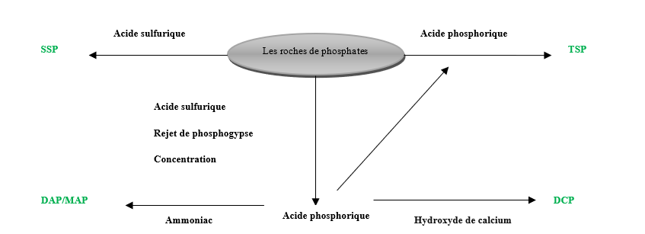
Figure 1 : A simplified diagram of phosphate fertilizer production is shown in the following figure

Organization chart of GCT(Group Chimique Tunisien):
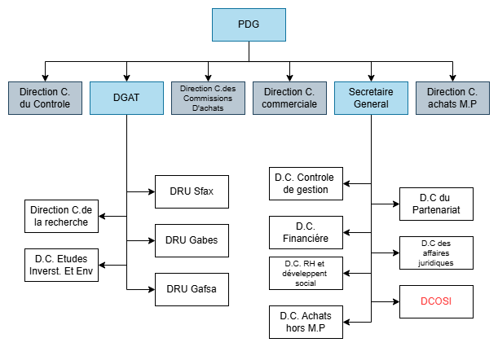
Figure 2: Organization chart of GCT

Project Presentation
This project aims to digitalize the management of company vehicles through a web application. The current process is fully manual and managed by a single person using Excel. It involves handling mission orders, service orders, fuel tracking, and maintenance. The goal of the new system is to make the process faster, more organized, and easier to track and report.

Analyze of the existent:

. Study of the existing:
Currently, all vehicle operations are handled manually by the manager using Excel sheets. The system includes:
- Mission Orders: An employee makes a request for using a vehicle. The manager approves, assigns a vehicle, and allocates the fuel needed using the Agilis card. After the trip, the employee gives a verbal report, which the manager writes down.
- Service Orders: An employee or a manger can also request a service (like a delivery). The manager handles the planning, assigns a vehicle and a driver, manages the fuel, and writes a final report.
- Fuel Management: Each company has an Agilis fuel card. The manager uses these cards to charge the fuel costs when assigning a vehicle.
- Maintenance:
  - Periodic maintenance is based on the mileage and done regularly.
  - Accidental maintenance is done when a problem is reported. The issue is first diagnosed by the park manager before the repair request is made.
All of this information is tracked in Excel, including vehicle usage, maintenance, and fuel spending.

. Criticism of the existing:
- The process is fully manual, which increases the chances of mistakes and makes it hard to manage many vehicles at once.
- Excel is not ideal for this kind of work. It lacks reminders, history tracking, and access control.
- No real-time information: It's hard to know the current status of a vehicle, order, or maintenance.
- Difficult to track fuel usage, especially across different companies and vehicles.
- Reports and documents are not organized or linked directly to the orders or vehicles.
- Only one-person (the manager) handles everything, which creates a risk if they are unavailable or leave

Proposed Solution:
To replace the manual Excel-based system, a web application will be developed to manage all company vehicle operations. The platform will support two main user roles: Admin, Employee and Manager.
- Admin can manage the users’ roles
- Employees can submit mission and service order requests online, with optional documents attached.
- Managers handle request approvals, vehicle assignment, fuel allocation using Agilis cards, and post-trip reporting.
The system will include:
- Order Management for both mission and service types
- Fuel Tracking per vehicle and company
- Maintenance Management for both periodic and unexpected repairs
- GPS Tracking to monitor vehicle locations and usage
- Reporting & Dashboards for summaries, history, and alerts
- Document Storage linked to orders and vehicles

This solution will make the process faster, more accurate, and easier to manage, removing the need for manual tracking and improving overall visibility and control.

Methodology and Adopted Approach
In this section, we define UML as our design language and present the methodology and architecture chosen for our project.

Design Methodology
We selected UML (Unified Modeling Language) as the modeling tool for our project design. As an object-oriented method, UML helps describe system problems without being tied to a specific programming language. It provides a visual way to define requirements, making it ideal for simplifying complex systems. We chose UML for its standardized norms and the variety of diagrams it offers (e.g., use case, class, sequence diagrams).

Agile Principles
The Agile approach, foundational to modern development methodologies, emphasizes:
- Flexibility and rapid adaptation to changes
- Team-client collaboration over rigid processes
- Functional software over excessive documentation
- Responding to change over strictly following a plan
These principles guided our choice of Scrum, an Agile framework that promotes iterative, responsive project management.

Scrum Method
Scrum has become a standard in modern enterprises and startups, enabling:
- Iterative development (Sprints)
- Daily stand-up meetings for progress tracking
- Continuous feedback from stakeholders
- Adaptive planning to refine priorities
Developed by Ken Schwaber and Jeff Sutherland in the 1990s, Scrum belongs to the family of iterative and incremental methodologies and is based on Agile principles.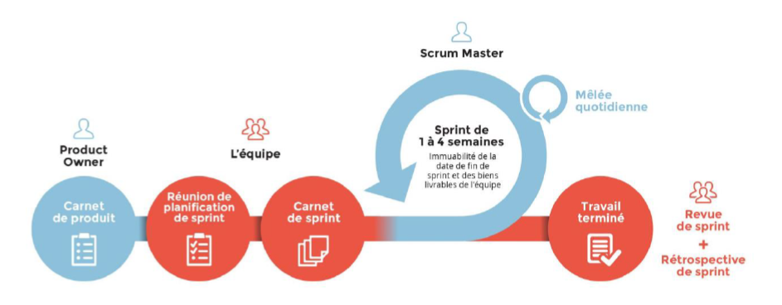
Figure 3:Scrum Method

Principle and Phases of SCRUM
The SCRUM process begins with the creation of a product backlog, which lists all the features to be developed. The features are prioritized, and the selected ones are incorporated into development cycles called Sprints. Each Sprint ends with the delivery of a functional product increment.

Project Planning with SCRUM
- Sprint Planning: The Sprint planning phase in SCRUM starts with a key meeting where backlog stories are validated to ensure everyone understands the requirements. During this meeting, the team, including the Product Owner and the SCRUM Master, discusses and designs solutions, identifies necessary tasks, estimates them, and assigns responsibilities.
- Sprint Review: This meeting allows the team to present the developments made during the Sprint. Only a working version is demonstrated.
- Sprint Retrospective: Conducted internally with the SCRUM Master, this step aims to reflect on areas for improvement by identifying any mistakes made.
- Daily SCRUM: This is a daily coordination meeting where each team member summarizes their progress, the day’s objectives, and any obstacles encountered.

Team and Roles
The team plays a key role in the SCRUM method, being structured to maximize flexibility and productivity. This team is self-organizing and possesses all the skills required to develop the product. It also holds the authority and responsibility necessary to carry out its tasks.
In summary, SCRUM identifies three key roles within the team:
- Product Owner: Carrier of the product vision, often an expert in the relevant field.
- SCRUM Master: Ensures the proper conduct of sprints and the application of SCRUM principles.
- Development Team: Composed of individuals responsible for implementing the client's needs, including developers, testers, etc.
In our project, Ms. Sondes Amri the Product Owner and acts as the SCRUM Master, while I am responsible for all development as the sole developer.

Chapter 2: Planning and Architecture:

Introduction:
This chapter presents the planning phase of the vehicle management system project. It includes the analysis of needs, the identification of user roles, and the definition of both functional and non-functional requirements. The goal is to create a reliable, easy-to-use web application that helps the manager track and control all vehicle-related operations more efficiently.

Needs Analysis:
The current process is entirely manual and handled using Excel spreadsheets. The manager is responsible for multiple companies’ vehicles, and manages:
- Mission and service orders
- Fuel usage using Agilis cards
- Regular and emergency maintenance
- Reporting and follow-up after orders: once a mission or service is completed, the employee gives verbal feedback to the manager. The manager then writes a report, and if any problems are found (e.g., vehicle damage or issues), he follows up by diagnosing the issue and organizing the necessary maintenance.
This manual process is time-consuming, error-prone, and difficult to track. There is no centralized system for storing documents, tracking fuel history, or monitoring vehicle usage in real time. Thus, a digital solution is needed to:
- Automate repetitive tasks
- Improve data organization
- Enhance visibility and reporting
- Enable real-time tracking and notifications

User Overview:
The system will have two main types of users:
- Employee:
- Can log in to create mission or service order requests
- Can attach documents to justify requests
- Can view the status of their orders
- New entry method for users via a Sign-Up system.
- Manager:
- Validates mission and service requests
- Assigns vehicles and manages Agilis card fuel allocation
- Handles and tracks maintenance (periodic and accidental)
- Records reports after each mission or service
- Monitors real-time vehicle location via GPS
- Generates reports and manages system data
- Admin: Manages user accounts, assigns or modifies roles, and oversees access rights.

Functional Requirements
This section defines the specific functionalities the system must offer to meet user needs:
- User Registration and Login:
- Allow new users to sign up
- System assigns default role (Employee).
- Users can log in using email and password.
- Role-Based Access Control:
- Users can access features according to their roles (Employee, Manager, Admin).
- Admin can update user roles from the admin panel.
- Order Management (Mission and Service Orders):
- Employees can:
- Submit mission or service order requests.
- Choose the type of order and provide a reason.
- Attach supporting documents (e.g., invitation, request letter).
- Manager can:
- View all incoming requests.
- Approve or reject requests.
- Assign an available vehicle and set a fuel budget (linked to Agilis card).
- Update the status (pending, approved, in progress, completed).
- Admin Panel:
- Admin can view all users and modify their roles.
- Full access to order records and logs.
- Fuel Management:
- Assign Agilis card per vehicle/company.
- Manager can:
- Allocate specific amounts of fuel for each order.
- View history of fuel usage per vehicle and company.
- Detect irregular fuel consumption.
- Maintenance Management:
- Two types of maintenance:
- Periodic: triggered automatically by mileage or schedule.
- Accidental: triggered manually when a problem is reported.
- Manager can:
- Add or edit vehicle mileage.
- Record maintenance activities and set reminders.
- Track the maintenance status of each vehicle.
- GPS Tracking:
- Real-time map view showing all active vehicle locations.
- Reporting Module:
- Auto-generate reports:
- Mission history per employee or vehicle.
- Fuel expenses per company or vehicle.
- Maintenance history and upcoming tasks.
- Export reports as PDF, Excel, or view online.
- Document Management:
- Upload and store documents:
- Order-related files (invitations, approvals).
- Maintenance reports.
- All files are organized and linked to their respective orders or vehicles.
- Notifications System:
- Email or in-app notifications for:
- New request submission.
- Request approval/rejection.
- Maintenance due dates.
- Vehicle return or issue alerts.

Non-Functional Requirements:
These requirements describe how the system should behave and ensure performance, quality, and user satisfaction:
- Usability:
- Clean, modern user interface.
- Easy navigation for users with basic computer skills.
- Minimal training required.
- Performance:
- Fast loading time for pages and reports.
- Ability to handle multiple users and data entries at the same time without delay.
- Security:
- Encrypted login and secure user sessions.
- Role-based access control must ensure only Admin can modify user roles
- Protection of sensitive data like Agilis card history, reports, and documents.
- Regular data backups.
- Scalability:
- Allow Adding more vehicles or companies in the future.
- Allow Supporting more users without affecting performance.
- Reliability:
- System should be available at least 99% of the time.
- Error handling should display clear messages and avoid crashes.
- Backups and recovery procedures in case of system failure.
- Maintainability:
- Clean and modular code structure.
- Easy to update or improve parts of the system later.
- Use of modern frameworks to ensure long-term support.
- Availability:
- Web-based and accessible from any device with a browser.
- Available 24/7 as long as the user has internet access.

Product Backlog:
Table 1: Product Backlog:
Priority | User Story | Complexity
1 | As an Admin, I want to manage user roles | Medium
2 | As an employee, I want to submit a mission order request with documents. | Medium
3 | As a manager, I want to view and approve mission and service orders. | Medium
4 | As a manager, I want to assign a vehicle and allocate fuel. | High
5 | As an employee, I want to track the status of my order (pending, approved). | Low
6 | As a manager, I want to receive notifications for new orders and due tasks. | Medium
7 | As a manager, I want to record reports after each order and track issues. | Medium
8 | As a manager, I want to trigger and manage periodic maintenance per vehicle. | High
9 | As a manager, I want to create accidental maintenance requests with details. | Medium
10 | As a manager, I want to track fuel consumption history per vehicle/company. | Medium
11 | As a manager, I want to view GPS location and route history of vehicles. | High
12 | As a user, I want to securely log in and see my dashboard. | Low
13 | As a manager, I want to export reports (orders, fuel, maintenance). | Medium
14 | As a user, I want to update my profile and change my password. | Low
15 | As a manager, I want to organize and search stored documents easily. | Medium

Sprint Planning:
By using the sprint methodology, we divided our project tasks into several short and intensive periods. This approach allows us to break down each task in more detail and simplify the execution process.
Would you like help translating more content or structuring a sprint plan?

Table 2: Sprint Planning
Sprint | Story User | Priority | Start Date | End Date
Sprint 1: user Management | As a user, I can authenticate myself. | High | 10/02/2025 | 02/03/2025
 | As a new user, I can register. | High
 | As a user I get my own dashboard based on my Role | High
 | As an administrator, I can manage user accounts. | Hight
Sprint 2: Vehicle & Driver Management | As a manager I can add in new Drivers | High | 03/03/2025 | 23/03/2025
 | As a manager I can add in new Fuel Cards | High
 | As a manager I can add in new vehicles | High
Sprint 3: Order management | As an employee/manager I can send a mission/service order | High | 24/03/2025 | 13/04/2025
 | As a manager I can manage mission/service order requests | High
 | As a manager I can report services | High
Sprint 4: Reporting Systeme | As an employee I can report my mission | High | 14/04/2025 | 04/05/2025
 | As a manager I can manage reports for all orders | Medium
 | Updating the system with necessary follow ups | Low
Sprint 5: Maintenance System | As a manager I can track Periodic Maintenance | Medium | 05/05/2025 | 25/05/2025
 | As a manager I can get notifications about Periodic Maintenance | Medium
 | As a manager I can manage accidental Maintenance | Medium

Work environment:

Hardware Environment:
Table 3: Hardware Environment
Category | Details
Workstation PC | Lenovo 5
Processor | AMD Ryzen 7 5800H 3.2 GHz
RAM | 16GB (1x16 GB)
Resolution | 1920x1080 FHD
Primary Storage | 512GB NVMe SSD M.2
GPU | NVIDIA RTX 3050
OS | Windows 11 Family
Weight | 2.2 kg

Software Environment:
In this section, we describe the software environment of our application in terms of programming languages, frameworks, software, and technologies used.

Languages and Frameworks Used
Table 4:Languages and Frameworks Used
 | Django is a high-level Python web framework that enables rapid development of secure and maintainable websites. It follows the "batteries-included" philosophy, providing built-in features like an ORM, authentication, and an admin panel. Django emphasizes reusability, modularity, and follows the DRY (Don’t Repeat Yourself) principle. It is scalable, versatile, and widely used for building everything from simple websites to complex, data-driven applications.
 | Python is a high-level, interpreted programming language known for its simplicity and readability. It supports multiple paradigms, including procedural, object-oriented, and functional programming. Python's extensive standard library and dynamic typing make it ideal for web development, data analysis, AI, scripting, and automation. Its cross-platform compatibility and large developer community further enhance its versatility.
 | Draw.io is a free, web-based diagramming tool used for creating flowcharts, UML diagrams, wireframes, network diagrams, and more. It offers a user-friendly interface with drag-and-drop functionality and supports real-time collaboration. Diagrams can be saved to cloud services (Google Drive, OneDrive) or locally in various formats (PNG, PDF, SVG). No login or installation is required.
 | JavaScript is a versatile, high-level programming language primarily used for adding interactivity and dynamic behavior to websites. As the core technology of the web (alongside HTML and CSS), it enables client-side scripting, DOM manipulation, and asynchronous operations (AJAX, Fetch API). Modern JavaScript (ES6+) supports object-oriented, functional, and event-driven paradigms. It also powers server-side runtime environments (Node.js) and cross-platform frameworks (React, Angular, Vue).

Software Used:
 | Visual Studio Code (VS Code) is a free, lightweight, and powerful source-code editor developed by Microsoft. It supports multiple programming languages with features like IntelliSense (smart code completion), debugging, Git integration, and extensions for customization. Cross-platform (Windows, macOS, Linux) and highly performant, it’s widely used for web, cloud, and app development.

Software Architecture:
MVT Model in Django:
- Model:
Manages the data and defines the structure of the database.
Contains the logic for interacting with the database (such as querying or saving data).
- View:
Handles user requests and contains the logic for processing and responding to those requests.
Retrieves data from the model and passes it to the template.

- Template:
Manages the presentation layer and defines how data is displayed to the user.
Uses a template language to render dynamic content into HTML.

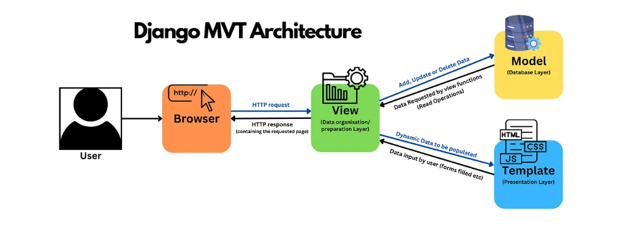
Figure 4: Software Architecture

Conclusion:
During this chapter, we conducted an in-depth analysis and outlined the detailed specifications required for the design and development of our vehicle management platform. Functional and non-functional requirements were meticulously defined to guide all development stages, ensuring the platform meets user expectations precisely.
The adoption of Agile methodology and UML as a design language reinforces our flexible and adaptive approach, which is essential for rapid and efficient development of our solution.

Chapiter 3: Sprint 1: User Management

Introduction:
For Sprint 1, titled "User Management", we will focus on implementing the essential functionalities that allow users to engage with our platform in a meaningful way.

Sprint 1 Backlog:
Table 5: Sprint 1 Backlog
User Story | Tasks | Duration
As a user, I can authenticate myself. | - Design login page UI | 2 days
 | - Implement login logic
 | - Add error messages for incorrect login
 | - Redirect to dashboard after login
As a new user, I can register. | - Design registration form UI | 3 days
 | - Implement user registration logic
 | - Validate input fields
 | - Show confirmation or error messages
As a user, I get my own dashboard based on my role. | - Design general dashboard layout | 5 days
 | - Create different views based on roles (admin, manager, employee)
 | - Implement logic to detect and load role-specific content
 | - Restrict access to unauthorized sections
As an administrator, I can manage user roles. | - Design a user role management interface | 5 days
 | - Implement logic to view, assign, and change user roles
 | Secure access to user management for Admin only
 | - Add confirmation and success/error feedback
 | - Protect access to this feature (admin-only)

Analysis and Requirements Specifications:

Use Case Diagram:
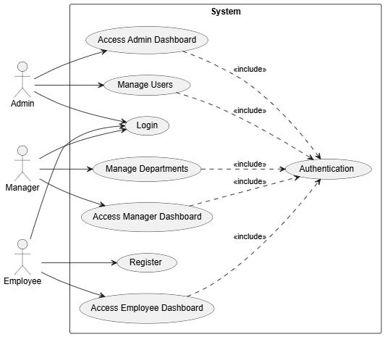
Figure 5: Use Case Diagram

textual description:

Textual description of the use case” Authentication”
Table 6: Textual description of the use case
Use case | Authentication
Actors | Admin, Manager, Employee
precondition | - User account must already exist in the system
Post condition | - The user is successfully logged in and redirected to their appropriate dashboard based on role
Nominal Scenario | 1. User visits the login page  2. Enters valid username/email and password  3. Clicks "Login"  4. System validates the credentials  5. System identifies the user's role  6. User is redirected to their dashboard
Exceptions | E1: Incorrect credentials → display error "Invalid username or password"  E2: Empty fields → prompt user to fill required fields

Textual description of the use case” Registration”
Table 7: Textual description of the use case
Use case | Registration
Actors | Employee
precondition | - User is not logged in
Post condition | - A new user account is created and saved to the system
Nominal Scenario | 1. User accesses the registration form  2. Enters required fields: name, email, password, etc.  3. Submits the form  4. System checks for valid input and uniqueness  5. User is added to the database  6. System displays success message
Exceptions | E1: - Email/CIN already in use → display appropriate error  E2: - Weak password → prompt user to strengthen it  E3: - Form not filled properly → highlight missing/invalid fields

Textual description of the use case” Role-Based Dashboard Display”
Table 8 :: Textual description of the use case
Use case | Role-Based Dashboard Display
Actors | Manager, Employee, Admin
precondition | - User must be logged in
Post condition | - User is shown a dashboard tailored to their role and access rights
Nominal Scenario | 1. After login, the system retrieves user role  2. System redirects user to the correct dashboard  3. Dashboard is loaded with widgets and options specific to that role  4. User can interact with only permitted features
Exceptions | E1: - Missing role assignment → show fallback dashboard or error message  E2: - Invalid role type → deny access or redirect  E3: - Unauthorized page access → redirect to user’s dashboard

Textual description of the use case” Role Update”
Table 9: Textual description of the use case
Use case | Role Update
Actors | Admin
precondition | The admin must be authenticated and authorized to access the user management interface.
Post condition | The admin successfully updates user roles, and changes take effect immediately.
Nominal Scenario | 1- The admin logs into the system and opens the "User Management" page.  2- The system displays a list of registered users with their current roles.  3- The admin selects a user and chooses a new role (example: Employee → Manager).  4- The system updates the user’s role securely in the database.  5- A confirmation message appears: "Role updated successfully."  6- The system enforces updated permissions immediately based on the new role
Exceptions | E1: Unauthorized Access  - Condition: A non-admin user tries to access the user management page.  - System Response:  • Redirects to user’s dashboard with a message: "Access denied."

Textual description of the use case” Department management”
Table 10 : Department management
Use case | Role Update
Actors | Manager
precondition | The Manager must be authenticated and authorized to access the Department management interface.
Post condition | The Manager successfully add or modify or delete Departments.
Nominal Scenario | 1- Manager navigates to the Department Management page.  2- Manager chooses to either add, edit, or delete a department.  3- Manager fills out or updates department information.  4- Manager confirms the action.  5- System saves the changes and displays a confirmation message.
Exceptions | E1: Unauthorized Access  - Condition: A non-Manager user tries to access the user management page.  - System Response:  • Redirects to user’s dashboard with a message: "Access denied."

Class Diagram of Sprint 1:
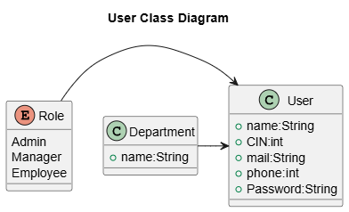
Figure 6: Class Diagram of Sprint 1

Squance Diagrame:
The sequence diagram illustrates the interactions between different objects in a scenario defined by a use case diagram.
To enhance understanding, the primary actor is placed on the left side of the diagram, while secondary actors and the system are positioned on the right.

Sequence diagram(authentication):
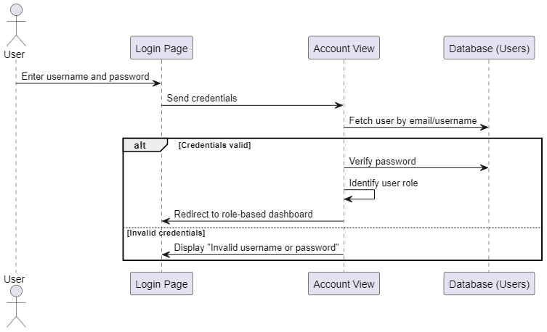

Sequence diagram (Registration):

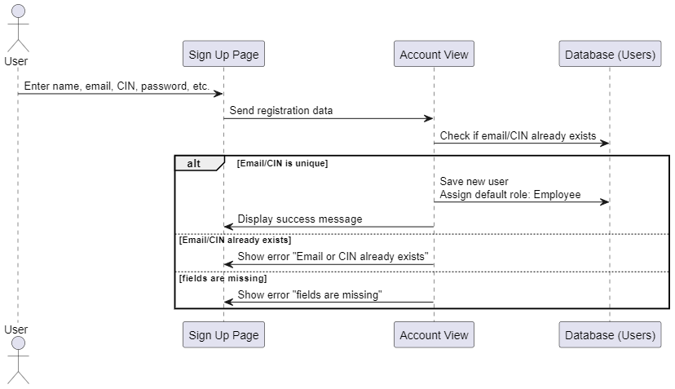

Sequence diagram (Role-Based Dashboard Display):
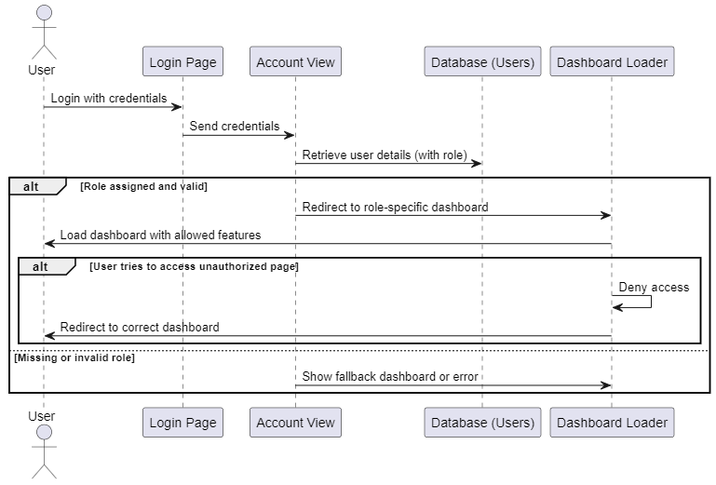

Sequence diagram (Role Update):
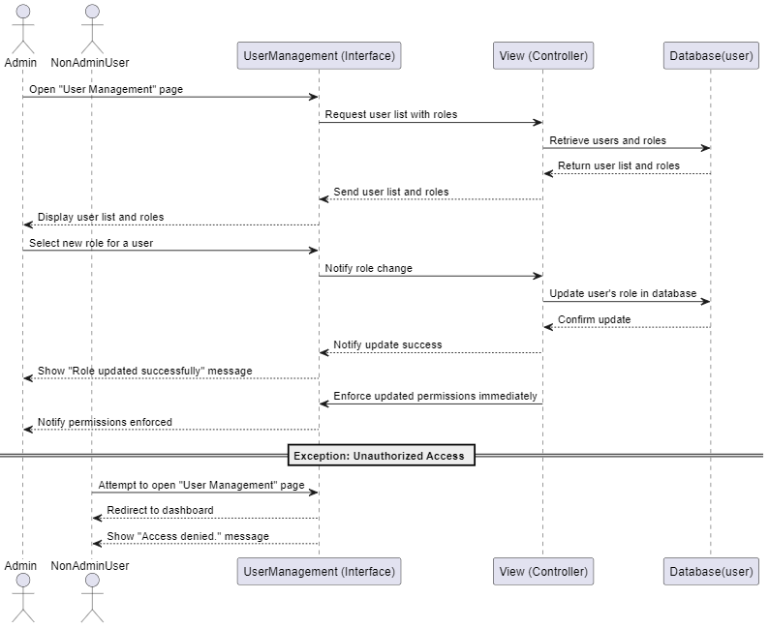

Sequence diagram (Department management):
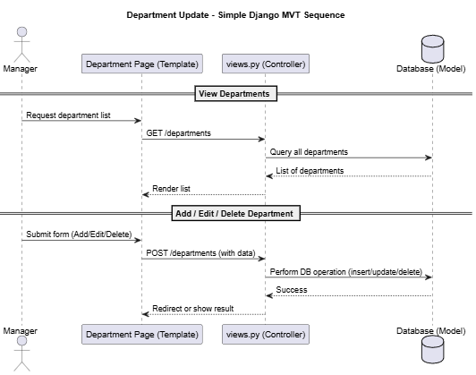
Figure 7;sequence diagram

Realization:
This section provides screenshots of our application and explanatory diagrams to better understand the tasks completed in this sprint.

Login interface:
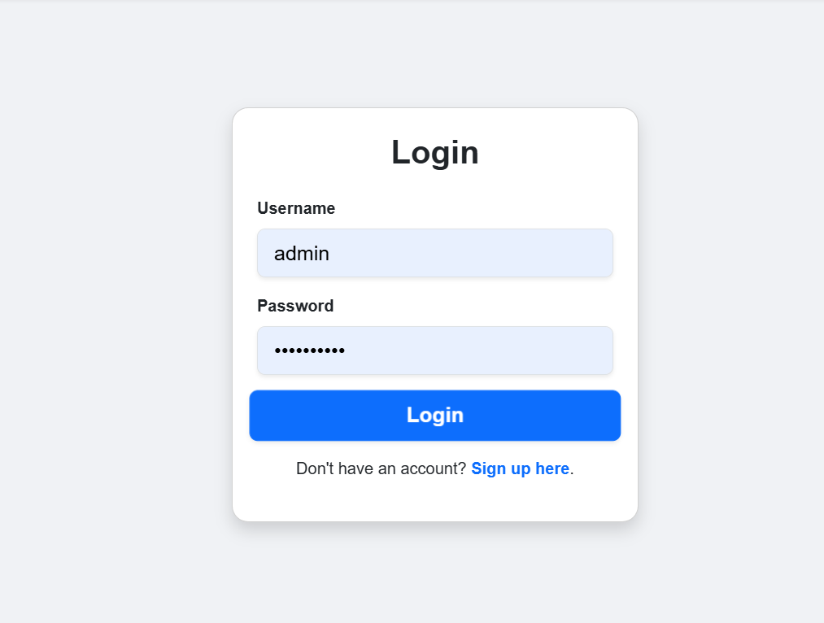
Figure 8 : login interface

Signe up interface:
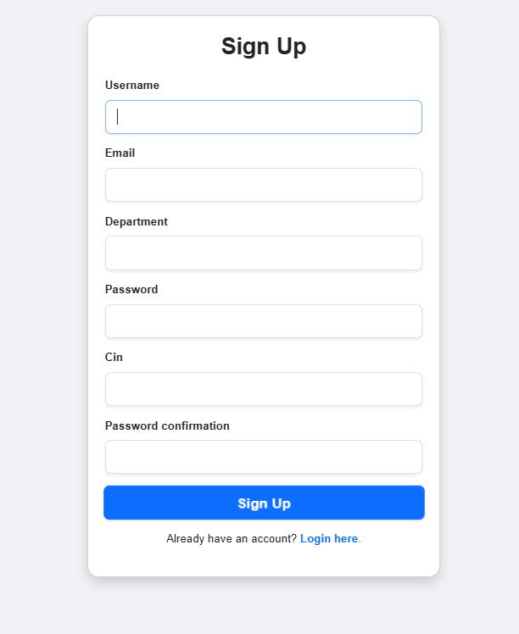
Figure 9 :Signe up interface

Admin Index interface:
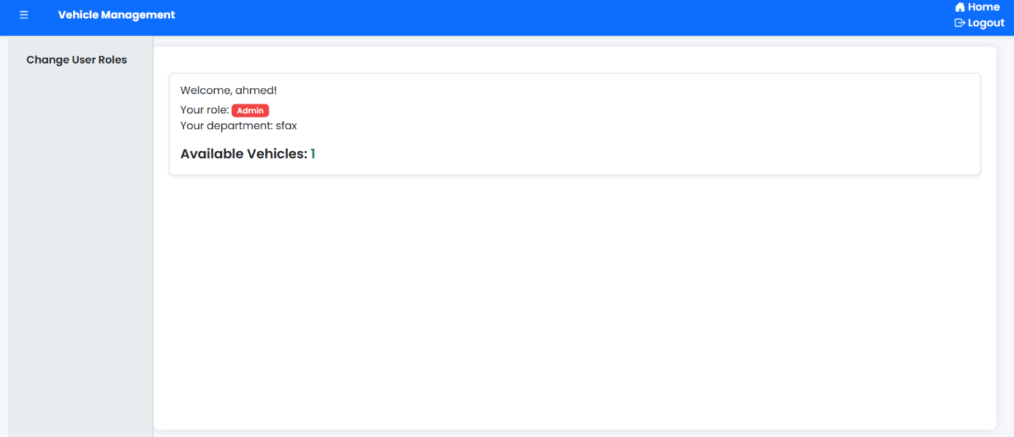
Figure 10 ;Admin Index interface

Manger Index interface:
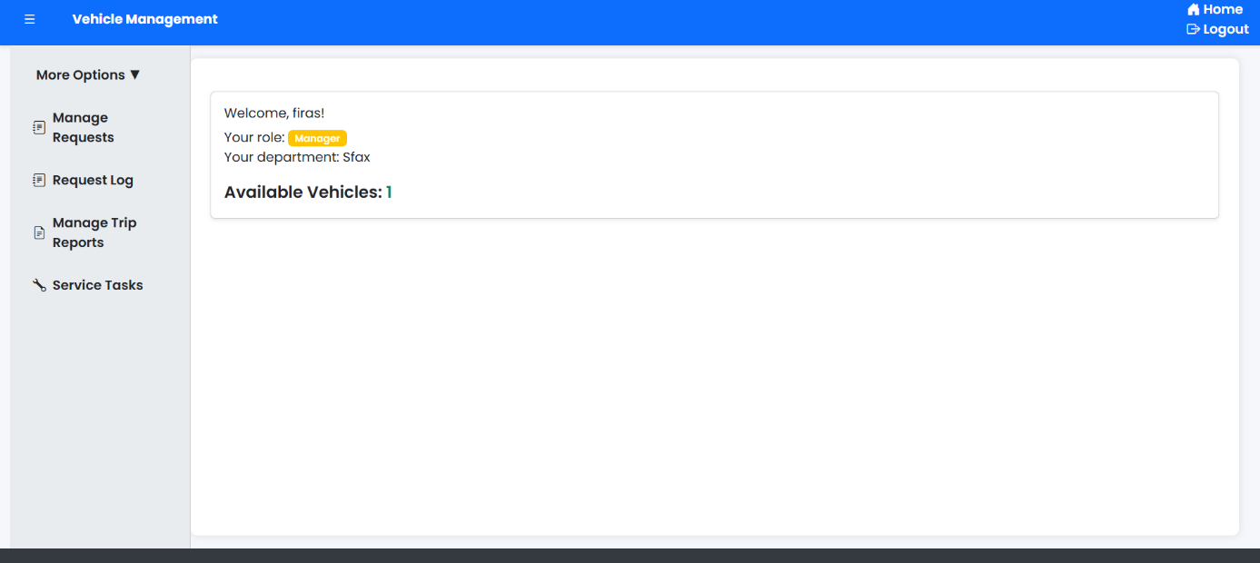
Figure 11 : Manger Index interface

Employee Index interface:
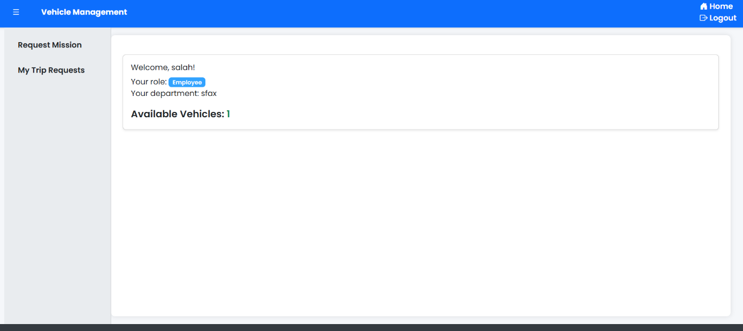
Figure 12;Employee Index interface

User Management interface:
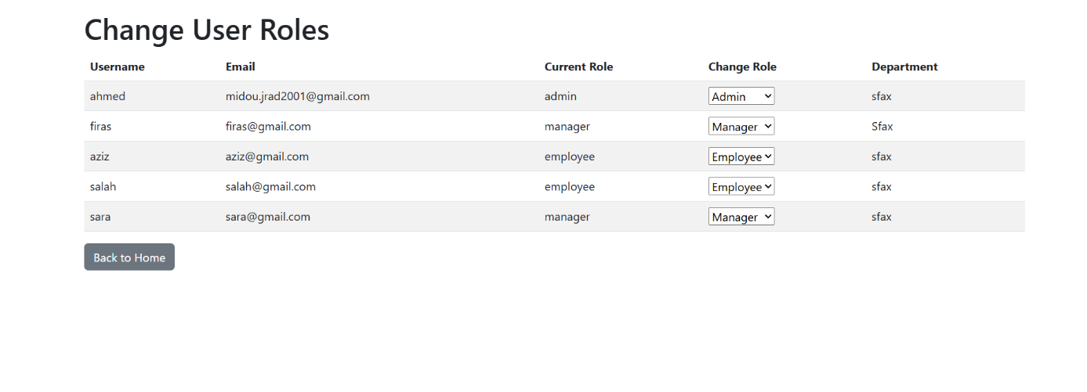
Figure 13 ;User Management interface

Success change user role interface:
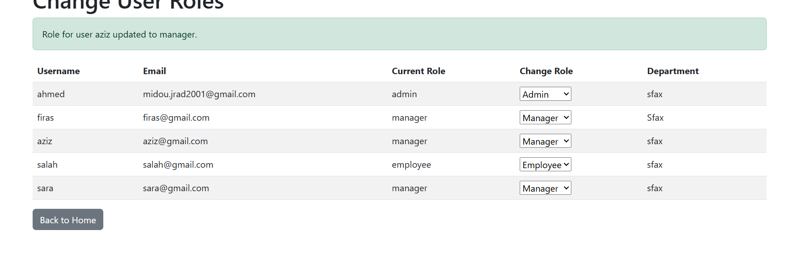
Figure 14 ; Success change user role interface:

Conclusion:

This sprint established core user management features. Users can now register, log in, and access role-specific dashboards. Admins have secure access to manage user roles. These features lay the foundation for secure access and personalized experiences.

Chapiter 4: Sprint 2:

Vehicle & Driver Management

Introduction:
For Sprint 1, titled " Vehicle & Entities ", we will focus on implementing the essential functionalities that allow users to engage with our platform in a meaningful way.

Sprint2 Back Log:
Table 11 ;Sprint2 Back Log
- User Story | Tasks | Duration
As a manager, I can add, edit, and delete Drivers. | - Design Driver form (UI) | 4 days
 | - Implement Driver model
 | - Create views for add/edit/delete
As a manager, I can add new vehicles | - Design Fuel Card form (UI) | 5 Days
 | - Implement Fuel Card model & Fuel Card Type
 | - Create views (add/edit/delete)- Implement vehicle addition logic
 | - Link cards to departments
 | - Fuel balance validation
As a manager, I can add, edit, and delete Vehicles. | - Design Vehicle form (UI) | 6 Days
 | - Implement Vehicle model
 | - Create views (add/edit/delete)
 | - Validate assignments (card, tracker, etc.)

Analysis and Requirements Specifications:

Use Case Diagram:
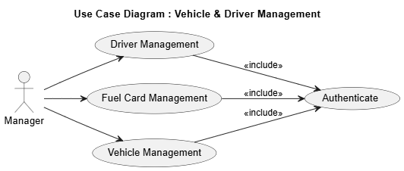
Figure 15 ; Case Diagram

textual description:

Textual description of the use case” Manage Drivers”
Table 12 :Textual description
Use case | Manage Drivers
Actors | Manager
precondition | The manager must be authenticated and authorized to access the driver management interface.
Post condition | A driver is successfully added, edited, or deleted in the system.
Nominal Scenario | 1- Manager logs into the system.  2- Manager navigates to the Driver Management page.  3- Manager selects an action: Add, Edit, or Delete a driver.  4- For Add/Edit: Manager fills in driver information and submits the form.  5- System saves the changes and displays a success message.  6- Updated driver data is reflected in the list view.
Exceptions | E1: Unauthorized access → Redirect to the manager dashboard with an "Access Denied" message.

Textual description of the use case” Manage Fuel Cards”
Table 13 : Textual description
Use case | Manage Fuel Cards
Actors | Manager
precondition | The manager must be authenticated and authorized to access fuel card management.
Post condition | A fuel card is added, updated, deleted, or linked successfully to departments or vehicles.
Nominal Scenario | 1- Manager logs into the system.  2- Manager navigates to the Fuel Card Management interface.  3- Manager chooses to add, edit, or delete a fuel card.  4- For Add/Edit: Manager inputs fuel card details (type, balance, department).  5- System validates inputs and saves the record.  6- Fuel card appears in the assigned department or vehicle view.
Exceptions | E1: Unauthorized access → Redirect to the user’s dashboard

Textual description of the use case” Vehicle management”:
Table 14 :Textual description of the use case
Use case | Vehicles management
Actors | Manager
precondition | -The manager is authenticated and authorized to access the vehicles management interface.
Post condition | -The new vehicle data is stored in the database.  -A confirmation or error message is displayed to the user.
Nominal Scenario | 1- The manager logs in using the login page.  2- The system validates the credentials and redirects the manager to their dashboard.  3- The manager navigates to the “Add Vehicle” section.  4- The system displays a vehicle entry form.  5- The manager enters required details  6- The manager submits the form.  7- The system validates the inputs.  8- If valid, the data is saved to the database and a success message is shown.  9- If invalid, the system displays appropriate error messages.
Exceptions | E1: Missing or invalid form data → Show specific validation errors.  E2: Unauthorized access → Redirect to the user’s dashboard

Class Diagrams of Sprint 2:

Class Diagram:
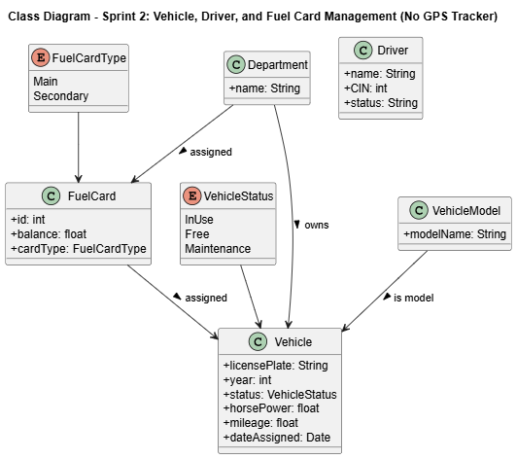
Figure 16 ;Class Diagrams of Sprint 2

Sequance Diagrame:
The sequence diagram illustrates the interactions between different objects in a scenario defined by a use case diagram.
To enhance understanding, the primary actor is placed on the left side of the diagram, while secondary actors and the system are positioned on the right.

sequence diagram “Vehicle Management”
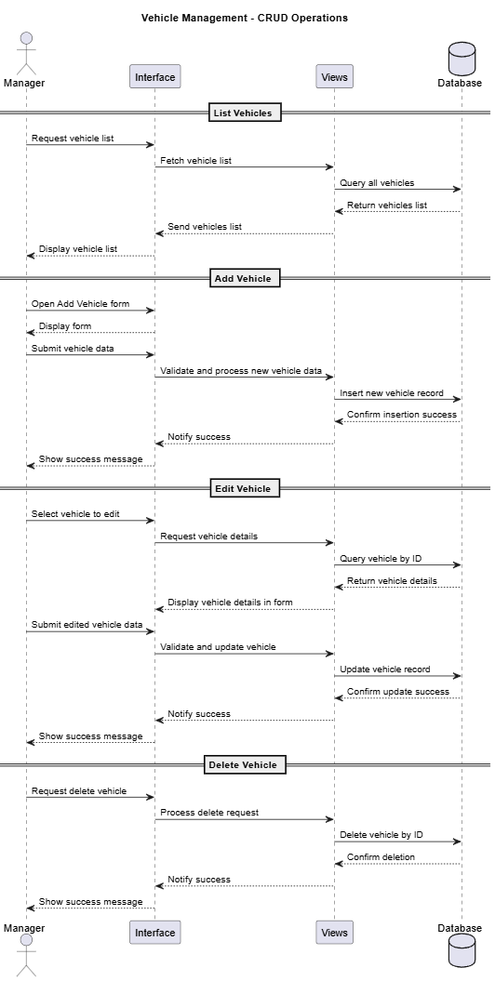
Figure 17 ;sequence diagram “Vehicle Management

. sequence diagram “Driver Management”:
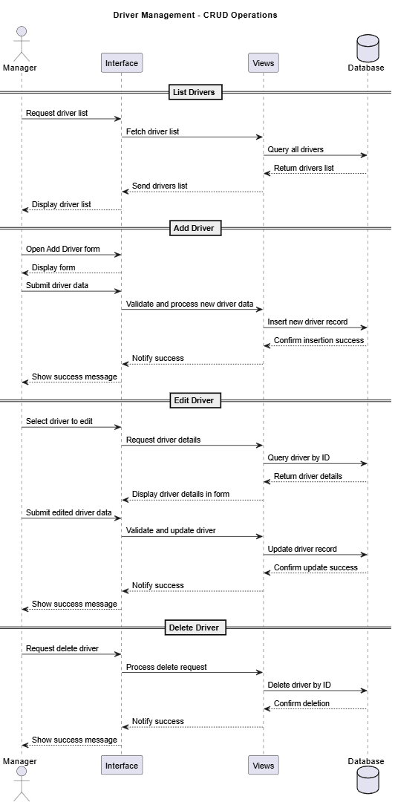
Figure 18 : sequence diagram “Driver Management

sequence diagram “Fuel Card Management”:
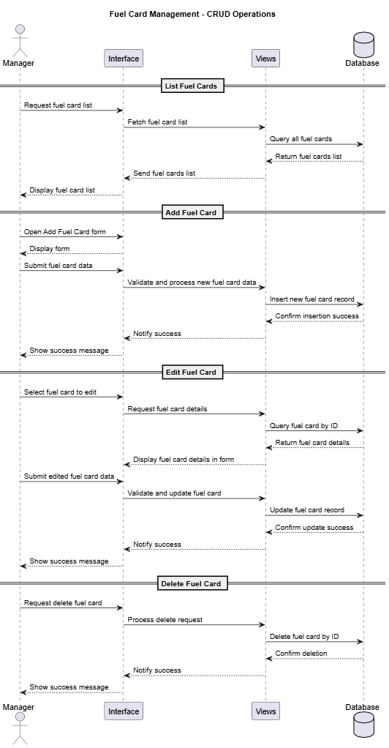
Figure 19 ; sequence diagram “Fuel Card Management

Conclusion:
The Vehicle, Driver, and Fuel Card Management modules provide comprehensive CRUD operations essential for managing a company’s fleet resources effectively. Each module allows the manager to list, add, edit, and delete records through a clear user interface that interacts with backend views and the database. This structured approach ensures data integrity, ease of maintenance, and seamless control over critical assets — enabling efficient operational workflows and reliable resource tracking within the system.

Chapiter 5: Sprint 3: Order management

Introduction:
For Sprint 1, titled " Order management ", we will focus on implementing the essential functionalities that allow users to engage with our platform in a meaningful way.

Sprint2 Back Log:
Table 15 ;Sprint2 Back Log
- User Story | Tasks | Duration
As an employee /manager, I can send a mission/service order | - Design UI for creating service orders | 5 days
 | - Design UI for creating mission orders
 | - Implement backend logic for submitting both types of orders
As a manager, I can manage mission/service order requests | - Design management interface for reviewing orders | 6 Days
 | - Implement approval/decline logic
 | - Allow manager to assign vehicle and fuel
 | - Update fuel card balance
As an employee, I can view the list of all my orders | - Create interface to list personal service/mission orders | 3 days

Analysis and Requirements Specifications:

Use Case Diagram:
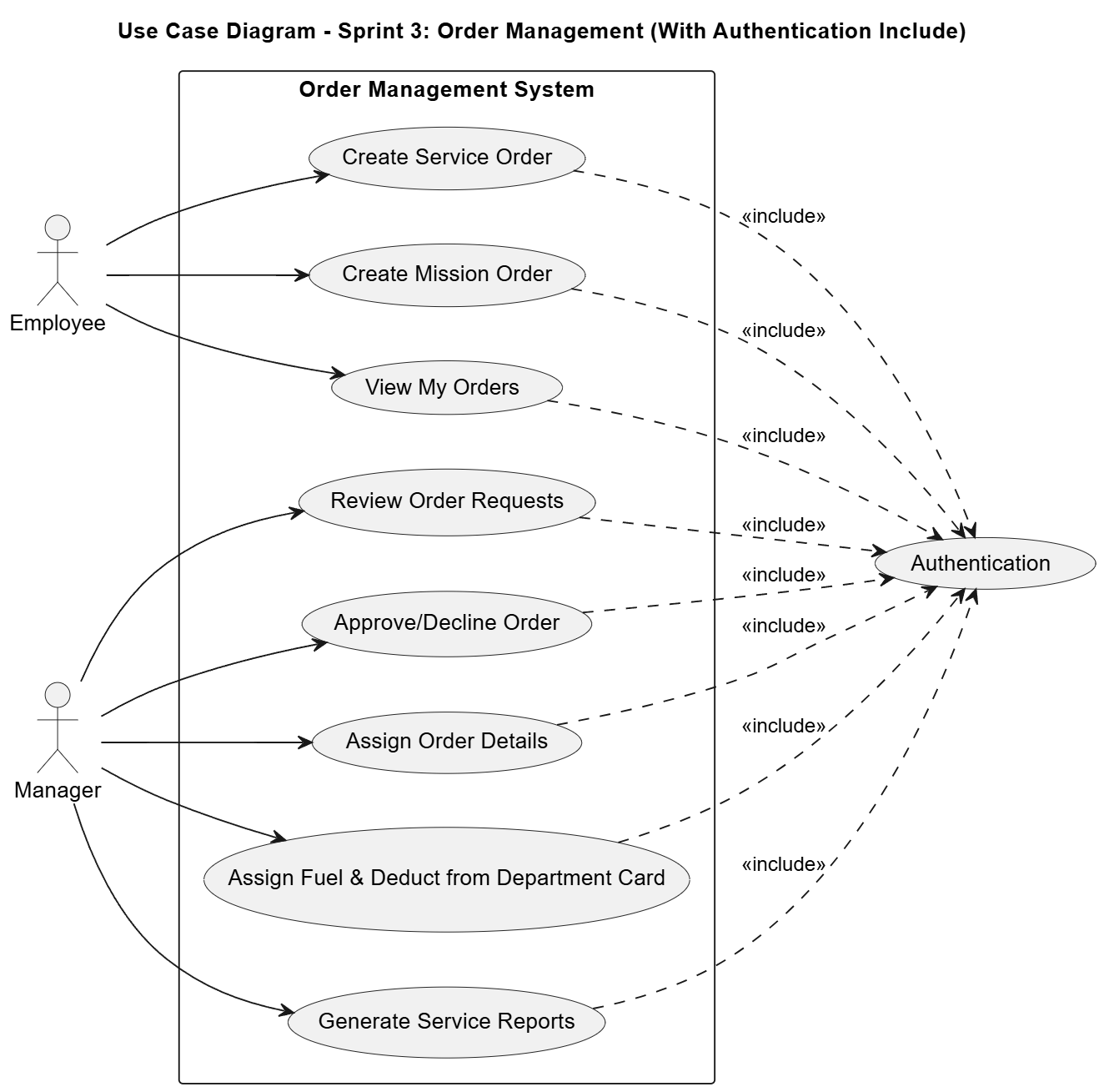
Figure 20 ;Use Case Diagram

textual description:

Textual description of the use case” order mission for employee”:
Table 16 : order mission for employee
Use case | order mission for employee
Actors | Employee
precondition | -The Employee is authenticated and authorized to access the Order mission interface.
Post condition | A new mission order is recorded in the system with all provided details.
Nominal Scenario | 1- Employee opens the “Order Mission” form.  2- Employee fills in the following details:  - Mission Date  - Going Date  - Coming Back Date  - Destination  - Motif (reason for mission)  - File (optional) (supporting document or attachment)  3- Employee submits the form.  4- System validates the data.  5- Mission order is saved successfully.  6- Employee receives confirmation of submission.
Exceptions | E1: Missing required fields: system prompts employee to complete them.  E2: Invalid date entries (e.g., coming back before going): system shows an error.  E3: File upload failure: employee is notified but can submit without the file.

Textual description of the use case” order Service for employee”:
Table 17 : order Service for employee
Use case | order Service for employee
Actors | Employee
precondition | -The Employee is authenticated and authorized to access the Order Services interface.
Post condition | A new service order is recorded in the system with all provided details.
Nominal Scenario | 1- Employee opens the “Order Service” form.  2- Employee provides the following details:  - Service Date  - Service Type  - Description  - File (optional)  3- Employee submits the service order request.  4- System checks for required fields and validates data.  5- The service request is saved in the system.  6- Employee receives confirmation that the service order was submitted.
Exceptions | E1: Missing required fields: system prompts employee to complete them.  E2: Invalid date entries (e.g., coming back before going): system shows an error.  E3: File upload failure: employee is notified but can submit without the file.

Textual description of the use case” order Service for Manager”:
Table 18 : order Service for Manager
Use case | order Service for Manager
Actors | Manager
precondition | -The Manager is authenticated and authorized to access the Order Services interface.
Post condition | A new service order is recorded in the system with all provided details.
Nominal Scenario | 1- Manager opens the “Order Service” form.  2- Employee provides the following details:  - Service Date  - Vehicle  - Service Type  - Motif  - Destination  - Driver  - Fuel amount  - File (optional)  3- Employee submits the service order request.  4- System checks for required fields and validates data.  5- The service request is saved in the system.  6- Employee receives confirmation that the service order was submitted.
Exceptions | E1: Missing required fields: system prompts employee to complete them.  E2: Invalid date entries (e.g., coming back before going): system shows an error.  E3: File upload failure: employee is notified but can submit without the file.

Textual description of the use case” mission Order Review”:
Table 19 ; mission Order Review
Use case | mission Order Review
Actors | Manager
precondition | The manager is logged into the system.  A mission order has been submitted by an employee and is awaiting review.
Post condition | The mission order is either accepted or denied (with status updated).
Nominal Scenario | 1- Manager opens the “Mission Orders requests” section.  2- Manager selects a mission order submitted by an employee.  3- The system displays all mission details:  - Mission Date  - Going Date  - Coming Back Date  - Destination  - Motif  - Attached file (if provided)  4- Manager chooses to either accept or deny the mission:  - If accepted:  - Manager selects the vehicle to be used.  - Manager specifies the fuel amount allocated.  - System updates mission status to "Accepted" and saves the vehicle and fuel info.  - If denied:  System updates mission status to "Denied".
Exceptions | E1: If required fields (vehicle, fuel) are missing when accepting: system prompts manager to complete them.  E2: If no available vehicle is found: manager is notified and cannot proceed with approval.  E3: If system fails to update status: error is shown and action is not completed.

Textual description of the use case” Service Order Review”:
Table 20 ; Service Order Review
Use case | mission Order Review
Actors | Manager
precondition | The manager is logged into the system.  A service order has been submitted by an employee and is awaiting review.  At least one available driver is registered in the system
Post condition | The service order is either accepted (with driver assigned) or denied (with status updated).
Nominal Scenario | 1-Manager accesses the “Pending Service Orders” section.  2-Manager selects a specific service order submitted by an employee.  3-The system displays all submitted service details, including:  - Service Date  - Vehicle concerned  - Service Type  - Description or Remarks  - Attached file (if any)  4-Manager chooses to either accept or deny the service request:  - If accepted:  - Manager selects a driver from the list of available drivers.  - System updates the service order with the assigned driver.  - Status of the service order is updated to “Accepted”.  - If denied:  - System updates the status to “Denied”.
Exceptions | E1: No available driver: system notifies the manager and prevents approval.  E2: Missing required fields (e.g., driver not selected): system prompts the manager.  E3: System failure during update: error message shown and action is rolled back.

Textual description of the use case” Service Order Review”:
Table 21 ; Service Order Review
Use case | mission Order Review
Actors | Manager
Precondition | The manager is logged into the system.  A service order has been submitted by an employee and is awaiting review.  At least one available driver is registered in the system
Post condition | The service order is either accepted (with driver assigned) or denied (with status updated).
Nominal Scenario | 1-Manager accesses the “Pending Service Orders” section.  2-Manager selects a specific service order submitted by an employee.  3-The system displays all submitted service details, including:  - Service Date  - Vehicle concerned  - Service Type  - Description or Remarks  - Attached file (if any)  4-Manager chooses to either accept or deny the service request:  - If accepted:  - Manager selects a driver from the list of available drivers.  - System updates the service order with the assigned driver.  - Status of the service order is updated to “Accepted”.  - If denied:  - System updates the status to “Denied”.
Exceptions | E1: No available driver: system notifies the manager and prevents approval.  E2: Missing required fields (e.g., driver not selected): system prompts the manager.  E3: System failure during update: error message shown and action is rolled back.

Class Diagrams:
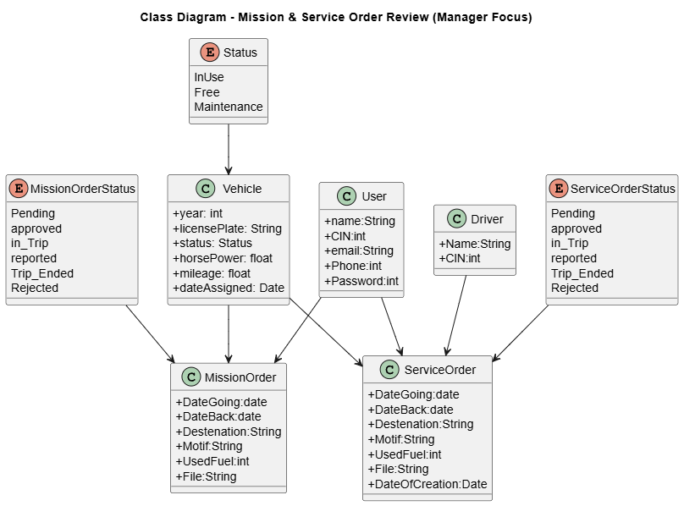
Figure 21 :Class Diagrams

Sequance Diagrame:
The sequence diagram illustrates the interactions between different objects in a scenario defined by a use case diagram.
To enhance understanding, the primary actor is placed on the left side of the diagram, while secondary actors and the system are positioned on the right.

sequence diagram “Employee submits a mission order”:
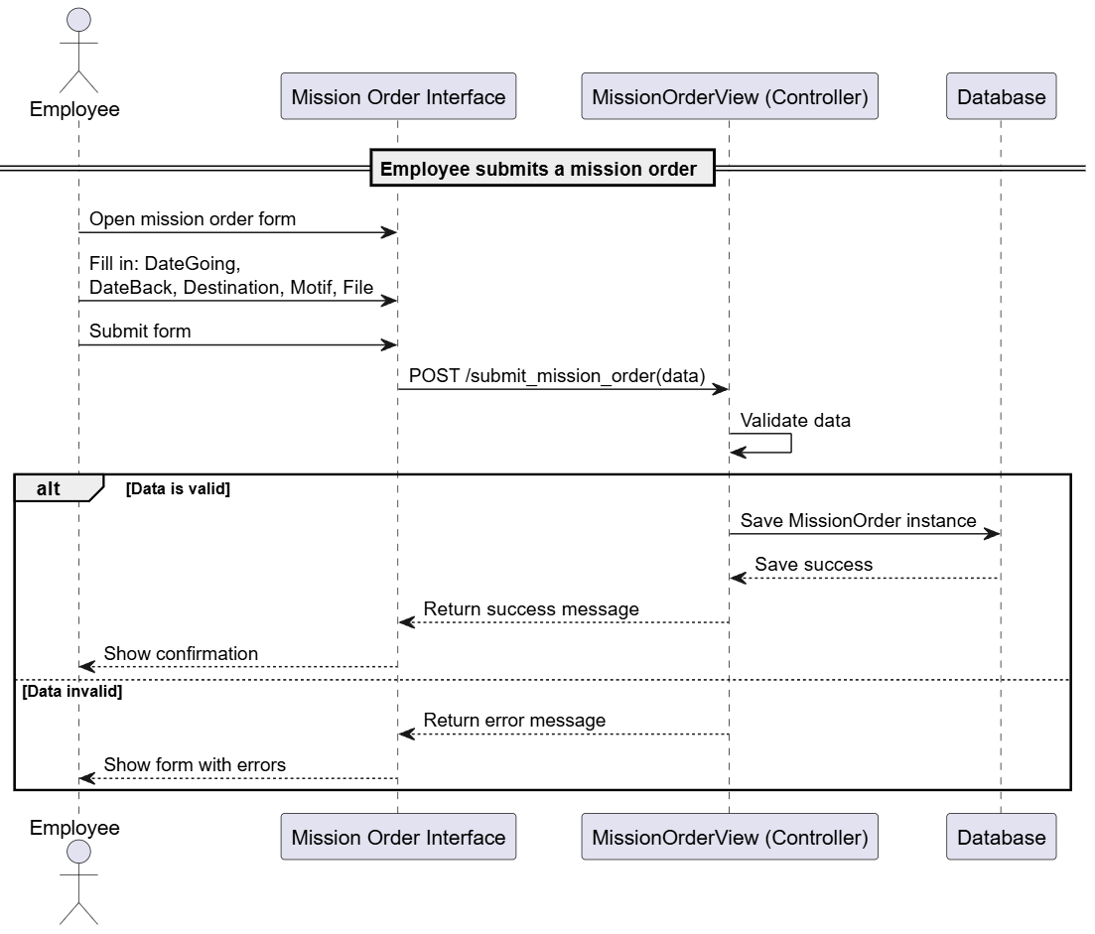
Figure 22 : Employee submits a mission order

sequence diagram “Employee submits a service order”:
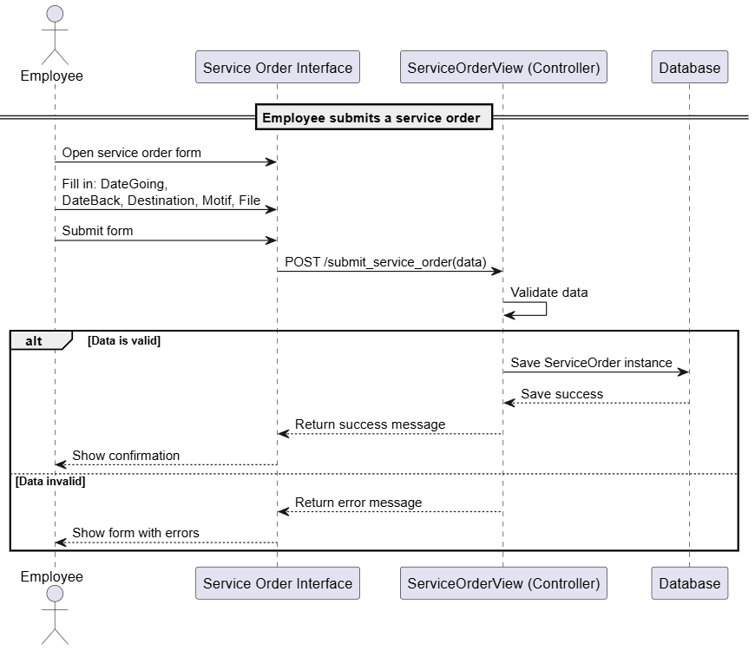
Figure 23 ; sequence diagram “Employee submits a service order

Sequence diagram “order Service review”:
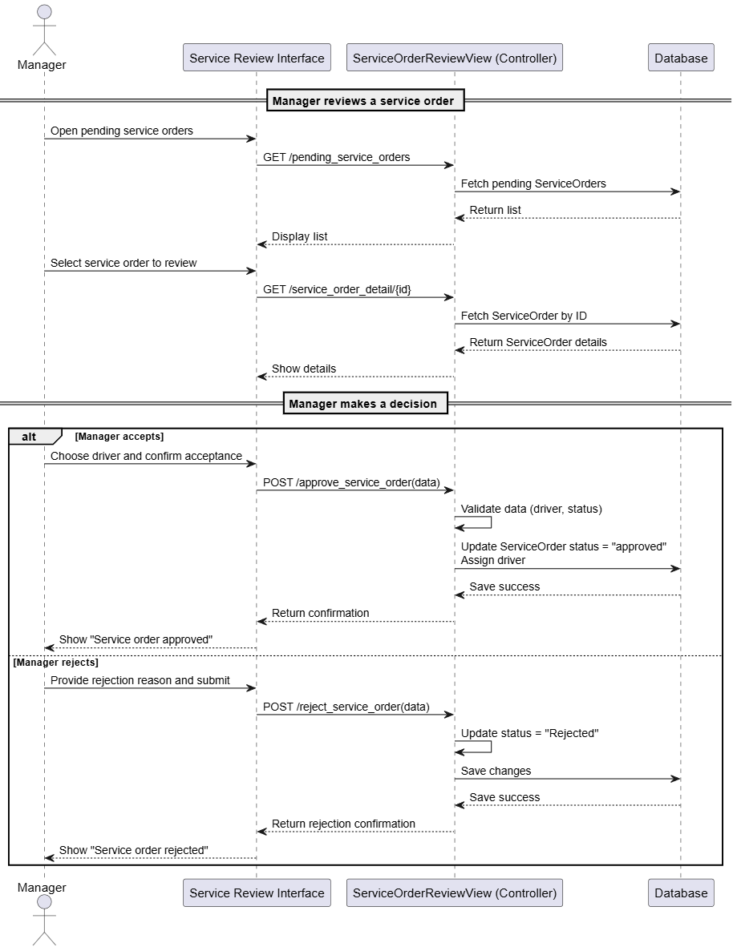
Figure 24 : order Service review

Sequence diagram “order mission for Manager”:
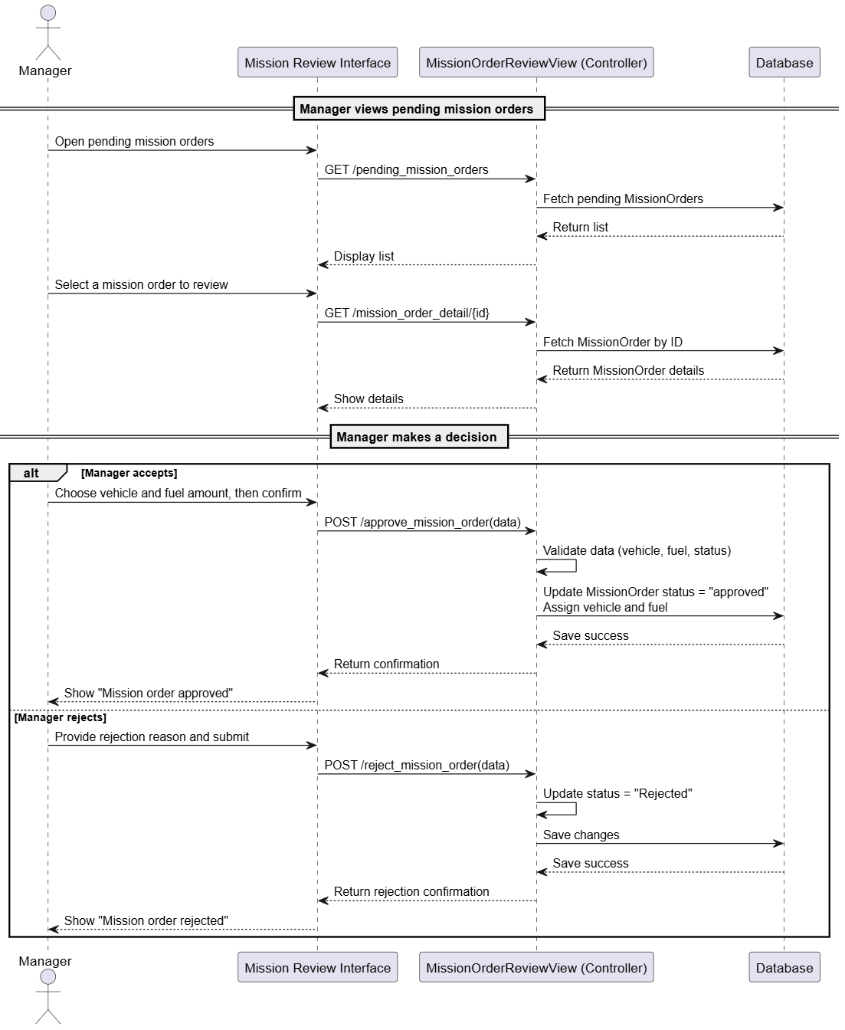
Figure 25 :Sequence diagram “order mission for Manager

Conclusion:
in this sprint, we implemented the core functionalities for managing mission and service orders. Employees can now easily submit requests for missions and services, while managers can review, approve, or reject these requests with the ability to assign necessary resources like vehicles, fuel, and drivers. This enhances the workflow automation and ensures better tracking and control over company operations.

Chapiter 6: Sprint 4: Reporting System

Introduction:
For Sprint 1, titled "User Management", we will focus on implementing the essential functionalities that allow users to engage with our platform in a meaningful way.

Sprint 1 Backlog:
Table 22:Sprint 1 Backlog
User Story | Tasks | Duration
As an employee, I can report my mission. | - Design mission report submission UI | 6days
 | - Implement backend endpoint for submitting reports
 | - Validate and store reports
 | - Allow report editing before validation
As a manager, I can manage reports for all orders | - Create reports dashboard | 7 days
 | - Add filter/sort/search features
 | - Review and validate reports
 | - Show confirmation or error messages
Update the system with necessary follow-ups | - Auto-generate follow-up actions | 8 days
 | - Integrate status updates
 | - integrate follow up for when there is an issue
 | - Restrict access to unauthorized sections

Analysis and Requirements Specifications:

Use Case Diagram:
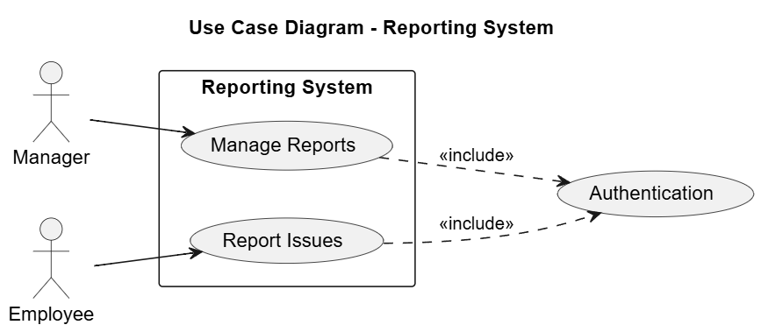
Figure 26 ;Use Case Diagram:

textual description: Textual description of the use case” submit report”
Table 23 : textual description: Textual description of the use case” submit report
Use case | Submit Report
Actors | Employee
precondition | -Employee is authenticated and authorized to submit reports.  -The mission or service order exists and is assigned to the employee.
Post condition | -The report is saved in the system with status Pending.  -Manager is notified of the new report.
Nominal Scenario | 1-Employee logs into the system.  2-Navigates to the "Report Issue" section.  3-Fills in the report details (description, mileage, issue status).  4-Submits the report.  5-System validates and stores the report, changing its status to Pending.  6-Notification sent to the manager for review.
Exceptions | E1: Report submission fails due to missing required fields.  E2: Employee tries to report on a mission/service not assigned to them.

Textual description of the use case” Registration”
Table 24: Textual description of the use case” Registration
Use case | Registration
Actors | Manager
precondition | Manager is authenticated and has appropriate permissions.
Post condition | -Reports status updated to Approved, altered, or remain Pending based on manager action.  - a follow up for maintenance
Nominal Scenario | 1- Manager logs into the system.  2- Opens the reports dashboard.  3- Filters and reviews submitted reports.  4- Selects a report for detailed view.  5- Approves, rejects, or requests clarification on the report.  6- System updates the report status accordingly and notifies the employee.
Exceptions | E1: - Email/CIN already in use → display appropriate error  E2: - Weak password → prompt user to strengthen it  E3: - Form not filled properly → highlight missing/invalid fields

Class Diagram of Sprint 1:
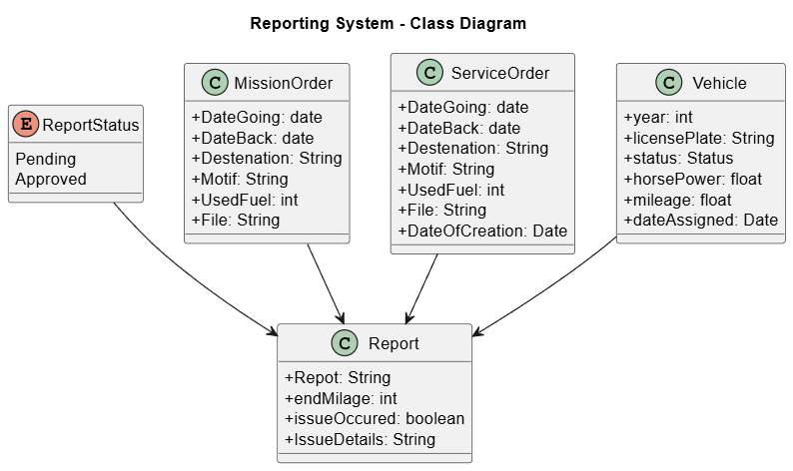
Figure 27 ; Class Diagram of Sprint 1

Squance Diagrame:
The sequence diagram illustrates the interactions between different objects in a scenario defined by a use case diagram.
To enhance understanding, the primary actor is placed on the left side of the diagram, while secondary actors and the system are positioned on the right.

Sequence diagram (Report summation):
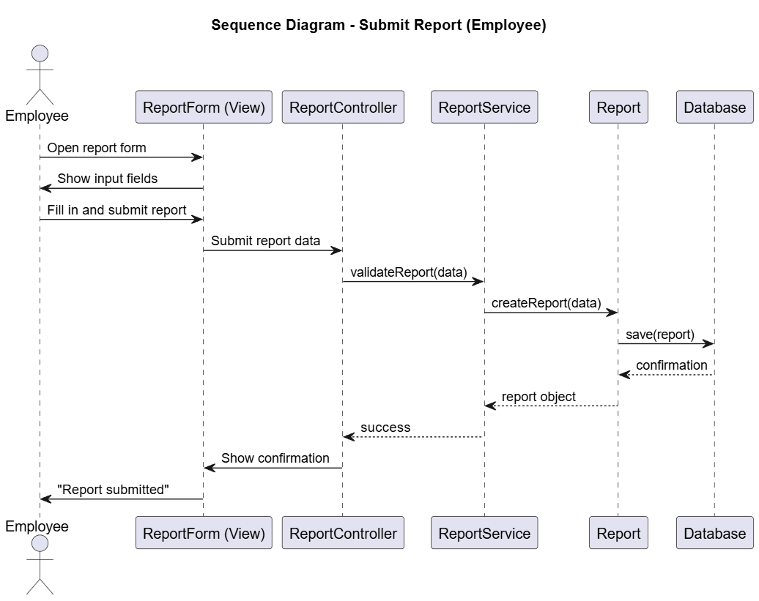
Figure 28 ; Sequence diagram (Report summation):

Sequence diagram (manage reports):
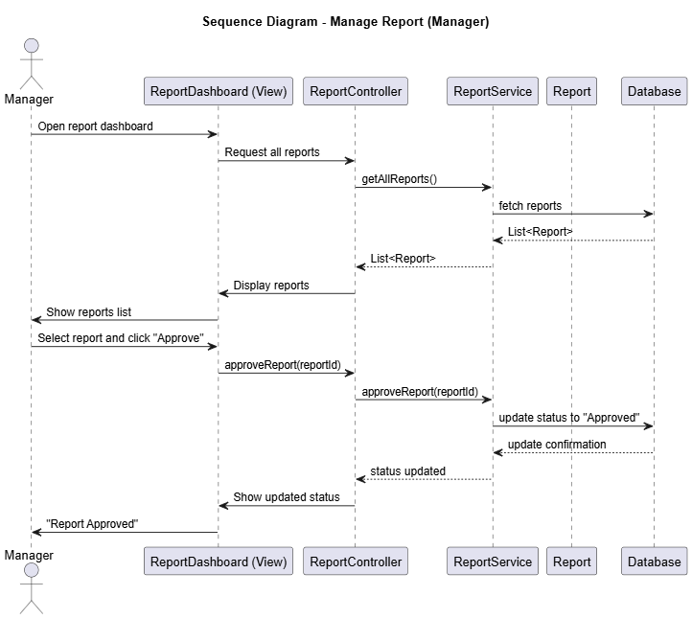
Figure 29 ; Sequence diagram (manage reports)

Conclusion:
Sprint 4 delivered a complete reporting system. Employees can now submit mission and service reports, while managers can review and manage them through a dashboard. Authentication ensures secure access. The system is ready for real use and future enhancements.

Chapiter 7: Sprint 5: Maintenance System

Introduction:
For Sprint 1, titled "User Management", we will focus on implementing the essential functionalities that allow users to engage with our platform in a meaningful way.

Sprint 1 Backlog:
Table 25 : Sprint 1 Backlog
User Story | Tasks | Duration
As a manager, I can track Periodic Maintenance | - Design periodic maintenance form (UI) | 5days
 | - Implement Periodic Maintenance model
 | - Create views for adding/editing maintenance records
 | - Link maintenance with vehicle and mileage tracking
As a manager, I can get notifications about Periodic Maintenance | - Define notification rules (e.g., mileage thresholds)  - Create Notification model | 4 days
 | - Implement background check
 | - Display alerts or upcoming maintenance in manager dashboard
As a manager, I can manage Accidental Maintenance | - Design accidental maintenance form (UI)  - Implement Accident Maintenance model | 4 days
 | - Create views for submitting and tracking accident records

Analysis and Requirements Specifications:

Use Case Diagram:
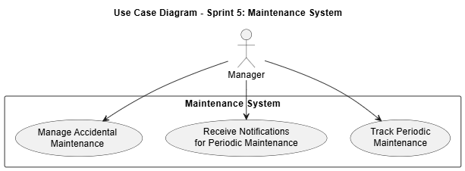
Figure 30 :Use Case Diagram

textual description:

Textual description of the use case”Track Periodic Maintenance”
Table 26 : Track Periodic Maintenance
Use case | Track Periodic Maintenance
Actors | Manager
precondition | - The vehicle exists in the system with an associated mileage record.
Post condition | A periodic maintenance entry is stored and linked to the corresponding vehicle.
Nominal Scenario | 1- Manager logs in.  2- Opens the maintenance section.  3- Selects a vehicle.  4- Adds or edits a periodic maintenance entry (type, mileage/date).  5- Saves the record.
Exceptions | E1: Vehicle not found.  E2: Mileage data not up-to-date.  E3: Form validation errors

Textual description of the use case” Receive Notifications for Periodic Maintenance”
Table 27 : Receive Notifications for Periodic Maintenance
Use case | Receive Notifications for Periodic Maintenance
Actors | Manager
precondition | Periodic maintenance rules (e.g., mileage threshold or date) have been defined.
Post condition | Notification appears when the condition is met
Nominal Scenario | 1- System runs a scheduled check .  2- Finds vehicles nearing maintenance thresholds.  3- Sends alert to the dashboard or email.
Exceptions | E1: Notification model is not set up correctly.  E2: Vehicle mileage not updated recently.

Textual description of the use case” Manage Accidental Maintenance”
Table 28 : Manage Accidental Maintenance
Use case | Manage Accidental Maintenance
Actors | Manager
precondition | An accident involving a company vehicle occurred.
Post condition | An accidental maintenance record is created and viewable in the system.
Nominal Scenario | 1- Manager logs in.  2- Navigates to the accident maintenance section.  3- Adds a report (vehicle, date, description, repair cost, etc.).  4- Submits the form.
Exceptions | E1: Incomplete form submission.  E2: Vehicle not found or already archived.  E3: Invalid input.

Class Diagram of Sprint 1:
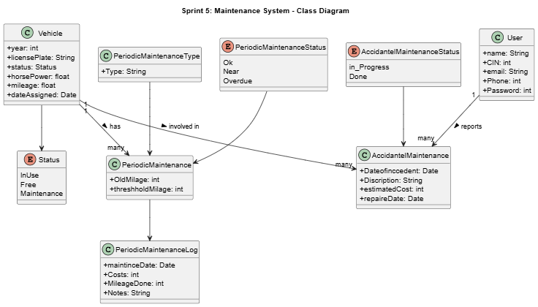
Figure 31 : Class Diagram of Sprint 1

Squance Diagrame:
The sequence diagram illustrates the interactions between different objects in a scenario defined by a use case diagram.
To enhance understanding, the primary actor is placed on the left side of the diagram, while secondary actors and the system are positioned on the right.

Sequence diagram (track periodic maintenance):
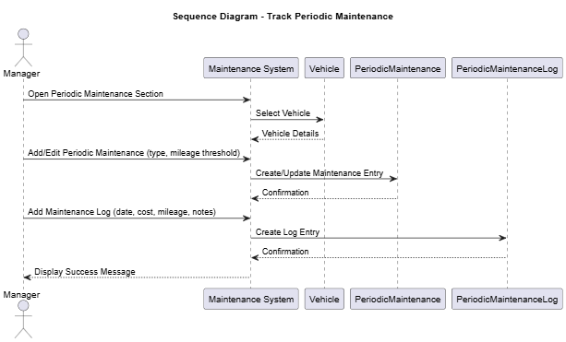
Figure 32 : Sequence diagram (track periodic maintenance)

Sequence diagram (Notifications for Periodic Maintenance):
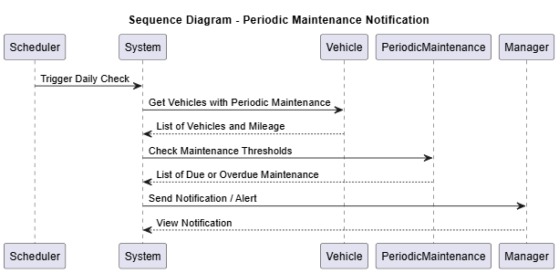
Figure 33:Sequence diagram (Notifications for Periodic Maintenance)

Sequence diagram (Manage Accidental Maintenance):
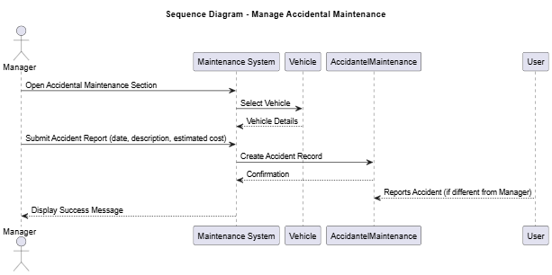

Conclusion:

This sprint successfully delivered a robust Maintenance System for managing both periodic and accidental vehicle maintenance. Managers can now efficiently track scheduled maintenance tasks, log repair details, and receive timely notifications for upcoming services. These enhancements promote proactive vehicle care, reduce downtime, and improve overall fleet management.

General Project Conclusion

This project delivers a comprehensive vehicle management system designed to streamline the administration of company vehicles. Key features include vehicle assignment and tracking, mission and service order management, fuel card control, driver and user administration, as well as a robust maintenance module covering both periodic and accidental repairs.
By integrating these functionalities into a unified platform, the system enhances operational efficiency, improves data accuracy, and provides managers with clear visibility over vehicle status and usage. Automated notifications and detailed reporting further support proactive decision-making, reducing downtime and maintenance costs.
Overall, the project successfully addresses the challenges of manual vehicle management, delivering a scalable and user-friendly solution that optimizes fleet performance and supports organizational goals.

Bibliography

[1] Django,2025 https://www.djangoproject.com/
[2] GCT, Tunisa,2025 http://www.gct.com.tn/accueil/
[3] PlantUML,2025 http://plantuml.com/
[4] Stack,2025 https://stackoverflow.com/
[5] bootstarp,2025 https://getbootstrap.com/docs/5.0/getting-started/introduction/

Tunisien Republic
Ministry of Higher Education and Scientific Research
General Directorate of Technological Studies
Higher Institute of Technological Studies of Sfax
IT Department
DESIGN AND IMPLEMENTATION OF A VHICULE MANAGEMENT

DEVELOPED BY:

- First and last name: Ahmed Jrad
Group: DSI33
Company:

« Groupe chimique tunisien »
Adress: Route de Gabès, Km 3.5, 3000 Sfax, Tunisia
Phone : +216 75 271 800
Web site: http://www.gct.com.tn/accueil/
E-mail : cpg.gafsa@cpg.com.tn

ABSTRACT
This report presents the detailed development of a comprehensive Vehicle Management System, designed to streamline the tracking and administration of company vehicles and their related operations. Created as part of an end-of-studies internship project, this web-based solution facilitates efficient management of vehicle assignments, driver information, fuel consumption, maintenance schedules, and service orders. Built on the robust Django framework, the system offers a user-friendly interface for managers and employees to access and update vehicle data securely. Leveraging Django’s powerful backend capabilities alongside a PostgreSQL database, the platform improves operational efficiency, enhances data accuracy, and centralizes vehicle-related processes within a single integrated digital environment. ecosystem.
Keywords:
Vehicle Management, Fleet Tracking, Driver Management, Maintenance Scheduling, Django, PostgreSQL, Web Application

