-Ministry of Higher Education and Scientific Research
Directorate-General for Technological Studies
Higher Institute of Technological Studies of Sfax
Department of Studies and Internships
IT Technology Department


Academic year: 2025 /2026

END OF STUDIES INTERNSHIP
In order to obtain the diploma of degree in computer technology
Option: Development of Information Systems (DSI)

Entitled

Design and implementation of a veterinary platform with teleconsultation

Developed by:
Nebras Mahmoudi and Yasmin dhifaoui

Company: ContinuousNet
Presented on 17/06/2025 in front of the jury commission
Mrs. | ANWAAR BOUKETTAYA | President
Mr. | NISSEN MASMOUDI | Rapporteur
Mr. | MOHAMED ELLEUCH | Supervisor (ISET)
Mr. | AHMED DJMAL | Supervisor (ISET)
Mrs. | ILHEM AZAIEZ | Supervisor (Company)

Dedication

I dedicate this work to the people who stood by me throughout this journey.
To my family, thank you for your endless love, encouragement, and support. Your belief in me gave me the strength to keep going, even during the most challenging times.
To my friends, thank you for the laughter, motivation, and all the moments of relief you brought into this demanding journey. Your presence made the hard days easier and the good days even better.
Last but not least, I want to thank me. I want to thank me for believing in me. I want to thank me for doing all this hard work, for trusting the process, and for never giving up when challenges came my way.

Dedication

Special Thanks

First of all, we would like to express our sincere gratitude to our supervisors at the Higher Institute of Technological Studies of Sfax, Mr. Mohamed Elleuch and Mr. Mohamed Djmal, for their valuable support and guidance throughout our internship.
We would also like to thank Mrs. Ilhem Azaiez, our company supervisor, for entrusting us with the realization of this project and for the time and effort she dedicated to guid us through the entire project .
Our thanks also go to the faculty of ISET, especially the computer technologies department, for the knowledge and expertise shared during our academic journey.
Finally, We extend our most sincere and respectful thanks to the members of the jury for taking the time to evaluate our humble work.

Summary

General Introduction 1
CHAPTER1: PRELIMINARY STUDY 2
I. Presentation of the host organization 3
1. Presentation of ContinuousNet 3
2. Field of Activity: 3
II. Project Presentation 4
1. Study and Critique of the Existing System 4
2. Objectives 5
3. Proposed solution 5
CHAPTER 2 : ANALYSIS AND SPECIFICATION NEEDS 7
I. Platform User Overview 8
II. Requirements Identification 8
1. Functional requirements 8
2. Non-functional requirements 9
III. Methodology used 10
1. Agile Scrum Methodology 10
2. Team composition 10
3. Key Scrum Events 10
IV. Breakdown of the project 11
1. Project Team 11
2. Product Backlog 11
V. Sprint planning 12
CHAPTER 3: SPRINT 0: Software Architecture and Development Framework 15
I. Backlog Sprint 0 16
II. Architectural view of the system 16
1. Overall System Architecture (4-Tier Model) 16
II. Backend Architecture (C# .NET Web API - 3-Tier) 18
1. Controllers (API Endpoints) 18
2. Services / Business Logic Layer 18
3. Repositories / Data Access Layer 18
4. Models (Entities / DTOs) 19
III. Frontend Architecture (High-Level) 19
5. Angular (Web Frontend) 19
6. Flutter (Mobile Frontend) 19
III. Developer Tools Overview 20
1. Hardware Environment 20
2. Software environment 20
CHAPTER 4: SPRINT 1: Authentication and Profiles 23
III. Backlog sprint 24
IV. Requirements Specification 25
2. Use Case Diagram 25
3. Text description of key use cases 25
4. Data dictionaries 29
5. Class Diagram 31
6. Sequence diagrams 33
V. Realization 37
1. Web Part (Admin Dashboard) 37
7. Mobile Part (Flutter App – Client / Veterinarian) 40
IV. Security and performance 46
1. Security Improvements 46
8. Performance Enhancements 47
VI. Test of validation sprint 1 47
CHAPTER 5: SPRINT 2: Appointment and Consultation Scheduling 50
I. Sprint backlog 51
II. Requirements Specification 53
1. Use Case Diagram 53
9. Text description of the use case 53
10. Class diagram 59
11. Sequence diagrams 60
III. Realization 64
1. Web part (Admin Dashboard) 64
12. Mobile Part (flutter App client/ Veterinarian) 66
IV. Test of validation sprint 2 68
CHAPTER 6: SPRINT 3: Messaging and Teleconsultation 70
I. Backlog du Sprint 71
II. Requirements Specification 72
1. Use case diagram 72
13. Text description of the use case 72
14. Sequence Diagram 75
III. Realization 77
1. Client Mobile Application 78
15. Veterinarian Mobile Application 79
IV. Validation Tests for Sprint 2 80
CHAPTER 7: SPRINT 4: Notifications 82

List of figures

Figure 1:logo of ContinuousNet 12
Figure 2:scrum Methodology 19
Figure 3:JWT Authentication Process Erreur ! Signet non défini.
Figure 4:Deployment Architecture 26
Figure 5: Visual Studio Code logo 29
Figure 6:Visual Studio Code logo 29
Figure 7: Logo de StarUML 30
Figure 8: Postman Logo 30
Figure 9: GitHub logo 30
Figure 10: Microsoft Word Logo 30
Figure 11:first sprint use case diagram 34
Figure 12:class diagram of first sprint 41
Figure 13:The sequence diagram for the "register" use case 42
Figure 14:sequence diagram for the " log in" use case 43
Figure 15:sequence diagram for the "Update Profile Data" use case 44
Figure 16:sequence diagram for the " Recover Password" use case 45
Figure 17:sequence diagram for the "Create Animal Profile" use case 46
Figure 18:admin authentication 47
Figure 19:verification 47
Figure 20:Admin Registration Interface 48
Figure 21:Admin Dashboard Interface 48
Figure 22:Admin Profile Editing Interface 49
Figure 23:Client App – Welcome Screen 50
Figure 24:Client App – Registration Interface 50
Figure 25:login and verify login screen 51
Figure 26:home screen 52
Figure 27:main page 52
Figure 28:register and verify screen 53
Figure 29:login and verify screen 54
Figure 30:home screen 55
Figure 31:class diagram 69
Figure 32:sequence diagram for the "book appointment" use case 70
Figure 33:The sequence diagram for the " View Vaccination History" use case 71
Figure 34:The sequence diagram for the "create consultation " use case 72
Figure 35:The sequence diagram for the " Edit Appointment Status" use case 73
Figure 36:appointments 74
Figure 37:add an appointment 74
Figure 38:book appointment 75
Figure 39:Appointments 76
Figure 40:vaccination per pet 76
Figure 41:use case diagram 81
Figure 42:sequence diagram for the " send Message " use case 85
Figure 43:sequence diagram for the " Start Teleconsultation Video Call " use case 86
Figure 44:send and receive messages 87

List of tables

General Introduction

Our project titled "Online Veterinary Services Platform: A Step Towards Digital Pet Healthcare" addresses the challenges faced in modern veterinary care, including difficulties in booking appointments, limited telemedicine access, and poor medical record management. Traditional clinics often fall short in offering the convenience expected by today’s clients.
This project plans an extensive digital platform which includes, a website-based admin panel, and two mobile apps for both vets and owners of pets. The platform intends to facilitate appointment scheduling, virtual consultations and access medical.
Key features include:
- Secure pet owner profile and medical history management
- Online appointment booking and modification
- Telemedicine with video consultations and messaging
- Medical record for each pet
This solution targets pet owners, veterinarians, and administrators, aiming to modernize pet healthcare and improve efficiency across the board.

CHAPTER1: PRELIMINARY STUDY

Introduction
The purpose of this first chapter is to analyze the host organization in detail, provide a critique of the current state, and provide context and goals for the application. Finally, the proposed solution will be justified.

Presentation of the host organization

Presentation of ContinuousNet
Founded in 2015, ContinuousNet is a regional player in the IT sector, providing competitive expertise, services, and tailor-made solutions to its clients in North Africa, Europe, and the Middle East through its various entities based in Tunisia, France, and Algeria. ContinuousNet relies on experienced, innovative, and multilingual teams with diverse technical expertise. The ContinuousNet teams have built their expertise in implementing high-performing IT strategies to successfully carry out various types of client projects. ContinuousNet builds its client relationships on attentive listening and responsiveness to tailor its solutions to the clients' needs.

Field of Activity:
ContinuousNet specializes in enterprise solutions, mobile applications, e-commerce solutions, embedded industrial applications, connected objects (IoT), social networks, and content management systems.
- Company Profile:
- Main Activity: Development of web and mobile applications
- Phone / Fax: (+216) 31 516 061
- Email: sahbi.khalfallah@continuousnet.com
- Postal Address: Avenue Yasser Arafat, Residence El Ahmed, Bloc B, Office No. 26, Sahloul 4072 – Sousse
- Website: https://www.continuousnet.com
- Legal Status: S.A.R.L. (Limited Liability Company)
- Date of Establishment: 20/02/2015


Figure 1:logo of ContinuousNet
Founded in 2015, ContinuousNet is a regional player in the IT sector, providing competitive expertise, services, and tailor-made solutions to its clients in North Africa, Europe, and the Middle East through its various partners based in Tunisia, France, Algeria, and the United Arab Emirates.
ContinuousNet specializes in enterprise solutions, mobile applications, e-commerce solutions, embedded industrial applications, connected objects (IoT), social networks, and content management systems.

Project Presentation

Study and Critique of the Existing System
Analyzing existing online veterinary service platforms is crucial to understanding the current digital pet-care ecosystem, identifying their strengths, weaknesses, and gaps that need improvement. In this context, we examine two key examples: Tobba.tn (A general medical platform with veterinary features) and FirstVet (a global telemedicine leader for pets).

a. Tobba.tn
Tobba.tn is a Tunisian platform offering remote veterinary consultations, pet health advice, and e-pharmacy services. However, it faces several critical limitations:
- Limited functionality (basic teleconsultations without AI-driven tools like symptom checkers).
- Outdated UX/UI design (non-intuitive interface, poor mobile optimisation).
- Low engagement (minimal interactive features for pet communities or follow-up care).
- Lack of trust signals (no transparent vet verification or user reviews).
- Slow admin responsiveness (delays in resolving technical/user issues).
These weaknesses hinder its potential as a comprehensive pet-care solution.

b. FirstVet
FirstVet (popular in the EU/US) is a subscription-based telemedicine platform with advanced features:
- 24/7 video consultations with licensed vets.
- AI triage tools (pre-consultation symptom assessment).
- EHR integration (digital pet health records).
- Partnerships with pet insurers for seamless payments.
But it also has drawbacks:
- High cost (subscription model excludes budget-conscious users).
- Limited emerging-market reach (focus on Western countries).
- Impersonal care (less emphasis on long-term vet-pet relationships).

Objectives
Developing comprehensive online veterinary platform that enables pet owners to access remote healthcare services for their animals through an integrated digital solution. The system will feature pet profile management with medical history tracking, online appointment scheduling, secure video consultations, e-prescriptions with an integrated pharmacy. Designed as a multi-platform solution, it will include a web admin panel, mobile apps for veterinarians and pet owners

Proposed solution
Following our analysis of existing veterinary platforms, we propose developing a comprehensive, user-centric online veterinary service platform to address current market gaps. Our solution will offer a complete ecosystem for pet healthcare, featuring: a three-tier system with an admin web portal for management, a vet-facing mobile app for consultations, and a pet owner app for seamless service access. The platform will integrate core functionalities including digital pet profiles with medical history tracking, appointment scheduling, secure video consultations (WebRTC), and automated health reminders. Distinct from generalist platforms like Tobba.tn, our specialized solution will bridge critical gaps in veterinary telemedicine by combining clinical utility with consumer-grade UX

Conclusion
In this chapter, we introduced the host organization and conducted a thorough analysis of the existing veterinary service platforms, identifying their strengths and limitations. Based on this evaluation, we presented our proposed solution, user-friendly platform designed to enhance remote veterinary care. The next chapter will focus on requirements engineering, where we will define both the functional and non-functional specifications of our application to ensure it meets all stakeholder needs effectively.

CHAPTER 2: ANALYSIS AND SPECIFICATION NEEDS

Introduction

The requirements analysis process is a critical phase of the development life-cycle for the Online Veterinary Services Platform. It will help to define the critical functional and non-functional requirements of the platform, along with the key stakeholders on the project (from pet owners to veterinarians to administrators). This step in the development process will also help to identify our focus users, key users and their interactions. In this chapter we will list out the required functionalities of the online platform along with their security, performance and regulatory requirements. We will also present the necessary non-functional requirements of the platform such as data security, system performance and regulatory compliance. This chapter will help us to organize the product backlog and establish timeframes for the development of the solution. This step in the development of life cycle will help us ensure that our solution provides a comprehensive and effective solution to current service lacks while remaining flexible, user-centric and innovative in its design.

Platform User Overview
The primary users of our veterinary services platform include:
- Administrator (Manages platform settings, users, and analytics)
- Veterinarian (Provides consultations, manages medical records)
- Pet Owner (Books appointments, accesses pet health data)

Requirements Identification

Functional requirements
Our system will enable the following functionalities:

Administrator

- Register & authenticate
- Configure platform settings
- Monitor system analytics & reports
- Oversee appointment scheduling
- Veterinarian
- Authenticate securely
- View & manage appointments
- Conduct video consultations
- Update pet medical records
- Prescribe medications
- Access telemedicine tools

- Pet Owner
- Register & authenticate
- Create & manage pet profiles
- Book , modify, or cancel appointments
- Join video consultations
- View medical history & prescriptions
- Purchase medications via e-pharmacy
- Receive automated reminders

Non-functional requirements

Usability

- The platform must be intuitive, with a clean interface following modern UX/UI principles.
- Accessible on both web and mobile devices.

Security
Strict authentication (role-based access control).
GDPR-compliant data protection.
Encrypted communications (HTTPS, secure video calls).

Reliability
High availability (minimal downtime).
Fast response times for critical functions (e.g., booking, video calls).

Methodology used

Agile Scrum Methodology
In our project, we adopted the Agile Scrum methodology to enhance our workflow efficiency. This approach fosters close collaboration among team members, ensuring transparent communication and a results-driven process. By breaking the project into iterative sprints, we maintained flexibility, adapted to changes, and consistently delivered functional increments of the platform.
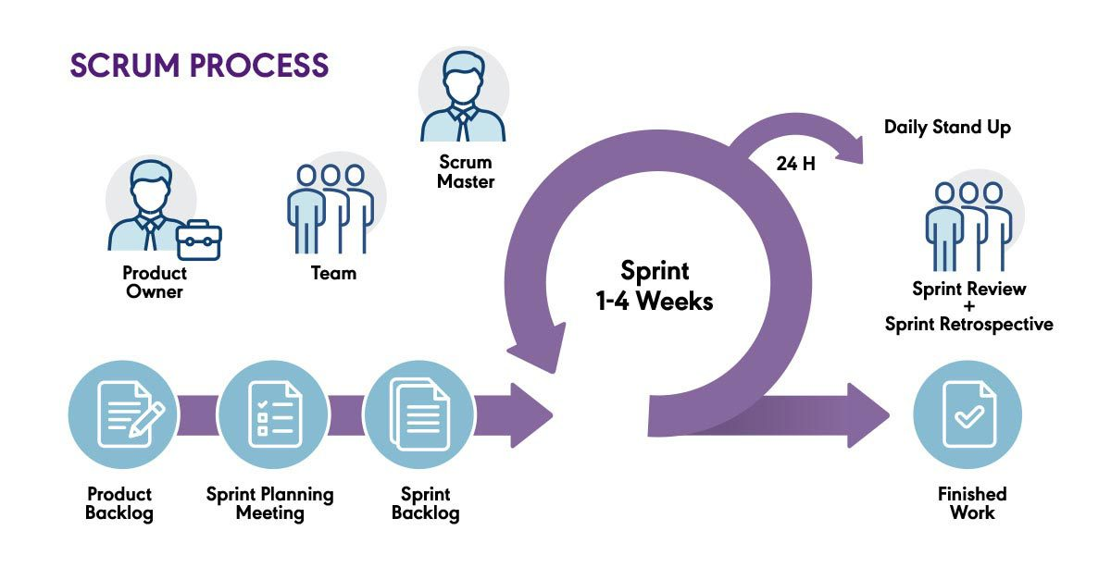
Figure 2:scrum Methodology

Team composition
Our Scrum team comprised:
- Product Owner: Defined priorities, managed the backlog, and ensured alignment with stakeholder needs..
- Scrum Master (SM): Facilitated Agile practices, removed roadblocks, and kept the team focused.
- Scrum Team: Developers, UI/UX designers, and QA testers collaborating cross-functionally.

Key Scrum Events
Scrum’s structured events kept us on track:
- Sprint Planning: Is a meeting where the development team and the product owner plan the work to be done during the next sprint.
- The daily review is a daily meeting where the development team discusses the progress of the work and any obstacles encountered.
- The sprint review is a meeting at the end of the sprint where the development team presents their completed work to stakeholders.
- The sprint retrospective is a meeting at the end of the sprint where the development team reflects on the past sprint and identifies ways to improve.

Breakdown of the project

Project Team

Role | Missions | Actors
Product Owner | Prioritizes work in the sprint planning meeting and motivates the team with clear goals, answering any questions. | Sahib khalfallah
Scrum Master | Ensures that Scrum rituals are applied throughout the duration of a project. | Mr. Mohamed Elleuch  Mr. Mohamed Djemal
Development Team | The team responsible for designing and delivering the actual product features as well as achieving the goals set for each sprint. | Yasmin dhifaoui  Nebras Mahmoudi

Product Backlog
In this table we have defined for each sprint the user story, the appropriate priority and the complexity.
Table 1: Product Backlog

Priority | User Story | Complexity
1 | As platform administrator, I can authenticate myself. | High
2 | As platform administrator, I can manage user accounts (veterinarians, pet owners, admin staff). | High
3 | As platform administrator, I can manage animal profiles. | High
4 | As platform administrator, I can manage appointments. | High
5 | As platform administrator, I can consult platform usage statistics. | Average
6 | As platform administrator, I can verify veterinarian credentials. | High
7 | As a client, I want to register/login to the platform so I can access my account. | Average
8 | As a user, I want to manage my profile information securely. | High
9 | As a client, I want to create and manage profiles for my animals. | High
10 | As a client, I want to view the medical history and vaccinations of my animals. | High
11 | As a vet, I want to view animal profiles during consultations. | High
12 | As a client, I want to book an appointment with a vet. | Average
13 | As a client, I want to view, edit, or cancel my appointments. | High
14 | As a vet, I want to view and update appointment statuses. | Average
15 | As an admin, I want to manage all appointments across the platform. | Average
16 | As a vet, I want to record consultation details (diagnosis, treatment, etc.). | Average
17 | As a client, I want to join a secure video consultation with a vet. | High
18 | As a vet, I want to start a video call from the appointment interface. | Average
19 | As a user, I want to chat and share documents during the video session. | High

Sprint planning
Table 2: Sprint Planning
No. | Sprint Name | User Story | Start Date | End Date
1 | Authentication & Profiles | - Create user registration interface  - Create login authentication interface  - Create password recovery interface  - Create user profile management interface  - Create veterinarian verification interface  - Create pet profile creation interface | 14 /02/2025 | 14/03/2025
2 | Medical Management (Animals, Appointments, Consultations) | - Create animal medical record interface  - Create appointment booking interface  - Create appointment calendar view  - Create emergency consultation request popup  - Create medical history timeline component | 15/03/2025 | 13/04/2025
3 | Teleconsultation | - Create video consultation interface  - Create chat consultation interface  - Create medication dosage calculator  - Create prescription validation workflow | 14/04/2025 | 04/05/2025
4 | Dashboard & Statistics | - Create admin dashboard overview  - Create consultation statistics module  - Create user activity logs | 05/04/2025 | 03/06/2025

Conclusion
In this chapter, we have discussed the different actors involved as well as the functional and non-functional requirements of the application. Next, we explained the first step in our methodology, which is to build the development team, create the backlog, and sprints.

CHAPTER 3: SPRINT 0: Software Architecture and Development Framework

Introduction
This sprint is dedicated to understanding the software architecture and its implementation through the development frameworks.

Backlog Sprint 0
The sprint is the heart of SCRUM. This is a block of time during which an increment of the product will be made. Before embarking on a Sprint, the SCRUM team must define the goal of the Sprint, which must be a descriptive table that specifies the workload for each task in number of days, so we were interested in establishing and defining our Sprint 0 is described in the following table:

Tasks | Actor | Priority | Period (in days)
- Research on the tools to use | Nebras/yasmin | High | 3 days
- Installation and configuration Visual studio code,Visual studio , Angular, Flutter | Nebras/yassmin | High | 2 days
- Configuring the Development Environment | Nebras/yassmin | High | 2 days
- Practical application and preparation on the project | Nebras/yassmin | High | 7 days

Architectural view of the system

Our application is designed with a robust N-Tier Architecture, specifically a 4-Tier model, to ensure optimal scalability, maintainability, and performance. This layered approach clearly separates concerns and efficient communication between components, and the development of each tier.

Overall System Architecture (4-Tier Model)
The system is logically divided into 4 distinct tiers, each with specific responsibilities:
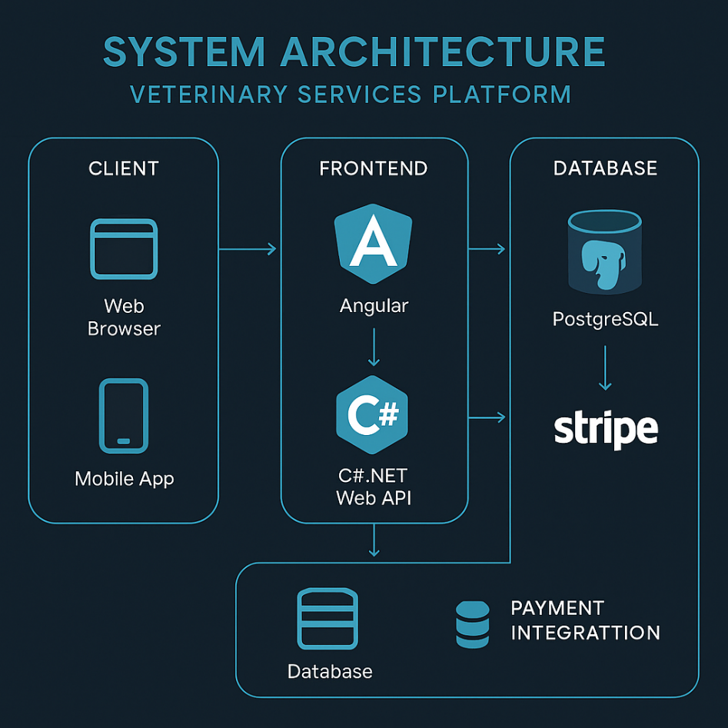
Figure 3:Deployment Architecture

1.1 Presentation Layer (Tier 1: User Interfaces)
- Role: This layer is responsible for user interaction, displaying information, and capturing user input. It provides the visual and interactive experience for different user roles.
- Components:
- Web Frontend (Angular - Admin Interface): Built with Angular, this provides a dynamic single-page application (SPA) for administrative tasks, managing the system, and viewing comprehensive data
- Mobile Frontend (Flutter - Client & Veterinarian Apps): Developed using Flutter, this enables natively compiled applications for both pet owners (clients) and veterinarians.
1.2 Business Logic Layer (Tier 2: Application Logic / API Endpoints)
  - Role: This layer serves as the central hub for processing requests from the presentation layer and implementing the application's core business rules and workflows.
  - Components:
- Backend: C# .NET Web API: This high-performance framework builds RESTful services that expose API endpoints. It acts as the gateway for both Angular and Flutter frontends, handling authentication, authorization, and the execution of business logic.
1.3 Data Access Layer (Tier 3: Repository / ORM)
- Role: This layer acts as an intermediary between the business logic layer and the actual database. Its primary responsibility is to provide a standardized, abstract interface for accessing and manipulating data, decoupling the business logic from the specifics of the database technology.
- Components:
- Backend C# .NET Web API (Repositories): Within the .NET Web API, this layer typically consists of Repository classes that encapsulate the logic for interacting with the database. It uses Object-Relational Mapping (ORM) tools (Entity Framework Core) to map database tables to C# objects.
1.4 Data Layer (Tier 4: Database)
- Role: This is the lowest tier, responsible for the persistent storage and retrieval of all application data.
- Components:
  - PostgreSQL Database: A powerful, open-source relational database.

II. Backend Architecture (C# .NET Web API - 3-Tier)
The C# .NET Web API, acting as the Business Logic Layer in the overall system, is itself structured internally into a 3-tier:

Controllers (API Endpoints)
  - Role: These are the entry points for external HTTP requests. They receive requests from the frontend, and delegate the actual business processing to the Service Layer. They are responsible for handling HTTP requests (GET, POST, PUT, DELETE) and returning HTTP responses.
  - Example: AppointmentsController, UsersController.

Services / Business Logic Layer
  - Role: This is the core of the backend, containing the application's specific business rules, validations, and complex operations.
  - Example: AppointmentService, UserService.

Repositories / Data Access Layer
  - Role: These classes abstract the data storage details from the business logic. Each repository typically handles CRUD operations for a specific entity (e.g., IUserRepository, IAppointmentRepository). They interact directly with the database using Entity Framework Core and return domain-specific objects to the services.
  - Example: UserRepository, AppointmentRepository.

Models (Entities / DTOs)
  - Role: These are simple classes that represent the data structures used throughout the application.
    - Entities: Represent the actual database schema (e.g., User, Appointment).
    - DTOs (Data Transfer Objects): Used for transferring data between layers (e.g., LoginRequestDto, AppointmentDto). They define the shape of data sent to and received from the API.

III. Frontend Architecture (High-Level)
Both the Angular (Web) and Flutter (Mobile) frontends follow modern, component-based architectures, emphasizing modularity, reusability, and reactive programming paradigms.

Angular (Web Frontend)
  - Components: The UI is built from reusable components (e.g., LoginComponent, DashboardComponent, AppointmentSchedulerComponent). Each component encapsulates its own template (HTML), styles (CSS), and logic (TypeScript).
  - Services: Angular services are used for shared logic, data fetching (e.g., HttpClient for RESTful API calls), and state management. They provide a single source of data for multiple components.
  - Routing: Angular's router manages navigation between different views within the application, providing a seamless user experience without full page reloads.

Flutter (Mobile Frontend)
  - Widgets: Flutter's UI is entirely composed of widgets (e.g., Scaffold, AppBar, Text, Container, custom widgets). Widgets are declarative and represent UI elements.
  - Routing: Flutter's Navigator stack manages screen navigation, allowing for push/pop operations to move between different views.
  - Services/API Integration: Flutter applications interact with the C# .NET Web API using HTTP clients to perform API calls for data exchange.

This structured architectural approach facilitates clear separation of concerns, simplifies development and testing, and provides a scalable foundation for future enhancements to the veterinary application.

Developer Tools Overview

Hardware Environment
The development of the application is carried out via a laptop computer with the characteristics presented by the table.
Table 3: Computer Specifications
Mark | DELL
Processor | Intel Core i7-12700H with Carte graphique Nvidia GeForce RTX 3050
RAM | 16 GB
Operating system | Windows 11.64-bit, x64 processor

Software environment
- Visual Studio Code

Figure 4: Visual Studio Code logo
Visual Studio Code (VSCode) is a software developed by Microsoft that combines the functionality of a source code editor and an integrated development environment (IDE). Available for Windows, Linux, and Mac, it offers extensive support for various programming languages such as C++, C#, Python, Java, and many more

- Visual Studio Code

Figure 5:Visual Studio Code logo

Visual Studio Community is a free, fully featured Integrated Development Environment (IDE) developed by Microsoft. It is intended for students, open-source contributors, and small teams. It provides robust tools for building applications on multiple platforms including web, mobile, desktop, and cloud.

- StarUML

Figure 6: Logo de StarUML
StarUML is a software engineering software specialized in UML modeling, developed by the Korean company MKLabs. It is a cross-platform tool compatible with Windows, Linux, and MacOS, allowing users to create UML templates for software design.

- Swagger


Figure 7: Postman Logo
Swagger is an open-source software framework created in 2011 by Tony Tam to help developers design, build, document, and consume RESTful web services. Originally developed at Wordnik, Swagger introduced a standardized way to describe APIs using the OpenAPI Specification (OAS), enabling better collaboration, auto-generated documentation, and easier API testing and integration
- GitHub

Figure 8: GitHub logo
GitHub is a website that provides a cloud service for developers to store and manage their code. It also provides follow-up and control of changes made to it. Today, it represents one of the most popular ways to host open-source projects and share content
- Microsoft Word

Figure 9: Microsoft Word Logo
Microsoft Word is a word processing program that allows you to create both simple and complex documents. With Office 365, you will be able to download the application to your hard drive and will also have access to the online version. The online version offers you the ability to share and collaborate with others on your files in real-time.

CHAPTER 4: SPRINT 1: Authentication and Profiles

Introduction
After having identified the different functionalities that our application must accomplish, we are interested in this chapter at the development of the first sprint.

Backlog sprint
The sprint backlog is a list of specific and detailed tasks to be completed during a sprint, which is a fixed period of time dedicated to the development of a specific product or feature.
The sprint backlog for the first sprint is organized as follows:
Table 4:Backlog of the first sprint
ID | User story | Spots | Wear out | Estimate (Days)
1 | As a client, veterinarian, or admin, I can log in to the platform | - Develop the login interface (Web + Mobile) | Yassmin/  Nebras | 2 days
 |  | - Implement the login API (C# .NET) | Yassmin/  Nebras | 2 days
2 | As a client, veterinarian, or admin, I can register on the platform | - Develop the registration interface (Web + Mobile) | Yassmin/  Nebras | 2 days
 |  | - Create the Users and Roles tables in PostgreSQL | Yassmin/  Nebras | 1 day
 |  | - Implement the user registration API | Yassmin/  Nebras | 2 days
3 | As a user, I want to recover my password if I forget it | - Develop the "Forgot Password" interface | Yassmin/  Nebras | 1 day
 |  | - Implement the password reset API (send reset email) | Yassmin/  Nebras | 2 days
4 | As a logged-in user, I can manage my personal profile | - Develop the profile view/edit interface | Yassmin/  Nebras | 2 days
 |  | - Implement the profile update API | Yassmin/  Nebras | 1 day
5 | As a client, I can create a profile for each of my animals | - Develop the animal profile creation interface | Yassmin/  Nebras | 3 days
 |  | Implement the animal management API (CRUD) | Yassmin/  Nebras | 1 days

Requirements Specification

Use Case Diagram
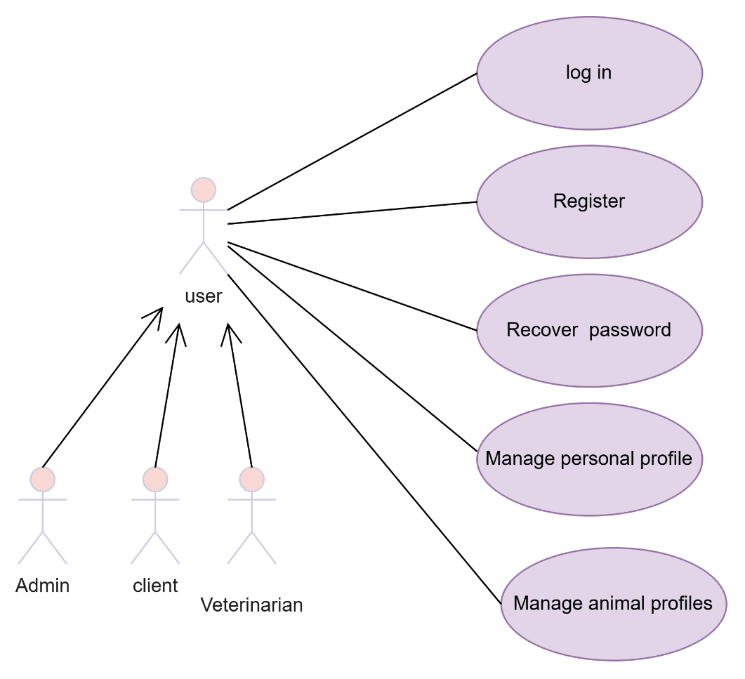

Figure 10:first sprint use case diagram

Text description of key use cases
- Text description of the "Request Registration" use case
Table 5: Text description of the use case " Register”
Actors : | User (Client, Veterinarian, Administrator)
Pre-condition | User is not registered
Post condition | Registered user
Nominal scenario | - The app displays the registration form.  - The user enters the necessary data.  - The user validates the data entry.  - The system validates the data.  - If valid:  - The system registers the user.  - The system generates a unique confirmation code.  - The system sends an email containing the code to the user's email address.  - The app navigates to a “Verify Email” page with an input field for the code.  - The user enters the code and submits the form.  - The system verifies the code.  - If the code is correct:  - The email is marked as confirmed.  - The system grants access or redirects to login/dashboard.
Exception scenario | E1: Email or User ID Already Exists  - The system displays an error ("Email already used").  - Return to Step 1.  E2: Invalid Input in Registration Form  - The system shows validation errors.  - User corrects input and resubmits.  E3: Wrong Confirmation Code  - User submits an incorrect code.  - The system shows an error ("Invalid code").  - User can try again.  E4: Confirmation Code Expired  - The code has expired (based on a time limit, e.g., 10 minutes).  - The system shows an expiration message.  - The user can request a new code.  E5: Email Not Confirmed  - If the user tries to log in without confirming the email:  - The system prevents access and redirects to the code verification page.
- Text description of the "log in" use case
Table 6: Text description of the "login" use case
Actors | User (Client, Veterinarian, Administrator)
Pre-condition | Registered user
Post condition | The user is authenticated
Nominal scenario | - The app displays the login form.  - The user enters his login and password.  - The user clicks the "Sign In" button.  - The system checks If the email , password exists  - If valid, the system generates a verification code.  - The system sends the code to the user’s registered email.  - The app displays a "Code Verification" form.  - The user enters the received code and clicks Submit.  - The system verifies the code:  If the code is valid and not expired, the login is completed.  10. The system redirects the user to their role-specific homepage
Exception scenario | - E1: Invalid Email or Password  - The system displays "Invalid credentials".  - The user stays on the login form.  - The scenario resumes at step 1.  - E2: Verification Code Incorrect  - The user enters an incorrect code.  - The system displays an error message ("Invalid code. Try again.").  - The user can retry code entry.  - E3: Verification Code Expired  - If the user takes too long to enter the code (e.g., 10+ minutes), the system displays:  - "Code expired. A new code has been sent to your email."  - A new code is automatically generated and sent.  - The scenario resumes at step 6.  - E4: Exceeded Login Attempts  - After 3 failed password attempts:  - The account is temporarily locked (e.g., 20 minutes).  - The system displays "Too many failed attempts. Try again later."  - E5: Exceeded Code Attempts  - If the user fails the code entry 3 times:  - The system invalidates the current session.  - The user must restart the login process from step 1.  - E6: Email Not Verified (Before Login Allowed)  - If the user never verified their email after registration:  - The system blocks login.  - It shows: "You must confirm your email before logging in."

- Text description of the " Recover Password" use case

Table 7: Text description of the " Recover Password" use case
Actors | User (Client, Veterinarian, Administrator)
Pre-condition | The user is authenticated
Post condition | A new password is changed
Nominal scenario | - The app displays the "Forgot Password" form.  - The user enters their registered email.  - The system sends a reset password email with a secure link.  - The user follows the link and sets a new password.  - The system confirms the password change.
Exception scenario | If the email is not found, an error is displayed and the process restarts from step 1.

- Text description of the "Create Animal Profile" use case
Table 8: Text description of the "Create Animal Profile" use case
Actors | Client
Pre-condition | The user is logged in
Post condition | A new animal profile is created
Nominal scenario | - The app displays the animal profile creation form.  - The user fills in details (name, species, breed, age, etc.).  - The user submits the form.  - The system validates and stores the animal data.  - The new animal appears in the user’s animal list.
Exception scenario | If required fields are missing or invalid, the system shows an error and returns to step 1.

- Text description of the " Update Profile (Client/Veterinarian/Admin)" use case
Table 9: Text description of the “Update Profile (Client/Veterinarian/Admin)” use case
Actors | User (Client, Veterinarian, Admin)
Pre-condition | The user is authenticated
Post condition | The user’s profile is updated with the new information
Nominal scenario | - The app displays the current user profile with editable fields.  - The user modifies the desired information (e.g., name, email, phone).  - The user submits the changes.  - The system validates the input data.  - The updated profile information is saved and confirmed to the user.
Exception scenario | - If required fields are missing or contain invalid data, the system displays an error message and returns to step 1.  - If the update request fails due to server or database issues, an error is displayed and the user is prompted to try again later.

Data dictionaries

Class | Code | Description | Type
User | Id | User ID (primary key), initialized with Guid.NewGuid() | String
 | Role | Custom role string | String
 | TwoFactorEnabled | Indicates if 2FA is enabled (default: false) | Bool
 | TwoFactorCode | Code used for 2FA | String
 | TwoFactorExpiration | Expiration date/time for 2FA code | Date
 | CodeConfirmationLogin | Code used for login confirmation | String
 | TokenCreationTime | Timestamp when token was created | Date
 | CreatedAt | Creation timestamp (default: UTC now) | Date
 | UpdatedAt | Last update timestamp (default: UTC now) | Date
 | Gender | User's gender | String
 | FirstName | User's first name (max length: 100) | String
 | LastName | User's last name (max length: 100) | String
 | BirthDate | User's birth date | Date
 | address | User's address (max length : 500) | String
 | zipCode | Postal code (max length : 10) | String
 | PhoneValidated | Indicates if the phone number is validated | Bool
 | PhoneValidationCode | Code used to validate the phone (max: 25) | String
 | EmailValidated | Indicates if the email is validated | Bool
 | EmailValidationCode | Code used to validate the email (max: 500) | String
 | Enabled | Indicates if the account is enabled | Bool
 | ConfirmationToken | Token used for confirming the account (max: 255) | String
 | Locked | Indicates if the account is locked | Bool
 | Expired | Indicates if the account is expired | Bool
 | ExpiresAt | Expiration date/time of the account | Date
Profile | UserName | User’s name | String
 | Email | User’s email | String
 | PasswordHash | hashed representation of the user's password for secure authentication. | String
 | PhoneNumber | user's phone number | String
 | CreatedAt | Creation timestamp (default: UTC now) | Date
 | UpdatedAt | Last update timestamp (default: UTC now) | Date

Class Diagram

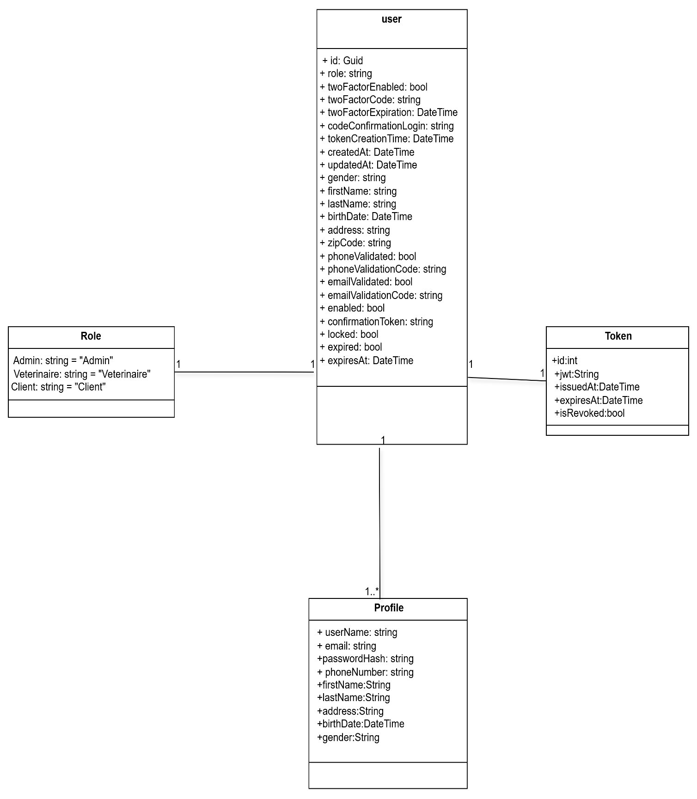
Figure 11:class diagram of first sprint

Sequence diagrams

This section is dedicated to the presentation of the different sequence diagrams detailed for this sprint that represent the dynamic view of our application.
The sequence diagram for the "register" use case is shown in the figure below.
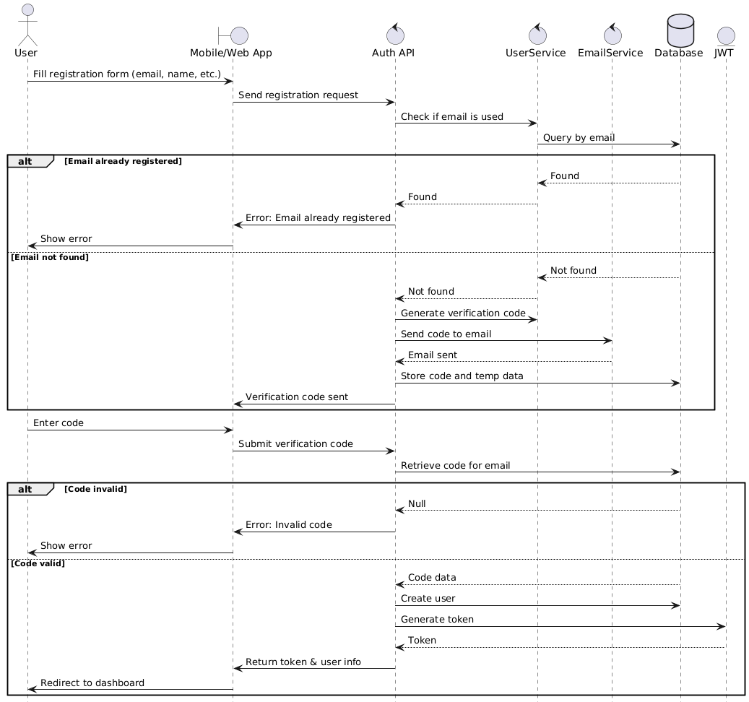
Figure 12:The sequence diagram for the "register" use case

The sequence diagram for the " log in" use case is shown in the figure below.

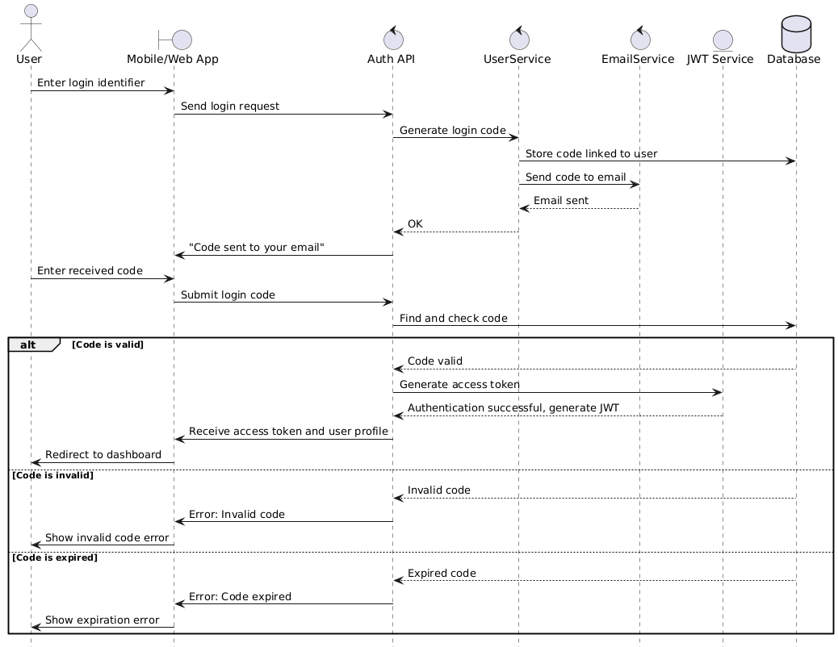
Figure 13:sequence diagram for the " log in" use case

The sequence diagram for the "Update Profile Data" use case is shown in the figure below
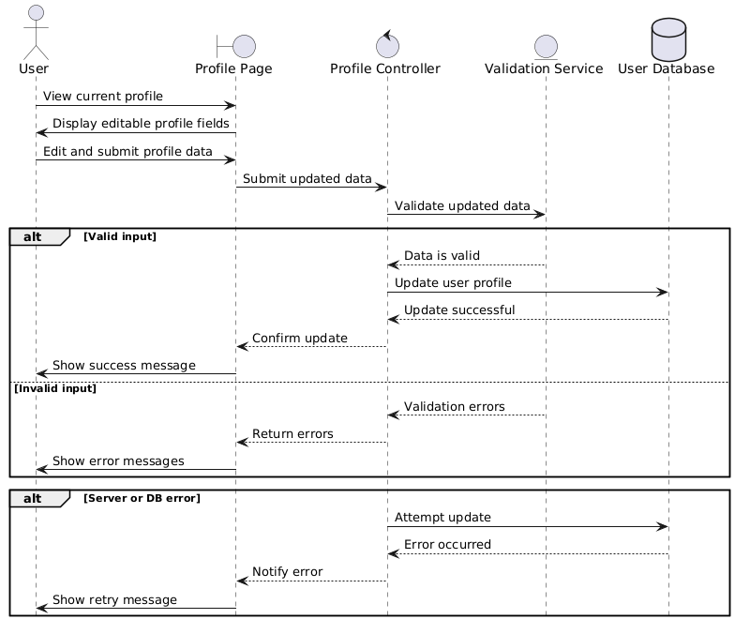
Figure 14:sequence diagram for the "Update Profile Data" use case
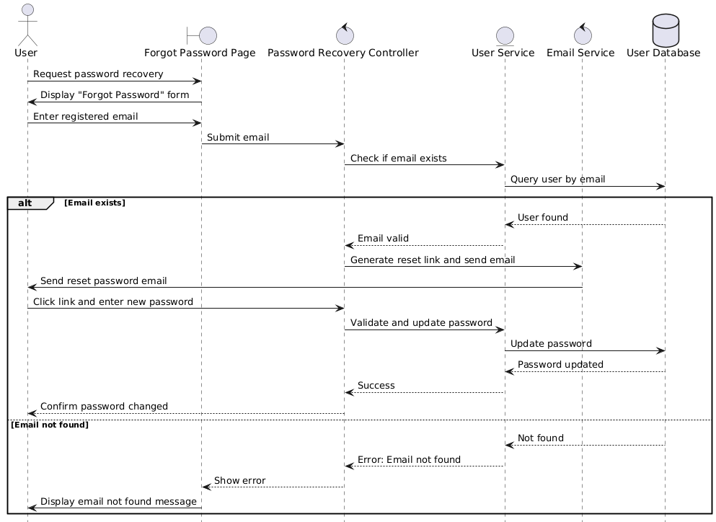
Figure 15:sequence diagram for the " Recover Password" use case
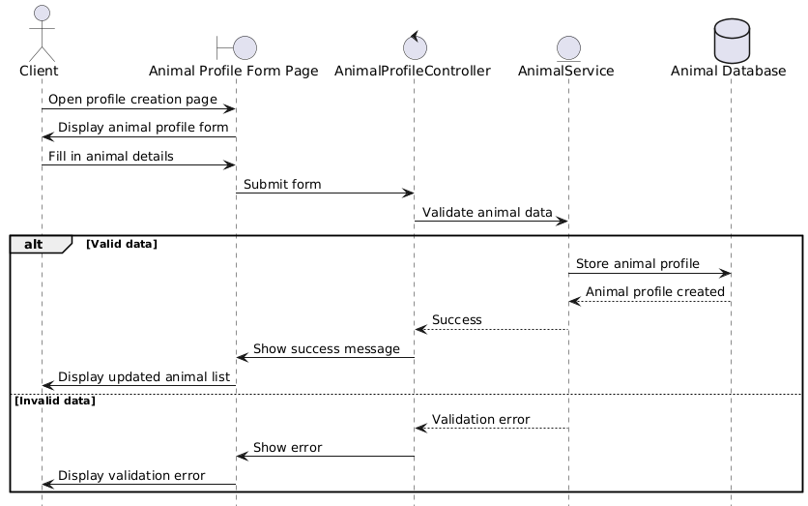
Figure 16:sequence diagram for the "Create Animal Profile" use case

Realization
The first version of the platform implements the authentication and profile management module, allowing administrators, clients, and veterinarians to register, log in, and manage their personal information securely.
In this section, we demonstrate the implementation of the authentication and profile management interfaces using modern frameworks to ensure intuitive and visually appealing user experiences. For the web application, we utilize Material-UI to create a responsive and user-friendly admin dashboard. For the mobile applications, we leverage Flutter to deliver seamless experiences for both clients and veterinarians.

Web Part (Admin Dashboard)
The web interface allows administrators to manage the platform through a secure dashboard. Admin users can register, log in, and edit their profile information.
The following figure shows the login interface:

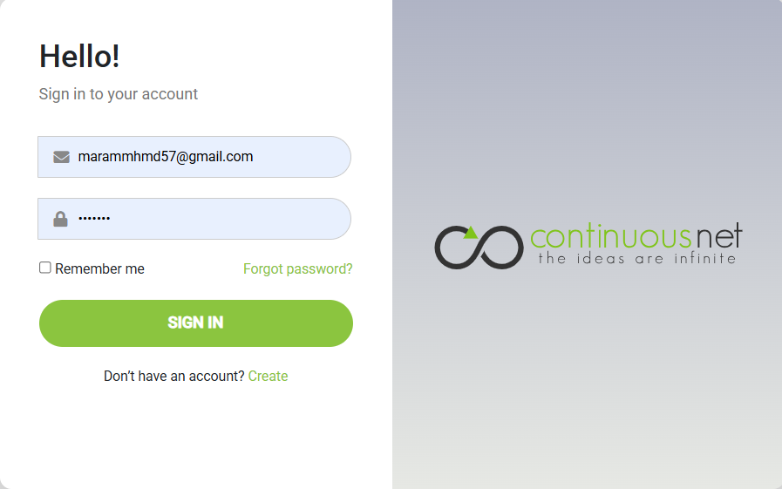
Figure 17:admin authentication
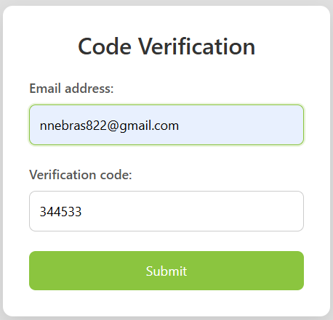
Figure 18:verification

The registration page includes all required fields for creating an admin account:

Figure 19:Admin Registration Interface
Once logged in, the admin is redirected to a simple and clear dashboard:

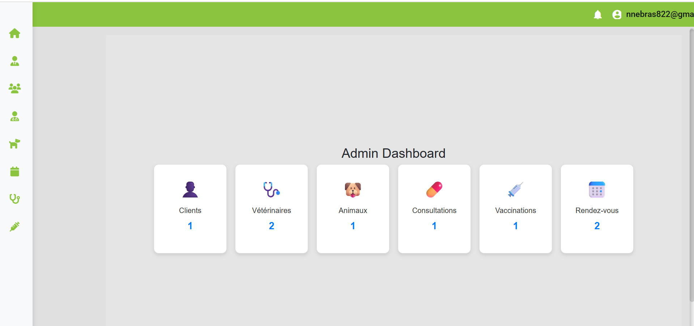
Figure 20:Admin Dashboard Interface
Admins can also access and update their personal profile from a dedicated interface:


Figure 21:Admin Profile Editing Interface

Mobile Part (Flutter App – Client / Veterinarian)
The platform includes two distinct mobile applications, one for clients (pet owners) and one for veterinarians. Both apps are developed using Flutter and offer a smooth and intuitive user experience, starting with registration, login, and profile management.
- Client Mobile Application
The client app allows pet owners to create an account, log in, and manage their personal information and pet profiles.
The first screen displays a welcome page with options to register or log in:
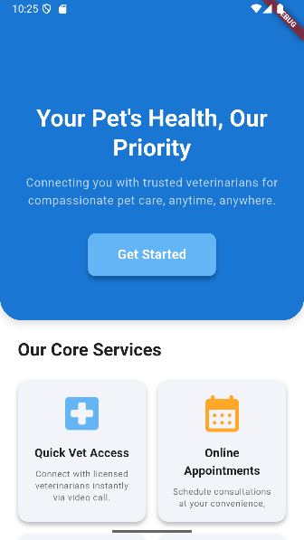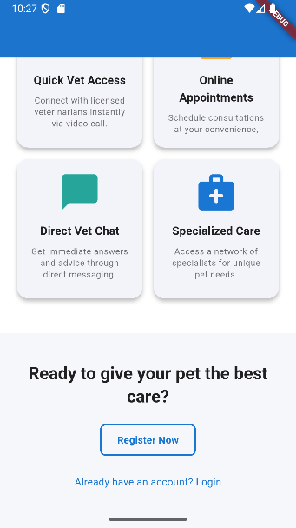

Figure 22:Client App – Welcome Screen
The registration form collects essential information to create a client account:
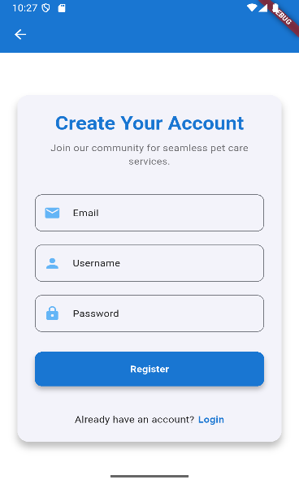
Figure 23:Client App – Registration Interface
The login interface allows clients to securely access their account:
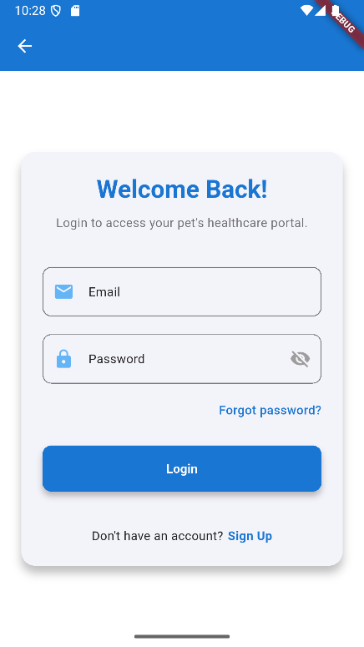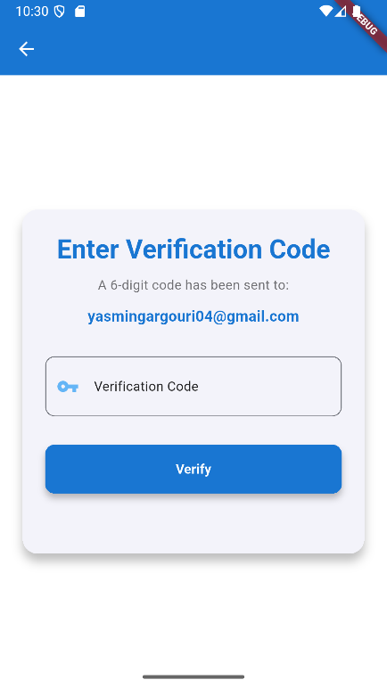
Figure 24:login and verify login screen

After logging in, the user is redirected to the home screen and can manage their profile:
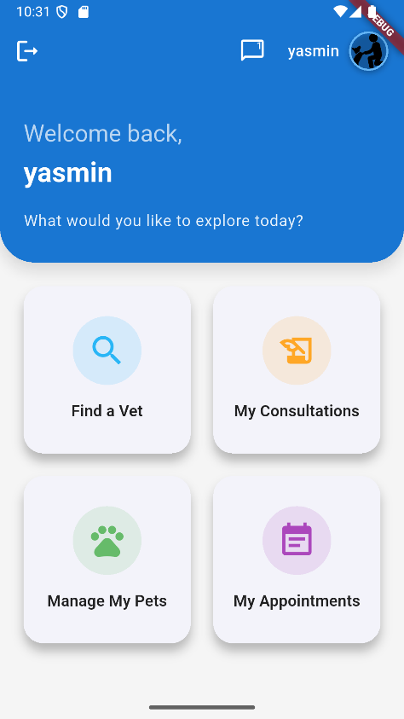
Figure 25:home screen
- Veterinarian Mobile Application
The veterinarian app offers a similar structure, adapted to the professional needs of veterinarians. It allows them to access their dashboard, manage appointments, and consult medical histories.
The welcome screen gives access to login or registration:
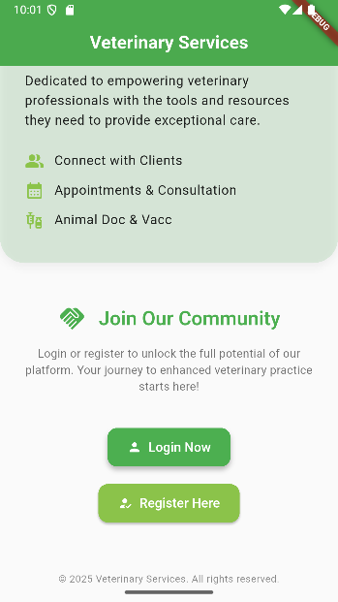
Figure 26:main page

The veterinarian registration form:
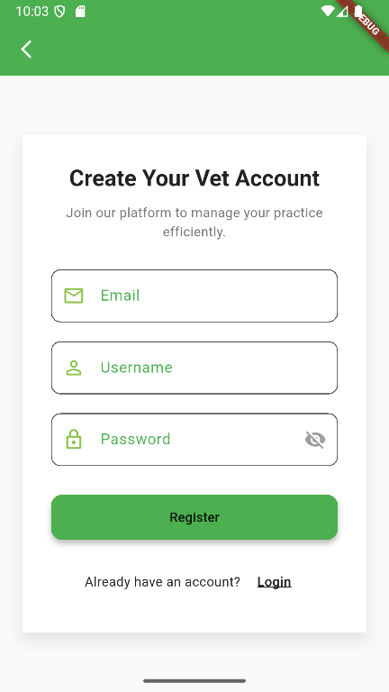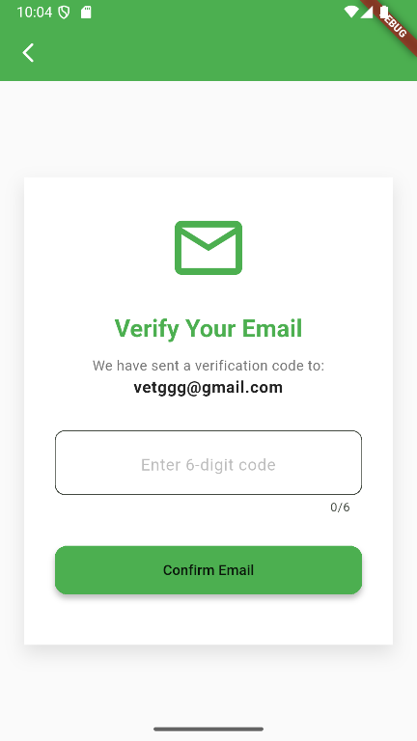

Figure 27:register and verify screen

The login interface provides secure access using encrypted token storage:
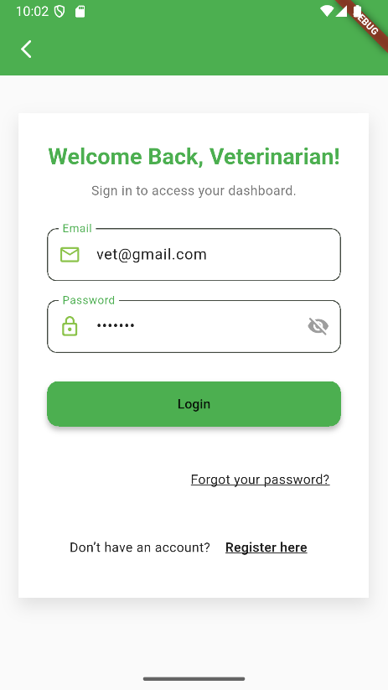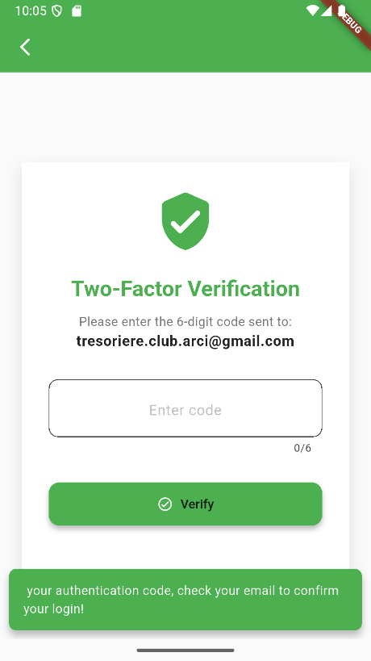
Figure 28:login and verify screen

After login, the veterinarian can access their profile and dashboard:

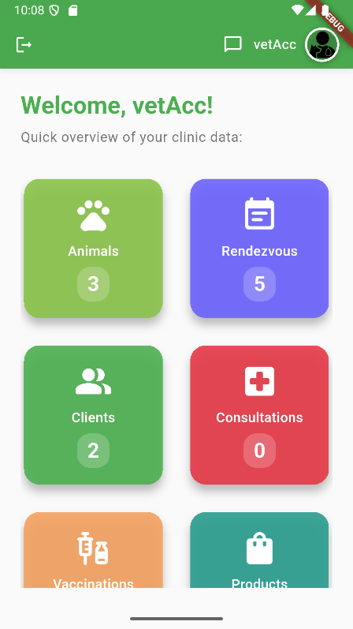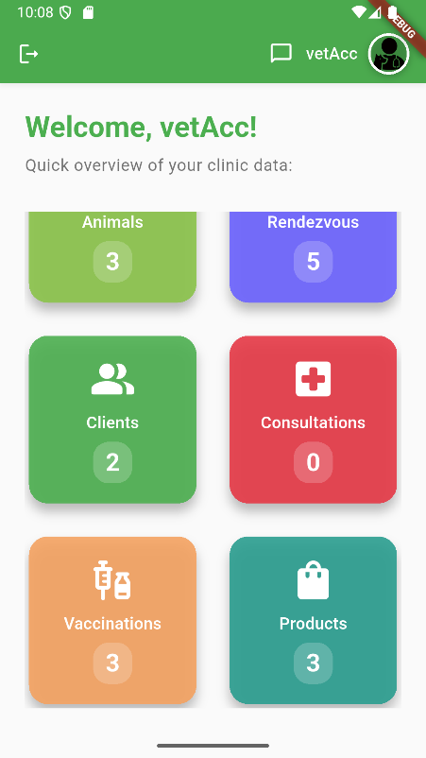
Figure 29:home screen
- Security and performance Ensuring the security and performance of our APIs is crucial for providing a safe experience to users .Hers’s how we’ve improved both aspects:

Security Improvements
- JWT Authentication: We use JSON Web Tokens (JWT) to securely transmit authentication information. Upon login, the API server generates a digitally signed and encrypted JWT containing the user’s identity. The client includes this token in subsequent requests, which the server validates. The token is stored in the user’s Auth object with a refresh token and expiration date, ensuring secure and scalable authentication.
- Rate Limiting: We’ve implemented rate limiting to prevent excessive requests and potential abuse of our API, maintaining system stability and protecting against malicious attacks.
- Data Encryption: Sensitive user information (e.g., passwords) is encrypted using the Advanced Encryption Standard (AES). A key and initialization vector are used to encode data into a secure Base64 string, ensuring data remains protected even if unauthorized access occurs.
- Route Guarding: Route guarding ensures users can only access authorized features based on their role (admin, client, veterinarian). This is implemented client-side to control access to different parts of the application.
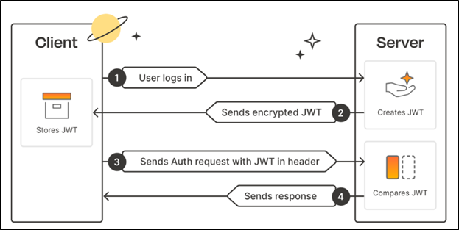
Figure 30:JWT Authentication Process

Performance Enhancements
Lazy Loading: We use lazy loading to reduce initial loading times by loading only essential resources upfront.
Caching: Frequently accessed data is cached locally to reduce server requests, improving response times and reducing server load.
With these security and performance enhancements, we strive to provide users with a secure, fast, and reliable experience.

Test of validation sprint 1
This phase is very important during which we process some tests on the developed features. In fact, the purpose of this process is to ensure that our application works properly in terms of quality and ergonomics. For each test case we will cite the approach followed, the expected behavior and the results of the test as shown in the following table:99

Test cases | Gait | Expected behavior | Results
Test  User registration  (Patient, Healthcare Professional) | Enter a user's information, send him an email verification code, save it, send him a success email. | - All the necessary information is entered.  - All input field checks are performed.  - The user is registered in the database. | Conformable
Testing  Connecting a user | Enter the login information and then verify it. | - The necessary information is entered.  - Checks of the information entered are carried out.  - The user is logged in. | Conformable
Token Generation Test on Login | Enter the login information and then verify the generation of the Token. | - A JWT token is generated and returned. | Conformable
Token Validation Testing | Use the generated token to access a protected resource. | - The Token is included in the request.  - The Token is valid.  - Access to the protected resource is granted. | Conformable
Testing for Modification of Personal Information | View information  Personal, make a  Edit and save. | - The user accesses his account containing his information.  - Changes to Personal Information.  - Storing information at the database level. | Conformable
Password Change Test | Change your password. | - Old password is entered.  - Enter a new password.  - Changing the password at the database level. | Conformable

Conclusion
Through this chapter, we have detailed the realization of the authentication and profile management module for the web and mobile applications. By implementing secure registration, authentication, and profile management processes using Material-UI and Flutter, we have established a robust foundation for the platform. Security and performance enhancements ensure a safe and efficient user experience, validated through comprehensive testing. The next sprint will focus on further enhancing user features, such as advanced profile customization and additional management functionalities.

CHAPTER 5: SPRINT 2: Appointment and Consultation Scheduling

Introduction
In this chapter, we focus on the development of the second sprint, which is dedicated to enhancing the appointment scheduling system for the veterinary telehealth platform. This sprint can be broken down into two main elements:
- Appointment booking, status management, and consultation creation
- Integration with user, animal, and consultation data We’ll explore each of these elements in detail throughout this section.

Sprint backlog
The second sprint backlog is organized as follows:
ID | User story | Tasks | Assigned To | Estimate (Days)
1 | As a client, I can book an appointment with a veterinarian to schedule a consultation for my animal. | - Develop interface for appointment booking (calendar, time slots, veterinarian selection) in the client mobile app (Flutter). | Yassmin/  Nebras | 2 days
 |  | - Implement API endpoints for creating and viewing appointments (C# .NET Web API). | Yassmin/  Nebras | 1 day
 |  | - Prepare the Appointments table in the database (PostgreSQL) with relationships to Users and Animals, including a status field (e.g., Confirmed, Canceled, Terminated). | Yassmin/  Nebras | 5 days
2 | As a veterinarian, I can create a consultation and edit the status of my scheduled appointments. | - Enhance the appointment status screen in the veterinarian mobile app (Flutter) to include "Create Consultation" and "Edit Details" buttons. | Yassmin/  Nebras | 2 days
 |  | - Develop consultation creation interface (date, diagnostic, treatment, prescription, notes, select rendezvous) in the vet app (Flutter), with option to create a new rendezvous.  • Implement API endpoints for creating consultations (POST /consultations) and updating appointment statuses (PUT /appointments/{id}) (C# .NET Web API). | Yassmin/  Nebras | 2 days
3 | As an admin, I can create a consultation and edit the status of all appointments on the platform. | - Develop interface for viewing and managing all appointments in the admin web interface (Angular), including "Create Consultation" and "Edit Details" options. | Yassmin/  Nebras | 2 days
 |  | - Enhance the consultation creation interface in the admin interface (Angular) with the same fields as the vet app. | Yassmin/  Nebras | 4 days
 |  | - Implement API endpoints to retrieve all appointments and manage statuses globally (C# .NET Web API). | Yassmin/  Nebras | 2 days
4 | As a veterinarian or admin, I can view appointment details and ensure data consistency. | - Develop interface to display appointment details (date, client, animal, status) with an editable popup in both vet app (Flutter) and admin interface (Angular). | Yassmin/  Nebras | 1 days
 |  | - Implement web services to retrieve appointment details and consultation data (GET /appointments/{id}, GET /consultations/{id}) (C# .NET Web API).  - Prepare the Consultations table in the database with fields (id, appointment_id, date, diagnostic, treatment, prescription, notes). | Yassmin/  Nebras | - day

Requirements Specification

Use Case Diagram
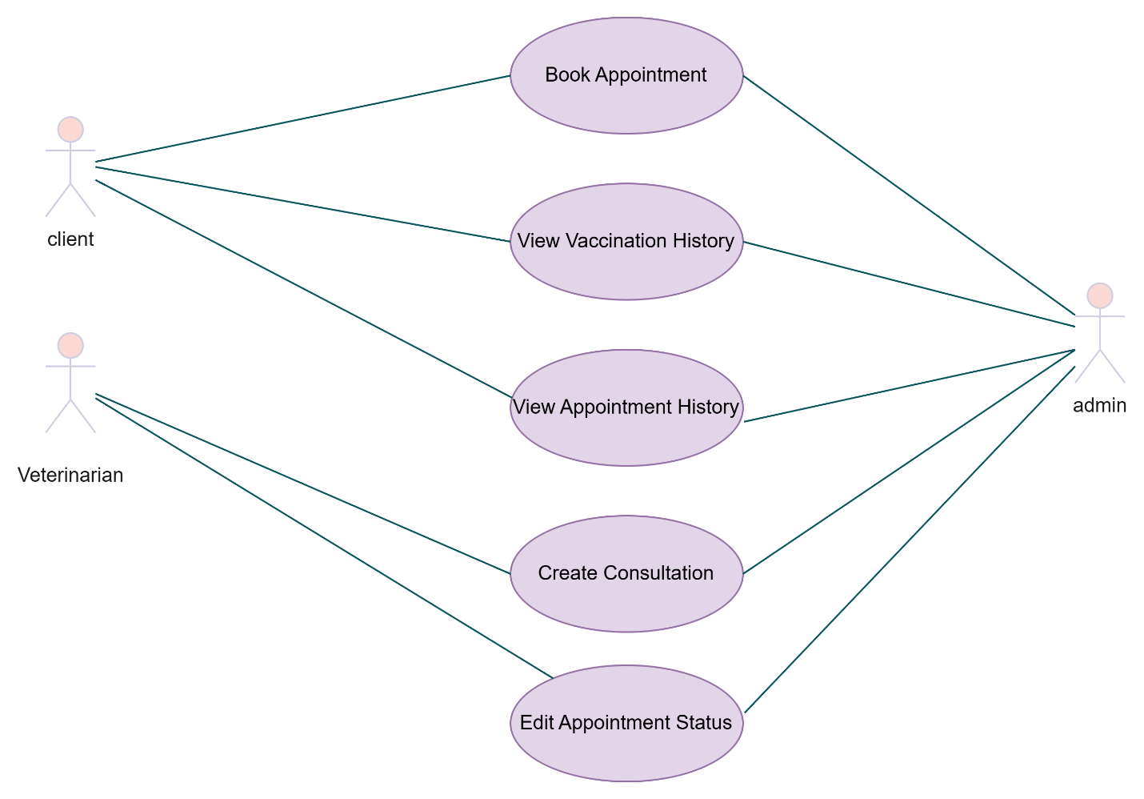
Figure 31:use case diagram

Text description of the use case
- Text description of the " Book Appointment" use case

Actors : | User (Client, Administrator)
Pre-condition | The client is authenticated and has at least one registered animal profile.
Post condition | An appointment request is created and saved in the system, awaiting confirmation.
Nominal scenario | - The client navigates to the “Appointments” section.  - The system displays a list of available veterinarians, dates, and time slots.  - The client selects a veterinarian, date, and time.  - The system displays the selected veterinarian’s profile and confirms availability.  - The client selects one of their animals for the appointment.  - The client optionally adds a note describing the reason for the visit.  - The client submits the booking request.  - The system saves the appointment and assigns it a status of “Pending Confirmation.”  - A confirmation message is shown to the client.  - A notification is sent to the selected veterinarian.
Exception scenario | - E1: No Animal Profile Found  - The client tries to book without a registered animal.  - The system shows an error ("You must first register an animal").  - Redirects to animal registration form.  - E2: Time Slot Already Taken  - The selected time becomes unavailable before confirmation.  - The system shows an error ("Selected time is no longer available").  - Returns to Step 2.  - E3: Invalid Date or Time Selection  - Client selects a past date or non-working hour.  - The system prevents submission and displays a validation error.  - Client adjusts the input and resubmits.  - E4: Veterinarian Unavailable  - The veterinarian becomes unavailable due to another booking or a schedule update.  - The system notifies the client and offers alternative time slots.  - E5: Appointment System Error  - The booking request fails due to a system error (e.g., backend service down).  - The system displays an error message ("Unable to process your request").  - The client may retry after some time.
- Text description of the " View vaccination history" use case

Actors : | User (Client, Administrator)
Pre-condition | - The user (client) is authenticated.  - he client has at least one registered animal profile in the system.
Post condition | - The system displays the selected animal’s full vaccination history, including vaccine name and date.
Nominal scenario | - The client navigates to the “MyAnimals” section of the application.  - The system displays a list of the client’s registered animals with details (name, species, breed, age, and gender).  - The client taps the vaccination icon for a specific animal (e.g., "catty").  - The system fetches and displays that animal’s Vaccination History:  - Each entry shows the vaccine name and date.  - Entries are displayed in a scrollable list.
Exception scenario | E1: No Animal Profile Found  - The client navigates to the “My Animals” section but has no animals registered.  - The system displays an error:  “You must first register an animal.”  - The user is redirected to the Animal Registration form.  E2: No Vaccination Records  - The client clicks the vaccination icon, but the selected animal has no vaccination records.  - The system displays:  “No vaccination history found for this animal.”

- Text description of the " View Appointments" use case

Actors : | User (Client, Administrator)
Pre-condition | - The user is authenticated.  - For clients: at least one appointment must exist (optional: one animal is registered).  - For admins: appointments exist in the system.
Post condition | - The system displays the user's list of appointments with associated details (date, time, veterinarian, animal…).
Nominal scenario | - The user navigates to the “Appointments” section from the main menu.  - The system displays a list of all upcoming and past appointments related to the authenticated user:  - For clients: only their own appointments.  - For admins: all appointments in the system.  - Each appointment entry shows :  - Date & time  - Veterinarian name  - Animal name  - Appointment status (e.g., Confirmed, Completed, Canceled)
Exception scenario | - E1: No Appointments Found  - The client has no existing appointments.  - The system displays:  “You have no appointments scheduled.”  - A button is shown to Book a New Appointment.  - E2: Server Error / Data Fetch Failure  - The appointment list fails to load due to a server issue or network error.  - The system displays an error:  “Unable to retrieve your appointments. Please try again later.”

- Text description of the " Create Consultation" use case

Actors : | User (Veterinarian, Administrator)
Pre-condition | - The user is authenticated as a veterinarian or Administrator.  - At least one confirmed appointment exists in the system.
Post condition | - A new Consultation record is created and associated with the selected appointment.
Nominal scenario | - The user navigates to the “Create Consultation” page.  - The system displays a form with the following fields:  - Date (with calendar picker)  - Diagnostic  - Treatment  - Prescription  - Notes  - appointment (dropdown selection from confirmed appointments)  - The user fills in all required fields.  - The user clicks Submit.  - The system:  - Validates the data.  - Creates a new Consultation associated with the selected appointment.  - Displays a success message: “Consultation created successfully”.  - The user is redirected or returned to the Consultations list or dashboard.
Exception scenario | E1: No appointment Available  - No confirmed appointments are available.  - The system shows an error:  “No available appointments found. Please ensure the appointment is confirmed first.”  E2: Missing Required Fields  - The user submits the form without filling all mandatory fields.  - The system highlights missing fields and shows:  “Please complete all required fields.”  E3: Server or Network Error  - The submission fails due to an internal error or connection issue.  - The system shows:  “Failed to create consultation. Please try again later.”
- Text description of the " Edit Appointment Status" use case

Actors : | User (Veterinarian)
Pre-condition | - The veterinarian is authenticated in the system.  - The veterinarian has access to at least one assigned appointment
Post condition | - The status of the selected appointment is updated (e.g., to Confirmed, Completed, or Canceled).
Nominal scenario | - The veterinarian navigates to the “Appointments” section.  - The system displays a list of appointments assigned to that veterinarian.  - The veterinarian selects an appointment from the list.  - The system opens the appointment details or a status editor (e.g., dropdown or buttons).  - The veterinarian changes the appointment status (e.g., from Pending to Confirmed).  - The veterinarian clicks Save or Update.  - The system:  - Validates the new status.  - Updates the appointment record in the database.  - Displays a success message:  “Appointment status updated successfully.”
Exception scenario | E1: No appointment Available  - No confirmed appointments are available.  - The system shows an error:  “No available appointments found. Please ensure the appointment is confirmed first.”  E2: Missing Required Fields  - The user submits the form without filling all mandatory fields.  - The system highlights missing fields and shows:  “Please complete all required fields.”  E3: Server or Network Error  - The submission fails due to an internal error or connection issue.  - The system shows:  “Failed to create consultation. Please try again later.”

Class diagram

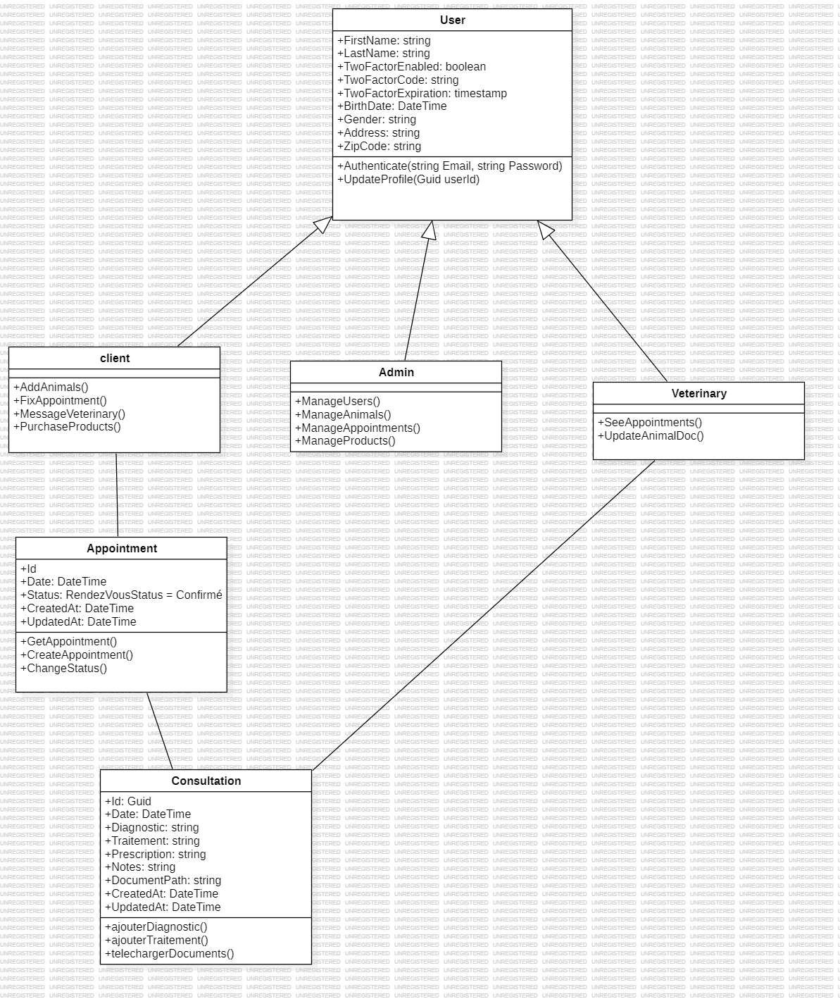
Figure 32:class diagram

Sequence diagrams
This section is dedicated to the presentation of the different sequence diagrams detailed for this sprint that represent the dynamic view of our application.
The sequence diagram for the "book appointment" use case is shown in the figure below.

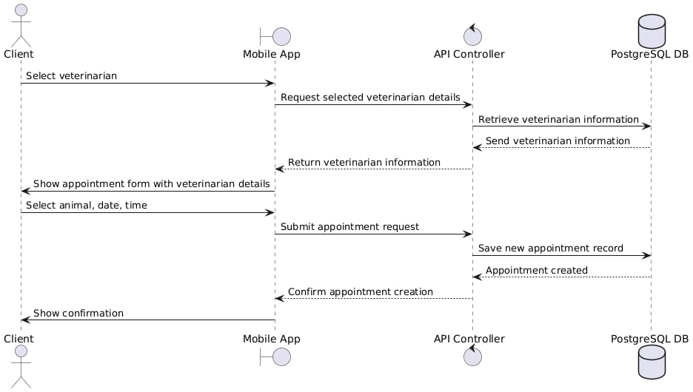
Figure 33:sequence diagram for the "book appointment" use case
The sequence diagram for the " View Vaccination History" use case is shown in the figure below. 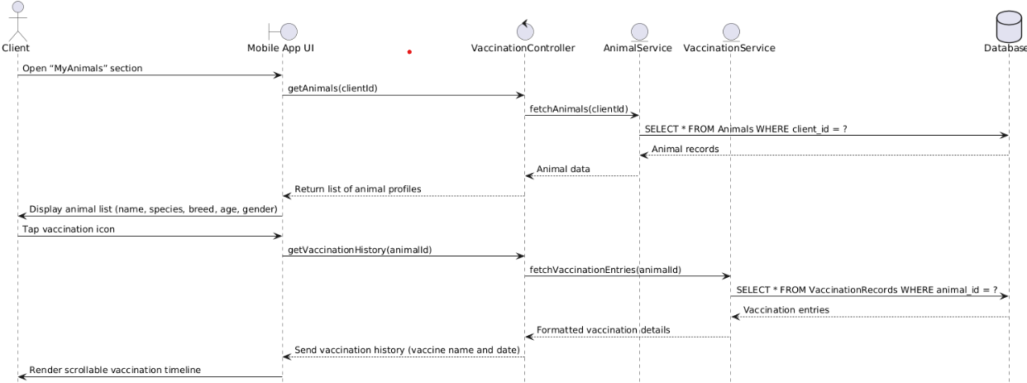
Figure 34:The sequence diagram for the " View Vaccination History" use case

The sequence diagram for the "create consultation " use case is shown in the figure below 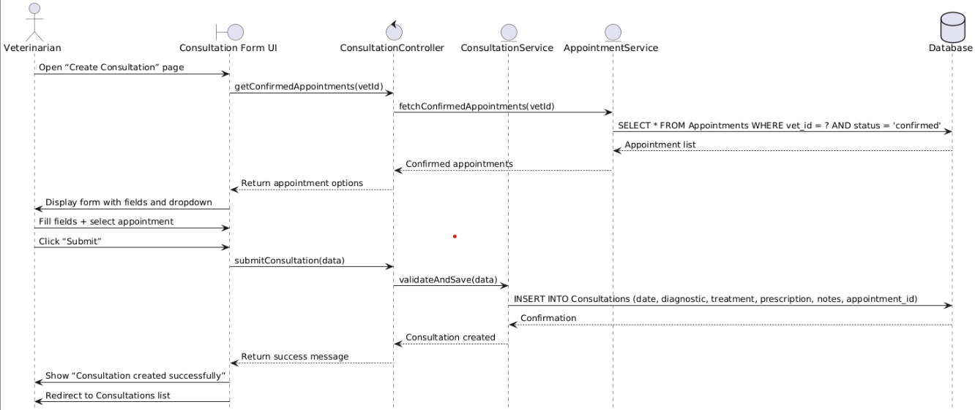
Figure 35:The sequence diagram for the "create consultation " use case

The sequence diagram for the " Edit Appointment Status" use case is shown in the figure below.

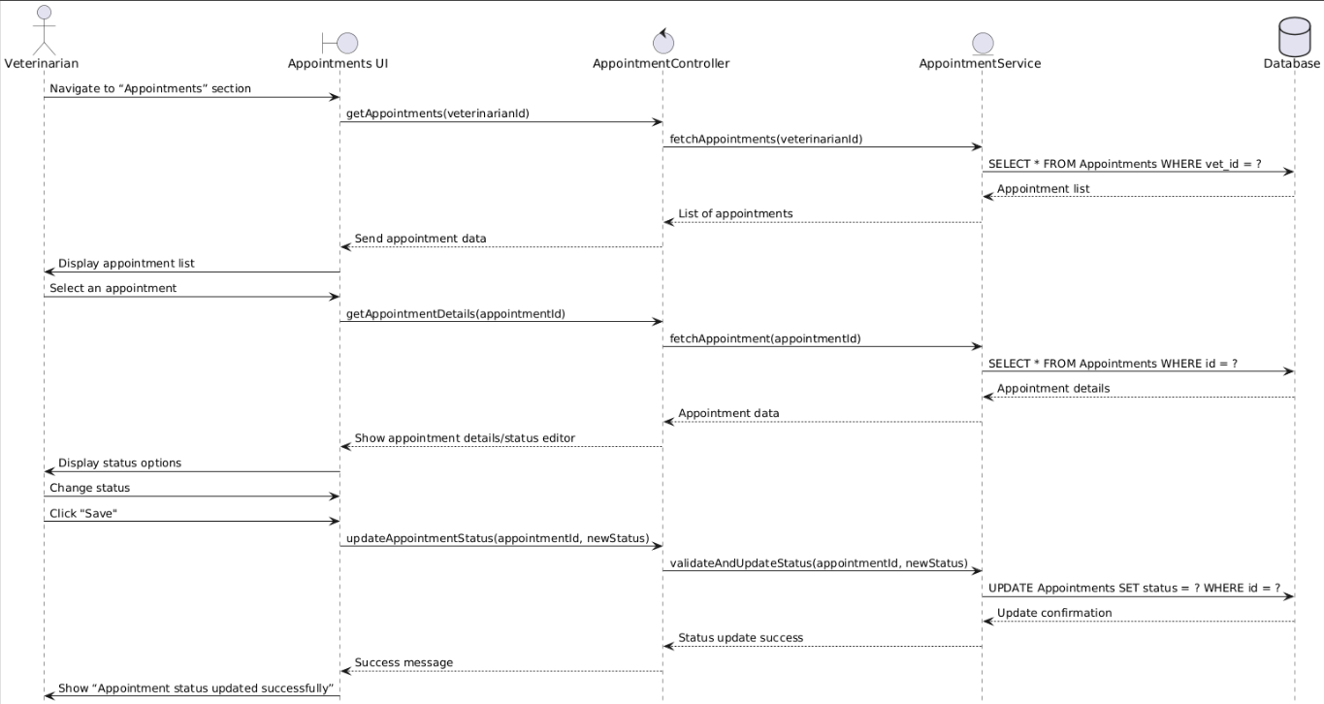
Figure 36:The sequence diagram for the " Edit Appointment Status" use case

Realization
This sprint implements the Appointment Scheduling module, enabling clients to book appointments, veterinarians to view and update their assigned appointments, and administrators to monitor the entire appointment history within the system.

Web part (Admin Dashboard)
The web interface allows the administrator to access and manage all appointments from a centralized and secure dashboard. A dedicated section displays a complete list of appointments across the platform with relevant details: date, time, pet, client, assigned veterinarian, and appointment status (e.g., pending, confirmed, canceled).
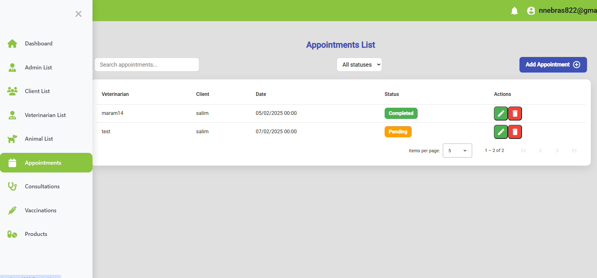
Figure 37:appointments
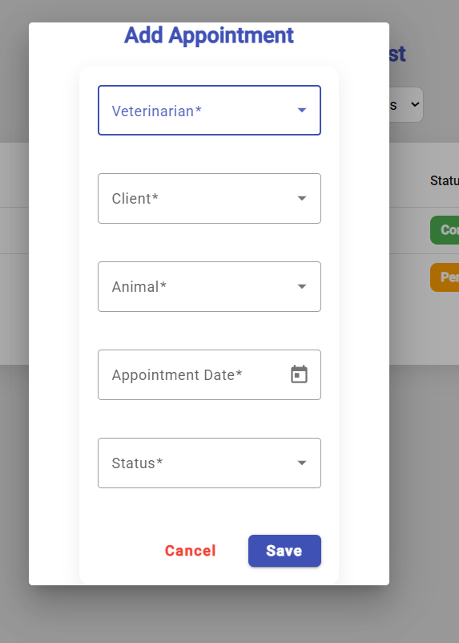
Figure 38:add an appointment
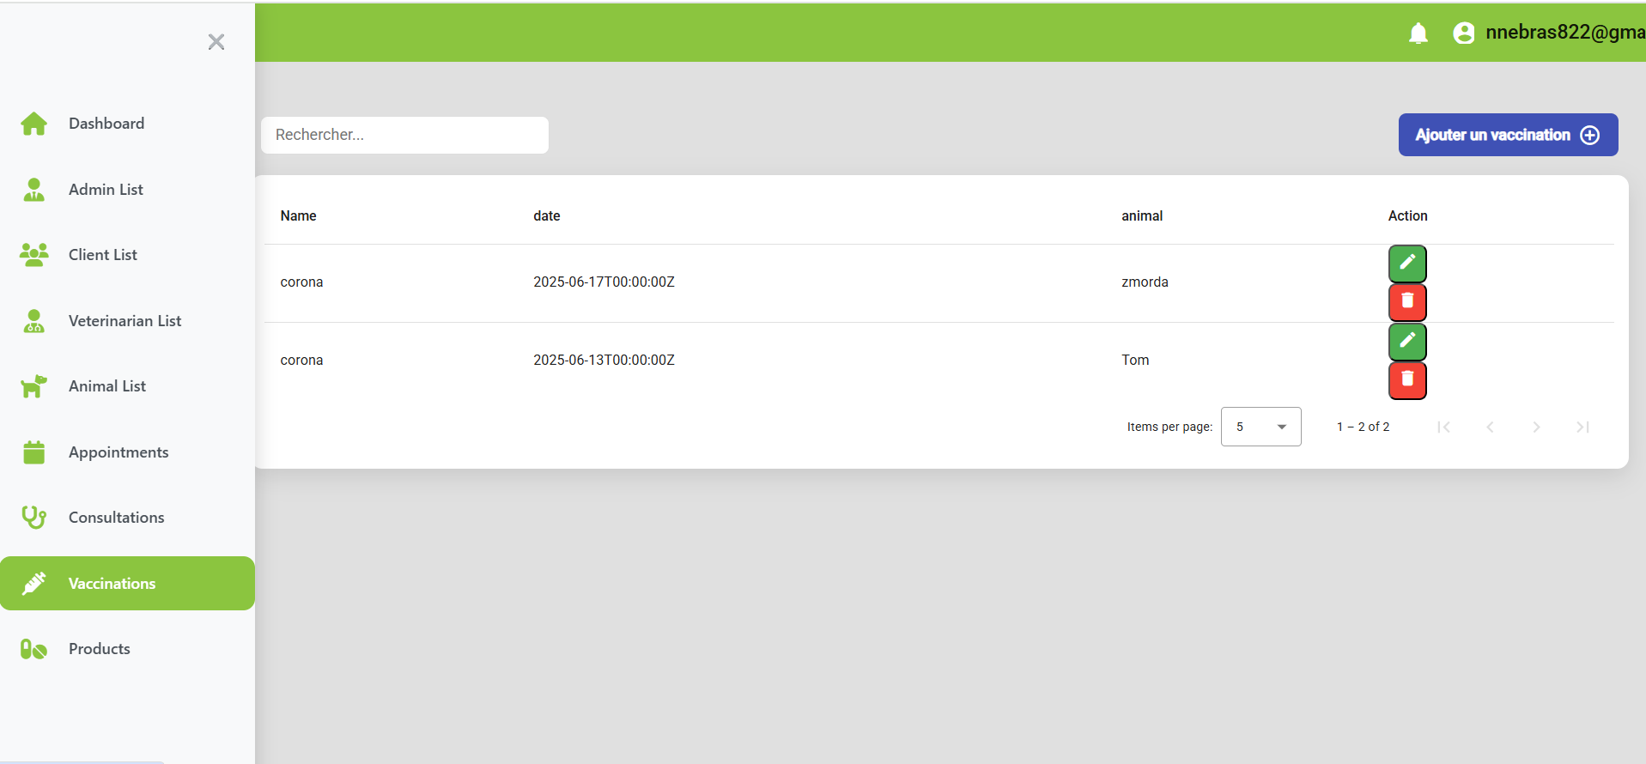
Figure 39:vaccination

Mobile Part (flutter App client/ Veterinarian)
Two separate mobile applications were developed using Flutter: one for clients (pet owners) and another for veterinarians. This sprint focuses on the appointment-related features implemented in both applications.
- Client Mobile Application
The client app allows pet owners to book appointments for their registered animals directly the app.
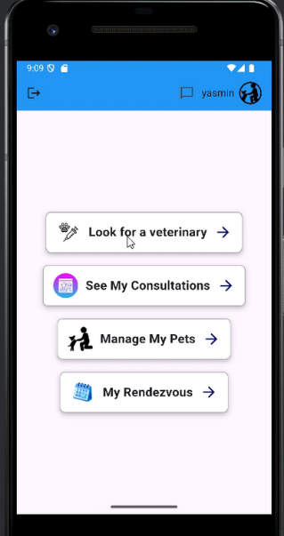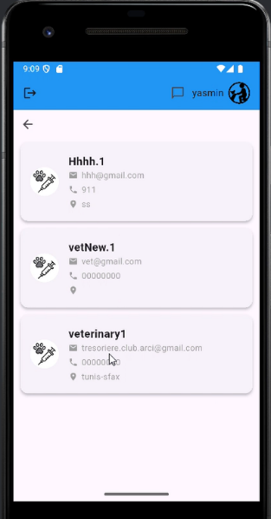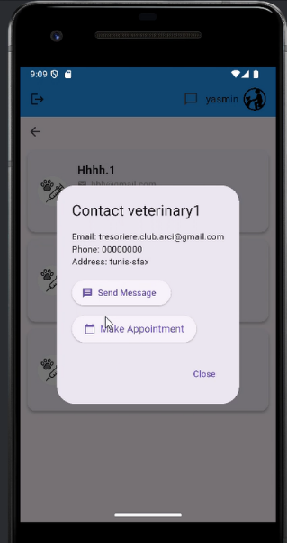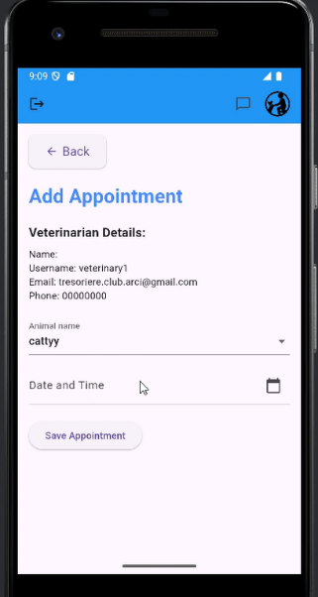
Figure 40:book appointment
Clients can access a personal history of all scheduled or past appointments.
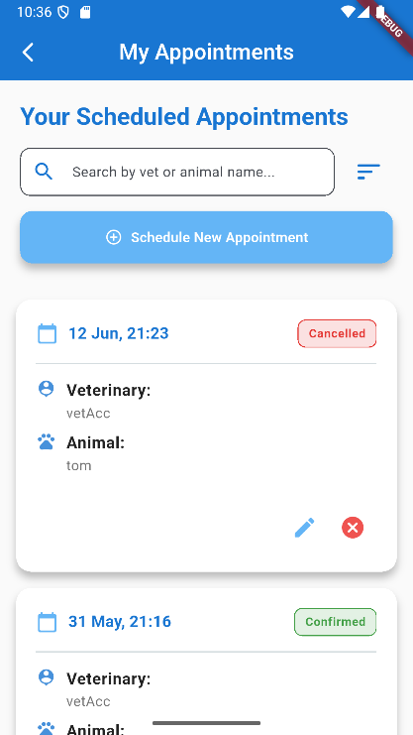
Figure 41:Appointments

Clients can also view the full vaccination record of each registered pet
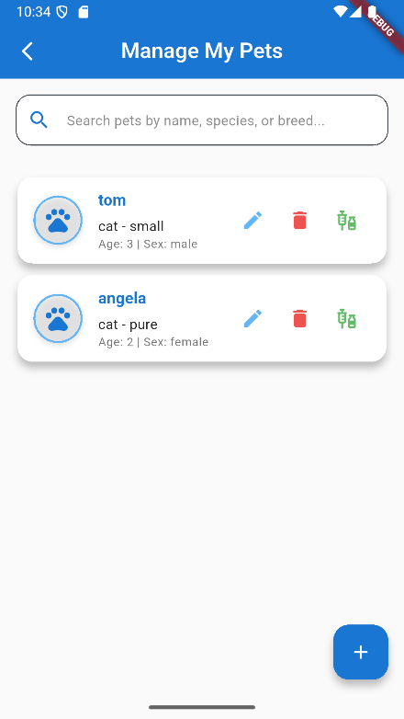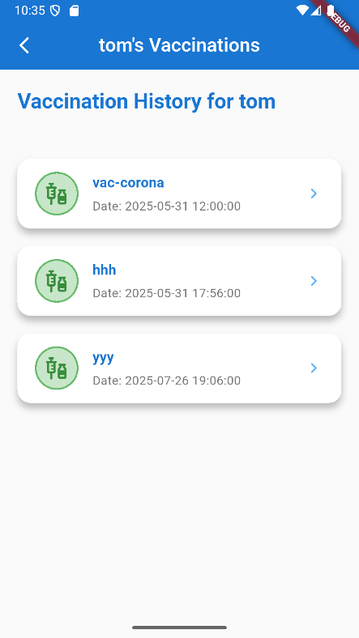
Figure 42:vaccination per pet

- Veterinarian Mobile Application
The veterinarian app provides professionals with tools to review and manage their assigned appointments.
Veterinarians can update the status of their assigned appointments (e.g., Confirmed, Canceled).
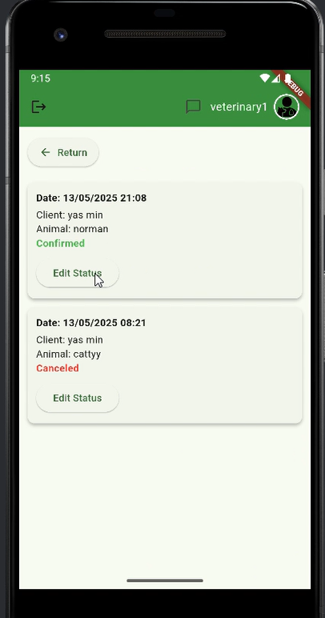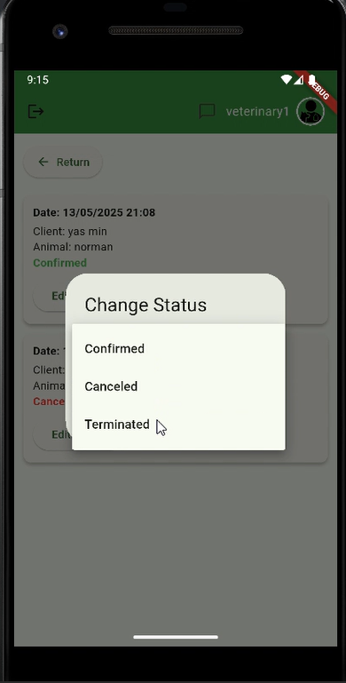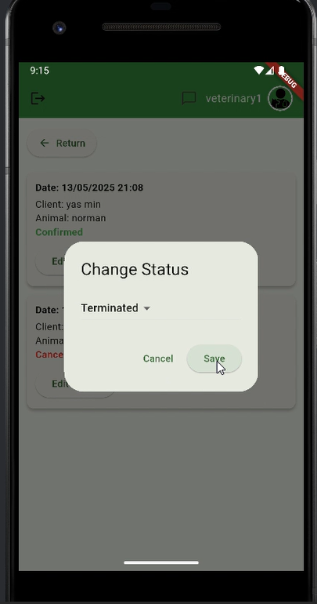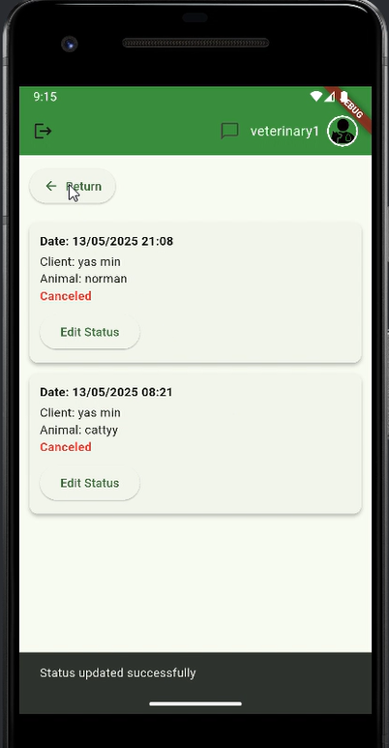

Test of validation sprint 2
Test cases | Gait | Expected behavior | Results
Appointment Booking Test (Client) | Select animal, choose date/time, select reason, send request | 1. Appointment form is filled correctly.2. Appointment request is saved in the database.3. Confirmation is shown to the user. | Conformable
Appointment Listing Test (Veterinarian) | Open "Rendez-vous" section in app | . List of all pending/accepted/rejected appointments is fetched.2. Appointments are displayed correctly. | Conformable
Appointment Status Update (Veterinarian) | Enter the login information and then verify the generation of the Token. | - A JWT token is generated and returned. | Conformable
Consultation Creation Test (Veterinarian) | After accepting appointment, create consultation | . Consultation form opens for accepted appointments.2. Consultation data is entered and saved.3. Animal medical record is updated accordingly. | Conformable
Consultation View Test (Client) | View consultation history | . Client sees a list of past consultations for each animal.2. Details are correctly loaded from the database | Conformable
Consultation Listing Test (Admin Web) | Admin accesses consultation section | . Admin can view all consultations with filters.2. Data is fetched from backend and displayed with correct pagination and filters. | Conformable
Appointment Filtering Test (Admin Web) | Use status and veterinarian filters | . Filtering returns the correct subset of appointments.2. Admin can search and manage appointments efficiently. | Conformable
Database Synchronization Test | Check if appointment and consultation changes reflect correctly | Any create/update/delete action is reflected in the PostgreSQL database.2. All foreign keys and relations are preserved. | Conformable

Conclusion
This sprint allowed us to implement the core functionalities related to appointment scheduling and consultation management. All tests confirmed the proper operation of the features across the different user roles and platforms. These developments represent solid progress toward a reliable and user-friendly veterinary telehealth system.

CHAPTER 6: SPRINT 3: Messaging and Teleconsultation

Introduction
This sprint focuses on implementing the core communication features of the platform, essential for enabling remote veterinary services. The goal is to allow clients and veterinarians to interact in real time through secure video consultations and instant messaging. These features aim to enhance the user experience by providing a seamless and efficient way to conduct follow-ups, share medical files, and offer remote diagnoses, all while maintaining a high level of security and confidentiality.

Backlog du Sprint
The second sprint backlog is organized as follows:
ID | User story | Tasks | Assigned To | Estimate (Days)
1 | As a client, I can send messages to the veterinarian before or after a consultation. | - Develop messaging interface in the client mobile app (Flutter) | Yassmin/  Nebras | 2 days
 |  | - Implement secure messaging API endpoints | Yassmin/  Nebras | 1 day
 |  | - Design the Messages table in the database with fields (id, consultation_id, sender_id, receiver_id, content, timestamp). | Yassmin/  Nebras | 5 days
2 | As a veterinarian, I can reply to client messages. | - Develop chat view for the veterinarian app (Flutter). | Yassmin/  Nebras | 2 days
 |  | - Reuse the same API endpoints to send and retrieve messages. | Yassmin/  Nebras | 2 days
3 | As a client, I can start a teleconsultation video call with the veterinarian | - Integrate a video call module (e.g., Jitsi, WebRTC) in the client app (Flutter).. | Yassmin/  Nebras | 2 days
 |  | - Implement backend signaling mechanism to initiate and join calls.. | Yassmin/  Nebras | 4 days
 |  | - Add a “Start Call” button visible at the scheduled time. | Yassmin/  Nebras | 2 days
4 | As a veterinarian, I can conduct a teleconsultation with the client via video call. | - Integrate the same video call module in the vet app (Flutter). | Yassmin/  Nebras | 1 days
 |  | - Ensure session is secured with tokens and linked to the scheduled appointment.  - . | Yassmin/  Nebras | - day

Requirements Specification

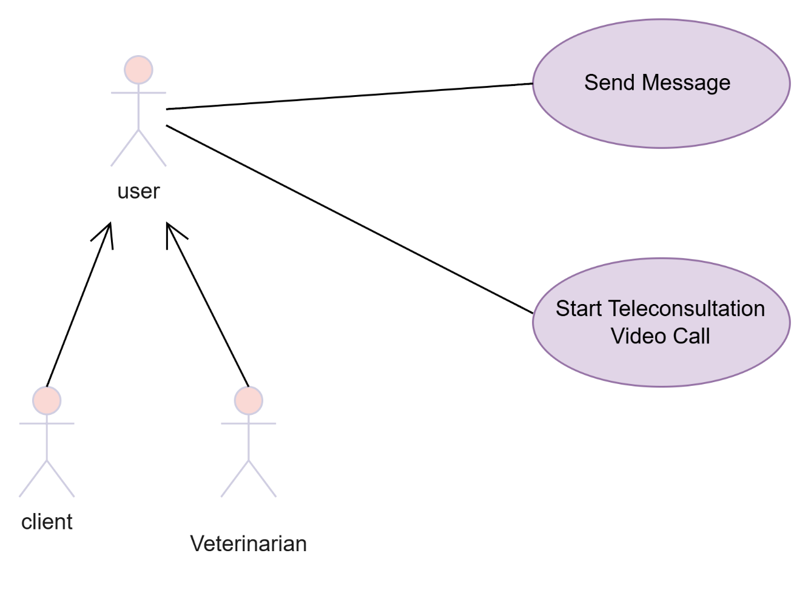
Use case diagram
Figure 43:use case diagram

Text description of the use case
- Text description of the " send Message" use case

Actors : | User (Client, Veterinarian)
Pre-condition | The user (client or veterinarian) is authenticated and has a conversation context
Post condition | The message is delivered and stored in the messaging system, and a notification is sent to the recipient.
Nominal scenario | - The user (client or veterinarian) navigates to the "Messages" section.  - The system displays existing conversations or allows starting a new one.  - The user selects a conversation or a recipient (e.g., the veterinarian for an upcoming appointment).  - The user types a message in the input field.  - The user sends the message.  - The system stores the message in the database with a timestamp, sender ID, and conversation ID.  - The recipient is notified (e.g., push notification or in-app alert).  - The message appears in the chat interface in real time.
Exception scenario | E1: No Conversation Context  - The user tries to send a message without an associated appointment or consultation.  - The system shows an error ("You can only message a veterinarian after booking an appointment").  - The user is redirected to the appointment booking page.  E2: Message Content Empty  - The user tries to send a blank message.  - The system prevents submission and displays a validation error ("Message cannot be empty").  - The user edits the message and resubmits.  E3: User Not Authenticated  - The session has expired or the user is not logged in.  - The system prompts the user to log in again before sending a message.  E4: Message Delivery Failure  - The system fails to store the message due to a backend or network error.  - The message is queued or can be retried manually.
- Text description of the “Start Teleconsultation Video Call" use case
Table 10: Text description of the use case Start Teleconsultation Video Call”
Actors : | User (Client, Veterinarian)
Pre-condition | A confirmed appointment exists between the client and the veterinarian. Both users are authenticated and available at the scheduled time.
Post condition | A video call session is established between the client and the veterinarian. The consultation can proceed in real time.
Nominal scenario | - At the scheduled appointment time, both client and veterinarian log in to their respective applications.  - The system displays a “Start Teleconsultation” button when the appointment status is "Confirmed" and the scheduled time is reached.  - The veterinarian clicks on “Start Teleconsultation.”  - The system initializes a secure video call session and generates a session link or token.  - The client receives a notification or prompt to join the video call.  - The client clicks “Join Teleconsultation.”  - The system connects both participants in a real-time video session.  - During the call, both users can speak, see each other, and share notes.  - When the consultation ends, the veterinarian or client clicks “End Call.”  - The system terminates the session and optionally saves session metadata (duration, participants).
Exception scenario | • E1: No Confirmed Appointment  - The user tries to start a teleconsultation without a confirmed appointment.  - The system displays an error message ("You must have a confirmed appointment to start a consultation").  - The user is redirected to the appointments page.  • E2: Outside of Scheduled Time  - The user tries to start the session too early or too late.  - The system prevents access and displays a message ("Teleconsultation will be available at the scheduled time").  E3: Video Call Service Unavailable  - The video service fails to initialize due to network or server issues.  - The system shows an error ("Unable to start video call. Please check your internet or try again later").  - The user is advised to switch to messaging or reschedule.  E4: Client Fails to Join  - The client does not respond to the invitation.  - The system allows the veterinarian to retry or send a reminder notification.  E5: Session Interrupted  - The session is interrupted due to a connection drop.  - The system attempts to reconnect the participants or resumes the session automatically.  .

Sequence Diagram
This section is dedicated to the presentation of the different sequence diagrams detailed for this sprint that represent the dynamic view of our application.
The sequence diagram for the " send Message " use case is shown in the figure below.
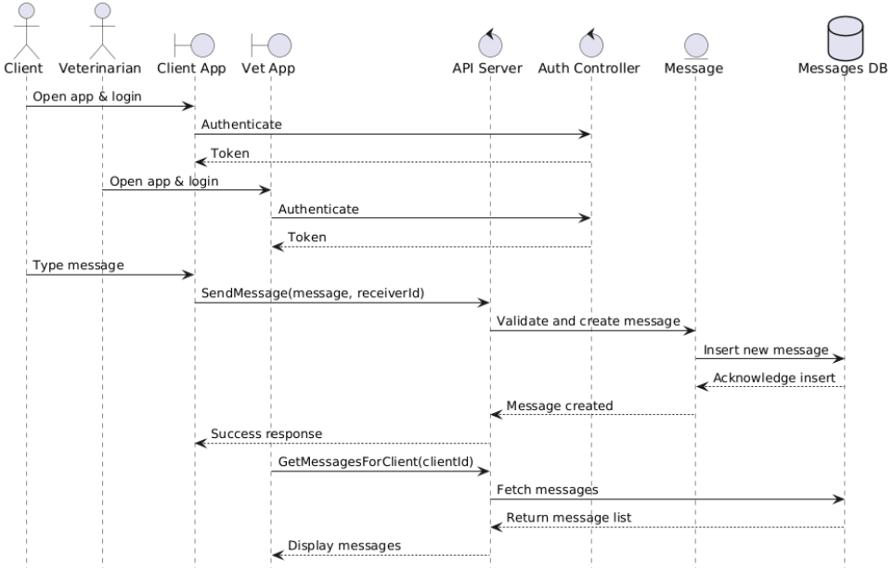
Figure 44:sequence diagram for the " send Message " use case

The sequence diagram for the " Start Teleconsultation Video Call " use case is shown in the figure below.
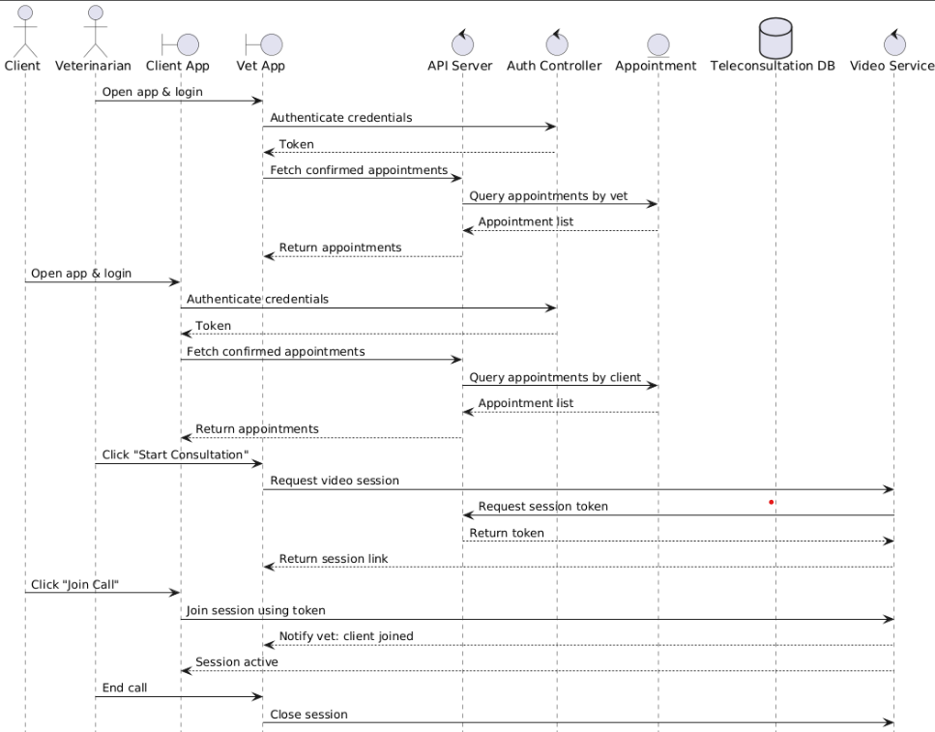
Figure 45:sequence diagram for the " Start Teleconsultation Video Call " use case

Realization
This sprint implements the Messaging and Teleconsultation modules, enabling real-time communication between clients and veterinarians and providing a secure environment for remote consultations through video calls.

Client Mobile Application
Clients can send and receive messages to/from assigned veterinarians.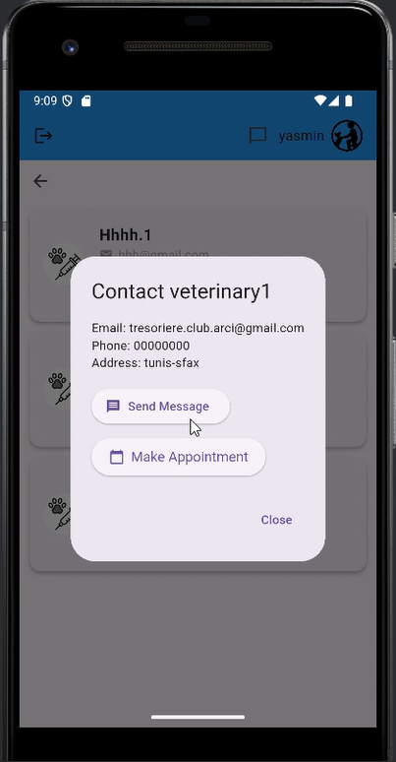 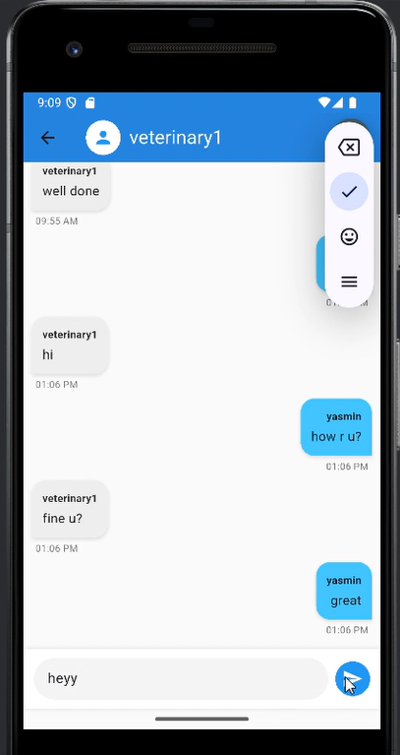 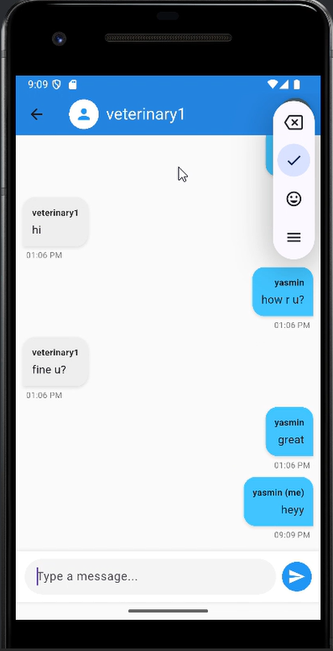
Figure 46:send and receive messages
Clients receive a secure video session link once a consultation is initiated.


Clients can join the teleconsultation session and communicate in real-time.


Veterinarian Mobile Application
Veterinarians can send messages to clients related to their appointments or general inquiries.

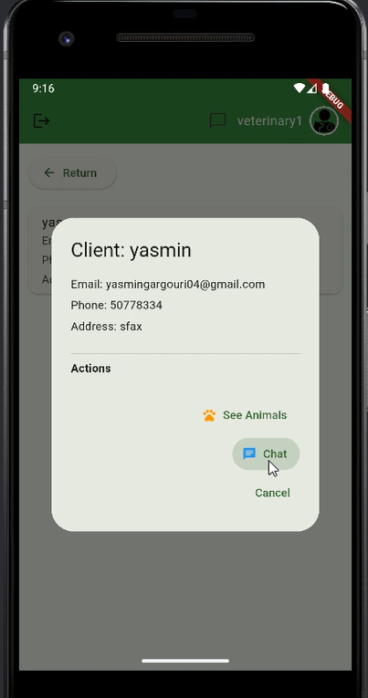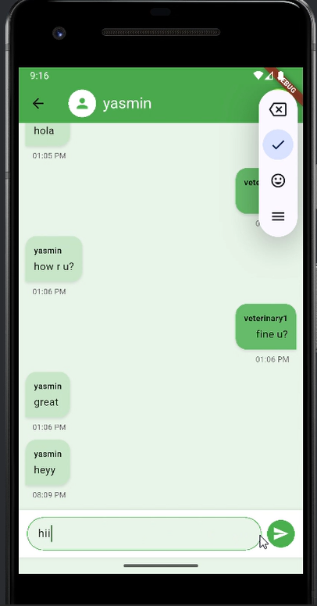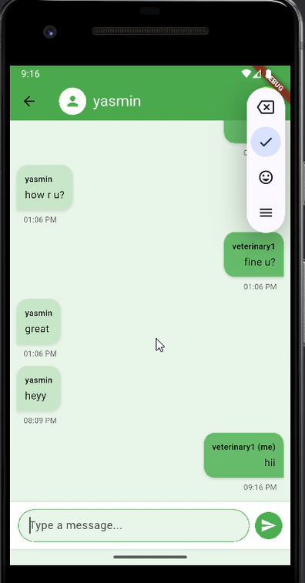
Veterinarians can initiate teleconsultation video calls by creating and sharing a video session link.

During the call, veterinarians can perform real-time consultations and update the medical record afterward.


Validation Tests for Sprint 2
Test cases | Gait | Expected behavior | Results
Message Sending Test (Client/Vet) | Compose message → Select recipient → Send message | 1. Message form is filled correctly. 2. Message is saved in the database and displayed in both inboxes. | Conformable
Message Fetching Test | Open chat interface | 1. Messages between client and veterinarian are loaded correctly from backend. | Conformable
Start Video Consultation (Vet) | Select appointment → Click "Start Consultation" | 1. Video session link is generated. 2. Session token is secured and shared with the client. | Conformable
Join Video Consultation (Client) | Click session link | . 1. Client is authenticated. 2. Client joins the video call successfully using token/session URL.. | Conformable
Video Session Lifecycle Test | Start → In-session → End consultation | 1. Connection established. 2. Video/audio quality maintained. 3. Proper termination and cleanup of session. | Conformable
Database Consistency Test | Verify message/consultation creation and deletion in PostgreSQL | . 1. All related tables are updated accurately. 2. Foreign key constraints are preserved. | Conformable

Conclusion
This sprint successfully delivered the core features for real-time communication and remote veterinary consultations. Messaging allows seamless interaction between users, while the video call system ensures high-quality, secure teleconsultations. All implemented functionalities passed validation tests, ensuring a consistent, integrated, and user-friendly experience across both mobile apps and the admin interface. These improvements significantly enhance the platform’s value for both veterinary professionals and pet owners.

CHAPTER 7: SPRINT 4: Notifications

