|  |  |  |  |  |
| --- | --- | --- | --- | --- |
| Description: logo baru PMTG | | | | |
| **CODE / COURSE** | **DFN40323-PROGRAMMING ESSENTIALS IN PYTHON** | **ASSESSMENT** | **PRACTICAL TEST** | |
| **PROGRAM / CLASS** | **DDT4A** | **DURATION** | **2 HOURS** | |
| **STUDENT’S NAME** | **MUHAMMAD AFIQ MUHAIMIN BIN MOHD ZAINI** | **CLO** | **1P** |  |
| **REG. NO.** | **32DDT20F2029** | **TOTAL MARKS** | **/100** | |
| **LECTURER’S NAME** | **PN. SHARIZAN BINTI ABDUL JAMIL** |

ANSWER SHEET FOR FINAL ASSESSMENT

(PRACTICAL TEST)

(100 MARKS)

SESSION I 2022/2023

**INSTRUCTIONS:**

1) Answer **ALL** questions.

2) **Save** all the answers **in a folder** (.py files **AND** Answer Sheet file) using the following format:

**<name>_<registration no>**. Example: SHARIZAN_32DDT20F1002

3) Compress folder into **.zip file format.**

4) **Upload** the file in **link provided in DFN40323 PROGRAMMING ESSENTIALS IN PYTHON on CIDOS platform**.

---------------------------------------------------------------------------------------------------------

|  |
| --- |
| **ANSWER QUESTION 1: (50 marks)**  ***JAWAPAN SOALAN 1: (50 markah)*** |
| **SOURCE CODE:**  ***KOD ATURCARA:***  **\*snip and paste your source code here. (Make sure it is snipped from your text editor/ Python platform). Refer Appendix 1 for an example.**  ***\*potong dan tampal kod aturcara anda di sini. (Pastikan diambil terus daripada ‘text editor’/ platform Python yang digunakan). Rujuk Lampiran 1 untuk contoh.*** |

|  |
| --- |
| **OUTPUT:**  ***KELUARAN:***  **\*snip and paste your output here. (Make sure it is from your command prompt/ Python platform). Refer Appendix 1 for an example.**  ***\*potong dan tampal keluaran anda di sini. (Pastikan diambil terus daripada ‘command prompt’/platform Python yang digunakan). Rujuk Lampiran 1 untuk contoh.*** |

|  |
| --- |
| **ANSWER QUESTION 2: (50 marks)**  ***JAWAPAN SOALAN 2: (50 markah)*** |
| **SOURCE CODE:**  ***KOD ATURCARA:***  **\*snip and paste your source code here. (Make sure it is snipped from your text editor/ Python platform). Refer Appendix 1 for an example.**  ***\*potong dan tampal kod aturcara anda di sini. (Pastikan diambil terus daripada ‘text editor’/ platform Python yang digunakan). Rujuk Lampiran 1 untuk contoh.***  ***Check Connection***    ***Create Database***    ***Create table***    ***Insert Data***    ***Update data***    ***Display Data*** |
| **OUTPUT:**  ***KELUARAN:***  **\*snip and paste your output here. (Make sure it is from your command prompt/ Python platform). Refer Appendix 1 for an example.**  ***\*potong dan tampal keluaran anda di sini. (Pastikan diambil terus daripada ‘command prompt’/platform Python yang digunakan). Rujuk Lampiran 1 untuk contoh.***  ***Create Connection***    **Create Database**      **Create table**      **Insert Data**      **Update Data**    **Before Update**    **After Update**    **Display data** |

**Appendix 1**

**Example of source code:**

1. If you use Python platform to write the source code

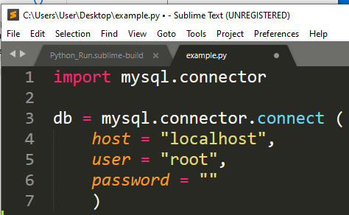

1. If you use text editor to write the source code

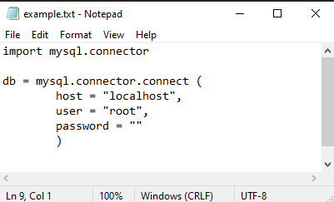

**Example of output:**

1. If you use Python platform (e.g Sublime to compile and execute)

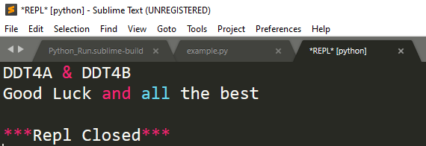

1. If you use Command Prompt to compile and execute

