Q1

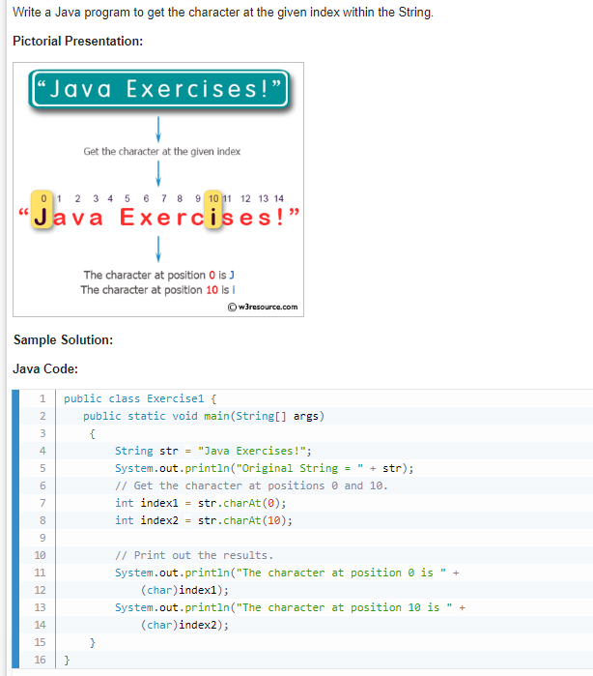

Code

Output

Q2

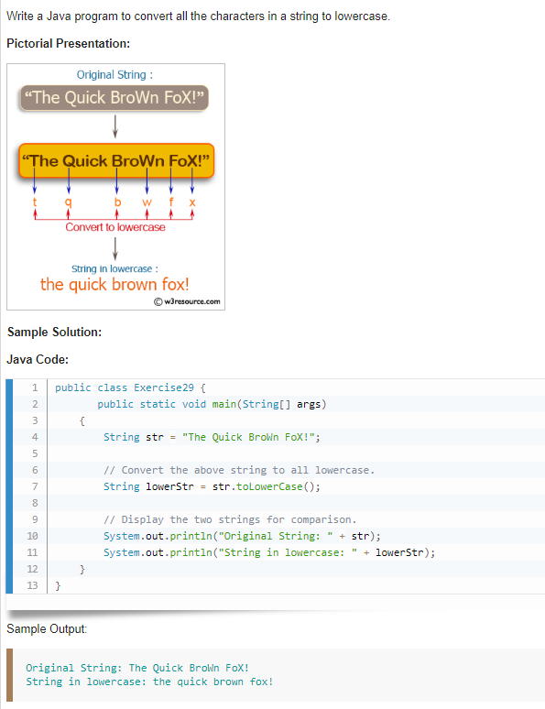

Code

Output

