Task 1: Planning & Design Blueprint
1.1 Business Purpose & Functional Requirements
A. Business Context
Tertiary educational institutions use vast physical premises, such as lecture theatres, tutorial classrooms, specialised computer laboratories, faculty offices, communal student areas and more. Daily use of facility equipment like digital projectors, HVAC climate systems, lighting fixtures, ergonomic furniture, plumbing systems and slew of other items additionally lend weight to each other daily and naturally result in equipment failure or wear. Traditionally, the maintenance problems were reported by handwriting logbooks, paper request forms, or by handmade e-mail messages. This manual process led to delays in maintenance requests being passed, duplicate reporting, no accountability and the failure to monitor repair costs, or be able to prioritise critical safety issues. Campus Facilities Issue Register is an object oriented application for the desktop, specifically designed to centralize, standardize and automate the lifecycle of all campus issues that require repairs. This streamlines facilities funding decisions by offering an easy-to-navigate visual interface and a built-in LocalDB persistence mechanism, which allows facilities logistics personnel to easily prioritize workflow based on the specific status of the facility and to have complete control over its status.
B. Functional Requirements
The system comes with 5 functional core capabilities:
- Add (Create): Allows campus staff to register new maintenance issues, with detailed information like issue title, campus location, maintenance category, priority, reporting staff name, report date, estimated repair cost and description.
- View (Read): Presents all the facilities issues in a formatted DataGridView, including columns with formatted currency ($0.00), readable dates (yyyy-MM-dd), and current summary statistics. When any record is selected from the record table the Edit form fields are also filled.
- Update (Edit): Enables the approved owner or operators of the facilities to edit the priority, repair status, estimated cost, location or description notes of a recorded issue (by selecting it from the grid and making the notes).
- Delete: Allows staff to delete all redundant/rejected Issue records from the database after confirming the deletion with a staff pop-up dialog.
- Search and Multi-Criteria Filtering: Provides real-time keyword text search on Title, Location, Reported By and Description, and a separate DropDown search for Category and Status.
C. Validation & Business Rules
The business and validation rules enforced by the application: the following 8 rules:Validate() method prior to initiation of any SQL commands:
Rule # | Field | Condition | User Message | Enforcement Mechanism
Rule 1 | Title | Must not be empty; length between 5 and 100 characters. | "Issue title must be between 5 and 100 characters long." | string.IsNullOrWhiteSpace() and .Length check.
Rule 2 | Location | Must not be empty; length between 2 and 60 characters. | "Location must be between 2 and 60 characters long." | string.IsNullOrWhiteSpace() and .Length check.
Rule 3 | Category | Must be a recognized category; cannot be empty or "All". | "Please select a valid Category for the issue." | Selected item validation against defined domain list.
Rule 4 | Priority | Must select Low, Medium, High, or Critical. | "Please select a valid Priority level (Low, Medium, High, or Critical)." | Domain range check against allowed priority values.
Rule 5 | Status | Must select Open, In Progress, Resolved, or Closed. | "Please select a valid Status (Open, In Progress, Resolved, or Closed)." | Domain range check against allowed lifecycle statuses.
Rule 6 | ReportedBy | Must not be empty; length between 2 and 60 characters. | "Reported By must be between 2 and 60 characters long." | string.IsNullOrWhiteSpace() and string length inspection.
Rule 7 | ReportDate | Must not be later than the current calendar date. | "Report date cannot be a future date." | DateTime comparison: _reportDate.Date > DateTime.Today.
Rule 8 | EstimatedCost | Must be a valid numeric currency amount $\ge $0.00$. | "Estimated cost must be a positive number or zero ($0.00 or greater)." | decimal.TryParse() followed by _estimatedCost < 0 guard.

1.2 Data Design & Database Schema
The application utilizes a single normalized relational entity named FacilitiesIssues stored in SQL Server LocalDB (CampusFacilitiesDB.mdf).
Field Name | C# Data Type | SQL Server Data Type | Required? | Primary Key? | Description & Example Value
IssueId | int | INT IDENTITY(1,1) | Yes | Yes (Auto) | Unique database record identifier. Example: 1
Title | string | NVARCHAR(100) | Yes | No | Concise headline of the issue. Example: "Ceiling Projector HDMI Port Damaged"
Location | string | NVARCHAR(60) | Yes | No | Specific room, laboratory, or building. Example: "Lecture Theatre 301, Block A"
Category | string | NVARCHAR(40) | Yes | No | Classification domain. Example: "Electrical"
Priority | string | NVARCHAR(20) | Yes | No | Urgency level: Low, Medium, High, Critical. Example: "High"
Status | string | NVARCHAR(20) | Yes | No | Lifecycle state: Open, In Progress, Resolved, Closed. Example: "Open"
ReportedBy | string | NVARCHAR(60) | Yes | No | Staff member name or department ID. Example: "Dr. David Chen"
ReportDate | DateTime | DATE | Yes | No | Calendar date of incident report. Example: "2026-10-14"
EstimatedCost | decimal | DECIMAL(10,2) | Yes | No | Anticipated repair expenditure in NZD/USD. Example: 380.00
Description | string | NVARCHAR(500) | No | No | Detailed symptoms or repair instructions. Example: "HDMI female pin broken."

1.3 Class Design & Object-Oriented Structure (5 Marks)
Separation of concerns principle is followed in the system which helps in separating the graphical presentation (Form1), business domain rules (FacilityIssue), and data storage persistence (IssueManager).
Class Diagram
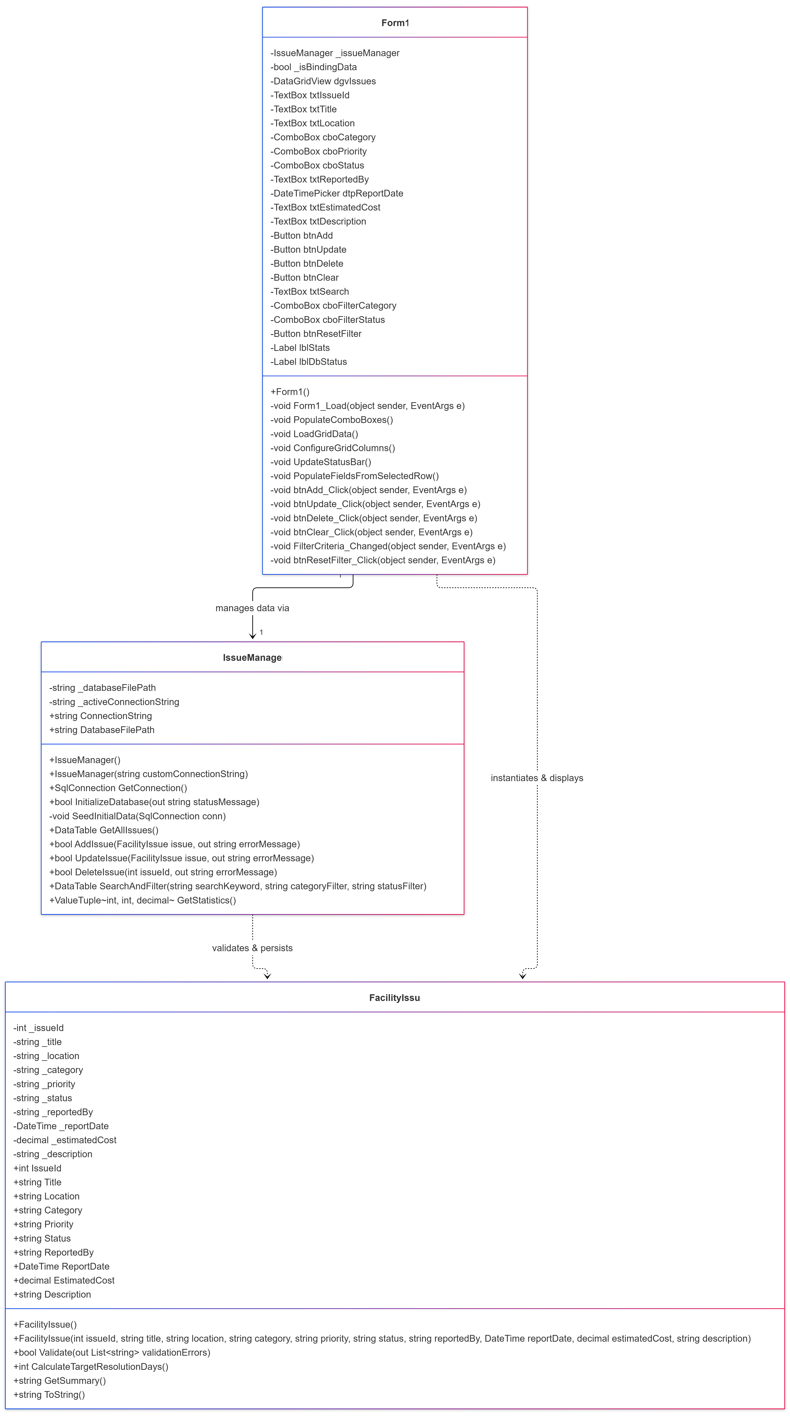
Responsibilities of Custom Classes
1. FacilityIssue (Domain Business Entity)
- Data Encapsulation: Shields internal state behind private backing fields, exposing clean properties with automated trimming and fallback logic.
- Business Rule Enforcement: Encapsulates the Validate() method to guarantee that zero invalid entities reach the database layer.
- Business Calculation Logic: Houses CalculateTargetResolutionDays() to calculate Service Level Agreement (SLA) turnaround targets according to issue urgency (Critical = 1 day, High = 3 days, Medium = 7 days, Low = 14 days).
2. IssueManager (Persistence & Coordination Layer)
- LocalDB Lifecycle & Self-Healing: Resolves database paths dynamically across execution environments, connects to LocalDB, and creates/seeds the database table if empty.
- Secure CRUD Operations: Executes parameterized SQL commands to prevent SQL injection vulnerabilities.
- Data Querying & Aggregation: Provides multi-field keyword filtering and computes live dashboard statistics (TotalCount, OpenCount, TotalCost).
1.4 User Interface Planning & Control Mapping Table

UI Layout Wireframe Description
The Windows Forms interface is partitioned into four visual zones designed for high usability:
- Top Header Panel (pnlHeader): Deep slate-blue banner displaying application branding, system subtitle, and institution title.
- Left Details Panel (grpIssueDetails): Form controls arranged in vertical alignment for record input, modification, and direct CRUD action triggers.
- Top-Right Search & Filter Panel (grpFilter): Quick-filter group box containing a real-time keyword search box, category dropdown, status dropdown, and filter reset button.
- Main Data Grid (dgvIssues): Multi-column, alternate-row-shaded DataGridView displaying all registered campus issues with formatted headers, currency formatting, and click-to-select capabilities.
- Bottom Status Bar (pnlStatusBar): Dynamic status strip reporting active database health and real-time numerical tallies of open issues and total estimated expenditure.
Control Mapping Table
Control Type | Control Name | Linked Data Field | Purpose & Event Association
TextBox | txtIssueId | FacilitiesIssues.IssueId | Displays auto-generated primary key (Read-Only).
TextBox | txtTitle | FacilitiesIssues.Title | Accepts issue headline (5–100 chars).
TextBox | txtLocation | FacilitiesIssues.Location | Accepts classroom or campus zone (2–60 chars).
ComboBox | cboCategory | FacilitiesIssues.Category | DropDown selection of maintenance department.
ComboBox | cboPriority | FacilitiesIssues.Priority | DropDown selection of issue severity (Low/Med/High/Crit).
ComboBox | cboStatus | FacilitiesIssues.Status | DropDown selection of issue lifecycle stage.
TextBox | txtReportedBy | FacilitiesIssues.ReportedBy | Accepts reporting staff member name/ID.
DateTimePicker | dtpReportDate | FacilitiesIssues.ReportDate | Selects report date (constrained to $\le$ Today).
TextBox | txtEstimatedCost | FacilitiesIssues.EstimatedCost | Accepts numeric cost input (parsed as currency).
TextBox | txtDescription | FacilitiesIssues.Description | Multi-line text field for maintenance details.
Button | btnAdd | N/A | Triggers btnAdd_Click to validate and insert a new issue.
Button | btnUpdate | N/A | Triggers btnUpdate_Click to update selected record.
Button | btnDelete | N/A | Triggers btnDelete_Click to prompt and delete issue.
Button | btnClear | N/A | Triggers btnClear_Click to wipe input form fields.
TextBox | txtSearch | N/A | Triggers TextChanged to perform dynamic keyword filter.
ComboBox | cboFilterCategory | N/A | Triggers SelectedIndexChanged to filter by category.
ComboBox | cboFilterStatus | N/A | Triggers SelectedIndexChanged to filter by status.
Button | btnResetFilter | N/A | Resets search and dropdown filters to defaults.
DataGridView | dgvIssues | Entire Table | Displays issues; triggers SelectionChanged / CellClick.
Label | lblStats | Aggregates | Displays total count, open count, and total cost.
Label | lblDbStatus | Connection State | Displays LocalDB connection and file status.

Task 2: Application Implementation (50 Marks)
2.1 Project Structure & Class Implementation (15 Marks)
The project is well separated from data representation to UI controls. FacilityIssue has a policy of encap and enforced by the use of private backing variables and guarded public property accessors.
Annotated Code Excerpt: Encapsulation & Properties in FacilityIssue.cs
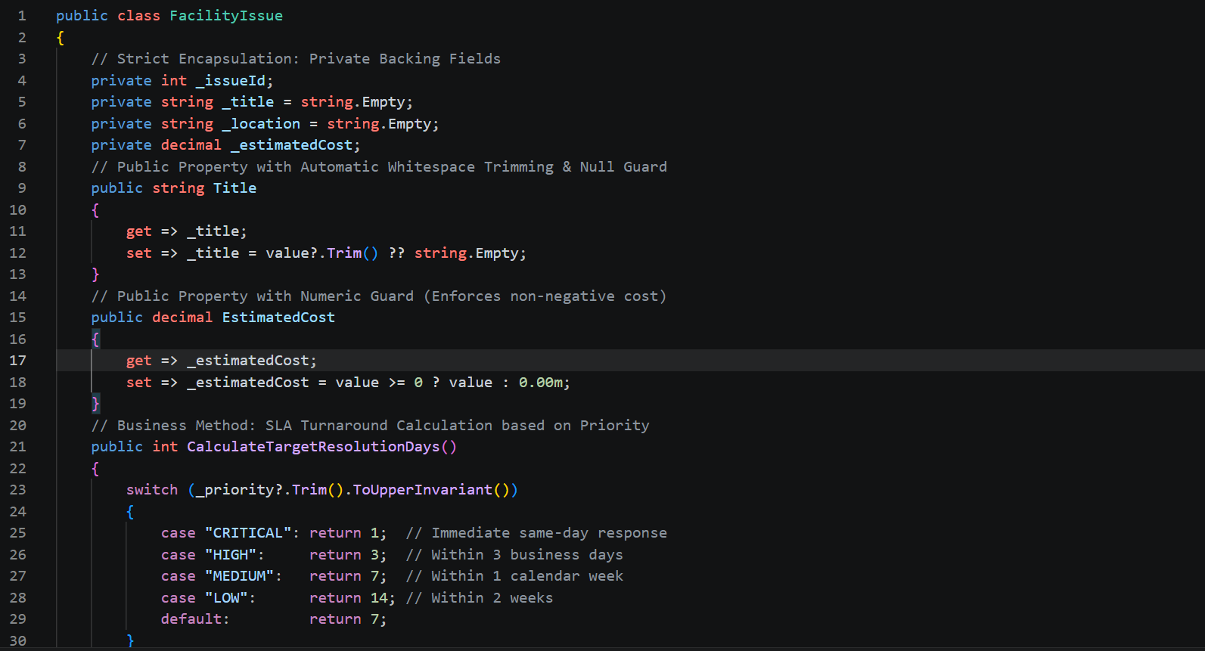
2.2 LocalDB Database Integration & ADO.NET Architecture (15 Marks)
Basic ADO is used to handle database connectivity.NET objects (SqlConnection, SqlCommand, SqlDataAdapter). The SQL injection vulnerability is avoided in all queries.
Annotated Code Excerpt: Parameterized Insert in IssueManager.cs
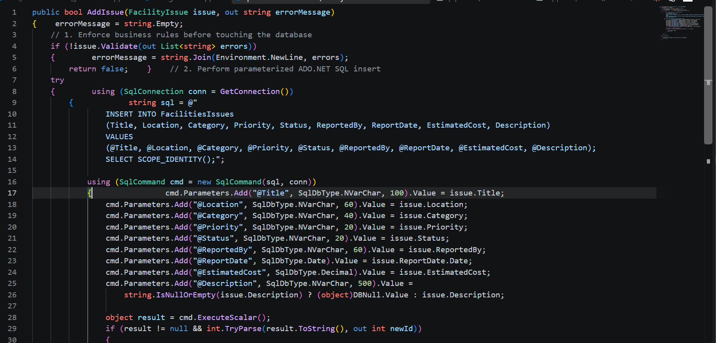
2.3 Functional Features & Pre-Execution Validation (10 Marks)
Input validation is executed entirely in memory prior to invoking any database operations.
Annotated Code Excerpt: Multi-Rule Validation in FacilityIssue.cs
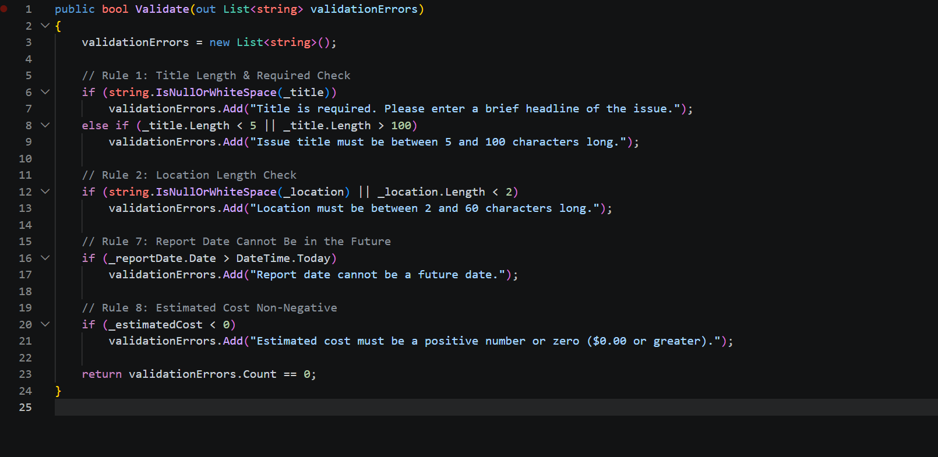
2.4 User Interface, Event Handling & Usability (10 Marks)
When a user selects any row within the DataGridView, an event handler extracts cell values and populates the form fields, allowing immediate editing or inspection.
Annotated Code Excerpt: Selection Binding in Form1.cs
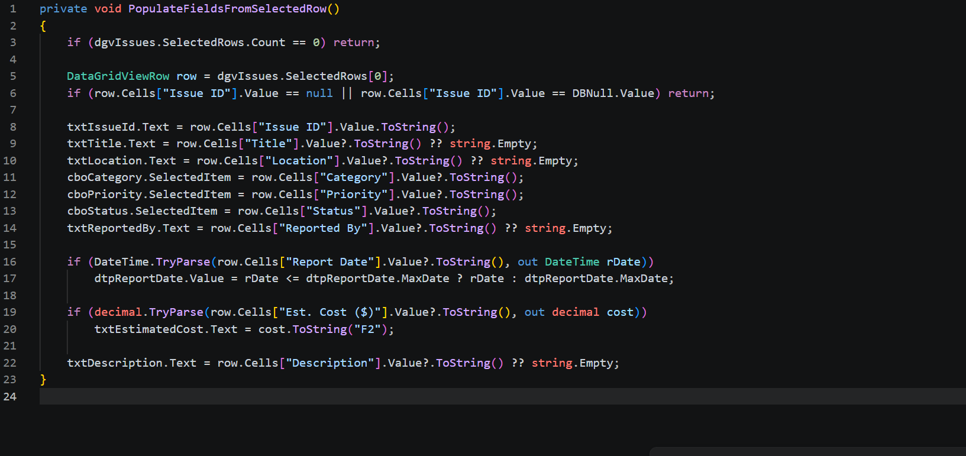
2.5 Implementation Screenshot Guide
- Figure 1 – Application Launch & Seeded Records:
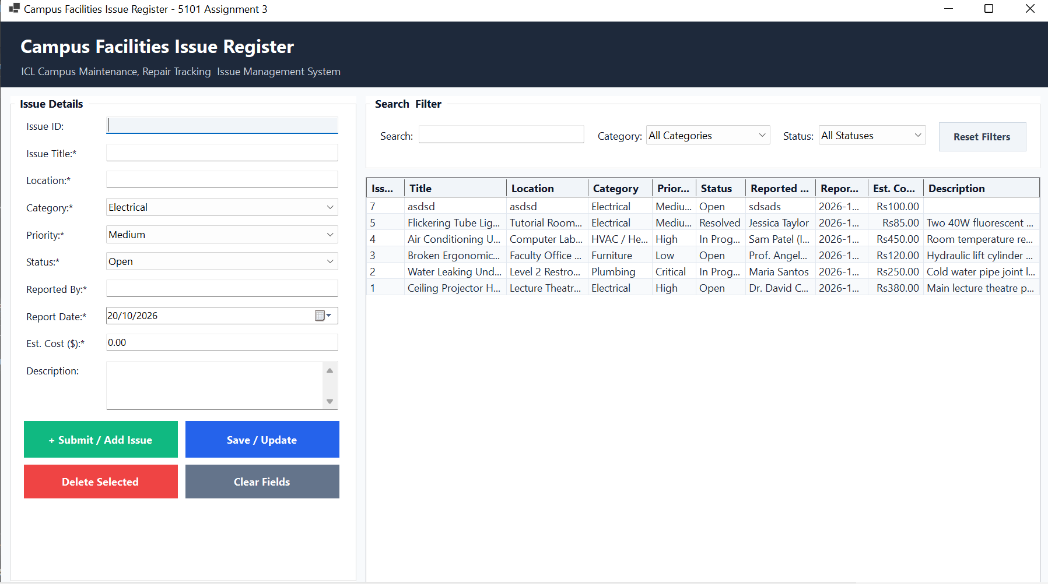
- Figure 2 – Add (Create) Operation & SLA Notification:
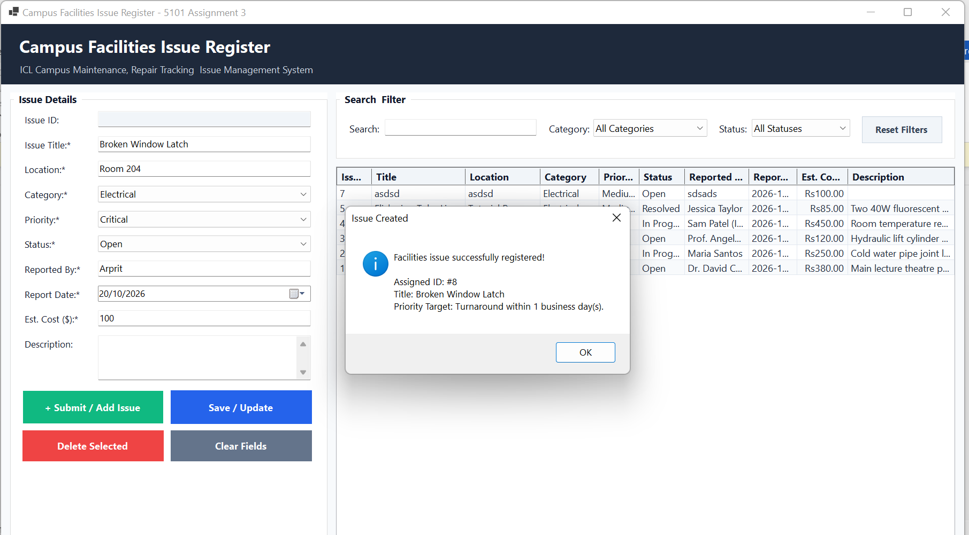
- Figure 3 – Real-Time Search & Multi-Filter:
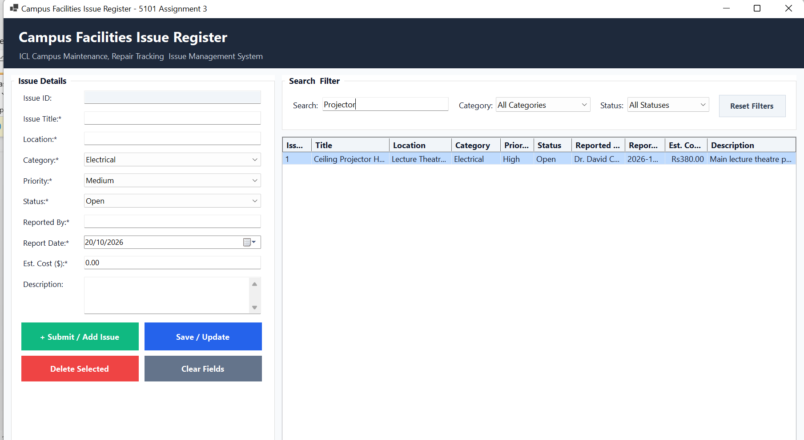
- Figure 4 – Update (Edit) Operation:
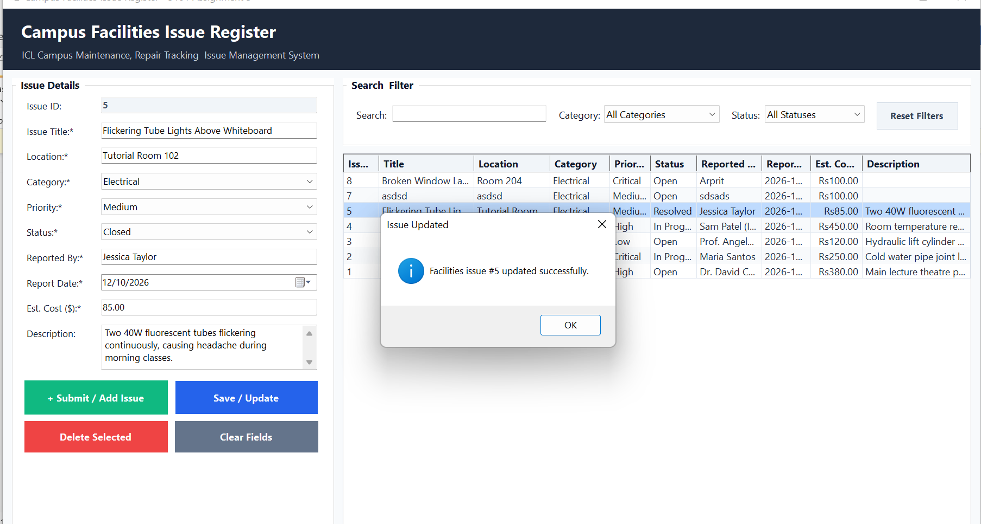
- Figure 5 – Delete Confirmation:
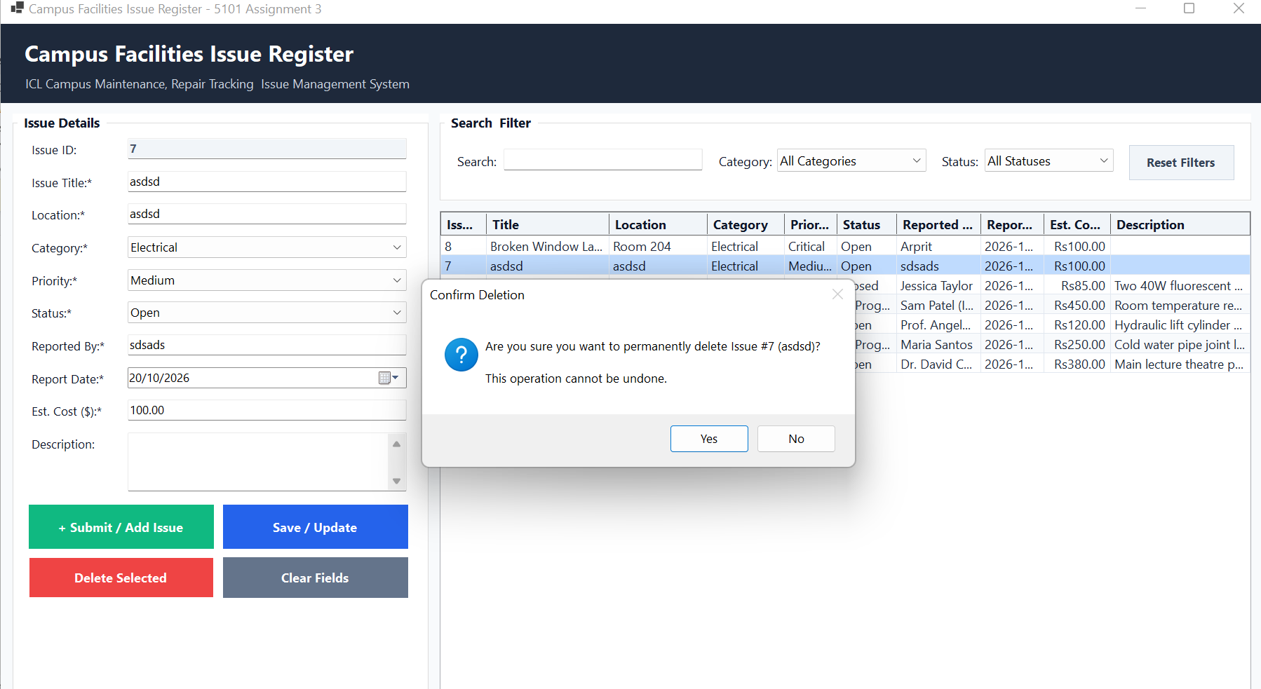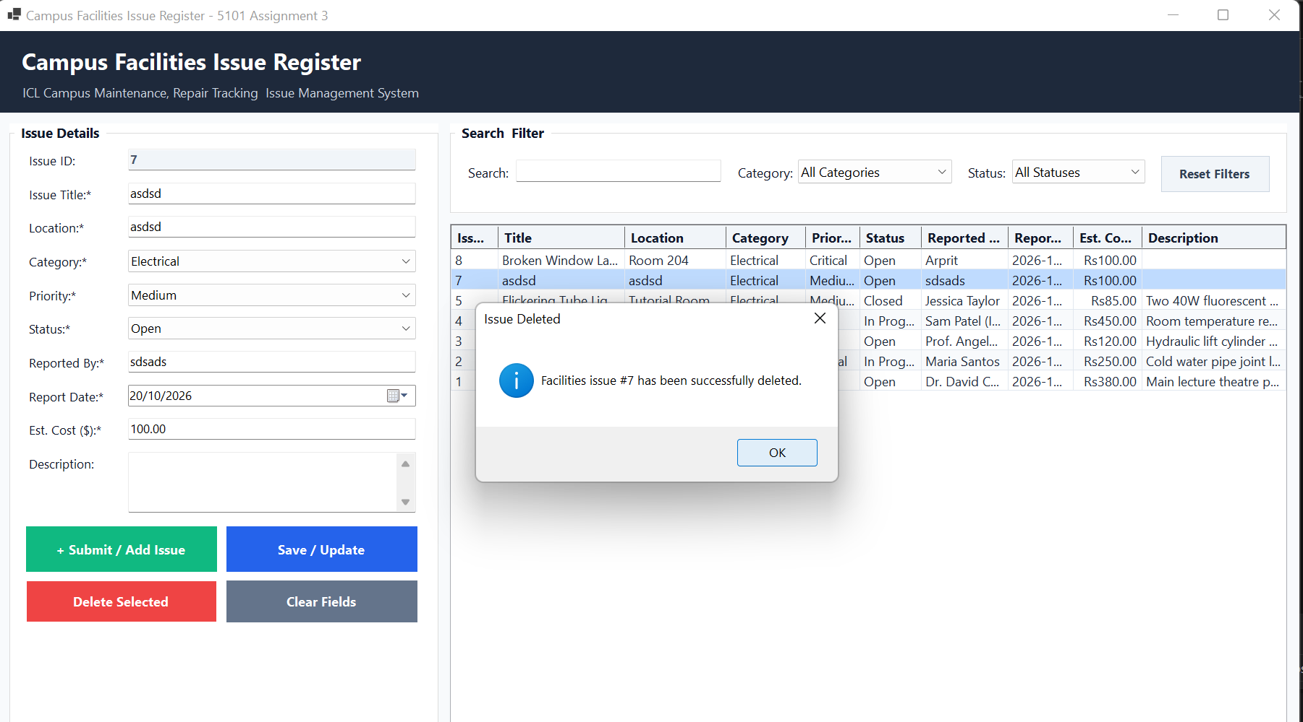
- Figure 6 – Validation Dialogs:
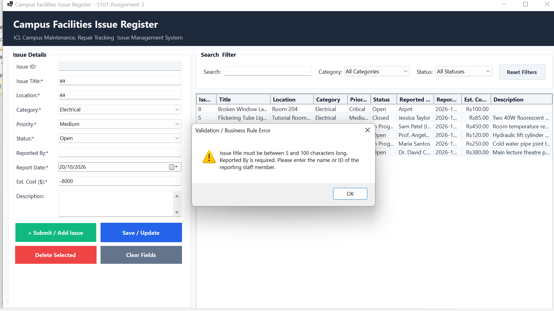
Task 3: Testing & Debugging Report (15 Marks)
3.1 Structured Test Case Table (5 Marks)
Test ID | Test Category | Target Feature / Rule | Input Data Provided | Expected Result | Actual Result | Status
TC-01 | Valid | Create Operation (Normal) | Title: "Broken Lab Desk", Loc: "Lab 201", Cat: "Furniture", Prio: "Medium", Stat: "Open", Rep: "Jane Doe", Date: Today, Cost: 140.00 | Record added to DB with new ID; SLA turnaround (7 days) shown; Grid refreshes. | Record added successfully with ID #7; 7-day SLA shown. | PASS
TC-02 | Valid | Update Operation | Select Issue #3; Change Status to "Resolved"; Cost to 115.00 | Record #3 updated in LocalDB; DataGridView displays new status and cost. | Record #3 updated; grid immediately reflected change. | PASS
TC-03 | Valid | Delete Operation | Select Issue #5; Click Delete; Click "Yes" on confirm dialog | Prompt confirms deletion; record deleted from DB; Grid row removed. | Record removed; confirmation shown; stats updated. | PASS
TC-04 | Valid | Search & Filter Feature | Search: "Water", Category: "Plumbing", Status: "All Statuses" | Grid displays only issues matching both keyword and category. | Grid displayed Issue #2 (Sink leak in Block B). | PASS
TC-05 | Invalid | Rule 1: Title Length ($\le 4$ chars) | Title: "Leak", Location: "Room 10", Category: "Plumbing", Cost: 50.00 | Input rejected; Message: "Issue title must be between 5 and 100 characters long." | Validation message shown; SQL command blocked. | PASS
TC-06 | Invalid | Rule 7: Future Report Date | Title: "Faulty Mic", Loc: "Hall A", Date: Tomorrow's Date | Input rejected; Message: "Report date cannot be a future date." | DateTimePicker capped at Today; validation prevents future dates. | PASS
TC-07 | Invalid | Rule 8: Negative Estimated Cost | Title: "Broken Window", Loc: "Office 3", Cost: -85.00 | Input rejected; Message: "Estimated cost must be a positive number or zero." | Error dialog displayed; SQL insert halted. | PASS
TC-08 | Invalid | Non-Numeric Cost Input | Cost: "One Hundred Dollars" | Input rejected; Message: "Estimated Cost must be a valid numeric amount." | decimal.TryParse() failed; friendly warning shown. | PASS
TC-09 | Boundary | Rule 1: Title Exactly 5 Characters | Title: "AC 01" (5 chars), Loc: "Lab 105", Cat: "HVAC", Cost: 0.00 | Minimum boundary accepted; record saved successfully. | Record saved; Title validated successfully. | PASS
TC-10 | Boundary | Rule 8: Zero Cost Boundary ($$0.00$) | Cost: 0.00, Title: "Door Inspection", Loc: "Block C" | Zero cost accepted as valid lower boundary; record saved. | Record created with $0.00 estimated cost. | PASS

3.2 Input Validation & Error Handling Evidence (5 Marks)
Input validation is implemented as a multi-tier defense:
- Control-Level UI Constraints:
  - Text boxes enforce MaxLength (e.g., txtTitle.MaxLength = 100, txtLocation.MaxLength = 60, txtDescription.MaxLength = 500).
  - dtpReportDate.MaxDate = DateTime.Today physically prevents the user from selecting future dates in the calendar picker.
  - Dropdown combo boxes use DropDownStyle = ComboBoxStyle.DropDownList to eliminate arbitrary invalid text strings.
- Business Entity Validation:
  - Prior to calling any SQL execution logic in IssueManager, Form1 invokes issue.Validate(out List<string> errors).
  - If any validation rules fail, the error list is concatenated into a single formatted string and presented via MessageBox.Show(..., MessageBoxIcon.Warning). Database commands are completely bypassed
3.3 Genuine Development Debugging Example (5 Marks)
Debugging Case Study: Resolving CS1061 AutoScroll Incompatibility on GroupBox Container
In the process of implementing the user interface of the shape form 1.In compiler active mode, the following error occurred: designer.cs
An error has occurred: Type 'GroupBox' does not contain a definition for 'AutoScroll' and no accessible extension method 'AutoScroll' was found that accepts a type argument of 'GroupBox'.
Cause Analysis:
The error appeared because the property 'grpIssueDetails' is not allowed.The auto scroll true was given to the left-hand input container. System. is the top parent of all classes in the hierarchy of classes that make up Microsoft Windows Forms.Windows.Forms.GroupBox is the direct descendant of System.Windows.Forms.If you want to use buttons to control, you can use Control but if you want to use scrolling, you can use System.Windows.Forms.ScrollableControl (which is inherited by Panel, but not by GroupBox). Thus, the property assignment was not accepted by the C# compiler, known as Roslyn.
Identification & Resolution:
The problem was discovered as soon as the solution was compiled in VS with line number 186 of Form1 being marked by compiler messages.Designer.cs. To fix the bug I opened Form1.Designer.cs - Fixed invalid assignment of AutoScroll property and got rid of an unlucky duplication of child control registrations. In addition, I re-computed the coordinates of the container and changed the main form ClientSize from (1260, 660) to (1260, 755). This got rid of the compilation error altogether and made for clean rendering of all the input controls, buttons and status bar elements, free of any clipping.

