**Oregon Health and Science University (OHSU-1): Functional Genomic Landscape of Acute Myeloid Leukaemia**

Beat AML program is a cohort of 672 tumor specimens collected from 562 patients. The study summarizes the initial findings of the analyses of *ex vivo* drug sensitivity. Samples were characterized using whole-exome sequencing, RNA sequencing and this data is available through [NCI Genomics Data Commons](https://gdc.cancer.gov/about-data/publications/BEATAML1-0-CRENOLANIB-2019). These datasets can be leveraged to address clinical, genomic, transcriptomic, and functional analyses of the biology of AML.

Read the [abstract](https://www.ncbi.nlm.nih.gov/pubmed/30333627)

### **Experimental Approaches**

*Ex vivo* functional drug screens were performed on freshly isolated mononuclear cells. In brief, 10,000 cells per well were arrayed into three, 384-well plates containing 122 small-molecule inhibitors. This panel contained graded concentrations of drugs with activities against two-thirds of the tyrosine kinome as well as other non-tyrosine kinase pathways, including mitogen-activated protein kinases (MAPKs), the pathway involving phosphatidylinositol-4,5-bisphosphate 3-kinase, AKT serine/threonine kinase 1, and mechanistic target of rapamycin kinase (PIK3C–AKT–MTOR); protein kinase AMP-activated (AMPK, also known as PRKAA1), ATM serine/threonine kinase (ATM), aurora kinases, calcium/calmodulin-dependent protein kinases (CAMKs), cyclin-dependent kinases (CDKs), serine/threonine-protein kinase 3 (GSK3), IκB kinase (IκK), cAMP-dependent protein kinase (PKA), protein kinase C (PKC), polo-like kinase 1 (PLK1), and RAF proto-oncogene serine/threonine kinase (RAF). In addition, the library contained small-molecule inhibitors with activity against the BCL2 family, bromodomain containing 4 (BRD4), hedgehog heat shock protein 90 (HSP90), NOTCH/γ-secretase, proteasome, survivin, signal transducer and activator of transcription 3 (STAT3), histone deacetylase (HDAC), and WNT/β-catenin. Drug plates were created using inhibitors purchased from LC Laboratories and Selleck Chemicals and master stocks were reconstituted in dimethyl sulfoxide (DMSO) and stored at −80 °C. Master plates were created by distributing a single agent per well in a seven-point concentration series, created from threefold dilutions of the most concentrated stock resulting in a range of 10 μM to 0.0137 μM for each drug (except dasatinib, ponatinib, sunitinib and YM-155, which were plated at a concentration range of 1 μM to 0.00137 μM). DMSO-control wells and positive-control wells containing a drug combination of flavopiridol, staurosporine, and Velcade were placed on each plate, with the final concentration of DMSO ≤0.1% in all wells. Daughter plates were created using a V&P Scientific 384-well pin tool head operated by the Caliper Sciclone ALH 3000 and equipped with 0.457-mm diameter, 30-nL, slotted stainless-steel pins (FP1NS30). Daughter and destination plates were sealed with peelable thermal seals using a PlateLoc thermal sealer. Destination plates were stored at −20 °C for no more than three months and thawed immediately before use. Primary mononuclear cells were plated across single-agent inhibitor panels within 24 h of collection. Cells were seeded into 384-well assay plates at 10,000 cells per well in Roswell Park Memorial Institute (RPMI) 1640 medium supplemented with fetal bovine serum (FBS) (10%), L-glutamine, penicillin-streptomycin, and β-mercaptoethanol (10–4 M). After three days of culture at 37 °C in 5% CO2, MTS reagent (CellTiter96 AQueous One; Promega) was added, the optical density was measured at 490 nm, and raw absorbance values were adjusted to a reference blank value and then used to determine cell viability (normalized to untreated control wells).

With regard to data processing, a workflow in which the data normalization, curve-fit parameters, and quality assurance/quality control steps are summarized is shown below (Figure 1). A given sample was run on one or more panels and within each panel, the majority of drugs were run without within-panel replicates. Two steps were performed to harmonize these data before model fitting.

First, a ‘curve-free’ AUC (integration based on fine linear interpolation between the seven data points themselves) was calculated for those runs with within-panel replicates after applying a ceiling of 100 and a floor of 0 for the normalized viability. The maximum change in AUC among the replicates was noted and those runs with differences >100 were removed. Second, the remaining within-plate replicates had their normalized viability averaged subject to a ceiling of 100 and floor of 0. An additional set of ‘curve-free’ AUCs was computed for sample-inhibitor pairs run on multiple panels. The maximum change in AUC among the across-panel replicates was noted and those runs with differences >75 were removed. At this point, the within- and across-plate replicates for the normalized viability were averaged together and a ceiling of 100 was applied. From the steps above, the floor was already at 0. On the basis of the methodology used in the prior drug-combination study1, a probit regression was fit to all possible run groups using the model: (normalized viability/100) ~ 1 + log10 (concentration). For all groups there were n=7 dose-response measurements. The summary analyses of curve fit were inspected and cut-offs were devised removing all runs with an Akaike information criteria (AIC) > 12 and deviance >2. For inhibitors that were run using multiple concentration ranges, only the most-recent concentration range was kept. Finally, these data were compared to the AUC values from third-order polynomial fits. Those runs that were discrepant in terms of sensitive or resistant calls were manually reviewed as subject to removal.

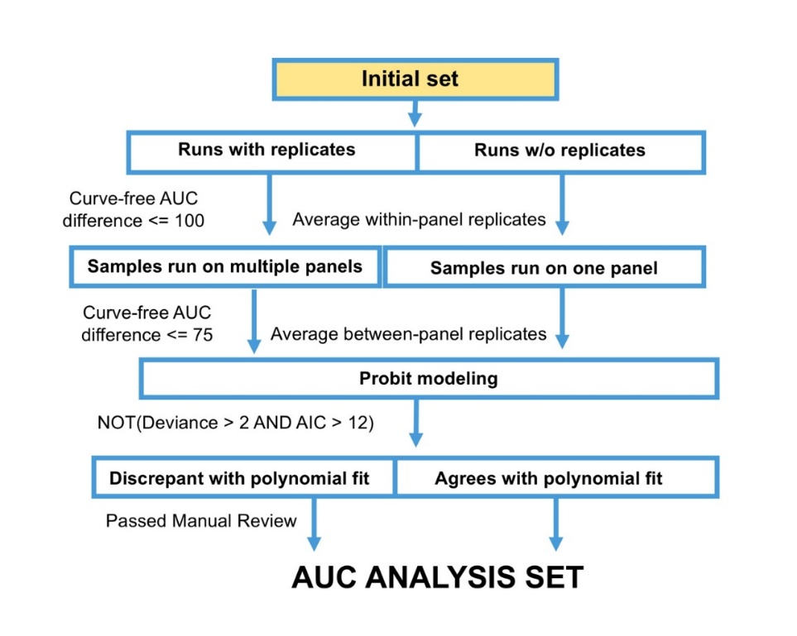

Read the detailed [Experimental Approaches](https://www.nature.com/articles/s41586-018-0623-z)

### **Data**

Access the Raw/Analyzed Data (DCC): <https://ctd2-data.nci.nih.gov/Public/OHSU-1/BeatAML_Waves1_2/>

For questions, please contact [Jeffrey Tyner](mailto:tynerj@ohsu.edu?subject=CTD%5e2%20Data%20Inquiry).

References

1. Kurtz SE et al. (2017). Molecularly targeted drug combinations demonstrate selective effectiveness for myeloid- and lymphoid-derived hematologic malignancies. Proc Natl Acad Sci USA. 114(36):E7554-E7563. (PMID: 28784769)