cmapstats - group means
Silver Rose
2026-08-17

INITIAL SETUP
# Sets the figure device and loads packages.
knitr::opts_chunk$set(echo = TRUE, dev = "emf", fig.ext = "emf", dpi = 300)
rm(list = ls())
library(ggplot2)
library(devEMF)
library(cowplot)
library(emmeans)
## Welcome to emmeans.
## Caution: You lose important information if you filter this package's results.
## See '? untidy'
library(lme4)
## Loading required package: Matrix
library(lmerTest) # must load after lme4
##
## Attaching package: 'lmerTest'
## The following object is masked from 'package:lme4':
##
## lmer
## The following object is masked from 'package:stats':
##
## step
library(car)
## Loading required package: carData
## Registered S3 method overwritten by 'car':
## method from
## na.action.merMod lme4
library(DHARMa)
## This is DHARMa 0.5.0. For overview type '?DHARMa'. For recent changes, type news(package = 'DHARMa')
##
## Note that the default setting in simulateResiduals was changed to conditional simulations since version 0.5.0. This is likely to change residual calculations for all hierarchical (in particular random effect) models. If you want to switch back to the old package version defaults, please use the argument simulateREs = "user-specified" in simulateResiduals(). For more details, see ?simulateREsiduals.
##
## Attaching package: 'DHARMa'
## The following object is masked from 'package:lme4':
##
## getData
library(GLMMadaptive)
##
## Attaching package: 'GLMMadaptive'
## The following object is masked from 'package:lme4':
##
## negative.binomial

DATA PREPARATION
Noise subtraction, artefact blanking, exclusions and normalisation of the pulse data.
# Builds the per-recording noise floor from the 2 mA recruitment-curve stimulus.
noise_current_ma <- 2
group_channels <- c("ADMpk2pk", "filtSNAPpk2pk", "filtelbowpk2pk")
recruitment_data <- read.csv("datafiles/RecruitmentCurves.csv")
# Sorting by `count` keeps the first 2 mA stimulus per subject x frequency.
noise_rows <- subset(recruitment_data, currAmp == noise_current_ma)
noise_rows <- noise_rows[order(noise_rows$subjID, noise_rows$freq, noise_rows$count), ]
noise_floor <- noise_rows[!duplicated(noise_rows[c("subjID", "freq")]),
c("subjID", "freq", group_channels)]
stopifnot(!anyNA(noise_floor[group_channels]))

Import and exclusions
# Builds `pulse_data`: noise-subtracted, artefact-blanked and with exclusions applied.
pulse_data <- read.csv("datafiles/ACpulsedata.csv")
noise_index <- match(paste(pulse_data$subjID, pulse_data$freq),
paste(noise_floor$subjID, noise_floor$freq))
stopifnot(!anyNA(noise_index))
for (ch in group_channels)
pulse_data[[ch]] <- pmax(pulse_data[[ch]] - noise_floor[[ch]][noise_index], 0)
tagged_areas <- read.csv("datafiles/tagged areas.csv")
tag_channel_map <- list(ADM = "ADMpk2pk",
SNAP = "filtSNAPpk2pk",
elbow = "filtelbowpk2pk")
for (i in seq_len(nrow(tagged_areas))) {
in_window <- pulse_data$filename == tagged_areas$filename[i] &
pulse_data$fileStimTime >= tagged_areas$start[i] &
pulse_data$fileStimTime <= tagged_areas$end[i]
for (grp in names(tag_channel_map))
if (tagged_areas[[grp]][i] == 1)
pulse_data[in_window, tag_channel_map[[grp]]] <- NA_real_
}
# Mean over non-NA values; NA rather than NaN when all are NA.
safe_mean <- function(x, ...) if (all(is.na(x))) NA_real_ else mean(x, na.rm = TRUE)
excluded_subjects <- "S03"
pulse_data <- subset(pulse_data, !(subjID %in% excluded_subjects))
stopifnot(all(unique(pulse_data$filename) %in%
pulse_data$filename[pulse_data$measure == "Train"]))
# Channels blanked by subject and frequency; `freq = NA` means all frequencies.
channel_exclusions <- data.frame(
subjID = c("S10", "S05", "S18",
"S18", "S08"),
freq = c( NA, 25, 100,
50, 100),
channel = c("filtelbowpk2pk", "filtelbowpk2pk", "filtSNAPpk2pk",
"ADMpk2pk", "filtSNAPpk2pk"),
stringsAsFactors = FALSE)
for (i in seq_len(nrow(channel_exclusions))) {
excluded_rows <- pulse_data$subjID == channel_exclusions$subjID[i] &
(is.na(channel_exclusions$freq[i]) |
pulse_data$freq == channel_exclusions$freq[i])
pulse_data[excluded_rows, channel_exclusions$channel[i]] <- NA_real_
}
# Blanks a channel for any recording whose pre-train singles mean is below this, in mV.
min_usable_baseline_mv <- 0.005
singles_data <- subset(pulse_data, measure == "Singles")
baseline_by_file <- aggregate(singles_data[group_channels],
by = list(filename = singles_data$filename),
FUN = safe_mean)
for (ch in group_channels) {
unusable <- baseline_by_file$filename[!is.na(baseline_by_file[[ch]]) &
baseline_by_file[[ch]] < min_usable_baseline_mv]
pulse_data[pulse_data$filename %in% unusable, ch] <- NA_real_
}

Building the train dataset
Each response is expressed as a proportion of that recording’s pre-train singles mean.
# Builds `train_data` (one row per train pulse) with time and normalised amplitudes.
train_data <- subset(pulse_data, measure == "Train")
# Seconds since train onset.
train_data$time <- with(train_data,
ave(fileStimTime, filename, FUN = function(t) t - min(t)))
stopifnot(abs(tapply(train_data$time, train_data$filename, max) - 239) < 1.5)
singles_data <- subset(pulse_data, measure == "Singles")
singles_baseline <- aggregate(singles_data[group_channels],
by = list(filename = singles_data$filename),
FUN = safe_mean)
norm_cols <- paste0(group_channels, "_norm")
for (ch in group_channels) {
baseline_row <- match(train_data$filename, singles_baseline$filename)
train_data[[paste0(ch, "_norm")]] <-
train_data[[ch]] / singles_baseline[[ch]][baseline_row]
}
freq_cols <- c("10" = "#1b9e77", "25" = "#d95f02",
"50" = "#7570b3", "100" = "#e7298a")
channel_labels <- c(
ADMpk2pk = "ADM CMAP (motor)",
filtSNAPpk2pk = "filtered SNAP (sensory)",
filtelbowpk2pk = "filtered elbow (mixed)")
channel_short <- c(
ADMpk2pk = "Motor",
filtSNAPpk2pk = "Sensory",
filtelbowpk2pk = "Mixed-nerve")
title_case_label <- function(x) gsub("\\b([a-z])", "\\U\\1", x, perl = TRUE)
ylab_norm <- function(ch) paste0(title_case_label(channel_labels[[ch]]),
"\nNormalised Peak-to-Peak Response")
# Sensory and mixed share one y limit; motor gets its own when it is more than 1.5x taller.
shared_y_channels <- c("filtSNAPpk2pk", "filtelbowpk2pk")
shared_y_ratio_cut <- 1.5
family_y_limit <- function(ch_max, ch, pad = 1.05) {
m_shared <- max(ch_max[names(ch_max) %in% shared_y_channels], na.rm = TRUE)
m_all <- max(ch_max, na.rm = TRUE)
if (m_all <= shared_y_ratio_cut * m_shared) return(m_all * pad)
if (ch %in% shared_y_channels) return(m_shared * pad)
ch_max[[ch]] * pad
}
# One y limit covering a group-mean frame and its single-subject counterpart.
family_y_max_paired <- function(group_df, value_col, subject_df, ch, channels_present,
suffix = "_norm", channel_col = "channel", pad = 1.05) {
group_max <- tapply(group_df[[value_col]], group_df[[channel_col]], max, na.rm = TRUE)
ch_max <- vapply(channels_present, function(k) {
v <- subject_df[[paste0(k, suffix)]]
both <- c(if (is.null(v) || all(is.na(v))) NA_real_ else max(v, na.rm = TRUE),
if (k %in% names(group_max)) group_max[[k]] else NA_real_)
if (all(is.na(both))) NA_real_ else max(both, na.rm = TRUE)
}, numeric(1))
family_y_limit(ch_max[!is.na(ch_max)], ch, pad)
}
# Y breaks from 0 with an increment that always puts a tick on 1.
baseline_breaks <- function(y_max, target_ticks = 6) {
candidates <- c(0.1, 0.2, 0.25, 0.5, 1)
inc <- candidates[which.min(abs(y_max / candidates - target_ticks))]
seq(0, ceiling(y_max / inc) * inc, by = inc)
}
axis_linewidth <- 0.8
line_data <- 0.5
line_baseline <- 0.5
line_summary <- 0.4
line_reference <- 0.3
line_trace <- 0.25
manuscript_theme <- function(base_size = 12) {
theme_classic(base_size = base_size) +
theme(
axis.line = element_line(linewidth = axis_linewidth, colour = "black"),
axis.ticks = element_line(linewidth = axis_linewidth, colour = "black"),
axis.ticks.length = unit(3.5, "pt"),
axis.title = element_text(size = base_size),
axis.text = element_text(size = base_size - 2, colour = "black"),
plot.title = element_text(size = base_size + 2, face = "bold"),
plot.subtitle = element_text(size = base_size - 3.5),
plot.caption = element_text(size = base_size - 4.5, colour = "grey35", hjust = 0),
legend.title = element_text(size = base_size - 2),
legend.text = element_text(size = base_size - 3),
legend.key.height = unit(0.8, "lines"))
}
baseline_hline <- function(yintercept = 1) {
geom_hline(yintercept = yintercept, linewidth = line_baseline, colour = "grey50")
}
overlay_subject <- "S01"

Per-second means of the normalised response
# Builds `train_sec_means`: one row per recording x second of mean normalised response.
train_data$sec <- floor(round(train_data$time, 6))
train_sec_means <- aggregate(train_data[c("time", norm_cols)],
by = list(filename = train_data$filename,
sec = train_data$sec),
FUN = safe_mean)
train_sec_means <- merge(unique(train_data[c("filename", "subjID", "freq")]),
train_sec_means, by = "filename")
train_sec_means <- train_sec_means[order(train_sec_means$filename, train_sec_means$sec), ]
stopifnot(nrow(train_sec_means) == 240 * length(unique(train_sec_means$filename)))

Recovery dataset
# Builds `recovery_data`: one row per post-train probe, normalised to the singles mean.
recovery_data <- subset(pulse_data, measure == "Recovery")
train_end_time <- tapply(train_data$fileStimTime, train_data$filename, max)
recovery_data$time_s <- recovery_data$fileStimTime -
train_end_time[recovery_data$filename]
recovery_data$time_min <- recovery_data$time_s / 60
# Drops trailing probes where no stimulus was delivered.
stopifnot(all(recovery_data$currAmp[recovery_data$time_s <= 0] == 0))
recovery_data <- recovery_data[recovery_data$time_s > 0, ]
for (ch in group_channels) {
baseline_row <- match(recovery_data$filename, singles_baseline$filename)
recovery_data[[paste0(ch, "_norm")]] <-
recovery_data[[ch]] / singles_baseline[[ch]][baseline_row]
}
recovery_data <- recovery_data[order(recovery_data$filename, recovery_data$time_s), ]

Group means
# Builds `train_group_means`, `recovery_group_means` and their shared y limits.
group_rows <- list()
for (ch in group_channels) {
ycol <- paste0(ch, "_norm")
d <- train_sec_means[!is.na(train_sec_means[[ycol]]), ]
keys <- list(freq = d$freq, sec = d$sec)
n_df <- aggregate(d[ycol], by = keys, FUN = length)
mean_df <- aggregate(d[ycol], by = keys, FUN = mean)
sd_df <- aggregate(d[ycol], by = keys, FUN = sd)
time_df <- aggregate(d["time"], by = keys, FUN = mean)
names(n_df)[3] <- "n"; names(mean_df)[3] <- "mean"; names(sd_df)[3] <- "sd"
g <- Reduce(function(a, b) merge(a, b, by = c("freq", "sec")),
list(n_df, mean_df, sd_df, time_df))
g$channel <- ch
group_rows[[ch]] <- g
}
train_group_means <- do.call(rbind, group_rows)
train_group_means$se <- with(train_group_means, sd / sqrt(n))
train_group_means$ci_lo <- with(train_group_means, mean - qt(0.975, n - 1) * se)
train_group_means$ci_hi <- with(train_group_means, mean + qt(0.975, n - 1) * se)
train_group_means <- train_group_means[order(train_group_means$channel,
train_group_means$freq,
train_group_means$sec), ]
train_overlay_subject_data <- subset(train_sec_means, subjID == overlay_subject)
train_y_limits <- setNames(
vapply(group_channels, function(ch)
family_y_max_paired(train_group_means, "ci_hi",
train_overlay_subject_data, ch, group_channels),
numeric(1)),
group_channels)
recovery_data$probe <- with(recovery_data,
ave(time_s, filename, FUN = function(t) rank(t)))
recovery_rows <- list()
for (ch in group_channels) {
ycol <- paste0(ch, "_norm")
d <- recovery_data[!is.na(recovery_data[[ycol]]), ]
keys <- list(freq = d$freq, probe = d$probe)
n_df <- aggregate(d[ycol], by = keys, FUN = length)
mean_df <- aggregate(d[ycol], by = keys, FUN = mean)
sd_df <- aggregate(d[ycol], by = keys, FUN = sd)
time_df <- aggregate(d["time_min"], by = keys, FUN = mean)
names(n_df)[3] <- "n"; names(mean_df)[3] <- "mean"; names(sd_df)[3] <- "sd"
g <- Reduce(function(a, b) merge(a, b, by = c("freq", "probe")),
list(n_df, mean_df, sd_df, time_df))
g$channel <- ch
recovery_rows[[ch]] <- g
}
recovery_group_means <- do.call(rbind, recovery_rows)
recovery_group_means$se <- with(recovery_group_means, sd / sqrt(n))
recovery_group_means$ci_lo <- with(recovery_group_means, mean - qt(0.975, n - 1) * se)
recovery_group_means$ci_hi <- with(recovery_group_means, mean + qt(0.975, n - 1) * se)
recovery_group_means <- recovery_group_means[order(recovery_group_means$channel,
recovery_group_means$freq,
recovery_group_means$probe), ]
recovery_overlay_subject_data <- subset(recovery_data, subjID == overlay_subject)
recovery_y_limits <- setNames(
vapply(group_channels, function(ch)
family_y_max_paired(recovery_group_means, "ci_hi",
recovery_overlay_subject_data, ch, group_channels),
numeric(1)),
group_channels)

End-of-train asymptotes and models
# Builds `train_asymptotes`: one row per recording x channel.
asymptote_window_seconds <- 5
max_sec_by_file <- tapply(train_sec_means$sec, train_sec_means$filename, max)
asymptote_rows <- train_sec_means[
train_sec_means$sec >
max_sec_by_file[train_sec_means$filename] - asymptote_window_seconds, ]
stopifnot(all(table(asymptote_rows$filename) == asymptote_window_seconds))
train_asymptotes <- do.call(rbind, lapply(group_channels, function(ch) {
ycol <- paste0(ch, "_norm")
d <- asymptote_rows[!is.na(asymptote_rows[[ycol]]), ]
if (!nrow(d)) return(NULL)
asymptote_by_file <- aggregate(d[ycol], by = list(filename = d$filename), FUN = safe_mean)
names(asymptote_by_file)[2] <- "asymptote"
out <- merge(unique(d[c("filename", "subjID", "freq")]),
asymptote_by_file, by = "filename")
out$channel <- ch
out
}))
train_asymptotes <- train_asymptotes[order(train_asymptotes$channel,
train_asymptotes$freq,
train_asymptotes$subjID), ]
stopifnot(all(is.finite(train_asymptotes$asymptote)), all(train_asymptotes$asymptote >= 0))
# Fits the end-of-train models and builds `asymptote_emmeans` and `asymptote_tests`.
asymptote_freq_levels <- sort(unique(train_asymptotes$freq))
asymptote_model_data <- train_asymptotes
asymptote_model_data$freq <- as.numeric(asymptote_model_data$freq)
admdata <- subset(asymptote_model_data, channel == "ADMpk2pk")
snapdata <- subset(asymptote_model_data, channel == "filtSNAPpk2pk")
elbowdata <- subset(asymptote_model_data, channel == "filtelbowpk2pk")
mod0 <- lmer(asymptote ~ freq + (1|subjID), data = admdata)
mod1 <- lmer(asymptote ~ freq + (1|subjID), data = snapdata)
mod2 <- lmer(asymptote ~ freq + (1|subjID), data = elbowdata)
asymptote_models <- list(ADMpk2pk = mod0,
filtSNAPpk2pk = mod1,
filtelbowpk2pk = mod2)
# `at =` is required: `freq` is continuous.
asymptote_emmeans <- do.call(rbind, lapply(names(asymptote_models), function(ch) {
s <- as.data.frame(summary(emmeans(asymptote_models[[ch]], ~ freq,
at = list(freq = asymptote_freq_levels))))
s$channel <- ch
s$freq <- as.numeric(s$freq)
s
}))
asymptote_tests <- do.call(rbind, lapply(names(asymptote_models), function(ch) {
a <- anova(asymptote_models[[ch]])
co <- summary(asymptote_models[[ch]])$coefficients
data.frame(channel = ch,
f = a[["F value"]][1],
num_df = a[["NumDF"]][1],
den_df = a[["DenDF"]][1],
p = a[["Pr(>F)"]][1],
t = co["freq", "t value"],
t_df = co["freq", "df"],
slope_per_hz = co["freq", "Estimate"],
slope_per_10hz = co["freq", "Estimate"] * 10,
stringsAsFactors = FALSE)
}))
# p formatted for a figure label.
format_p_label <- function(p) {
if (!is.finite(p)) return("p = NA")
if (p < 0.001) return("p < 0.001")
paste0("p = ", sprintf(paste0("%.", max(0, 1 - floor(log10(p))), "f"), p))
}

Recovery-time models
# Builds `recovery_threshold_times` and the recovery-time models, means and tests.
recovery_threshold_ratio <- 0.9
recovery_threshold_consecutive <- 2
recovery_window_end_min <- max(recovery_data$time_min)
# Time of the first of `consecutive` probes all above `threshold`, or NA if none.
first_sustained_crossing <- function(value, time_min, threshold, consecutive) {
above <- !is.na(value) & value > threshold
n <- length(above)
if (n < consecutive) return(NA_real_)
runs <- Reduce(`&`, lapply(seq_len(consecutive) - 1, function(k)
above[seq(1 + k, n - consecutive + 1 + k)]))
hit <- which(runs)
if (!length(hit)) return(NA_real_)
time_min[hit[1]]
}
recovery_threshold_rows <- list()
for (ch in group_channels) {
ycol <- paste0(ch, "_norm")
for (f in sort(unique(recovery_data$filename))) {
d <- recovery_data[recovery_data$filename == f, ]
d <- d[order(d$time_min), ]
v <- d[[ycol]]
if (all(is.na(v))) next
t_cross <- first_sustained_crossing(v, d$time_min,
recovery_threshold_ratio,
recovery_threshold_consecutive)
recovery_threshold_rows[[paste(ch, f)]] <- data.frame(
channel = ch,
subjID = d$subjID[1],
freq = d$freq[1],
filename = f,
t_cross = t_cross,
censored = is.na(t_cross),
stringsAsFactors = FALSE)
}
}
recovery_threshold_times <- do.call(rbind, recovery_threshold_rows)
# Censored recordings are plotted at the window end.
recovery_threshold_times$y_plot <- ifelse(recovery_threshold_times$censored,
recovery_window_end_min,
recovery_threshold_times$t_cross)
recovery_threshold_times$freq_index <-
match(recovery_threshold_times$freq, asymptote_freq_levels)
recovery_threshold_model_data <- recovery_threshold_times
recovery_threshold_model_data$freq <- as.numeric(recovery_threshold_model_data$freq)
# Censored-lognormal model; response column 2 is 0 for exact, 2 for right-censored.
recovery_threshold_models <- setNames(lapply(group_channels, function(ch) {
a <- subset(recovery_threshold_model_data, channel == ch)
a$resp <- cbind(log(a$y_plot), ifelse(a$censored, 2L, 0L))
mixed_model(resp ~ freq, random = ~ 1 | subjID, data = a,
family = censored.normal(), n_phis = 1)
}), group_channels)
# Marginal means back-transformed to minutes; `at =` is required.
recovery_threshold_emmeans <- do.call(rbind, lapply(group_channels, function(ch) {
s <- as.data.frame(summary(emmeans(recovery_threshold_models[[ch]], ~ freq,
at = list(freq = asymptote_freq_levels))))
lo <- if ("asymp.LCL" %in% names(s)) s$asymp.LCL else s$lower.CL
hi <- if ("asymp.UCL" %in% names(s)) s$asymp.UCL else s$upper.CL
data.frame(channel = ch,
freq = as.numeric(s$freq),
emmean = exp(s$emmean), lower.CL = exp(lo), upper.CL = exp(hi),
stringsAsFactors = FALSE)
}))
recovery_threshold_lrt <- function(null_fit, full_fit, df) {
stat <- 2 * (as.numeric(logLik(full_fit)) - as.numeric(logLik(null_fit)))
c(chisq = stat, p = pchisq(stat, df, lower.tail = FALSE))
}
recovery_threshold_tests <- do.call(rbind, lapply(group_channels, function(ch) {
a <- subset(recovery_threshold_model_data, channel == ch)
a$resp <- cbind(log(a$y_plot), ifelse(a$censored, 2L, 0L))
m_null <- mixed_model(resp ~ 1, random = ~ 1 | subjID, data = a,
family = censored.normal(), n_phis = 1)
df_freq <- 1L
t <- recovery_threshold_lrt(m_null, recovery_threshold_models[[ch]], df_freq)
slope_log_per_hz <- fixef(recovery_threshold_models[[ch]])[["freq"]]
data.frame(channel = ch, chisq = t[["chisq"]], df = df_freq, p = t[["p"]],
slope_log_per_hz = slope_log_per_hz,
time_ratio_per_25hz = exp(25 * slope_log_per_hz),
stringsAsFactors = FALSE)
}))
recovery_threshold_y_max <- recovery_window_end_min * 1.22

RAW WAVEFORM TRACES
Raw ADM, filtered SNAP and filtered elbow traces at the start and end of two trains.
# Builds the raw trace figures.
raw_trace_files <- c(
"50 Hz, first 5 pulses" = "datafiles/ac trace S01_01 start.txt",
"50 Hz, last 5 pulses" = "datafiles/ac trace S01_01 end.txt",
"10 Hz, first 5 pulses" = "datafiles/ac trace S01_02 start.txt",
"10 Hz, last 5 pulses" = "datafiles/ac trace S01_02 end.txt"
)
# Reads a Spike2 text export into waveform samples and event times.
read_spike2_text <- function(path) {
lines <- readLines(path, warn = FALSE)
starts <- grep('^"CHANNEL"', lines)
ends <- c(starts[-1] - 1, length(lines))
waveforms <- list()
events <- list()
for (b in seq_along(starts)) {
block <- lines[starts[b]:ends[b]]
unquote <- function(x) gsub('^"|"$', "", trimws(x))
ch_type <- unquote(block[2])
ch_title <- unquote(block[4])
numeric_line <- suppressWarnings(!is.na(as.numeric(trimws(block))))
if (ch_type == "Waveform") {
start_line <- grep('^"START"', block)
start_fields <- strsplit(block[start_line], "\t")[[1]]
t0 <- as.numeric(start_fields[2])
dt <- as.numeric(start_fields[3])
keep <- numeric_line & seq_along(block) > start_line
mv <- as.numeric(trimws(block[keep]))
waveforms[[ch_title]] <- data.frame(
channel = ch_title,
time_s = t0 + (seq_along(mv) - 1) * dt,
mv = mv,
stringsAsFactors = FALSE)
} else if (ch_type == "Evt+") {
keep <- numeric_line & seq_along(block) > 4
events[[ch_title]] <- as.numeric(trimws(block[keep]))
}
}
list(waveforms = do.call(rbind, waveforms), events = events)
}
raw_trace_plot <- function(trace, window_label, current_ma, freq_hz,
facet_pulses = FALSE) {
w <- trace$waveforms
stim_times <- trace$events[["trigger"]]
t_zero <- min(stim_times)
span_s <- diff(range(w$time_s))
use_ms <- span_s < 1
x_scale <- if (use_ms) 1000 else 1
x_lab <- if (use_ms) "Time from first stimulus (ms)" else
"Time from first stimulus (s)"
w$x <- (w$time_s - t_zero) * x_scale
stim_x <- (stim_times - t_zero) * x_scale
x_range <- c(0, max(w$x))
channel_order <- intersect(raw_trace_channels, unique(w$channel))
w <- w[w$channel %in% channel_order, ]
# Re-cuts the trace into one sweep per stimulus.
if (facet_pulses) {
facet_s <- raw_trace_facet_ms / 1000
w <- do.call(rbind, lapply(seq_along(stim_times), function(i) {
seg <- w[w$time_s >= stim_times[i] & w$time_s <= stim_times[i] + facet_s, ]
if (!nrow(seg)) return(NULL)
seg$x <- (seg$time_s - stim_times[i]) * 1000
seg$pulse <- factor(sprintf("pulse %d", i),
levels = sprintf("pulse %d", seq_along(stim_times)))
seg
}))
x_range <- c(0, raw_trace_facet_ms)
x_lab <- "Time from each stimulus (ms)"
}
w$channel <- factor(w$channel, levels = channel_order)
panels <- lapply(seq_along(channel_order), function(i) {
ch <- channel_order[i]
is_last <- i == length(channel_order)
d <- w[w$channel == ch, ]
cap <- raw_trace_ylim_mv[[ch]]
p <- ggplot(d, aes(x = x, y = mv)) +
geom_vline(xintercept = if (facet_pulses) 0 else stim_x, linetype = "dotted",
linewidth = line_reference, colour = "grey55") +
baseline_hline(0) +
geom_line(linewidth = line_trace, colour = "grey15") +
coord_cartesian(xlim = x_range, ylim = c(-cap, cap), expand = FALSE) +
scale_y_continuous(breaks = pretty(c(-cap, cap), n = 4)) +
labs(x = if (is_last) x_lab else NULL,
y = raw_trace_channel_labels[[ch]]) +
manuscript_theme() +
theme(axis.title.y = element_text(size = 9))
if (facet_pulses) {
p <- p + facet_wrap(~ pulse, nrow = 1) +
theme(panel.spacing.x = unit(3, "pt"),
strip.background = element_blank(),
strip.text = if (i == 1) element_text(size = 8) else element_blank())
}
if (!is_last) {
p <- p + theme(axis.text.x = element_blank(),
axis.ticks.x = element_blank(),
axis.line.x = element_blank())
}
p
})
panel_heights <- c(rep(1, length(panels) - 1), 1.3)
stack <- cowplot::plot_grid(plotlist = panels, ncol = 1,
align = "v", axis = "lr",
rel_heights = panel_heights)
header_text <- sprintf("Individual Participant - %g Hz - %s", freq_hz, window_label)
# Sampling rate from one channel's own consecutive samples.
sampling_khz <- local({
t1 <- sort(w$time_s[w$channel == channel_order[1]])
round(1 / diff(t1[1:2]) / 1000, 1)
})
sub_text <- sprintf(
paste("%d channels at %g kHz, amplitude in mV, %d stimuli at %g mA | %s"),
length(channel_order), sampling_khz,
length(stim_times), current_ma,
if (facet_pulses)
sprintf(paste("one panel per stimulus, first %g ms of each;",
"the %g ms between pulses is not drawn"),
raw_trace_facet_ms,
round(1000 / freq_hz - raw_trace_facet_ms))
else "dotted lines = stimulus instants")
cap_text <- paste(sprintf("%s +/-%g", channel_order,
unlist(raw_trace_ylim_mv[channel_order])),
collapse = ", ")
cap_full <- paste(strwrap(paste0(
"Spike2 text export, un-normalised and NOT noise-subtracted. ",
"Y limits are FIXED per channel (", cap_text, " mV) and traces are clipped at them, ",
"so a deflection reaching the panel edge is larger than shown - the stimulus ",
"artefact in the first ~2 ms of each sweep is the main one. ",
"Panel heights are NOT comparable between channels. ",
"The unfiltered SNAP and elbow channels are recorded but not drawn."), width = 118),
collapse = "\n")
header <- cowplot::ggdraw() +
cowplot::draw_label(header_text, x = 0.01, y = 0.72, hjust = 0,
size = 12, fontface = "plain") +
cowplot::draw_label(sub_text, x = 0.01, y = 0.28, hjust = 0,
size = 8.5, colour = "grey25")
footer <- cowplot::ggdraw() +
cowplot::draw_label(cap_full, x = 0.01, y = 0.5, hjust = 0,
size = 7.5, colour = "grey35")
footer_rel <- 0.06 * length(strsplit(cap_full, "\n")[[1]])
cowplot::plot_grid(header, stack, footer, ncol = 1,
rel_heights = c(0.13, 1, footer_rel))
}
# Recording name from line 2 of each export.
raw_trace_source <- vapply(raw_trace_files, function(p) {
info <- gsub('^"|"$', "", trimws(readLines(p, n = 2, warn = FALSE)[2]))
sub("\\.smrx$", "", info)
}, character(1))
stopifnot(all(raw_trace_source %in% pulse_data$filename))
# Frequency and modal train current per export.
raw_trace_meta <- lapply(raw_trace_source, function(src) {
p <- subset(pulse_data, filename == src & measure == "Train")
list(freq = p$freq[1],
current_ma = as.numeric(names(sort(table(p$currAmp), decreasing = TRUE))[1]))
})
names(raw_trace_meta) <- names(raw_trace_files)
raw_trace_channels <- c("ADM", "filt_SNAP", "filt_Elbow")
raw_trace_facet_ms <- 40
raw_trace_facet_span_s <- 0.25
raw_trace_ylim_mv <- list(ADM = 1,
filt_SNAP = 0.03,
filt_Elbow = 0.03)
raw_trace_channel_labels <- c(
ADM = "ADM CMAP\n(motor)",
filt_SNAP = "filtered SNAP\n(sensory)",
filt_Elbow = "filtered elbow\n(mixed)")
raw_traces <- lapply(raw_trace_files, read_spike2_text)
raw_trace_span_s <- vapply(raw_traces,
function(tr) diff(range(tr$waveforms$time_s)), numeric(1))
raw_trace_faceted <- raw_trace_span_s > raw_trace_facet_span_s
raw_trace_plots <- setNames(lapply(names(raw_traces), function(nm)
raw_trace_plot(raw_traces[[nm]],
sub("^[^,]*, ", "", nm),
raw_trace_meta[[nm]]$current_ma,
raw_trace_meta[[nm]]$freq,
facet_pulses = raw_trace_faceted[[nm]])),
names(raw_traces))
for (nm in names(raw_traces)) print(raw_trace_plots[[nm]])
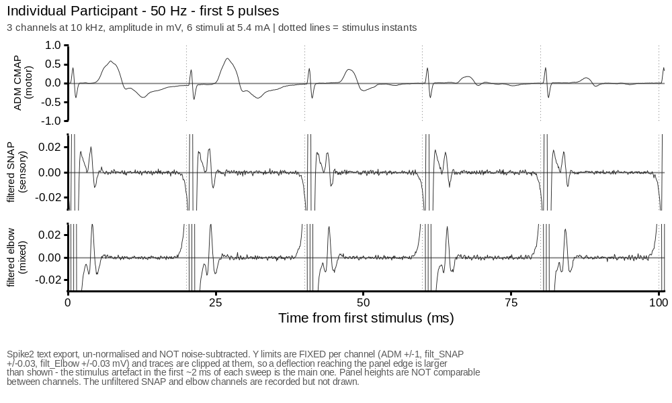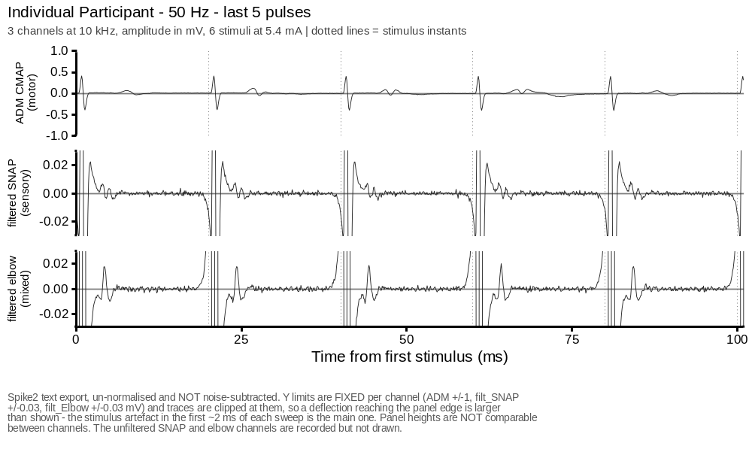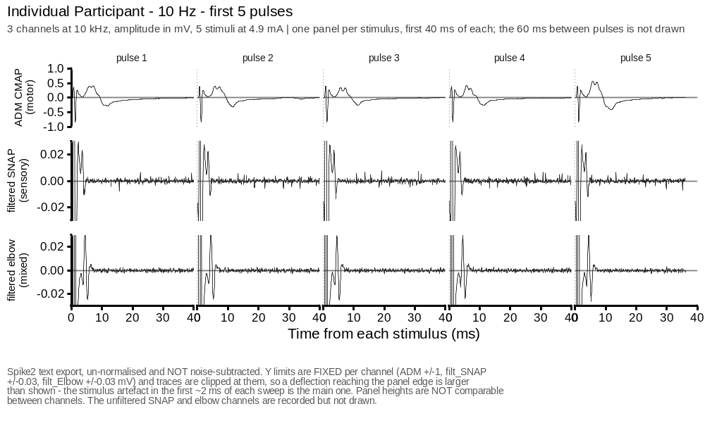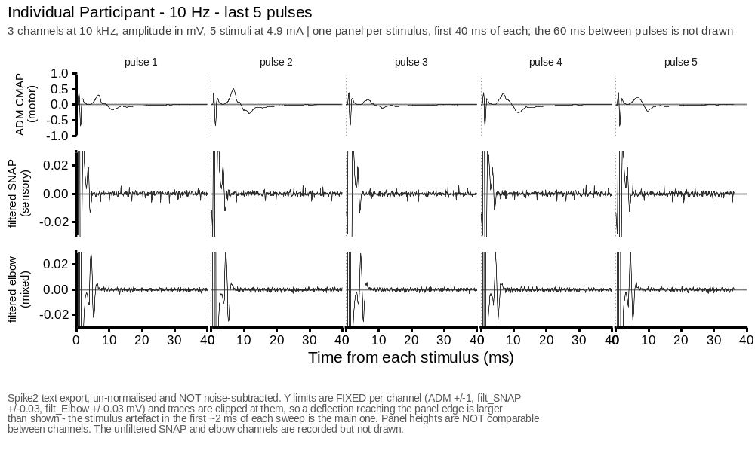

INDIVIDUAL PARTICIPANT
One participant’s response during the train and during recovery at each frequency.
# Builds the three single-subject train figures.
train_subject <- overlay_subject
stopifnot(train_subject %in% train_sec_means$subjID)
train_subject_data <- subset(train_sec_means, subjID == train_subject)
train_subject_overlay_plot <- function(ch, df = train_subject_data) {
ycol <- paste0(ch, "_norm")
d <- df[!is.na(df[[ycol]]), ]
if (!nrow(d)) return(NULL)
d$norm_value <- d[[ycol]]
ggplot(d, aes(x = time, y = norm_value, colour = factor(freq))) +
baseline_hline() +
geom_line(linewidth = line_data) +
scale_colour_manual(values = freq_cols, name = "Frequency (Hz)") +
scale_x_continuous(breaks = seq(0, 240, by = 60), limits = NULL,
expand = expansion(mult = c(0, 0.05))) +
expand_limits(x = 0) +
coord_cartesian(ylim = c(0, train_y_limits[[ch]])) +
scale_y_continuous(breaks = baseline_breaks(train_y_limits[[ch]]),
expand = expansion(mult = c(0, 0.05))) +
labs(x = "Time (s)", y = ylab_norm(ch),
title = paste0("Individual Participant: ", channel_short[[ch]],
" Response During the Train"),
caption = "one recording per frequency, per-second means") +
manuscript_theme()
}
train_subject_overlay_plots <- Filter(Negate(is.null),
setNames(lapply(group_channels, train_subject_overlay_plot), group_channels))
for (p in train_subject_overlay_plots) print(p)
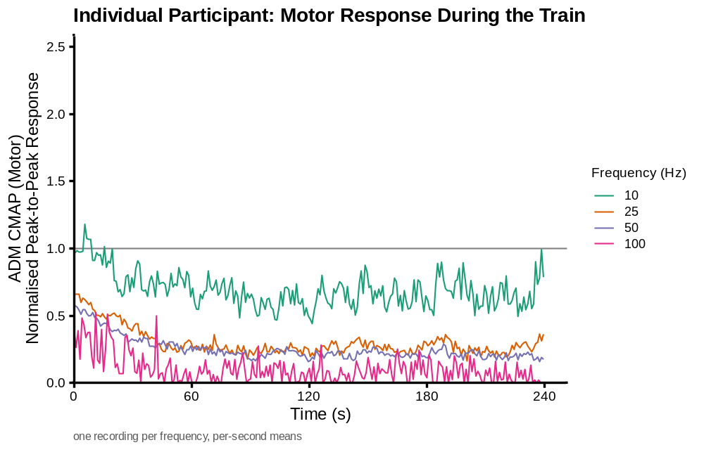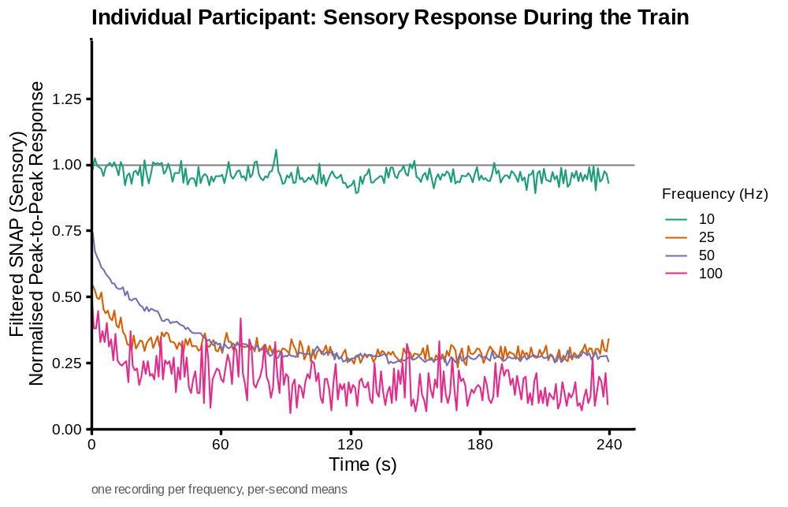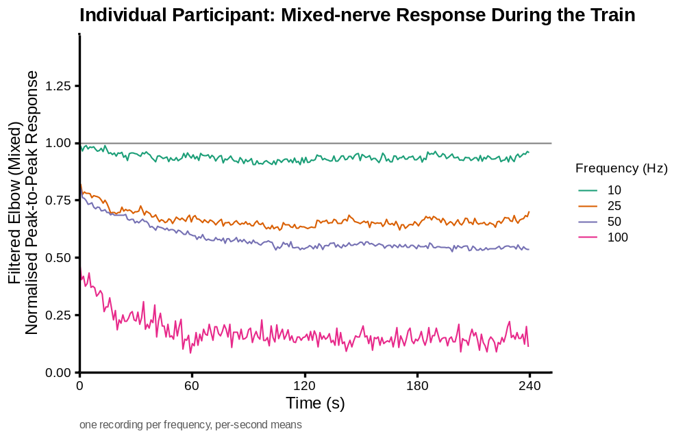
# Builds the three single-subject recovery figures.
recovery_subject <- overlay_subject
stopifnot(recovery_subject %in% recovery_data$subjID)
recovery_subject_data <- subset(recovery_data, subjID == recovery_subject)
recovery_subject_overlay_plot <- function(ch, df = recovery_subject_data) {
ycol <- paste0(ch, "_norm")
d <- df[!is.na(df[[ycol]]), ]
if (!nrow(d)) return(NULL)
d$norm_value <- d[[ycol]]
ggplot(d, aes(x = time_min, y = norm_value, colour = factor(freq))) +
baseline_hline() +
geom_line(linewidth = line_data) +
geom_point(size = 0.7) +
scale_colour_manual(values = freq_cols, name = "Frequency (Hz)") +
scale_x_continuous(breaks = seq(0, 15, by = 3),
expand = expansion(mult = c(0, 0.05))) +
expand_limits(x = c(0, 15)) +
coord_cartesian(ylim = c(0, recovery_y_limits[[ch]])) +
scale_y_continuous(breaks = baseline_breaks(recovery_y_limits[[ch]]),
expand = expansion(mult = c(0, 0.05))) +
labs(x = "Time since end of train (min)", y = ylab_norm(ch),
title = paste0("Individual Participant: ", channel_short[[ch]],
" Response During Recovery"),
caption = "one recording per frequency, one point per probe") +
manuscript_theme()
}
recovery_subject_overlay_plots <- Filter(Negate(is.null),
setNames(lapply(group_channels, recovery_subject_overlay_plot), group_channels))
for (p in recovery_subject_overlay_plots) print(p)
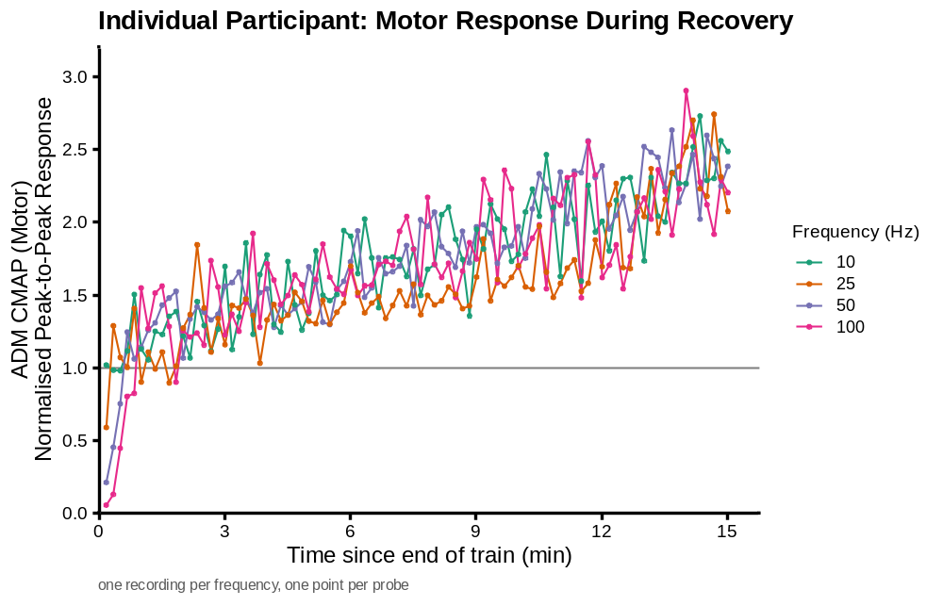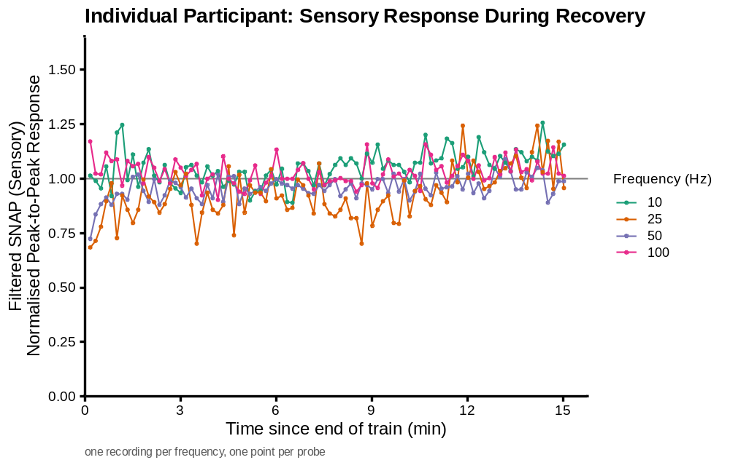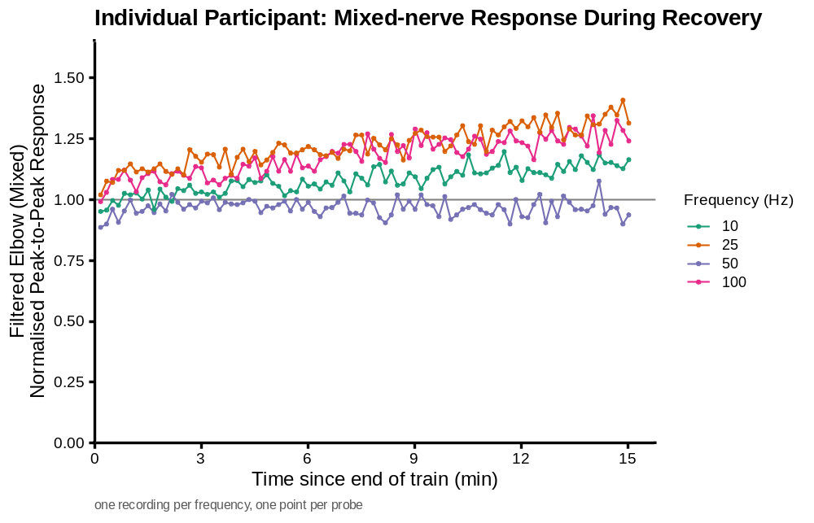

GROUP MEANS DURING THE TRAIN
Mean normalised response across subjects during the train, with 95% confidence intervals.
# Builds the three train group-mean figures.
train_group_plot <- function(ch) {
g <- train_group_means[train_group_means$channel == ch, ]
n_range <- tapply(g$n, g$freq, function(x)
if (min(x) == max(x)) as.character(max(x)) else paste0(min(x), "-", max(x)))
subtitle_text <- paste0("mean across subjects, 95% CI | n = ",
paste0(names(n_range), " Hz: ", n_range, collapse = "; "))
ggplot(g, aes(x = time, y = mean,
colour = factor(freq), fill = factor(freq))) +
baseline_hline() +
geom_ribbon(aes(ymin = ci_lo, ymax = ci_hi), colour = NA, alpha = 0.18) +
geom_line(linewidth = line_data) +
scale_colour_manual(values = freq_cols, name = "Frequency (Hz)") +
scale_fill_manual(values = freq_cols, guide = "none") +
scale_x_continuous(breaks = seq(0, 240, by = 60), limits = NULL,
expand = expansion(mult = c(0, 0.05))) +
expand_limits(x = 0) +
coord_cartesian(ylim = c(0, train_y_limits[[ch]])) +
scale_y_continuous(breaks = baseline_breaks(train_y_limits[[ch]]),
expand = expansion(mult = c(0, 0.05))) +
labs(x = "Time (s)", y = ylab_norm(ch),
title = paste0(channel_short[[ch]], " Response During the Train"),
caption = subtitle_text) +
manuscript_theme()
}
for (ch in group_channels) print(train_group_plot(ch))
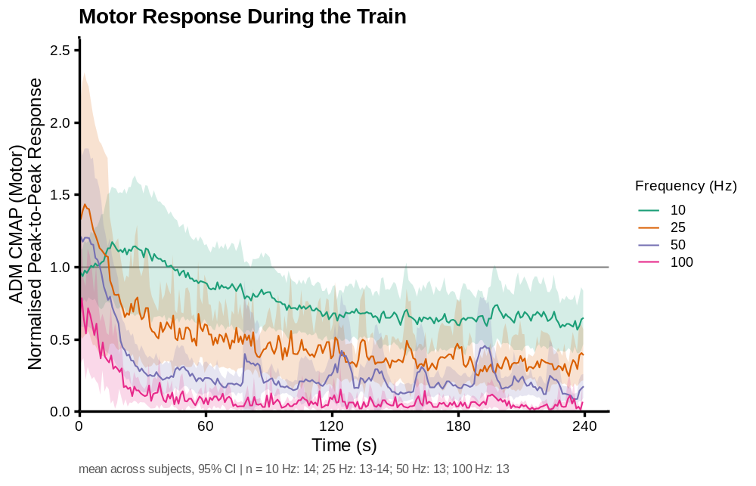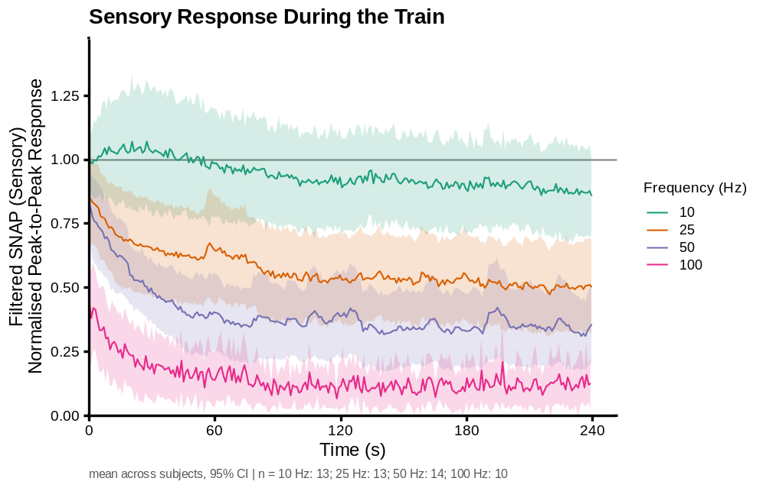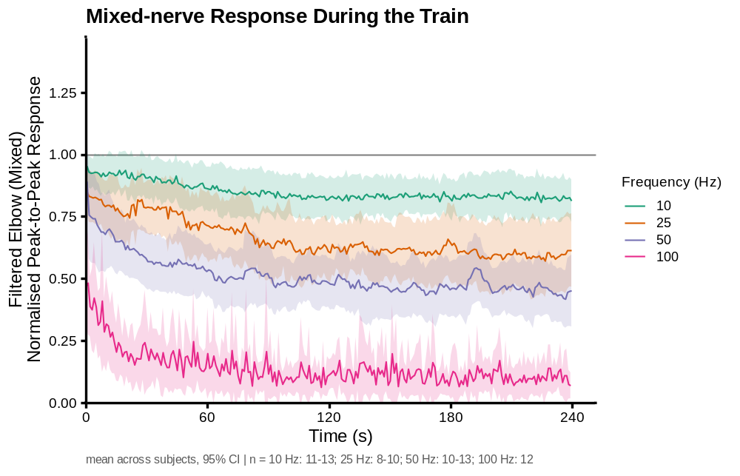

GROUP MEANS DURING RECOVERY
Mean normalised response across subjects to the single probes during the 15 minutes after the train.
# Builds the three recovery group-mean figures.
recovery_group_plot <- function(ch) {
g <- recovery_group_means[recovery_group_means$channel == ch, ]
n_range <- tapply(g$n, g$freq, function(x)
if (min(x) == max(x)) as.character(max(x)) else paste0(min(x), "-", max(x)))
subtitle_text <- paste0("mean across subjects, 95% CI | n = ",
paste0(names(n_range), " Hz: ", n_range, collapse = "; "))
ggplot(g, aes(x = time_min, y = mean,
colour = factor(freq), fill = factor(freq))) +
baseline_hline() +
geom_ribbon(aes(ymin = ci_lo, ymax = ci_hi), colour = NA, alpha = 0.18) +
geom_line(linewidth = line_data) +
scale_colour_manual(values = freq_cols, name = "Frequency (Hz)") +
scale_fill_manual(values = freq_cols, guide = "none") +
scale_x_continuous(breaks = seq(0, 15, by = 3),
expand = expansion(mult = c(0, 0.05))) +
expand_limits(x = c(0, 15)) +
coord_cartesian(ylim = c(0, recovery_y_limits[[ch]])) +
scale_y_continuous(
breaks = baseline_breaks(recovery_y_limits[[ch]]),
expand = expansion(mult = c(0, 0.05))) +
labs(x = "Time since end of train (min)", y = ylab_norm(ch),
title = paste0(channel_short[[ch]], " Response During Recovery"),
caption = subtitle_text) +
manuscript_theme()
}
for (ch in group_channels) print(recovery_group_plot(ch))
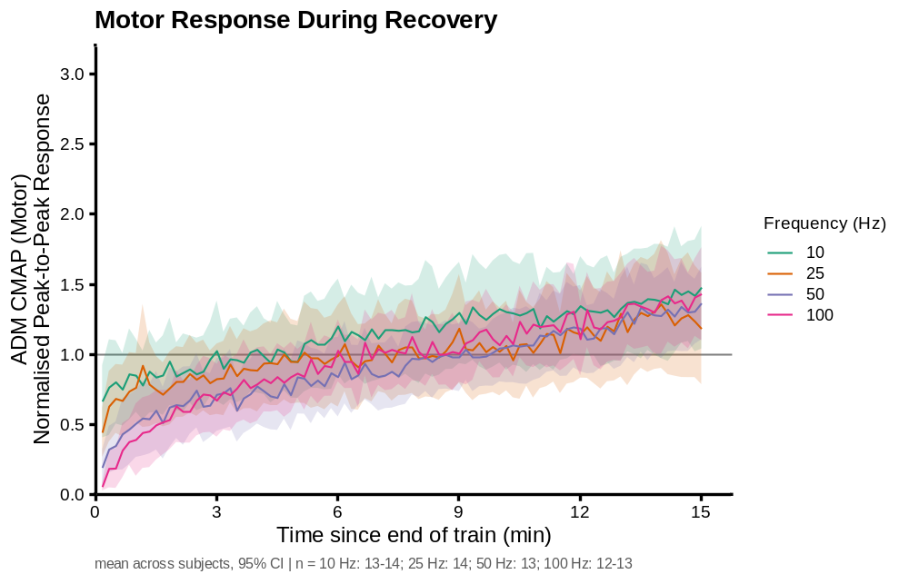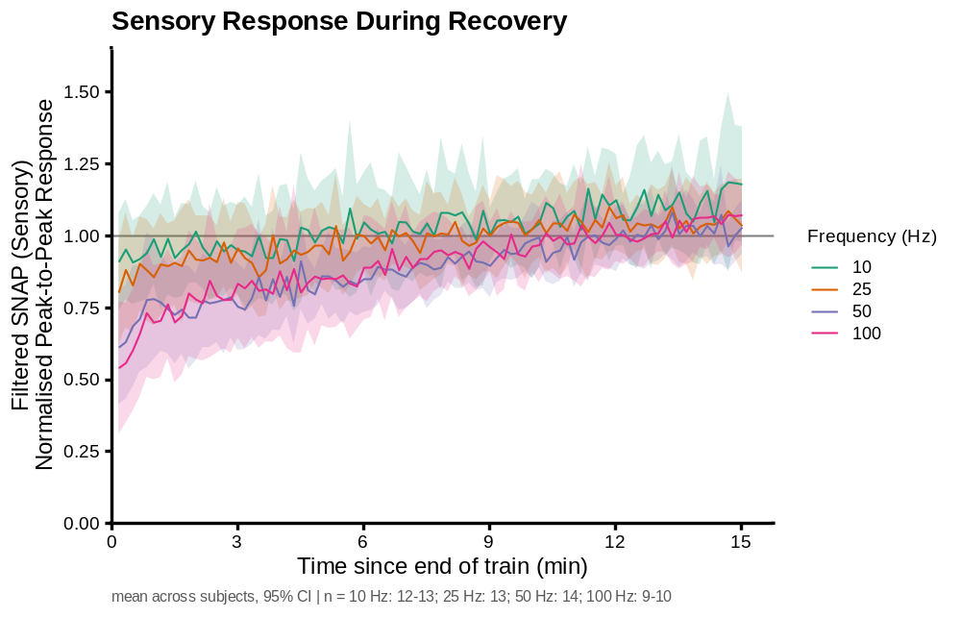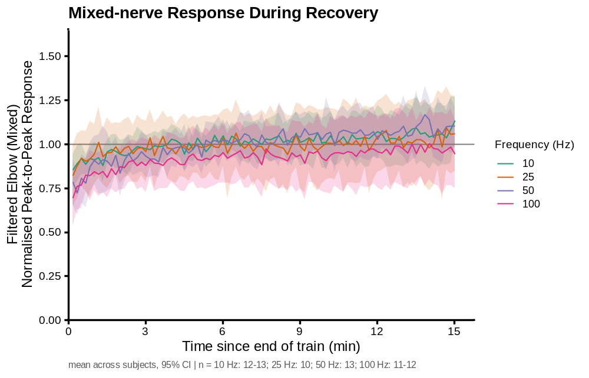

END-OF-TRAIN ASYMPTOTE AGAINST FREQUENCY
Mean normalised response over the last 5 seconds of each train, against stimulation frequency.
# Builds the three end-of-train scatter figures.
asymptote_subjects <- sort(unique(train_asymptotes$subjID))
subject_cols <- setNames(hcl.colors(length(asymptote_subjects), "Dark 3"),
asymptote_subjects)
asymptote_freq_span <- diff(range(asymptote_freq_levels))
asymptote_freq_min_gap <- min(diff(asymptote_freq_levels))
asymptote_dodge_width <- 0.025 * asymptote_freq_span
asymptote_crossbar_width <- 0.45 * asymptote_freq_min_gap
asymptote_ci_cap_width <- 0.4 * asymptote_crossbar_width
asymptote_freq_pad <- 0.06 * asymptote_freq_span
asymptote_freq_limits <- range(asymptote_freq_levels) +
c(-1, 1) * asymptote_freq_pad
asymptote_q1 <- function(x) quantile(x, 0.25, names = FALSE)
asymptote_q3 <- function(x) quantile(x, 0.75, names = FALSE)
asymptote_data_top <- max(c(train_asymptotes$asymptote, asymptote_emmeans$upper.CL))
asymptote_y_inc <- 0.25
asymptote_y_max <- ceiling(asymptote_data_top * 1.05 / asymptote_y_inc) * asymptote_y_inc
asymptote_y_breaks <- seq(0, asymptote_y_max, by = asymptote_y_inc)
asymptote_scatter_plot <- function(ch) {
d <- train_asymptotes[train_asymptotes$channel == ch, ]
d$freq_index <- match(d$freq, asymptote_freq_levels)
subject_offsets <- setNames(
seq(-asymptote_dodge_width / 2, asymptote_dodge_width / 2,
length.out = length(asymptote_subjects)),
asymptote_subjects)
d$x_pos <- d$freq + subject_offsets[d$subjID]
# Splits a subject's line where a frequency is missing.
d <- d[order(d$subjID, d$freq_index), ]
d$segment <- ave(d$freq_index, d$subjID,
FUN = function(i) cumsum(c(1, diff(i) > 1)))
n_by_freq <- table(factor(d$freq, levels = asymptote_freq_levels))
subtitle_text <- paste0(
"mean of the last ", asymptote_window_seconds,
" s, proportion of pre-train singles | n = ",
paste0(names(n_by_freq), " Hz: ", as.integer(n_by_freq), collapse = "; "))
em <- asymptote_emmeans[asymptote_emmeans$channel == ch, ]
tst <- asymptote_tests[asymptote_tests$channel == ch, ]
test_label <- paste0("effect of frequency:\nt(",
sprintf("%.1f", tst$t_df), ") = ",
sprintf("%.2f", tst$t), ", ", format_p_label(tst$p),
"\nslope = ", sprintf("%+.4f", tst$slope_per_hz), " per Hz")
ggplot(d, aes(x = x_pos, y = asymptote, colour = subjID)) +
baseline_hline() +
geom_errorbar(data = em, inherit.aes = FALSE,
aes(x = freq, ymin = lower.CL, ymax = upper.CL),
width = asymptote_ci_cap_width, linewidth = line_summary,
colour = "grey30") +
geom_crossbar(data = em, inherit.aes = FALSE,
aes(x = freq, y = emmean,
ymin = emmean, ymax = emmean),
width = asymptote_crossbar_width, linewidth = line_summary,
colour = "grey30") +
geom_line(aes(group = interaction(subjID, segment)),
linewidth = line_summary, alpha = 0.7, linetype = "dashed") +
geom_point(size = 1.6, alpha = 0.9) +
annotate("text", x = Inf, y = Inf, label = test_label,
hjust = 1.05, vjust = 1.2, size = 2.6, colour = "grey20",
lineheight = 0.95) +
scale_colour_manual(values = subject_cols, guide = "none") +
scale_x_continuous(breaks = asymptote_freq_levels,
limits = asymptote_freq_limits) +
coord_cartesian(ylim = c(0, asymptote_y_max)) +
scale_y_continuous(breaks = asymptote_y_breaks,
expand = expansion(mult = c(0, 0.05))) +
labs(x = "Stimulation frequency (Hz)",
y = paste0(title_case_label(channel_labels[[ch]]),
" at End of Train\nNormalised Peak-to-Peak Response"),
title = paste0(channel_short[[ch]], " Response at End of Train"),
caption = paste0(
subtitle_text,
"\nGrey: fitted mean (horizontal bar) and its 95% CI (vertical line) from",
"\nlmer(asymptote ~ freq + (1|subjID)), frequency continuous in Hz, evaluated at",
" the four\nfrequencies tested - four points on one line, not four separate means.",
"\nTop right: t test of the linear effect of frequency in that model",
" (Satterthwaite df), and its slope.\nThe straight-line assumption behind that",
" slope is not tested by this document.")) +
manuscript_theme()
}
for (ch in group_channels) print(asymptote_scatter_plot(ch))
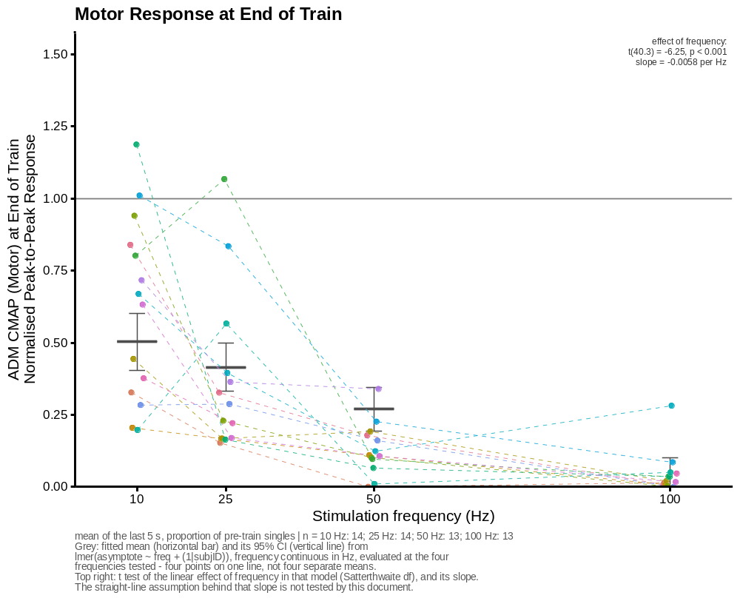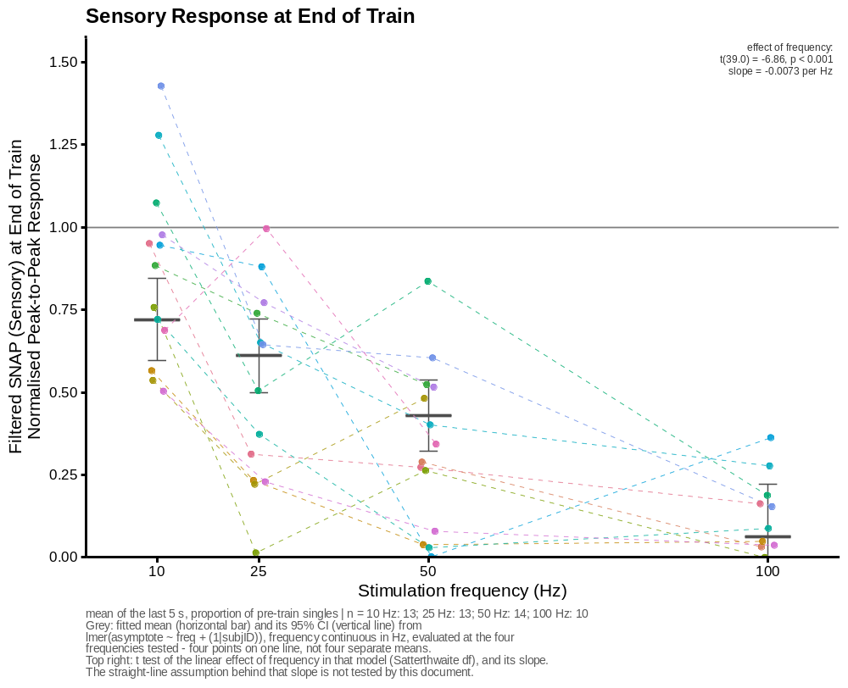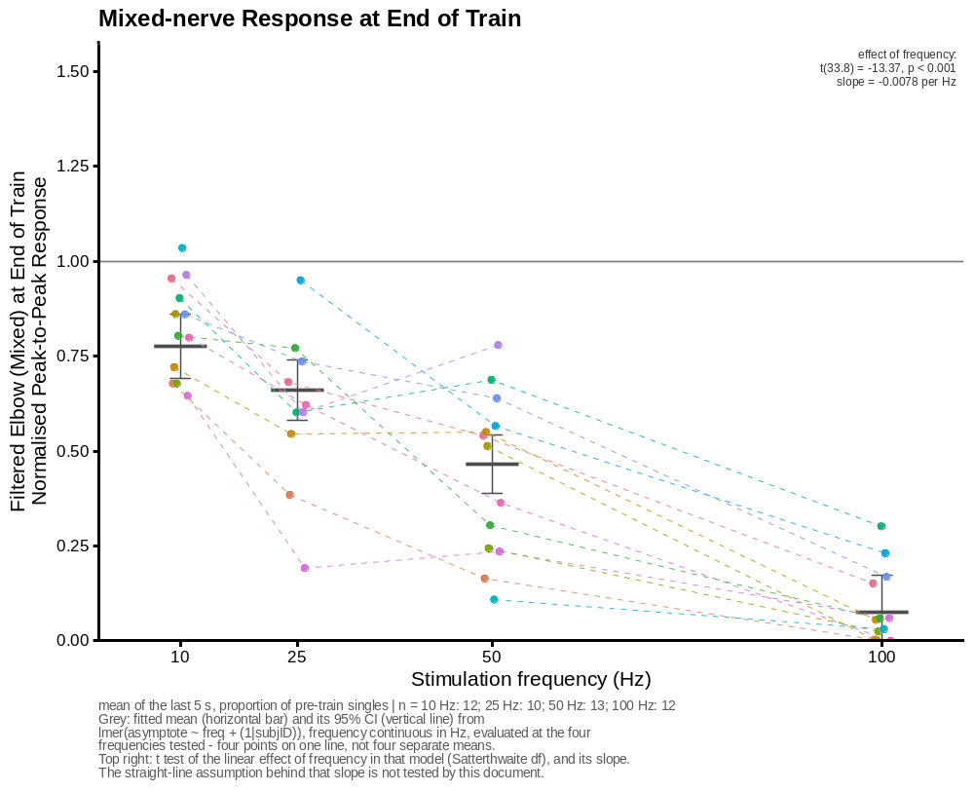

TIME TO SUSTAINED RECOVERY
Time for each recording to reach two consecutive probes above 90% of baseline, against frequency.
# Builds the three recovery-time scatter figures.
recovery_threshold_plot <- function(ch) {
d <- recovery_threshold_times[recovery_threshold_times$channel == ch, ]
em <- recovery_threshold_emmeans[recovery_threshold_emmeans$channel == ch, ]
tst <- recovery_threshold_tests[recovery_threshold_tests$channel == ch, ]
test_label <- paste0("effect of frequency:\nchi-square(", tst$df, ") = ",
sprintf("%.2f", tst$chisq), ", ", format_p_label(tst$p),
"\ntime ratio = ", sprintf("%.2f", tst$time_ratio_per_25hz),
" per 25 Hz")
subject_offsets <- setNames(
seq(-asymptote_dodge_width / 2, asymptote_dodge_width / 2,
length.out = length(asymptote_subjects)),
asymptote_subjects)
d$x_pos <- d$freq + subject_offsets[d$subjID]
# Splits a subject's line where a frequency is missing.
d <- d[order(d$subjID, d$freq_index), ]
d$segment <- ave(d$freq_index, d$subjID,
FUN = function(i) cumsum(c(1, diff(i) > 1)))
n_by_freq <- table(factor(d$freq, levels = asymptote_freq_levels))
cens_by_freq <- tapply(d$censored, factor(d$freq, levels = asymptote_freq_levels), sum)
cens_by_freq[is.na(cens_by_freq)] <- 0
subtitle_text <- paste0(
"first of ", recovery_threshold_consecutive, " consecutive probes above ",
recovery_threshold_ratio, " x pre-train singles | n = ",
paste0(names(n_by_freq), " Hz: ", as.integer(n_by_freq), collapse = "; "),
"\ngrey: fitted mean (horizontal bar) and 95% CI (vertical line), from a",
" censored-lognormal AFT",
"\n(GLMMadaptive, log-time, random intercept per subject, frequency continuous in Hz) -",
"\nfour points on one fitted line in log-time, and an interval on the ESTIMATE, not the",
" spread of the recordings",
if (any(cens_by_freq > 0))
paste0("\ntriangles = had not recovered by ",
sprintf("%.1f", recovery_window_end_min), " min (",
paste0(names(cens_by_freq)[cens_by_freq > 0], " Hz: ",
as.integer(cens_by_freq[cens_by_freq > 0]), collapse = "; "),
") - plotted at the window end, not measured there")
else "",
"\ntop right: likelihood-ratio test of the linear effect of frequency against a null",
" carrying the same\nrandom intercept (1 df), with the slope as a time ratio")
ggplot(d, aes(x = x_pos, y = y_plot, colour = subjID)) +
geom_hline(yintercept = recovery_window_end_min, linetype = "dotted",
linewidth = line_reference, colour = "grey60") +
geom_errorbar(data = em, inherit.aes = FALSE,
aes(x = freq, ymin = lower.CL, ymax = upper.CL),
width = asymptote_ci_cap_width, linewidth = line_summary,
colour = "grey30") +
geom_crossbar(data = em, inherit.aes = FALSE,
aes(x = freq, y = emmean, ymin = emmean, ymax = emmean),
width = asymptote_crossbar_width, linewidth = line_summary,
colour = "grey30") +
geom_line(aes(group = interaction(subjID, segment)),
linewidth = line_summary, alpha = 0.7, linetype = "dashed") +
geom_point(data = subset(d, !censored), size = 1.6, alpha = 0.9) +
geom_point(data = subset(d, censored), shape = 2, size = 2.2,
stroke = 0.7, show.legend = FALSE) +
annotate("text", x = Inf, y = Inf, label = test_label,
hjust = 1.05, vjust = 1.2, size = 2.6, colour = "grey20",
lineheight = 0.95) +
scale_colour_manual(values = subject_cols, guide = "none") +
scale_x_continuous(breaks = asymptote_freq_levels,
limits = asymptote_freq_limits) +
expand_limits(y = c(0, recovery_threshold_y_max)) +
scale_y_continuous(breaks = seq(0, 15, by = 3),
expand = expansion(mult = c(0, 0.05))) +
labs(x = "Stimulation frequency (Hz)",
y = "Recovery time (mins)",
title = paste0(channel_short[[ch]], " Response: Time to Sustained Recovery"),
caption = subtitle_text) +
manuscript_theme() +
theme(plot.caption = element_text(size = 7, colour = "grey35", hjust = 0))
}
recovery_threshold_plots <- setNames(lapply(group_channels, recovery_threshold_plot),
group_channels)
for (p in recovery_threshold_plots) print(p)
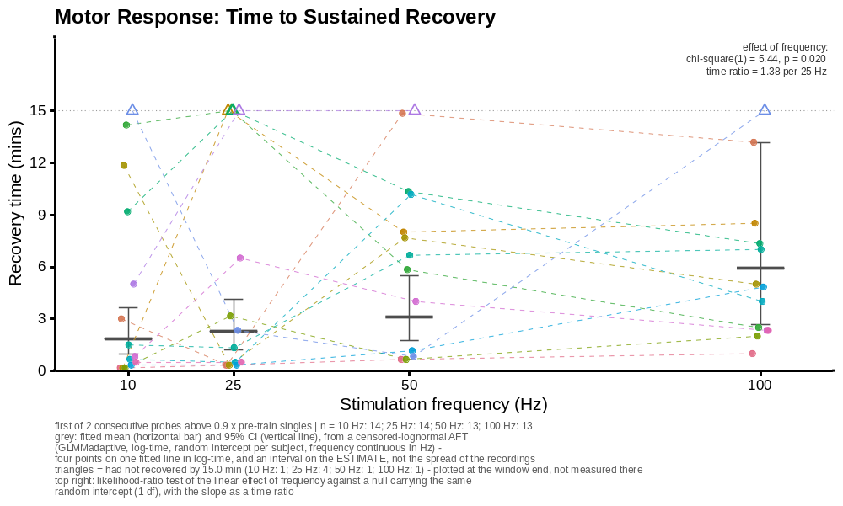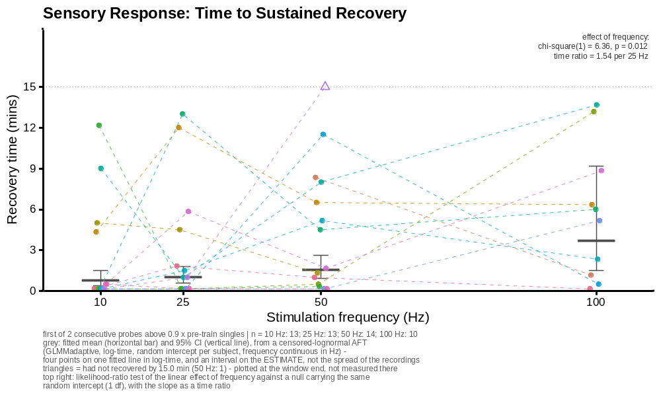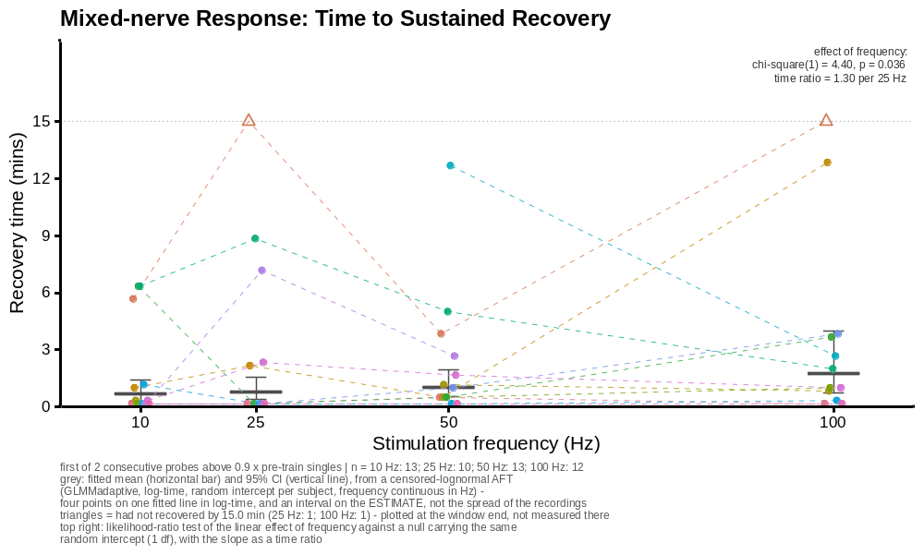

ADDITIONAL FIGURES AND MODEL OUTPUT

Recruitment curve
One participant’s ADM recruitment curve, with the intensity reaching 5% of Mmax marked.
# Builds the recruitment-curve figure.
recruitment_subject <- "S01"
recruitment_session_freq <- 10
recruitment_curve <- subset(recruitment_data,
subjID == recruitment_subject &
freq == recruitment_session_freq)
# `count` is delivery order.
recruitment_curve <- recruitment_curve[order(recruitment_curve$count), ]
recruitment_pulses_delivered <- nrow(recruitment_curve)
# Truncates at the first pulse delivered above this intensity, in mA.
recruitment_max_ma <- 11
recruitment_above_cap <- which(recruitment_curve$currAmp > recruitment_max_ma)
if (length(recruitment_above_cap))
recruitment_curve <- recruitment_curve[seq_len(recruitment_above_cap[1] - 1), ]
recruitment_noise_mv <- recruitment_curve$ADMpk2pk[
recruitment_curve$currAmp == noise_current_ma][1]
recruitment_curve$admpk2pk_mv <- pmax(recruitment_curve$ADMpk2pk -
recruitment_noise_mv, 0)
recruitment_mmax_rows <- subset(pulse_data,
subjID == recruitment_subject &
freq == recruitment_session_freq &
measure == "Mmax")
recruitment_mmax_rows <- recruitment_mmax_rows[order(recruitment_mmax_rows$count), ]
recruitment_mmax_mv <- recruitment_mmax_rows$ADMpk2pk[1]
recruitment_threshold_mv <- 0.05 * recruitment_mmax_mv
recruitment_curve_means <- aggregate(recruitment_curve["admpk2pk_mv"],
by = list(currAmp = recruitment_curve$currAmp),
FUN = mean)
recruitment_curve_means <-
recruitment_curve_means[order(recruitment_curve_means$currAmp), ]
# Interpolates the first upward crossing of the 5% level.
n_levels <- nrow(recruitment_curve_means)
recruitment_crossings <-
which(recruitment_curve_means$admpk2pk_mv[-1] >= recruitment_threshold_mv &
recruitment_curve_means$admpk2pk_mv[-n_levels] < recruitment_threshold_mv)
stopifnot(length(recruitment_crossings) > 0)
i <- recruitment_crossings[1]
x0 <- recruitment_curve_means$currAmp[i]
y0 <- recruitment_curve_means$admpk2pk_mv[i]
x1 <- recruitment_curve_means$currAmp[i + 1]
y1 <- recruitment_curve_means$admpk2pk_mv[i + 1]
recruitment_threshold_ma <- x0 + (recruitment_threshold_mv - y0) * (x1 - x0) / (y1 - y0)
recruitment_threshold_plot <-
ggplot(recruitment_curve, aes(x = currAmp, y = admpk2pk_mv)) +
geom_hline(yintercept = recruitment_threshold_mv, linetype = "dashed",
linewidth = line_reference, colour = "grey40") +
geom_vline(xintercept = recruitment_threshold_ma, linetype = "dotted",
linewidth = line_reference, colour = "grey20") +
geom_line(data = recruitment_curve_means, linewidth = line_data, colour = "grey30") +
geom_point(size = 1.8, alpha = 0.8) +
annotate("text", x = recruitment_threshold_ma,
y = max(recruitment_curve_means$admpk2pk_mv),
label = sprintf("5%% of Mmax = %.3f mV\nat %.2f mA",
recruitment_threshold_mv, recruitment_threshold_ma),
hjust = -0.08, vjust = 1, size = 3, colour = "grey20") +
scale_x_continuous(breaks = seq(0, 30, by = 1),
expand = expansion(mult = c(0, 0.05))) +
expand_limits(x = 0) +
expand_limits(y = 0) +
scale_y_continuous(expand = expansion(mult = c(0, 0.08))) +
labs(x = "Stimulus intensity (mA)",
y = "ADM CMAP peak-to-peak (mV)",
title = sprintf("Individual Participant: ADM Recruitment Curve (%g Hz Session)",
recruitment_session_freq),
caption = sprintf(paste("noise-subtracted, ramp truncated at %g mA:",
"%d of %d pulses\nMmax %.2f mV (first Mmax",
"pulse) | 5%% of Mmax at %.2f mA"),
recruitment_max_ma,
nrow(recruitment_curve), recruitment_pulses_delivered,
recruitment_mmax_mv, recruitment_threshold_ma)) +
manuscript_theme()
print(recruitment_threshold_plot)
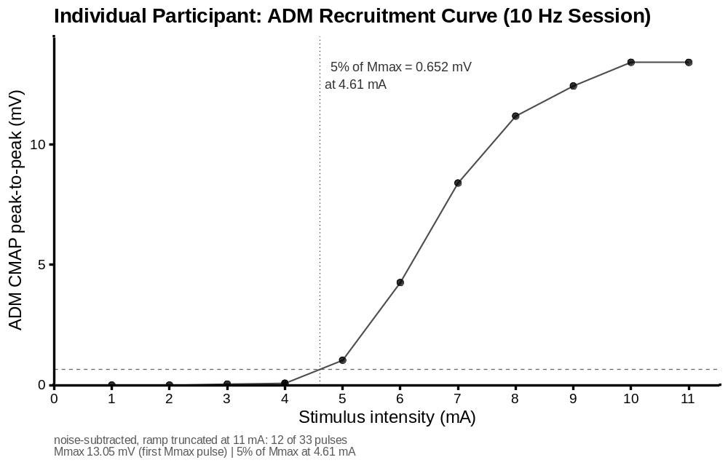

End-of-train models
# Prints the end-of-train model summaries, marginal means and tests.
summary(mod0)
## Linear mixed model fit by REML. t-tests use Satterthwaite's method [
## lmerModLmerTest]
## Formula: asymptote ~ freq + (1 | subjID)
## Data: admdata
##
## REML criterion at convergence: 14
##
## Scaled residuals:
## Min 1Q Median 3Q Max
## -1.2374 -0.7678 -0.2203 0.3407 2.8690
##
## Random effects:
## Groups Name Variance Std.Dev.
## subjID (Intercept) 0.003331 0.05771
## Residual 0.054455 0.23336
## Number of obs: 54, groups: subjID, 14
##
## Fixed effects:
## Estimate Std. Error df t value Pr(>|t|)
## (Intercept) 0.5615729 0.0550458 45.7046397 10.202 2.31e-13 ***
## freq -0.0058449 0.0009353 40.2946696 -6.249 2.05e-07 ***
## ---
## Signif. codes: 0 '***' 0.001 '**' 0.01 '*' 0.05 '.' 0.1 ' ' 1
##
## Correlation of Fixed Effects:
## (Intr)
## freq -0.767
summary(mod1)
## Linear mixed model fit by REML. t-tests use Satterthwaite's method [
## lmerModLmerTest]
## Formula: asymptote ~ freq + (1 | subjID)
## Data: snapdata
##
## REML criterion at convergence: 22.3
##
## Scaled residuals:
## Min 1Q Median 3Q Max
## -2.05505 -0.57534 0.03845 0.49887 2.38992
##
## Random effects:
## Groups Name Variance Std.Dev.
## subjID (Intercept) 0.01824 0.1350
## Residual 0.05575 0.2361
## Number of obs: 50, groups: subjID, 14
##
## Fixed effects:
## Estimate Std. Error df t value Pr(>|t|)
## (Intercept) 0.793471 0.067338 34.153415 11.783 1.39e-13 ***
## freq -0.007300 0.001064 38.966747 -6.861 3.34e-08 ***
## ---
## Signif. codes: 0 '***' 0.001 '**' 0.01 '*' 0.05 '.' 0.1 ' ' 1
##
## Correlation of Fixed Effects:
## (Intr)
## freq -0.680
summary(mod2)
## Linear mixed model fit by REML. t-tests use Satterthwaite's method [
## lmerModLmerTest]
## Formula: asymptote ~ freq + (1 | subjID)
## Data: elbowdata
##
## REML criterion at convergence: -24.1
##
## Scaled residuals:
## Min 1Q Median 3Q Max
## -2.41409 -0.40845 0.09493 0.48513 2.14466
##
## Random effects:
## Groups Name Variance Std.Dev.
## subjID (Intercept) 0.01090 0.1044
## Residual 0.01821 0.1349
## Number of obs: 47, groups: subjID, 13
##
## Fixed effects:
## Estimate Std. Error df t value Pr(>|t|)
## (Intercept) 0.8536866 0.0445916 27.2088215 19.14 < 2e-16 ***
## freq -0.0077686 0.0005811 33.8410008 -13.37 4.63e-15 ***
## ---
## Signif. codes: 0 '***' 0.001 '**' 0.01 '*' 0.05 '.' 0.1 ' ' 1
##
## Correlation of Fixed Effects:
## (Intr)
## freq -0.617
cat("\nestimated marginal means (as drawn on the scatter figures):\n")
##
## estimated marginal means (as drawn on the scatter figures):
print(asymptote_emmeans[c("channel", "freq", "emmean", "SE", "lower.CL", "upper.CL")],
row.names = FALSE, digits = 3)
## channel freq emmean SE lower.CL upper.CL
## ADMpk2pk 10 0.5031 0.0483 0.4052 0.601
## ADMpk2pk 25 0.4155 0.0400 0.3321 0.499
## ADMpk2pk 50 0.2693 0.0357 0.1924 0.346
## ADMpk2pk 100 -0.0229 0.0624 -0.1483 0.103
## filtSNAPpk2pk 10 0.7205 0.0608 0.5954 0.846
## filtSNAPpk2pk 25 0.6110 0.0531 0.4987 0.723
## filtSNAPpk2pk 50 0.4285 0.0500 0.3207 0.536
## filtSNAPpk2pk 100 0.0634 0.0786 -0.0952 0.222
## filtelbowpk2pk 10 0.7760 0.0413 0.6902 0.862
## filtelbowpk2pk 25 0.6595 0.0374 0.5798 0.739
## filtelbowpk2pk 50 0.4653 0.0351 0.3887 0.542
## filtelbowpk2pk 100 0.0768 0.0466 -0.0183 0.172
cat("\neffect of frequency (annotated on the scatter figures):\n")
##
## effect of frequency (annotated on the scatter figures):
print(data.frame(channel = asymptote_tests$channel,
t = round(asymptote_tests$t, 2),
df = round(asymptote_tests$t_df, 1),
p = signif(asymptote_tests$p, 3),
slope_per_hz = signif(asymptote_tests$slope_per_hz, 3),
slope_per_10hz = signif(asymptote_tests$slope_per_10hz, 3),
f = signif(asymptote_tests$f, 3)),
row.names = FALSE)
## channel t df p slope_per_hz slope_per_10hz f
## ADMpk2pk -6.25 40.3 2.05e-07 -0.00584 -0.0584 39.1
## filtSNAPpk2pk -6.86 39.0 3.34e-08 -0.00730 -0.0730 47.1
## filtelbowpk2pk -13.37 33.8 4.63e-15 -0.00777 -0.0777 179.0

Residual diagnostics for the end-of-train models
# Builds the residual diagnostic plots and outlier tests for the end-of-train models.
asymptote_diagnostics <- function(model, label) {
cat("\n---", label, "---\n")
qqp(resid(model))
plot(residuals(model) ~ predict(model, re.form = NA),
xlab = "fitted (fixed effects only)", ylab = "residual", main = label)
simres <- simulateResiduals(model)
plot(simres)
print(testOutliers(simres))
}
asymptote_diagnostics(mod0, "motor (ADMpk2pk)")
##
## --- motor (ADMpk2pk) ---
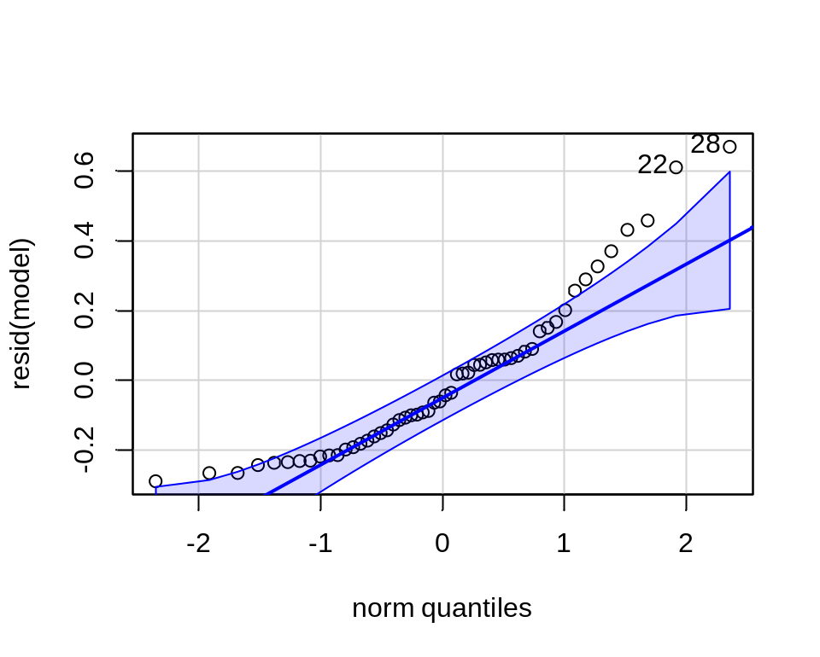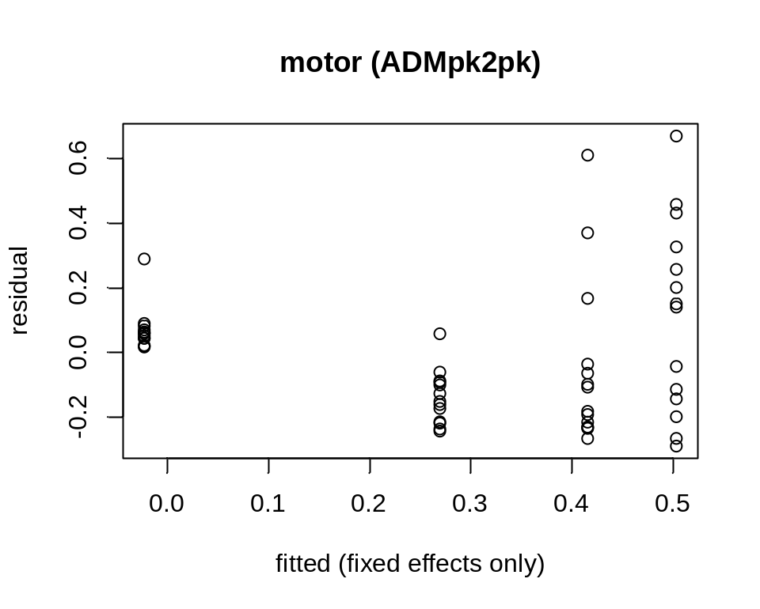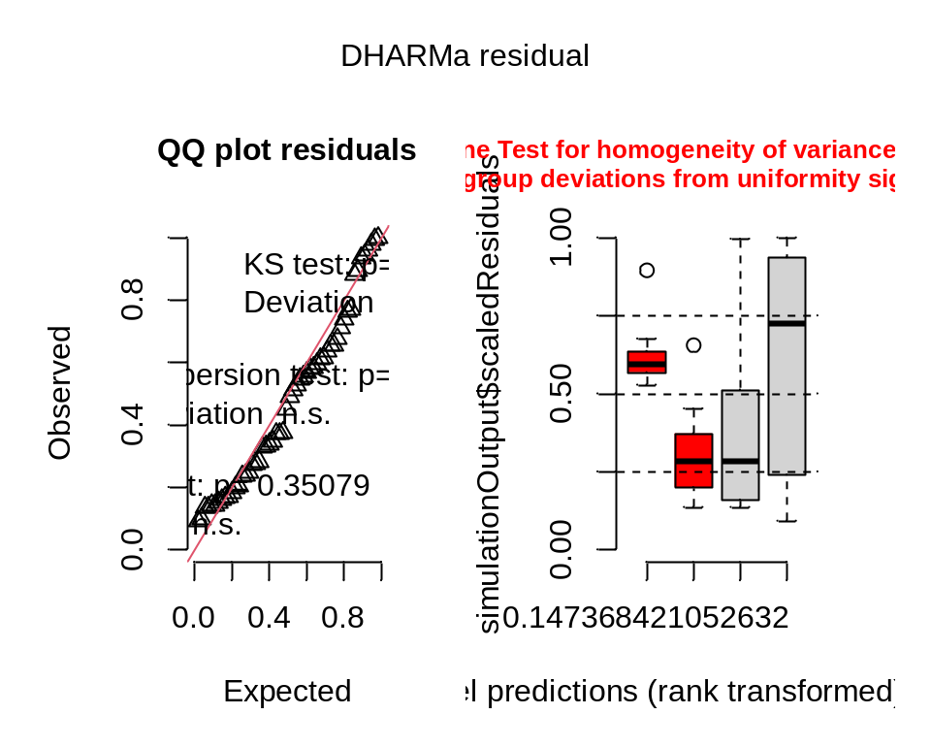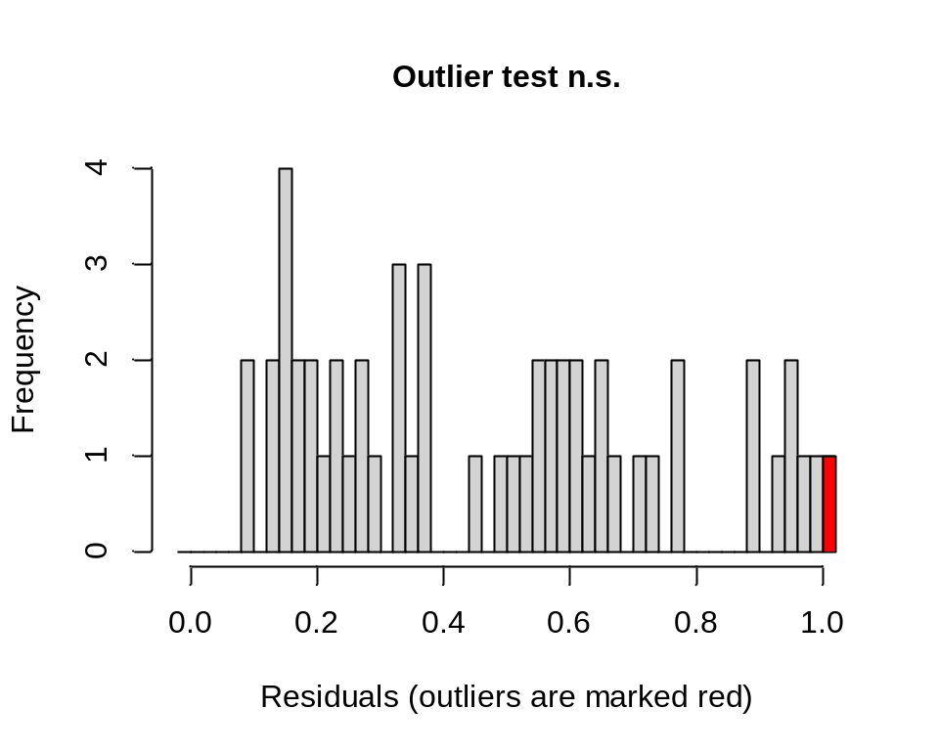
##
## DHARMa outlier test based on exact binomial test with approximate
## expectations
##
## data: simres
## outliers at both margin(s) = 1, observations = 54, p-value = 0.3508
## alternative hypothesis: true probability of success is not equal to 0.007968127
## 95 percent confidence interval:
## 0.0004687384 0.0989151595
## sample estimates:
## frequency of outliers (expected: 0.00796812749003984 )
## 0.01851852
asymptote_diagnostics(mod1, "sensory (filtSNAPpk2pk)")
##
## --- sensory (filtSNAPpk2pk) ---
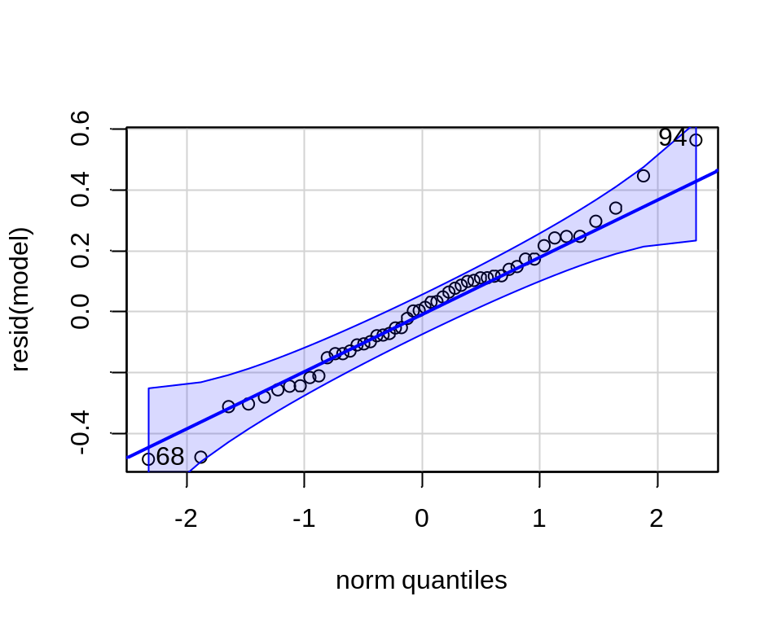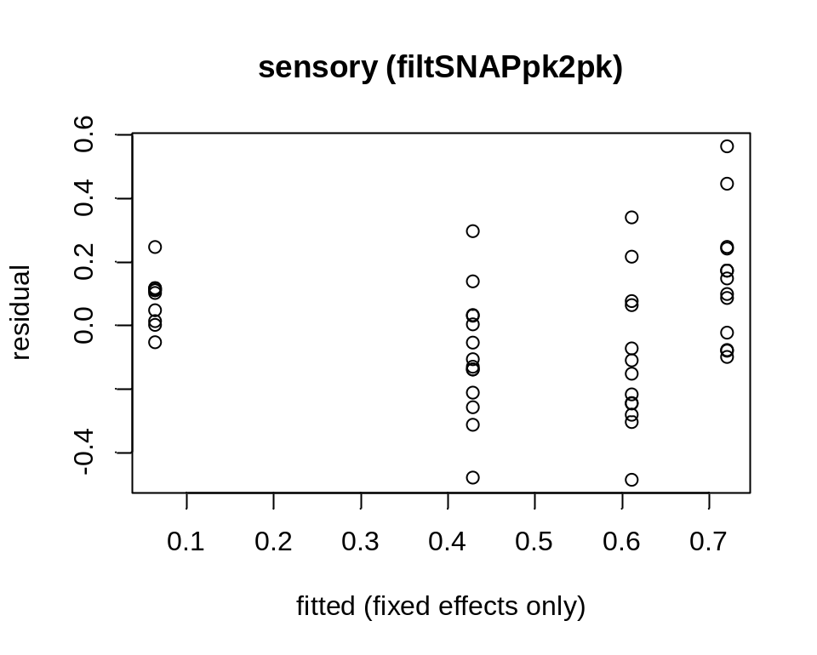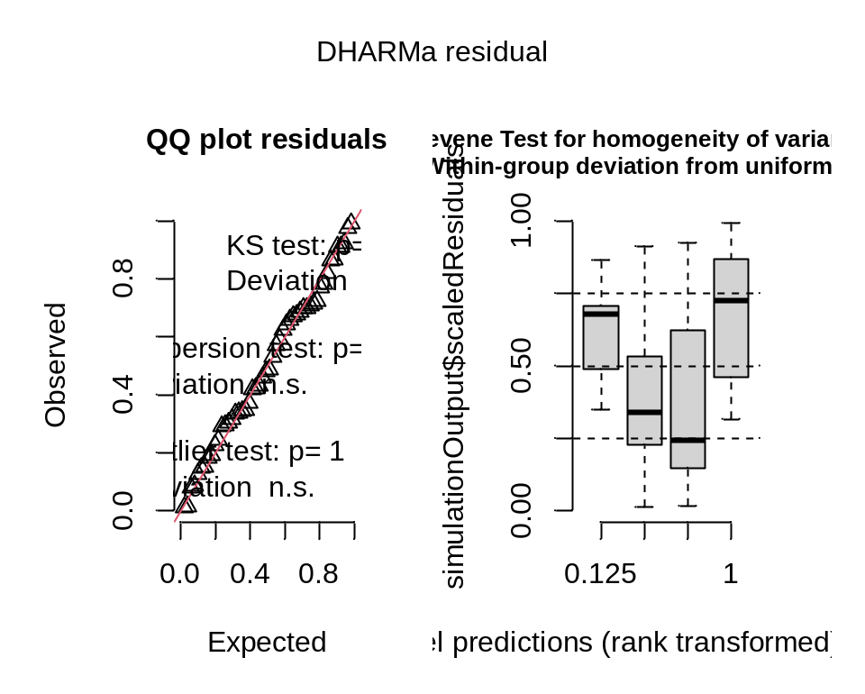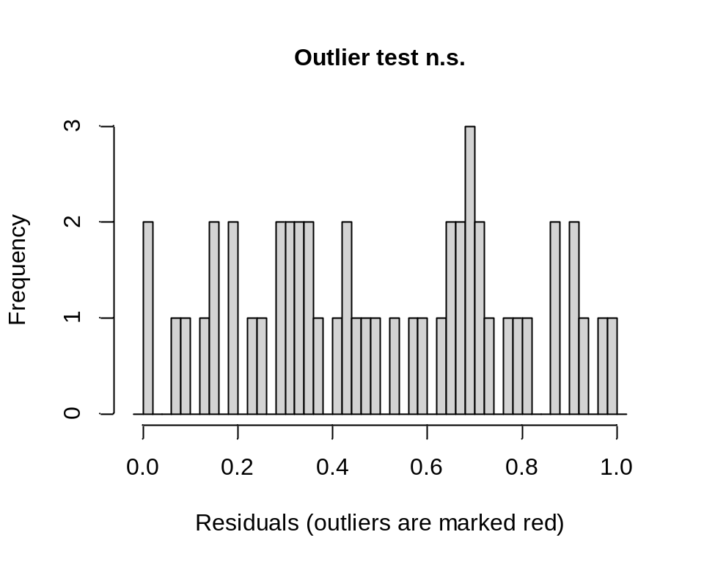
##
## DHARMa outlier test based on exact binomial test with approximate
## expectations
##
## data: simres
## outliers at both margin(s) = 0, observations = 50, p-value = 1
## alternative hypothesis: true probability of success is not equal to 0.007968127
## 95 percent confidence interval:
## 0.00000000 0.07112174
## sample estimates:
## frequency of outliers (expected: 0.00796812749003984 )
## 0
asymptote_diagnostics(mod2, "mixed (filtelbowpk2pk)")
##
## --- mixed (filtelbowpk2pk) ---
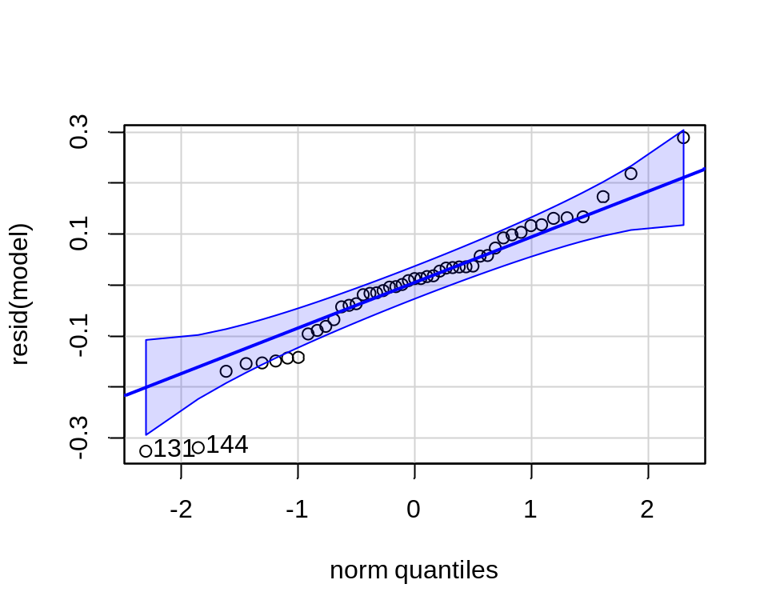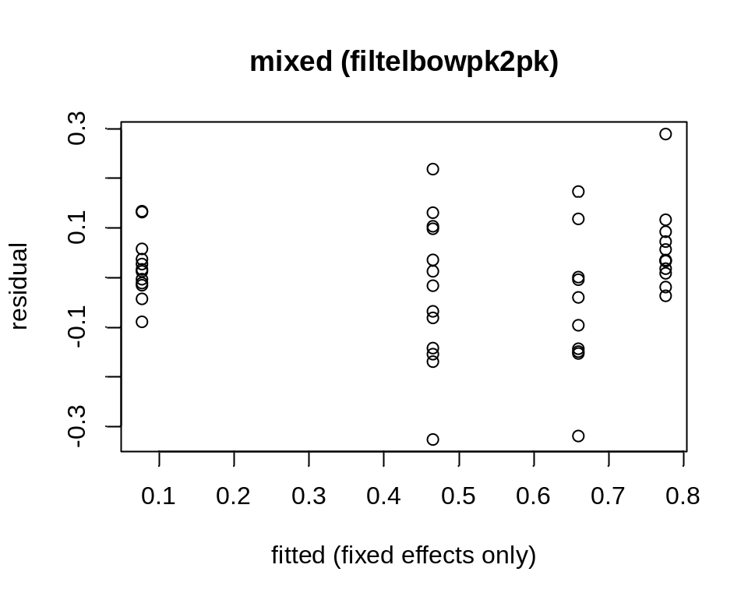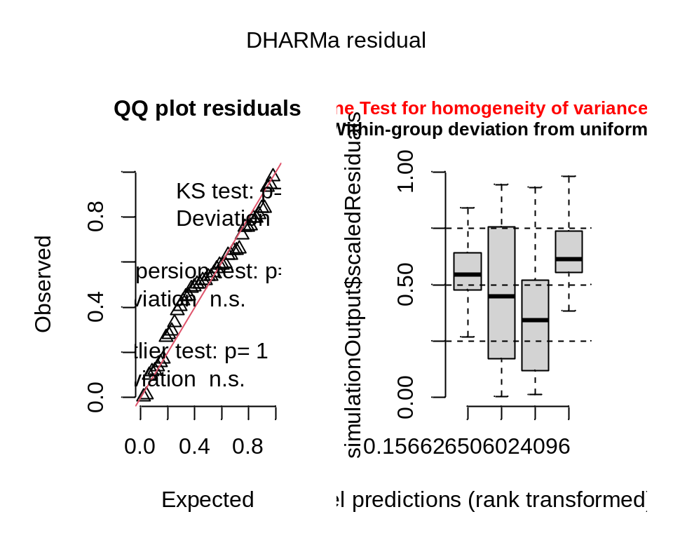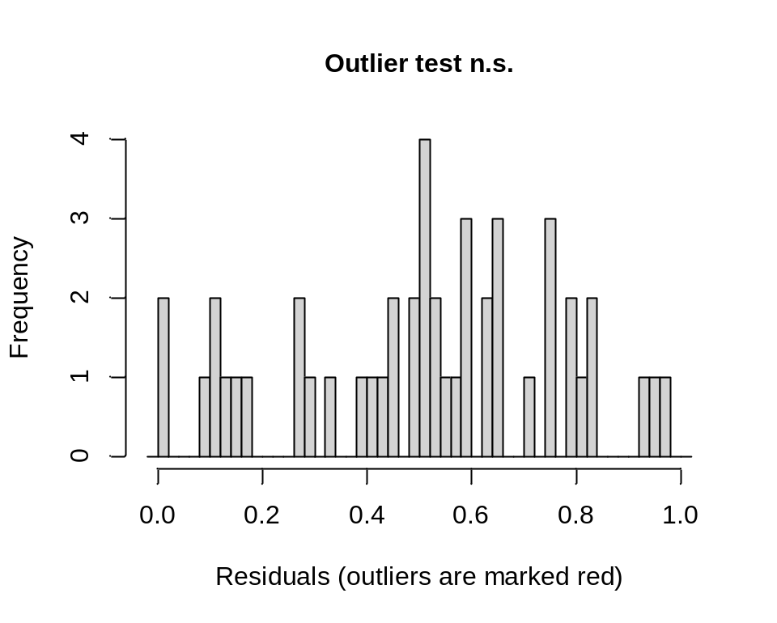
##
## DHARMa outlier test based on exact binomial test with approximate
## expectations
##
## data: simres
## outliers at both margin(s) = 0, observations = 47, p-value = 1
## alternative hypothesis: true probability of success is not equal to 0.007968127
## 95 percent confidence interval:
## 0.00000000 0.07548573
## sample estimates:
## frequency of outliers (expected: 0.00796812749003984 )
## 0

Recovery-time model output
Recovery-time model summaries, and recovery times by channel and frequency.
# Prints the recovery-time model summaries and recovery-time table.
for (ch in group_channels) print(summary(recovery_threshold_models[[ch]]))
##
## Call:
## mixed_model(fixed = resp ~ freq, random = ~1 | subjID, data = a,
## family = censored.normal(), n_phis = 1)
##
## Data Descriptives:
## Number of Observations: 54
## Number of Groups: 14
##
## Model:
## family: censored normal
## link: identity
##
## Fit statistics:
## log.Lik AIC BIC
## -91.95358 191.9072 194.4634
##
## Random effects covariance matrix:
## StdDev
## (Intercept) 0.8491512
##
## Fixed effects:
## Estimate Std.Err z-value p-value
## (Intercept) 0.4984 0.3721 1.3394 0.180427
## freq 0.0128 0.0052 2.4555 0.014067
##
## log(residual std. dev.):
## Estimate Std.Err
## 0.2458 0.1219
##
## Integration:
## method: adaptive Gauss-Hermite quadrature rule
## quadrature points: 11
##
## Optimization:
## method: EM
## converged: TRUE
##
## Call:
## mixed_model(fixed = resp ~ freq, random = ~1 | subjID, data = a,
## family = censored.normal(), n_phis = 1)
##
## Data Descriptives:
## Number of Observations: 50
## Number of Groups: 14
##
## Model:
## family: censored normal
## link: identity
##
## Fit statistics:
## log.Lik AIC BIC
## -93.24038 194.4808 197.037
##
## Random effects covariance matrix:
## StdDev
## (Intercept) 0.6010633
##
## Fixed effects:
## Estimate Std.Err z-value p-value
## (Intercept) -0.4256 0.3894 -1.0928 0.2744958
## freq 0.0174 0.0066 2.6192 0.0088144
##
## log(residual std. dev.):
## Estimate Std.Err
## 0.3936 0.1182
##
## Integration:
## method: adaptive Gauss-Hermite quadrature rule
## quadrature points: 11
##
## Optimization:
## method: hybrid EM and quasi-Newton
## converged: TRUE
##
## Call:
## mixed_model(fixed = resp ~ freq, random = ~1 | subjID, data = a,
## family = censored.normal(), n_phis = 1)
##
## Data Descriptives:
## Number of Observations: 48
## Number of Groups: 13
##
## Model:
## family: censored normal
## link: identity
##
## Fit statistics:
## log.Lik AIC BIC
## -82.03348 172.067 174.3268
##
## Random effects covariance matrix:
## StdDev
## (Intercept) 1.032783
##
## Fixed effects:
## Estimate Std.Err z-value p-value
## (Intercept) -0.5075 0.4008 -1.2661 0.205470
## freq 0.0106 0.0049 2.1650 0.030385
##
## log(residual std. dev.):
## Estimate Std.Err
## 0.1298 0.1209
##
## Integration:
## method: adaptive Gauss-Hermite quadrature rule
## quadrature points: 11
##
## Optimization:
## method: EM
## converged: TRUE
cat(sprintf("\ntime to %d consecutive probes above %.2f (min), by channel x frequency:\n",
recovery_threshold_consecutive, recovery_threshold_ratio))
##
## time to 2 consecutive probes above 0.90 (min), by channel x frequency:
for (ch in group_channels) {
a <- recovery_threshold_times[recovery_threshold_times$channel == ch, ]
cat(" ", ch, "\n")
print(do.call(rbind, lapply(split(a, a$freq), function(x) data.frame(
freq = x$freq[1],
n = nrow(x),
reached = sum(!x$censored),
censored = sum(x$censored),
median_min = round(median(x$y_plot), 2),
q1_min = round(asymptote_q1(x$y_plot), 2),
q3_min = round(asymptote_q3(x$y_plot), 2)))),
row.names = FALSE)
}
## ADMpk2pk
## freq n reached censored median_min q1_min q3_min
## 10 14 13 1 1.17 0.38 8.14
## 25 14 10 4 1.84 0.38 12.90
## 50 13 12 1 6.67 1.17 10.18
## 100 13 12 1 4.84 2.34 7.34
## filtSNAPpk2pk
## freq n reached censored median_min q1_min q3_min
## 10 13 13 0 0.17 0.17 4.34
## 25 13 13 0 1.00 0.17 4.50
## 50 14 13 1 3.09 0.63 7.63
## 100 10 10 0 5.59 1.46 8.22
## filtelbowpk2pk
## freq n reached censored median_min q1_min q3_min
## 10 13 13 0 0.34 0.17 1.17
## 25 10 9 1 1.17 0.17 5.97
## 50 13 13 0 1.00 0.50 2.67
## 100 12 11 1 1.50 0.71 3.71

