Layout:

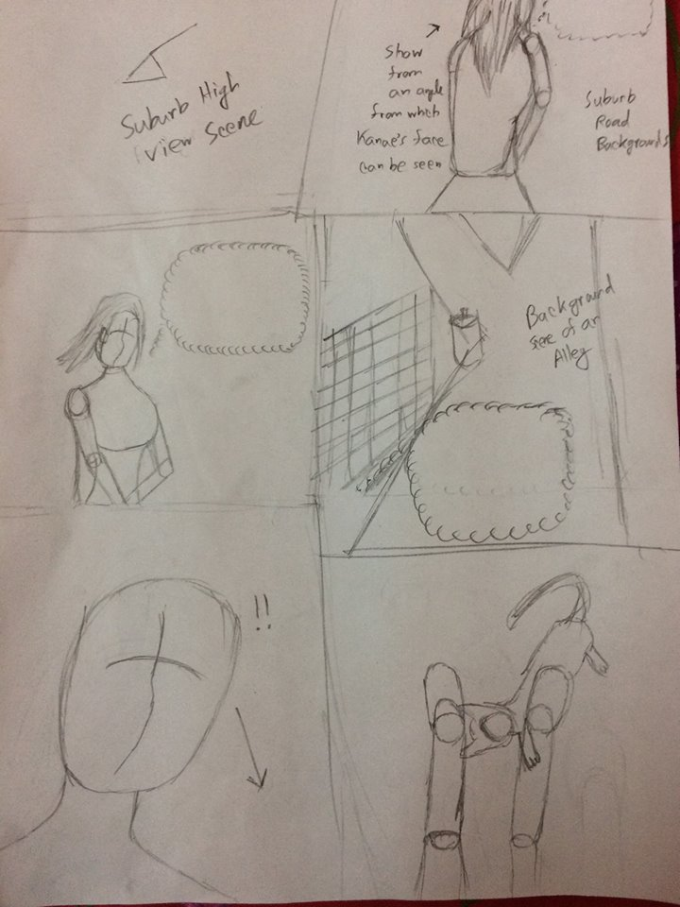

Panel-1: A high view scene of the suburbs, Kanae will be walking beside the road, others will walk beside her as well. She will be seen carrying a bag. A reference scene for the suburbs-

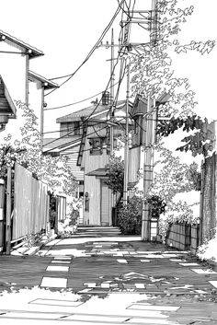

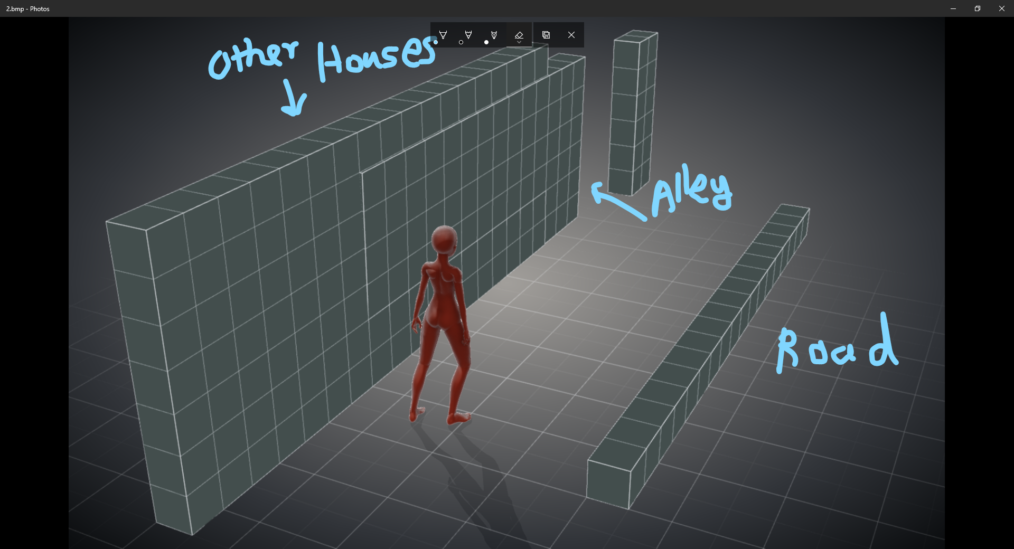

Panel-2: Kanae will be thinking as she closes to the alley.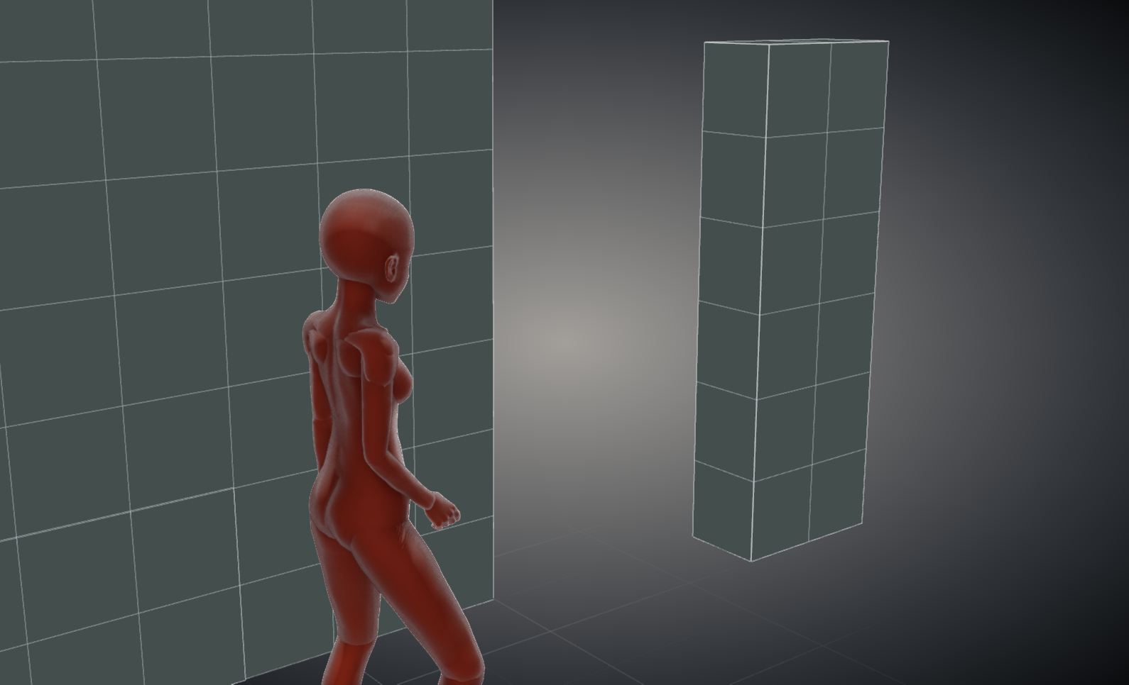

Panel-3: Continuing Kanae’s thoughts from panel-3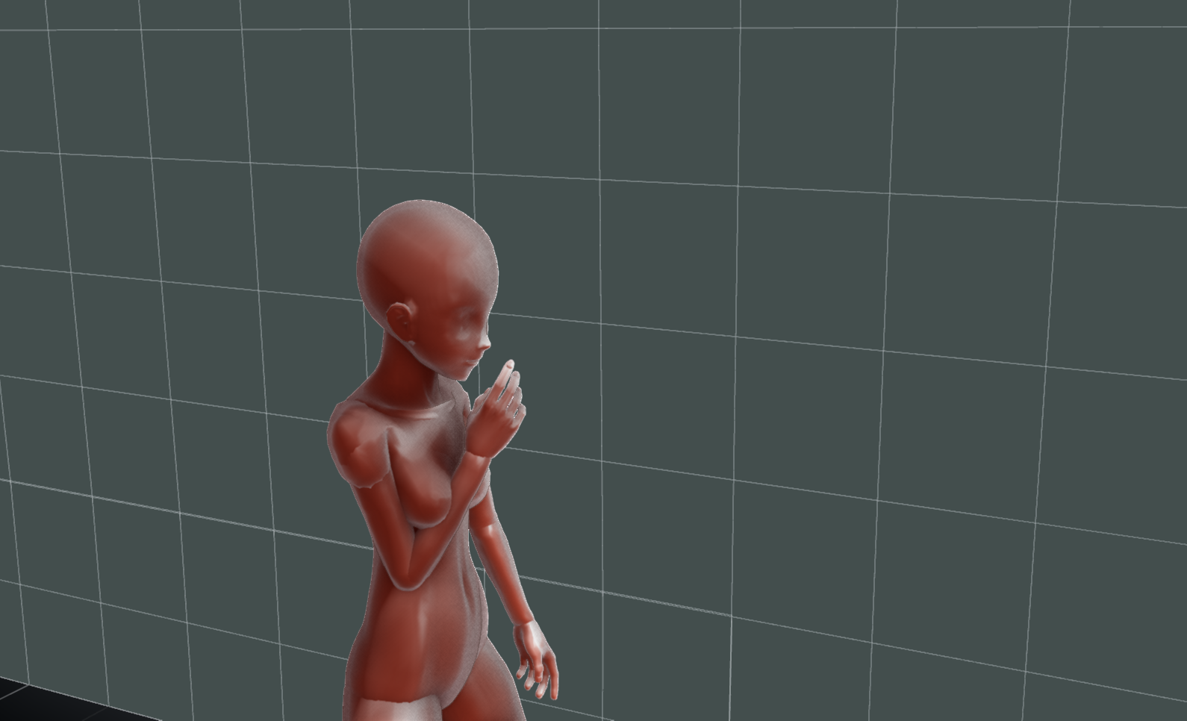

Panel-4: A scene from Kanae’s point of view. It will show the road, and also an alley at the left. Kanae’s thoughts will continue from the previous panels.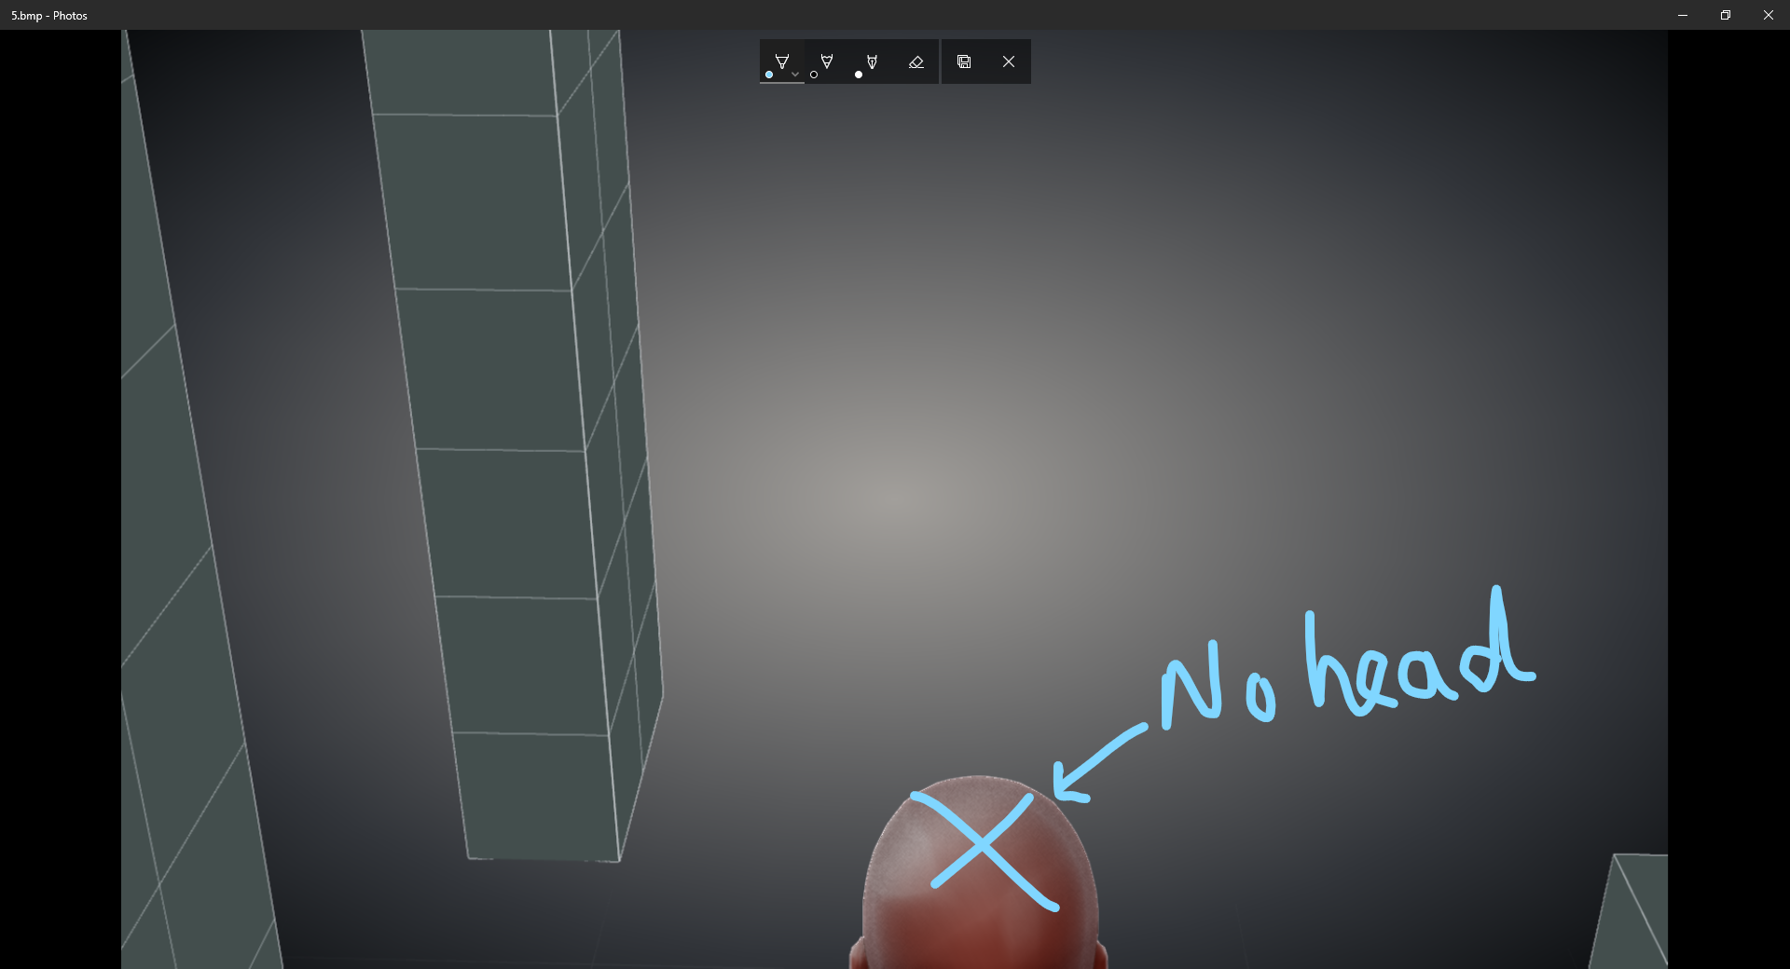

Panel 5: A close-up scene…her expressions will show mild surprisement. She will look downwards.

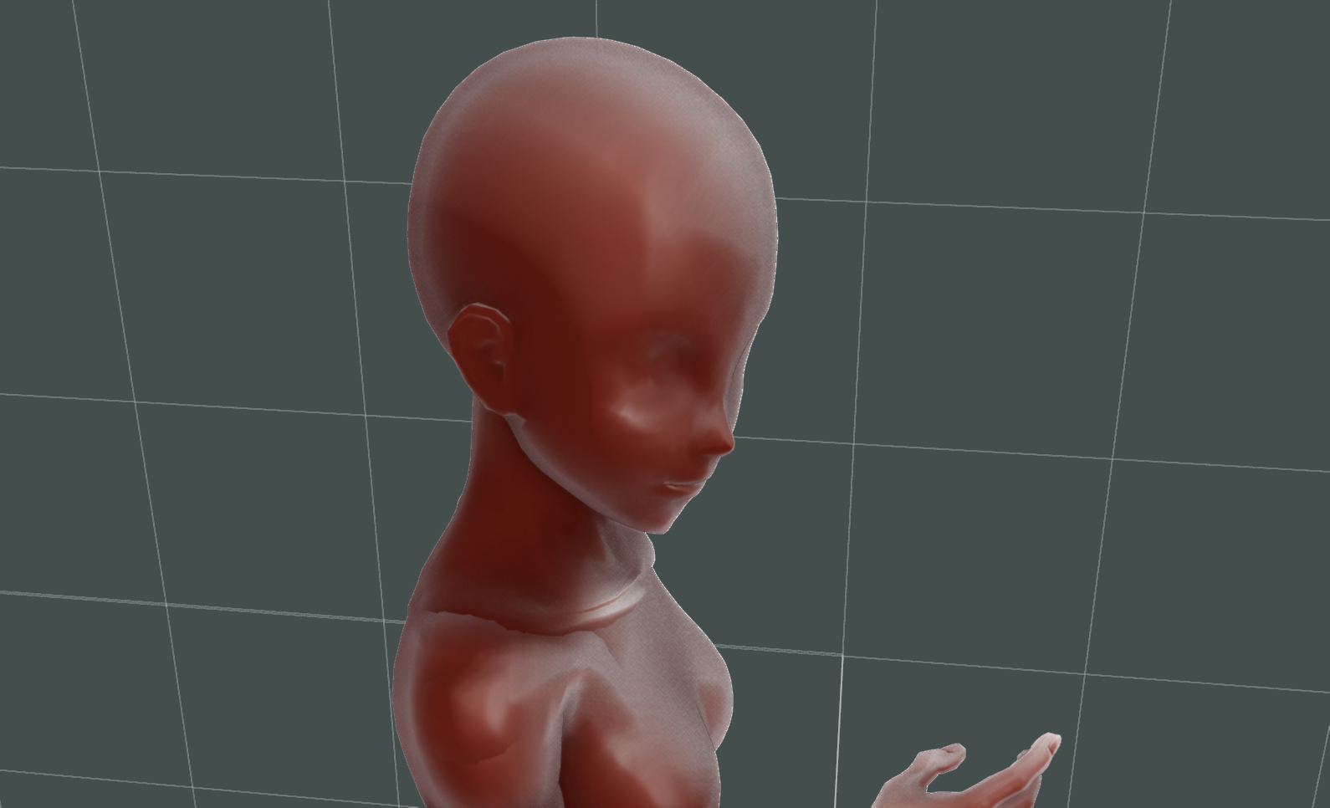

Panel-6: View from the top of Kanae’s head. It will show the cat looking at her.

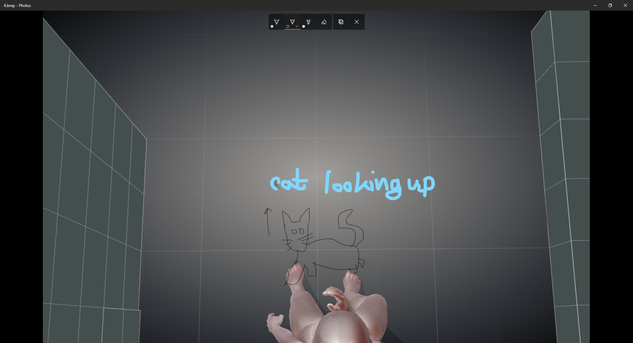

Something like this

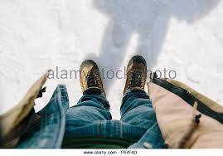

Except she is wearing a skirt.