Page Layout:

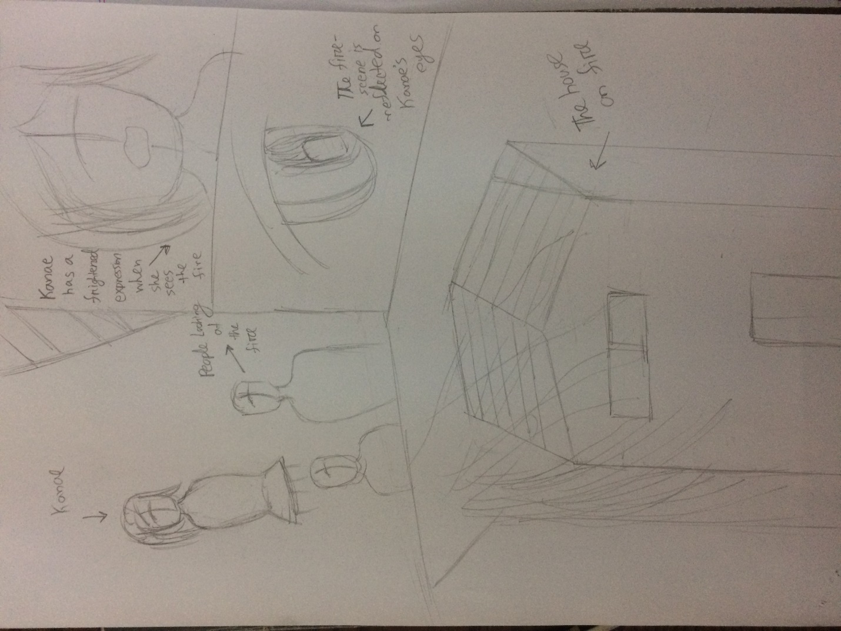

Panel-1: Kanae will be looking at the crowd while walking. A couple of people (or more) will be looking a the buiding which caught fire. Kanae will be wondering, “What’s going on here?” She will have confused expressions.



Panel 2: A semi close-up scene of Kanae. When she sees that the building is on fire she becomes scared. This scene will show her scared expression as she looks at the house.

Panel 3: This scene will show Kanae’s eye where the building on fire will be reflected.

Panel 4: A wide bottom panel showing the house on fire. The house will look something like this, but the angle should be a bit higher. 