Page -8

The Layout: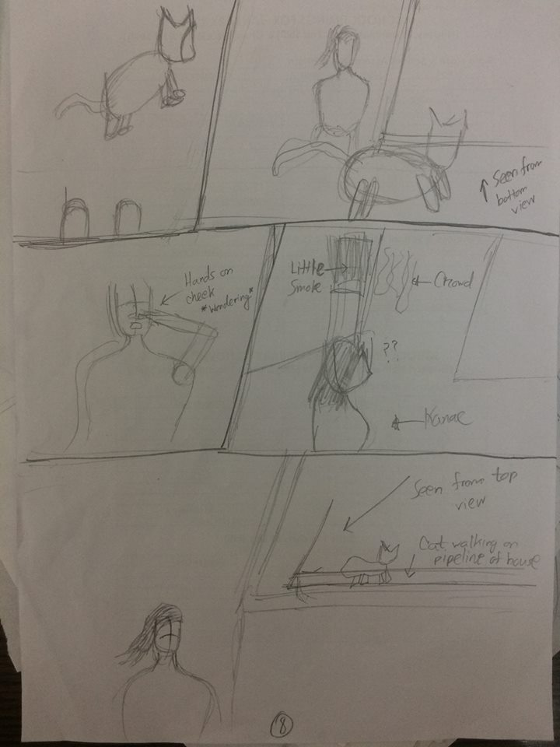

Panel -1: This scene is similar to the last panel of page-8. Kanae’s legs will be shown from her point of view. The cat will be leaving in this scene as if it is trying to tell her to go somewhere.

Panel-2: In this scene the cat will be going through the alley. Kanae will be looking that way as the cat leaves. Her expression will be a bit confused. 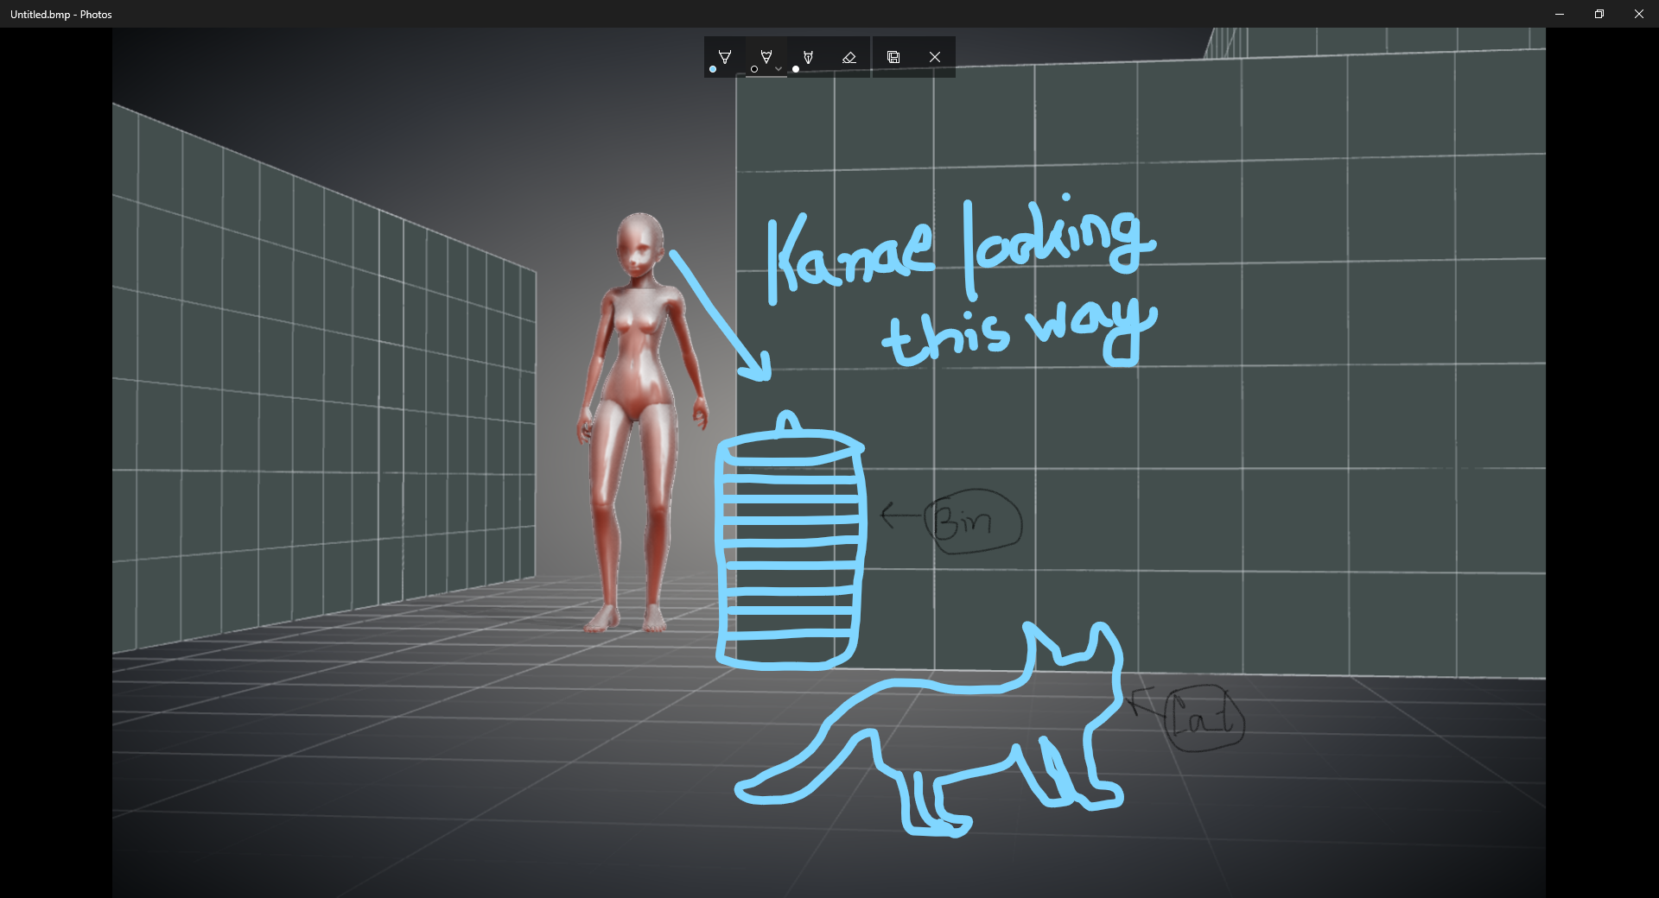

Panel 3: A semi-closeup scene of Kanae. She will have her hand on her cheek wondering why the cat left. She will think, “Uh-it left. It looked as if it wanted to show me something.” Her expressions will be a bit confused.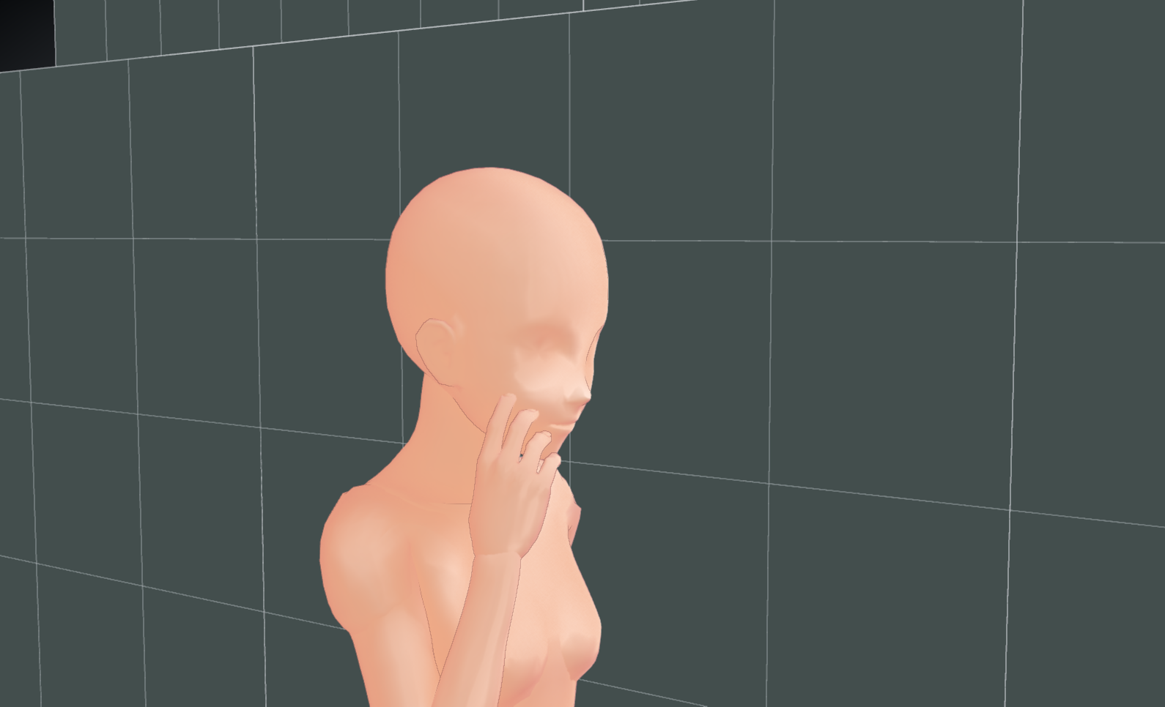

Panel 4: As kanae starts to walk further she looks left at the alley. There’s a small crowd in front of a house. Kanae looks at the crowd and wonders, “What’s doing on there?”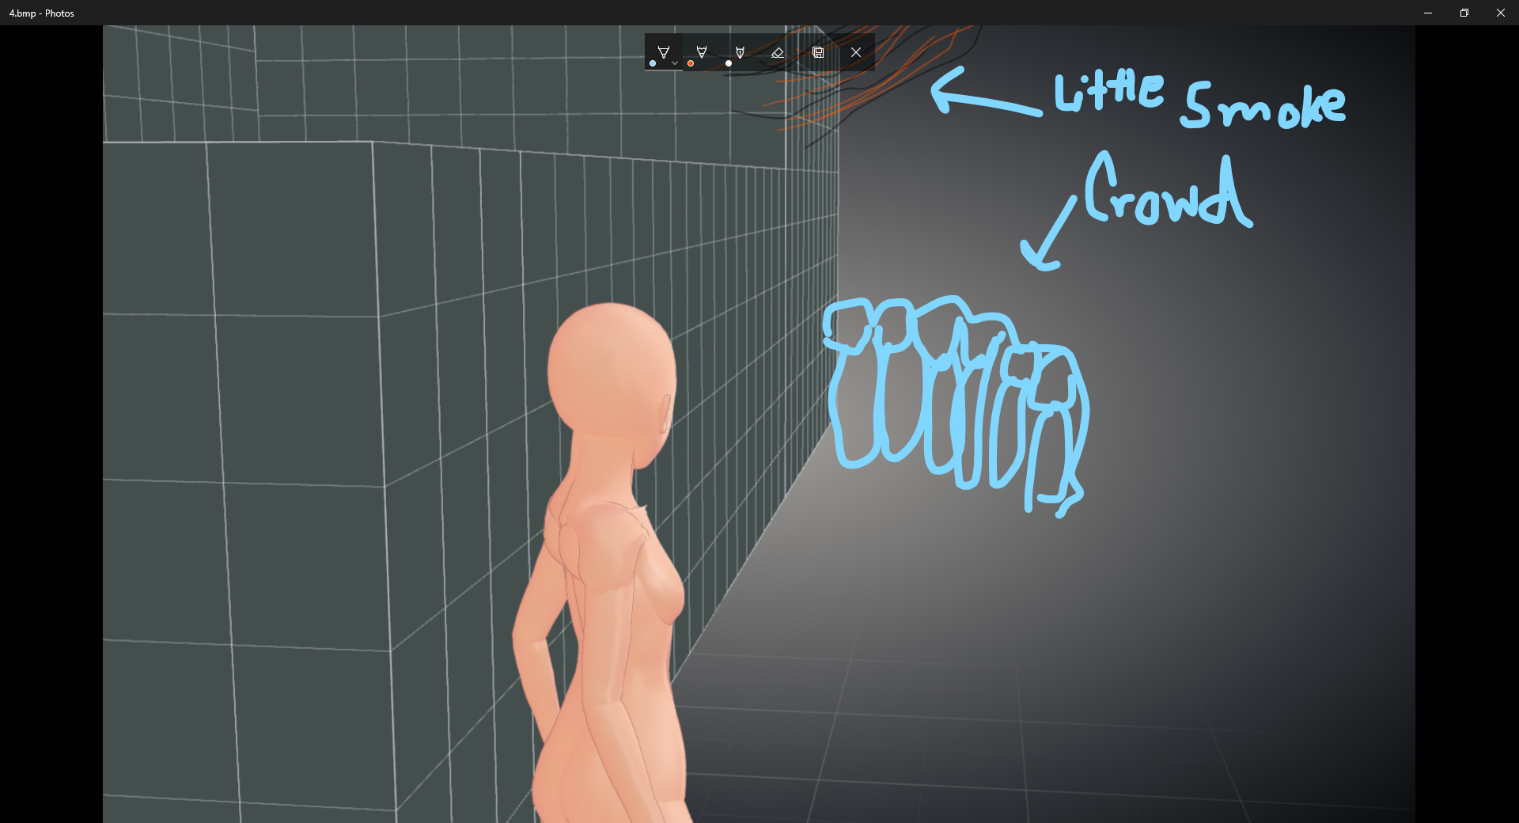

Panel 5:In this scene Kanae will be walking towards the crowd. The cat will be show from top angle. The cat will be walking on the roofpipe and it will be getting close to the building on fire. A little smoke will be shown at the bottom of the scene.

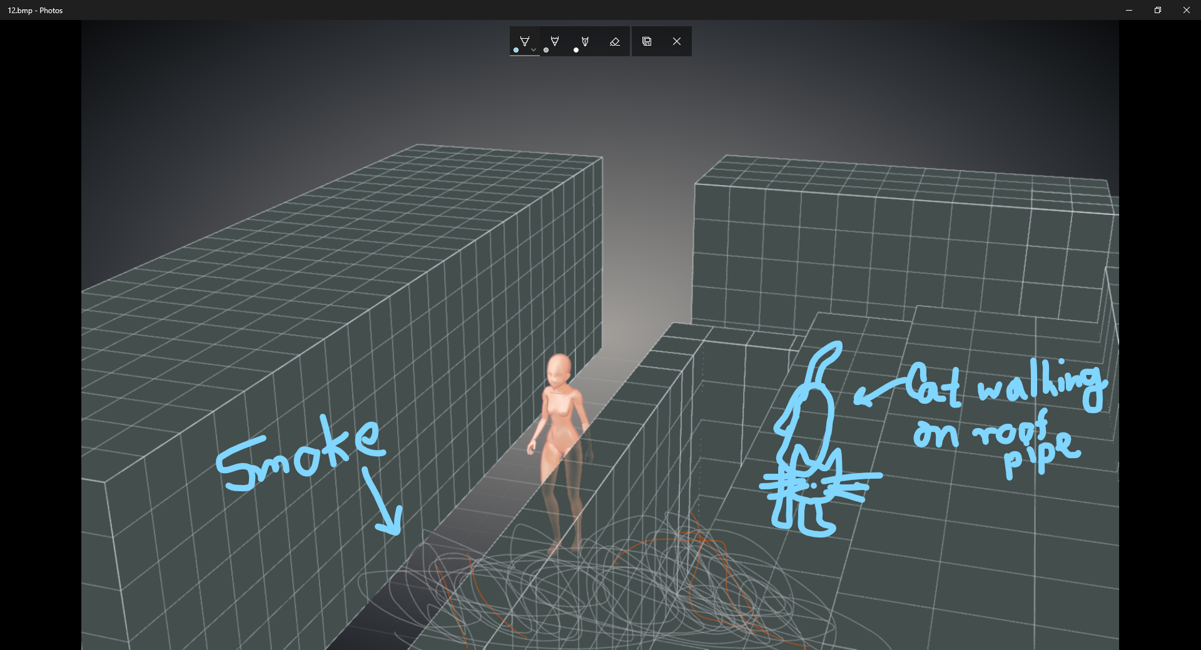

Here’s a pic of the whole area for understanding:

