Module A.1 Report
Landon Cardozo
The solution to a one-dimensional linear advection equation was analyzed using a first order finite volume (FV) method on both uniform and non-uniform grids. Tabulated below are error values for varying CFL and final time T values and total cells Nx. As expected, the error decreases by an order of magnitude (OOM) as the total number of cells increases by an OOM. This trend can be explained by the choice of a first order FV method. Also observed is a slight increase in error as T increases; more time means more time steps, and each step introduces a little numerical error that accumulates.
Table 1: Errors on a smooth uniform grid
CFL | 0.5 |  |  | 0.9 |  |  | 1.5
T | 0.5 | 1 | 1.5 | 0.5 | 1 | 1.5 | 1.5
Nx | Error
16 | 3.27E-01 | 5.04E-01 | 5.99E-01 | 3.32E-01 | 5.08E-01 | 6.01E-01 | 6.09E-01
32 | 1.88E-01 | 3.26E-01 | 4.27E-01 | 1.89E-01 | 3.27E-01 | 4.28E-01 | 4.30E-01
64 | 1.01E-01 | 1.88E-01 | 2.62E-01 | 1.01E-01 | 1.88E-01 | 2.62E-01 | 1.16E+09
128 | 5.25E-02 | 1.01E-01 | 1.46E-01 | 5.25E-02 | 1.01E-01 | 1.46E-01 | 1.30E+34
256 | 2.67E-02 | 5.25E-02 | 7.72E-02 | 2.67E-02 | 5.25E-02 | 7.72E-02 | 8.40E+84
512 | 1.35E-02 | 2.67E-02 | 3.97E-02 | 1.35E-02 | 2.67E-02 | 3.97E-02 | Inf
1024 | 6.78E-03 | 1.35E-02 | 2.02E-02 | 6.78E-03 | 1.35E-02 | 2.02E-02 | NaN
2048 | 3.40E-03 | 6.78E-03 | 1.01E-02 | 3.40E-03 | 6.78E-03 | 1.01E-02 | NaN
4096 | 1.70E-03 | 3.40E-03 | 5.09E-03 | 1.70E-03 | 3.40E-03 | 5.09E-03 | NaN

I evaluated the method on CFL values of 0.5, 0.9 and 1.5, where stability is defined on, $∈\left(0,1\right].$ There was no observed difference in the magnitude of error between CFL values within stability limits. However, the error quickly grows without bound for CFL equal to 1.5. These solutions are highly unstable regardless of grid uniformity and smoothness. Below, figures depict this instability in the smooth uniform (left) and non-smooth, non-uniform (right) cases. 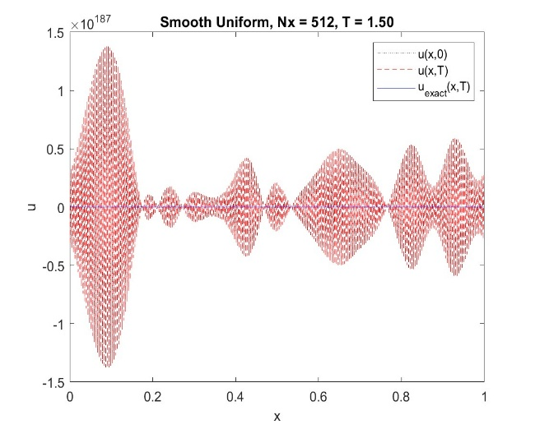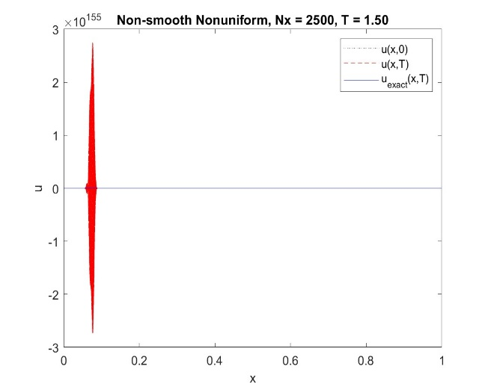

To model the effects of a shockwave, an un-smooth initial condition was used.
$$U_{0}(x)=\left\{\begin{aligned}1, &0.25≤x≤0.5 \\ 0, &otherwise\end{aligned}\right.$$
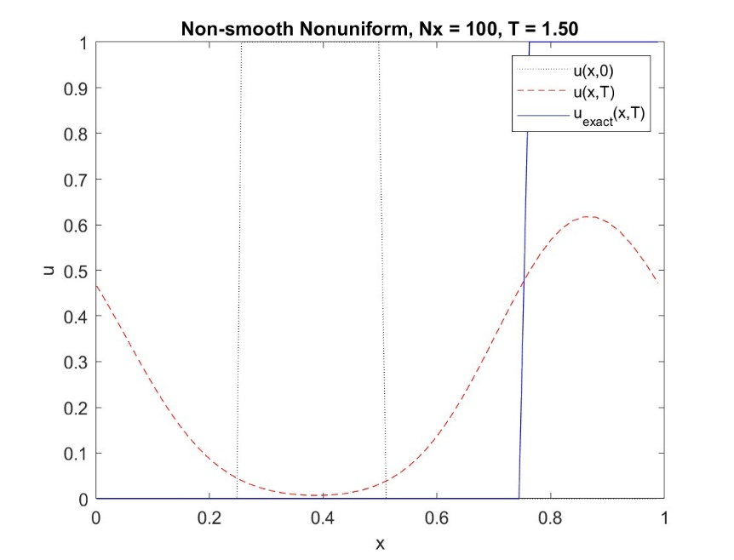
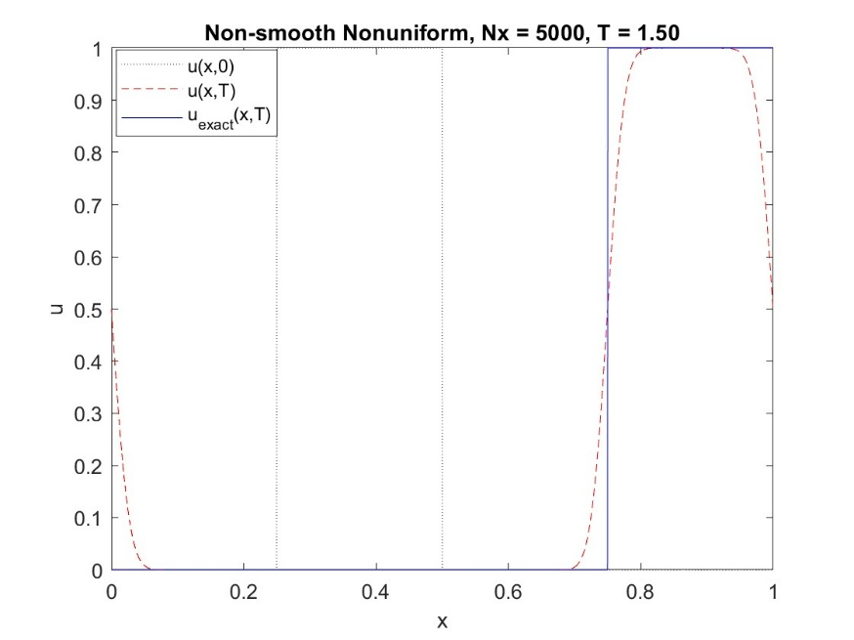
Similar to the smooth case, as Nx increases the model becomes more accurate, however, it never truly becomes sharp. As cells increase, the discontinuity from 0 to 1 is spread out between more cells narrowing the domain but the first order nature prevents perfect capture. Results plotted below.

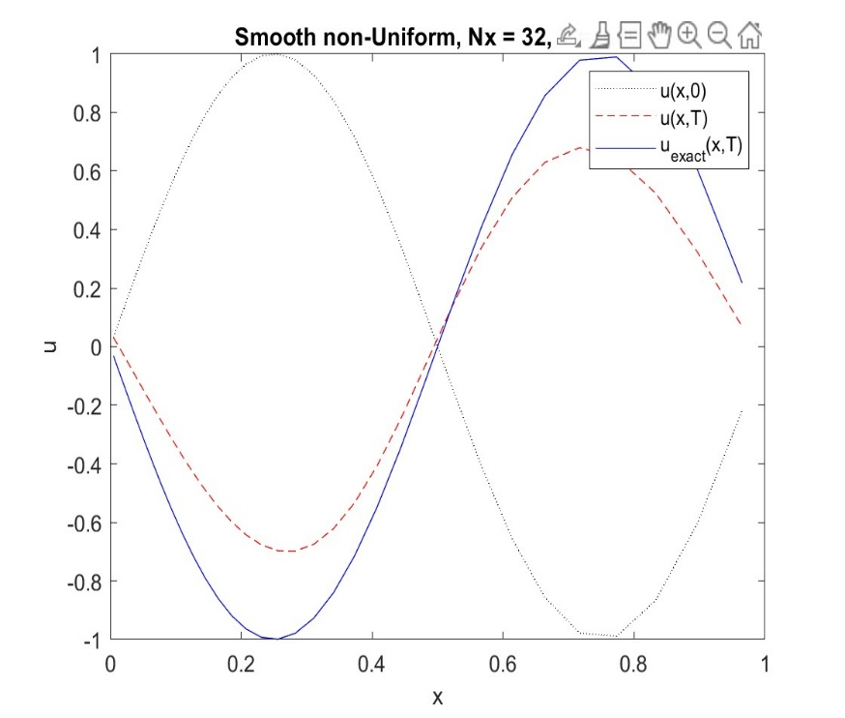
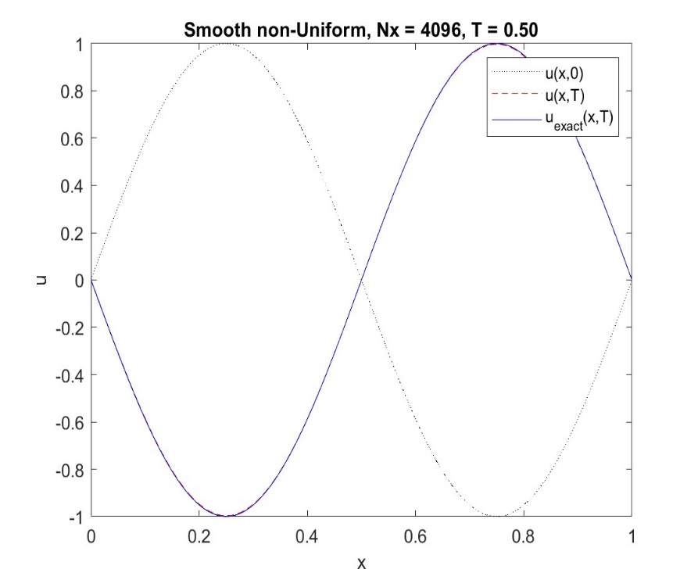
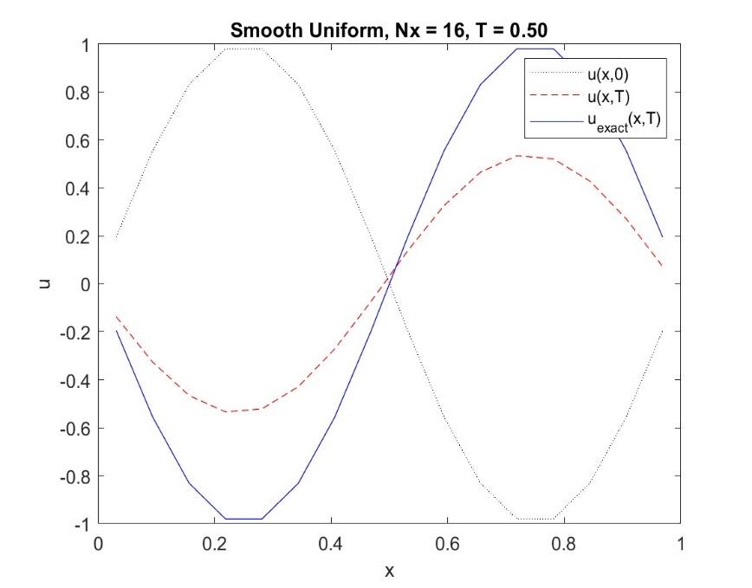
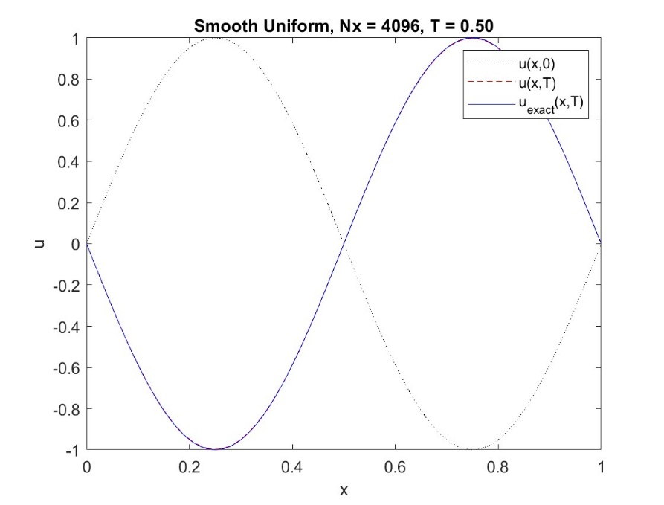
Depicted below are plots of the smooth case for uniform and non-uniform grids (CFL=0.5).

