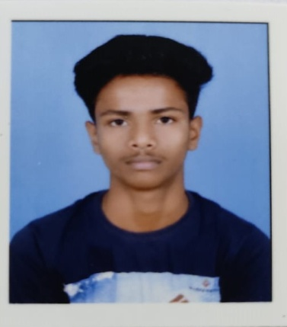 JEET PRAMANIK

EDUCATION:

SCHOOL NAME- BANDWAN R.N.C.V

BANDWAN— SECONDARY

PASSED IN 2020

SCHOOL NAME- BANDWAN R.N.C.V

BANDWAN— HIGHER SECONDARY

PASSED IN 2022

ADDRESS:

NAME: JEET PRAMANIK

S/O: HIMANSHU PRAMANIK

VILL: KENDAPARA, P.O: BANDWAN, P.S: BANDWAN, DIST: PURULIA,

PIN: 723129, W.B; INDIA.

E-MAIL: [jeetpramanik282@gmail.com](mailto:jeetpramanik282@gmail.com)

MOBILE- 8436526104

CAREER OBJECTIVE: TO WORK IN AN ORGANIZATION THAT HELPS ME TO GROW AND LEARN WHERE MY KNOWLEDGE ABILITY AND SKILLS ARE ENHANCE IN A DYNAMIC THERE BY CONTRIBUTING THE ORGANIZATION TO THE BEST OF MY CAPABILITIES.

PERSONAL INFORMATION:

SEX:- MALE

DATE OF BIRTH: 28TH AUGEST, 2004

NATIONALITY:- INDIAN

LANGUAGE: BENGALI, HINDI, ENGLISH

MARITAL STATUS: UNMARRIED

DECLARATION: I HERE BY DECLARE THAT THE ABOVE MENTIONED INFORMATION IS CORRECT TO THE BEST OF MY KNOW , I BETHE RESPONSIBILITY FOR CORRECTNESS OF THE ABOVE MENTIONED PARTICULAR.