Performance Evaluation Report
Project: Apni Chakki (BSIT Final Year Project)
Prepared By: Rizwan Tariq, Lead Developer
Focus Area: Backend API Load Testing (PHP & MySQL)

1. Executive Summary
A rigorous concurrency load test was conducted on the core product retrieval endpoint (/get_all_products.php). The test simulated 50 simultaneous users sending 1,000 total requests to evaluate backend stability before connecting the ReactJS frontend. The system demonstrated 100% reliability with zero dropped requests, successfully maintaining a throughput of 115 requests per second under heavy traffic.

2. Performance Visualizations
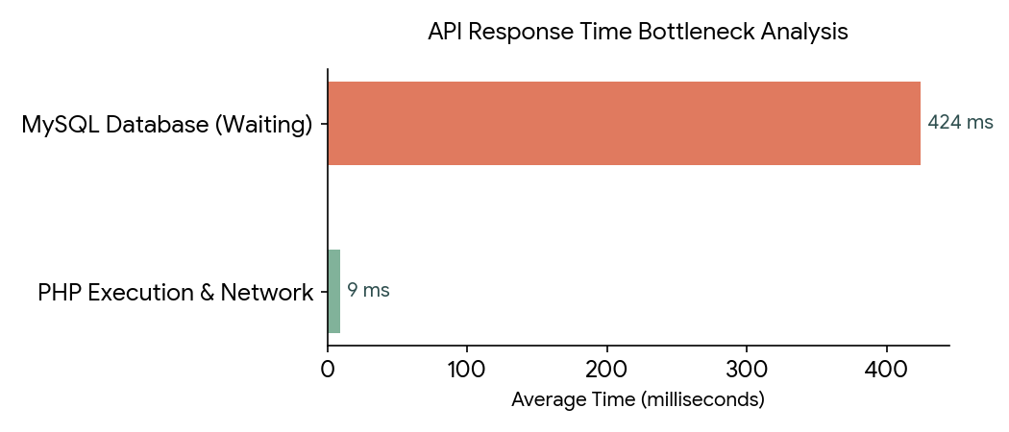
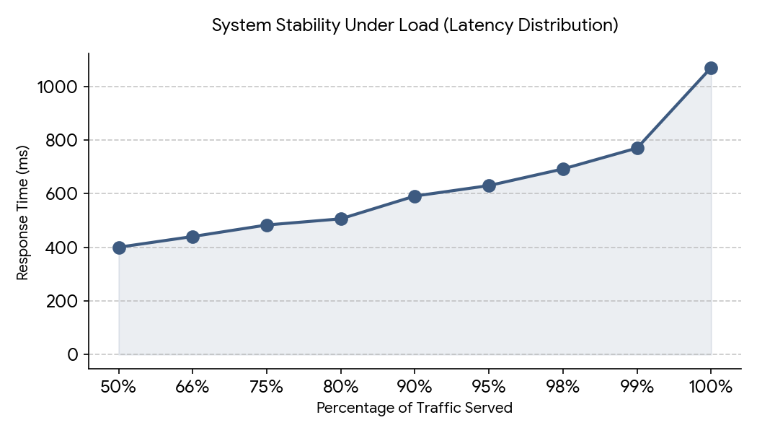

3. Key Findings & Bottleneck Analysis
- • High Reliability: The Apache server successfully handled the traffic spike without returning any 500 Internal Server Errors or connection timeouts, proving the base architecture is robust.
- • Throughput Capacity: Processing ~115 requests per second provides a highly stable baseline for initial user rollout.
- • Database Latency Bottleneck: The average response time was 433ms. Analysis of the benchmark logs indicates that 424ms of this time was spent entirely in the "Waiting" phase (Time to First Byte). This isolates the performance bottleneck directly to the MySQL database query execution rather than the PHP processing logic or network layer.

4. Proposed Optimization Strategy
To achieve sub-100ms response times for a seamless ReactJS frontend experience, the following optimizations will be implemented:

Phase 1: SQL Indexing
Database queries are currently performing full-table scans. We will implement B-Tree indexes on frequently filtered columns within the database to allow MySQL to instantly locate product rows rather than scanning the entire table.

Phase 2: Payload Pagination
The current API payload size is 22.4 KB per request, loading the entire inventory simultaneously. We will implement LIMIT and OFFSET parameters in the PHP controllers. This allows the React application to lazily load products in batches of 15-20, drastically reducing database memory overhead.

Phase 3: Query Refactoring
We will review the PHP controller logic to ensure no N+1 query loops are present, replacing any nested iterative database calls with unified SQL JOIN statements.

