I) Introduction:  
This is a logical self explanatory document detailing all design decisions made for the development of an functional and acceptable computer organization to perform all ARM v8 operations.   
  
II) Datapath Design   
 1) Logic circuitry for accomplishing all data operations in CPU.

2) ASMD

<https://docs.google.com/a/upr.edu/presentation/d/1mr-EAguuwUloBhAiOhI3Kh7VxdQ5WpdI35vV6mpwLv4/edit?usp=sharing>

3) Details signals in verilog of system:

<https://docs.google.com/a/upr.edu/spreadsheets/d/1ddIKTCiXAooGlyupXqe__j2l9rYdhfo_uYfniRAZNWQ/edit?usp=sharing>

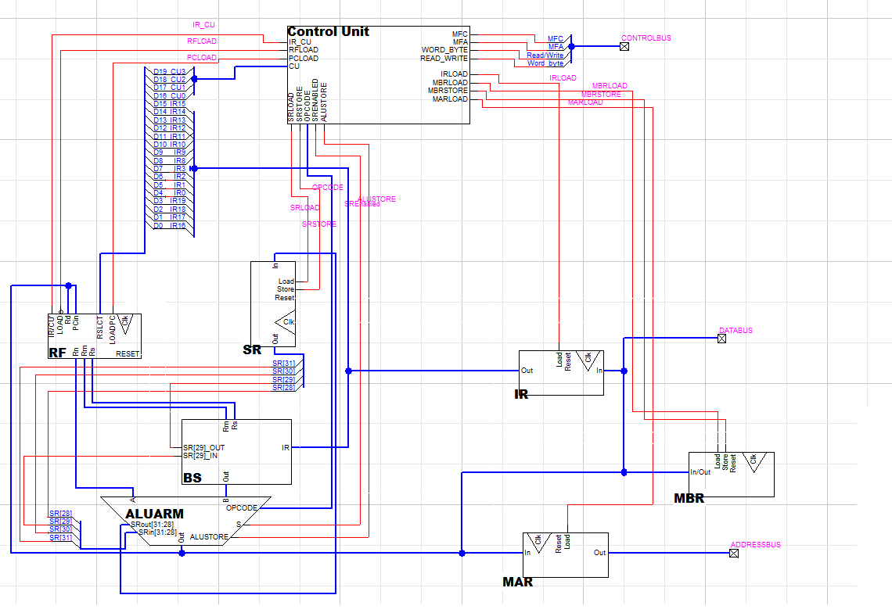

III) Control unit design