Coral Del Mar:

# Research tittle:

This will be defined as we scope into a specific algorithm.

## Research Theme

Fundamentals of Algorithmics with Java

## Notes:

Esta investigación conllevara el estudio de conceptos algorítmicos con el uso de varios problemas, las soluciones algorítmicas y finalmente su implementación dentro del lenguaje Java. Como objetivo final se implementara un algoritmo de gran complejidad. **Cuando digo algoritmo me refiero a algoritmo de computadoras.**

# Topics:

* Algoritmos : la ciencia que estudia los algoritmos.
* Variety of computer solvable problems.

Start by Reading This :

Definiciones :

#### Algorithmics:

“Algorithmics is more than a branch of computer science. It is the core of

computer science, and, in all fairness, can be said to be relevant to most of

science, business, and technology.” [Har92, p. 6] - *Algorithmics: the Spirit of Computing*

#### Importance of Algorithms:

“A person well-trained in computer science knows how to deal with algorithms:

how to construct them, manipulate them, understand them, analyze them.

This knowledge is preparation for much more than writing good computer

programs; it is a general-purpose mental tool that will be a definite aid to

the understanding of other subjects, whether they be chemistry, linguistics,

or music, etc. The reason for this may be understood in the following way:

It has often been said that a person does not really understand something

until after teaching it to someone else. Actually, a person does not *really*

understand something until after teaching it to a *computer*, i.e., expressing

it as an algorithm . . . An attempt to formalize things as algorithms leads to

a much deeper understanding than “- Donald Knuth

#### Algorithm

“An ***algorithm*** is a sequence of unambiguous instructions for solving a problem, i.e., for obtaining a required output for any legitimate input in a finite amount of time.” - Introduction to the Design and Analysis of Algorithms 3rd Edition, Anany Levitin

* The nonambiguity requirement for each step of an algorithm cannot be compromised.
* The range of inputs for which an algorithm works has to be specified carefully.
* The same algorithm can be represented in several different ways.
* There may exist several algorithms for solving the same problem.

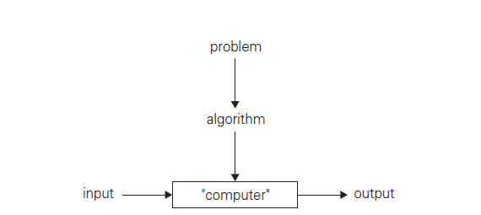’

#### Computer Algorithm

Is an algorithm that can be solved by a computer via computations.

#### Problems with computer algorithms:

We will not duel deep into these because of they require some background in Computer Theory.

* The haling problem: given an algorithm and an input; Does the algorithm halts?
* The correctness problem: if the algorithm halts; Does it return the right answer?

Watch this video :

http://d396qusza40orc.cloudfront.net/algo1/recoded_videos%2Fintronew%20%5Be0d4ad02%5D%20.mp4

My Suggestions:  
Study these definitions and we will begin analysing and solving problems.  
  
Problem 1:

#### Definion:

Given two nonnegave integers m and n, not--‐both--‐zero, their **greatest** **common** **divisor** is defined to be the largest integer that divides m and n (meaning that the remainder is 0 in both divisions)

#### Example:

Consider m = 60 and n = 24.

Their common divisors are: 1, 2, 3, 4, 6, and 12.

Therefore, the greatest common divisor of m and n is **12**; or, **gcd(60,** **24)** **=** **12**  
**nota: gcd() = greates common divisor**

#### Simple algorithm for computing gcd(m, n)

//Computes gcd*(m, n)* by Euclid’s algorithm

//Input: Two nonnegative, not-both-zero integers *m* and *n*

//Output: Greatest common divisor of *m* and *n*

***Step 1:*** Get the mínimum value of *n* and *m*, let’s call it “*t*”

***Step 2:*** Divide *n* by the value of *t* and if the reminder of the division is *0* then n is divisible by *t*

***Step 3:*** Divide *m* by the value of *t* and if the reminder of the division is *0* then *m* is divisible by *t*

***Step 4:*** If one of the numbers is not divisible by *t* subtract *1* from *t* and go to ***Step 2***