**ICOM 4015-Advanced Programming**

Spring 2014

Instructor: Dr. Amir H. Chinaei

TAs: Hector Franqui, Jose Garcia, and Antonio Tapia

Reference: **Big Java**

By Hortsmann, Ed 4

**Lab 4**

**Introduction to Jar Files, RESTFUL Methods and Web Sockets.**

Department

of

Electrical and Computer Engineering

University of Puerto Rico at Mayagüez

**Before laboratory:**

1. Read up on Java Jar Files
2. Review JPanels
3. Review Action Listeners
4. Review JComboBox,JTextField, JTextArea
5. Print (at least) the Evaluation sheet in the last page.
6. **Login to computer (1 minute)**
7. **Using JAR Files(20 minutes)**
   1. Download all the the jarfile from “https://github.com/Apo45ty/ICOM4015LABS/tree/master/Laboratory_05/resources/jars”
   2. Create a folder in your eclipse folder and name it lib
   3. Move the Jar files into the lib folder
   4. Refresh your project in eclipse.
   5. Right click on each folder and select the option “Build Path > Add To build path”
   6. Your project should look as follows:

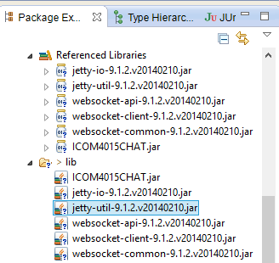

**Show your code to instructor 1(20 points)**

1. **Build a GUI ( 25 minutes) – Compile in a the JFrame and run it.**
   1. **Create a new class and call it “WelcomePanel” and add the following piece code to it :**

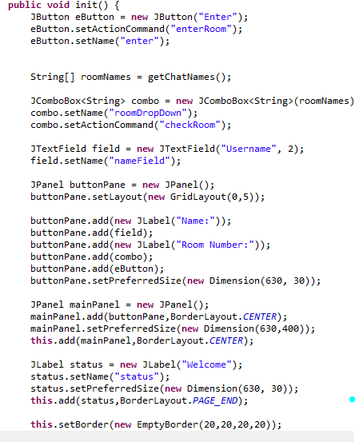

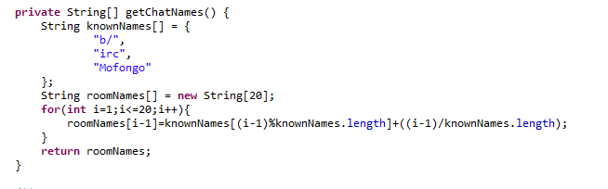

* 1. **Now add the following main method to test the code:**

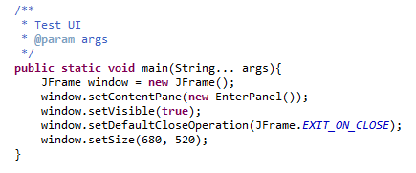

* **Run this class and you should see the window below:**

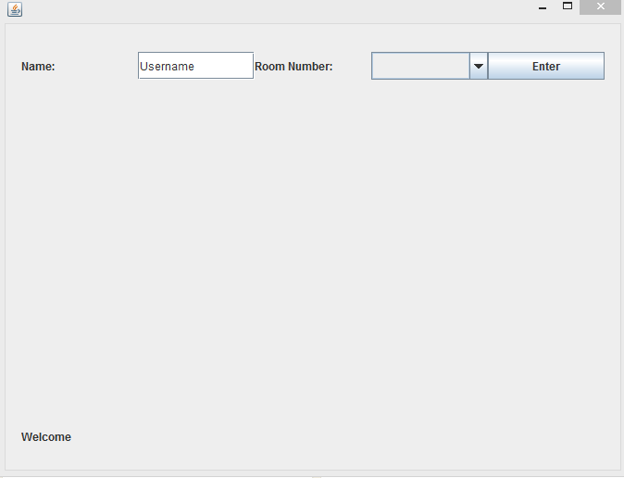

* **Now create a new class and name it “ChatPanel” and add the following piece of code to it:**

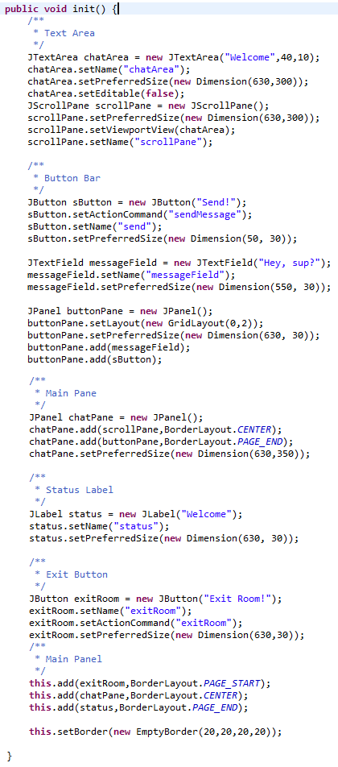

* 1. **Now add the following main method to test the code**

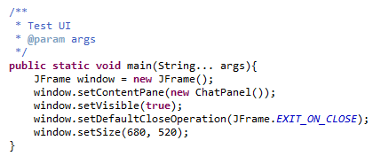

* 1. **Run this class and you should see the window below:**

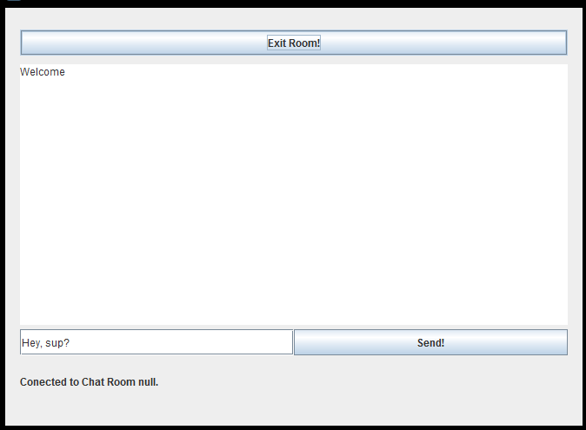

**Customize the UI Code below so that it looks more awesome (change button colours, background colour... ).**

**Show your code to instructor 2(20 points)**

1. **Chat Engine is an abstract class already implements most of what we need to make our chat client but first we must implement a few methods. (10 minutes)**
   1. **Create a new class that extends the “ChatEngine” class, namely “MyClassEngine”.**
   2. **Now Implement the method “setName()”.**

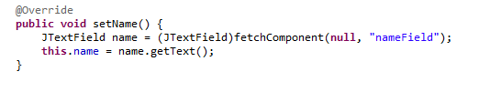

Notice that the class chat engine has some objects and methods already implemented

1. **HTTP or the Hypertext Transfer Protocol is the most used protocol on the web for information sharing. (35 minutes)**
   1. **TAs explain information on slides (15 minutes)**

**- Now implement the “checkRoomImp” method.**

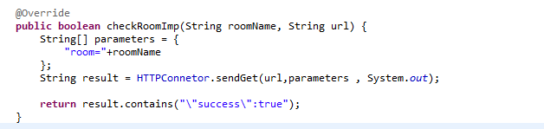

1. **Do a POST that adds User to the Room parsing the server response.**
   1. **Implement the “exitRoomImp”**

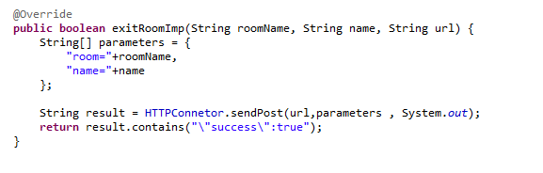

**Show your code to instructor 3(20 points)**

* + - **Implement the POST for “registerUserInRoomImp”**

**Show your code to instructor 4(20 points)**

1. **Sockets is another method of communication on the web and it is commonly used in chat services, games and all services needing duplex(two way) communication (19 minutes):**
   1. **TAs explain information on slides (10 minutes)**
      * **Ask to implement a WEB SOCKET for “sendMessageImp” user clicks send message to chat(15 minutes).**

**Show your code to instructor 5(20 points)**

**After Lab**

* **Read on HTTP Methods**
* **Evaluation Sheet**
* **(optional)Check out the chat server on Github “https://github.com/Apo45ty/NodeSimpleChatServer”**

### Evaluating Lab 4

### Write Your Section# here: ……..

### Please evaluate the quality of the lab and performance of the instructors by filling up the following table and give it to your lab representative. (Choose 5 as the highest and 1 as the lowest grade).

|  |  |  |  |  |  |
| --- | --- | --- | --- | --- | --- |
| Items | 5 | 4 | 3 | 2 | 1 |
| The lab started on time SHARP. |  |  |  |  |  |
| The instructor covered adequately the HTTP Methods, WebSockets and answered the group’s questions thoroughly. |  |  |  |  |  |
| The instructor covered adequately Jar files and answered the group’s questions thoroughly. |  |  |  |  |  |
| The instructor overall followed the specified timeline for each step |  |  |  |  |  |
| You found the lab today overall Great (helpful, fruitful, interesting, etc.). |  |  |  |  |  |