**ICOM 4015-Advanced Programming**

Spring 2014

Instructor: Dr. Amir H. Chinaei

TAs: Hector Franqui, Jose Garcia, and Antonio Tapia

Reference: **Big Java**

By Hortsmann, Ed 4

**Lab 4**

**Introduction to Jar Files and Web Development**

Department

of

Electrical and Computer Engineering

University of Puerto Rico at Mayagüez

**Before laboratory:**

1. Read up on Java Jar Files
2. Review JPanels
3. Review Action Listeners
4. Review JComboBox,JTextField, JTextArea
5. Print (at least) the Evaluation sheet in the last page.
6. **Login to computer (1 minute)**
7. **Using JAR Files**
   1. Download the jarfile from “”
   2. Add the “Jar” file to the project

Show you progress 1

1. **Build a GUI ( minutes) – Compile in a the JFrame and run it.**
   1. **Add the UI for my UI:**

public class EnterPanel extends SimplePanel{

@Override

void init() {

JButton eButton = new JButton("Enter");

eButton.setActionCommand("enterRoom");

eButton.setName("enter");

String roomNames[] = new String[20];

JComboBox<String> combo = new JComboBox<String>(roomNames);

combo.setName("roomDropDown");

combo.setActionCommand("checkRoom");

JTextField field = new JTextField("Username", 2);

field.setName("nameField");

JPanel buttonPane = new JPanel();

buttonPane.setLayout(new GridLayout(0,5));

buttonPane.add(new JLabel("Name:"));

buttonPane.add(field);

buttonPane.add(new JLabel("Room Number:"));

buttonPane.add(combo);

buttonPane.add(eButton);

buttonPane.setPreferredSize(new Dimension(630, 30));

JPanel mainPanel = new JPanel();

mainPanel.add(buttonPane,BorderLayout.CENTER);

mainPanel.setPreferredSize(new Dimension(630,400));

this.add(mainPanel,BorderLayout.CENTER);

JLabel status = new JLabel("Welcome");

status.setName("status");

status.setPreferredSize(new Dimension(630, 30));

this.add(status,BorderLayout.PAGE_END);

this.setBorder(new EmptyBorder(20,20,20,20));

}

/**

* Test UI

* @param args

*/

public static void main(String... args){

JFrame window = new JFrame();

window.setContentPane(new EnterPanel());

window.setVisible(true);

window.setDefaultCloseOperation(JFrame.EXIT_ON_CLOSE);

window.setSize(680, 520);

}

}

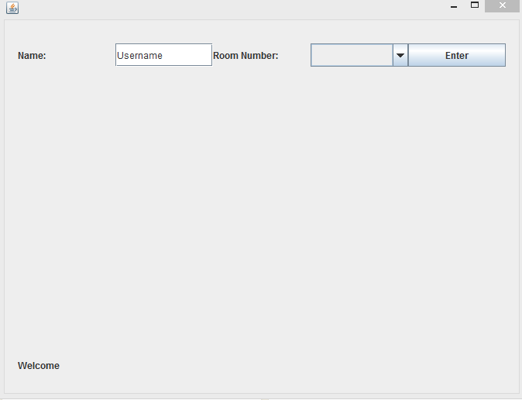

public class ChatPanel extends SimplePanel{

@Override

void init() {

/**

* Text Area

*/

JTextArea chatArea = new JTextArea("Welcome");

chatArea.setName("chatArea");

chatArea.setPreferredSize(new Dimension(630,300));

chatArea.setEditable(false);

/**

* Button Bar

*/

JButton sButton = new JButton("Send!");

sButton.setActionCommand("sendMessage");

sButton.setName("send");

sButton.setPreferredSize(new Dimension(50, 30));

JTextField messageField = new JTextField("Hey, sup?");

messageField.setName("messageField");

messageField.setPreferredSize(new Dimension(550, 30));

JPanel buttonPane = new JPanel();

buttonPane.setLayout(new GridLayout(0,2));

buttonPane.setPreferredSize(new Dimension(630, 30));

buttonPane.add(messageField);

buttonPane.add(sButton);

/**

* Main Pane

*/

JPanel chatPane = new JPanel();

chatPane.add(chatArea,BorderLayout.CENTER);

chatPane.add(buttonPane,BorderLayout.PAGE_END);

chatPane.setPreferredSize(new Dimension(630,350));

/**

* Status Label

*/

JLabel status = new JLabel("Welcome");

status.setName("status");

status.setPreferredSize(new Dimension(630, 30));

/**

* ExitButton

*/

JButton exitRoom = new JButton("Exit Room!");

exitRoom.setName("exitRoom");

exitRoom.setActionCommand("exitRoom");

exitRoom.setPreferredSize(new Dimension(630,30));

/**

* Main Panel

*/

this.add(exitRoom,BorderLayout.PAGE_START);

this.add(chatPane,BorderLayout.CENTER);

this.add(status,BorderLayout.PAGE_END);

this.setBorder(new EmptyBorder(20,20,20,20));

}

/**

* Test UI

* @param args

*/

public static void main(String... args){

JFrame window = new JFrame();

window.setContentPane(new ChatPanel());

window.setVisible(true);

window.setDefaultCloseOperation(JFrame.EXIT_ON_CLOSE);

window.setSize(680, 520);

}

}

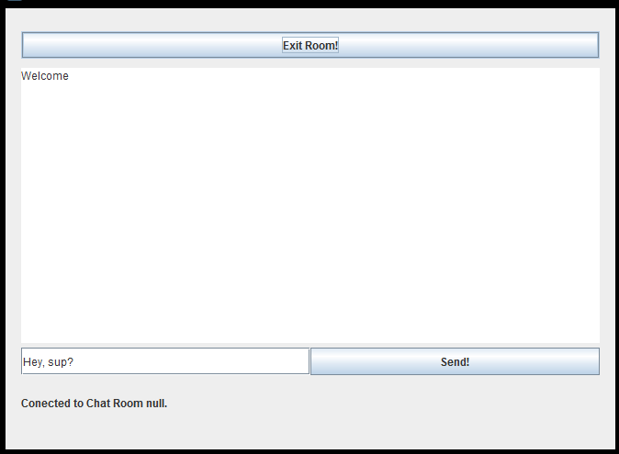

**Customize the UI Code below so that it looks more awesome(change button colors background color).**

**Show you progress 2.**

* 1. **Create a new class that extends the “ChatEngine” class.**
  2. **Show them this implementation of the “setName()” method.**

@Override

**public** **void** setName() {

JTextField name = (JTextField)fetchComponent(**null**, "nameField");

**this**.name = name.getText();

}

1. **Do a GET request to ask the server for room (max 20 rooms of 10 users).**
   1. **Show implementation of the “checkRoomImp”**
2. **Do a POST that adds User to the Room parsing the server response.**
   1. **Show implement implementation of “enterRoomImp”**
3. **Ask students to implement missing POST and GET methods :**
   * + **Ask to implement POST for “sendMessageImp” user clicks send message to chat**
     + **Ask to implement GET for “exitRoomImp”**

### Evaluating Lab 4

### Write Your Section# here: ……..

### Please evaluate the quality of the lab and performance of the instructors by filling up the following table and give it to your lab representative. (Choose 5 as the highest and 1 as the lowest grade).

|  |  |  |  |  |  |
| --- | --- | --- | --- | --- | --- |
| Items | 5 | 4 | 3 | 2 | 1 |
| The lab started on time SHARP. |  |  |  |  |  |
| The instructor covered adequately the GUI material and answered the group’s questions thoroughly. |  |  |  |  |  |
| The instructor covered adequately the Listeners material and answered the group’s questions thoroughly. |  |  |  |  |  |
| The instructor overall followed the specified timeline for each step |  |  |  |  |  |
| You found the lab today overall Great (helpful, fruitful, interesting, etc.). |  |  |  |  |  |

**Evaluating Lab 4**

### Write Your Section# here: ……..

### Please evaluate the quality of the lab and performance of the instructors by filling up the following table and give it to your lab representative. (Choose 5 as the highest and 1 as the lowest grade).

|  |  |  |  |  |  |
| --- | --- | --- | --- | --- | --- |
| Items | 5 | 4 | 3 | 2 | 1 |
| The lab started on time SHARP. |  |  |  |  |  |
| The instructor covered adequately the GUI material and answered the group’s questions thoroughly. |  |  |  |  |  |
| The instructor covered adequately the Listeners material and answered the group’s questions thoroughly. |  |  |  |  |  |
| The instructor overall followed the specified timeline for each step |  |  |  |  |  |
| You found the lab today overall Great (helpful, fruitful, interesting, etc.). |  |  |  |  |  |