|  |
| --- |
| Universidad De Puerto Rico Recinto unversitario De Mayaguez |
| Microprocessors |
| Course Final Project |
|  |
| **Antonio Ahmed Tapia Maldonado** |
| **5/12/2014** |

|  |
| --- |
| This is the final assignment for the course INEL4206. |

# Objective

The objective of this project was to design a system capable of measuring the speed at which an object crosses a series of infrared photodiodes to determine the objects velocity. The point of this system was to design it so that it could run on its own once it is discarded into the msp430. The finality of this assignment is to effectively demonstrate dominion over the following themes: Interrupts, Timers, polling mechanism, current stirring and finally micro processor interfacing principals.

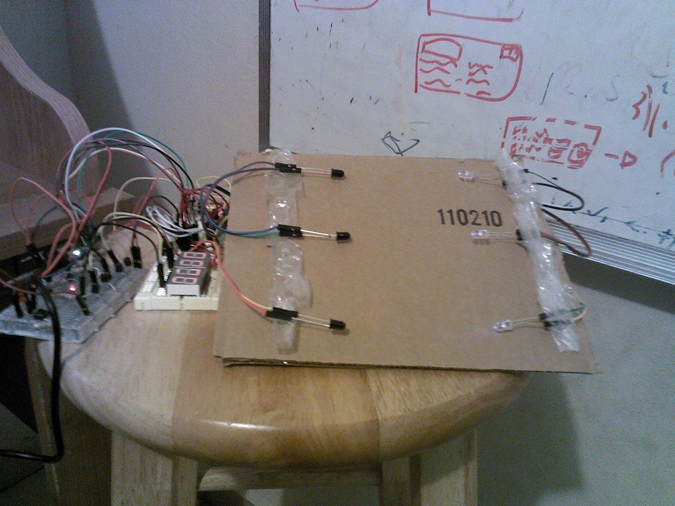

# Introduction

Speed ramps have been around for a very long time and they operate on very basic physical principals. This principals described by Sir Isaac Newton’s laws of motion allow embedded systems designers to create a digital speed measuring ramp. We utilize the laws that govern gravity at relatively low speeds to deduct that velocity is d/ t and because we have a fixed distance between PhotoDiodes we know that we need only divide the time taken from the first PhotoDiode to the rest of the Diodes. Photodiodes are those whom when hit by light at a band frequency they conduct and their resistance goes near zero.

We utilize photodiodes because we desire to utilize a light frequency5 beyond normal eyesight and thus reduce the opportunity for error with our readings. In order to drive these diode we utilize 3 of them and connect them to ports on the microcontroller, namely the MSP430. Other features utilize in this project was the Timer A and 8 other ports to drive out four seven segment displays to display the measured speed.

# How your team determine how to proceed

I decided that I would proceed by making the physical software because this allowed me to very that all components worked perfectly and smoothly. Later this build up the confidence to setup the housing for the circuit and the program that the microprocessor would run. The design process

for the Software design I took an approach that would include vectors and polling in order to allow for the detection of an interrupt. The systems sets off an interrupt once it detects the presence of an object through its lenses.

# Software:

main:

mov.w #0001h,R7 ; set the delay parameter 1

mov.w #2000,R8 ; set the delay parameter 2

bic.b #00010000b,&P2OUT;

clr.b &P1OUT

mov.b BCD1,&P1OUT ; Move BCD Value 1 to output register

bis.b #00010000b,&P1OUT; turn on first Seven Segment

call #delay

clr.b &P1OUT

mov.b BCD2,&P1OUT ; Move BCD Value 2 to output register

bis.b #00100000b,&P1OUT; turn on first Seven Segment

call #delay

clr.b &P1OUT

mov.b BCD3,&P1OUT ; Move BCD Value 3 to output register

bis.b #01000000b,&P1OUT; turn on first Seven Segment

call #delay

clr.b &P1OUT

mov.b BCD4,&P1OUT ; Move BCD Value 4 to output register

bis.b #00010000b,&P2OUT; turn on first Seven Segment

call #delay

jmp main ;start over

For the software system I created a main loop that executes the code corresponding to switching between the seven segment displays. Here we utilize pins P1.0-P1.3 to set the BCD value for the decoder that sets the Seven Segment displays. It is only when an user interrupts the infrared signal send to the photodiode that we trigger the event and the following code:

RESET: mov #0400h ,SP ; Initialize stackpointer

StopWDT: mov #WDTPW+WDTHOLD,&WDTCTL ; Stop WDT

bis.b #LFXT1S_2,&BCSCTL3 ; ACLK = VLO (Very Low Clock 12KHz)

mov.w #0x110,&TA0CTL ; Timer_A0 with ACLK @ 12KHz, count UP (TASSEL_1 + MC_1)

mov.w #120,&TA0CCR0 ; count limit (16 bits) TA0CCR0=12000 para 1 segundo

bis.b #0x7F,&P1DIR ;P1.0-P1.7 as output port

bis.b #0x30,&P2DIR ;P2.0-P2.3 as input port and 2.4,2.5 as output

bis.b #00000001b,&P2IE ; enable P2.0,P2.1, P2.2 & P2.3 interrupt

Here on line “bis.b #00000001b,&P2IE” we set the pin p2.0 as a trigger for the interrupt associated with port 2. The in the case of an interrupt the interrupt would change the values stored in values BCD3-BCD1 and thus altering what is shown by the seven segments. In addition I utilized the timmer A configured with the “ACLK” inside the msp430 which is an internal clock to the msp running at 12khz

.

# Tasks assigned to each member

Software Development –Antonio Ahmed Tapia Maldonado

Description:

The software developer is in charge of developing all software related to the interfacing of the buttons and photodiodes.

Circuit Assembly – Antonio Ahmed Tapia Maldonado

Description:

The circuit mounting is a very important task that required a background with hardware projects.\

Integration and Testing –Antonio Ahmed Tapia Maldonado

Description:

This position required the tester to extensively test all components of the project and integrate them into a single unit.

## Achievement of each member

Antonio Ahmed Tapia Maldonado : Tested software components and ensured proper functionality. Designed and tested all software components. Configured the Timer A.

# Pictures of your design with all parts clearly identified

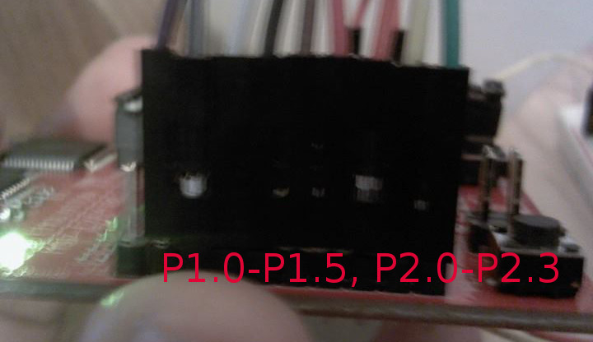Image 2: left side View of pixels

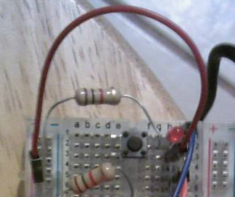

Image3 : Push button Circuit

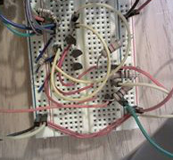

Image 4: Dynamic PhotoDiode circuit.

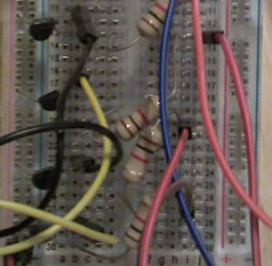

Image 5: Current Stirring BJTs used to set a voltage to the seven segment displays when switch among them.

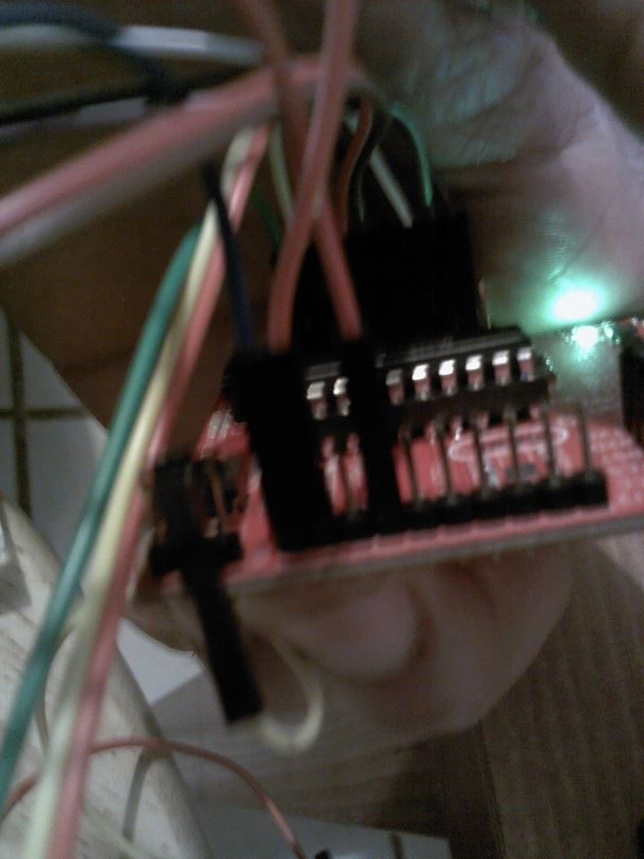

Image 6: Right side of the MSP with P2.3,P2.4 and P1.6 taken for use.

# Your system I/O interface schematic

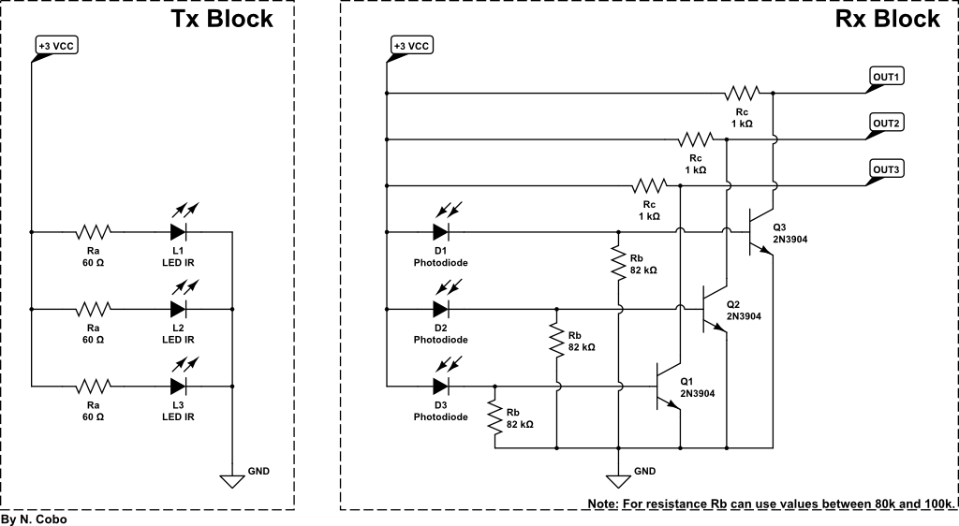

Imagen 7: Circuito conductor de los diodos y circuito photo sensitivo.

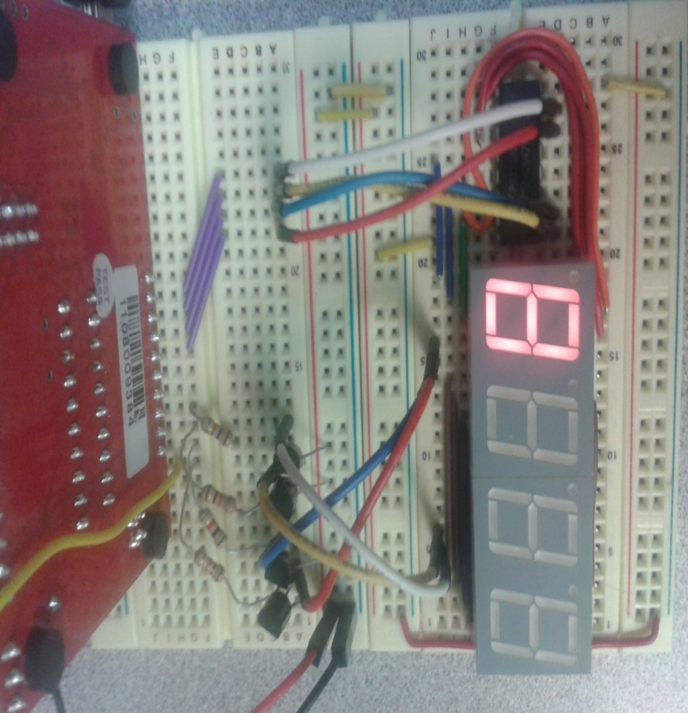

Image 8: Perteneciente a Nicolas Cobo Y.