**Core POC Deployment**

This document contains the deployment steps of web API application developed in .net core 2.0

Below are the step needs to follow during deployment:

1. Add below code in Program.cs file of core project
2. Use Kestrel
3. Use IIS Integration

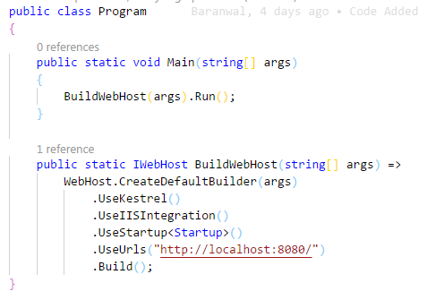

1. Change database configuration details in appsetting.json file as below:

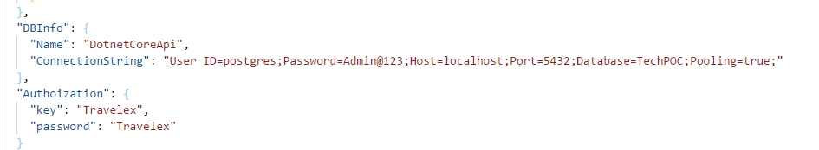

1. Publish application using below command in visual studio code :
2. Go on directory of projects and fire the below command
3. dotnet publish c:/webs/web1

or

dotnet publish

1. Copy the publish folder from the location and paste on the deployment server/ location
2. If System does not have internet then install the below dll first

[Microsoft Visual C++ 2015 Redistributable Update 3](https://www.microsoft.com/en-us/download/details.aspx?id=53840)

1. Install [.Net Core Windows Server Hosting Bundles](https://aka.ms/dotnetcore-2-windowshosting) on hosting machine
2. Install [Asp.net Core Module](https://docs.microsoft.com/en-us/aspnet/core/fundamentals/servers/aspnet-core-module?tabs=aspnetcore2x)
3. All the deployable DLLs are available on local folder Deployment Support DLLs
4. Create app pool with .net framework ‘No Manage Code’ and managed pipeline would be Integrated
5. Now add web site and do the required configuration and set the required port.
6. Restart the system or execute **net stop was /y** followed by **net start w3svc** from a command prompt to pick up a change to system path.
7. Use below link for more details:

[Refer Link for deployment details](https://docs.microsoft.com/en-us/aspnet/core/host-and-deploy/iis/?tabs=aspnetcore2x)