|  |  |
| --- | --- |
| 开发包 | 依赖的其他开发包 |
| Mainui | Informationui,orderui,hotelrecordui,creditrecordui,searchui,commandui,memberui,promotionui,creditpayui,usermanageui,hoteladdui,vo |
| Informationui | 界面类库包,informationblservice,vo |
| informationbl | Informationblservice,informationdataservice,po, |
| informationblservice |  |
| informationdata | Databaseseutility,po,informationdataservice,java RMI |
| informationdataservice | Java RMI,po |
| orderui | 界面类库包，vo,orderblservice |
| orderbl | Orderblservice,orderdataservice,po,informationbl,promotionbl |
| orderblservice |  |
| orderdata | Orderdataservice,databaseseutility,java RMI,po |
| orderdataservice | Java RMI,po |
| hotelrecordui | 界面类库包，hotelrecordblservice,vo |
| hotelrecordbl | Hotelrecordblservice,hotelrecorddataservice,po,orderbl |
| hotelrecordblservice |  |
| hotelrecorddata | Databaseseutility,po,java RMI,hotelrecorddataservice |
| hotelrecorddataservice | Java RMI,po |
| creditrecordui | 界面类库包，creditrecordblservice,vo |
| creditrecordbl | Creditrecordblservice,creditrecorddataservice,po,orderbl |
| creditrecordblservice |  |
| creditrecorddata | Databaseseutility,po,java RMI,creditrecorddataservice |
| creditrecorddataservice | Java RMI,po |
| searchui | 界面类库包,searchblservice,,vo |
| searchbl | Searchblservice,searchdataservice,po,informationbl |
| searchblservice |  |
| searchdata | Databaseseutility,java RMI,po,searchdataservice |
| searchdataservice | Java RMI,po |
| evaluateui | 界面类库包,vo,evaluateblservice |
| evaluatebl | Evaluateblservice,evaluatedataservice,po |
| Evaluateblservice |  |
| evaluatedata | Databaseseutility,java RMI,po,evaluatedataservice |
| Evaluatedataservice | Java RMI,po |
| memberui | 界面类库包,memberblservice,vo |
| memberbl | Memberblservice,memberdataservice,po,informationbl |
| memberblservice |  |
| memberdata | Databaseseutility,java RMI,po,memberdataservice |
| memberdataservice | Java RMI,po |
| promotionui | 界面类库包,vo,promotionblservice |
| promotionbl | Promotionblservice,promotiondataservice,po |
| promotionblservice |  |
| Promotiondata | Databaseseutility,java RMI,po,promotiondataservice |
| promotiondataservice | Java RMI,po |
| creditpayui | 界面类库包,creditpayblservice,vo |
| creditpaybl | Creditpayblservice,creditpaydataservice,po |
| creditpayblservice |  |
| creditpaydata | Databaseseutility,java RMI,po,creditpaydataservice |
| creditpaydataservice | Java RMI,po |
| usermanageui | 界面类库包,vo,usermanageblservice |
| usermanagebl | Usermanageblservice,usermanagedataservice,po,informationbl |
| usermanageblservice |  |
| usermanagedata | Databaseseutility,java RMI,po,usermanagedataservice |
| usermanagedataservice | Java RMI,po |
| hoteladdui | 界面类库包,vo,hoteladdblservice |
| hoteladdbl | Hoteladdblservice,hoteladddataservice,po |
| hoteladdblservice |  |
| hoteladddata | Hoteladddataservice,databaseseutility,java RMI,po |
| hoteladddataservice | Java RMI,po |
| vo |  |
| po |  |
| 界面类库包 |  |
| Java RMI |  |
| utilitybl |  |
| databaseseutility | JDBC |

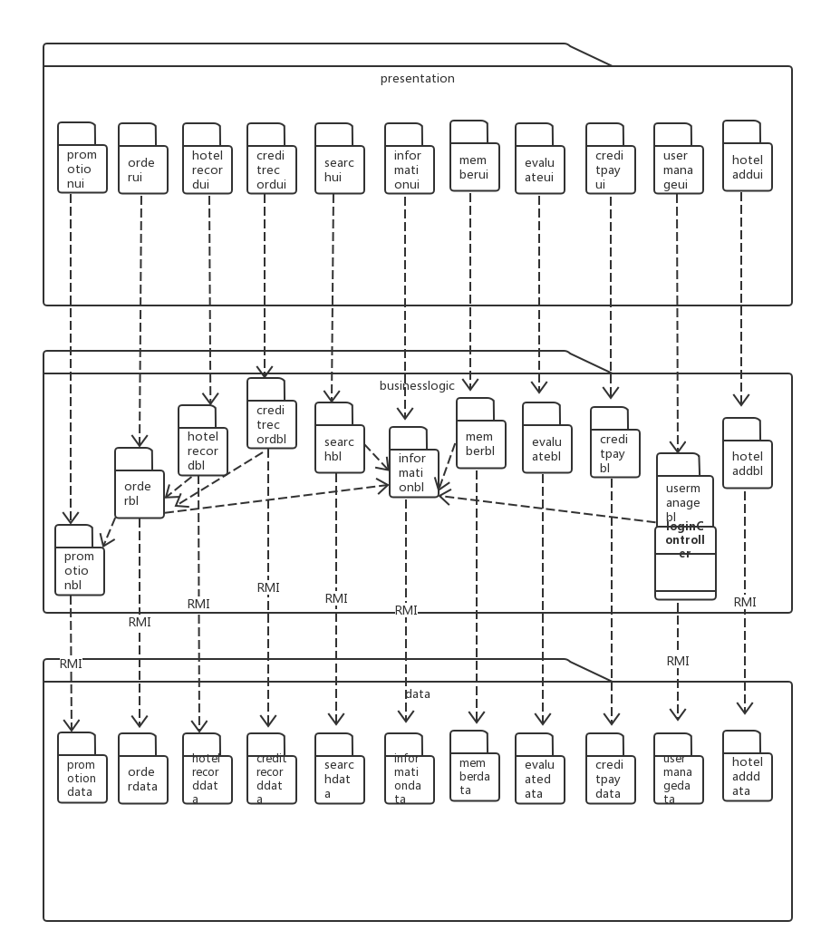

体系结构设计方案

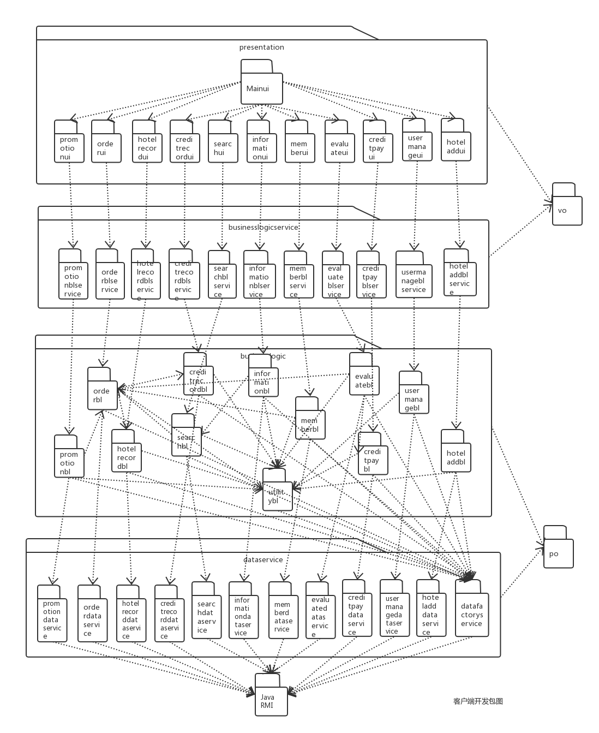

客户端开发包图

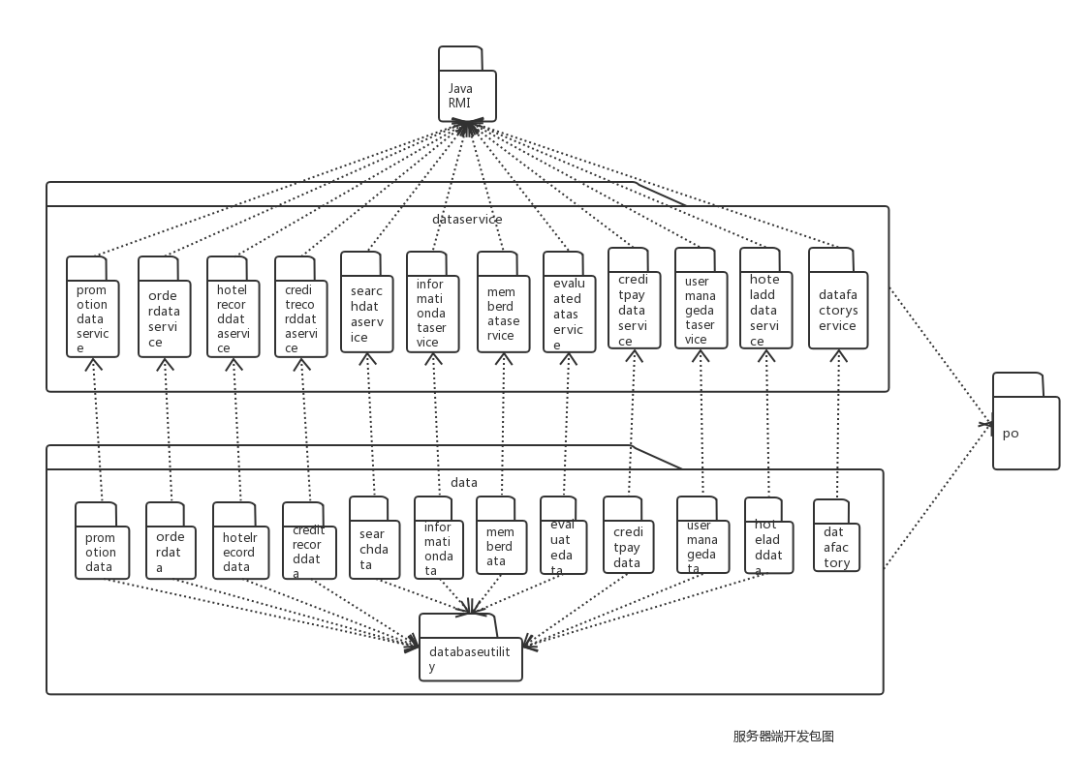

服务器端开发包图