John Conway’s Game Of Life

**2011**

Author: Paul Millar

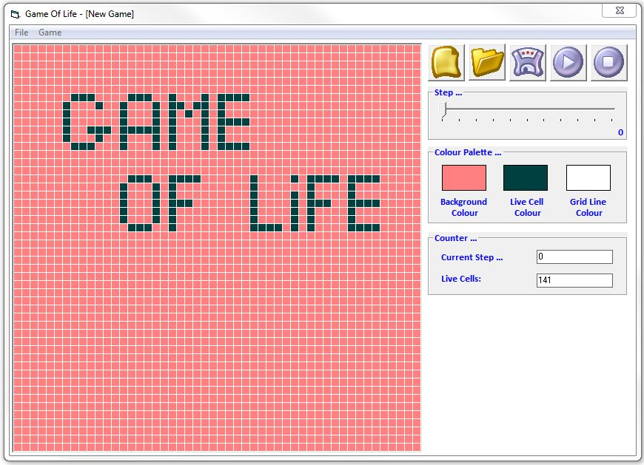

# Introduction

The **Game of Life**, also known simply as **Life**, is a [cellular automaton](http://en.wikipedia.org/wiki/Cellular_automaton) devised by the British mathematician [John Horton Conway](http://en.wikipedia.org/wiki/John_Horton_Conway) in 1970.

The "game" is a zero-player game, meaning that its evolution is determined by its initial state, requiring no further input. One interacts with the Game of Life by creating an initial configuration and observing how it evolves.

This game was developed in 2011 using Visual Basic 5.0 CCE which also demonstrates the use of random file access.

# Rules

The universe of the Game of Life is a two-dimensional orthogonal grid of square *cells*, each of which is in one of two possible states, *alive* or *dead*. Every cell interacts with its eight neighbours, which are the cells that are horizontally, vertically, or diagonally adjacent.

At each step in time, the following transitions occur:

1. Any live cell with fewer than two live neighbours dies, as if caused by under-population.
2. Any live cell with two or three live neighbours lives on to the next generation.
3. Any live cell with more than three live neighbours dies, as if by overcrowding.
4. Any dead cell with exactly three live neighbours becomes a live cell, as if by reproduction.

The initial pattern constitutes the *seed* of the system. The first generation is created by applying the above rules simultaneously to every cell in the seed—births and deaths occur simultaneously, and the discrete moment at which this happens is sometimes called a *tick* (in other words, each generation is a pure function of the preceding one). The rules continue to be applied repeatedly to create further generations.

For a more detailed description on John Conway’s game, please visit [Game of Life](http://en.wikipedia.org/wiki/Conway%27s_Game_of_Life).

# Module Overview

There are extensive comments provided in each class to give a detailed account of the functionality and purpose of all its members. The following is just a quick overview of the overall functionality of each class.

FRM_Game_Of_Life

This is simply the GUI which displays the game and it’s configuration. There are options to create, open, save, play or stop a game. You can even change the appearance of the game grid or set the maximum number of steps to be taken (0 = infinite).

CLS_Game_Of_Life

This is essentially the game engine. It tracks game configurations and kills or creates life cells. This is achieved by iterating through all cells at each step, and applying the rules to each cell as specified earlier.

CLS_File_Access

This is our data access point. Game configurations are stored in plain text files (*.GOF).

# How To Play

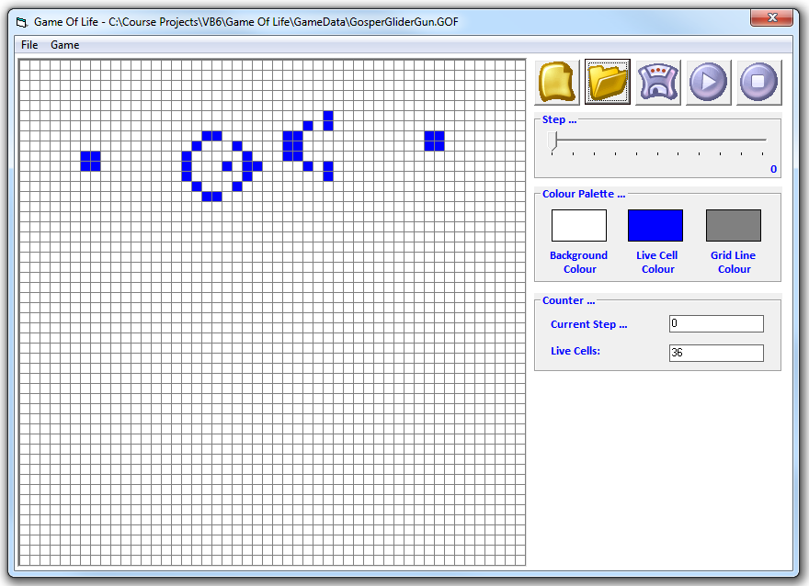

1. Click the new icon  to start a fresh game.
2. Using your mouse, click on individual cells within the grid to create whatever shape you want. (see example above)
3. Press the run/restart icon  to view the outcome.
4. You can pause the game at any stage using the stop icon .
5. Games can be saved using the  icon.
6. Open a previous game using the  icon.
7. The Step slider 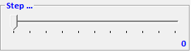 allows you to specify the maximum number of re-generations possible. A value of zero allows infinite re-generations.
8. The colour palette 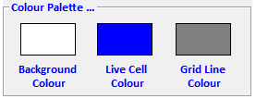 allows you change the grid & cell colours.

Tags: VB6, Random File Access

Built using: Visual Basic 5.0 CCE

Type: Game