**Meeting Minutes**

**February 1, 2016**

Going over initial front end design

What might we see on each page / forms

Question:

Ask prof about showing schedules per semester or remaining years?

Prof’s answer (see email correspondence below)

I would make an option box where user can specify whether to generate one year or multi-years plan.

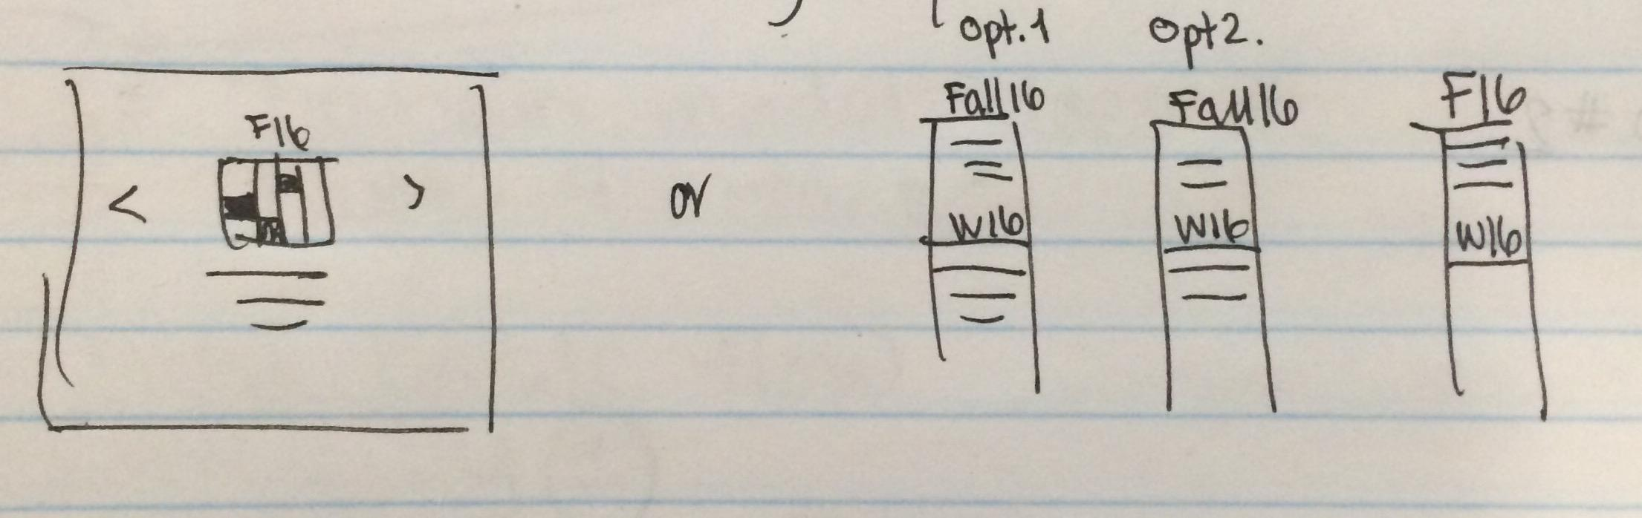

Whiteboard notes:

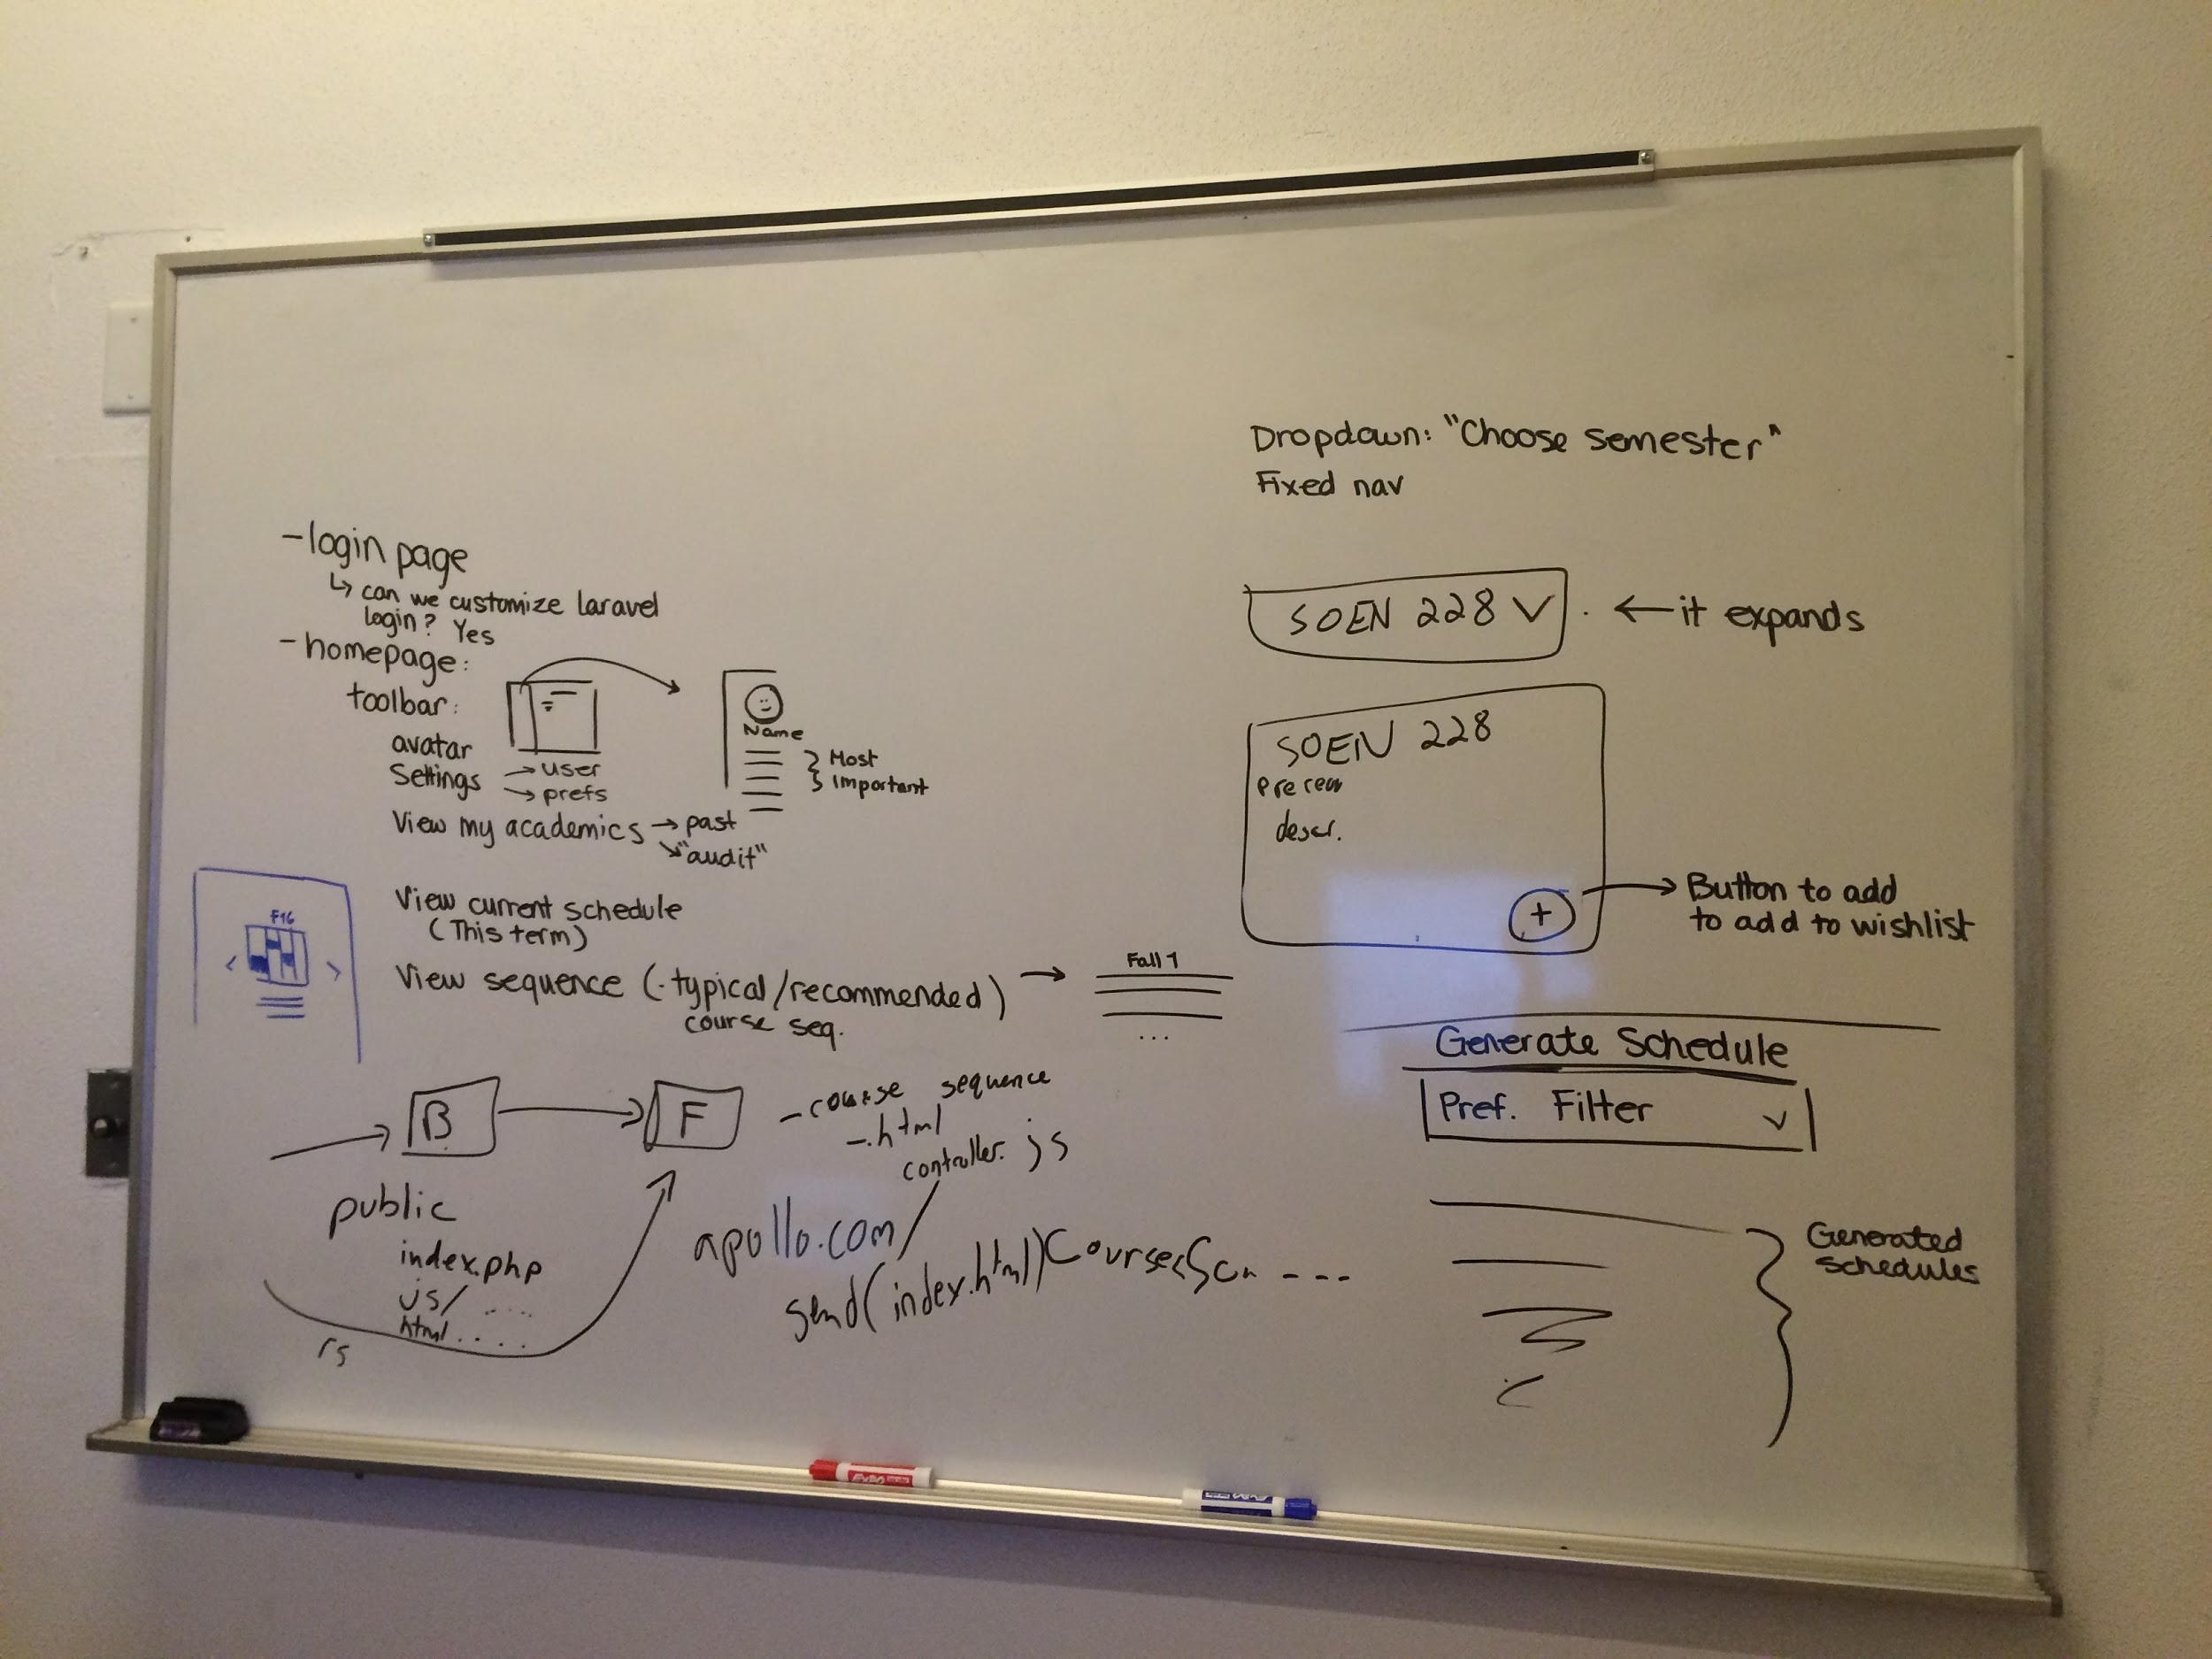

Email correspondence:

Q: After inputting user preferences, will the scheduler show multiple versions or show one optimized course sequence for the remaining years?

Prof: I would make an option box where user can specify whether to generate one year or multi-years' plan.

Q: Would it show as a one set list of courses (like image A) or cycle through semester by semester (image B)?

Prof: I like the way shown in image B. But it's up to you. Image A's issues is that there shows no schedule.

Q: The requirements mention that a cache should store attempts, should the student also have the ability to save a sequence?

Prof: Yup. I think that's a reasonable requirement.

Q: And should the student be allowed to add a course section to a wishlist and/or have it be a included in their constraints?

Prof:I don't think this is a must.

Prof: In short, I think focusing on the process, rather than the project, should be more important.