**Meeting Minutes**

**March 11, 2016**

Based off what Steve did on the board:

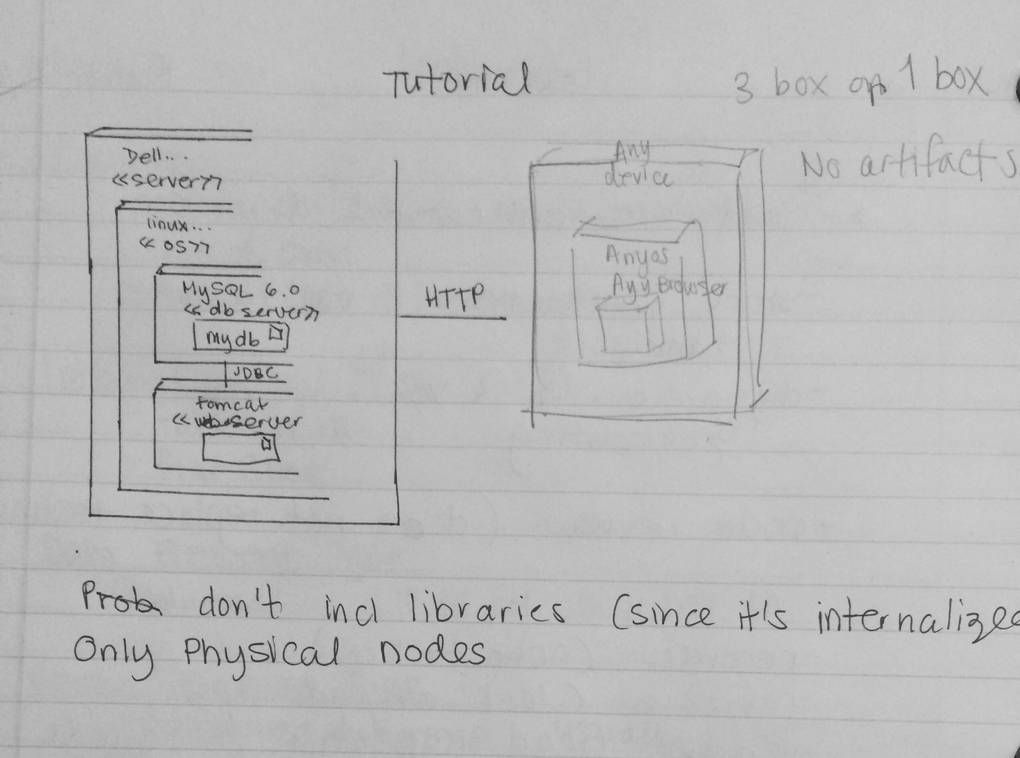

1. Deployment: <<device>> , :AppServer (when to use underline and colon?), or what’s with the little page symbol?
   1. Keep the :Name
2. Can we add the user’s device in the deployment diagram?

No (see written notes)

1. Which views for symbols etc? Example which db box or cylinder?
   1. Not a cylinder
2. DB/App: do we specify who is hosting in diagram?
   1. See written notes
3. Architecture: what could be our 2 subsystems??

Subsystem specifications:

Numerate the components as they appear in your component diagram

This is not an API

They will go back to your component diagram to make sure they match

See Bacon for subsystem

**Architecture:**

Either whole class diagram if it can fit on the page

Or can trim to Anything important for class diagram

**DO A WHOLE ONE : they might give extra pts**

**Detailed:**

Slice it down into subsystems (should map to components but may not)

They think its better to show class diag subsytem then the unit description (See bacon or nexus)

For the deployment diagram:

The outer box: :**GoDaddy Cloud**

Underneath put <<Web server>>

Then next box is: **:Linux**

<<OS>>

Then the next is mysql etc

**From previous meeting with Francis / Bower:**

* Install git
* Download / install npm/node.js
* Restart computer so npm is avail
* Npm -v (check if it works)
* Npm install bower
* Open git bash go to htdocs: bower install (in angular branch since it has bower.json)