Name: Group Fantastic 4
Github Name: https://github.com/CSC317-F25/group-project-ApolloTheG0d/tree/huy
Student ID: #
CSC 317 Section #04

Build HTML/CSS From Group Design

Description:
This part of the assignment emphasized the designation part of the collective website. This way, we are seeking to condense our thoughts into a designation that serves as the common among every groupmates.

Approach / What I Did:
We seek to design the website in a convenient measure, in which our new pages should be expandable. Thus, we took the suggestion from class, which is about generating a ejs template that comprises all pages with a set of default layout in views folder. Each time a new page is created in the public directory, it will take the header and footer ejs of the views.

In terms of major pages that are also listed on the header’s navigator, they are home, about, service, appointments, meet and greet, FAQ, contact, and sign in.

Homepage and about are textual paragraphs of the description of our site’s purpose as a pet seeing service. The service page comprises a variety of short service descriptions. Each of them is written as a service card format defined in our stylesheets.

Appointment page and Meet and Greet pages are those involving a form. The form consists of pet and owner information. Also the service schedule options that involve some javascripts below. Then the FAQ is also a descriptive page that writes potential questions and answers in textual form. Contact page, is a smaller form that has the blank for name, email, and then a text box. Lastly, the sign in page is where a form asks for email and password. There are still a few layers of pages such as creating an account, reset password, privacy, terms, etc… they are relatively visual, but can still be flushed out better.

Issues and Resolutions:
We encountered the way that html in the public were not being able to be read by the server. With a few attempts trying to adjust the app.js that drives the server, there was no resolution. Then the next approach is the router of the middlewares, whereas a loop was created that wires the html or ejs files over the directory of public.

Analysis:
The project gives the experience to site design and collective team work. It asks for bringing previous plannings into site design that lives on the server. I noticed that solving layout problems is a challenge, in which centering divisions, fixing misaligned icons, and adopting flex containers. These small struggles show how front-end design often feels like arranging puzzle pieces by piece. Another aspect that takes up the most of the time is the design, in which without it, there won’t be such an outcome. I had to consider carefully what content to plan, and certain resources to use. Scavenging for resources and compressing to a server friendly import, is a time consuming task. Let alone first finding the visual files, and then cutting through them in an acceptable manner, finally compressing it for import. Overall, this project feels like an artistic design, which really exercises one’s creativity. Also, the grammatical structuring of the html that brings the design to view is also a good take away. Finally, the designation that always need to be discussed and compromised with other team members, which exercises the teamwork ability.

Relevant Code and Screenshots:
The “var publicDir = path.join(__dirname, '..', 'public');” and then loop is through var files = fs.readdirSync(publicDir); files.forEach(function(f){“ wires the public folder available for the server.
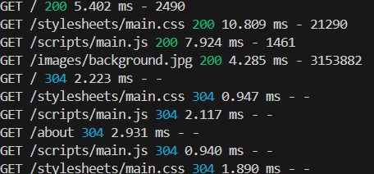
The scheduling in the dropdown input of “<input id="date" name="date" type="date" class="paws-input" required>” and “<input id="time" name="time" type="time" class="paws-input" required>” are defined lower in script. In which “const date = $("#date");”, “const pad = n => String(n).padStart(2, "0");”, “ const min = today.getFullYear() + "-" + pad(today.getMonth() + 1) + "-" + pad(today.getDate());” are the ones responsible on instantiating the available time frames such as date or clocks.
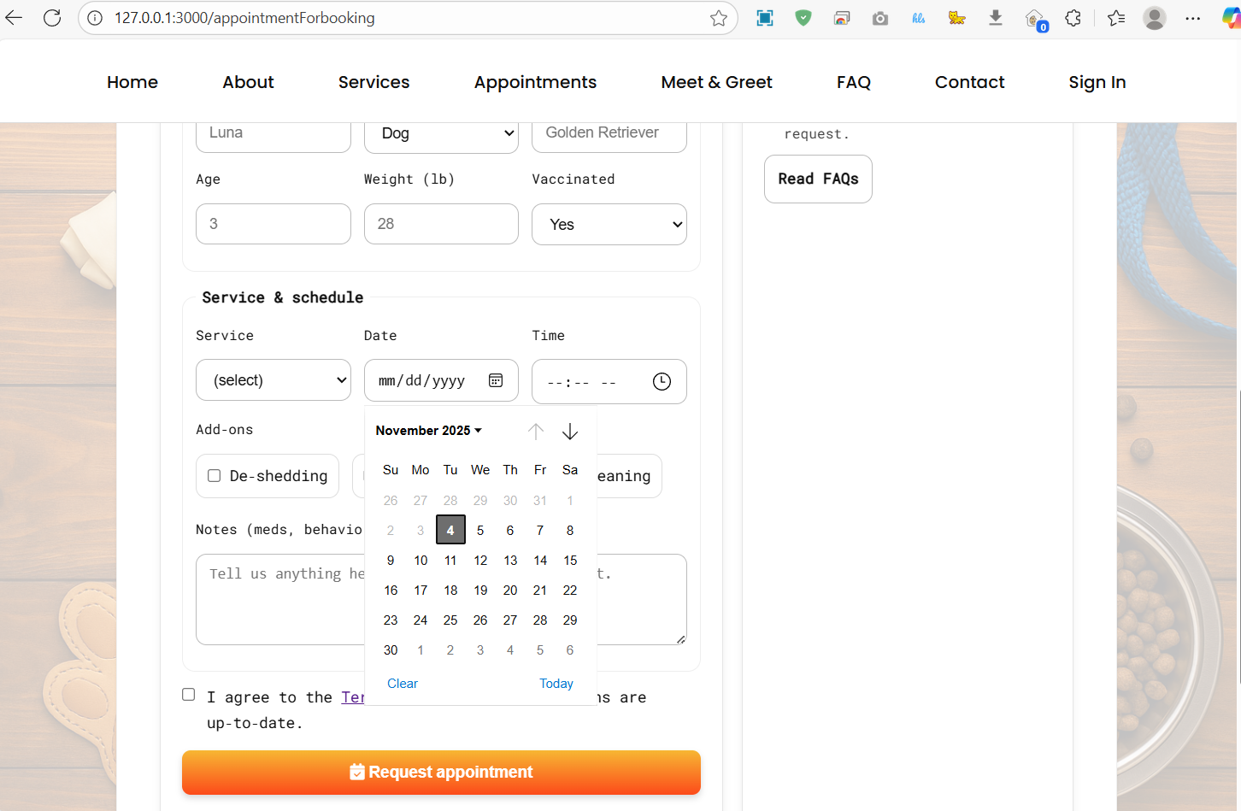

Use of GenAI:
The use of Chatgpt-5, to line up the documentation notes and fit the paragraphs in well phrased forms. The use of Gemini, Sonnet, Claud, and GPT-5 from copilot for inline code suggestions and revisions. Fine fitting overall code, coming up with grounded calculative expressions, graphic design, and extra purpose modules as well.

