.

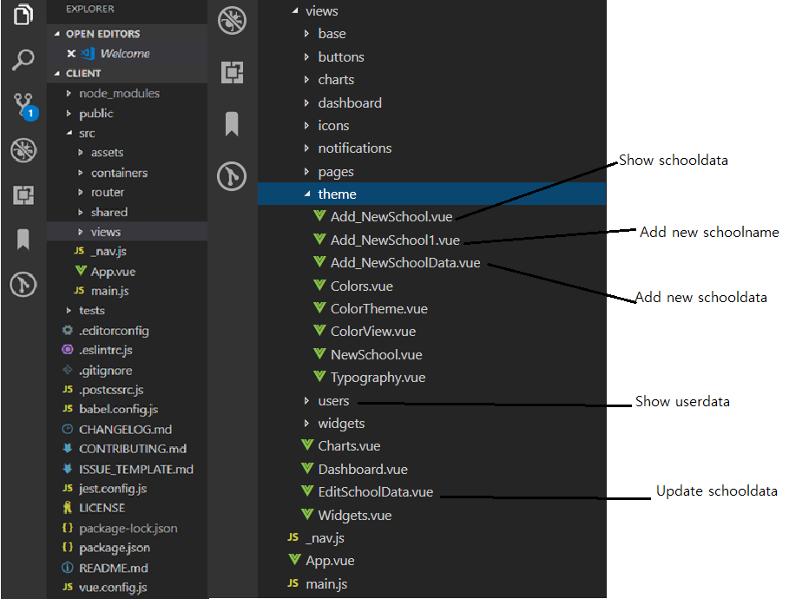

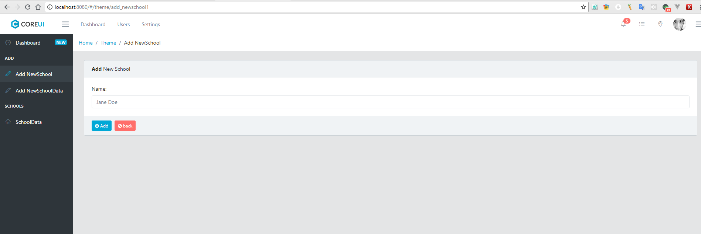

Add New School’s screen

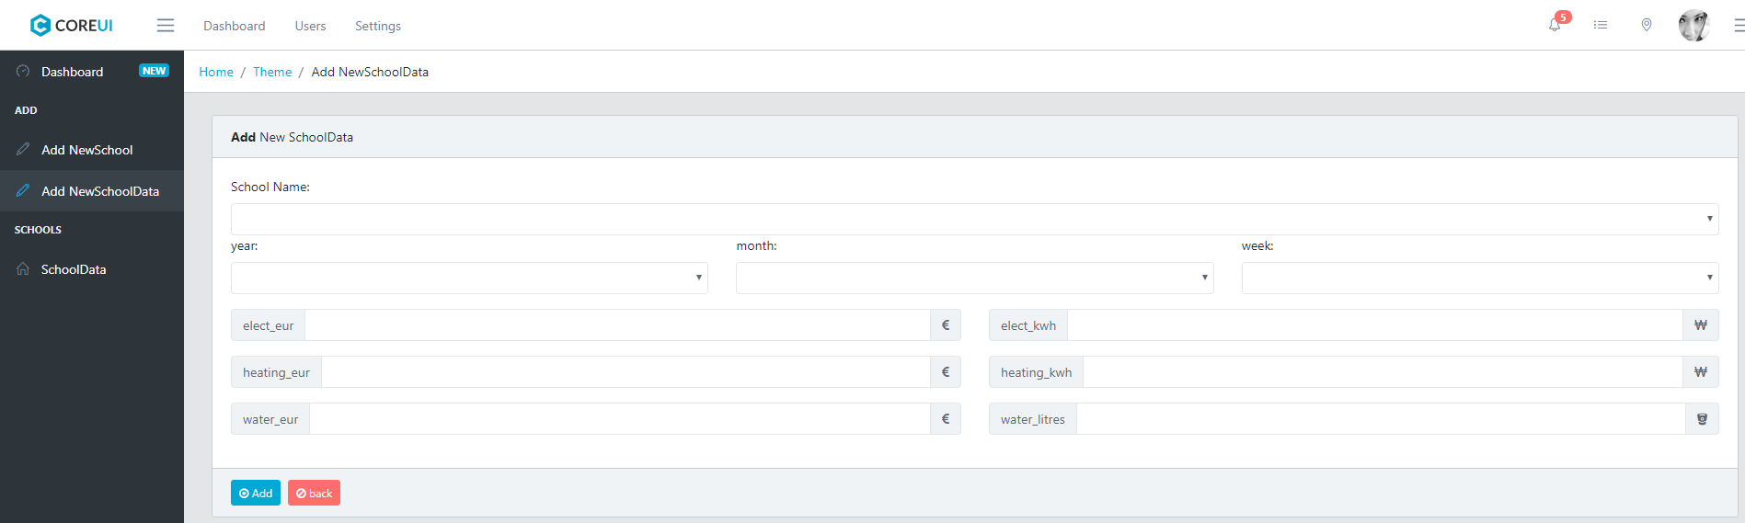

Add New SchoolData’s screen

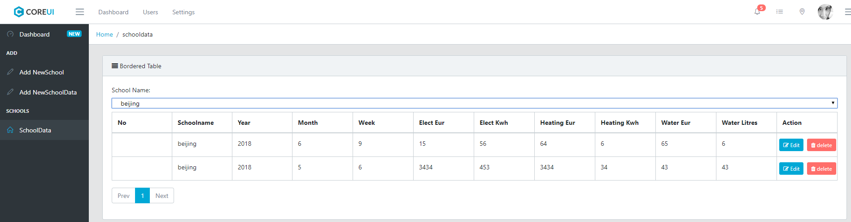

Show SchoolData,s screen

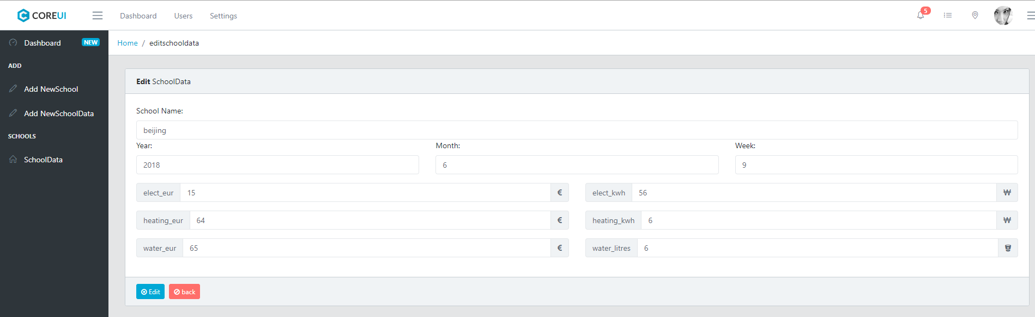

Update Schooldata’s screen

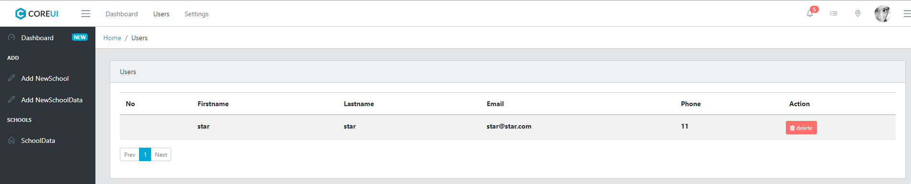

Show UserData’s screen

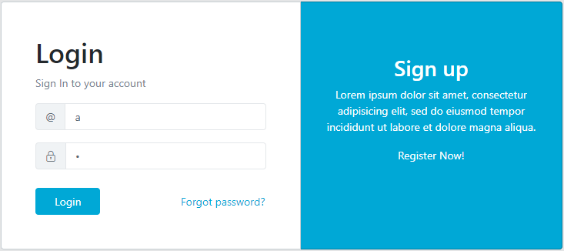

Login page’s screen

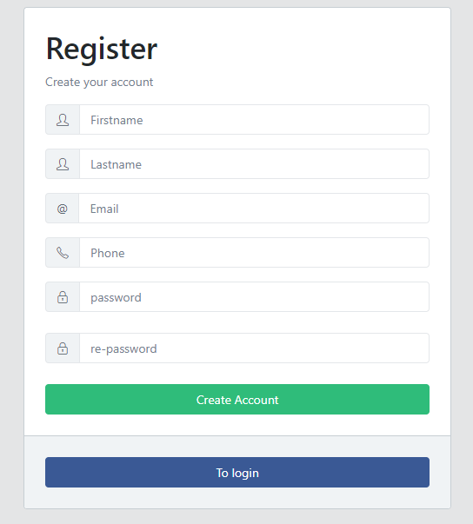

Register’s screen