Phase 7 — Predictive Intelligence & Production Hardening

Goal
Close two gaps in CloudGuardian AI:
1. No predictive operations — add a forecast engine that predicts metric breaches before they happen
2. No AI reasoning — add an LLM-powered agent that explains incidents in plain English and answers questions

Plus production hardening: JWT auth, CI/CD, tests, structured logging, real alerting.

Existing Conventions (will match exactly)

Convention | Pattern
Framework | FastAPI + Uvicorn
Base image | python:3.11-slim
Internal port | 8000 (all services)
Dockerfile | COPY requirements.txt → pip install → COPY main.py → EXPOSE 8000 → CMD uvicorn
Health check | GET /health → {"status": "healthy"}
DB connection | psycopg2.connect(DATABASE_URL) with get_connection() helper
DB init | init_db() called in a retry loop at startup
Background work | threading.Thread(target=..., daemon=True).start()
CORS | allow_origins=["*"], allow_methods=["*"], allow_headers=["*"]
Port mapping | External 80X0:8000 (8010, 8020, 8030 → 8040, 8050 next)
Network | cloudguardian-net (external, created by Terraform)
Services list | ["auth-service", "payment-service", "inventory-service"]
Metrics | cpu_percent, memory_mb, latency_ms, error_rate

Architecture After Phase 7
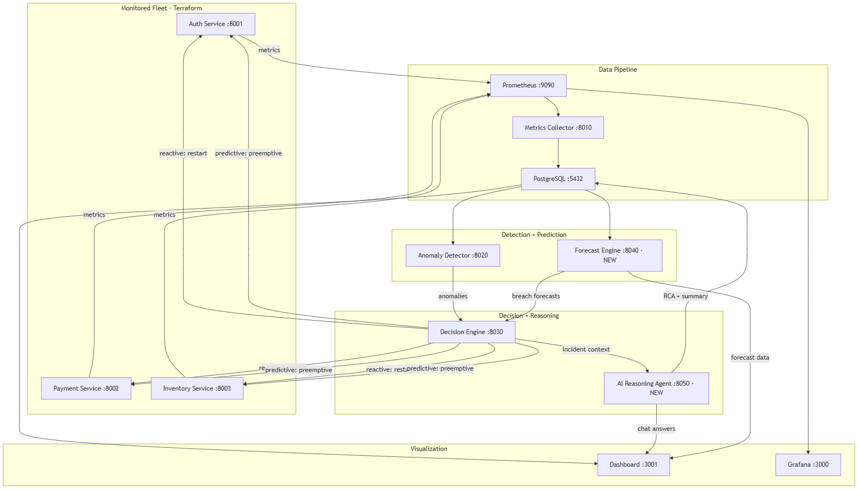

[!IMPORTANT]
New data flow: Forecast Engine reads from Postgres (same as anomaly-detector), produces breach-risk predictions. Decision Engine polls both anomaly-detector AND forecast-engine, logging incidents as type: reactive or type: predictive. AI Reasoning Agent is invoked after each incident to produce a root-cause analysis.

Build Order & Detailed Changes

Step 1: Forecast Engine (new service)

[NEW] services/forecast-engine/main.py
Why statsmodels (Holt-Winters) over Prophet: Prophet requires cmdstanpy which needs a C++ compiler and >500MB of dependencies — incompatible with python:3.11-slim without a multi-stage build. Holt-Winters from statsmodels is lightweight (~30MB), works well for seasonal/trending time-series, and fits the existing slim Docker pattern.

Design:
- Background thread reads last 200 data points per service per metric from metric_readings table every 5 minutes, fits Holt-Winters (Exponential Smoothing) model
- Models cached in memory dict {(service, metric): {"model", "fitted_at", "params"}}
- Danger thresholds (configurable via env): cpu_percent > 85, memory_mb > 800, latency_ms > 400, error_rate > 0.15

Endpoints:
- GET /forecast/{service}/{metric}?minutes=10 → predicted values + confidence interval
- GET /forecast/breach-risk → for every metric, whether forecast crosses threshold and ETA
- GET /health → {"status": "healthy"}
- GET /metrics → Prometheus text with forecast_breach_risk{service=...,metric=...} gauge

New Postgres table (created by forecast-engine's init_db):
CREATE TABLE IF NOT EXISTS forecasts (
id SERIAL PRIMARY KEY,
service_name TEXT NOT NULL,
metric_name TEXT NOT NULL,
predicted_values JSONB NOT NULL,
breach_risk DOUBLE PRECISION,
breach_eta_minutes DOUBLE PRECISION,
generated_at TIMESTAMPTZ NOT NULL DEFAULT now()
);

[NEW] services/forecast-engine/Dockerfile
Identical pattern to anomaly-detector.

[NEW] services/forecast-engine/requirements.txt
fastapi==0.111.0
uvicorn[standard]==0.30.1
psycopg2-binary==2.9.9
pandas==2.2.2
numpy==1.26.4
statsmodels==0.14.2
prometheus_client==0.20.0

[NEW] services/forecast-engine/README.md
Short doc explaining purpose, endpoints, and model choice.

[MODIFY] docker-compose.yml
Add forecast-engine service block (port 8040:8000, depends on postgres + metrics-collector).

[MODIFY] prometheus.yml
Add scrape target forecast-engine:8000.

[MODIFY] render.yaml
Add forecast-engine entry.

Step 2: Wire Forecast into Decision Engine

[MODIFY] decision-engine/main.py
1. Add `incident_type` column to incidents table via idempotent ALTER TABLE
2. New env vars: FORECAST_ENGINE_URL, FORECAST_BREACH_CONFIDENCE_THRESHOLD
3. New function check_forecast_breaches(): polls GET /forecast/breach-risk
4. New function trigger_preemptive_action(): lighter remediation for predicted breaches, logged as incident_type='predictive'
5. Modify `_decision_loop()`: call forecast check after anomaly check
6. Update endpoints to include incident_type in responses

[MODIFY] decision-engine/requirements.txt
Add requests==2.32.3.

Step 3: AI Reasoning Agent (new service)

[NEW] services/ai-reasoning-agent/main.py
- Uses anthropic SDK with claude-sonnet-4-6
- `POST /agent/analyze-incident`: receives incident context from decision-engine, produces root-cause hypothesis + summary, persists to incident_reports table
- `POST /agent/ask`: free-text chat using live system state as context
- `GET /agent/incidents/{id}/report`: retrieves stored RCA report
- Graceful degradation: if API key missing or call fails, returns fallback response — never blocks healing pipeline

New Postgres table:
CREATE TABLE IF NOT EXISTS incident_reports (
id SERIAL PRIMARY KEY,
incident_id INTEGER REFERENCES incidents(id),
root_cause TEXT NOT NULL,
summary TEXT NOT NULL,
confidence DOUBLE PRECISION NOT NULL,
evidence JSONB NOT NULL,
generated_at TIMESTAMPTZ NOT NULL DEFAULT now()
);

[NEW] services/ai-reasoning-agent/{Dockerfile, requirements.txt, README.md}

[MODIFY] decision-engine/main.py
After trigger_remediation(), fire-and-forget POST to ai-reasoning-agent with incident context.

[MODIFY] docker-compose.yml, prometheus.yml, render.yaml
Add ai-reasoning-agent entries.

[NEW] .env.example
ANTHROPIC_API_KEY=sk-ant-your-key-here
JWT_SECRET=change-this-to-a-random-string
SLACK_WEBHOOK_URL=https://hooks.slack.com/services/your/webhook/url

Step 4: JWT Auth Layer

[NEW] services/shared/auth.py
- create_token(subject, role), verify_token(token), FastAPI Depends middleware
- Service-to-service: shared SERVICE_TOKEN env var

[MODIFY] All service main.py files
- Auth middleware on all non-health/metrics endpoints
- Inter-service calls include Authorization: Bearer {SERVICE_TOKEN}

Dashboard login
- [NEW] LoginScreen.jsx — email/password form
- [MODIFY] api.js — JWT storage + header attachment
- Login endpoint on decision-engine: POST /auth/login

Step 5: Dashboard Updates

[NEW] services/dashboard/src/components/ForecastPanel.jsx
- Trend line with shaded confidence band (SVG, matching PulseLine pattern)
- Breach-risk warnings with time-to-breach countdown
- Service/metric selector dropdowns

[NEW] services/dashboard/src/components/AICopilot.jsx
- Chat UI: input + scrollable message history
- Calls POST /agent/ask, renders markdown responses
- Graceful "AI unavailable" fallback

[NEW] services/dashboard/src/components/IncidentDetailModal.jsx
- Modal triggered by clicking incident in timeline
- Fetches + displays LLM-generated RCA report

[MODIFY] IncidentTimeline.jsx
- Add predictive vs reactive badge (🔮 blue vs ⚡ amber)
- Make rows clickable → opens modal

[MODIFY] App.jsx, App.css, api.js
- Import new components, add forecast/AI endpoints, JWT handling, login gate

[MODIFY] package.json
- Add react-markdown dependency

Step 6: Tests + CI

New test files

File | Tests
services/forecast-engine/tests/test_forecast.py | Holt-Winters training, breach-risk calc, endpoint shapes
services/anomaly-detector/tests/test_anomaly.py | Z-score flagging, IsolationForest threshold, DB insert
services/decision-engine/tests/test_decision.py | Cooldown logic, trigger threshold, reactive vs predictive, verification
services/ai-reasoning-agent/tests/test_agent.py | Graceful degradation, report persistence, chat endpoint
services/metrics-collector/tests/test_collector.py | PromQL parsing, gap detection, DB write
tests/test_integration.py | Full pipeline: chaos → detect → decide → heal → resolve

[NEW] .github/workflows/ci.yml
Jobs: lint (ruff), test (pytest), build (docker build all services), terraform-validate (all 3 configs)

Step 7: Structured Logging + Alerting

All Python services
- Replace print() with JSON-formatted logging via python-json-logger
- Fields: service, correlation_id, severity, timestamp
- Decision engine generates correlation_id (UUID) per incident, passed to AI agent

[MODIFY] decision-engine/main.py
- After incident creation: publish to LocalStack SNS (cloudguardian-alerts topic) via boto3
- If SLACK_WEBHOOK_URL set: POST formatted alert to Slack webhook
- Both wrapped in try/except — alerting never blocks healing

[MODIFY] decision-engine/requirements.txt
Add boto3==1.34.0, python-json-logger==2.0.7.

[MODIFY] terraform/aws-simulated/main.tf
Add aws_sns_topic resource for cloudguardian-alerts.

Step 8: Tier 3 Stretch Items
[!NOTE]
Tier 3 status — documented but not implemented:
- Kubernetes manifests / Helm chart: Not implemented. Next step: translate docker-compose → K8s Deployments, add kubectl-based remediation executor.
- Cost-governance panel: Not implemented. Could show estimated $ saved per healing action with mock pricing.
- Chaos calendar: Not implemented. Could be a cron-based service reading schedules from Postgres.

Files Summary

Category | New | Modified
Forecast Engine | 4 files (main.py, Dockerfile, requirements.txt, README.md) | —
AI Reasoning Agent | 4 files | —
Decision Engine | — | main.py, requirements.txt
Auth | services/shared/auth.py | All service main.py files
Dashboard | 4 new components | App.jsx, App.css, api.js, IncidentTimeline.jsx, package.json
Tests | 6 test files | —
CI/CD | .github/workflows/ci.yml | —
Config | .env.example | docker-compose.yml, render.yaml, prometheus.yml, .gitignore
Terraform | — | aws-simulated/main.tf

Open Questions
[!IMPORTANT]
Anthropic API key: The AI reasoning agent needs an API key from console.anthropic.com. It degrades gracefully without one (returns stub responses). Do you already have a key, or should I focus on a fully functional stub mode?

[!IMPORTANT]
Dashboard theme: The Phase 7 brief says "styled consistently with the existing dark/glassmorphism theme." This conflicts with our earlier redesign discussion. I'll keep the existing dark theme for Phase 7. We can revisit the light theme separately afterward. OK?

[!NOTE]
Slack webhook: Optional for alerting. If you have a Slack workspace, you can set up an incoming webhook. Otherwise alerting works via LocalStack SNS (visible in docker logs). Include Slack integration or skip?

Verification Plan
After each step:
cd terraform/local-infra && terraform apply -auto-approve && cd ../..
docker compose up --build
curl.exe -X POST "http://localhost:8002/chaos/cpu_spike?duration_seconds=90"
curl.exe http://localhost:8040/health # forecast-engine
curl.exe http://localhost:8050/health # ai-reasoning-agent
curl.exe http://localhost:8040/forecast/breach-risk
curl.exe http://localhost:8030/incidents/current?minutes=10
pytest services/ -v

