CloudGuardian AI — Full Project Walkthrough

Overview
CloudGuardian AI is an AI-powered, self-healing cloud infrastructure platform. It automatically monitors cloud services, detects anomalies using machine learning (Isolation Forest), makes remediation decisions, and executes healing actions — all in real-time. It's built as a microservices architecture with Docker, Prometheus, Grafana, Terraform, and a React dashboard.

Project Tree
cloudguardian-ai/
├── .gitignore
├── README.md
├── docker-compose.yml
├── render.yaml
├── scripts/
│ └── evaluate_detector.py
├── services/
│ ├── anomaly-detector/
│ │ ├── Dockerfile
│ │ ├── main.py
│ │ └── requirements.txt
│ ├── dashboard/
│ │ ├── .dockerignore
│ │ ├── Dockerfile
│ │ ├── index.html
│ │ ├── nginx.conf
│ │ ├── package.json
│ │ ├── vite.config.js
│ │ └── src/
│ │ ├── main.jsx
│ │ ├── App.jsx
│ │ ├── App.css
│ │ ├── api.js
│ │ ├── styles.css
│ │ └── components/
│ │ ├── AnomalyFeed.jsx
│ │ ├── ChaosControlPanel.jsx
│ │ ├── IncidentTimeline.jsx
│ │ ├── PulseLine.jsx
│ │ ├── ServiceVitalCard.jsx
│ │ └── TopBar.jsx
│ ├── decision-engine/
│ │ ├── Dockerfile
│ │ ├── main.py
│ │ └── requirements.txt
│ ├── metrics-collector/
│ │ ├── Dockerfile
│ │ ├── main.py
│ │ └── requirements.txt
│ └── simulated-service/
│ ├── Dockerfile
│ ├── main.py
│ └── requirements.txt
├── monitoring/
│ ├── grafana/
│ │ └── provisioning/
│ │ ├── dashboards/dashboards.yml
│ │ └── datasources/datasource.yml
│ └── prometheus/
│ └── prometheus.yml
└── terraform/
├── aws-simulated/
│ ├── main.tf
│ ├── variables.tf
│ └── outputs.tf
├── gcp-real/
│ ├── main.tf
│ ├── variables.tf
│ ├── outputs.tf
│ └── startup-script.sh.tpl
└── local-infra/
├── main.tf
├── variables.tf
└── outputs.tf

Architecture
graph TD
subgraph "Simulated Cloud"
SS["Simulated Service<br/>(Flask :5050)"]
end
subgraph "Data Collection"
MC["Metrics Collector<br/>(Flask :5001)"]
end
subgraph "AI / ML"
AD["Anomaly Detector<br/>(Flask :5002)"]
end
subgraph "Self-Healing"
DE["Decision Engine<br/>(Flask :5003)"]
end
subgraph "Visualization"
DB["React Dashboard<br/>(Vite → Nginx :80)"]
GF["Grafana (:3000)"]
end
subgraph "Monitoring"
PM["Prometheus (:9090)"]
end
SS -->|metrics| MC
MC -->|raw data| AD
AD -->|anomalies| DE
DE -->|heal| SS
MC --> PM
AD --> PM
DE --> PM
PM --> GF
MC --> DB
AD --> DB
DE --> DB

[!IMPORTANT]
The data flows in a closed loop: Simulated Service → Metrics Collector → Anomaly Detector → Decision Engine → Simulated Service (heal). This is the self-healing feedback loop.

Service-by-Service Breakdown

1. Simulated Service (services/simulated-service/)
Purpose: Simulates a real cloud service with controllable failure modes (chaos engineering).

File | Description
main.py | Flask app on port 5050
Dockerfile | Python 3.11-slim container
requirements.txt | flask, prometheus_client

Key Features:
- Chaos injection endpoints: POST /chaos/inject to trigger failures like cpu_spike, memory_leak, latency_spike, error_rate, disk_full
- Auto-recovery endpoint: POST /chaos/recover to restore normal operation
- Health endpoint: GET /health returns current status and active chaos conditions
- Metrics endpoint: GET /metrics exposes Prometheus-compatible gauges (sim_cpu_usage, sim_memory_usage, sim_request_latency, sim_error_rate, sim_disk_usage)
- Background thread generates realistic metric variations using random noise

2. Metrics Collector (services/metrics-collector/)
Purpose: Polls the simulated service and collects/stores metrics with timestamps.

File | Description
main.py | Flask app on port 5001
Dockerfile | Python 3.11-slim container
requirements.txt | flask, requests, prometheus_client

Key Features:
- Background thread polls http://simulated-service:5050/health every 5 seconds
- Stores up to 1000 data points in a ring buffer
- Exposes GET /metrics/latest (last 100 points) and GET /metrics/summary (mean, max, min, std for each metric)
- Exposes Prometheus gauges: collector_cpu_usage, collector_memory_usage, etc.
- GET /health returns collector status with collection count

3. Anomaly Detector (services/anomaly-detector/)
Purpose: Uses an Isolation Forest ML model to detect anomalies in real-time metrics.

File | Description
main.py | Flask app on port 5002
Dockerfile | Python 3.11-slim container
requirements.txt | flask, numpy, scikit-learn, requests, prometheus_client

Key Features:
- Training: Background thread continuously fetches data from the metrics collector. Once 50+ samples are gathered, it trains an IsolationForest model (contamination=0.1, n_estimators=100, random_state=42)
- Detection: Background thread runs every 10 seconds, scoring the latest metrics. If the model predicts anomaly (-1) AND the anomaly score < -0.5, it's flagged
- Rule-based fallback: Even without a trained model, threshold rules flag CPU > 80%, memory > 85%, latency > 500ms, error rate > 10%, disk > 90%
- Anomaly history: Stores up to 100 detected anomalies
- Endpoints: GET /anomalies/latest, GET /anomalies/history, GET /health, GET /metrics (Prometheus)

4. Decision Engine (services/decision-engine/)
Purpose: Consumes anomaly data and decides on remediation actions, then executes self-healing.

File | Description
main.py | Flask app on port 5003
Dockerfile | Python 3.11-slim container
requirements.txt | flask, requests, prometheus_client

Key Features:
- Background thread polls http://anomaly-detector:5002/anomalies/latest every 15 seconds
- Healing strategies map metric types to actions:
  - cpu_usage → scale horizontally (add instances)
  - memory_usage → restart service
  - request_latency → enable caching / optimize
  - error_rate → rollback to last stable version
  - disk_usage → clean temporary files
- Cooldown: 60-second cooldown between heal actions for the same metric type
- Automatic recovery: Calls POST http://simulated-service:5050/chaos/recover to execute the heal
- Incident timeline: Stores up to 200 incident records (detection → decision → healing action → result)
- Endpoints: GET /decisions/latest, GET /incidents, GET /health, GET /metrics

5. Dashboard (services/dashboard/)
Purpose: A real-time React dashboard for visualizing the entire self-healing pipeline.

File | Description
App.jsx | Main React app — fetches from all APIs every 3s
api.js | API client with BASE_URL for all backend services
App.css | Dark-themed CSS with glassmorphism effects
styles.css | Additional component-level styles
main.jsx | React entry point
index.html | HTML shell with Google Fonts (Inter)
vite.config.js | Vite config with API proxy to port 5001
package.json | React 19, Vite 6, Recharts for charts
Dockerfile | Multi-stage build: Node → Nginx
nginx.conf | Nginx config serving static files on port 80

Dashboard Components

Component | Description
TopBar.jsx | Header with title, shield icon, and live status indicator (pulsing green/red dot)
ServiceVitalCard.jsx | Metric cards showing CPU, Memory, Latency, Error Rate, Disk with color-coded severity
PulseLine.jsx | Real-time line chart using Recharts (LineChart with area gradient) showing last 30 data points
AnomalyFeed.jsx | Live anomaly alert feed with severity badges and timestamps
ChaosControlPanel.jsx | Buttons to inject chaos (CPU Spike, Memory Leak, Latency, Errors, Disk Full) and trigger recovery
IncidentTimeline.jsx | Scrollable incident timeline showing detection → decision → healing action → outcome

Infrastructure & Monitoring

Docker Compose (docker-compose.yml)
Orchestrates 7 containers on a shared cloudguardian bridge network:

Service | Port | Build Context
simulated-service | 5050 | ./services/simulated-service
metrics-collector | 5001 | ./services/metrics-collector
anomaly-detector | 5002 | ./services/anomaly-detector
decision-engine | 5003 | ./services/decision-engine
dashboard | 3001 | ./services/dashboard
prometheus | 9090 | (image: prom/prometheus)
grafana | 3000 | (image: grafana/grafana)

Dependencies are set so services start in order: simulated-service → metrics-collector → anomaly-detector → decision-engine.

Prometheus (prometheus.yml)
- Scrape interval: 15 seconds
- Targets: metrics-collector:5001, anomaly-detector:5002, decision-engine:5003, simulated-service:5050
- Path: /metrics on all targets

Grafana
- datasource.yml: Auto-provisions Prometheus as the default data source (http://prometheus:9090)
- dashboards.yml: Auto-provisions dashboards from /var/lib/grafana/dashboards

Terraform Configurations

1. AWS Simulated (terraform/aws-simulated/)
Uses localstack/localstack provider to simulate AWS locally:
- Creates an S3 bucket (cloudguardian-metrics-store) for metrics archival
- Creates a DynamoDB table (cloudguardian-incidents) for incident logs (partition key: incident_id, sort key: timestamp)
- Creates an SNS topic (cloudguardian-alerts) for alert notifications
- Outputs: bucket name, table name, SNS topic ARN

2. GCP Real (terraform/gcp-real/)
For real GCP deployment:
- Creates a GCE instance (e2-medium, Debian 11) with Docker pre-installed via a startup script template
- Configures a firewall rule allowing ports 3000, 3001, 5001-5003, 5050, 9090
- Startup script clones the repo, runs docker-compose up -d
- Outputs: instance IP, SSH command, dashboard URL

3. Local Infra (terraform/local-infra/)
Uses the Docker Terraform provider to manage containers locally:
- Creates a cloudguardian Docker network
- Builds and runs 4 service containers (simulated-service, metrics-collector, anomaly-detector, decision-engine) from local images
- Maps ports matching docker-compose

Deployment Config

Render (render.yaml)
Defines 5 Render web services (all free plan, Docker runtime):
- cloudguardian-simulated-service (port 5050)
- cloudguardian-metrics-collector (port 5001) — depends on SIMULATED_SERVICE_URL
- cloudguardian-anomaly-detector (port 5002) — depends on METRICS_COLLECTOR_URL
- cloudguardian-decision-engine (port 5003) — depends on ANOMALY_DETECTOR_URL and SIMULATED_SERVICE_URL
- cloudguardian-dashboard (port 80)

Evaluation Script

evaluate_detector.py
A standalone evaluation script that:
1. Generates synthetic data: 1000 normal samples + 100 anomalous samples across 5 metrics
2. Trains an IsolationForest model with same parameters as the detector service
3. Evaluates: Calculates accuracy, precision, recall, F1 score, and confusion matrix
4. Prints a detailed report with per-metric analysis and recommendations

Key Technical Decisions

Decision | Rationale
Isolation Forest (unsupervised) | Doesn't require labeled anomaly data; learns normal patterns and flags deviations
Rule-based fallback | Ensures anomaly detection works even before ML model is trained (cold start)
60s cooldown in decision engine | Prevents cascading heal actions from overwhelming the system
Microservices architecture | Each concern (collection, detection, decision, simulation) is independently scalable and deployable
Prometheus + Grafana | Industry-standard observability stack for real-time metrics and dashboards
React + Vite + Recharts | Fast dev experience, lightweight charting, modern frontend
LocalStack for AWS | Enables full AWS simulation locally without cloud costs
Multi-stage Docker builds | Keeps production images small (node build → nginx serve)

Data Flow Summary
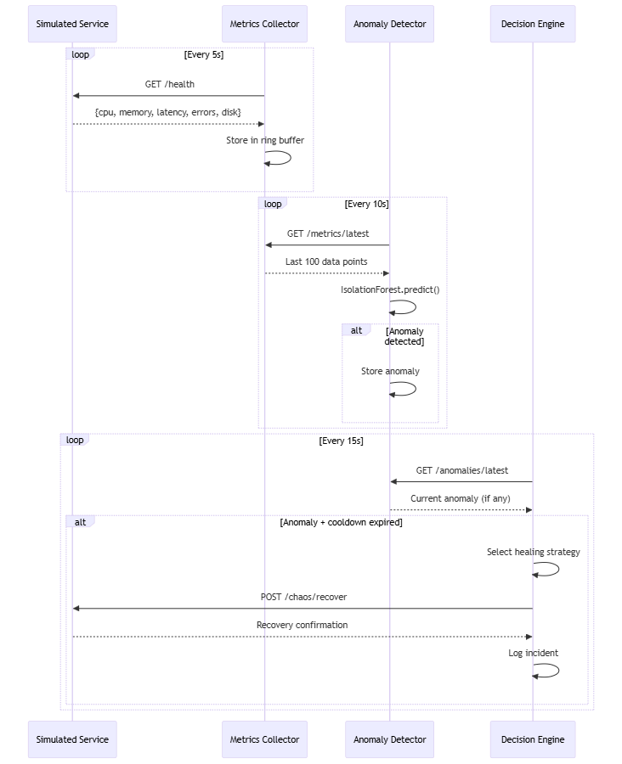

Potential Improvements
[!TIP]
Areas that could be enhanced:
- Persistence: Currently all data is in-memory (ring buffers). Adding Redis/PostgreSQL would survive restarts.
- Authentication: No auth on any endpoints. Adding JWT/API keys for production use.
- Multi-model detection: Could add LSTM or Autoencoders alongside Isolation Forest for ensemble detection.
- Alert notifications: SNS topic is provisioned in Terraform but not wired to the decision engine.
- CI/CD: No GitHub Actions or pipeline configs yet.
- Tests: No unit/integration tests beyond the evaluation script.

