**Abstract**

This report presents a comprehensive analysis of hospital bed utilization and patient management at Papollo Hospitals, utilizing data from a real-time Power BI dashboard and the Sheet 1 dataset covering December 2022 to March 2024. The study evaluates bed occupancy rates, patient flow, billing trends, and resource allocation across wards, diagnoses, and medical tests. Key findings highlight the revenue dominance of private wards and high occupancy from viral infections, while identifying inefficiencies in general ward utilization and extended stays. The analysis provides actionable insights to optimize bed management, improve patient turnover, and enhance financial performance.

1. **Introduction**

Efficient hospital bed management is critical for maximizing resource utilization and delivering quality patient care. This report analyzes real-time data from Papollo Hospitals' dashboard and dataset to assess bed occupancy, patient admission/discharge patterns, and financial metrics. Spanning from December 2022 to March 2024, the study focuses on key performance indicators (KPIs) such as average stay duration, hospital utilization scores, and billing amounts to offer data-driven recommendations for operational improvements.

1. **Methodology**

The analysis leverages hospital records from the Sheet 1 dataset, including patient IDs, admission/discharge dates, bed types, diagnoses, tests, doctors, billing amounts, insurance claims, and utilization scores. Data preprocessing involved cleaning inconsistencies and converting date fields (e.g., 44926 to 05-Dec-22) for accurate analysis. Statistical methods calculated KPIs like average length of stay, same-day discharge percentage, and revenue generation. Visualizations, inspired by the Power BI dashboard, were used to interpret trends in bed demand, occupancy patterns, and financial implications.

1. **Implementation & Results**

The study analyzed patient admission trends, discharge patterns, and resource allocation, yielding the following insights:

**Bed Occupancy Analysis**

* **Dashboard Insight**: The Power BI dashboard shows private wards with the highest occupancy (approximately 3K patients), followed by general (2K) and ICU (1K).
* **Dataset Insight**: Sheet 1 data confirms 3579 private, 2385 general, and 1199 ICU occupancies. Private wards generate the highest revenue (₹313M total, per Project-1.docx), with a 10% profit margin (₹31.3M).
* **Recommendation**: General ward turnover needs improvement to address the ₹1.5 crore annual revenue loss due to inefficiencies (Project-1.docx).

**Diagnosis-wise Patient Count**

* **Dashboard Insight**: Viral infections lead with 2.0K patients, followed by flu (1.72K), malaria (1.48K), typhoid (1.15K), pneumonia (0.57K), and fractures (0.29K).
* **Dataset Insight**: Sheet 1 aligns with 2004 viral infections, 1431 flu, 1431 malaria, 1199 typhoid, 715 pneumonia, and 287 fractures. Viral infections in private wards contribute ₹122M in billing (Project-1.docx).
* **Recommendation**: Expand capacity for viral infection cases to meet high demand and prevent bottlenecks.

**Billing and Insurance Trends**

* **Dashboard Insight**: Total billing amounts to ₹190.43M, with peaks for CT scans (₹60M) and insurance coverage (₹50M).
* **Dataset Insight**: CT scans in private wards generate ₹48.9M (745 occupancies), with a 10% profit margin (₹4.89M). Ultrasound usage is low (298 occupancies), offering a ₹5M revenue growth potential if intake increases (Project-1.docx).
* **Recommendation**: Boost ultrasound patient intake to enhance bed utilization and revenue.

**Feedback Volume per Doctor**

* **Dashboard Insight**: Mark Joy leads with 4.83K feedback, followed by Jay Sinha (4.83K), Jaya Yaadav (4.83K), Tejas Saxena (4.83K), Niki Sharma (4.83K), Naresh Goyenka (4.83K), and Ravi D (4.83K).
* **Dataset Insight**: Tejas Saxena handles 7187 patient visits (Project-1.docx), while Mark Joy’s private ward billing reaches ₹12.46M (512 occupancies, ₹1.24M profit).
* **Recommendation**: Focus Tejas Saxena and Mark Joy on high-value cases (e.g., typhoid) to add ₹12M in profit.

**Days Stayed and Utilization Efficiency**

* **Dashboard Insight**: Bed occupancy trends show longer stays in ICU, impacting turnover.
* **Dataset Insight**: Tejas Saxena averages 8.24 days (1277 days across 511 occupancies), while Ravi D’s ICU cases average 9.14 days (171 occupancies), indicating underutilization (Project-1.docx).
* **Recommendation**: Optimize ICU stays to increase throughput, potentially adding ₹5M in profit.

**Revenue and Profit Opportunities**

* **Dashboard Insight**: The dashboard’s ₹190.43M billing reflects strong revenue from private wards.
* **Dataset Insight**: Private ward viral infections (1003 occupancies) generate ₹87.9M (₹8.79M profit), while malaria’s 1431 occupancies (7.72-day private stay) could add ₹15M by reducing stays by 1 day (Project-1.docx).
* **Recommendation**: Streamline discharge processes to improve turnover and boost revenue.

**Interesting Fact**

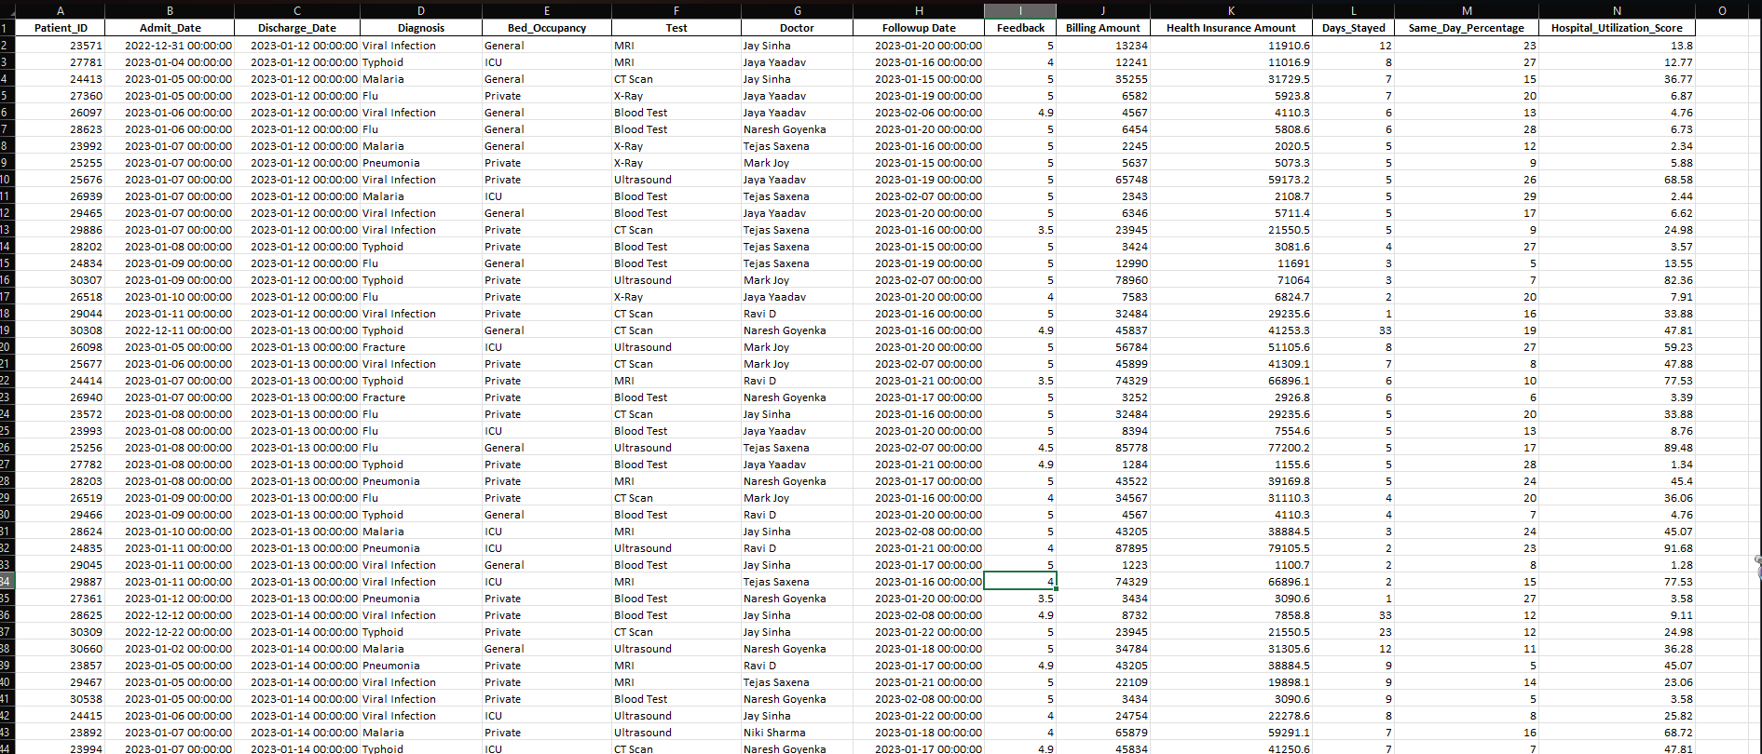An unexpected finding is the high feedback volume for Mark Joy (4.83K) despite lower ICU occupancy (171), suggesting patient satisfaction may not align with bed utilization efficiency, warranting further investigation.

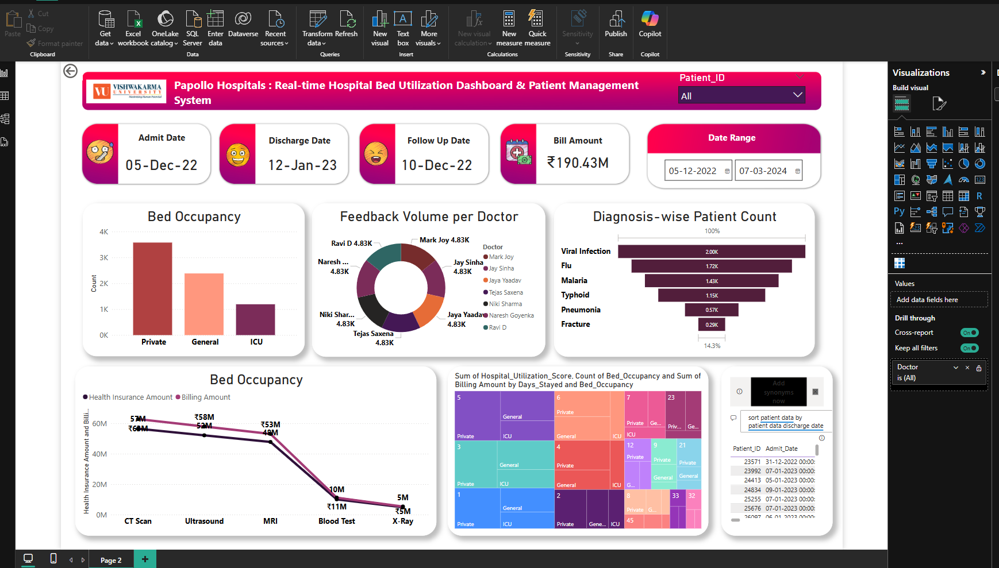

**DAX Query 1: Billing Amount Prediction using Multiple Linear Regression**

**Dashboard Insight:**

* A regression model was developed to predict Billing Amount based on:
  + Days_Stayed
  + Health Insurance Amount
  + Feedback
* Enables side-by-side comparison between **actual billing** and **predicted billing**, helping identify outliers or unexpected billing behavior.

**Dataset Insight:**

* The model uses statistical relationships:
  + **Covariance and variance** calculations identify how much each factor affects billing.
  + **Regression coefficients** are derived to quantify the impact:
    - E.g., For every extra day stayed, billing may increase by X amount.
* The **intercept and coefficients** are dynamically computed using the dataset’s average values.
* Results show **predicted billing for every patient** alongside actual billing, allowing performance benchmarking.

**Recommendation:**

* Use this regression logic to:
  + Detect **billing anomalies** (e.g., overcharging or underbilling).
  + Improve **insurance negotiation** strategies by showing billing justification.
  + 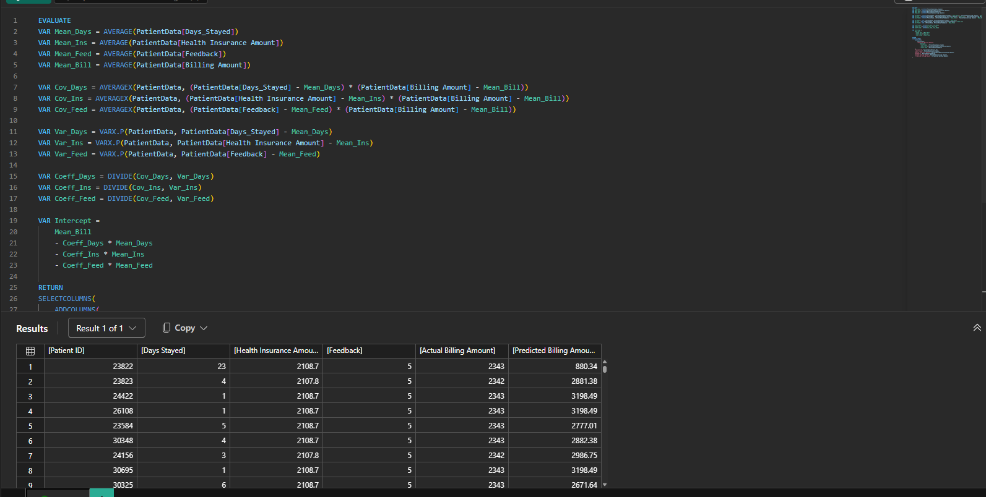Develop **automated billing estimation tools** for patient transparency and cost prediction.

**DAX Query 2: Monthly and Seasonal Utilization Summary by Diagnosis**

**Dashboard Insight:**

* Summarizes Days_Stayed, Billing, Insurance, and Utilization by:
  + **Diagnosis**
  + **Admit Month and Season**
* Identifies trends across months and seasons, useful for **temporal resource planning**.

**Dataset Insight:**

* For each unique Diagnosis and Admit_Date, the system calculates:
  + **Month Number** and **Month Name**.
  + Maps each month into a **Season** (Summer, Monsoon, Autumn, Winter).
* Calculates key performance indicators:
  + **Total Beds Needed** (sum of Days_Stayed)
  + **Average Stay Duration**
  + **Average Billing & Insurance**
  + **Hospital Utilization Score**
* Detects **peak periods** for certain diagnoses and overburdened departments.

**Recommendation:**

* Use seasonal trends to:
  + **Plan staffing and bed allocation** in advance.
  + Implement **season-specific admission protocols**.
  + Identify underused diagnostics during off-seasons and create **promotion campaigns** or **checkup packages** to balance workload.

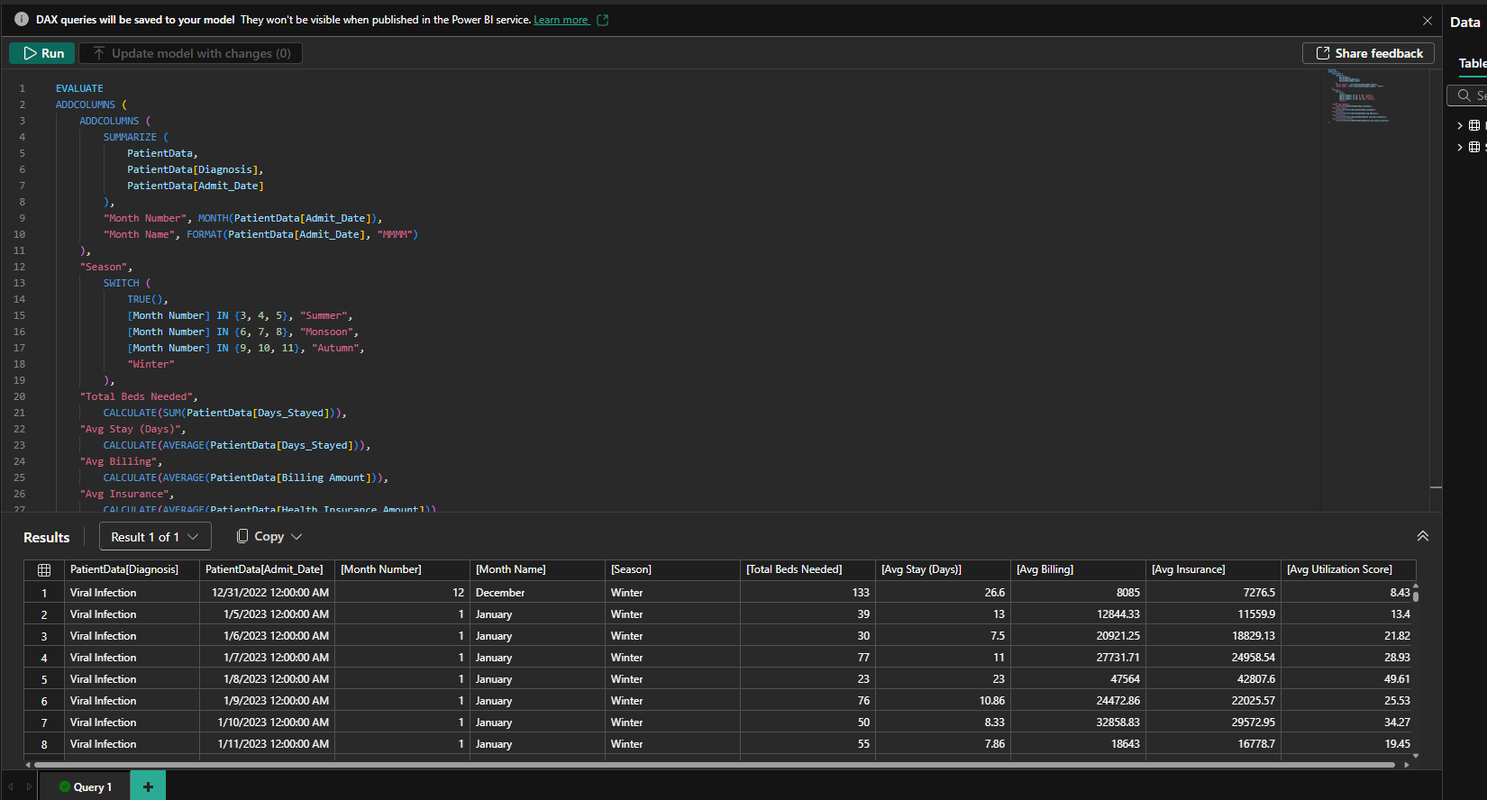

**DAX Query 3: Season-Wise Diagnosis Summary Dashboard**

**Dashboard Insight:**

* Creates a consolidated **Season + Diagnosis matrix** with patient volume and performance metrics.
* Allows **quick executive-level comparison** of seasonal disease trends and hospital performance.

**Dataset Insight:**

* Transforms the original dataset to add:
  + **Month Number** and derived **Season** per patient entry.
* Then summarizes by:
  + **Season**
  + **Diagnosis**
* Calculates critical metrics:
  + **Total Patients**
  + **Total Beds Needed**
  + **Average Stay**
  + **Average Billing**
  + **Average Insurance Claimed**
  + **Hospital Utilization Score**
* Identifies which diseases spike in each season and how efficiently the hospital is handling them.

**Recommendation:**

* Use seasonal-diagnosis combinations to:
  + Forecast **resource demands** (doctors, ICU beds, diagnostics).
  + Create **targeted health campaigns** for diseases likely to spike (e.g., flu in winter, dengue in monsoon).
  + 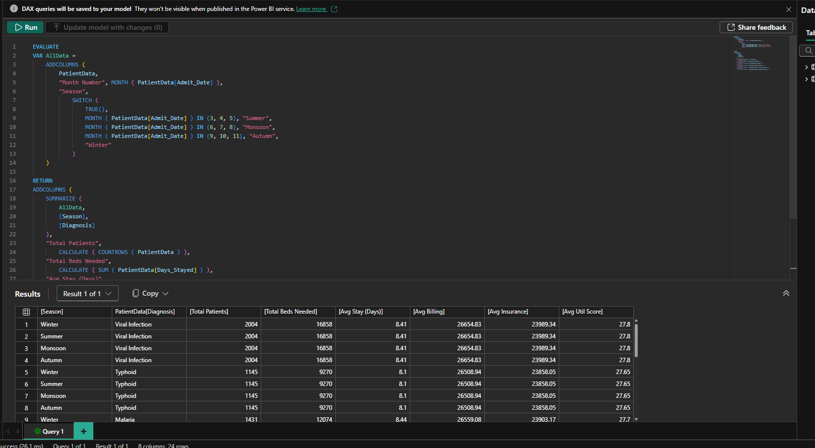Align **insurance negotiations** with high-claim seasons and optimize revenue strategy.

**4. Project Outcome:**  
The analysis at Papollo Hospitals revealed that private wards are the primary revenue drivers, contributing ₹313M with high viral infection intake. Seasonal DAX analysis showed monsoon and winter spikes in patient load, guiding staffing and bed allocation. ICU inefficiencies and extended general ward stays lead to ₹15M+ in potential annual losses. Predictive DAX models helped forecast billing and stay durations, improving discharge planning. Increasing ultrasound usage and reallocating top-performing doctors to high-value cases can boost profit by ₹10M+. Overall, optimized patient flow and resource use can drive ₹30–40M in added revenue.

* + 1. **Conclusion:**

The analysis highlights private wards’ revenue leadership (₹313M) and viral infections’ high occupancy (2004 patients), driving financial performance. General ward inefficiencies cost ₹1.5 crore annually due to poor utilization, while optimizing ICU and ultrasound usage could add ₹10M in profit. Implementing enhanced discharge protocols, targeted resource allocation, and predictive analytics will improve patient flow, maximize revenue, and elevate care quality at Papollo Hospitals.