# A TECHNICAL REPORT OF

# STUDENTS’ INDUSTRIAL WORK EXPERIENCE SCHEME (SIWES)

# UNDERTAKEN AT

# HOUSE OF ODUDUWA RESOURCE LIMITED

# OONI’S PALACE, ENUWA, ILE-IFE OSUN STATE

# PREPARED /SUBMITTED BY

# AFOLABI CALEB FOLAHAN

# BLD/2017/015

# SUBMITTED TO

# THE DEPARTMENT OF BUILDING

# FALCULTY OF ENVIRONMENTAL DESIGN AND MANAGEMENT

# OBAFEMI AWOLOWO UNVERSITY, ILE-IFE, OSUN STATE IN

# PARTIAL FULFILMENT OF THE REQUIREMENTS FOR THE AWARD OF BACHELOR OF SCIENCE (B.SC) DEGREE IN BUILDING

# NOVEMBER TO JANUARY

ABSTRACT  
 The Students’ Industrial Work Experience Scheme (SIWES) was initiated by  
Industrial Training Fund (ITF) through the Federal Government of Nigeria to solve,  
majorly, the problem of lack of adequate practical skills of tertiary institutions’  
products in Nigerian industries. This siwes program, therefore exposes students to  
professional work methods and acquisition of relevant technical skills and experience  
intheir chosen fields.  
 This report gives the details of the practical skills and experience gained at MOPOL BASE, during the period of attachment. Skills and construction methods employed in carrying out the various activities on the site with practical application of various equipment are well reported.  
 Conclusively, the period of industrial training provided a platform to gain insightful  
knowledge that Builders can take up some special aspects of project operations such as project management, consultancy and management of resources. Also, the major objective of SIWES was achieved as previoustheoretical knowledge gained in the classroom were seen practically at work.

Recommendations to the participating and coordinating bodies (Federal Government,ITF, Obafemi Awolowo University and projects house of oduduwa) were made from observations andlessons learnt.

DEDICATION  
To the Almighty God, the giver of inspiration and understanding, who provided me  
the help and encouragement I needed before, during and after the period of industrial  
training.  
To all who have in one way or the other contributed a quota to the successful  
completion of my SIWES program.  
To everyone who will not relent in their pursuit for all round excellence.

ACKNOWLEDGEMENT  
Special thanks to God Almighty who has been the giver of strength and life. He alone  
has been the source of encouragement to me throughout the period of the SIWES and  
preparation of this report.  
To my dear parents, Mr. and Mrs. Afolabi, I say thank you for your unrelenting  
support so far financially, morally and spiritually. I deeply appreciate the unrelenting guardianship of engineer Jidefinancially and morally.

I greatly acknowledge the workers at projects house of oduduwa, for the knowledge well passed as everyone isa product of what he has learnt from others. Also, I acknowledge thecare and guidance of my industrial based supervisors, the Managing Director Engr. Fisayo, Engr. Tobi, Arch. Slankama, Engr. Barry White, Engr. Segun, and Mr. Femi the security officer, all these personnelhas been pivotal to my commitment to learning the necessary skills needed at my place ofattachment.  
And to my fellow student trainees, Samuel, Gabriel, Dolapo, Bolu, Lanre, Korede, Micheal and Mohammed thanks for your understanding as we shared knowledge during the siwes program.

I appreciate the assistance of Engr. Jide, Engr. Fisayo, Engr. Tobi and other personnel on site for standing in the gap.   
This report wouldn’t be complete without appreciating the help and support of  
Engr. Tobi, Engr. Fisayo, Engr. Barry White, and Engr. Segun  
Thank you and God bless you

**Table of Contents**

**ABSTRACT………………………………………………………………………ii**

**DEDICATION……………………………………………………………………iii**

**ACKNOWLEDGEMENT……………………………………………………….iv**

**TABLES AND FIGURES………………………………………………………..7**

**CHAPTER ONE………………………………………………………………….8**

**INTRODUCTION………………………………………………………………….8**

1.1 Students’ industrial work Experience Scheme (SIWES)………………………..8

1.1.1 Objectives of SIWES………………………………………………………….8

1.1.2 Roles of students during siwes…………………………………………...........9

1.2 Company’s Profile……………………………………………………………...10

1.2.1 House of Oduduwa Resource Limited…………………………………..........10

1.3Objective of Report……………………………………………………..............10

1.4Scope of Report…………………………………………………………………10

**CHAPTER TWO……………………………………………………………..........12**

**2.0LITERTURE REVIEW……………………………………………………….12**

2.1 Building………………………………………………………………………....12

2.2 Main Stages of Construction Projects…………………………………………..13

**CHAPTER THREE………………………………………...…………………......18**

**3.0 MACHINERIES, EQUIPMENT AND SAFETY……………………………18**

3.1Machineries & Equipment………………………………………………………18

**CHAPTER FOUR………………………………………………….........................19**

**4.0 TECHNICAL EXPERIENCES GAINED…………………………………….19**

4.1 General Experience……………………………………………………………....19

4.1.1 Concrete mix ratio and grade…………………………………………………..19

4.1.2 Casting and Curing of concrete………………………………………………...19

4.2 Foundation………………………………………………………………………19

4.3 Column reinforcement…………………………………………………………..22

4.4 Slab reinforcement………………………………………………………………23

4.5 Beam reinforcement……………………………………………………………. 25

4.6 Scaffold………………………………………………………………………….27

4.7 Coarse Aggregate………………………………………………………………..28

4.8 Plastering………………………………………………………………………...28

4.9 Rendering………………………………………………………………………..29

4.10 Roof…………………………………………………………………………….30

4.11 Human relation and conflict resolution………………………………………...35

**CHAPTER FIVE…………………………………………………………………...36**

**5.0 CONCLUSION AND RECOMMENDATION……………………………….36**

5.1 Conclusion……………………………………………………………………….36

5.2 Recommendation………………………………………………………………...36

5.2.1 To the Federal Government of Nigeria………………………………………...36

5.2.2 To Industrial Training Fund (ITF)……………………………………………..37

5.2.3 To the School…………………………………………………………………..37

5.2.4 To House of Oduduwa Resource Limited……………………………………..37

5.2.5 To Clients………………………………………………………………………37

**REFERENCES……………………………………………………………………...38**

**TABLE AND FIGURES**

**FIGURES**

Fig 1.1 Pad Foundation Construction

Fig 1.2 Formwork supported by other wood

Fig 1.3 Casted column

Fig 1.4 & Fig 1.5 Cantilever slabs

Fig 1.6 Slab reinforcement

Fig 1.7 Casting of concrete

Fig 1.8 & Fig 1.9 Beam reinforcement

Fig 1.10 Offload of scaffold

Fig 1.11 Scaffold

Fig 1.12 Mixture of Plaster

Fig 1.13 Plastering of external surface

Fig 1.14 &Fig 1.15 Rendering of internal surface

Fig 1.16 Steel purlin

Fig 1.17 & Fig 1.18 Steel trusses

Fig 1.19 Steel trusses, painted with red oxide emulsion paint

Fig 1.20 & Fig 1.21 Bolt and knot

Table1 : Common concrete grades and mix ratios

# CHAPTER ONE

## 1.0 INTRODUCTION

**1.1 Students’ Industrial Work Experience Scheme (SIWES)**Students’ Industrial Work Experience Scheme (SIWES), was initiated by Industrial  
Training Fund (ITF) in the year 1973 as a skill training program to solve the problem of lack of adequate practical skills of tertiary institutions’ products in the Nigerian industries. This is as a result of the realization by the Federal Government of Nigeria of the need to introduce a new dimension to the quality and standard of education obtained in the country in order to achieve the much-needed technological advancement.  
SIWES now forms part of the approved minimum academic standards in thevariousdegree programs in Nigerian tertiary institutions. It is an effort to bridge the gap thatexists between the theory and practice of engineering and technology, sciences,agriculture, medicine, management and other professional educational program inNigerian tertiary institutions. It is aimed at exposing students to machinery andequipment employed in the industries, professional work methods and ways of safeguarding the work areas and co-workers in the industry.  
The scheme is a tripartite program involving the student, the institution and the  
industry (employers of labour). It is funded by the Federal Government of Nigeria and jointly coordinated by Industrial Training Fund (ITF) and the National Universities Commission (NUC).

Over the years, SIWES has contributed immensely to building the common pool of  
technical and allied skills available to the Nigerian economy which are needed for the nation’s industrial development.

**1.1.1 Objectives of SIWES**The objectives of Students’ Industrial Work Experience Scheme (SIWES) are to:  
• Provide avenue for students to acquire skills and experience in their course of  
study restricted to Engineering and Technology, including Environmental  
studies and other courses that may be approved.  
• Prepare students for the industrial work situation they are likely to meet after  
graduation.  
• Expose students to work methods and techniques in handling equipment and  
machinery that may not be available in their institutions.  
• Make transition from the university to the world of work easier, and thus  
enhance students’ contact for later job placement.  
• Provide students with an opportunity to apply their theoretical knowledge in  
real work situation, thereby bridging the gap between classroom work and  
actual practice.  
• Enlist and strengthen employers’ involvement in the entire educational process  
of preparing tertiary institution graduates for employment in the industry.  
**1.1.2 Roles of students during SIWES**Students who participate in the SIWES program are generally expected to carry out  
some basic activities. Their roles are summarized as follow:

• Students are to report on time on the expected date at their respective place of  
industrial attachment and are expected to resume duty daily and punctually;  
• Students are to display high level of responsibility, observe diligently the rules  
and regulations of the organization in which they are attached and not in any  
way constitute nuisance;  
• Students are not to develop a nonchalant attitude or indifference to the tasks  
assigned to them;  
• They are expected to consult their industry-based supervisor whenever  
challenges are encountered during the program.

**IMPORTANCE OF SIWES AS IT RELATE MY COURSE OF STUDY**

The importance of SIWES as it relates my course of study cannot be over emphasized because SIWES is not only a program in my course of study but compulsory, this is because my course of study as it is, is a field that requires not only a good theoretical background but also a very good practical knowledge on site, therefore SIWES creates an avenue for this practical knowledge to be acquired. SIWES makes the theoretical knowledge previously gained more realistic and applicable.

**COMPANY PROFILE**

House of Oduduwa Resource Limited was founded in the year 2015 and started operating in the year 2015. House of Oduduwa Resource Limited is located at Ooni’s palace, Enuwa, Ile-Ife Osun state. Her nature of business is developers whose area of specialization is Building Construction. They are into real estate development which comprises of multi storey buildings and also construction of shopping malls, and hostels.

1.3 Objective of Report  
 This report seeks to present the technical experience gained, lessons learnt and  
 relevance of the training to the BUILDING profession during the period of  
 siwes at House of Oduduwa resource limited.

1.4 Scope of ReportThis report was prepared based on personal skills and experience gained during the  
program at House of Oduduwa resource limited. And relates some basic principles reviewed from existing literature from various sources, especially in industrial buildings – Anchor to rods. Conclusions were drawn from observations made during the training and necessary recommendations were addressed.

**COMPANY’S ORGANOGRAM**

EXECUTIVE DIRECTOR OFFICER

HEAD OF MAINTENANCE UNIT

HEAD OF BUILDING ENGR

HEAD OF QTS DEPT

HEAD OF CIVIL ENGR WORK

HEAD OF MECH &ELECT WORK

WORK

HEAD OF PROJECT UNIT

PLUMBING SECTION

MASONRY SECTION

CARPENTARY SECTION

BUILDING ENGINEERS

CIVIL ENGINEERS

ARCHITECT

QUANTITY SURVEYORS

TECHNICAL PERSONNEL

WATER SERVICES SECTION

# CHAPTER TWO

## 2.0 LITERTURE REVIEW

**2.1 BUILDING**

Aperfect understanding of building construction is the first step to a successful construction project. And what constitute a successful construction project is listed below;

**The pre-construction stages**

* Building plan
* Budget estimation
* Land acquisition
* Documentation

**The construction stages**

* Site clearing
* Foundation
* Plinth beam or slab
* Superstructure
* Brick masonry work
* The lintel
* Roofing coating
* Electrical and plumbing
* Exterior and interior finishing
* Flooring
* Painting

**2.2 Construction Projects**

A construction project is the organized process of constructing, renovating, refurbishing, etc. a building, structure or infrastructure. Construction project starts with an overarching (bring it all together)requirement which is created through the creation of a brief, feasibility studies, option studies, design, financing and construction process.

**Main Stages of Construction Projects**

* The conception of a project
* Design
* Pre-construction stage
* Procurement stage
* Construction stage
* Post-construction stage

For every stage of a construction project, from the simplest to the most complex, there are certain steps and processes that need to be followed to ensure a successful outcome. Projects in construction may vary based on their size, the number of stakeholders involved, budget and delivery date. Regardless of the case, though, a construction project is always a long and demanding process. The good news is that with the continuous progress of digital solutions, the management of the different project phases can now be done much easier and with higher precision. As regards that, the collection of valuable data from the field can play a decisive role in improving, and ideally, standardizing the construction process for future projects.

1.**The conception of the project**

Normally, the conception of the project starts with the client. This is where the dream begins as well as the research for the right location and the specifications/standards that should be followed. Depending on the project, the conception stage might vary. It can take anywhere from a few days to a few months or more, depending on how imminent the need for the completion of the project. It goes without saying that construction workers usually don’t have much input during this stage, as the ball is still in the hands of the project owner.  
2.**Design**Once the project is closer to fruition, it is time to sit down and talk design. This is still a preliminary stage, which means that nothing is guaranteed at this point. Nevertheless, design is the stage where usually the bidding process begins. The team that oversees the design, led by an architect or an engineer, will need to make sure that each of the state regulations and codes is met while respecting the vision of the project owner as well as ensuring that the newly built structure will be usable. There are normally four different steps within the design stage and they include programming and feasibility, schematic design, design development, and contract documents. During the programming and feasibility step, each of the objectives and goals of the project must be outlined. Numerous decisions are made at this stage, including how large the building will be, how space will be used, and how many rooms will be needed. The schematic design is a sketch that will show the space as well as materials, colours, and even textures. That sketch will be used during the design development to research the equipment needed, along with the cost for them and the materials being used. Once the contract documents are drawn up, everything is close to being finalized, because they contain the final drawings and specifications. These documents are used in the construction field by those placing bids to work on the project.  
3.**The pre-construction stage**The next stage of a construction project begins when the bidding is completed and the contractor has been chosen to do the work. As soon as the contractor is chosen, the project team is put together. Typically, a project team has the task to prepare the construction site before the work begins. As a rule, it consists of the following specialties:

1. Contract administrator
2. Project manager
3. Superintendent
4. Field engineer
5. Health and safety manager

In close collaboration with the contractor, the project team is responsible for visiting the field in order to complete a site examination. The site examination will allow the project team to detect or predict any environmental challenges that might emerge during the building process. Soil testing is also an integral part of this step. When all information is collected, all plans and findings should be reviewed by the city authorities. This is usually a long procedure, as all concerns and opinions should be heard and addressed.  
4.**The procurement stage**Now it’s time for the project team to order and obtain materials, equipment, and workforce. This stage of the project can be complex and challenging depending on how big the project is, the available resources and the agreed start date. Many of the big construction companies have their own procurement departments. In such cases, it is common that the construction company will simultaneously order labourers, equipment and materials for several projects. This process might vary a lot in smaller projects.All this work is usually performed by the general contractor, however, there are times when subcontractors will oversee certain parts. The subcontractors may be responsible for hiring their own workers or obtaining their own materials so that they know that they have exactly what they need to complete their portion of the job.  
5.**The construction stage**Before the construction work begins, a pre-construction meeting is done to ensure that everyone is on the same page when the construction starts. This meeting normally includes information about the following topics:

1. How to access the job site

2. The quality control of the project

3. How and where to store all the materials

4. The hours that everyone will be working

Each worker may be given their own schedule. It is also important to note that the schedule of each project agent might vary depending on their role. This is especially true for subcontractors who need certain parts of the job completed before they can begin their portion. It easily becomes evident that bad planning at this point can lead to serious delays and budget overruns.  
Once the meeting is over and there are no lingering questions, the very first step of the project can begin. The goal at this point is to have planned everything so carefully that everything goes off without a hitch. Of course, that rarely happens, as something always goes wrong during a construction project. To avoid pitfalls, while planning your construction project, you should use digital solution.  
6.**The post-construction stage**Last but certainly not least, the post-construction stage. Now that all the work on the job site has been completed, the project will soon end. Nonetheless, there are still a few steps that need to be done before the keys to the building can be handed over. In general, the final stage of the construction project is divided into three critical steps:  
a.**New construction building commissioning**First things first, an inspection of the whole building needs to be done. If everything is done correctly, these inspections are simple to pass. The reason is that other inspections should have already been completed during the entire project. It is during those previous inspections that issues should have been found and corrected.As soon as everything has been checked, it is time for the project team to train the client in operating and maintaining the newly built structure. That is a step of considerable importance as it will contribute to increasing the lifecycle of the project.  
b.**Owner occupancy**  
Now that the training is completed, the owner can take over the building. This is when the warranty period is on. In that way, the project owner can feel safe that there is enough time to examine all the different systems, equipment, and materials that have been installed. There are three main types of warranty in construction:  
Express warranty: It is normally included in the contract.  
Implied warranty: It is imposed by law.  
Statutory warranty: It is introduced in a state’s regulations.  
c.**Closure**That is the last step in the long process of designing and completing a construction project. The project team must overall contractual agreements and make sure that the project is free from any type of legal burden. At this point, it is also a good practice to carry out a post-project review which could help the different agents to detect any tasks that weren’t completed, analyze why this happened and put together a list of insights for the future. A post-project review can also be the foundation for the creation of an in-depth project completion report.

At the end of the day, every stage of a construction project is a chain of tasks, decisions, and numerous tools. Its complexity depends vastly on the size and type of the project but there are always some core steps that can’t be skipped. Impeccable communication between the different stakeholders and fact-based decisions are two fundamental pillars in the effort of streamlining a construction project and making sure that all phases will be developed and completed within the agreed timeframe and budget.

# CHAPTER THREE

## 3.0 MACHINERIES, EQUIPMENT AND SAFETY

### **Machineries & Equipment**

* **Levelling Instrument:** This consists of Spirit level, Long and Short tapes, plumb line, pegs and plumb for levelling.
* **Concrete mixer:** This is a machine that evenly mixes cement with aggregates like sand or gravel, as well as water, to make concrete.
* **Poker vibrator:** A vibrator is used to compact the concrete so as to make the concrete free of air bubbles so thatthe concrete will remain strong and have a smooth finish even after the formwork is removed.While not necessary for small jobs, this tool is essential on large load bearing projects.
* **Welding machine**: This is used for the fabrication of two or more metals by the means of heat.
* **Wheelbarrow:** This is used for the transfer of building materials from one point to another within the site.
* **Truck**: For transferring and transporting building materials to the site.
* **Tipper:** For supplying and packing aggregates to the site.
* **Hand gloves:** The hand glove can protect the hands from skin contact with the concrete, from electrical shocks and from cuts.

**CHAPTER FOUR**

## 4.0 TECHNICAL EXPERIENCE

### **4.1 General Experience**

#### **4.1.1 Concrete mix ratio and grade**

Grade of concrete is defined as the minimum strength the concrete must posses after 28 days of construction with proper quality control. This is shown in the table below.

Table 1: Common concrete grades and mix ratios

|  |  |  |
| --- | --- | --- |
| Concrete Grade | Mix Ratio  (Cement : Sand : Aggregates) | Compressive Strength |
| M10 | 1 : 3 : 6 | 10 MPa |
| M15 | 1 : 2 : 4 | 15 MPa |
| M20 | 1 : 1.5 : 3 | 20 MPa |
| M25 | 1 : 1 : 3 | 25 MPa |

#### **4.1.2 Casting and Curing of concrete**

The procedures involved in casting of reinforced concrete, ranging from putting formwork in place, setting and tying the reinforcement bars with links or stirrups to aid strength and casting of concrete.

#### **4.2 FOUNDATION**

The foundation of a structure is the part of the structure in direct contact with the ground and which transmits the load of the structure to the (soil)ground.

The Pad foundation used on our site is usually provided to support structural columns.Generally,they may consist of a simple circular, square, or rectangular slab of uniform thickness, or may be stepped or hunched to distribute the load from a heavy column to the soil.

The foundation used on oursite is the pad foundation. The engineers had chosen the pad foundation due to the structure of the building which was a high-rise building. Pad foundations are used to support individual or multiple columns, spreading the load to the ground below. They are generally square or rectangular in plan, with the plan area being determined by the permissible bearing pressure of the soil. The shape in plan will be dictated by the arrangement of the columns and the load to be transferred into the soil. Footing is the lower part of the foundation which is constructed below the ground level in solid surface. The purpose of footing is to transfer the live and dead loads of the structure to the soil over a large enough area so that neither the soil nor the building will move and it resist settlement and lateral load. A typical example is shown below to illustrate Pad Foundation;

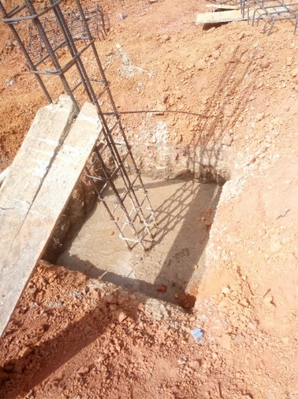

Fig 1.1Pad Foundation Construction

**Design of Pad Foundation**

The design of pad foundations involves sizing the base slab to satisfy geotechnical requirements and providing adequate thickness and reinforcements to satisfy structural requirements.

The dimensions of a pad foundation should not be too small so as to cause excessive settlement or bearing capacity failure of the soil. Most importantly, allowable capacity is normally used to control settlement during the design of a pad foundation, hence it is treated as aserviceability limit state parameter. The width of a pad foundation is expected not to be less than 1000 mm, and the thickness not less than 150 mm.

**Method of Constructing the Pad Footing**

1. Clearing the site then pegging the site with correct position of foundation
2. Excavation commences from the reduce level, down to the desired level (soffit of footing with allowance for thickness of lean concrete)
3. Lay a layer of lean concrete to prepare a clean and firm base for the footing
4. Build the formwork to the side of pad footing and supported by other wood to prevent the formwork collapse when the concrete is being casted into it (as shown in fig.2 below).
5. Spacer blocks are placed before reinforcements are laid. This is to provide sufficient concrete cover for rebars
6. Rebars were bent and tied with steel wire mesh before the whole reinforcements been lowered and placed inside the formwork
7. Stump (remains) reinforcements were then erected. Length of rebars should be extended beyond stump level and act as starter bars for column above
8. We then Provide addition ties to formwork, if necessary
9. Concrete will set and curing shall be performed to avoid excessive loss of water during hardening. When the concrete has gained sufficient strength, formwork can be dismantled.

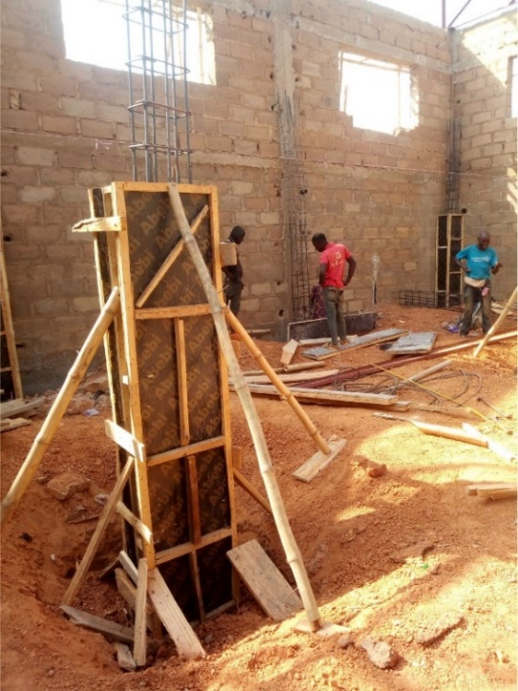

Fig 1.2 Formworksupported by other wood

#### **4.3COLUMN REINFORCEMENT**

Columns are vertical or inclined compression members used for transferring superstructure load to the foundation. This load comprises of both dead and live load coming directly from the slab, beams, wind load and the roof. Columns usually comes in different shapes, some which are square, rectangle, circular, hexagon etc.

On our site we used the rectangular column. The rectangular columns used has 6Y16mm in diameter and spacing of 250mm.

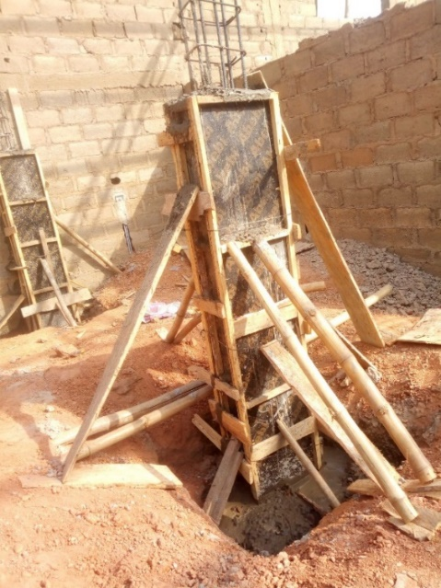

Fig 1.3Casted column

#### **4.4 SLAB REINFORCEMENT**

A slab is a structural element, made of concrete, that is used to create flat horizontal surfaces such as floors, roof decks and ceilings. A slab is generally several inches thick and supported by beams and columns. Concrete slab can be prefabricated off-site and lowered into place or may be poured in-situ using formwork.

The convectional slab was used on site also known as a two-way slab. The two-way slab is supported by beams on all four sides, carrying the load along both directions.

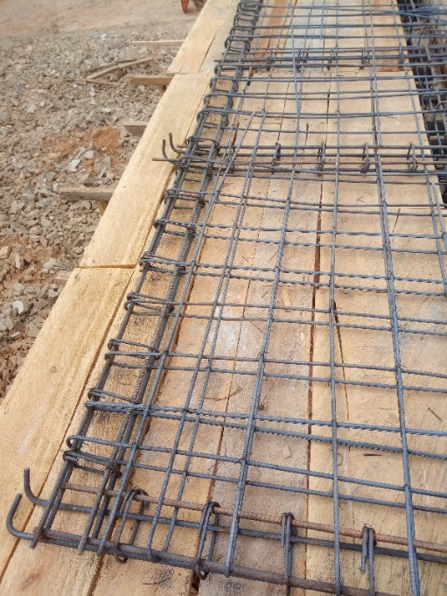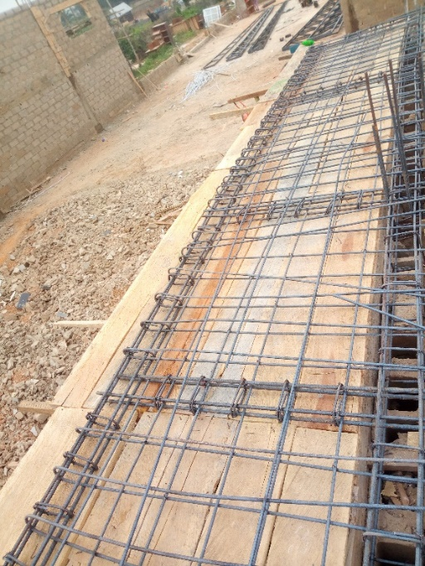

Fig 1.4 Cantilever slabFig 1.5Cantilever slab

**Concrete Floor Slab Construction Process**

1. Assemble and Erect Formwork

2. Prepare and Place Reinforcement

3. Pour, Compact and Finish Concrete

4. Curing Concrete and Remove Formwork

1.**Assemble and erect formwork**

The formwork is designed to withstand construction loads such as fresh concrete pressure and weight of workers and operators and their machines. Moreover, there are various construction aspects that need to be considered during the erection of formworks. For example, it should be positioned correctly, lined and levelled, joints sealed adequately, and prevent protruding of nails into the concrete etc.

2.**Prepare and Place Reinforcement for Slab**

Prior to the placement of reinforcement for concrete floor slab construction, inspect and check forms to confirm that the dimensions and the location of the concrete members conform to the structural plans.

After preparation is completed, steel bars are placed into their positions with the provision of specified spacings and concrete cover.

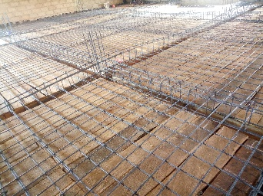

Fig 1.6 Slab reinforcement

3.**Cast, Compact and Finishing Concrete Floor Slab**

Mixing, transporting, and handling of concrete shall be properly coordinated with placing and finishing works. In floor slab, begin concrete placing along the perimeter at one end of the work with each batch placed against previously dispatched concrete.

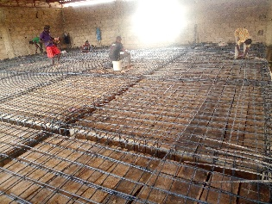

Fig 1.7 Casting of concrete

4.**Curing Concrete and Remove Formwork**

After finishing ended, suitable technique shall be used to cure the concrete adequately. Slab curing methods such as water cure; concrete is flooded; ponded; or mist sprayed.

But on our site, liquid substance was poured into the formwork before the slab was casted, the purpose for this was used to keep the slab surface wet continuously and to aid the removal of the formwork after hardening.

Regarding curing, it is recommended to remove formworks after 14 days.

***4.5* BEAM REINFORCEMENT**

Beams are structural elements that resist loads applied laterally to their axis. Beams basically transfer horizontal loads. They typically transfer loads imposed along their length to their endpoints where the loads are transferred to columns, foundations, and to the soil.

**Beam Construction Method**

1. **Formwork:** The formwork is essential for sustaining concrete properly. Formworkoffers the strong support to the wet concreteunless it has attained adequate stability to become self-supporting.
2. **Bending and binding steel bars:** While creating the design of the beam, it is assumed that the concrete has good compressive strength but it is feeble in tensile strength. To make the structure sustainable against the tensile stress, the steel bars are arranged properly.
3. **Placement of steel bars:** Steel bars diameter and its distance in RCC slab is computed by designing the beam based on the load and span of the slab. 16 mm diameter steel bars were utilized in the beam.
4. **Laying of cement concrete:** Arrange walking way on steel bars by setting wooden plates to get rid of any issue in steel bars. Now, the cement concrete mix should be placed according to design but it should be kept over 1:2:4.. ratio. The mix should have been mixed mechanically and vibrated after being placed on the slab.
5. **Curing:** Once the beam is laid, it should be cured for 28 days to attain complete strength.

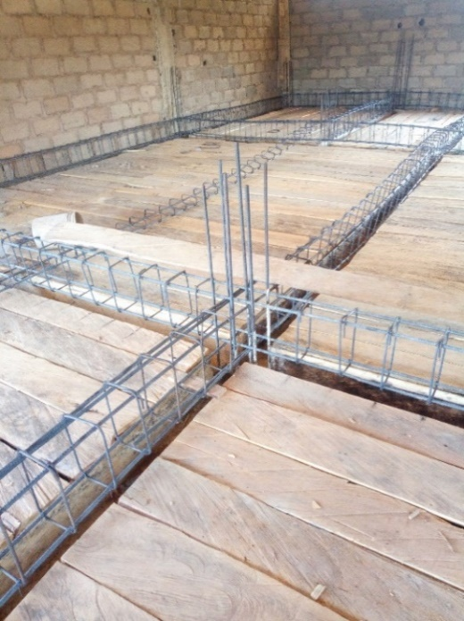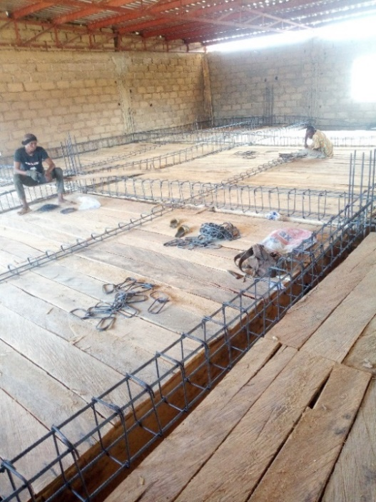

Fig 1.8 Beam reinforcement Fig1.9 Beam reinforcement

#### **4.6 SCAFFOLD**

During installation of the scaffolds, the materials we used were selected wisely to avoid the eventual of building collapse. Examples of these materials are bamboo.

However, for large scale construction, steel scaffolds are preferable because it can withstand some adverse weather conditions and more stress compared to bamboo scaffolds. Examples of these bamboo scaffolds like the ones used on our site are independent scaffolds and putlog scaffold.

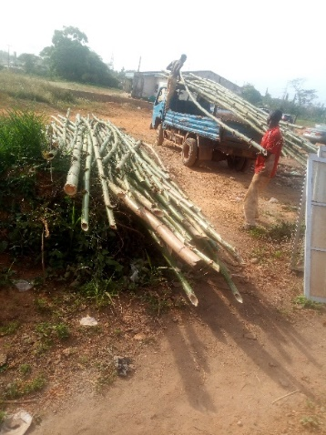

Fig 1.10Offload of scaffold

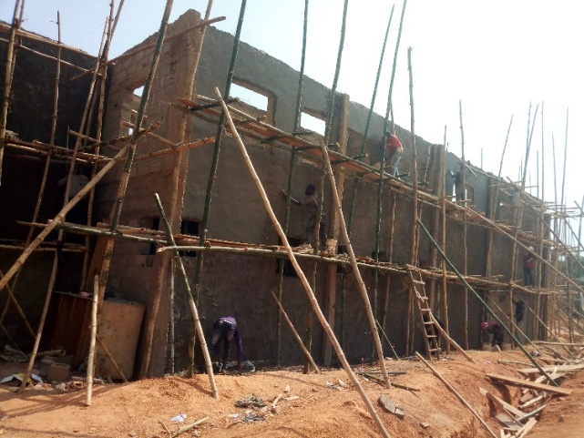

Fig 1.11Scaffold

#### **4.7 COARSE AGGREGATES**

Coarse aggregate is used in every Construction projects which includes the construction of Buildings, Roads, Railway Tracks etc. Coarse Aggregate make up 40-55% of concrete. Coarse aggregates are irregular broken stones or naturally occurring round gravels that are used to make concrete, coarse aggregates for structural concrete consists of broken stones of hard rock like granite and limestone.

#### **4.8 PLASTERING**

Plaster is a building material which comprises of cement, sand and water. They are used for coating, protecting and decorating internal walls and ceilings. While plastering is durable, it can be prone to cracking if the building experiences settle or if it has been applied incorrectly.

**PLASTERING PROCESS**

Step 1: Preparation

Step 2: Mix the Plaster.

Step 3: Apply Plaster ontothe walls

Step 4: Skim And Smooth

Step 6: Scrape

Step 7: Finishing Touches

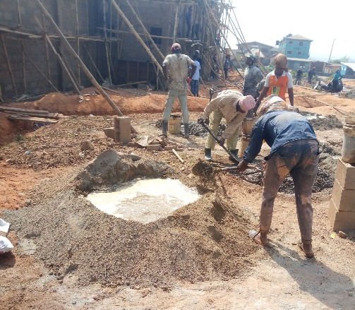

Fig 1.12Mixture of plaster

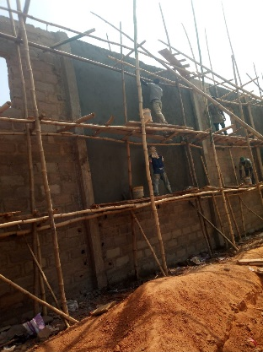

Fig 1.13Plastering of external surface

#### **4.9 RENDERING**

Rendering is a plastered finish for external walls that gives a smooth finish and protects brickwork against elements. It is also known as a protective coating added to the brickwork of a property, which leaves a smooth or textured finish.

**RENDERING PROCESS**

Step 1: Preparation

Step 2: Mix the Plaster.

Step 3: Apply Plaster onto The Walls

Step 4: Skim and Smooth

Step 6: Scrape

Step 7: Finishing Touches

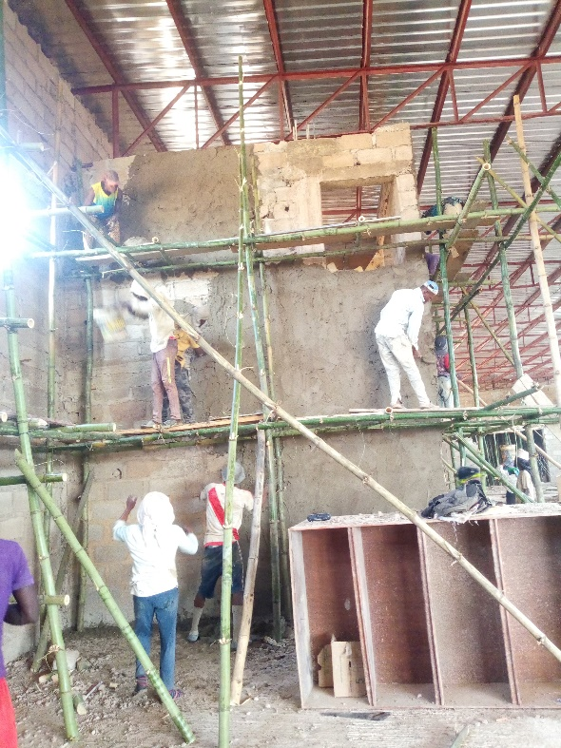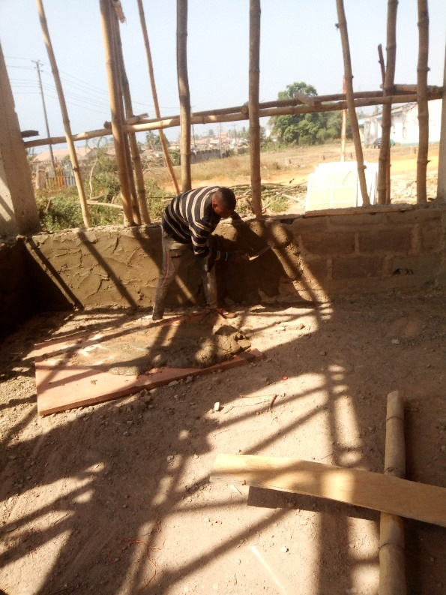

Fig 1.14Rendering of internal surfaceFig 1.15Rendering of internal surface

#### **4.10 ROOF**

The roof used on site is known as the flat roof. Flat roof are used for buildings, homes, garage, extinctions and many other buildings.

The primary aim for the use of roof construction is to protect against rain, snow, sunlight, wind and extreme temperatures.

**Components of the roof trusses**

1.**Joists and Purlins**

On the use of steel joists or steel purlins (which was used on our site, experience shows that each case must be studied. Standard steel joist specifications are based upon distributed loads only. Modifications for concentrated loads should be done in accordance with the Code of Standard Practice. However, progressive failure should be considered if there is a possibility for a loss in continuity after installation.

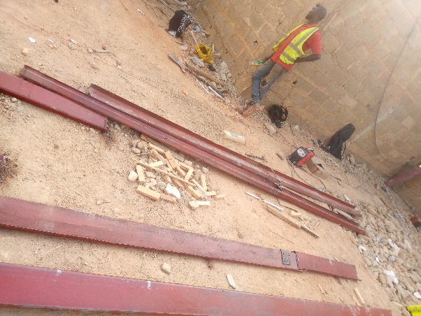

Fig 1.16 Steel purlin

2. **Roof Trusses**

A truss is essentially a triangulated system of (usually) straight interconnected structural elements, it is sometimes referred to as open web girder. The individual elements are connected at nodes; the connections are often assumed to be nominally pinned.

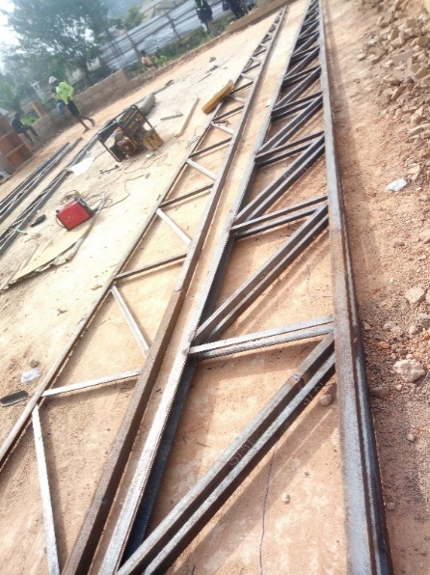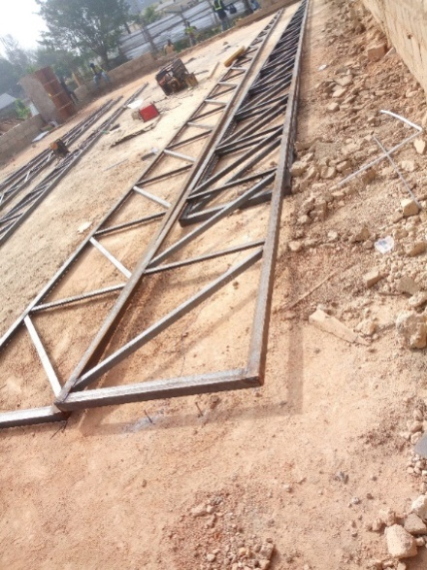

Fig 1.17Steel trussesFig 1.18Steel trusses

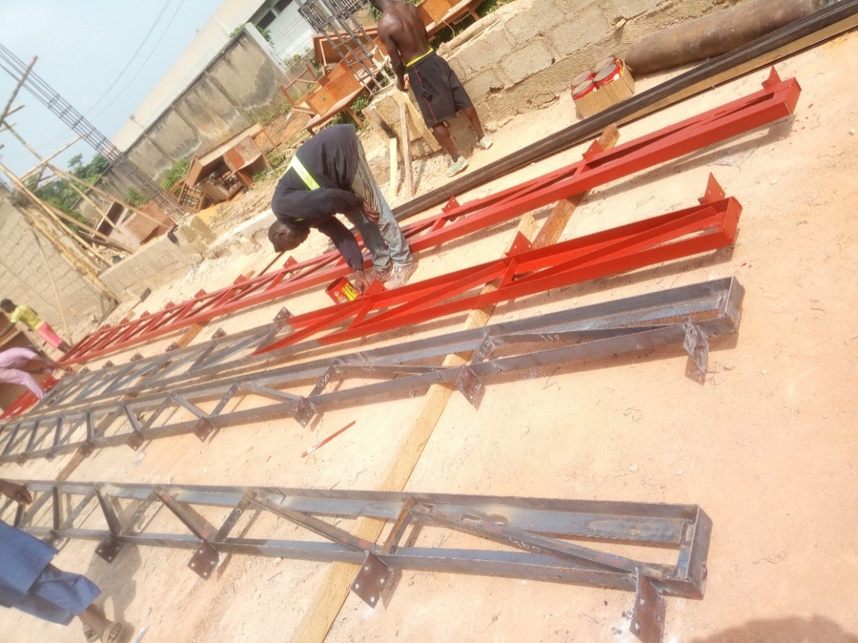

Fig 1.19Steel trusses, painted with red oxide emulsion paint

**Connection Considerations**

The bolt and knot were well coupled to the purlin to ensure proper rigidity with the roof.

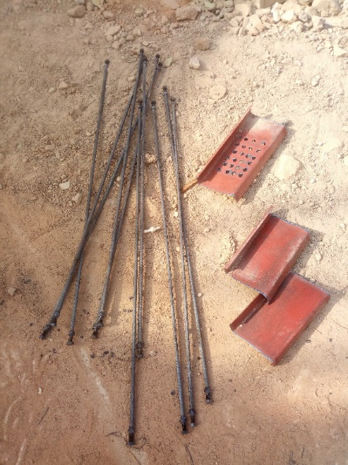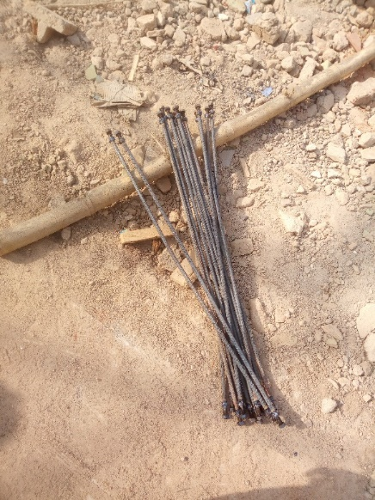

Fig 1.20Bolt and knot Fig 1.21Bolt and knot

**LOADING CONDITIONS AND LOADING COMBINATIONS**

Loading conditions are categorized as follows:

1. **Dead load:** They are also known as permanent or static loads. They are loads that remain relatively constant over time and comprises of beams, columns, slabs & roofs.
2. **Live load:** This load represents the force imposed on the structure by the occupancy and use of the building. Building codes give minimum design live loads which vary with the classification of occupancy and use.
3. **Rain loads:** These loads are now recognized as a separate loading condition. In the past, rain was accounted for in live load. However, some codes have a more refined standard. Rain loading can be a function of storm intensity, roof slope, and roof drainage.
4. **Wind loads:** These are well codified, and are a function of local climate conditions, building height, building geometry and exposure as determined by the surrounding environment and terrain. Building codes account for increases in local pressure at edges and corners.

**Points to consider in the application of flat roof**

1**. Insulation and Roofing**

Due to concern about energy, the use of additional and/or improved roof insulation has become common. Co-ordination with the mechanical requirements of the building is necessary. Generally, the use of additional insulation is warranted.

2. **Expansion Joints**

Although industrial buildings are often constructed of flexible materials, roof and structural expansion joints are required when horizontal dimensions are large. It is not possible to state exact requirements relative to distances between expansionjoints because of the many variables involved, such as ambient temperature during construction and the expected temperature range during the life of the buildings.

3.**Roof Drainage and ponding**

Prior to determining a framing scheme and the direction of primary and secondary framing members, it is important to decide how roof drainage is to be

accomplished. If the structure is heated, interior roof drains may be justified. For unheated spaces exterior drains and gutters may provide the solution.

Ponding as it applies to roof design has two meanings.

To the roofing industry, ponding describes the condition in which water accumulated in low spots has not dissipated within 24 hours of the last rainstorm. Ponding of this nature is addressed in roof design by positive roof drainage and control of the deflections of roof framing members.

**General Design and Economic Considerations** No absolute statements can be made about what truss configuration will provide the most economical solution. For some other situations, however, the following statements can be made regarding truss design:

1. Span-to-depth ratios of 15 to 20 generally prove to be economical; however, shipping depth limitations should be considered so that shop fabrication can be maximized. The maximum depth for shipping is conservatively 14 ft. Greater depths will require the web members to be field bolted, which will increase erection costs.
2. The length between splice points is also limited by shipping lengths. The maximum shippable length varies according to the destination of the trusses, but lengths of 80 ft are generally shippable and 100 ft is often possible. Because maximum available length is approximately 70 ft, the distance between splice points is normally set at a maximum of 70 ft. Greater distances between splice points will generally require truss chords to be shop spliced.
3. The lateral bracing requirements for the top and bottom chords should be considered interactively while selecting chord sizes and types. Particular attention should be paid to loads that produce compression in the bottom chord. In this condition additional chord bracing will most likely be necessary.
4. If possible, select the lateral bracing requirements for the top and bottom chords should be considered interactively while selecting chord sizes and types. Particular attention should be paid to loads that produce compression in the bottom chord. In this condition additional chord bracing will most likely be necessary.
5. Truss depths so that tees can be used for the chords rather than wide flange shapes. Tees can eliminate (or reduce) the need for gusset plates.
6. Higher strength steels (Fy = 50 ksi or more) usually results in more efficient truss members.

#### **4.11 Human relation and conflict resolution**

In every construction project, different people from diverse background and family issues come together. Each individual involved in a profession, especially construction have to be at peace with one another. Peace must be sought by all means. In case of any dispute, the situation should be nipped in bud immediately. Malice must not reign among the professionals. Matters should be resolved by holding unto what unites us.

# CHAPTER FIVE

## 5.**0CONCLUSION AND RECOMMENDATION**

### **5.1 Conclusion**

My period of industrial attachment at House of Oduduwa Resource Limitedafforded me the opportunity of gaining vast experience in building construction. These experiences are the use of concrete mixer for making concrete, poker vibrator for compacting, good attitude towards one’s profession, good interpersonal relation and lots more. The period of training during the siwes made me gain insightful knowledge of the roles of Builders, architect and other professionals in a building project.

Also, I was able to relate knowledge gained in BLD310 (Design of Concrete Structures I), BLD303&304 (Construction technology 1&2), and BLD301 & BLD302 (Buildingconstruction) in various site activities. I had good rapport with the some of the professionals on site.

Summarily, the six weeks of the siwes was worthwhile as it has prepared me forthe industrial work situation and challenges. I am preparing my mind ahead for the industry.

### **5.2 Recommendation**

Having participated fully in the industrial training and for the SIWESobjectives to be maximally achieved, I hereby give the following recommendations tothe following bodies.

**5.2.1 To the Federal Government of Nigeria**  
The demands of construction workers should be met appropriately toencourage them to work effectively and efficiently, instead of stoppingoperation as construction also form the bedrock of the nation.

Quick payment of contractor’s claims to prevent avoidable embarrassment from creditorslike banks that lends money to struggling contractors and suppliers. Completion of various abandoned large projects all over the nation.Training allowance for student trainees should be increased and paid as at when due toIndustrial Training Fund (ITF).  
**5.2.2 To Industrial Training Fund (ITF)**  
Student trainees should be paid allowances during/after the period of training tohelp motivate them as most are not being paid any form of allowance at theirplace of industrial attachment.

Students should be treated with respect in all ITF offices

#### **5.2.3 To the School**

The school should partner with various industrial establishments to helpstudents secure placements on time. This will, in no little way, alleviate thestress and challenges most students encounter when seeking for placements.

#### 5.2.4 To House of Oduduwa resource limited

Provision of incentives & insurance for interns on site

#### **5.2.5 To Clients**

I give kudos to clients (Government/Private owners) for the fact that there have always ensure that their projects are always completed. However, there used to be delay in payment. Clients should faithfully stick to contract terms to ensure the quick completion of their projects and quality service from the contractors. This should be given immediate attention to ensure smooth progress of the project and relationship.

# REFERENCES

* **James M. Fisher 2004**

**Industrial Buildings – Roof to Anchor Rods 2ND Edition**

# Anderson, J.p. and J.H. Woodward, “Calculation of effective length and effective slenderness ratios of stepped columns

# Dalal, s.t., “some Non-convectional cases of column design.

# Huang, H.c, “Determination of slenderness ratios for heavy Design of heavy Mill Building stepped columns,” iron and steel engineering

# Agrawal, K.M., STEPCOL – computer program to calculate slenderness ratio of stepped columns, H.A. Simons (international) Ltd. Engineering computing Department, Vancouver, B.C., Canada, March 1980