Things I understood from the blog given by you
- Traditional retrieval-augmented generation (RAG) methods are designed to enhance the information retrieval process in large language models (LLMs). The goal is to retrieve valuable, relevant information from a knowledge base by providing documents and embeddings, alongside the user query, to the LLM for response generation. In this system, embeddings—vector representations of chunks of text—are central. These embeddings capture the semantic meaning of the text and allow the model to retrieve information based on the similarity between the user query and the stored chunks.
- However, traditional RAG approaches often treat all retrieved information as having equal context, which can lead to problems when the retrieved chunks don’t fully encapsulate what the user is asking for. For instance, in a technical support scenario where someone queries about "error 191," the model might return all chunks containing the word “error” without recognizing the specific relevance of "191." While embeddings are good at capturing the broader semantic meaning, they may not catch these more specific, context-dependent cases.
- This is where contextual retrieval comes into play. Contextual retrieval introduces more precise methods like BM25, which is based on the TF-IDF (Term Frequency-Inverse Document Frequency) model. BM25 is highly effective in matching exact terms and phrases, especially in cases where specific technical identifiers or terms are important. For example, if the query includes a precise term like "TS-999," BM25 will locate documents that mention that exact code, rather than just semantically related chunks.
- Yet, even with better term-matching methods, sometimes the model still misses the full context. That's where the technique of contextual embeddings helps. By appending a short, concise explanatory note to each chunk, we improve the model's ability to understand what the chunk is really about before embedding it. For example, if you ask about revenue growth in Q2 for a specific company, instead of just embedding "revenue grew by 3%," we prepend additional context like, “This is from an SEC filing about ACME Corp's Q2 2023 performance.”
- The use of prompt caching further improves this process by allowing developers to save and reuse frequent prompts, reducing both latency and costs. This is particularly useful when dealing with large knowledge bases because it means we don’t need to fetch or compute the same data repeatedly for similar queries.
- Once relevant chunks are retrieved, reranking is applied to improve retrieval accuracy even further. Reranking models assign scores to the retrieved chunks, filtering the best matches to pass them to the LLM for final response generation. This step ensures the highest quality and most relevant information is included, balancing both semantic similarity and exact matches.
Ultimately, combining contextual embeddings, BM25, and reranking delivers far superior performance in retrieving the right information compared to traditional RAG. It reduces failed hits, enhances context preservation, and boosts the accuracy of LLM responses. As noted in the user's own experience, embedding models like Voyage and Gemini have shown the best results when integrated into this enhanced retrieval process.
My Pseudo Code is based on the below flowchart given in the blog provided by you . 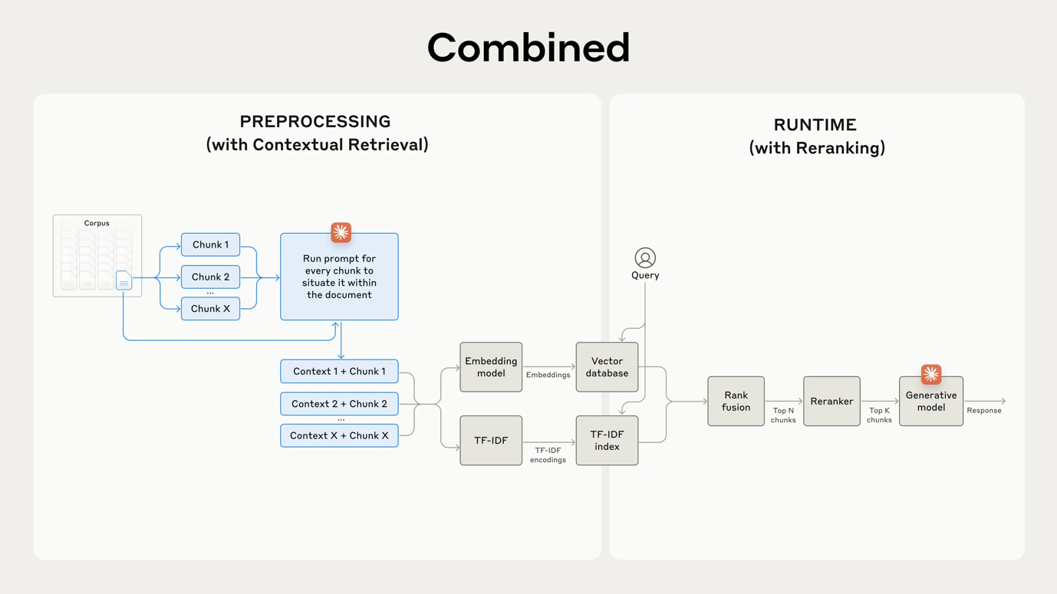

A small explanation of the algorithm used in the pseudo code-
# Preprocessing Stage
FOR each chunk in the corpus:
CONTEXTUALIZE chunk by adding relevant document context
ADD contextualized chunk to a list of processed chunks

# Runtime Stage
# Step 1: Query Processing
RECEIVE query from the user
EMBED the query using an embedding model

# Step 2: Document Retrieval
RETRIEVE relevant documents from the vector database using the query embedding
RETRIEVE additional documents using TF-IDF (term frequency-based retrieval)
COMBINE results from both retrieval methods using rank fusion

# Step 3: Reranking
RERANK the combined document results using a reranking algorithm

# Step 4: Response Generation
SELECT the top K reranked documents
GENERATE final response using the generative model, based on selected documents

# Output
RETURN the final response to the user

My Pseudocode-
# Preprocessing Step: Adding context to each chunk of the corpus

class Preprocessing:
def __init__(self, corpus):
self.corpus = corpus # Corpus of documents divided into chunks
self.contextual_chunks = [] # Store contextualized chunks

def preprocess_chunks(self):
# Iterate over each chunk in the corpus
for chunk in self.corpus:
# Add contextual information to each chunk
context_chunk = self.add_context(chunk)
self.contextual_chunks.append(context_chunk)

def add_context(self, chunk):
# Run a prompt to situate the chunk within the larger document context
context = f"Context: This is part of the larger document discussing {chunk['topic']}."
return f"{context} {chunk['content']}"

# Runtime Step: Retrieval and Reranking

class RuntimeRetrievalSystem:
def __init__(self, embedding_model, tfidf_model, vector_database, reranker):
self.embedding_model = embedding_model # Embedding model (Voyage/Gemini)
self.tfidf_model = tfidf_model # TF-IDF model for term matching
self.vector_database = vector_database # Vector database for embeddings
self.reranker = reranker # Reranker model

# Step 1: Process the user query
def process_query(self, query):
# Retrieve embedding for the query
query_embedding = self.embedding_model.embed(query)
return query_embedding

# Step 2: Retrieve documents based on embeddings and TF-IDF
def retrieve_documents(self, query_embedding, query):
# Search the vector database for semantically similar documents (embeddings)
embedding_results = self.vector_database.search_by_embedding(query_embedding)

# Search using TF-IDF for term-based matching
tfidf_results = self.tfidf_model.search(query)

# Perform rank fusion (combining embeddings and TF-IDF results)
fused_results = self.rank_fusion(embedding_results, tfidf_results)
return fused_results

# Rank Fusion: Combine results from embedding and TF-IDF searches
def rank_fusion(self, embedding_results, tfidf_results):
final_results = {}
for doc, score in embedding_results.items():
final_results[doc] = score * 0.7 # 70% weight for embeddings
for doc, score in tfidf_results.items():
if doc in final_results:
final_results[doc] += score * 0.3 # 30% weight for TF-IDF
else:
final_results[doc] = score * 0.3
return final_results

# Step 3: Rerank the top N documents
def rerank_documents(self, fused_results):
# Sort results by their rank and apply reranking logic
reranked_results = self.reranker.rerank(fused_results)
return reranked_results

# Step 4: Generate response using top reranked documents
def generate_response(self, query, reranked_results):
# Use the top reranked chunks for generating the final answer
relevant_chunks = self.get_relevant_chunks(reranked_results)
response = self.run_generative_model(query, relevant_chunks)
return response

# Extract top chunks based on reranking
def get_relevant_chunks(self, reranked_results):
chunks = [self.vector_database.get_chunk(doc[0]) for doc in reranked_results[:5]] # Top 5
return " ".join(chunks)

# Run the generative model to form the final response
def run_generative_model(self, query, relevant_chunks):
return f"LLM Response based on: {relevant_chunks}"

# Example Usage

# Preprocessing
corpus = [{'topic': 'error codes', 'content': 'Error 191 is a system error...'}, {'topic': 'ML', 'content': 'Machine learning is...'}, ...] # Document chunks
preprocessing = Preprocessing(corpus)
preprocessing.preprocess_chunks()

# Runtime Retrieval
embedding_model = EmbeddingModel()
tfidf_model = TFIDFModel()
vector_database = VectorDatabase(preprocessing.contextual_chunks) # Preprocessed chunks are used in the vector database
reranker = Reranker()

retrieval_system = RuntimeRetrievalSystem(embedding_model, tfidf_model, vector_database, reranker)

# Process the user query
query = "What is error 191?"
query_embedding = retrieval_system.process_query(query)

# Retrieve documents and rerank
fused_results = retrieval_system.retrieve_documents(query_embedding, query)
reranked_results = retrieval_system.rerank_documents(fused_results)

# Generate response using top reranked documents
response = retrieval_system.generate_response(query, reranked_results)
print(response) # Final response from LLM

