High Performance Application - Project Documentation

1. Project Overview
This project demonstrates the design and implementation of a high-performance Python application. It focuses on concurrency, caching mechanisms, monitoring tools, and performance optimization. The system processes data efficiently using multi-threading, stores results in a database, and monitors CPU and memory usage.

2. Project Goals and Objectives
- Demonstrate concurrent data processing using ThreadPoolExecutor.
- Implement caching to reduce repeated computation.
- Store processed results in a database.
- Monitor CPU and memory usage for performance analysis.
- Provide benchmarking results for system performance evaluation.

3. Setup Instructions
Step 1: Install Python (version 3.8 or above).
Step 2: Install required libraries using pip:
pip install psutil
Step 3: Download or clone the project.
Step 4: Navigate to the project directory.
Step 5: Run the application using: python app.py

4. Code Structure
high-performance-app/
│
├── app.py
├── cache.py
├── models/
│ └── data_model.py
├── services/
│ └── data_service.py
├── database/
│ └── db.py
├── monitoring/
│ └── monitor.py
├── tests.py
├── unit.py
├── integration.py
└── performance.py

5. Architecture Design
The application follows a modular architecture. Data models represent the data structure. Services handle business logic. The cache layer stores temporary results to improve performance. The database module manages data storage and retrieval. Monitoring tools track system performance.

6. Performance Optimization Guide
- Use ThreadPoolExecutor for parallel processing.
- Implement caching to reduce repeated computation.
- Use efficient data structures for faster data access.
- Monitor CPU and memory usage to detect bottlenecks.

7. Deployment Instructions
1. Install dependencies.
2. Configure the environment.
3. Run the application using python app.py.
4. Verify outputs and logs.

8. Monitoring Setup
The monitoring module uses the psutil library to track CPU and memory usage. This information helps analyze system performance and detect resource bottlenecks.

9. Benchmark Results
Benchmark tests measure application performance. The results include execution time and average processing time per record.

10. Scalability Considerations
- Increase worker threads for larger workloads.
- Use distributed caching systems like Redis.
- Deploy the application using containers such as Docker.
- Use load balancing for handling high traffic.

11. Testing Evidence
The project includes unit tests, integration tests, and performance tests to validate system functionality and reliability.

12. Visual Documentation (Screenshots)
Application Home Page Output
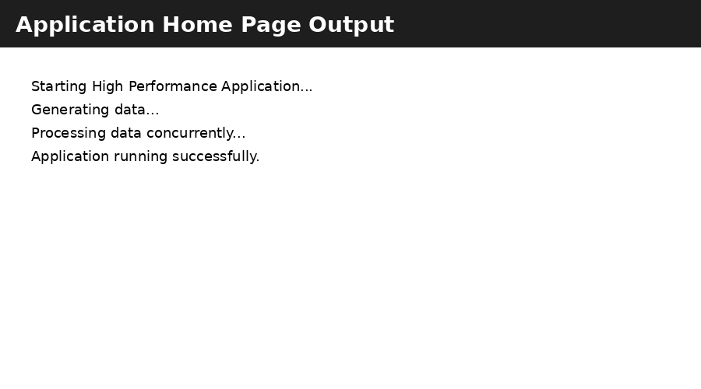
Concurrent Processing Execution Log
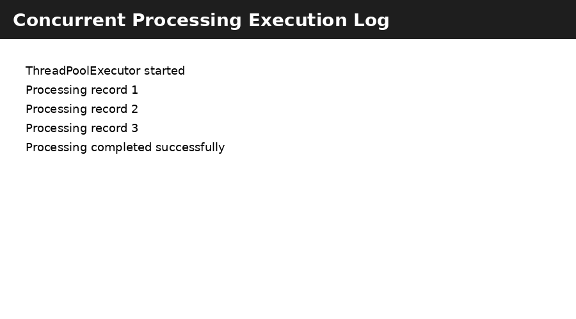
Performance Benchmark Results
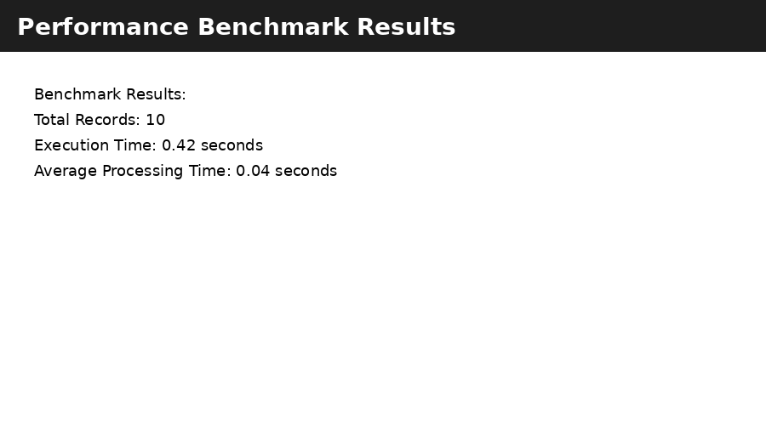
Caching Layer Output Verification
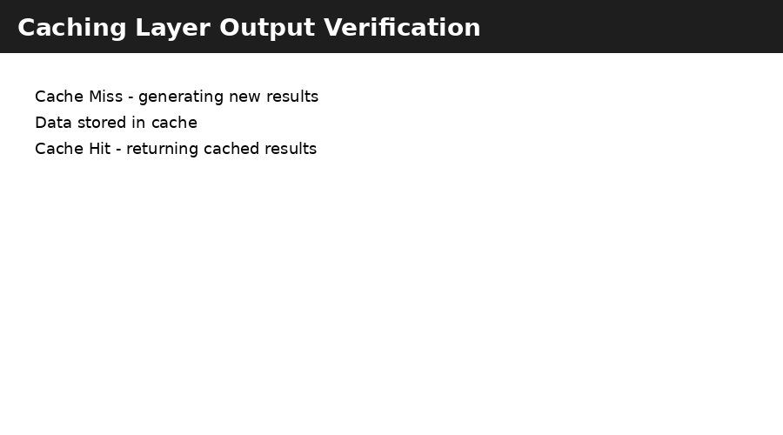
Monitoring Dashboard Overview
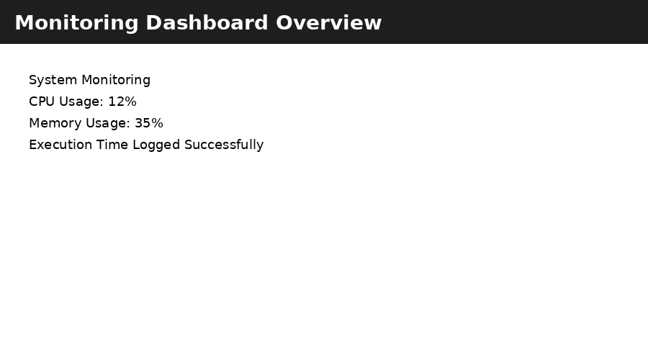

13. Technical Details
The application uses Python's concurrent.futures module for parallel execution. The caching layer is implemented using an in-memory dictionary with expiration logic. The database layer uses SQLite for simplicity, and monitoring tools use psutil for system metrics.

