**Key Performance Indicator (KPI)**

Key Performance Indicators (KPIs) are the critical (key) indicators of progress toward an intended result. KPIs provides a focus for strategic and operational improvement, create an analytical basis for decision making and help focus attention on what matters most. As Peter Drucker famously said, “What gets measured gets done.”  
  
Managing with the use of KPIs includes setting **targets** (the desired level of performance) and tracking progress against that target. Managing with KPIs often means working to improve **leading indicators** that will later drive lagging benefits. Leading indicators are precursors of future success; **lagging indicators** show how successful the organization was at achieving results in the past.

KPIs can be categorized into several different types:

1. **Inputs** measure attributes (amount, type, quality) of resources consumed in processes that produce outputs
2. **Process** or activity measures focus on how the efficiency, quality, or consistency of specific processes used to produce a specific output; they can also measure controls on that process, such as the tools/equipment used or process training
3. **Outputs** are result measures that indicate how much work is done and define what is produced
4. **Outcomes** focus on accomplishments or impacts, and are classified as Intermediate Outcomes, such as customer brand awareness (a direct result of, say, marketing or communications outputs), or End Outcomes, such as customer retention or sales (that are driven by the increased brand awareness)
5. **Project** measures answer questions about the status of deliverables and milestone progress related to important projects or initiatives

Every organization needs both strategic and operational measures, and some typically already exist.

* **Strategic Measures** track progress toward strategic goals, focusing on intended/desired results of the End Outcome or Intermediate Outcome. When using a balanced scorecard, these strategic measures are used to evaluate the organization’s progress in achieving its Strategic Objectives depicted in each of the following four balanced scorecard perspectives:
  + Customer/Stakeholder
  + Financial
  + Internal Processes
  + Organizational Capacity

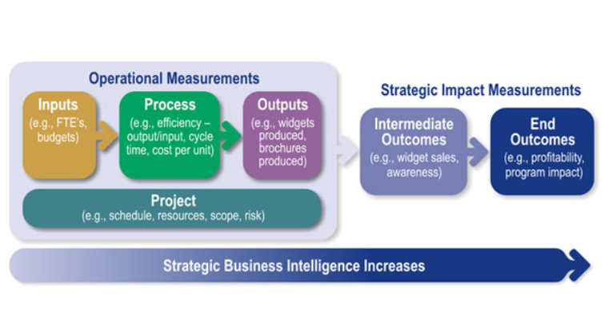

* **Operational Measures,** which are focused on operations and tactics, and designed to inform better decisions around day-to-day product / service delivery or other operational functions
* **Project Measures,** which are focused on project progress and effectiveness
* **Risk Measures,** which are focused on the risk factors that can threaten our success
* **Employee Measures**, which are focused on the human behavior, skills, or performance needed to execute strategy
* An entire family of measures, including those from each of these categories, can be used to help understand how effectively strategy is being executed.

**How KPI Work?**

Your organization's business model, industry, and even the department in which you operate will have an impact on the type of KPI you need

### Step 1 - Determine the Key Strategic Objectives

Before writing KPIs, you'll first need to determine which of your organization's strategic objectives you're trying to gauge. If you've been following along our mini series ["How To Write A Strategic Plan: The Cascade Model'](https://www.executestrategy.net/blog/how-to-write-a-strategic-plan) then you will have already defined some strategic objectives for your organization, and you're ready to create some KPIs.

If you haven't defined any strategic objectives (or goal) for your organization yet, [check out this article](https://www.executestrategy.net/blog/strategic-objectives) first and then jump back over here to create your KPIs.

**E.g. Strategic Objective: Increase the flow of the marketing pipeline.**

### Step 2 - Define Success

Now that you've identified your strategic objectives, you'll need to begin thinking about what the success of each objective looks like. Sticking with the same example used in Step 1, if my objective is to increase the flow of the marketing pipeline, the success of this objective means increasing the number of contacts that enter the pipeline, and increasing the number of contacts that pass through the end of the pipeline and get handed over to Sales. By first defining what success looks like, deciding how you will measure the success of your objective becomes a lot easier.

When defining the success of your KPI, you will usually find there are multiple parts to the definition of your objectives success. In the example used above, we found there were two parts to achieving success of our objective -

1. **Increasing the number of contacts that enter the pipeline.**
2. **Increasing the number of contacts that pass through the end of the pipeline and get handed over to Sales.**

As mentioned earlier, this is the time when it might be useful to look through a [few KPI examples](https://www.executestrategy.net/blog/kpi-examples) to help get some inspiration for how you can define the success of your key business objectives. Again, you should avoid copying KPIs straight from a list, as, chances are, they won't perfectly fit your strategic objectives. Instead, use the KPI examples as a way to ideate how you can measure the success of your own strategic objectives.

We've collated a whole bunch of KPI examples already and grouped them by the department to help give you a little inspiration:

1. [Sales KPIs](https://www.executestrategy.net/blog/kpi-for-sales)
2. [Marketing KPIs](https://www.executestrategy.net/blog/digital-marketing-kpis)
3. [Financial KPIs](https://www.executestrategy.net/blog/financial-kpis)
4. [HR KPIs](https://www.executestrategy.net/blog/12-examples-kpis-hr-teams)
5. [Customer Service KPIs](https://www.executestrategy.net/blog/kpis-customer-service-teams)
6. [Health & Safety KPIs](https://www.executestrategy.net/blog/kpis-health-and-safety)
7. [IT KPIs](https://www.executestrategy.net/blog/kpis-it-teams)
8. [Change Management KPIs](https://www.executestrategy.net/blog/kpis-for-change-management)

### Step 3 - Decide on measurement

Next, you'll need to decide how you will actually measure success. Going back to our example once again, we've identified that the success of our objective means increasing the number of contacts that enter our pipeline AND increasing the number of contacts that pass through the end of our pipeline

Let's start with the first part of this - Increasing the number of contacts that enter our pipeline. Contacts enter our marketing pipeline when they subscribe to our mailing list or exchange their details for content for the first time. When contacts engage in either activity, they automatically get added to our marketing automation platform as a subscriber. Using the number of new subscribers added to our marketing automation platform over a time period is an easy way for us to measure the number of contacts entering our marketing pipeline.

Now let's look at the second part - Increasing the number of contacts that pass through the end of our marketing pipeline. Contacts pass through the end of the marketing pipeline when they're ready to be handed over to our Sales Team. We use the term "SQL" [(Sales Qualified Lead)](https://knowledge.hubspot.com/articles/kcs_article/contacts/use-lifecycle-stages?__hstc=87814215.b7fa1c9dd36c39ec44d5bc40398edb47.1607832874768.1607832874768.1607832874768.1&__hssc=87814215.1.1607832874770&__hsfp=111619351) to define a lead that has moved through the end of our marketing pipeline and is ready for our Sales Team to pick up. Our marketing automation platform adds a tag on each contact profile to identify which life-cycle stage they are in based on certain activity. Again, through our marketing automation software, we can use the number of contacts who become a SQL in a given time period to measure our success.

This is where it might be wise to start considering dashboard software to track and display your KPIs. You'll likely use various platforms and tools across your business to measure your KPIs, but having a central location to track and view all your departmental and organizational KPIs will ensure you have a clear view of your success. [Cascade's Dashboard tool](https://www.executestrategy.net/features-strategy-dashboard-software) is extremely powerful and allows you to pull data from all around your business, so you can display your most important information, real time, to whoever in your organization needs it.

### Step 4 - Write your KPIs

Finally, it's time to begin actually writing your KPIs. KPIs should follow the [SMART format](http://www.resilium.com.au/advice-centre/staff-resources/how-set-smart-kpis-your-employees#.XGInPVwzaUk) (specific, measurable, attainable, relevant, and time-bound), to ensure your KPIs meet this criterion, we've devised a formula that you can follow to ensure you end up with SMART KPIs every time. The main advice here is to keep things simple. KPIs should be understood by everyone within the organization. That means no jargon (if possible), and keeping them to one sentence long.

We suggest a structure as follows:

Action Detail Value Unit Deadline

Putting it all together, our KPIs may look something like this:

###### Example 1

Increase new HubSpot lead profiles to 40,000 people by 31st December 2019

###### Example 2

Increase new SQL profiles to 20,000 people by 31st December 2019

Starting off with a verb forces you to be specific about what you’re trying to do. A metric and unit ensure your KPI is measurable and a deadline will do wonders for staying timely on your progress.

[Cascade](https://www.executestrategy.net/) does a great job helping write KPIs this way with it's goal designer (See screenshot below)

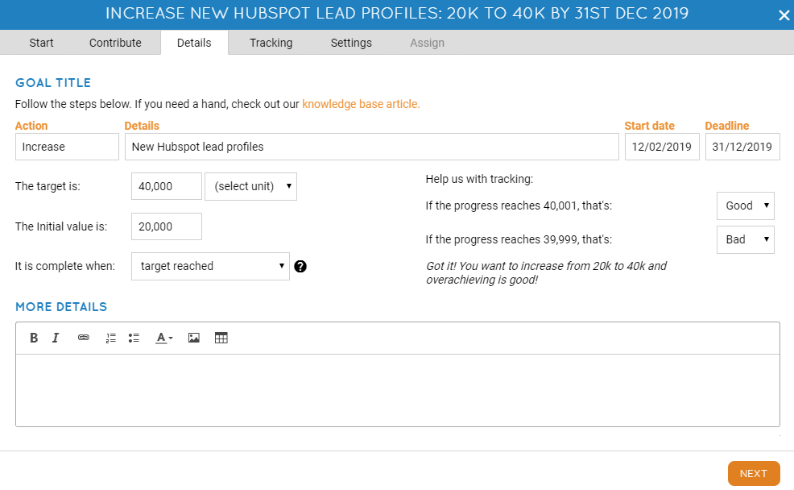

## **How Are KPIs Used in an Organization?**

Key performance indicators are a communication tool for organizations. They inform business leaders of their organization's progress towards reaching key business objectives. KPIs are able to provide this information because they actually track the most important performance measures, which can be taken together to represent how successful you are in achieving an objective. This information channel is extremely valuable as, in a well-designed strategy, an organization's key business objectives should have a direct impact on the organization's overall performance. Therefore, KPIs will communicate whether your activities are achieving, for example, business growth at the rate expected or not, and how much growth you've actually achieved.

KPIs also assist in identifying issues with organizational processes. If the progress on an objective falls behind, the key performance indicator associated with it will communicate this to business leaders as soon as the trend begins to show itself ([assuming you have leading & lagging KPIs](https://www.executestrategy.net/blog/leading-and-lagging-kpis)). The organization will know that something has gone wrong and an investigation is required. A strategy to mitigate the issue can then be created and implemented before it has far-reaching effects on the organization's performance.

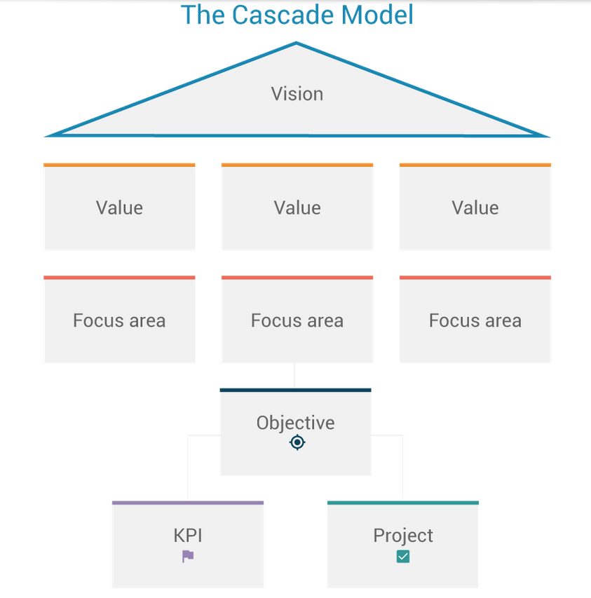

## **The value of KPIs on business objectives**

**KPIs** are important to **business** objectives because they keep objectives at the forefront of decision making. It's essential that **business** objectives are well communicated across an organization, so when people know and are responsible for their own **KPIs**, it ensures that the **business's** overarching goals are top of mind. KPIs also ensure that performance is measured not blindly in pursuit of the KPI but in relation to the larger business objectives. This means that every part of work is done with intentionality and for the right purpose.

There are many reasons, of course, but here are 4 that stand out to me:

1. KPIs strengthen employee morale
2. KPIs support and influence business objectives
3. KPIs foster personal growth
4. KPIs are critical for performance management

**Lead Generating sites**

## **What is a lead?**

A lead is any person who indicates interest in a company's product or service in some way, shape, or form.

Leads typically hear from a business or organization after opening communication (by submitting personal information for an offer, trial, or subscription) … instead of getting a random cold call from someone who purchased their contact information.

Let's say you take an online survey to learn more about how to take care of your car. A day or so later, you receive an email from the auto company that created the survey about how they could help you take care of your car. This process would be far less intrusive than if they'd just called you out of the blue with no knowledge of whether you even *care* about car maintenance, right? This is what it's like to be a lead.

And from a business perspective, the information the auto company collects about you from your survey responses helps them personalize that opening communication to address your existing problems — and not waste time calling leads who aren't at all interested in auto services.

Leads are part of the broader lifecycle that consumers follow when they [transition from visitor to customer](https://blog.hubspot.com/blog/tabid/6307/bid/33711/The-Steps-You-Need-to-Define-the-Stages-of-Your-Sales-Marketing-Funnel.aspx). Not all leads are created equal (nor are they [qualified the same](https://blog.hubspot.com/marketing/beginner-inbound-lead-generation-guide-ht#how-to-qualify-a-lead)). There are different types of leads based on how they are qualified and what lifecycle stage they're in.

### Marketing Qualified Lead (MQL)

[Marketing qualified leads](https://blog.hubspot.com/marketing/definition-marketing-qualified-lead-mql-under-100-sr) are contacts who've engaged with your marketing team's efforts but aren't ready to receive a sales call. An example of an MQL is a contact who fills out a landing page form for an offer (like in [our lead generation process scenario below](https://blog.hubspot.com/marketing/beginner-inbound-lead-generation-guide-ht#lead-generation-process)).

### Sales Qualified Lead (SQL)

[Sales qualified leads](https://blog.hubspot.com/sales/ultimate-guide-to-sales-qualification) are contacts who've taken actions that expressly indicate their interest in becoming a paying customer. An example of an SQL is a contact who fills out a form to ask a question about your product or service.

### Product Qualified Lead (PQL)

[Product qualified leads](https://blog.hubspot.com/sales/pql) are contacts who've used your product and taken actions that indicate interest in becoming a paying customer. PQLs typically exist for companies who offer a product trial or a [free or limited version of their product](https://blog.hubspot.com/service/freemium) (like HubSpot!) with options to upgrade, which is where your sales team comes in. An example of a PQL is a customer who uses your free version but engages or asks about features that are only available upon payment.

### Service Qualified Lead

[Service qualified leads](https://blog.hubspot.com/service/what-is-a-service-qualified-lead) are contacts or customers who've indicated to your service team that they're interested in becoming a paying customer. An example of an service qualified lead is a customer who tells their customer service representative that they'd like to upgrade their product subscription; at this time, the customer service representative would up-level this customer to the appropriate sales team or representative.

These lead generators are just a few examples of lead generation strategies you can use to attract potential customers and guide them towards your offers. (We talk about [more strategies later](https://blog.hubspot.com/marketing/beginner-inbound-lead-generation-guide-ht#lead-generation-strategies).)

Whenever someone outside the marketing world asks me what I do, I can't simply say, "I create content for lead generation." It'd be totally lost on them, and I'd get some really confused looks.

So instead, I say, "I work on finding unique ways to attract people to my business. I want to provide them with enough goodies to get them naturally interested in my company so they eventually warm up to the brand enough to want to hear from us!"

That usually resonates better, and that's exactly what lead generation is: **It's a way of warming up potential customers to your business** and getting them on the path to eventually making a purchase.

### Why do you need lead generation?

When a stranger initiates a relationship with you by showing an organic interest in your business, the transition from stranger to customer is much more natural.

Lead generation falls within the second stage of the [inbound marketing methodology](https://www.hubspot.com/inbound-marketing). It occurs **after** you've attracted an audience and are ready to convert those visitors into leads for your sales team (namely [sales-qualified leads](https://blog.hubspot.com/marketing/beginner-inbound-lead-generation-guide-ht#sales-qualified-lead)).

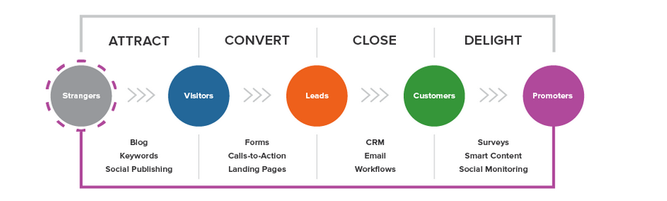

# Top Lead Generation Companies in India(Prime)

## 1 . SalesAladin - Customer Acquisition Made Easy

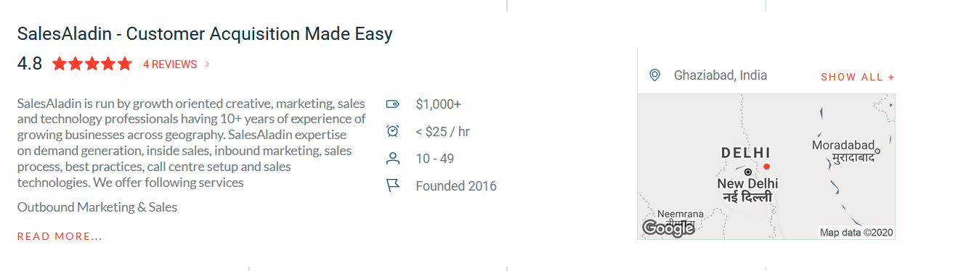

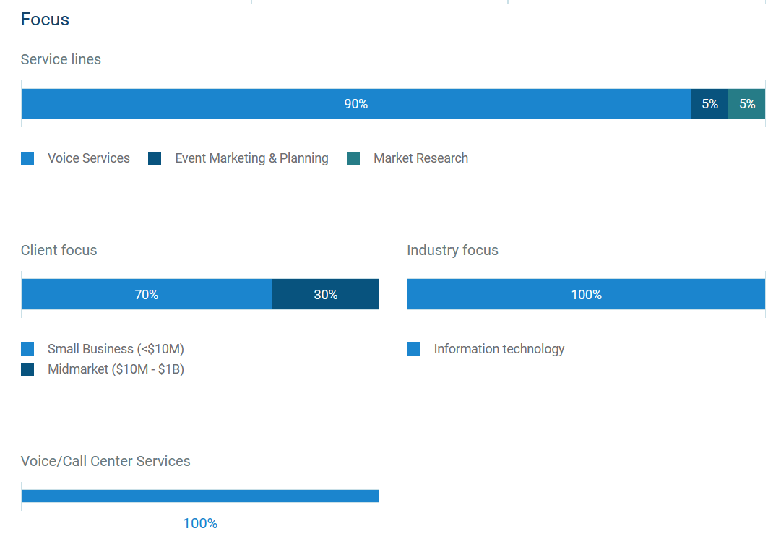

# 2.[Flatworld Solutions](https://www.flatworldsolutions.com/)

# 

# 

### [VSynergize](https://clutch.co/profile/vsynergize) Your Most Reliable Growth Partner

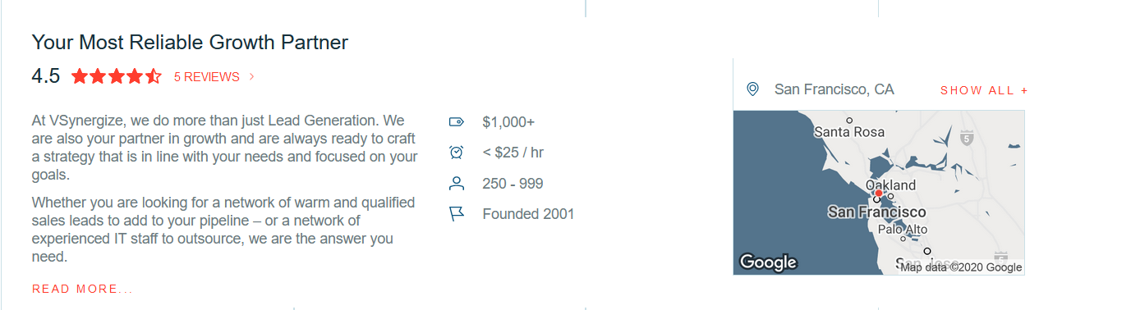

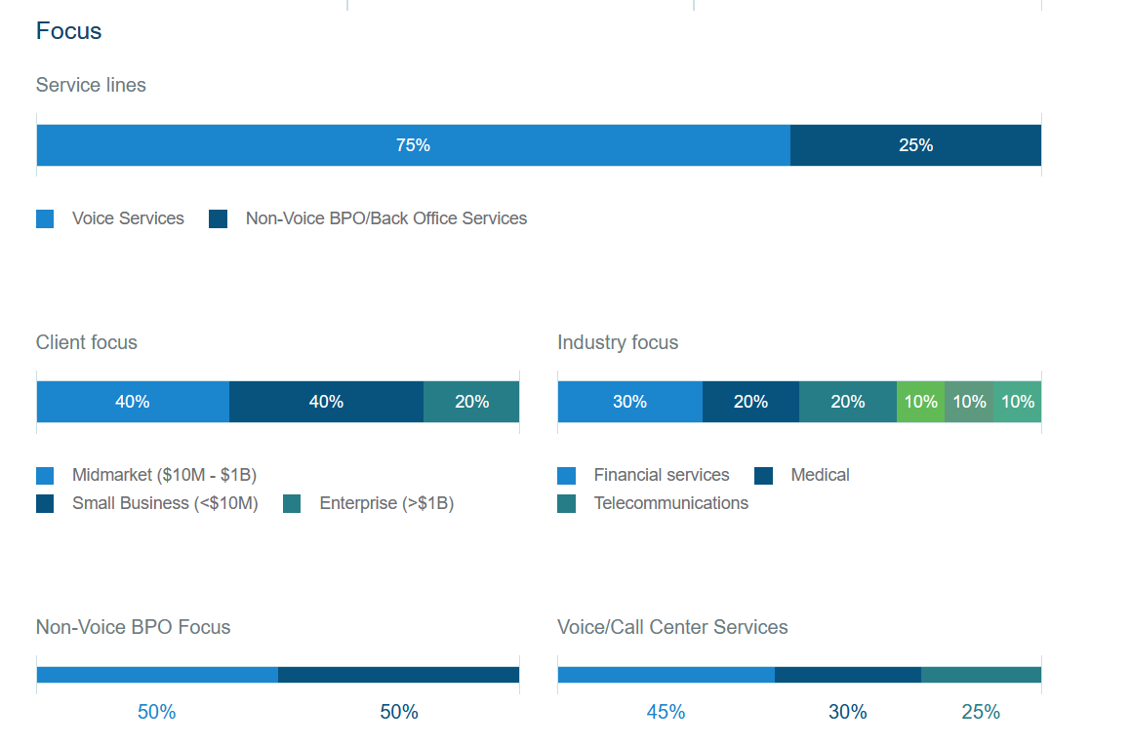

**Google analytics role in Lead Generation**

Your company is looking to grow and generate more leads. This is an on-going struggle for a large percentage of companies as they look to remain competitive in their industry. The Marketing and Sales Departments work endlessly on this, but it seems like it is just never enough. Well, the answer to growing your business and generating more leads may just be within your Google Analytics, rather than another expensive trade show or radio advertisement.

For Google Analytics first do tracking set up on your website, and have the proper access to your account.

Setting up of google analytics

1. Ask your IT, Web Development or Marketing Department if you have Google Analytics tracking enabled and if you can have access to it.

2. If for some reason, you don’t want to talk to those departments, you can check for yourself using tools like [BuiltWith](https://builtwith.com/) or [Google Tag Assistant](https://get.google.com/tagassistant/) and then ask around your organization for access.

**Google Analytics & the Service Providers Report**

Within your Google Analytics account is the Service Providers report. It tells you the names of the Internet Service Providers (ISPs) that have visited your website. More commonly than not, companies will register their internet name as their company name. This means, that with the proper filtering and diligence, this report can tell you the names of the companies that have visited your website! To access this report, follow these steps:

1. Log into your *Google Analytics* accounts and start at the home dashboard

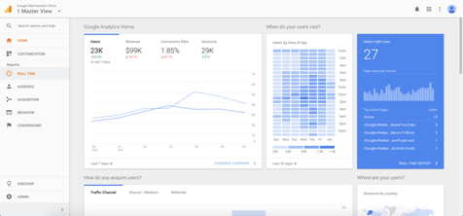

2. Expand the *Audience Reports* by clicking on the audience tab

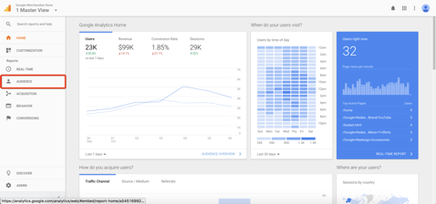

3. Click the *Technology tab*

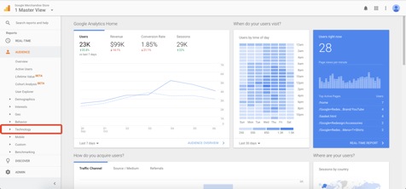

4. Select *Network*

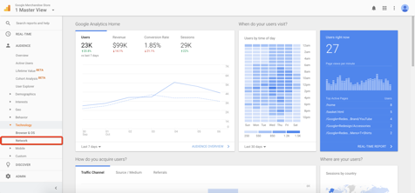

You’ll now see the *Service Providers* report, and a list of all the names of the ISPs that have visited your website. However, for numerous reasons, this report will typically have large commercial internet providers scattered throughout. So, what we want to do next is filter out as many of these as possible.

**Filtering Internet Service Providers in Google Analytics**

To help narrow down this list to be the names of businesses that have visited your website, you are going to want to add an advanced segment. To do this, follow these steps:

1. Go to the admin section of Google Analytics

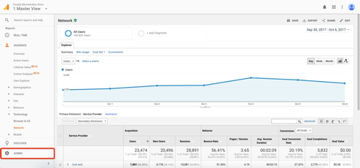

2. In the *View* column, click on *Segments*

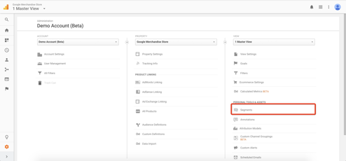

3. Click *+New Segment*

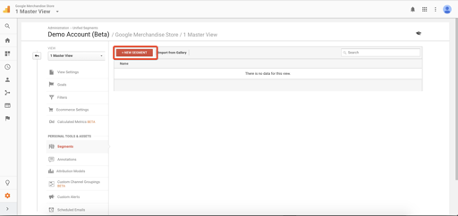

4. Click *Conditions* under the *Advanced Section*

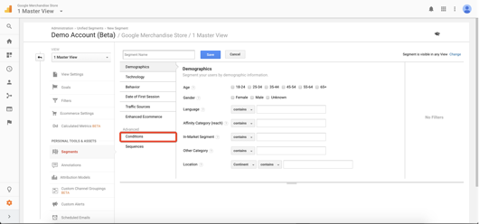

5. Then, we want to filter sessions by *Service Providers* that *Does Not Match Regex*

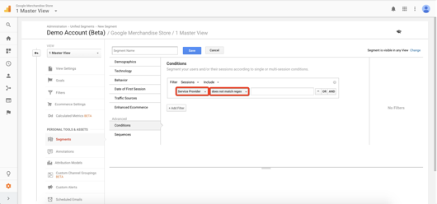

6. Paste the following common expressions for commercial internet providers into the empty text field

ISP|HSE|Hosting|Verizon|Comcast|at&t|telekom|qwest|cox|broadband|pool|ip | (notset) |customer|internet|tele|block|provider|unknown| communication

7. Name your segment anything you’d like, just ensure you remember it and click save

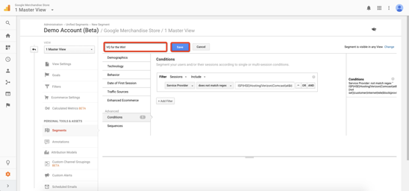

Now when you go back to the service providers report, you want to apply your advanced segment by following these steps:

1. Click *+Add Segment* at the top of the dashboard

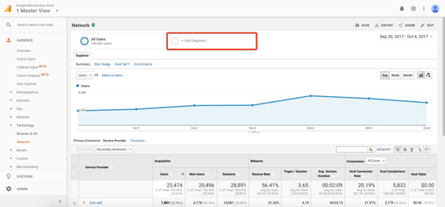

2. A list will appear of all your segments, unselect the one that is currently applied and select the one you just made

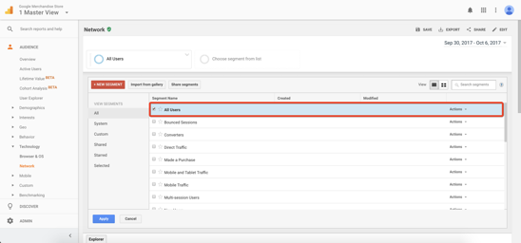

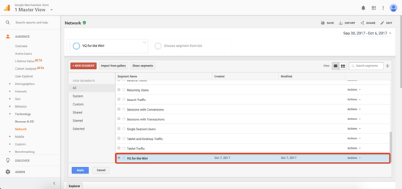

3. Click the apply button to apply the segment

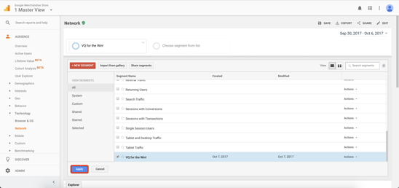

You should now see a smaller list that will look more like actual leads for your B2B company, and less like large commercial internet providers. As a disclaimer though, this *Advanced Segment* is not perfect and it will not be able to eliminate all the commercial internet providers on earth. We suggest you analyze the results for your company closely and add to your *Advanced Segment* as you go. Further, the results of this will vary for each company due to several contributing factors.

**Kpi we should must use**

## **1 Customer Satisfaction Score (CSAT)**

Measuring customer satisfaction is hard. You’re asking your customers to express an emotion, and emotions are harder to grasp than objective facts, such as the sales department's financial KPIs.

Customer satisfaction is everything. Measuring customer satisfaction is hard.

[Bill Price](https://www.youtube.com/watch?v=A1Xlb7zbM6E) , President of Driva Solutions  [Tweet this](https://twitter.com/intent/tweet?text=Customer%20satisfaction%20is%20everything.%20Measuring%20customer%20satisfaction%20is%20hard.%20-%20Bill%20Price%20,%20President%20of%20Driva%20Solut…&url=https://www.userlike.com/en/blog/customer-service-kpi) :

[The most popular KPI](https://www.userlike.com/blog/6-proven-methods-for-measuring-your-customer-satisfaction) for measuring customer satisfaction is the CSAT. With it, you directly ask your customers to rate their satisfaction with your business, product, or service. Your score is the average of all customer responses.

Your CSAT scale can consist of regular numbers, but it could also consist of stars, smiley faces, tiny unicorns, etc. You can also choose various scale ranges, but note that simpler scales are [more robust to cultural differences](http://www.jstor.org/stable/40063010?seq=1#page_scan_tab_contents) .

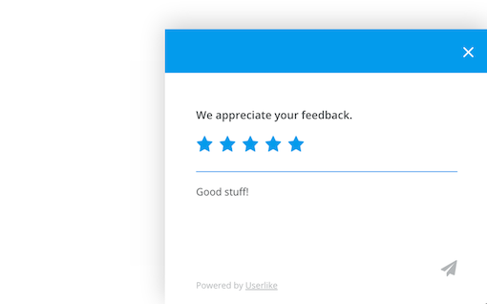

User like uses a 5-star system for post-chat ratings.

## **2 Net Promoter Score (NPS)**

The NPS measures how likely your customers are to refer you to someone else. Its advantage over the CSAT is that it aims at an intention, not an emotion. As a result, the reply is less influenced by the mood of the moment.

You ask your customers how likely they are to recommend you on a scale from 1 to 10. Their replies put them into one of three categories: promoters (9-10), passives (7-8), or detractors (0-6). Take the percentage of respondents who fall under the "promoter" category (10 - 9) and subtract it from the "detractors" (0 - 6). Voilà, there’s your NPS.

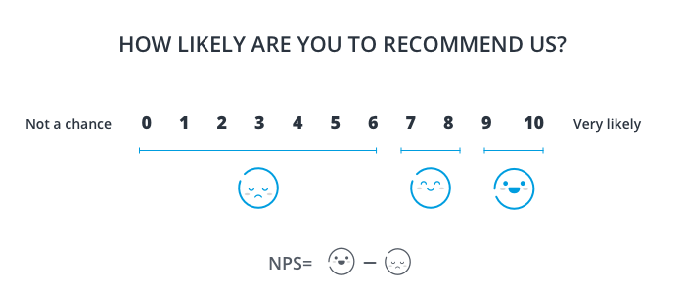

Subtract your detractors from your promoters to get your NPS.

Some tools work with email questionnaires. [Trustfuel NPS](https://www.trustfuelnps.com/) (free) and [Promoter.io](https://www.promoter.io/) (paid) are two popular ones. Others work with in-app surveys, like [Wootric](https://www.wootric.com/) (freemium), appears while your customers are still on your website or app.

Rob Markey from *Bain & Company* gives tips on [how and why to benchmark your NPS competitively](http://www.bain.com/publications/articles/the-benefits-of-a-competitive-benchmark-net-promoter-score.aspx) . Take a look at the [Net Promoter Network](https://www.netpromoter.com/compare/) to put your results into perspective. Leading customer loyalty companies like Apple reach scores of 75-85%.

## 3 **First Response Time**

Speed is a [stable determinant for customer satisfaction](http://www.iei.liu.se/fek/frist/722g60/gruppernas_artiklar_och_presentationer/1.149265/GruppD3-Determinantsofservicequality..avRobertJohnston.pdf) . Your customers expect a smooth and efficient shopping experience. Quickly answering your customers’ requests is essential, as your competitor is only a mouse click away. Customers are tuned like the Spice Girls: *“If you wanna get with me, better make it fast!”*

A [Salesforce study](https://www.salesforce.com/blog/2013/08/customer-service-stats.html) found that a third of the respondents felt positive about companies that offered a quick first response. But here’s the juicy part: Customers preferred a response that was quick instead of one that was thorough but delayed - even if it didn’t solve the issue.

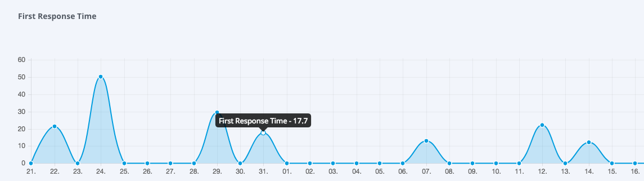

We try to keep our first response time under 20 seconds.

Make use of this by sending out an automated message that “someone’s on the issue”. This is technically not an actual first response, but a handy trick to comfort customers that their request reached target, which [makes their wait more bearable](http://www.columbia.edu/~ww2040/4615S13/Psychology_of_Waiting_Lines.pdf) .

At Userlike, we've recently "outsourced" this task to [Chat Butler](https://www.userlike.com/blog/chat-butler) , a friendly chatbot that greets our customers and collects their questions when no Operator is available in the chat.

Bear in mind that customer expectations regarding response times will differ depending on the chosen contact channel.

## **Customer Retention Rate**

Customer retention refers to a business’ ability to keep a paying customer over a set period of time. Acquiring new customers is expensive, costing a business [5 to 25 times more](https://hbr.org/2014/10/the-value-of-keeping-the-right-customers) than it takes to retain one.

You might attract a lot of visitors to your website and convert them into paying customers, but can you hold on to them over a longer period of time?

The prosperity of your business relies largely on retaining your customers. According to [RJmetrics](https://rjmetrics.com/metrics/repeat-purchase-rate/) , the most successful Ecommerce businesses get more than half of their revenue from returning customers. One KPI to keep an eye on here is the customer retention rate.

It shows what percentage of your customers have stayed with you over a given period of time. It can be calculated on an annual, monthly, or weekly basis. [Jeff Haden](http://www.inc.com/jeff-haden/best-way-to-calculate-customer-retention-rate.html) outlines an accurate way of measuring it:

* **Customer Retention Rate = ((CE – CN) / CS)) x 100**
* CE = Number of customers at end of period
* CN = Number of new customers acquired during period
* CS = Number of customers at start of period

Check [out this post](https://www.userlike.com/blog/customer-retention-metrics) to see a sample calculation and learn more about customer retention metrics.

## **Employee Engagement**

While we focus on the KPIs mentioned above, it’s easy to forget a factor which is not that obvious, but equally important: your team. If your employees aren’t satisfied with their job, your service will suffer.

[According to Harvard Business Review](https://hbr.org/2016/08/germanys-midsize-manufacturers-outperform-its-industrial-giants) , “long-term employment relationships are the key to high performance and enduring levels of employee motivation.” A high employee turnover, on the other hand, will cost you up to twice of an employee’s salary for finding and training new employees.

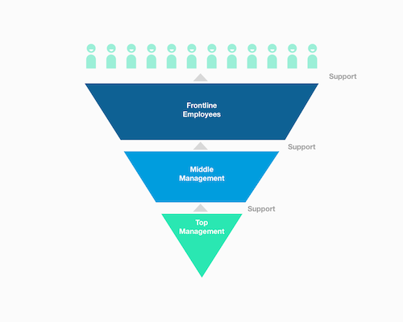

So how do you measure employee engagement? The standard approach is to [ask your employees direct questions](https://www.qualtrics.com/blog/employee-satisfaction-survey/) like, “How meaningful is your work?”, “How much do your opinions about work matter to your supervisor?”, “Are you proud to be a member of your team?” [SurveyMonkey](https://www.surveymonkey.com/mp/employee-satisfaction-surveys/) (Freemium) is a tool with which you can set up such surveys.

**Conclusion**

To have an effective lead management process, you must adopt an analytical marketing mindset. Analyzing the key metrics and determining the right KPIs will help you focus on the rising conversion problems and improve the overall conversion rate by making the right modifications in your content and website.

Identify what your target buyers need at every stage of your conversion funnel, determine and track your key KPI goals and tweak the process until you ensure that the process is a success.

I’ve researched lot on to Google Analytics pros and rookies alike, some of them have heard of this trick, while a majority have not. It can be an easy, quick way for small businesses to identify companies that have visited their website but isn’t necessarily ideal for companies with a large amount of website visitors.