**Nagarro Evaluation Project**

Summary

Create a web app, where users can login with their email and password and manage a list of their favourite bands.

Added Functionality

* User Authentication
* Signup
* Login
* Add new band to the list
* Remove a band from the list
* Edit a band’s name from the list
* A user may only manage his/her own list

User Authentication

* Login with user’s email and password as credentials
* New Users must have the following fields

1. Name
2. College/Company
3. Date Of Birth
4. Email

* Forgot Password Feature: A user can reset own password by confirming an OTP sent to his email.

**Step to run forgot password functionality**

1.In order to run forgot password functionality,please add your email and password in script.js file

As shown below:

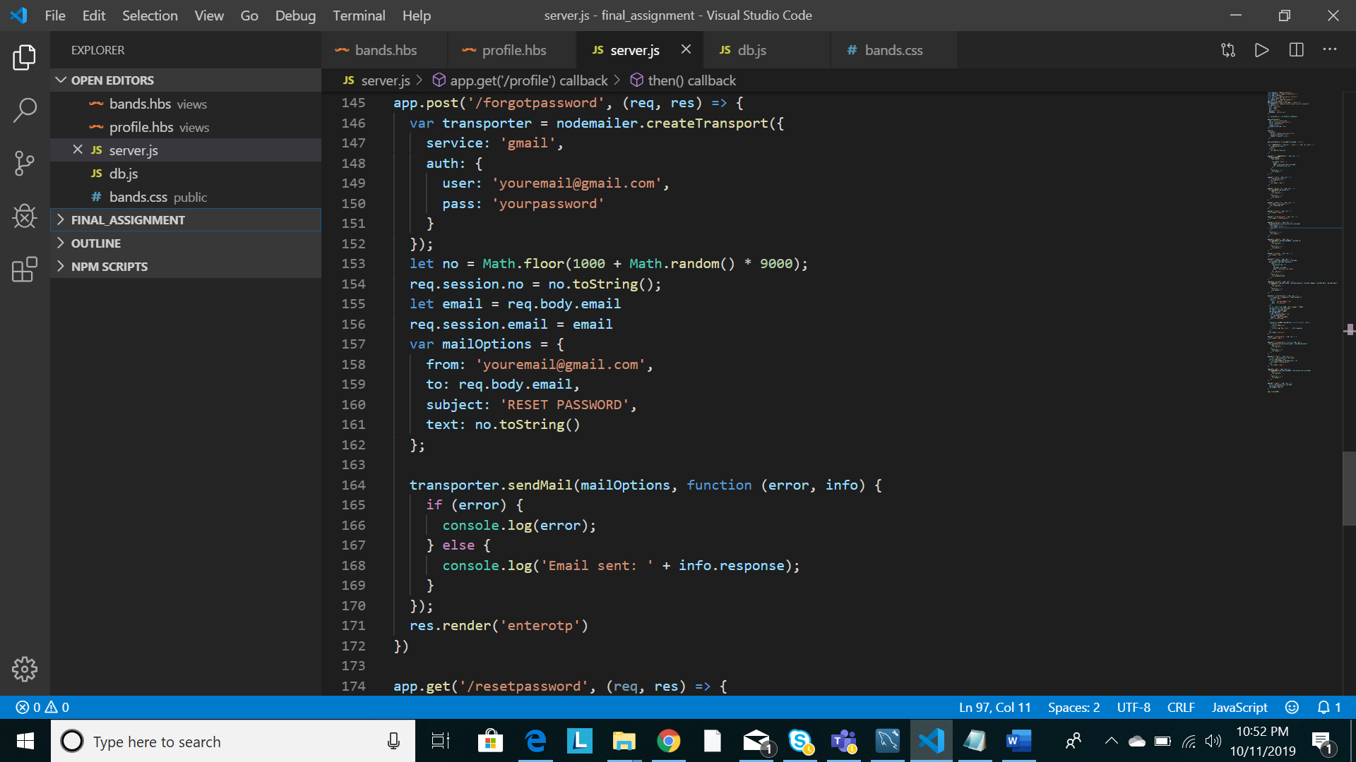

Figure 1

In figure 1 ,Replace ‘youremail@gmail.com’ with your gmail account email address and ‘yourpassword’ with your gmail account password.

2. Then go to <https://myaccount.google.com/lesssecureapps> and set enable less secure app access to ON state.

Bingo! You are now ready to go.