**DAILY ONLINE ACTIVITIES SUMMARY**

|  |  |  |  |  |  |  |  |  |
| --- | --- | --- | --- | --- | --- | --- | --- | --- |
| **Date:** | **23/06/2020** | | | | | **Name:** | **Apoorva K N** | |
| **Sem & Sec** | **6th & A sec** | | | | | **USN:** | **4AL17CS012** | |
| **Online Test Summary** | | | | | | | | |
| **Subject** | | **PAP (assignment 4)**  **Java Programming and Data Structures** | | | | | | |
| **Max. Marks** | | **20**  **10** | | **Score** | | | **16**  **9** | |
| **Pre-Placement Training Summary** | | | | | | | | |
| **Pre placement training** | **9:00 am to 11:00 am - Programming in Java**  **11:00 am to 1:00pm - Data structures** | | | | | | | |
| **Faculty** | | | **Mr. Sharan Pias**  **Mrs. Merlyn Melita** | | **Duration** | | | **4 hr** |
| **Assessments** | | | | | | | | |
| Java Quiz in techgig. | | | | | | | | |
| **Status: Completed** | | | | | | | | |
| **Uploaded the report in Github** | | | | | **Yes** | | | |
| **If yes Repository name** | | | | | <https://github.com/Apoorva-K-N/pre-placement-training> | | | |
| **Uploaded the report in slack** | | | | | **Yes** | | | |

**Online Test:**

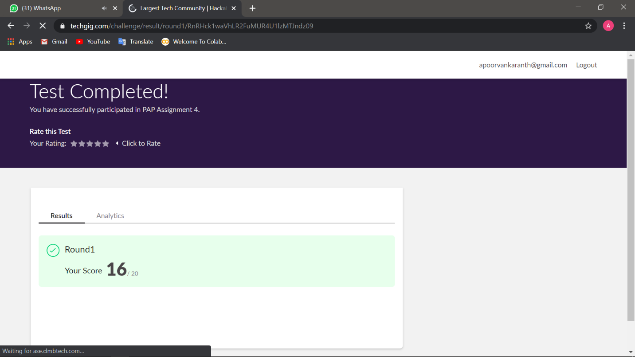

**Training snapshots:**

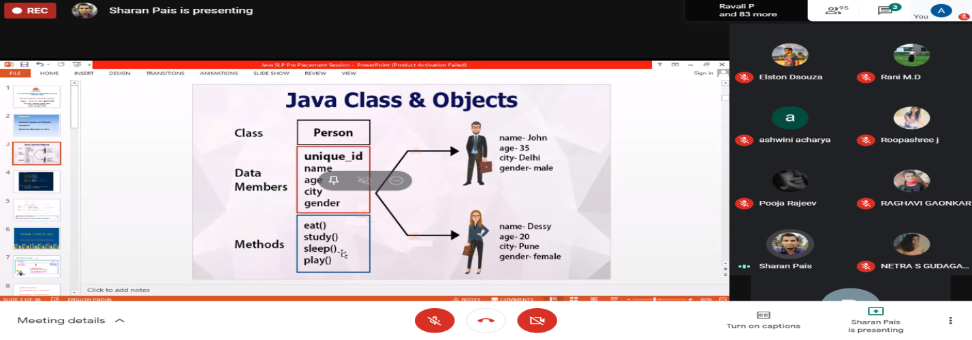

**Assessment :**

