Understanding Large Language Models
Auto-Regressive vs Auto-Encoding Architectures
A Conceptual Reference Guide

1. The Two Families of LLMs
Not all large language models work the same way. At the architectural level, LLMs fall into two distinct families, each trained differently and suited to different tasks:

Auto-Regressive LLMs  Generate text token by token. The backbone of modern chat AI. | Auto-Encoding LLMs  Understand and encode entire inputs into rich vector representations.

2. Auto-Regressive LLMs

2.1 What Are They?
Auto-regressive LLMs are the most widely known type of language model. When people mention GPT, Claude, Gemini, Grok, or models served via Groq's inference infrastructure, they are almost always referring to auto-regressive (also called decoder-only or generative) models.

The word regressive is key: the model looks back over its context and predicts what should come next. At each step it produces one new token, appends it to the sequence, and repeats.

2.2 How Are They Trained?
Training uses a technique called causal language modelling. Given a sequence, the model learns to predict every next token from all previous tokens:

a b c → d
a b c d → e
a b c d e → f

Because the labels come from the training text itself (no human annotation needed), this is a form of self-supervised learning — one reason these models can be trained on enormous internet-scale datasets.

Key insight: An LLM described without any qualifier is almost certainly auto-regressive. If it chats, writes, or generates, it is a decoder model.

2.3 How Do They Process Input?
Auto-regressive models read tokens left-to-right (unidirectionally). Each token can only attend to the tokens that came before it — not the ones that follow. This causal masking is what makes sequential generation possible.
Despite being called 'language models', these models work on tokens (numerical IDs), not raw words. Text is split into subword tokens before being fed in, and generated tokens are decoded back to text for the user.

2.4 Notable Examples
- GPT-4 / GPT-4o (OpenAI)
- Claude 3 / Claude Sonnet / Claude Opus (Anthropic)
- Gemini 1.5 Pro / Gemini Flash (Google DeepMind)
- Grok (xAI)
- LLaMA 3 (Meta) — open weights
- Mistral, Qwen, Phi — other open-weight families

Note on Groq: Groq is an inference hardware and cloud platform (Language Processing Unit chips) that runs models like LLaMA and Mistral at very high speed. It is not a model family itself, but a fast way to serve auto-regressive models.

3. Auto-Encoding LLMs

3.1 What Are They?
Auto-encoding LLMs — also called encoder models or embedding models — are trained to deeply understand an entire input rather than to generate new text. They compress an input sequence into a dense numerical representation called a vector embedding.
Because they see the whole sequence bidirectionally (left context and right context simultaneously), they build a richer semantic understanding than a unidirectional model can at the representation stage.

3.2 How Are They Trained?
The most influential training objective is Masked Language Modelling (MLM), introduced by BERT (Google, 2018). Random tokens in the input are masked, and the model must predict them using both surrounding context:

Input: "The cat sat on the [MASK]"
Target: "mat"

The model sees the full sentence (minus the mask) — bidirectional.

This forces the model to develop a deep, context-aware understanding of every word in relation to every other word.

3.3 Output: Vector Embeddings
Instead of generating text, an encoder model outputs a vector — a list of hundreds or thousands of floating-point numbers. This vector is the model's numerical 'understanding' of the input.

- Tokens are the numerical input to the model (numeric IDs representing words or subwords).
- Vectors are the numerical output — a high-dimensional point in semantic space.
- A vector can represent a single word, a sentence, a full document, or an abstract concept.
- Similar meanings produce vectors that are close together in that high-dimensional space.
- Distance between vectors can be measured (e.g. cosine similarity) to find related content.

Practical example: The sentences 'I love dogs' and 'Puppies are wonderful' would produce vectors close to each other in embedding space, even though they share no words.

3.4 Primary Applications
- Semantic Search: find documents by meaning, not keyword matching.
- Sentiment Analysis: classify text as positive, negative, or neutral.
- Text Classification: spam detection, topic labelling, intent detection.
- Retrieval-Augmented Generation (RAG): vectorise a knowledge base for retrieval (see Section 5).
- Clustering: group similar documents without labelled data.

3.5 Notable Examples
- BERT (Google, 2018) — the founding encoder model
- RoBERTa (Meta) — a robustly trained BERT variant
- text-embedding-3-small / text-embedding-3-large (OpenAI)
- all-MiniLM / all-mpnet (Sentence-Transformers, open-source)
- Cohere Embed, Voyage AI, Jina Embeddings — specialised providers

4. Side-by-Side Comparison

Feature | Auto-Regressive LLM | Auto-Encoding LLM
Also called | Decoder model / Generative model | Encoder model / Embedding model
Training objective | Predict the next token from prior tokens | Understand full context; map input to vector
Input processing | Left-to-right (causal/unidirectional) | Bidirectional (sees full sequence at once)
Output type | New tokens (text generation) | Dense vector (embedding / classification label)
Primary tasks | Chat, code gen, summarisation, reasoning | Semantic search, RAG retrieval, classification, sentiment
Examples | GPT-4, Claude, Gemini, Grok, Groq | BERT, RoBERTa, OpenAI Embeddings
Used in RAG? | Yes — generates the final answer | Yes — vectorises documents and queries

5. Tokens vs Vectors — Clarifying the Terminology
These two terms are often confused because they both involve numbers. The distinction is straightforward:

 | Token | Vector
Role | Input to the model | Output of an encoder model
What it is | Integer ID mapped from a word/subword by a tokeniser | List of floats (e.g. 1,536 dimensions)
Carries | Identity of a word piece | Semantic meaning of the full input
Example | 'cat' → token ID 3807 | 'The cat sat...' → [0.23, -0.11, 0.87, ...]

6. Retrieval-Augmented Generation (RAG)
RAG is the most important real-world architecture that combines both model types. It solves a key limitation of auto-regressive LLMs: they can only answer from what was in their training data. RAG gives them access to external, up-to-date, or private knowledge at inference time.

6.1 The RAG Pipeline
A RAG system has two parallel pipelines that meet at the generative LLM:
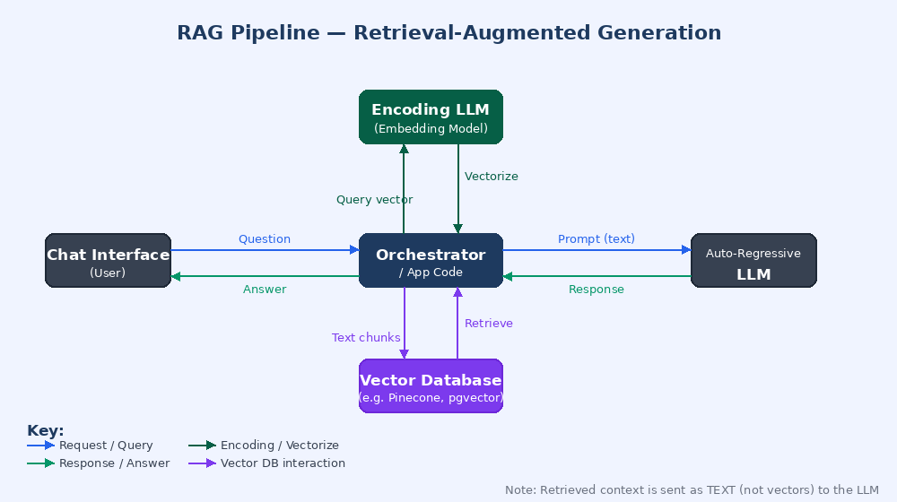

Indexing Pipeline (offline)  - Source documents are collected (PDFs, web pages, databases).  - Each document is passed through an Encoding LLM.  - The resulting vectors are stored in a Vector Database (e.g. Pinecone, Weaviate, pgvector). | Query Pipeline (real-time)  - User sends a question to the chat interface.  - The question is vectorised by the same Encoding LLM.  - Similar vectors are retrieved from the Vector Database.  - Retrieved text chunks are injected into a prompt.  - The Auto-Regressive LLM generates a grounded answer.

6.2 Why Two Different Models?
The encoder and the generative model play completely different roles and are independent of each other:

- Encoding LLM: operates on numbers (vectors). Its job is retrieval — finding the right information. It does not generate language.
- Auto-Regressive LLM: operates on language (tokens). Its job is generation — synthesising a coherent answer from the retrieved context. It does not produce vectors.

Important clarification: The Encoding LLM and the Auto-Regressive LLM in a RAG system are completely separate models. They do not share weights, architecture, or even the same modality. One speaks numbers; the other speaks words.

7. Choosing the Right Model Type
A practical decision guide:

If you need to... | Use...
Generate text, answer questions, write code | Auto-Regressive LLM (GPT, Claude, Gemini, etc.)
Classify documents or sentences | Auto-Encoding LLM (BERT, fine-tuned)
Find semantically similar content | Auto-Encoding LLM (embedding model)
Build a search engine over your own data | Both: encoder for indexing + retrieval, generative for answering
Detect sentiment at scale | Auto-Encoding LLM (fast, small, efficient)
Chat with your documents (RAG) | Both: encoder for retrieval, auto-regressive for generation

8. Summary

Large language models are not a monolithic category. Two architecturally distinct families serve complementary roles in modern AI systems:

- Auto-Regressive LLMs are the text generators. Trained to predict the next token from past context, they produce coherent language, answer questions, reason, and converse. These are the models behind almost every AI chatbot and coding assistant. When no qualifier is given, assume a model is auto-regressive.

- Auto-Encoding LLMs are the text understanders. Trained to reconstruct masked tokens bidirectionally, they compress meaning into dense vector embeddings. These vectors enable semantic search, document classification, and the retrieval backbone of RAG systems.

In production AI systems — particularly RAG pipelines — both model types work together: the encoder finds the right information, and the generative model articulates the answer. Understanding which model does which job is essential for building effective AI applications.

End of Document

