**DATA METHODOLOGY**

**Step 1: Story Boarding**

* We went through the data to get familiarized with it and noted down the important fields.
* Made a mind map of the various slides of the presentation.
* Made a rough template based on this mind map.

**Step 2: Data Wrangling**

* Did univariate analysis using Tableau on the fields to see their distributions, the unique values in a field, the missing values and to check for outliers if any.
* There was a small proportion of null values which would not affect the analysis so, we let them stay as it is.
* Price was highly positively skewed so median was very close to the lower quartile with some outliers as seen in the boxplot below.

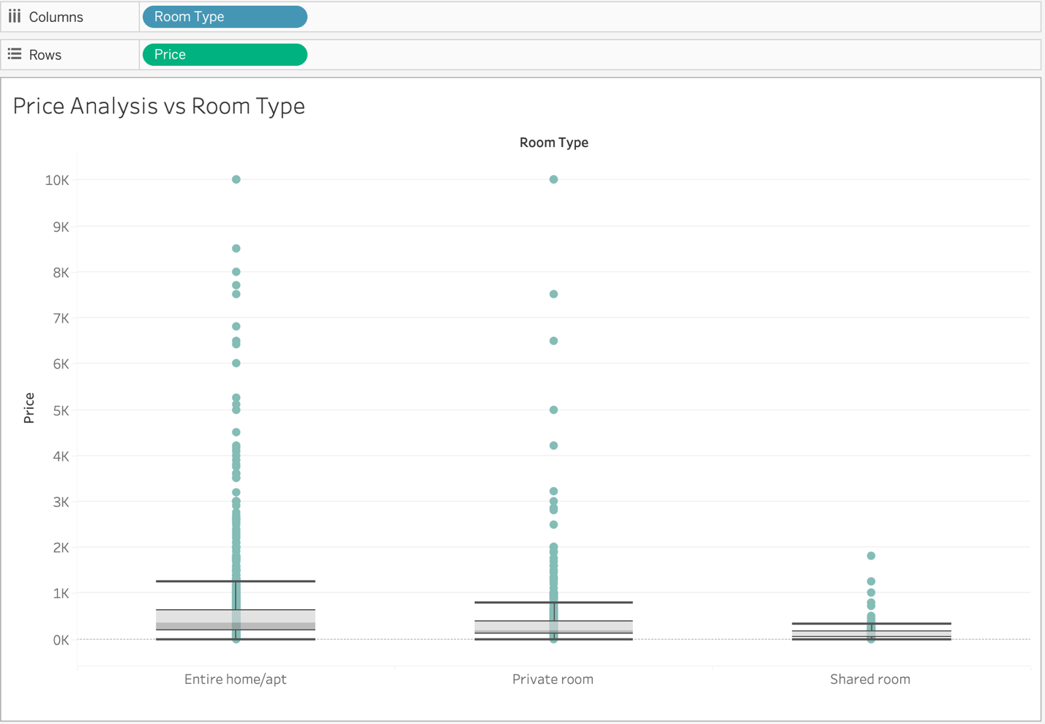

* Since price has outliers, MEDIAN is used instead of mean as the measure for price.
* Host Listings count is maximum for entire home/apartment and private room, but it is very less for shared room, as shown in the pie chart below.

* Created a grouped field for Minimum Nights assuming null values belonged to the category

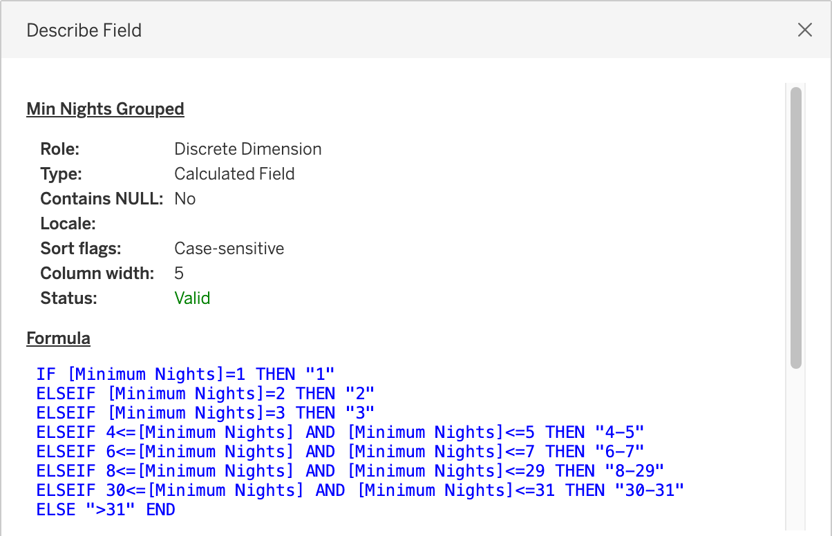

* Created a calculated field of number of reviews per listing

**Step 3: Data Analysis**

* Checked neighborhood grouped wise distribution of price and room type

Through these plots we infer:

* Entire home/apt, private rooms are very popular.
* Except in Manhattan, shared rooms are unpopular.
* Entire rooms review per listing for Manhattan is 35% lower than the overall average and number of listings is the highest.

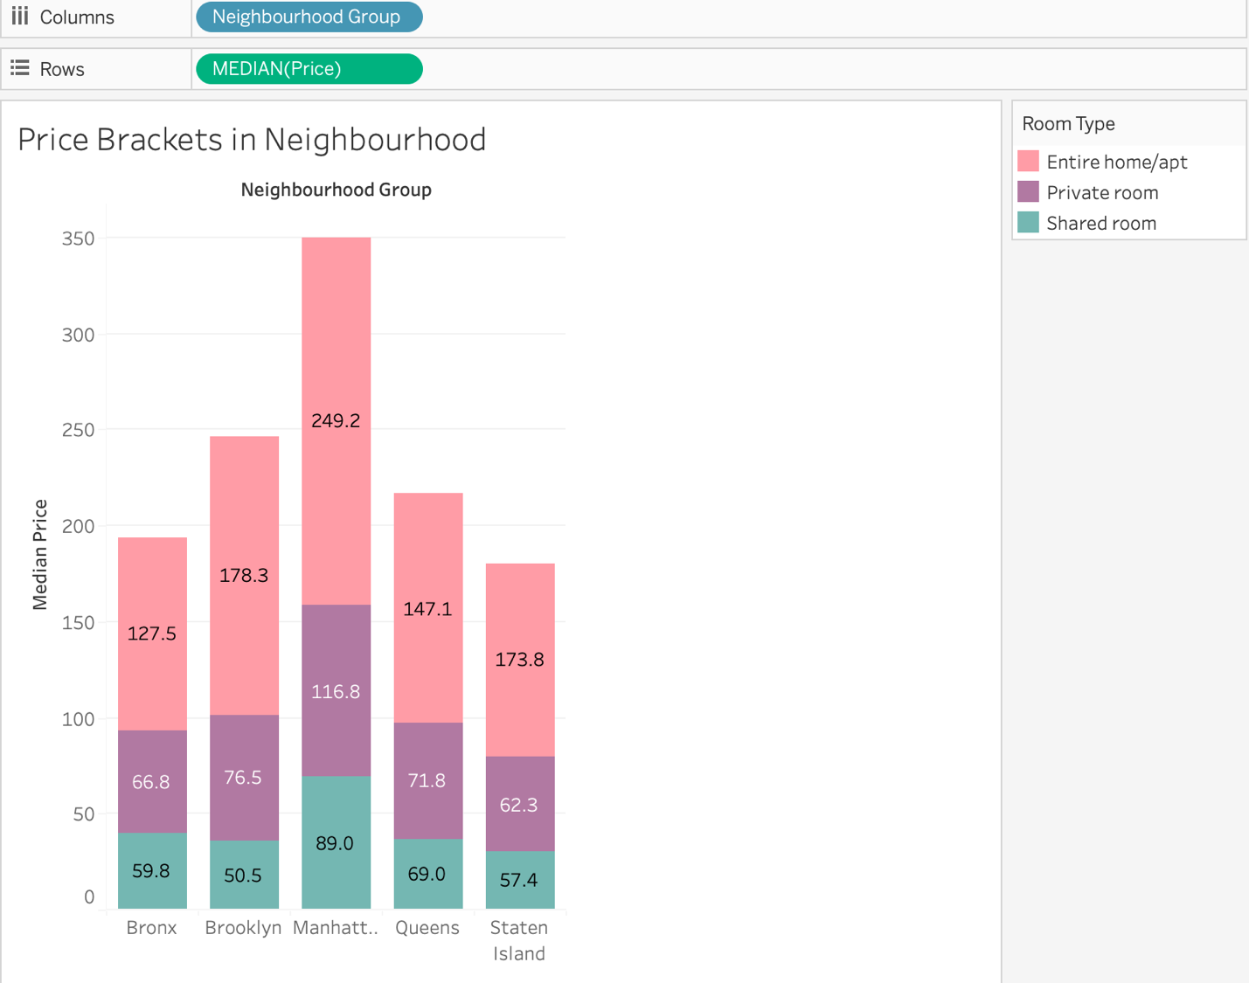

* Manhattan is costliest overall.
* We find little cheaper in the following:
  + Entire apt: Bronx
  + Private room: Staten Islands
  + Shared room: Brooklyn
* Found difference in prices between shared rooms, private rooms and entire apartments for each neighborhood as shown below:

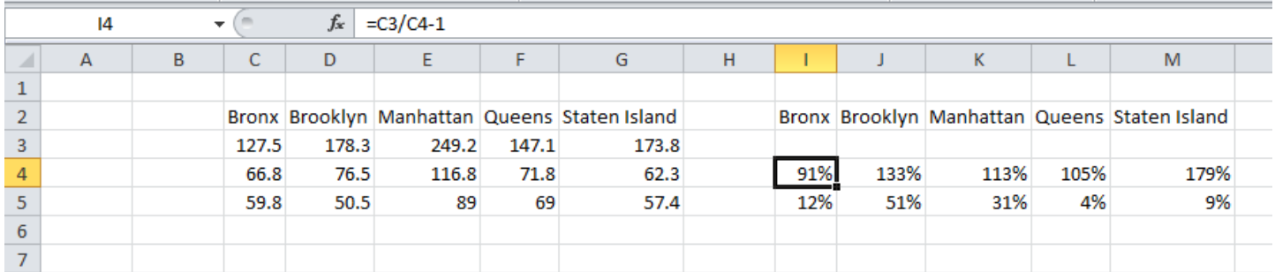

* Through this we can say that:
  + Entire home/apt ‘s price is ~100% more than private rooms except Brooklyn and Staten Island with ~150%
  + Private room’s price is ~10% more than shared rooms except Brooklyn and Manhattan with ~40%

**Step 4: Presentation**

* Made the presentation adhering to best practices and pyramid principle
* Added recommendations for the respective departments.