**Mini Project Report on**



**TITLE**



**Submitted in partial fulfillment of the requirement for the award of the degree of**

**BACHELOR OF TECHNOLOGY**

**IN**

**COMPUTER SCIENCE & ENGINEERING**

**Submitted by:**

**Student Name**  **University Roll No.**

**Apoorva Rajput ----------**

***Under the Mentorship of***

**------**

**-**



**Department of Computer Science and Engineering**

**Graphic Era (Deemed to be University)**

**Dehradun, Uttarakhand**

**July-2023**



**CANDIDATE’S DECLARATION**

I hereby certify that the work which is being presented in the project report entitled **“Secure and Smart Healthcare Mechanism”** in partial fulfillment of the requirements for the award of the Degree of Bachelor of Technology in Computer Science and Engineeringof the Graphic Era (Deemed to be University), Dehradun shall be carried out by the under the mentorship of **---**, Department of Computer Science and Engineering, Graphic Era (Deemed to be University), Dehradun.

Name University Roll no.

Apoorva Rajput ---------

**Table of Contents**

|  |  |  |
| --- | --- | --- |
| **Chapter No.** | **Description** | **Page No.** |
| Chapter 1 | Introduction | 1-3 |
| Chapter 2 | Literature Survey | 4-5 |
| Chapter 3 | Methodology | 6-8 |
| Chapter 4 | Result and Discussion | 9-10 |
| Chapter 5 | Conclusion and Future Work | 11-13 |
|  | References | 14 |

**Chapter 1**

**Introduction**

* 1. **Introduction**

In the digital transformation era, as more and more aspects are shifting online, healthcare organizations face unpredictable challenges in securing and managing medical records. With the increasing digitalization of patients' data, coupled with increasing threats of cyber security, and data breaches, it is necessary to introduce a robust and innovative approach to protect and safeguard patients' privacy and at the same time ensure the availability of data in the fastest way possible over a large network having millions and billions of patients data.

Blockchain technology is a decentralized, immutable, distributed, and public digital ledger that facilitates the process of recording transactions and tracking assets in a business network.

By leveraging the power of blockchain, healthcare providers can overcome the shortcomings of traditional systems and establish a secure and smart healthcare mechanism. Four important dimensions of blockchain are Shared Ledger, Smart Contract, Consensus, and Privacy.

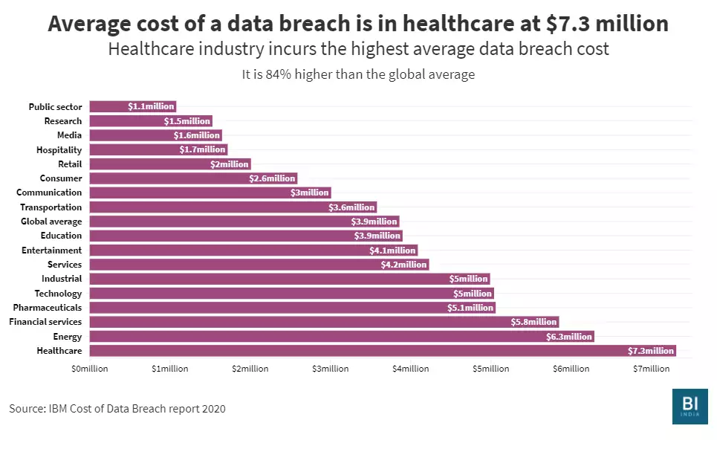

**Figure 1.1** Wrapper method for feature selection

* 1. **Objectives**

The primary objectives of this project are as follows

* **Develop a Decentralized Web Application**: Design and develop a web application utilizing blockchain technology as the underlying framework. The application will facilitate secure storage, management, and access to patient's medical health records in a decentralized manner.
* **Enhance Data Security and Privacy**: Implement robust security measures to ensure the confidentiality, integrity, and availability of patients' data. By leveraging blockchain's cryptographic features, the project aims to provide a high level of data security and privacy, mitigating the risks of unauthorized access and data breaches.
* **Enable Seamless Data Accessibility**: Establish a decentralized network where authorized healthcare providers can access patients' medical health records seamlessly and efficiently. Through the use of blockchain technology, the project seeks to eliminate the need for redundant data entry and enable real-time data sharing across different healthcare entities, ultimately improving patient care and reducing administrative burdens.
* **Evaluate Feasibility and Scalability**: Assess the technical feasibility and scalability of the developed decentralized web application. Conduct performance testing, analyze the system's capacity to handle a large volume of data, and evaluate its ability to adapt to future growth and advancements in the healthcare sector.

By accomplishing these objectives, the project aims to advance secure and patient-centric healthcare data management, fostering trust and promoting the efficient exchange of information within the healthcare ecosystem.

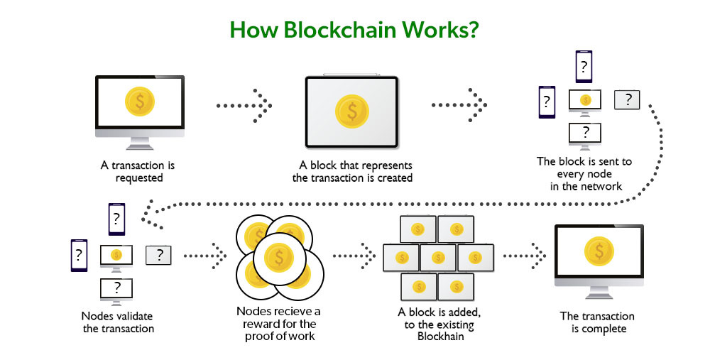

**Figure 1.2** Demonstration of working of blockchain

* 1. **Scope and Significance**

**Scope and Significance**

* The project focuses on the development of a decentralized web application utilizing blockchain technology for the security of patients' data.
* The scope includes the design, development, and implementation of the application, along with the integration of blockchain functionalities for data storage, access control, and immutability.
* The project will explore the technical aspects of building a decentralized system, including the selection of appropriate blockchainplatforms, smart contract development, and data encryption techniques.

**Chapter 2**

**Literature Survey**

It is one of the major objectives of any project which bring out the logical context of the works and research that have been done previously, it is a reflection of the methodology that have adopted previously by various people in the same field of technology.

Intelligent analysis of the previous works can reflect on different flaws, drawbacks, and difficulties faced during the development of the project. Depth analysis and a logical conclusion with the judgemental solution all are a part of the literature survey.

Following are the few methodologies developed by researchers and a few practical mechanisms developed to achieve a smart and secure healthcare mechanism :

1. **MedRec**: This is a pioneering project developed by researchers at MIT in 2016. MedRec is a blockchain-based system designed to securely store and share electronic health records (EHRs) and medical research data. It aims to provide patients with greater control over their data while ensuring privacy and security.
2. **FHIRChain**: Proposed by Zhang et al. in 2016, FHIRChain explores the use of blockchain technology to securely and scalably share clinical data. It focuses on integrating blockchain with the Fast Healthcare Interoperability Resources (FHIR) standard to enhance data interoperability and privacy in healthcare settings.
3. **Ancile**: Dagher et al. presented Ancile in 2018, which is a privacy-preserving framework for access control and interoperability of electronic health records using blockchain technology. Ancile aims to address the challenges of patient data privacy and secure access control in healthcare systems while maintaining data integrity.
4. **MedBlock**: Developed by researchers at Stanford University, MedBlock utilizes blockchain technology to secure medical records and ensure data integrity. It employs smart contracts to regulate access to patient records, enabling the secure sharing of medical information among authorized entities.
5. **Guardtime**: Guardtime is a real-world implementation of blockchain technology for securing healthcare data. It focuses on ensuring the integrity and authenticity of electronic health records through blockchain-based timestamping and verification mechanisms.

These existing works have played a significant role in demonstrating the feasibility and potential benefits of using blockchain to secure medical health records. They have contributed to the advancement of research and practical implementations in the field, providing valuable insights and paving the way for further innovation and adoption of blockchain technology in healthcare.

**Chapter 3**

**Methodology**

The methodology of this project can be depicted in this image.

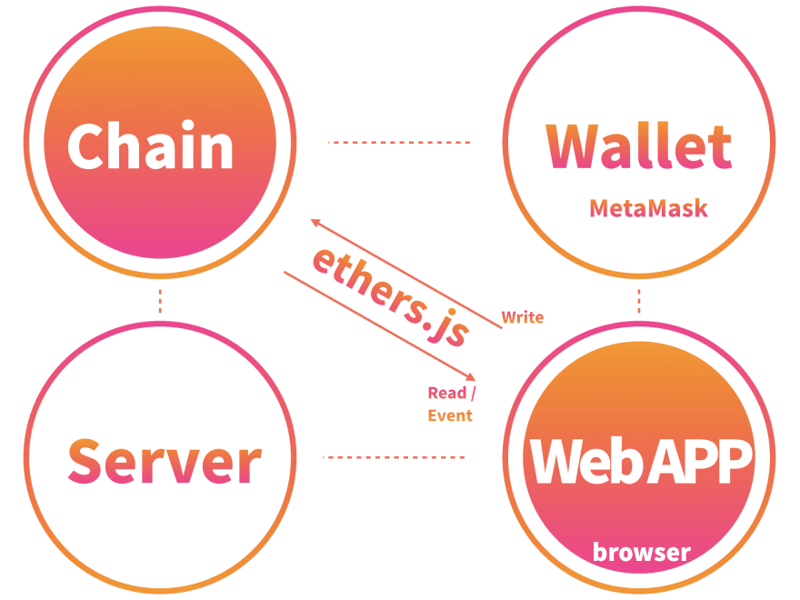

**Figure 3.1** Overview of the architecture of blockchain

**3.1 Technologies and Frameworks**

* **Backend – Blockchain**

In the backend the Ethereum blockchain is working with is connected to a smart contract, the smart contract is deployed through hardhat. Metamask is used to communicate as well.

1. Ethereum blockchain: it is deployed using TestNet, the TestNet using is Sepolia TestNet, and the transaction is recorded and details are recorded at Seppolia transaction Hash.

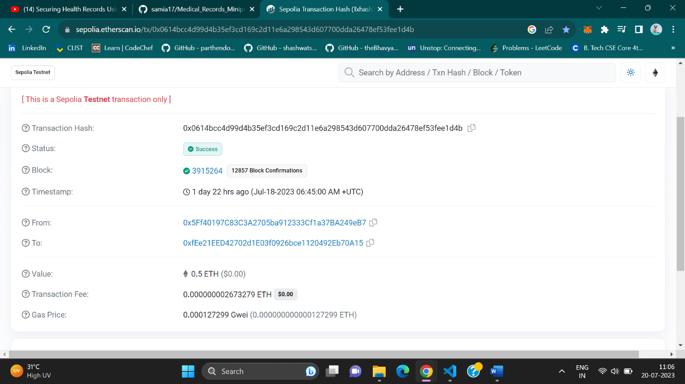

**Figure 3.2** Depiction of how transaction details are shown in Sepolia TestNet

1. Smart Contract: It is like the brain of the whole project. It can be tested on Remix IDE. The smart contract is written using Solidity. The image below depicts how easily a smart contract can be tested on Remix IDE. The steps are simple to compile and then deploy.

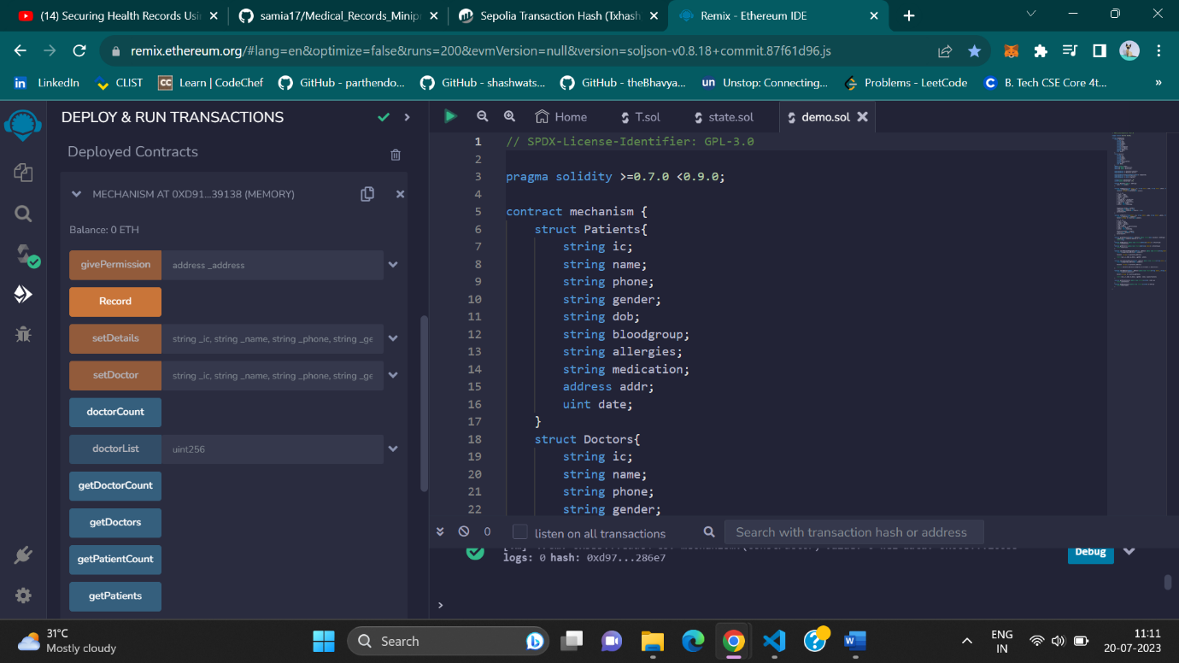

**Figure 3.3** Remix IDE

1. Web3 and Ganache: Using this we can communicate between blockchain and computer. There are other alternatives for it such as :
2. Using Metamask and selecting Test network: It makes it easy for us to select TestNet and make multiple accounts and easily obtain addresses to test our project.

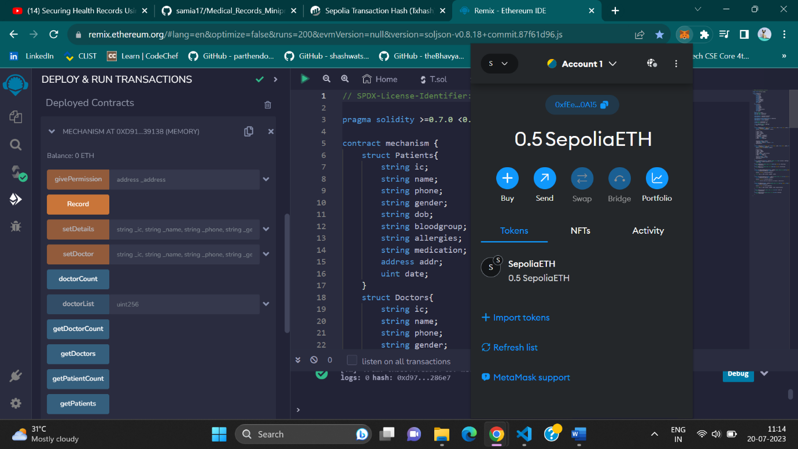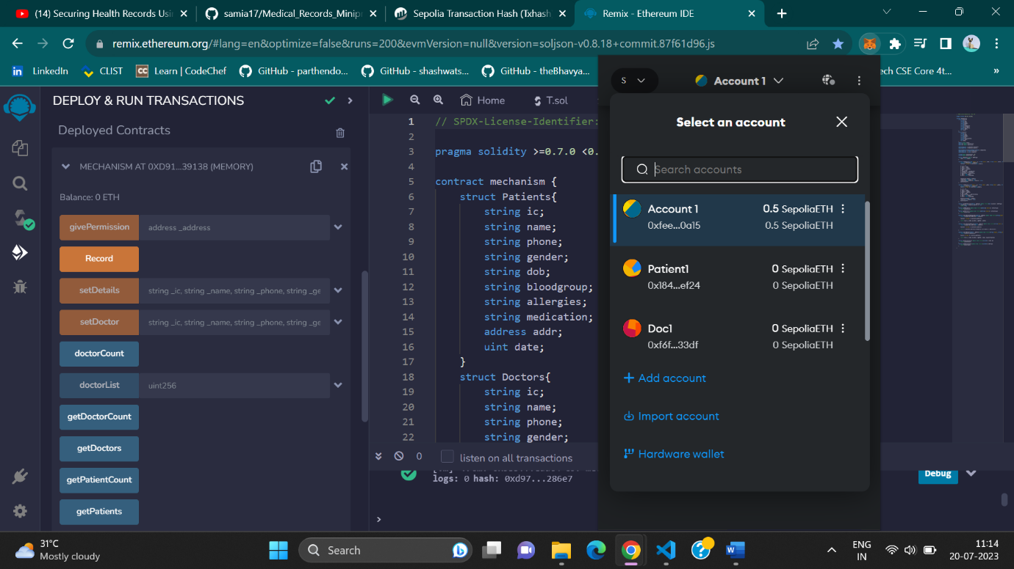

**Figure 3.4** MetaMask

* **Frontend – HTML, CSS, React**

For Frontend we are simply using HTML, CSS, and ReactJS to make a friendly user interface UI.

**Chapter 4**

**Result and Discussion**

The project can perform the following actions successfully.

* Enter the patient's details.
* Enter doctor details.
* Manage to permit others to view records to others (if required).
* Show and retrieve details of patients and doctors.
* Show the transaction history of all transactions

A brief demonstration of all these steps is shown below

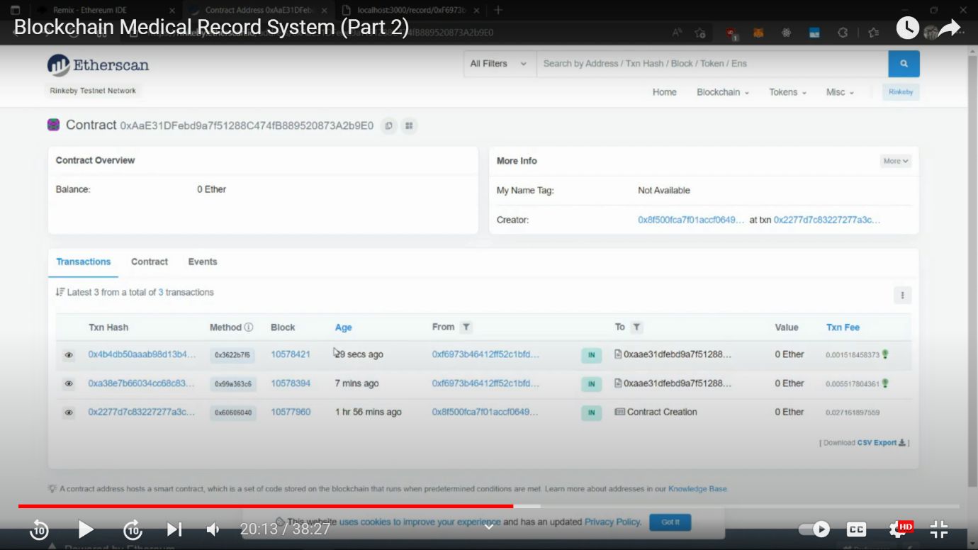

**Figure 4.1** Etherscan

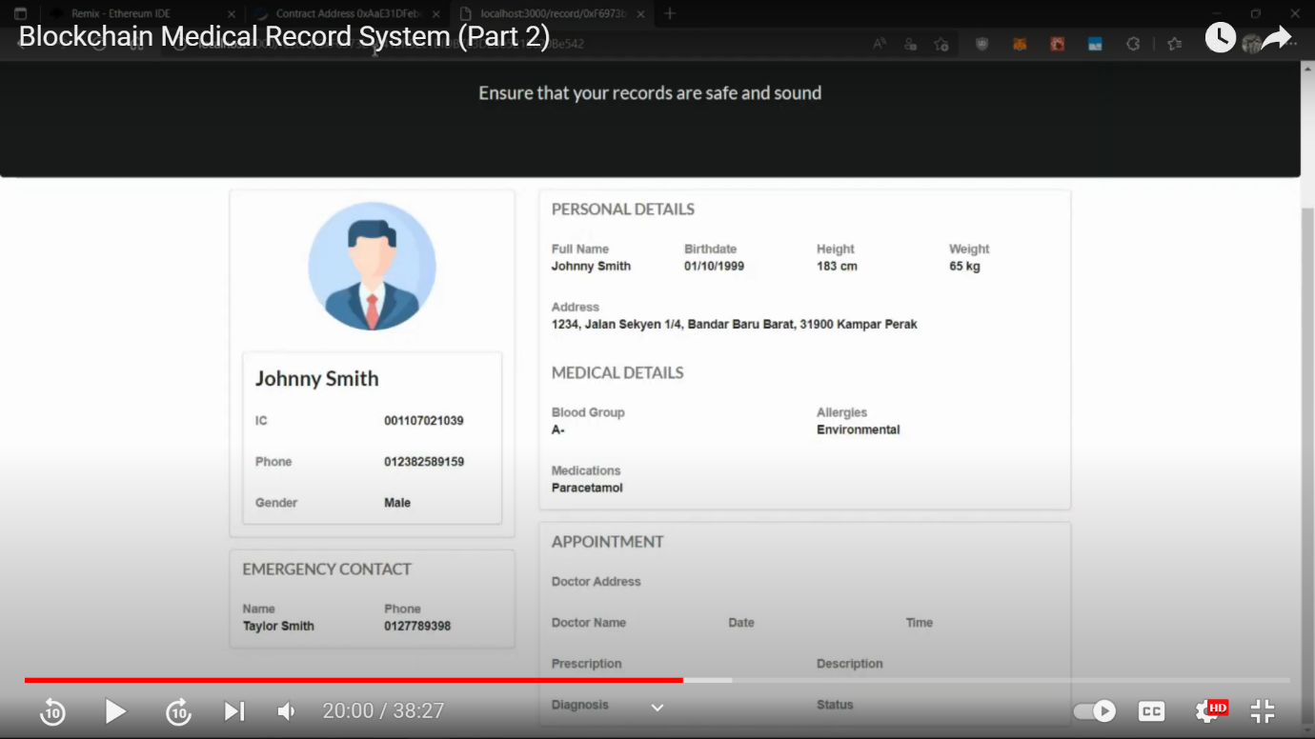

**Figure 4.2** Inputting patient’s details into the blockchain

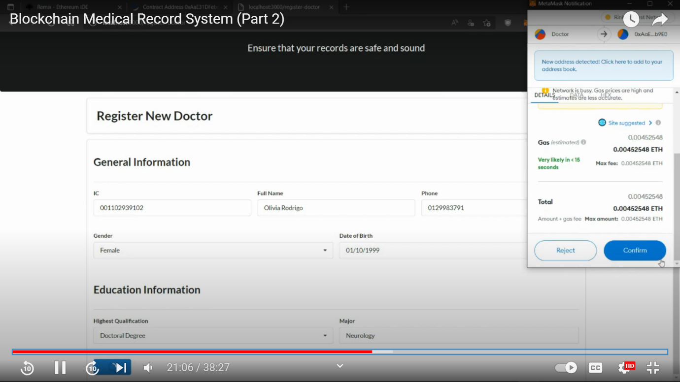

**Figure 4.3** Inputting Doctor’s Details in the Blockchain

**Chapter 5**

**Conclusion and Future Work**

* 1. **Conclusion**

Blockchain technology provides a robust and secure solution for healthcare data management:

The decentralized nature of blockchain ensures data integrity and mitigates the risks of data breaches and tampering.

Smart contracts and access control mechanisms enable fine-grained control over data sharing, ensuring patient privacy and consent management.

The immutability of blockchain enhances the trustworthiness of medical health records, bolstering data integrity and auditability.

Decentralized web applications can empower patients with greater data control:

The developed web application showcased how patients can securely manage their medical health records and grant access to authorized healthcare providers.

Empowering patients with control over their data fosters patient-centric healthcare and builds trust between patients and healthcare organizations.

* 1. **Challenges and future scope**
* Scalability remains a crucial challenge for blockchain technology, and further research is required to optimize blockchain solutions for handling large-scale healthcare data.
* Interoperability standards need to be established to facilitate seamless data exchange among different healthcare systems and platforms.
* Legal and regulatory frameworks must be established to address privacy, data ownership, and compliance with healthcare regulations in blockchain-based systems.
* The successful implementation of the decentralized web application and the promising outcomes from the literature survey open up several avenues for future research and development.
* Enhanced Scalability: Investigate and implement innovative techniques to improve the scalability of blockchain-based healthcare systems. Research on sharding, sidechains, and layer-2 solutions can be explored to optimize the performance of the decentralized web application.
* Interoperability Standards: Collaborate with healthcare organizations and industry stakeholders to establish interoperability standards and frameworks. These standards will enable seamless data exchange and integration across different healthcare systems, promoting data sharing and collaboration.
* Privacy and Security Enhancements: Continue research on enhancing privacy and security in blockchain-based healthcare systems. Develop advanced cryptographic techniques and consensus algorithms that prioritize patient data privacy while maintaining data integrity.
* Real-world Implementation and Adoption: Further refine the developed web application and conduct pilot studies with healthcare institutions to assess its practical applicability. Monitor user feedback and make iterative improvements to ensure seamless integration with existing healthcare workflows.

**References**

[1] Prtenus. (2018). 5.6M Patient Records Breached in 2017 , as Healthcare Struggles to Proactively Pritect Health Data. Blatimore: Protenus

[2] Vaishali Patel, P.H. (2016). Trends in Individuals’ Perceptions regarding Privacy and Security of Medical Records and Exchange of Health Information: 2012-2014. ONC Data Brief 33

[3] What is Blockchain Technology? A Step-by-Step Guide For Beginners. (n.d.). Retrieved from blockchain Hub **(Example : Website)**

[4]Aboody, D. and Lev, B., 2000. Information Asymmetry, R&D, and Insider Gains. Journal of Finance, Vol. 55, pp. 2747-2766