# UNIVERSITY MODEL REPORT

# OBJECTIVE:

The goal is to develop and maintain a performance assessment system that will help universities assess the quality of education they provide to their students.

# ABSTRACT:

The aim of this project is to assess the university's success by collecting feedback from students on classes, teachers, and personal growth and feeding it into a framework that will measure the criteria that the university should concentrate on.

# DESCRIPTION:

A good university is one that provides students with high-quality education that will help them develop a successful career. A university is responsible for providing students with valuable tools that will allow them to succeed.

A University has many constituents, the most important ones are:

1. The Colleges and students associated with the University,

2. The administration which includes workers at different levels.

3. The Universities status in the education world and the responsibility of handling the quality of education and their success rate.

Though many universities are trying to impart best quality education to their students, they aren’t able to produce successful career stories.

It is indeed like a chain reaction every event is dependent on each other, i.e. A good university imparts good quality education to a student,

the student is able to make the most out of the resources at his disposal and builds a successful career,

this enhances the reputation of the university in the industry and which will raise the bar of the university and

the university will make the necessary changes to improve their education and also tie up with the companies in

various industries to give the students a better perspective and so more students will become successful using these resources and it goes on.

It is important for a university to keep track of its students' successes and accomplishments because the standard of education offered by the university is what allowed the student to succeed. A university can keep in contact with its former students through every available channel, such as Facebook, LinkedIn, career blogs, and so on. When a university is related to an alumni, it demonstrates how much the university cares about the individual's growth.

The university has an education system in place with different projects associated with each course, but the effect of each course on each person is unknown. Exam results can be used to determine this.

Another way to increase education quality is to ensure that students recognize the significance of a specific course in the current industry and the associated criteria.

A university should devote a few resources to keeping track of its students across different channels, and in the event that their designations or profiles change, the university should store this information in its own database.

Keeping track of their former students' successes and progress would allow them to assess how a certain faculty and course of study supported the student in achieving that success (promotion)

and how they can improve it further to improve their students' success rate.

Since most students use LinkedIn to develop their professional profiles, a university may use its tools to track down any of their students' activities by tracking them or requiring them to join an alumni community at their school and continue to share their accomplishments and papers in order for the university to keep track of their advances.

A university should identify its KPIs, or Key Performance Indicators, to track the progress of former students over time, which can include two years of course completion and five years of work experience.

This above digital idea should not be restricted to universities, in fact it will be more useful if this idea is incorporated all the way from kindergarten to 12.

As schools are smaller organizations it will be easier to keep track of the performance of school, teacher and students from a very early age.

And in future by making this a centralized portal where the data is under the government it will be easier to scout talents in studies, sports and work.

And every organization can authenticate or cross verify the data with the government.

# Flow:

1. Students will take a bunch of courses and would be graded for each.
2. Average of the GPA of all the students would be calculated.
3. Student, Faculty and University directories would be maintained.
4. Average rating of all the faculties of a particular university would be calculated.
5. Average salary of all the students would be calculated.
6. On the basis of average student GPA, average faculty ratings and average student joining salary, ratings of the universities would be calculated.
7. On the basis of the university ratings, the university rankings would be calculated.

# ENTITIES:

# Classes

# Course: This class contains the details about a course. It has id, name and credits as it’s attributes.

# CourseLoad: This class contains the information about the courses a student has taken and the grades he/she has scored in it. It has attributes like studentID, course and grade in it.

# Faculty: This class contains the basic information about a faculty, course taught by that faculty and their rating. It has attributes like facultyID, facultyName, coursesTaught and rating.

# FacultyDirectory: This class contains the list of all the faculties present in the university. It has the attribute called faculties.

# Transcript: This class contains a list of courses taken by a student. It has an attribute called coursesTaken.

# StudentProfile: This class contains the information about a student. It has attributes like studentID, studentName, joiningSalary, salaryAfterFiveYears and transcript.

# StudentDirectory: This class contains the list of all the students who are from a particular university. It has an attribute called directory.

# University: This class contains all basic information about a university. It is meant to compare universities on the basis of it’s rating. It has attributes like universityID, universityName, studentDirectory, facultyDirectory and rating.

# UniversityDirectory: This class contains the list of all the universities present in the university. It has the attribute called universities.

# UniversityModelAssignment: This class has the main method and is generating rankings of the universities on the basis of their ratings.

# Methods

# addCourse: This method is a part of Faculty class. It is used to add the courses taught by a particular faculty.

# addFaculty: This method is a part of FacultyDirectory class. It is used to add any faculty in the faculty directory.

# getAverageFacultyRating: This method is a part of FacultyDirectory class. It is used to calculate the average rating of all the faculties of a university.

# getCoursesTaken: This method is a part of Transcript class. It is used to fetch the list of courses taken by a student.

# getGPA: This method is a part of StudentProfile class . It is used to calculate the GPA of a student on the basis of the number of courses taken by the student.

# addStudent: This method is a part of StudentDirectory class. It is used to add a student in the student directory.

# getSalaryData: This method is a part of StudentDirectory class. It is used to fetch the joiningSalary and salaryAfterFiveYears of all the students of a university.

# getAverageJoiningSalary: This method is a part of StudentDirectory class. It is used to calculate the average joining salary of all the students of a university.

# setUniversityRating: This method is a part of University class. It is used to calculate the rating of a university by calculating the average of the average GPA, average faculty rating and average joining salary.

# compareTo: This method is a part of University class. It is used to compare the universities on the basis of their ratings.

# addUniversity: This method is a part of UniversityDirectory class. It is used to add any university in the university directory.

# getUniversities: This method is a part of UniversityDirectory class. It is used to sort the universities on the basis of their ratings.

# main: This method is a part of UniversityModelAssignment class. It has all the data to generate rankings of the universities on the basis of their ratings.

# Note: All the attributes in the classes are made private so that they can only be accessed through getters and setters.

# DIAGRAM

1. SEQUENCE DIAGRAM

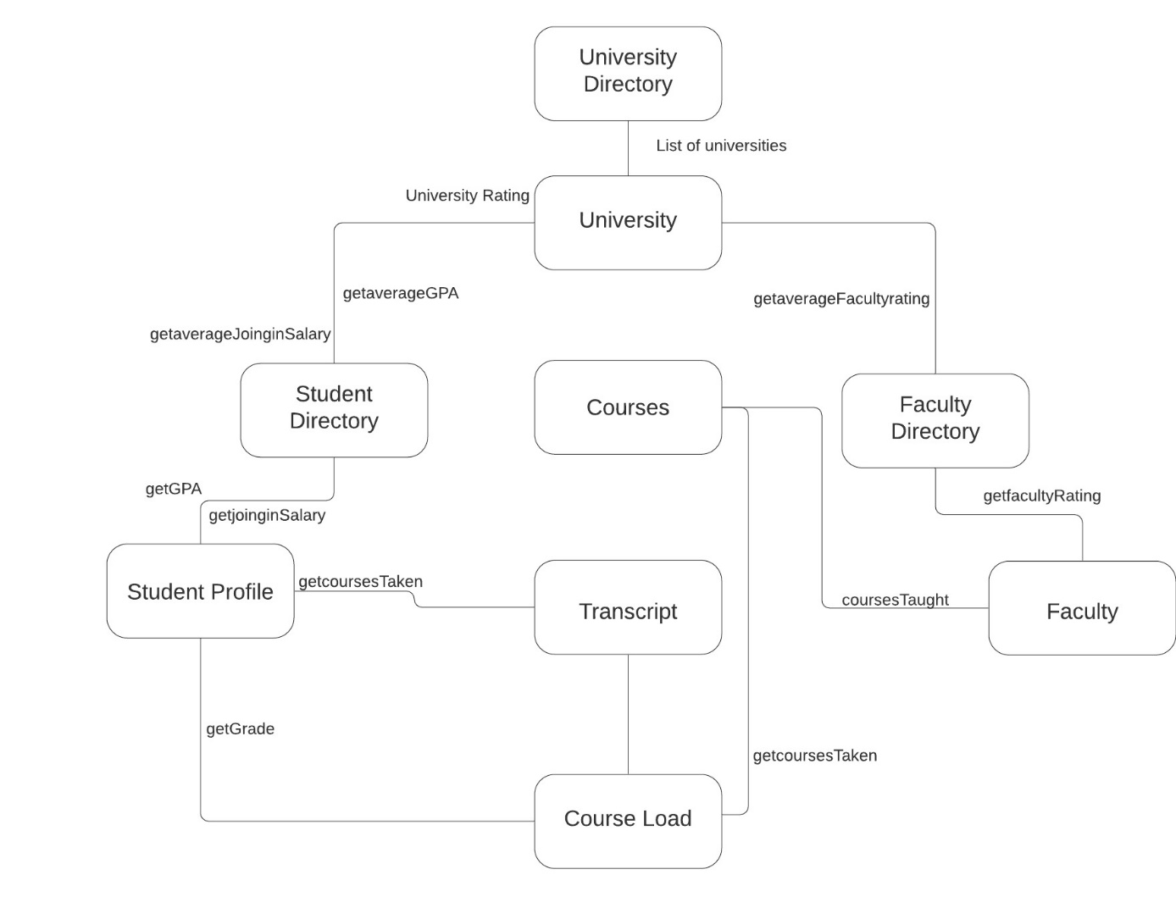

# INTERFACE: