**BANGALORE INSTITUTE OF TECHNOLOGY**

K.R. Road, V.V. Pura, Bengaluru-560 004



**Department of Computer Science & Engineering**

# Mini-Project Synopsis

**VI – Sem 2023-2024 (Even)**

MINI - PROJECT GROUP

|  |  |  |  |  |  |  |
| --- | --- | --- | --- | --- | --- | --- |
| **Sl.**  **No.** | **USN** | **NAME** | **Sec.** | **Email-Id** | **Phone No** | **Signature** |
| **1** | 1BI21CS014 | Amrit Raj | A | amrit24120@gmail.com | 6206732633 |  |
| **2** | 1BI21CS026 | Arnab Bhowmik | A | arnabbhowmik499@gmail.com | 8259953682 |  |
| **3** | 1BI21CS053 | Hitesh Gupta | A | Hiteshgt21@gmail.com | 8368103479 |  |

MINI-PROJECT DETAILS:

|  |  |
| --- | --- |
| **Title:** | Simulation of self-driving car |
| **Domain:** | Artificial Intelligence |

For office use only:

|  |  |
| --- | --- |
| **Group ID:** |  |
| **Guide:** |  |
| **Status:** | **Accepted / To be modified / Rejected** |

Signature of the Mini Project Co-ordinator

**Contents of the Synopsis**

1. **Title: Centre Aligned**
2. **Abstract (100 words)**
3. **Introduction**
4. **Problem Statement**
5. **Objectives**
6. **Block Diagram / Architecture**
7. **Modules / Components Description**
8. **Expected outcome**
9. **References**

<IEEE Format>

Note: Title: Font style-Times New Roman, Font size- 16 BOLD Heading: Font style-Times New Roman, Font size- 14 BOLD Content: Font style-Times New Roman, Font size- 12

* + **Submission Deadline: 20-05-2024**
  + **Mode of Submission: Soft Bound Hard Copy**
  + **Submit to –**

**Dr. M S Bhargavi Associate Professor Department of CSE, BIT**

**YouTube Clone**

**Abstract**

This project aims to develop a YouTube clone, leveraging modern web development tools including HTML, CSS, JavaScript, Node.js, Express, MongoDB, and React. The application will facilitate video uploading, streaming, user authentication, and social interactions such as commenting and liking videos. This project emphasizes practical application of full-stack development skills, integrating front-end and back-end technologies to create a comprehensive video-sharing platform.

**Introduction**

This project involves creating a YouTube clone that allows users to upload, view, and interact with videos. The application will be built using HTML and CSS for structure and styling, JavaScript for interactivity, Node.js and Express for the back-end, MongoDB for database management, and React for the front-end. The goal is to provide a functional and user-friendly video-sharing platform, illustrating the integration of various web technologies.

**Tools**

This project utilizes several essential web development tools, each playing a crucial role in the creation and functionality of the YouTube clone.

1. **HTML (HyperText Markup Language):**
   * Purpose: HTML provides the basic structure of the web pages, defining the layout and elements of the user interface.
   * Usage: HTML is used to create the structure for video display, and interactive elements such as buttons and forms.**.**
2. **CSS (Cascading Style Sheets):**
   * Purpose: CSS is responsible for the visual styling of HTML elements, ensuring that the application is visually appealing and user-friendly.
   * Usage: CSS is used to style the video player, navigation menus, and other components, enhancing the overall user experience.
3. **JavaScript:**
   * Purpose: JavaScript brings interactivity and logic to the web pages.
   * Usage: JavaScript is used to handle dynamic content, video playback controls, and interactions such as commenting and liking videos.
4. **Node.js:**
   * Purpose: Node.js is used for building the back-end server, handling requests, and managing business logic.
   * Usage: Node.js processes user authentication, video uploads, and data retrieval from the database.
5. Express**:**
   * Purpose: Express is a web application framework for Node.js, used to build the API.Usage: Express defines routes for user authentication, video management, and social interactions.
6. MongoDB**:**
   * Purpose: MongoDB is used for storing user data, video metadata, and interaction records.
   * Usage: MongoDB manages the database operations for user accounts, video information, and comments.
7. React**:**
   * Purpose: React is a front-end library used for building the user interface.Usage: React components are used to create a responsive and interactive user interface, handling state management and rendering dynamic content.

**Problem Statement**

Creating a comprehensive video-sharing platform like YouTube involves integrating various technologies to handle video uploads, user authentication, and social interactions. This project aims to provide an educational and practical example of building such a platform, demonstrating full-stack development and the integration of front-end and back-end technologies.

**Objectives**

The primary objective of this project is to develop an interactive YouTube clone using modern web development tools. The project aims to achieve the following specific goals:

1. **User Authentication:** Implement secure user authentication and authorization using auth.js.
2. **Video Management:** Allow users to upload, view, and manage videos
3. **Responsive Design:** Create a visually appealing and responsive user interface with React.
4. **Full-Stack Integration:** Demonstrate the integration of front-end and back-end technologies.

**Block Diagram / Architecture**

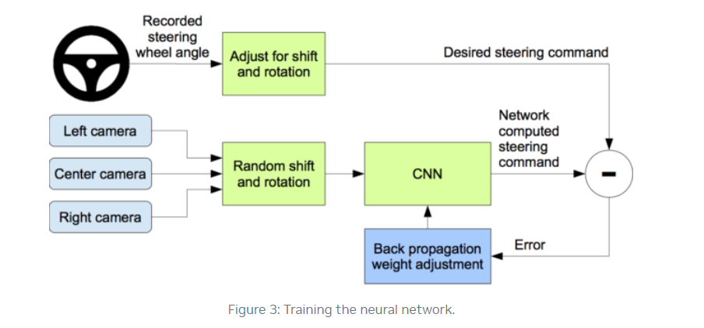

**Modules / Components Description**

**User Authentication Module -** Handles user registration, login, and authentication using passport.

**UI Components Module -** Develops reusable React components for various UI elements such as video player, comment section, and user profile.

**User Interaction Module -** Enables commenting and liking functionalities.

**Search and Recommendation Module -** Implements search functionality and video recommendations.

**Video Management Module -** Manages video uploads, storage, and streaming.

**Expected outcome**

The expected outcomes for this project are:

1. Functional Self-Driving Car Simulation:
   * A working application where users can upload, view, and interact with videos.
2. Educational Resource:
   * A comprehensive example of full-stack web development, suitable for learning and teaching.
3. Interactive Learning Platform:
   * An interactive web-based platform demonstrating the integration of various web technologies.

**References**

<https://www.w3schools.com/html/default.asp>

<https://www.geeksforgeeks.org/web-development/>

<https://www.freecodecamp.org/>