

RV University

**Diabetes Prediction System**

**Software Requirements Specification**

**Version 1.0**

**06-07-2023**

**RV Restricted**

|  |
| --- |
| RV University. This document is not to be copied or distributed without the express written consent of RV University. No part of this document may be used for purposes other than those intended by RV University.    **Based on template Version: PRHB_SRS_T_V_1.0** |

Document Identification

|  |  |
| --- | --- |
| Project Name | Diabetes Prediction System |
| Document Home | <> |
| Version No | 1.0 |
| Status | Revised |
| Audience | RV internal |

Document Revision History

|  |  |  |  |
| --- | --- | --- | --- |
| Version | Date | Description | Document owner / Modified by |
| 1.0 | 07-06-2023 | Document created | Apoorva Hegde |

**Software Requirement Specification**

TABLE OF CONTENTS

13. Table Of Figures....................................................................................................................... 4

1. OBJECTIVES AND SCOPE................................................................................................. 5

2. INTENDED AUDIENCE...................................................................................................... 5

3. DEFINITIONS, ACRONYMS AND ABBREVIATIONS................................................... 5

4. REFERENCES....................................................................................................................... 6

5. REQUIREMENTS OVERVIEW........................................................................................... 6

5.1 Project Perspective 6

5.2 Project functions 7

5.3 Operating Environment 9

5.4 Customer enforced technology choices 9

5.5 User Documentation 9

5.6 Assumptions ,dependencies and external risks 9

6. EXTERNAL INTERFACE REQUIREMENTS................................................................ 10

6.1 User Interfaces 10

6.2 Hardware interfaces 10

6.3 Software interfaces 11

6.4 Communication interfaces 11

7. FUNCTIONAL REQUIREMENTS.................................................................................... 11

7.1 Graphical User Interface 11

7.2 Encoder/Decoder……………………………………………………………….14

7.3 Communication module 19

8. PERFORMANCE REQUIREMENTS............................................................................... 23

9. ACCEPTANCE REQUIREMENTS................................................................................... 23

10. MAINTAINABILITY REQUIREMENTS......................................................................... 23

11. OTHER REQUIREMENTS................................................................................................. 23

11.1 Portability Requirements 23

11.2 Reliability requirements 24

11.3 Scalability requirements 24

12. OPEN ISSUES...................................................................................................................... 24

13. Table Of Figures

Figure 1 Flow Diagram.. 6

Figure 2 PDU Format 7

Figure 3 PDU Fields. 8

Figure 4 Network Elements. 10

Figure 5 Manager-Agent 11

Figure 6 GetRequest Window. 12

Figure 7 SetReuest Window. 13

Figure 8 Response Window. 14

Figure 9 Error Window. 14

Figure 10 GetRequest PDU. 17

Figure 11 TLV Format 17

Figure 12 Socket call for UDP. 23

**1.**OBJECTIVES AND SCOPE

We have developed a system that utilizes machine learning algorithms and datasets concerning glucose levels and blood pressure to make predictions about the likelihood of an individual having diabetes.

**2.**INTENDED AUDIENCE

This document aims to be examined by the customer, developers responsible for test planning, and the developers of the code.

**3.**DEFINITIONS, ACRONYMS AND ABBREVIATIONS

|  |  |
| --- | --- |
| **ML** | Machine Learning |
| **AI** | Artificial Intelligence |
| **DL** | Deep learning |
| **NB** | Naïve Bayes |

**4.**REFERENCES

Code provided

**5.**REQUIREMENTS OVERVIEW

## **Project Perspective**

The objective of this project is to provide accurate predictions regarding an individual's likelihood of having diabetes by analyzing their glucose and blood pressure levels. The program is designed to be platform-independent, ensuring easy and efficient utilization by simply inputting the desired dataset for analysis.

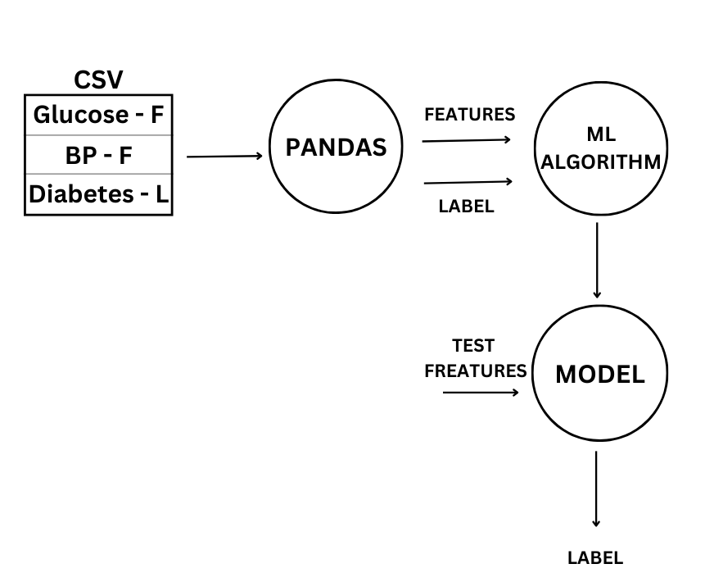

**Project functions**

PDU being the basic unit of transfer for the SNMP protocol implementation, The main functionality of the project involves constructing the PDU. To construct a PDU , Basic Encoding Rules have to be followed, which constitutes as a part, using the ASN.1 notation.

Figure 2 PDU Format

There are five types of PDU that can be transferred from the manager to the agent and vice versa .  
 SNMP is a simple request/response protocol. NMSs can send multiple requests without receiving a response. Five basic SNMP operations are defined which are described below.

Message Types:

Get

Allows the NMS to retrieve an object instance from the agent.

GetNext

Allows the NMS to retrieve the next object instance from a table or list within an agent. In SNMP, when an NMS wants to retrieve all elements of a table from an agent, it initiates a Get operation, followed by a series of GetNext operations.

GetResponse

This give a corresponding response for the get and the getNext.

Set

Allows the NMS to set values for object instances within an agent.

Trap

Used by the agent to asynchronously Inform the NMS of some event. The SNMP trap message is designed to replace the SNMP trap message.

PDU Packet Format

Figure 3 PDU Fields

Brief Description of the PDU Fields

Version

Community

SNMP PDU

PDU Type

Get-request[0]

Get-next-request[1]

Set-request[2]

Get-response[3]

Trap[4]

Request ID

To track a message with the expected response

Error Status

ErrorStatus::=

INTEGER

{

noError(0)

tooBig(1)

noSuchName(2)

badValue(3)

readOnly(4)

genErr(5)

}

Error Index

It is used to provide additional information on the error status.

Name and Value pair

## **Operating Environment**

· Hardware platform Pentium III, 166 MHz Pentium II or higher.

· Operating system Linux or HP-UX

· Software components C, GTK, Minimum of 64 MB of RAM

The software to be written will use the underlying UDP/IP protocol stack and the sockets for its complete implementation.

UDP/IP connectivity to at least one SNMP-capable device (agent)

## **Customer enforced technology choices**

* The supported operating systems for this project are Linux and Windows.
* The implementation of the described product should be done using the Python programming language.

## **User Documentation**

## Users will be provided with a user manual that will include instructions on how to use the product

## **Assumptions ,dependencies and external risks**

· The data set has been provided and is accurate

· The pattern developed can be used to predict the presence of diabetes

**6.**EXTERNAL INTERFACE REQUIREMENTS

## **User Interfaces**

* The system will include a user interface where users can input their glucose and blood pressure levels accurately.
* If the entered data appears to be outside the normal range, a warning window will be displayed to notify the user.

## **Hardware interfaces**

CPU above i5  
 RAM of at least 8GB to 16GB  
 Storage to store the data set

## **Software interfaces**

Data set collection

Warning page

## **Communication interfaces**

Data collection interface

Data processing interface

Prediction interface

**7.**FUNCTIONAL REQUIREMENTS

## **Graphical User Interface**

### **7.1.1** **RFP Id-F1**

### **7.1.2** **Description**

F1.1 window for Prediction results

This user window will accept the

· Glucose

· Blood pressure

**8.**Code

import numpy as np

import pandas as pd

from sklearn.model_selection import train_test_split

from sklearn.naive_bayes import GaussianNB

from sklearn.metrics import accuracy_score

import matplotlib.pyplot as plt

import seaborn as sns

df = pd.read_csv("Naive-Bayes-Classifier-Data.csv")

df.head()

x=df.drop('diabetes',axis=1)

y=df['diabetes']

x_train,x_test,y_train,y_test = train_test_split(x,y,test_size=0.25,random_state=42)

model=GaussianNB()

model.fit(x_train,y_train)

y_pred = model.predict(x_test)

y_pred

**9.**MAINTAINABILITY REQUIREMENTS

Maintaining the data model