**Setup**

1. **Configure Image server:**

Launch Chrome extension – Web Server for Chrome

Choose a directory of your choice (one time setup)

Pin it on your taskbar (you need to run this every time the project runs)

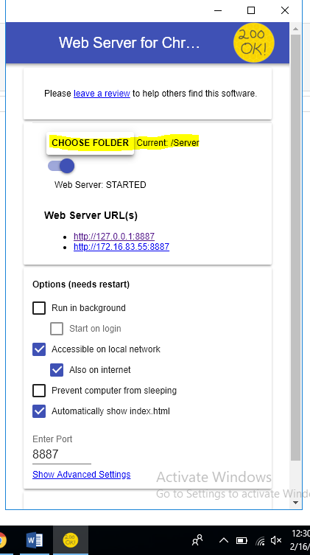

1. **Changing current working dir placed the config.properties file in the same:**

Eclipse > Run > Run Configuration

Change the current working directory in Arguments (Suggestion: keep it same as image server location)

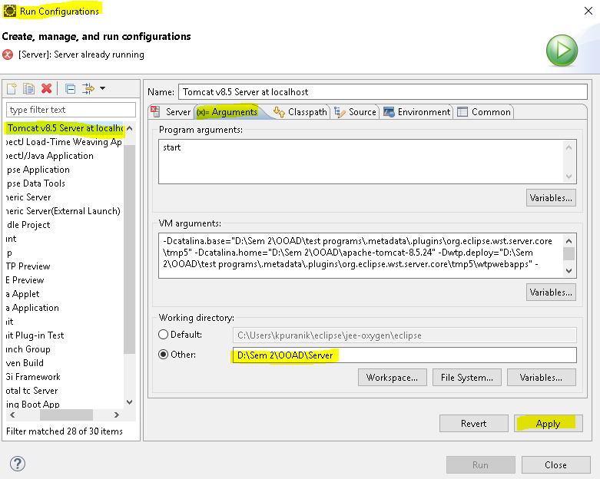

Download the following config.properties file and update your server path



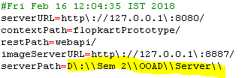

Place the config.properties file in your working directory