UNIVERSITY OF MUMBAI

PROJECT ENTITLED

“Hospital Management System”

SUBMITTED BY
APOORVA SHANKAR GHORPADE

UNDER GUIDANCE OF

Miss. Simran Shinde

SUBMITTED FOR THE FULFILLMENT OF THE CURRICULUM OF DEGREEOF BACHELOR OF SCIENCE IN COMPUTER SCIENCE


PILLAI COLLEGE OF ARTS, COMMERCE & SCIENCE (AUTONOMOUS), NEW PANVEL

2023-2024

MAHATMA EDUCATION SOCIETY’S
PILLAI COLLEGE OF ARTS COMMERCE & SCIENCE (AUTONOMOUS)
(Affiliated to University of Mumbai)
NEW PANVEL - 410206 MAHARASHTRA

DEPARTMENT OF COMPUTER SCIENCE


CERTIFICATE

This is to certify that the project entitled “Hospital Management System”, is bonafied work of Miss. Apoorva Shankar Ghorpade bearing Seat No: [8837] submitted in partial fulfilment of the requirements for the award of degree of BACHELOR OF SCIENCE in COMPUTER SCIENCE from University of Mumbai.

Date: External Examiner

Internal Guide Coordinator/HOD

College Seal

ACKNOWLEDGEMENT

A part from the efforts of myself, the success of the project depends largely on the encouragement and guidelines of many others. I take this opportunity to
express my gratitude to the people who have been instrumental in the successful completion of this project.
I would like to express a deep sense of gratitude to my Project Guide Professor Simran Shinde for her cordial support and for her guidance and supervision as well as for providing necessary information regarding the project and also for the support in completing the project.
My thanks and appreciation also goes to my College Computer Laboratory Administrators for their support for making the right resources available in time for my project.
Finally, I also extend my heartiest thanks to my parents, friends and well- wishers for being with me and extending encouragement throughout the project.

Yours faithfully,
Apoorva Shankar Ghorpade.
(Final Year Computer Science)

TABLE OF CONTENTS
SR. NO | CHAPTER NO | PAGE NO | SIGNATURE
CHAPTER 1
1 | Introduction | 6
1.1 | Background | 7
1.2 | Objective | 7
1.3 | Purpose | 8
1.4 | Scope | 9
1.5 | Applicability | 10
CHAPTER 2
2 | Feasibility study | 11
2.1 | Technical Feasibility | 12
2.2 | Economic Feasibility | 12
2.3 | Financial Feasibility | 13
2.4 | Operational Feasibility | 13
2.5 | Stakeholder | 14
CHAPTER 3
3 | Requirement and Analysis | 15
3.1 | Planning and scheduling | 15
3.2 | Software and Hardware Requirement | 16
3.3 | Conceptual Models | 17
3.3.1 | ER Diagram | 17
3.3.2 | Class Diagram | 18
3.3.3 | Use Case Diagram | 19
3.3.4 | Deployment Diagram | 20
3.3.5 | Sequence Diagram | 21-22
3.3.6 | Object Diagram | 23
CHAPTER 4
4 | System Design | 24
4.1 | Data Integrity and Constraints | 24-25
4.2 | User Interface and Design | 26-35
4.3 | Security Issues | 36
4.4 | Test Cases | 37

TABLE OF CONTENTS

SR. NO | CHAPTER NO | PAGE NO | SIGNATURE
CHAPTER 5
5 | System Coding, Implementation and Testing | 38
5.1 | Code of Project | 38-68
5.2 | Testing Output | 69-77
5.3 | Testing Approach | 78
5.3.1 | Unit Testing | 78
5.3.2 | Integrated Testing | 78
5.4 | Modifications and Improvement’s | 78
CHAPTER 6
6 | Conclusion and Future Scope | 79
CHAPTER 7
7 | Reference | 80

CHAPTER 1

Introduction

In the rapidly evolving landscape of healthcare, efficient management of hospitals and healthcare facilities is paramount to ensure the delivery of high-quality patient care. Hospital Management Systems (HMS) play a pivotal role in streamlining administrative, operational, and clinical processes within healthcare organizations.
A Hospital Management System (HMS) is an essential tool for efficiently managing the various aspects of a hospital's operations. Among the key modules of an HMS are those dedicated to administrative tasks, user management, appointment scheduling, doctor management, and patient management.

The admin module serves as the central hub for overseeing the entire system. Admin users have access to all functionalities and can manage user accounts, set permissions, and configure system settings. They play a crucial role in maintaining the security and integrity of the HMS.

The appointment module allows users to schedule and manage appointments with doctors. Patients can easily book appointments online, and staff can efficiently organize the doctor's schedule to ensure smooth operations.

The doctor module provides comprehensive profiles of all doctors associated with the hospital. Admins can add, edit, and remove doctor profiles, including their specialties, contact information, and availability.

The patient module stores detailed information about patients, including personal details, medical history, and appointment records. Admins can manage patient records, track their health progress, and ensure they receive the necessary care and attention.

Overall, these modules work together seamlessly to streamline hospital operations, improve patient care, and enhance the overall efficiency of the healthcare facility.

BACKGROUND.
In recent years, the healthcare industry has undergone significant transformations driven by advancements in technology, changes in regulatory requirements, and evolving patient expectations. Hospital Management Systems (HMS) have emerged as a response to these challenges, offering comprehensive solutions to streamline administrative, clinical, and operational processes within healthcare organizations.

The concept of Hospital Information Systems (HIS) emerged in the late 20th century, aiming to digitize patient records, automate billing, and streamline administrative tasks. Early HIS solutions focused primarily on digitizing medical records and automating billing processes but lacked integration and interoperability across different departments and systems.

OBJECTIVE
- Efficiency: To streamline hospital operations and administrative tasks, reducing paperwork and minimizing manual errors.
- Improved Patient Care: To enhance the quality and delivery of patient care by providing quick access to medical records and facilitating better communication among healthcare staff.
- Cost-effectiveness: To optimize resource utilization and reduce operational costs through automation and efficient management of hospital resources.
- Compliance: To ensure compliance with regulatory requirements and maintain the privacy and security of patient information.
- Data-driven Decision Making: To collect and analyze data for actionable insights that support informed decision-making by hospital administrators and healthcare providers.

PURPOSE
A Hospital Management System (HMS) serves as the backbone of modern healthcare facilities, designed to intricately manage and integrate diverse aspects of hospital operations. At its core, an HMS operates to streamline administrative, clinical, and operational workflows, ushering in a new era of efficiency and effectiveness in healthcare delivery. Through digital transformation, mundane tasks such as patient registration, appointment scheduling, billing, and medical record management are seamlessly automated, freeing up valuable time for healthcare professionals to focus on delivering high-quality patient care. By consolidating and centralizing data, an HMS facilitates smooth communication and coordination between various departments, ensuring a cohesive approach to patient management. Moreover, the system plays a pivotal role in ensuring compliance with regulatory standards and protocols, safeguarding patient privacy and data security. With robust analytics capabilities, an HMS empowers hospital administrators and decision-makers with actionable insights derived from real-time data, enabling them to make informed decisions to optimize resource allocation, improve operational efficiency, and enhance overall patient outcomes. In essence, the overarching goal of an HMS is to revolutionize hospital operations, driving continuous improvement in the quality and accessibility of healthcare services provided to patients.

  - SCOPE
The scope of a Hospital Management System (HMS) is expansive, encompassing a wide array of functionalities aimed at optimizing various aspects of healthcare operations. At its core, an HMS is designed to streamline administrative, clinical, and operational processes within a healthcare organization, ensuring smooth functioning and effective patient care delivery.
Central to its capabilities is the management of patient information, which includes storing, retrieving, and updating medical records securely. Appointment scheduling features allow for efficient allocation of resources and time management, optimizing patient flow and reducing wait times. Billing and invoicing functionalities ensure accurate and timely financial transactions, facilitating revenue management and accounting processes. Inventory management modules enable the tracking and maintenance of medical supplies and equipment, ensuring their availability when needed. Staff management tools aid in the efficient allocation of human resources, scheduling shifts, and managing employee records. Electronic health records (EHR) centralize patient information, allowing healthcare providers seamless access to medical histories and treatment plans, enhancing continuity of care. Reporting features generate insightful analytics and performance metrics, aiding hospital administrators in strategic decision-making and resource allocation. Moreover, the HMS fosters communication and collaboration among different departments, promoting interdisciplinary teamwork and coordination. Compliance with regulatory requirements is ensured through built-in features that adhere to industry standards and best practices. Ultimately, the overarching goal of an HMS is to enhance efficiency, improve patient care delivery, reduce costs, maintain compliance, and enable better management of hospital resources, thereby contributing to the overall effectiveness and sustainability of the healthcare organization.

APPLICABILITY
Hospital Management Systems (HMS) are integral to the functioning of healthcare facilities, offering comprehensive software solutions tailored to streamline administrative, clinical, and operational tasks. These systems are versatile and find widespread application across various healthcare settings, including hospitals, clinics, and medical centers. HMS plays a pivotal role in the efficient management of patient records, offering secure and organized storage, retrieval, and updating of crucial medical information. Moreover, it facilitates seamless appointment scheduling, ensuring optimal utilization of resources and minimizing patient wait times. Billing processes are streamlined through automated invoicing and payment tracking functionalities, enhancing financial management and revenue generation. Inventory control features enable healthcare providers to monitor and manage medical supplies, ensuring adequate stock levels and reducing instances of shortages or overstocking. Staff management functionalities simplify workforce scheduling, task allocation, and performance monitoring, promoting staff efficiency and productivity. Additionally, HMS aids in ensuring compliance with regulatory standards and requirements, mitigating risks of penalties or legal issues. By automating manual tasks and integrating disparate departments, HMS optimizes operational workflows, improves communication and collaboration among healthcare professionals, and ultimately enhances the overall quality of patient care delivery. Its scalability makes it suitable for healthcare organizations of all sizes, offering tailored solutions to meet the diverse needs and challenges of modern healthcare environments.

CHAPTER 2

FEASIBILITY STUDY
An important outcome of preliminary investigation is to determine whether the proposed system is feasible or not. A feasibility study is a test of a system proposal according to its work ability, ability to meet users need an effective use of resources. It is conducted to select the best system that meets the performance standards. It reviews the alternative solution, and its objective is not solving the problem. Three key considerations are involved in feasibility analysis.

- Technical feasibility
- Economic feasibility
- Financial feasibility
- Operational feasibility

TECHNICAL FEASIBILITY
In this study, a company's capabilities in terms of technical expertise are the main focus. This evaluation takes the outline of the system or project requirements into consideration. When the technical feasibility study report is complete, the following factors are vital-
- A business description to evaluate additional factors that affect the study.

- The specific component/ division of the project business under assessment.

- The human resources and cost efficiency factors

- The possible or alternative solutions to the problems

In our project as we have used HTML as our front-end language combined with Html
CSS, Bootstrap , JavaScript, Bootstrap as main back-end languages, Servlet , JDBC and MySQL providing the database we require to store the data of our website. Server is Apache tomcat server and also tools – Eclipse Ide, MySQL workbench.

ECONOMIC FEASIBILITY

The purpose of an economic feasibility study is to demonstrate the net benefit of a proposed project for accepting or disbursing electronic funds/benefits, taking into consideration the benefits and costs to the agency, other state agencies, and the general public as a whole.
This project can help small scale offline shop owners as they can keep their website online 24/7 leading to great profits. This can also help in reduce the machine and manpower utilization which in turn saves time and money.

FINANCIAL FEASIBILITY
A study on whether a project is viable after taking into consideration its total costs and probable revenues. If the revenues cover the costs of the project, then the project is visible. For instance, the cost of expanding production will entail $500,000; however, the expected increase in revenue will be $1,000,000. Thus, the project is feasible as its revenue more than cover its costs.

This project is financially feasible for small shop owners as they can afford this as well as this can be a huge source of income with their products being online 24/7 reducing manpower and also help their customers to buy products from the comfort of their home.

OPERATIONAL FEASIBILITY
Operational feasibility is mainly concerned with issues like whether the system will be used if it is developed and implemented. Whether there will be resistance from users that will affect the possible application benefits? The essential questions that help in testing the operational feasibility of a system are following.

- Does management support the project?

- Are the users not happy with current business practices? Will it reduce the time (operation) considerably? If yes, then they will welcome the change and the new system.

- Have the users been involved in the planning and development of the project? Early involvement reduces the probability of resistance towards the new system.

- Will the proposed system really benefit the organization?

2.5 STAKE HOLDERS

OWNER

Owner is the one who owns the company. He will always monitor what is happening in the system.

ADMIN

Admin is the one who controls all the data entered by the users in the website forms. Admin filters all the data received and provide genuine information to the customer. Therefore, the Admin has complete control over the website.

DEVELOPERS

Developer's areas stakeholders as they will keep on working on the project for future development. If any issues occur in the system, they will find the problem and try to find a solution for it.

USERS

Users are the ones who really matters in the successful run of the software. They are the ones who decide the future of the website.

CHAPTER 3

REQUIREMENT AND ANALYSIS
  - PLANNING AND SCHEDULING
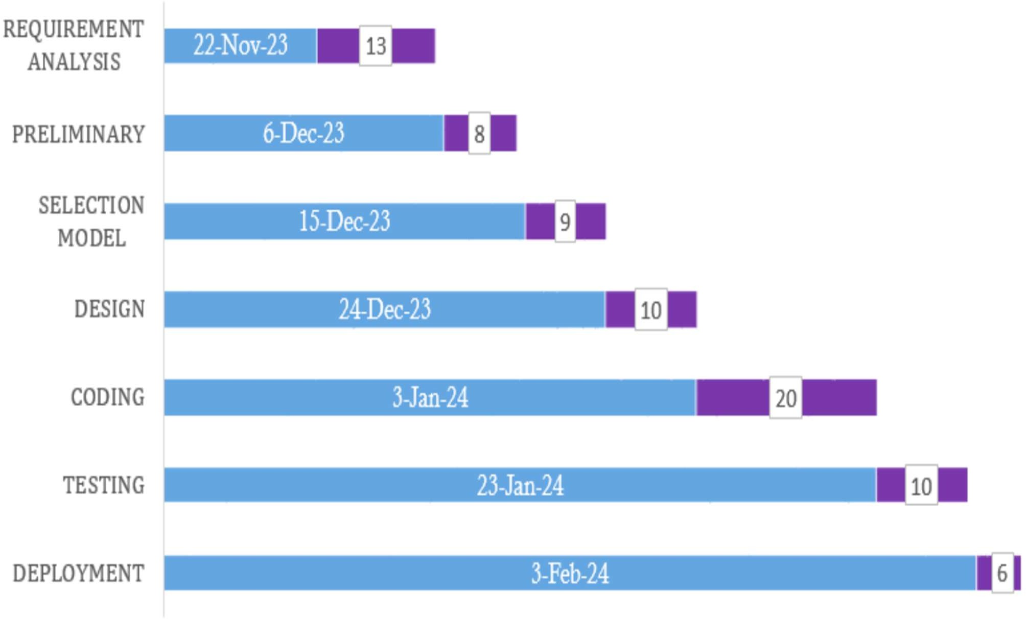

  - SOFTWARE AND HARDWARE REQUIREMENTS.
HARDWARE REQUIREMENT
DEVELOPER SIDE

 | Processor | Ram | DiskSpace
Client Side | 1.6GHz or Faster processor | 1GB RAM | 200 GB Disk Space
Server Side | Server environment capable hardware | 2GB RAM | 2GB RAM
SOFTWARE REQUIREMENTS

Front end | Html , CSS, Bootstrap , JavaScript, Bootstrap
Back end | Servlet , JDBC
Database | MySQL
Operating System | Windows 11

    - ER DIAGRAM:

CONCEPTUAL MODEL
What is ER diagram?
ER Diagram stands for Entity Relationship Diagram, also known as ERD is a diagram that displays the relationship of entity sets stored in a database. In other words, ER diagrams help to explain the logical structure of databases. ER diagrams are created based on three basic concepts: entities, attributes and relationships.
ER Diagrams contain different symbols that use rectangles to represent entities, ovals to define attributes and diamond shapes to represent relationships,
At first look, an ER diagram looks very similar to the flowchart. However, ER Diagram includes many specialized symbols, and its meanings make this model unique. The purpose of ER Diagram is to represent the entity framework Infrastructure
The ER Model represents real-world entities and the relationships between them. Creating an ER Model in DBMS is considered as a best practice before implementing your database.

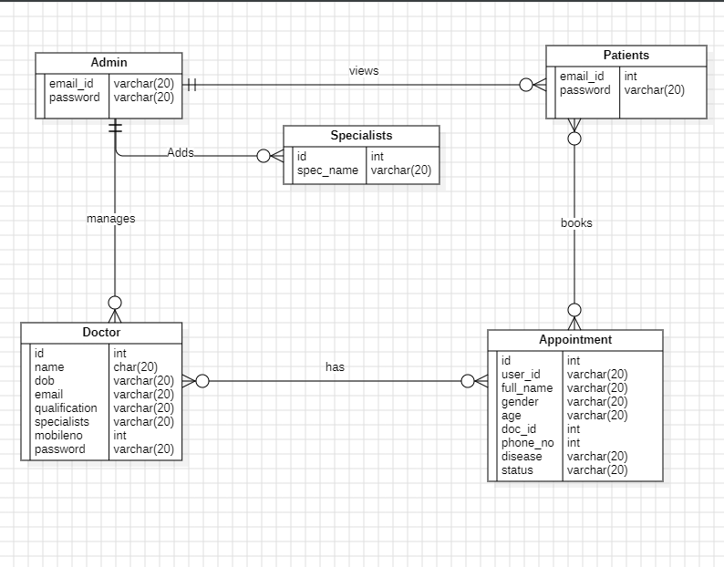

    - CLASS DIAGRAM:
In software engineering, a class diagram in the Unified Modeling Language (UML) is a type of static structure diagram that describes the structure of a system by showing the system's classes, their attributes, operations (or methods), and the relationships among objects.
The class diagram is the main building block of object-oriented modeling. It is used for general conceptual modeling of the structure of the application, and for detailed modeling translating the models into programming code. Class diagrams can also be used for data modeling. The classes in a class diagram represent both the main elements, interactions in the application, and the classes to be programmed.

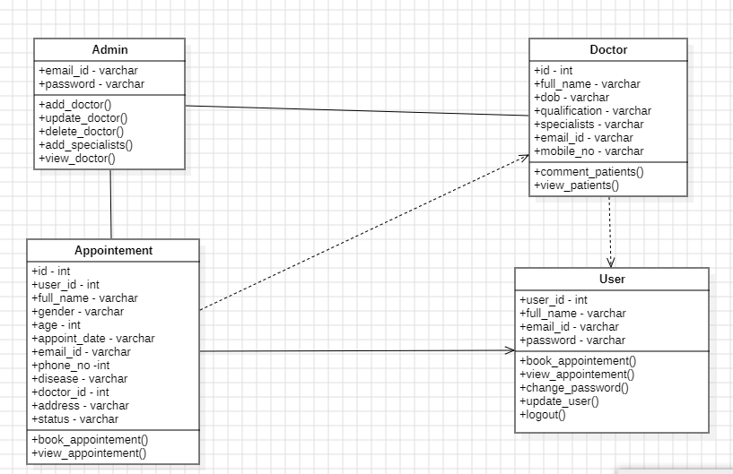

    - USE CASE DIAGRAM:
A use case diagram is a way to summarize details of a system and the users within that system. It is generally shown as a graphic depiction of interactions among different elements in a system. Use case diagrams will specify the events in a system and how those events flow, however, use case diagram does not describe how those events are implemented.

A use case is a methodology used in system analysis to identify, clarify, and organize system requirements. In this context, the term "system" refers to something being developed or operated, such as a mail-order product sales and service Web site. Use case diagrams are employed in UML (Unified Modelling Language), a standard notation for the modelling of real-world objects and systems. There are a number of benefits with having a use case diagram over similar diagrams such as flowcharts.
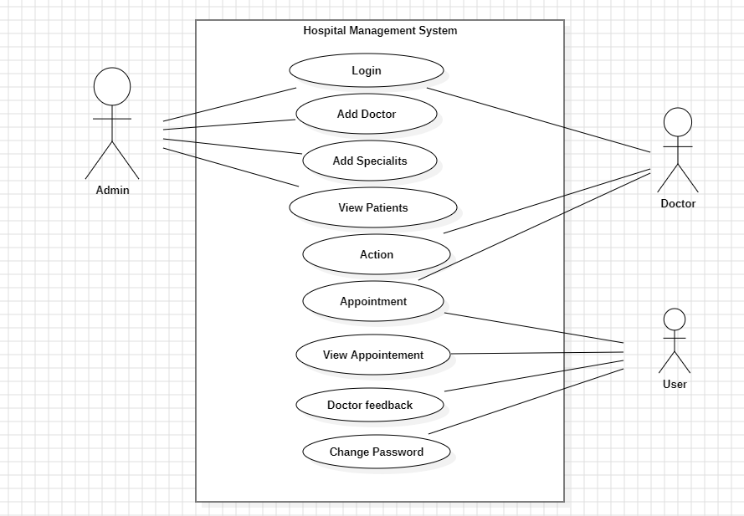

    - DEPLOYMENT DIAGRAM:
A deployment diagram is a UML diagram type that shows the execution architecture of a system, including nodes such as hardware or software execution environments, and the middleware connecting them.

Deployment diagrams are typically used to visualize the physical hardware and software of a system. Using it you can understand how the system will be physically deployed on the hardware.

Deployment diagrams help model the hardware topology of a system compared to other UML diagram types which mostly outline the logical components of a system.
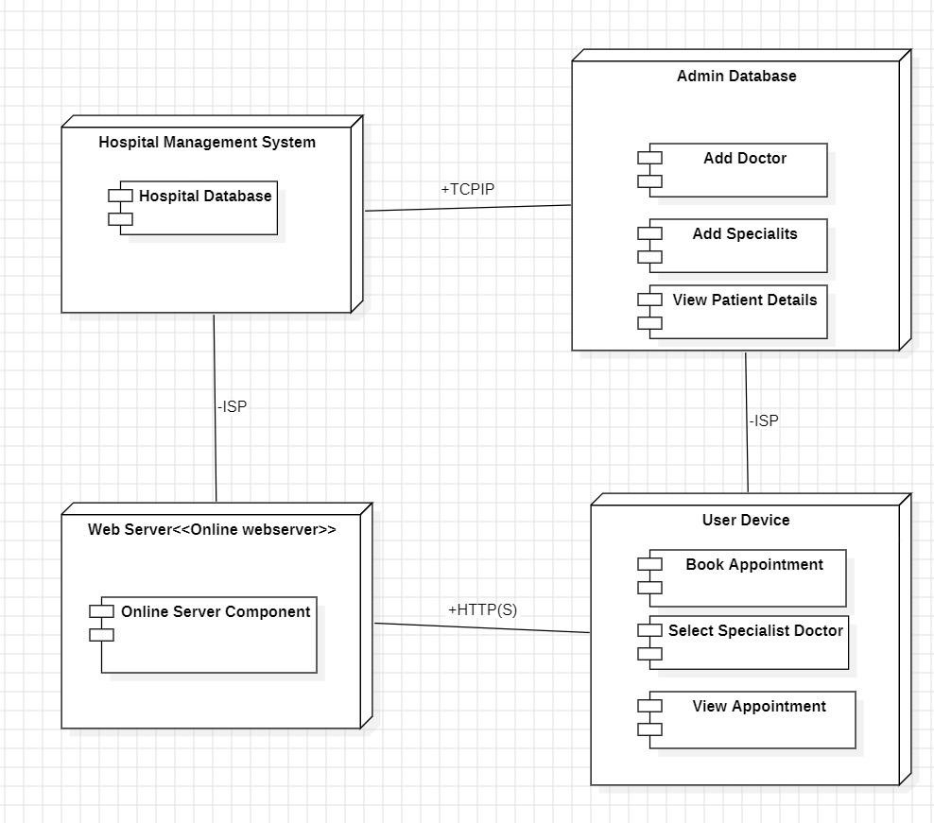

    - SEQUENCE DIAGRAM

UML Sequence Diagrams are interaction diagrams that detail how operations are carried out. They capture the interaction between objects in the context of a collaboration. Sequence Diagrams are time focus and they show the order of the interaction visually by using the vertical axis of the diagram to represent time what messages are sent and when.

ADMIN SIDE

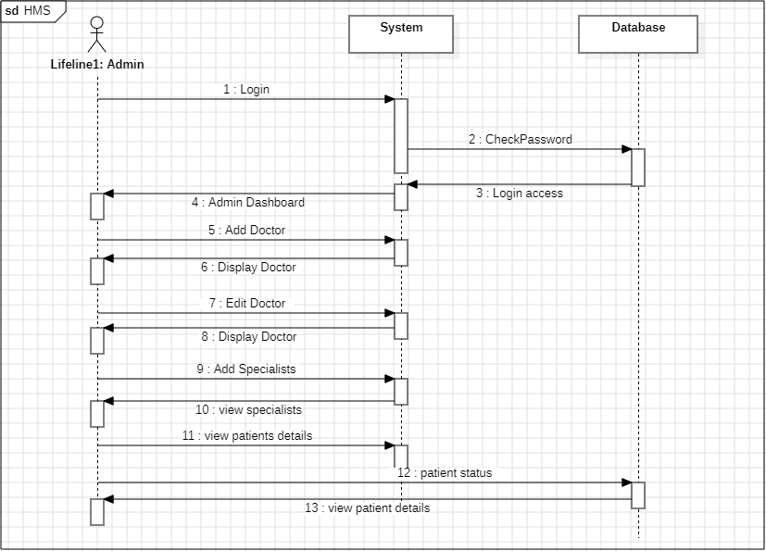

USER SIDE
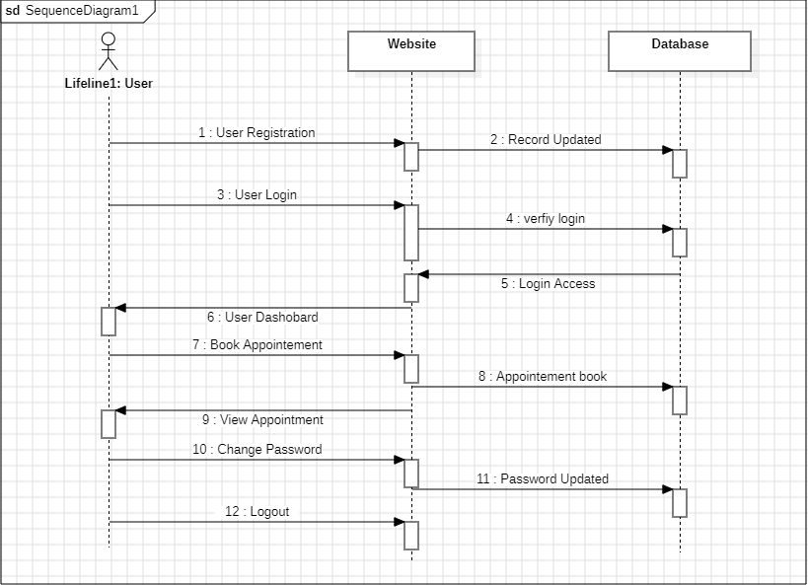

    - OBJECT DIAGRAM

An object diagram is a graphical representation that showcases objects and their relationships at a specific moment in time. It provides a snapshot of the system's structure, capturing the static view of the instances present and their associations

An object diagram may be considered a special case of a class diagram, Object diagrams use a subset of the elements of a class diagram in order to emphasize the relationship been instances of classes at some point in time. They are useful in understanding clam diagrams. They don't show anything architecturally different so class diagrams, but reflect multiplicity and rises.

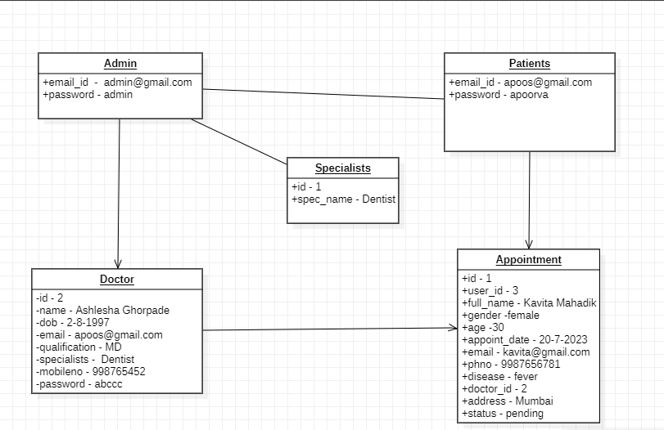

CHAPTAR 4 SYSTEM DESIGN
  - DATA INTREGITY AND CONSTRAINTS. USER TABLE
Attribute name | Data type | Constraints
id | Int | auto_increment,primary key.
Fullname | Varchar(20)
email | Varchar(20)
password | Varchar(20)
DOCTOR TABLE.

Attribute name | Data type | Constraints
id | int | auto_increment, primary key.
full_name | Varchar(20)
dob | date
qualification | Varchar(20)
specialist | Varchar(20)
email | Varchar(20)
mobno | int
password | Varchar(20)

SPECIALIST TABLE.

Attributes | Datatype | Constraints
id | int | auto_increment , primary key
spec_name | Varchar(20)

APPOINTEMENT TABLE.

Attributes | Datatype | Constraints
id | Int | Auto_increment,primary key
user_id | Int
fullname | Varchar(20)
gender | Varchar(20)
age | Int
appoint_date | Varchar(20)
email | Varchar(20)
phno | Varchar(20)
diseases | Varchar(20)
doctor_id | Int
address | Varchar(20)
status | Varchar(20)

  - USER INTERFACE AND DESIGN:

In the industrial design field of human-computer interaction, a user interface (UI) is the space where interactions between humans and machines occur. The goal of this interaction is to allow effective operation and control of the machine from the human end, whilst the machine simultaneously feeds back information that aids the operators' decision- making process. Examples of this broad concept of user interfaces include the interactive aspects of computer operating systems, hand tools, heavy machinery operator controls, and process controls. The design considerations applicable when creating user interfaces are related to, or involve such disciplines as, ergonomics and psychology.

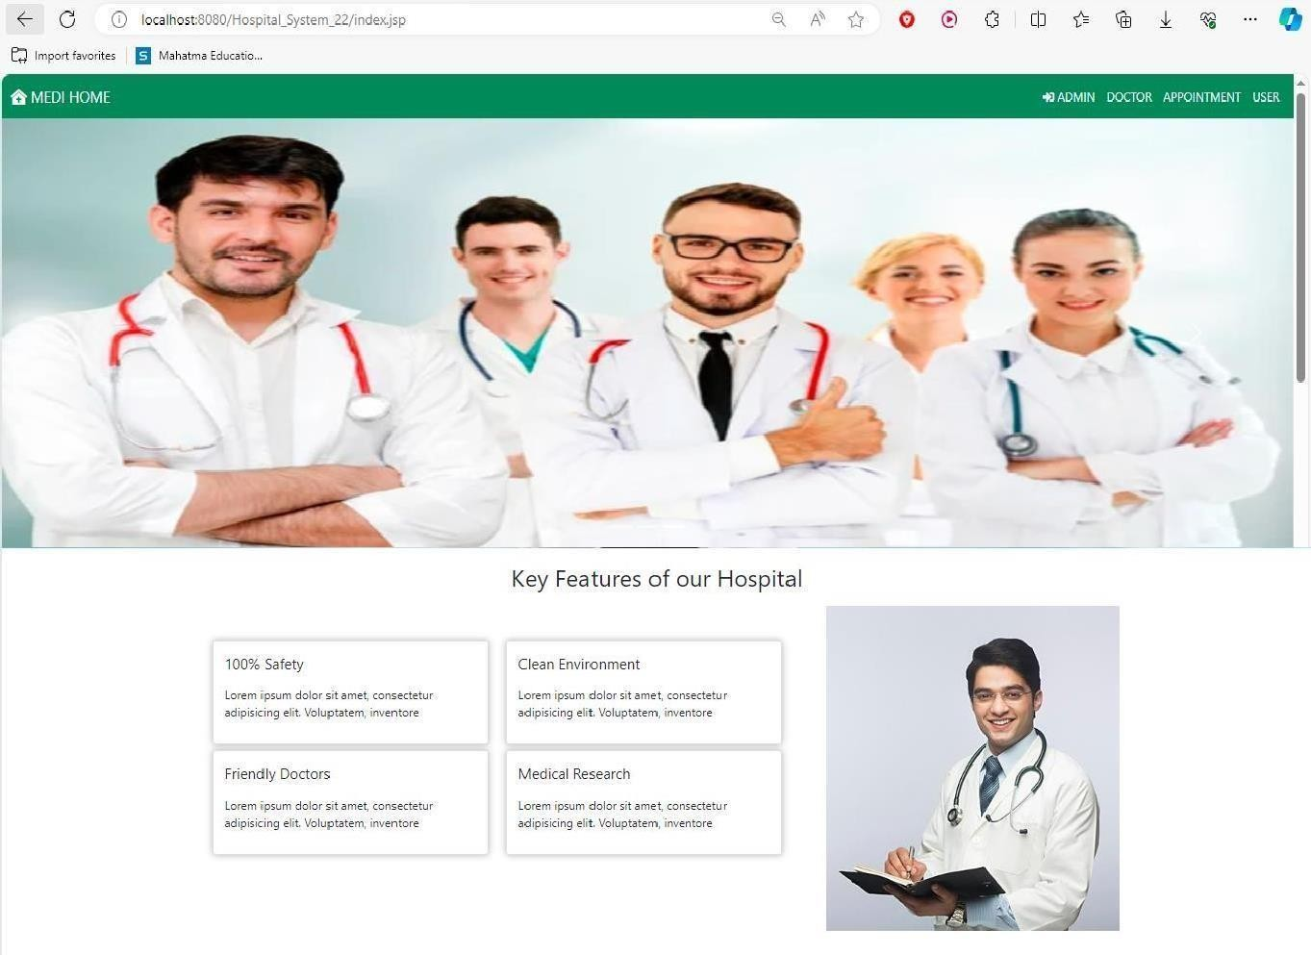
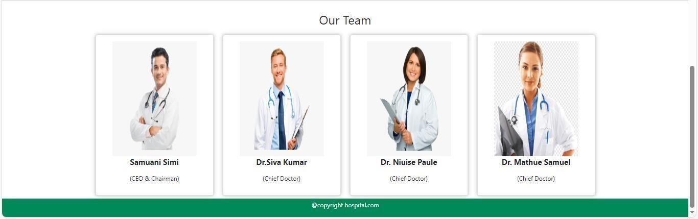
HOME PAGE

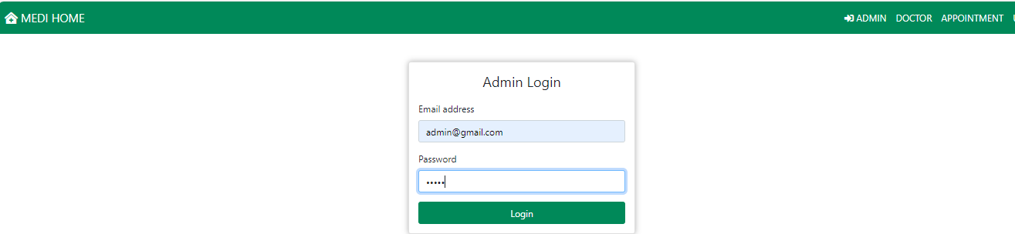
Admin Login
Admin Dashboard.
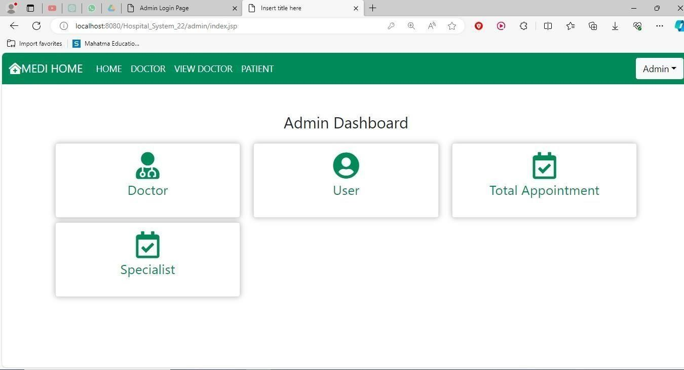

ADD DOCTOR PAGE
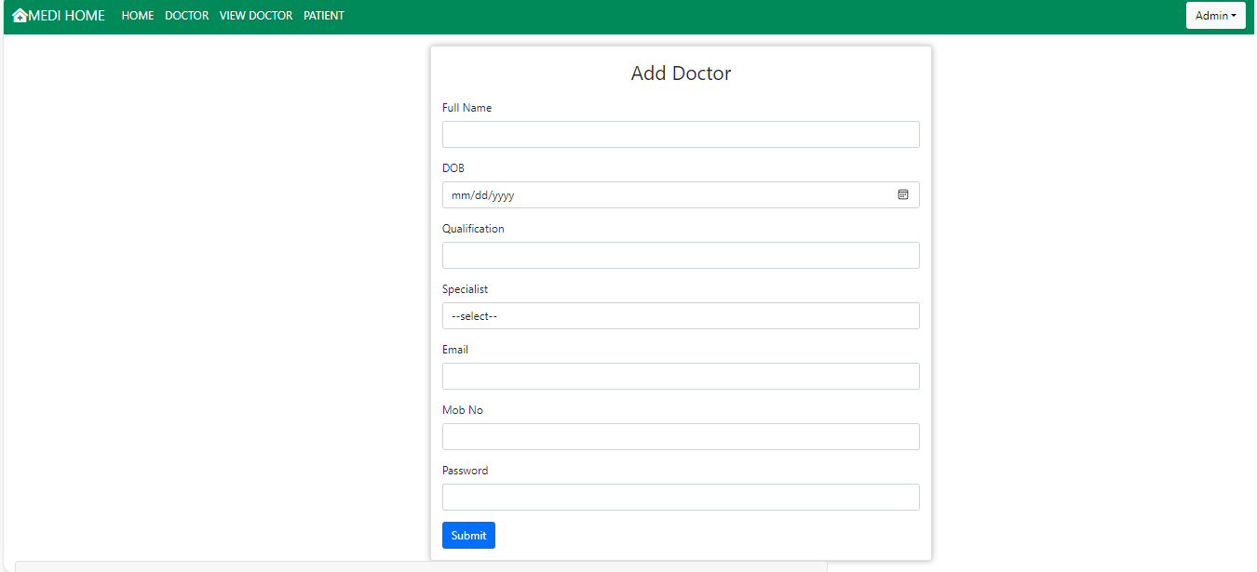

VIEW DOCTOR
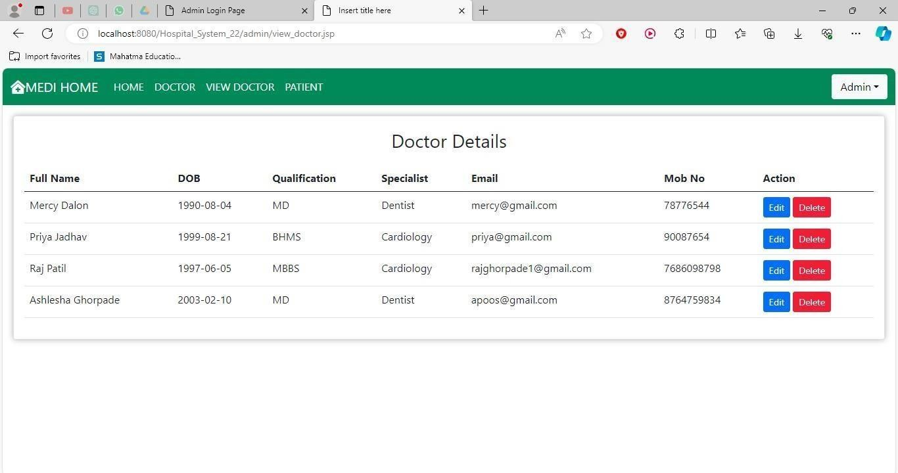

ADD SPECIALIST PAGE

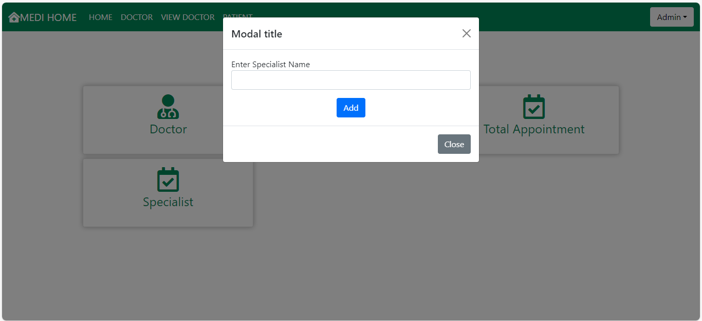

DOCTOR LOGIN PAGE
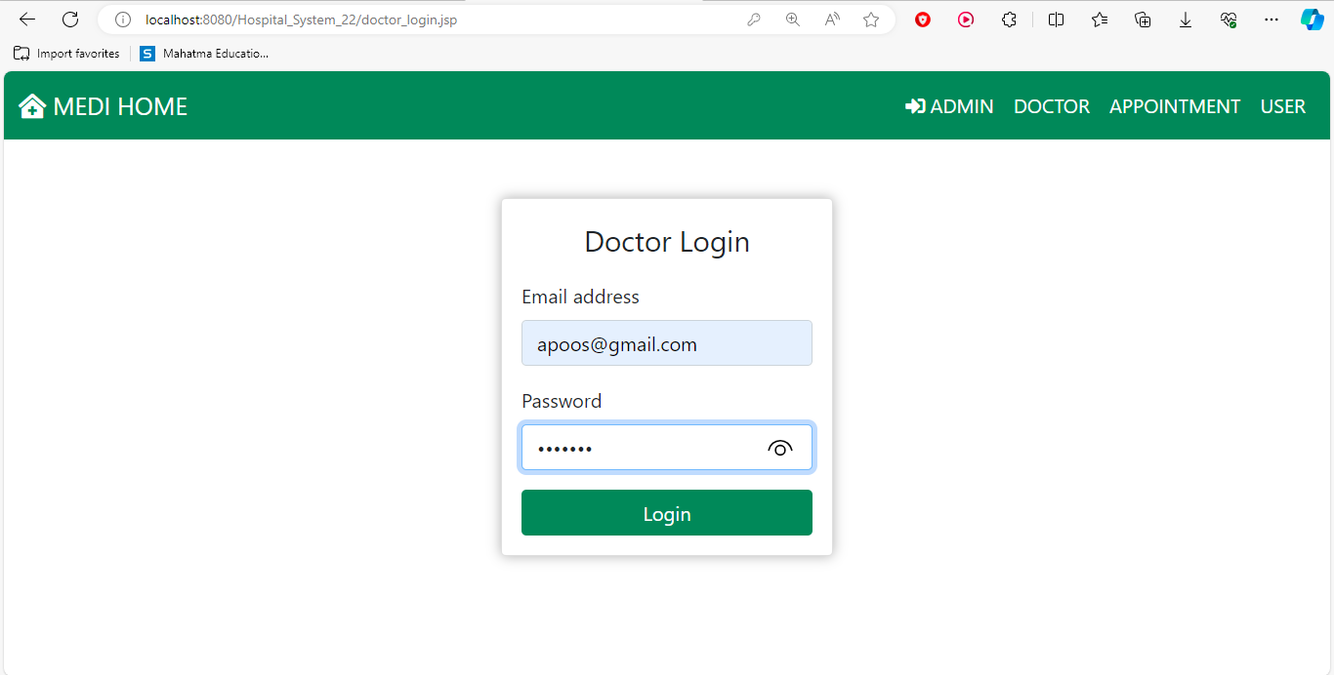

DOCTOR DASHBOARD
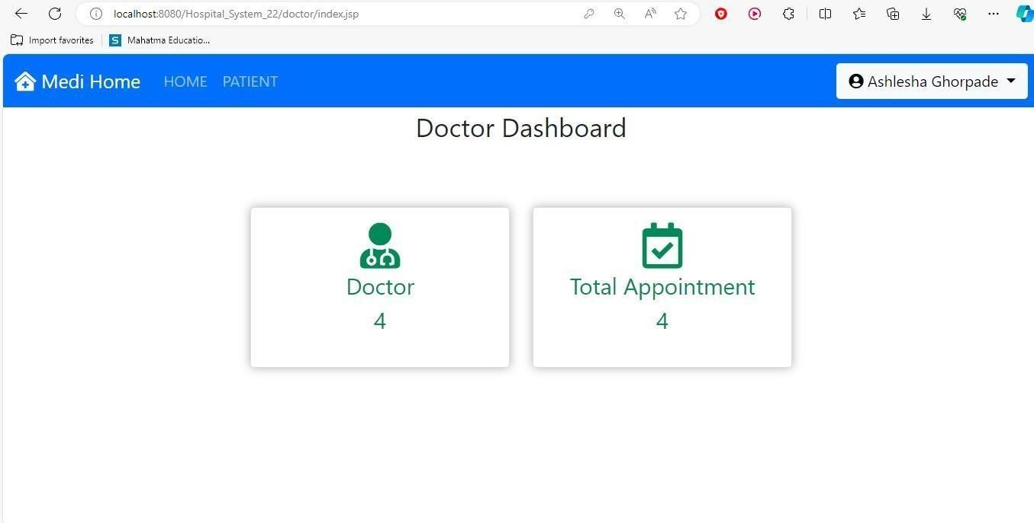

PATIENT DETAILS
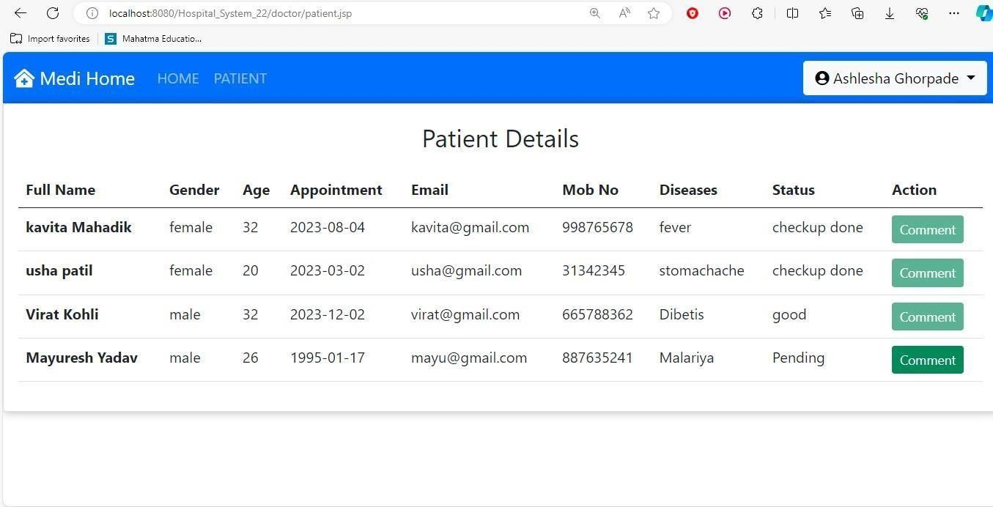

Comment for Patient
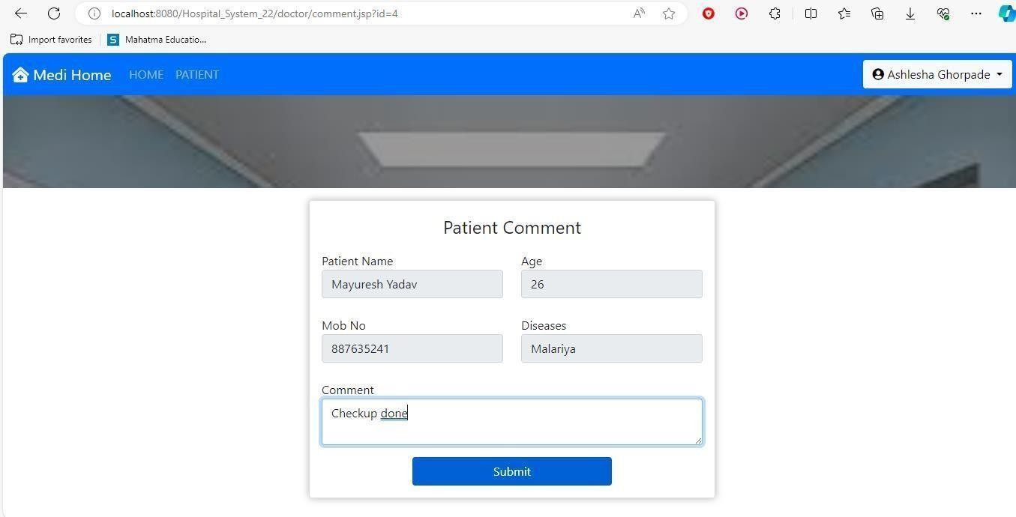

USER LOGIN

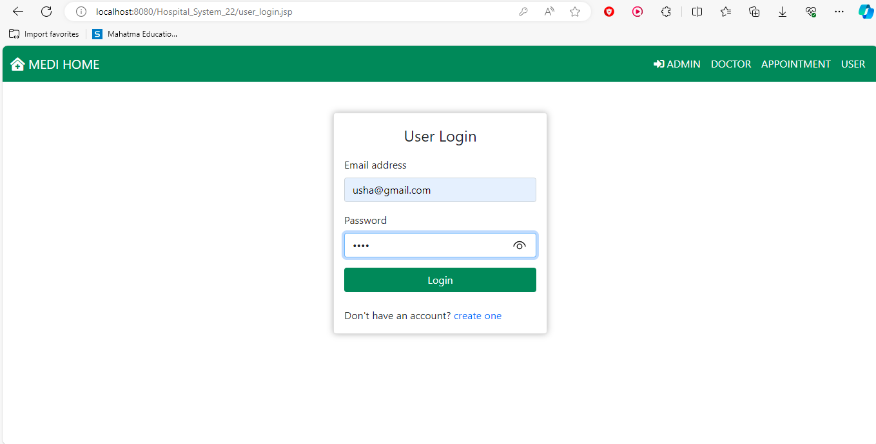

APPOINTEMENT PAGE

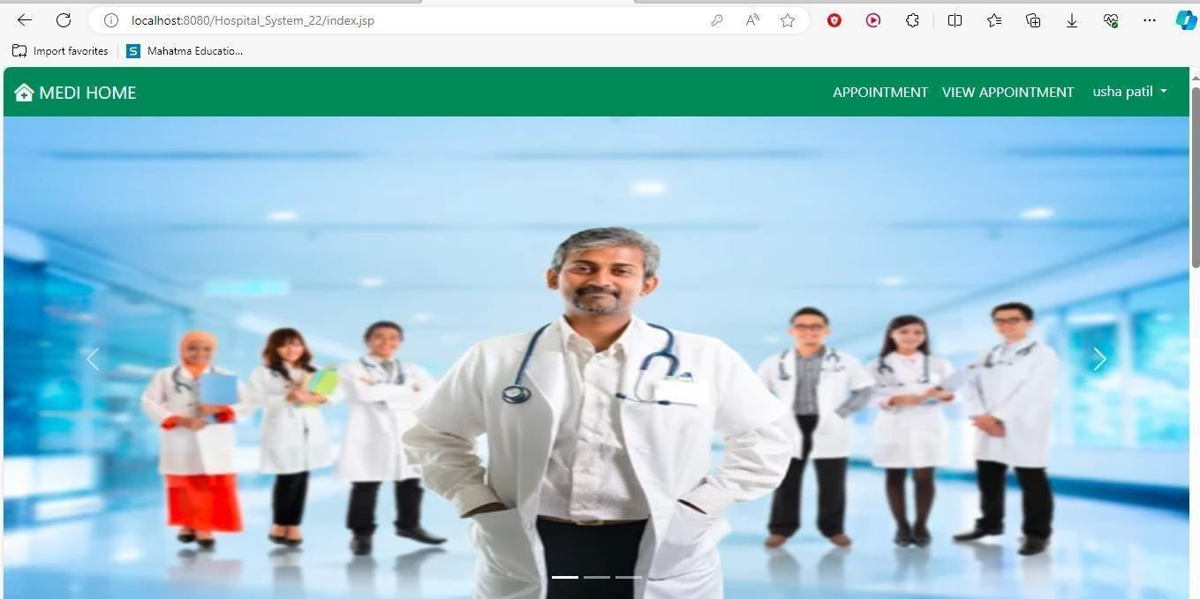

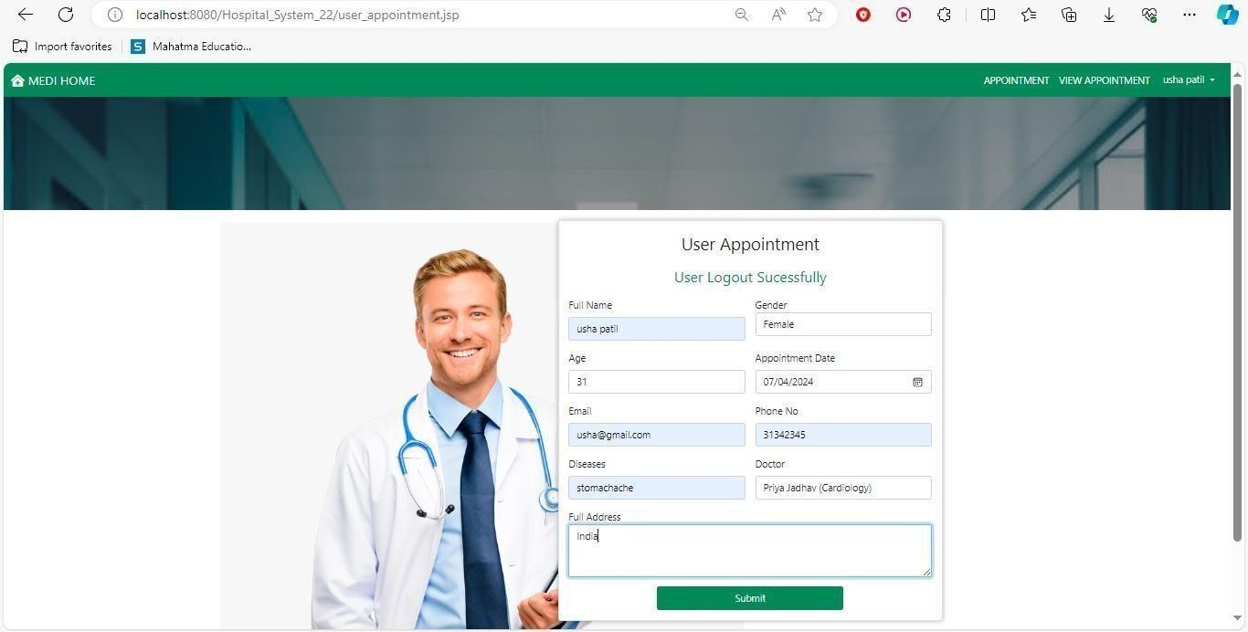

VIEW APPOINTEMENT PAGE

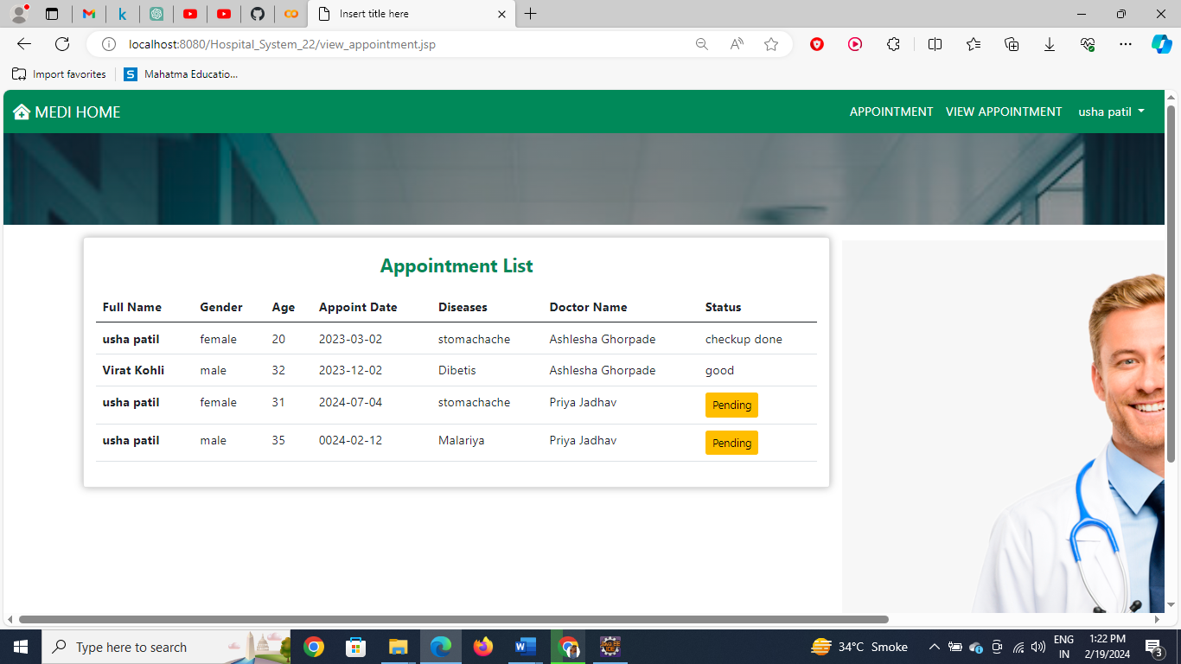
USER REGISTERATION
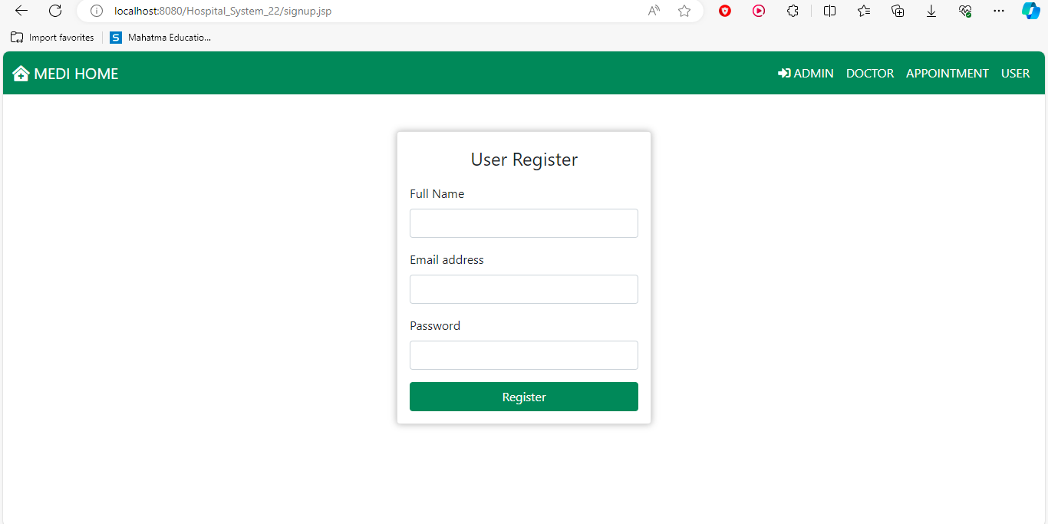

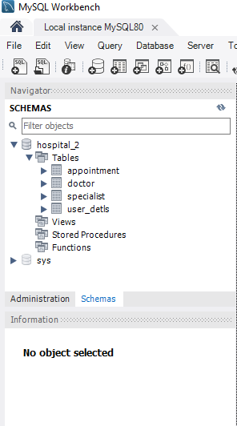
Databases
Appointment table
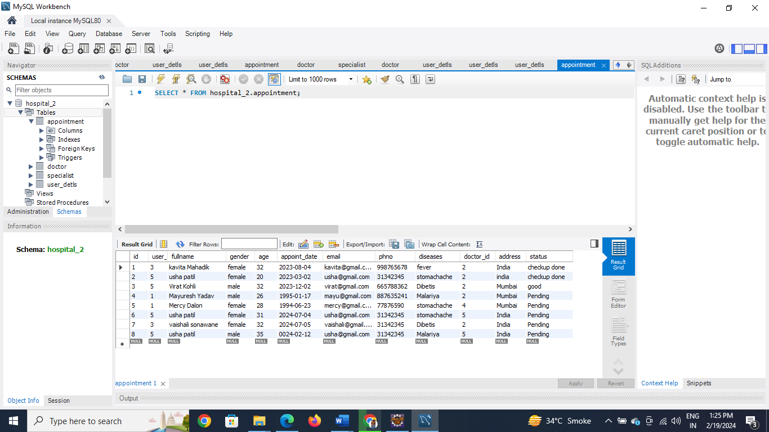

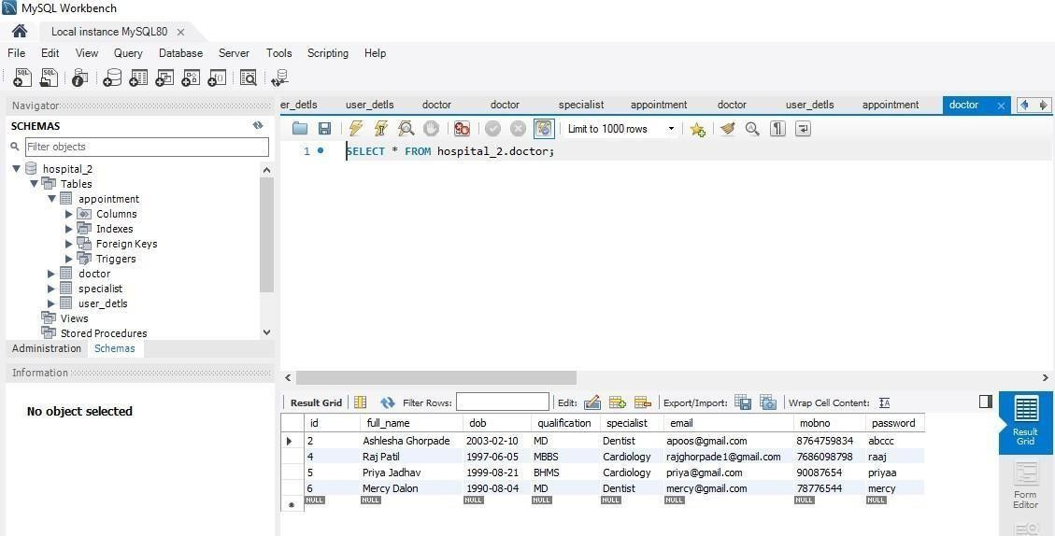
Doctor table
UserDetails table
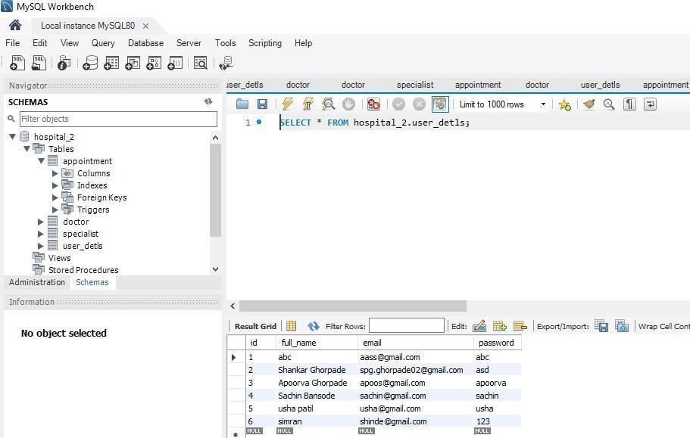
Specialist table
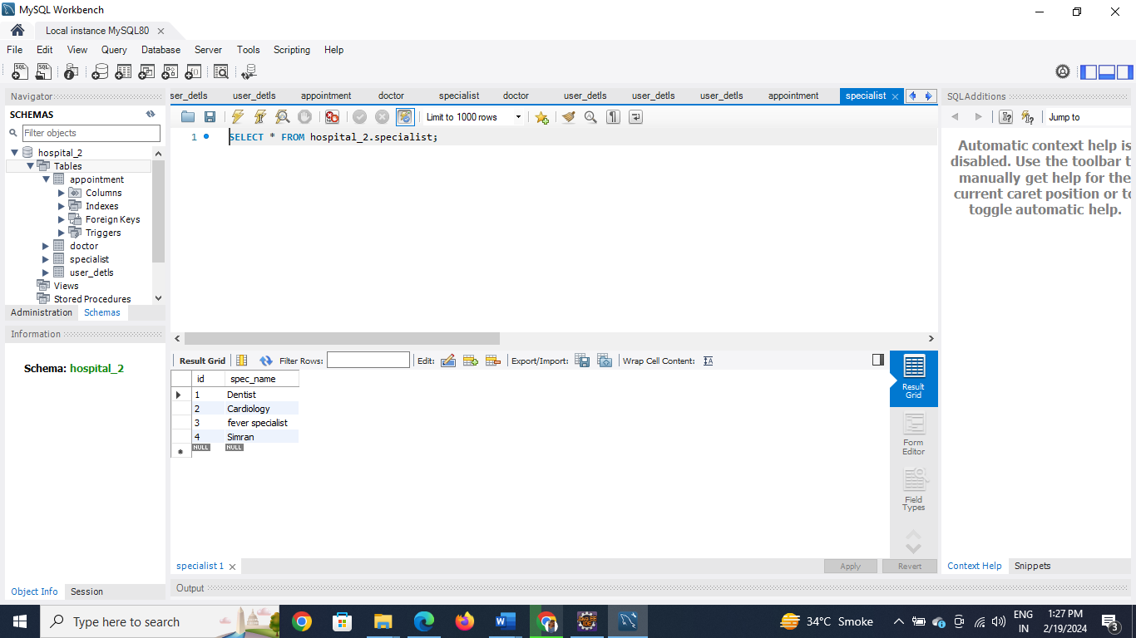

  - SECURITY ISSUES:
Most Common Website Security Issues are as follows:
- SQL INJECTION
SQL injection is a code injection technique that might destroy your database. SQL injection is one of the most common web hacking techniques. SQL injection is the placement of malicious code in SQL statements, via web page input.
- CROSS-SITE-SCRIPTING (XSS):
Cross-Site Scripting (XSS) is a vulnerability that allows attackers to inject malicious scripts into web pages viewed by other users. These scripts can hijack user sessions, deface websites, or redirect users to malicious sites.
- CROSS-SITE-REQUEST-FORGERY (CSRF):
Cross-Site Request Forgery (CSRF) is an attack where an attacker tricks a user into performing actions on a website without their knowledge or consent. This is done by exploiting the trust that a website has in a user's browser. For example, an attacker can craft a malicious link or form that, when clicked or submitted by the victim, performs actions on the victim's behalf.
- BROKEN AUTHENTICATION:
Broken authentication occurs when an application improperly implements authentication mechanisms, allowing attackers to compromise user accounts, passwords, or session tokens. Common vulnerabilities include weak password policies, predictable session tokens, and improper session management.
- SECURITY MISCONFIGURATION:
Security misconfiguration refers to the improper configuration of web servers, frameworks, or applications, leading to vulnerabilities that can be exploited by attackers. This includes default configurations, unnecessary services, open ports, and error messages that reveal sensitive information.
- SENSITIVE DATA EXPOSURE
This web security vulnerability is about crypto and resource protection. Sensitive data should be encrypted at all times, including in transit and at rest. No exceptions. Credit card information and user passwords should never travel or be stored unencrypted, and passwords should always be hashed. Obviously the crypto/hashing algorithm must not be a weak one when in doubt, web security standards recommend AES (256 bits and up) and RSA (2048 bits and up).

  - TEST CASES

Sr. No | Form Name | Test Condition | Steps for procedure | Input Test Data | Actual Output | Pass/Fail
1 | Admin Login | Check login with valid input | Email with  correct password | Email id:admin@gmail.com Password: admin | Admin dashboard opens | Pass
2 | Doctor Login | Check login with valid input | Email with  correct password | Email id: mercy@gmail.com Password: mercy | Doctor dashboard opens | Pass
3 | Admin Login | Check login with invalid input | Email with  Incorrect password | Email id:admin@gmail.com Password:welcome | Invalid email& password | Pass
4 | Doctor Login | Check login with invalid input | Email with  incorrect password | Email id: mercy@gmail.com Password:thankyou | Invalid email& password | Pass
5 | User Login | Check login  With valid input | Email  with correct password | Email id:  apoos@gmail.com  Password : apoorva | User Dashboard opens | Pass
6 | User Login | Check with invalid input | Email with incorrect password | Email id apoos@gmail.com  Password : apurva | Invalid  Email &  password | Pass

CHAPTER 5: System Coding, Implementation and Testing
  - Code of Project
BACKENED

AddDoctor.java
package com.admin.servlet; import java.io.IOException;
import javax.servlet.ServletException; import javax.servlet.annotation.WebServlet; import javax.servlet.http.HttpServlet;
import javax.servlet.http.HttpServletRequest; import javax.servlet.http.HttpServletResponse; import javax.servlet.http.HttpSession;
import com.dao.DoctorDao; import com.db.DBConnect; import com.entity.Doctor;
@WebServlet("/addDoctor")
public class AddDoctor extends HttpServlet { @Override
protected void doPost(HttpServletRequest req, HttpServletResponse resp) throws ServletException, IOException {
try {

String fullName = req.getParameter("fullname"); String dob = req.getParameter("dob");
String qualification = req.getParameter("qualification"); String spec = req.getParameter("spec");
String email = req.getParameter("email"); String mobno = req.getParameter("mobno");
String password = req.getParameter("password");
Doctor d = new Doctor(fullName, dob, qualification, spec, email, mobno, password);
DoctorDao dao = new DoctorDao(DBConnect.getConn()); HttpSession session = req.getSession();
if (dao.registerDoctor(d)) {
session.setAttribute("succMsg", "Doctor Added Sucessfully..");
resp.sendRedirect("admin/doctor.jsp");

} else {
session.setAttribute("errorMsg", "something wrong on server"); resp.sendRedirect("admin/doctor.jsp");

}
} catch (Exception e) {
e.printStackTrace();
} } }

AddSpecialist.java
package com.admin.servlet; import java.io.IOException;
import javax.servlet.ServletException; import javax.servlet.annotation.WebServlet; import javax.servlet.http.HttpServlet;
import javax.servlet.http.HttpServletRequest; import javax.servlet.http.HttpServletResponse; import javax.servlet.http.HttpSession;
import com.dao.SpecialistDao; import com.db.DBConnect; import com.entity.User; @WebServlet("/addSpecialist")
public class AddSpecialist extends HttpServlet { @Override
protected void doPost(HttpServletRequest req, HttpServletResponse resp) throws ServletException, IOException {
String specName = req.getParameter("specName"); SpecialistDao dao = new SpecialistDao(DBConnect.getConn()); boolean f = dao.addSpecialist(specName);
HttpSession session = req.getSession(); if (f) {

} else {

}}}
session.setAttribute("succMsg", "Specialist Added"); resp.sendRedirect("admin/index.jsp");

session.setAttribute("errorMsg", "something wrong on server"); resp.sendRedirect("admin/index.jsp");

AdminLogin.java
package com.admin.servlet; import java.io.IOException;
import javax.servlet.ServletException; import javax.servlet.annotation.WebServlet;
import javax.servlet.http.HttpServlet;
import javax.servlet.http.HttpServletRequest; import javax.servlet.http.HttpServletResponse; import javax.servlet.http.HttpSession;
import com.entity.User; @WebServlet("/adminLogin")
public class AdminLogin extends HttpServlet {
@Override
protected void doPost(HttpServletRequest req, HttpServletResponse resp) throws ServletException, IOException {
try {
String email = req.getParameter("email");
String password = req.getParameter("password"); HttpSession session = req.getSession();
if ("admin@gmail.com".equals(email) && "admin".equals(password)) { session.setAttribute("adminObj", new User()); resp.sendRedirect("admin/index.jsp");

} else {

}

session.setAttribute("errorMsg", "invalid email & password"); resp.sendRedirect("admin_login.jsp");

} catch (Exception e) {
e.printStackTrace();
}}}

AdminLogout.java
package com.admin.servlet; import java.io.IOException;
import javax.servlet.ServletException; import javax.servlet.annotation.WebServlet; import javax.servlet.http.HttpServlet;
import javax.servlet.http.HttpServletRequest; import javax.servlet.http.HttpServletResponse; import javax.servlet.http.HttpSession; @WebServlet("/adminLogout")
public class AdminLogout extends HttpServlet { @Overrideprotected void doGet(HttpServletRequest req, HttpServletResponse resp) throws ServletException, IOException {
HttpSession session = req.getSession(); session.removeAttribute("adminObj"); session.setAttribute("succMsg", "Admin Logout Sucessfully"); resp.sendRedirect("admin_login.jsp");
}}

DeleteDoctor.java
package com.admin.servlet; import java.io.IOException;
import javax.servlet.ServletException; import javax.servlet.annotation.WebServlet; import javax.servlet.http.HttpServlet;
import javax.servlet.http.HttpServletRequest; import javax.servlet.http.HttpServletResponse; import javax.servlet.http.HttpSession;
import com.dao.DoctorDao; import com.db.DBConnect; @WebServlet("/deleteDoctor")
public class DeleteDoctor extends HttpServlet { @Override
protected void doGet(HttpServletRequest req, HttpServletResponse resp) throws ServletException, IOException {
int id = Integer.parseInt(req.getParameter("id")); DoctorDao dao = new DoctorDao(DBConnect.getConn()); HttpSession session = req.getSession();
if (dao.deleteDoctor(id)) {
session.setAttribute("succMsg", "Doctor Delete Sucessfully.."); resp.sendRedirect("admin/view_doctor.jsp");

} else {

}}}
session.setAttribute("errorMsg", "something wrong on server"); resp.sendRedirect("admin/view_doctor.jsp");

UpdateDoctor.java
package com.admin.servlet; import java.io.IOException;
import javax.servlet.ServletException; import javax.servlet.annotation.WebServlet; import javax.servlet.http.HttpServlet;
import javax.servlet.http.HttpServletRequest; import javax.servlet.http.HttpServletResponse; import javax.servlet.http.HttpSession;
import com.dao.DoctorDao; import com.db.DBConnect; import com.entity.Doctor; @WebServlet("/updateDoctor")
public class UpdateDoctor extends HttpServlet { @Override
protected void doPost(HttpServletRequest req, HttpServletResponse resp) throws ServletException, IOException {
try {

password);
String fullName = req.getParameter("fullname"); String dob = req.getParameter("dob");
String qualification = req.getParameter("qualification"); String spec = req.getParameter("spec");
String email = req.getParameter("email"); String mobno = req.getParameter("mobno");
String password = req.getParameter("password"); int id = Integer.parseInt(req.getParameter("id"));
Doctor d = new Doctor(id,fullName, dob, qualification, spec, email, mobno,

DoctorDao dao = new DoctorDao(DBConnect.getConn()); HttpSession session = req.getSession();
if (dao.updateDoctor(d)) {
session.setAttribute("succMsg", "Doctor Update Sucessfully.."); resp.sendRedirect("admin/view_doctor.jsp");

} else {

}

session.setAttribute("errorMsg", "something wrong on server"); resp.sendRedirect("admin/view_doctor.jsp");

} catch (Exception e) {
e.printStackTrace();
}}}

DBConnect.java
package com.db;
import java.sql.Connection; import java.sql.DriverManager; public class DBConnect {
private static Connection conn; public static Connection getConn()
{
try {
Class.forName("com.mysql.cj.jdbc.Driver"); conn =
DriverManager.getConnection("jdbc:mysql://localhost:3306/hospital_2", "root", "root75");
} catch (Exception e) {
e.printStackTrace();
}
return conn; }}

DoctorLogin.java
package com.doctor.servlet; import java.io.IOException;
import javax.servlet.ServletException; import javax.servlet.annotation.WebServlet; import javax.servlet.http.HttpServlet;
import javax.servlet.http.HttpServletRequest; import javax.servlet.http.HttpServletResponse; import javax.servlet.http.HttpSession;
import com.dao.DoctorDao; import com.db.DBConnect; import com.entity.Doctor; @WebServlet("/doctorLogin")
public class DoctorLogin extends HttpServlet { @Override
protected void doPost(HttpServletRequest req, HttpServletResponse resp) throws ServletException, IOException {
String email = req.getParameter("email");
String password = req.getParameter("password"); HttpSession session = req.getSession();
DoctorDao dao = new DoctorDao(DBConnect.getConn()); Doctor doctor = dao.login(email, password);
if (doctor != null) {

} else {

}}}
session.setAttribute("doctObj", doctor); resp.sendRedirect("doctor/index.jsp");

session.setAttribute("errorMsg", "invalid email & password"); resp.sendRedirect("doctor_login.jsp");

DoctorLogout.java
package com.doctor.servlet; import java.io.IOException;
import javax.servlet.ServletException; import javax.servlet.annotation.WebServlet; import javax.servlet.http.HttpServlet;
import javax.servlet.http.HttpServletRequest; import javax.servlet.http.HttpServletResponse; import javax.servlet.http.HttpSession; @WebServlet("/doctorLogout")
public class DoctorLogout extends HttpServlet{ @Override
protected void doGet(HttpServletRequest req, HttpServletResponse resp) throws ServletException, IOException {
HttpSession session = req.getSession(); session.removeAttribute("doctObj"); session.setAttribute("succMsg", "Doctor Logout Sucessfully"); resp.sendRedirect("doctor_login.jsp");
}}

UserRegister.java
package com.user.servlet; import java.io.IOException;
import javax.servlet.ServletException; import javax.servlet.annotation.WebServlet; import javax.servlet.http.HttpServlet;
import javax.servlet.http.HttpServletRequest; import javax.servlet.http.HttpServletResponse; import javax.servlet.http.HttpSession;
import com.dao.UserDao; import com.db.DBConnect;

import com.entity.User; @WebServlet("/user_register")
public class UserRegister extends HttpServlet { private static final long serialVersionUID = 1L;
protected void doPost(HttpServletRequest req, HttpServletResponse resp) throws ServletException, IOException {
try {
String fullName = req.getParameter("fullname"); String email = req.getParameter("email");
String password = req.getParameter("password"); User user = new User(fullName, email, password);
UserDao userDao = new UserDao(DBConnect.getConn()); HttpSession session = req.getSession();
boolean isSuccess = userDao.register(user); if (isSuccess) {
session.setAttribute("sucMsg", "Registration Successful"); resp.sendRedirect("signup.jsp");
} else {
session.setAttribute("errorMsg", "Something went wrong on the server"); resp.sendRedirect("signup.jsp");
}
} catch (Exception e) { e.printStackTrace();
// Log the exception or handle it appropriately
} }}

User.java
package com.entity; public class User {
private int id;
private String fullName; private String email; private String password; public User() {
super();
// TODO Auto-generated constructor stub
}
public User(String fullName, String email, String password) { super();
this.fullName = fullName; this.email = email; this.password = password;
}

public int getId() {
return id;
}
public void setId(int id) {
this.id = id;
}
public String getFullName() { return fullName;
}
public void setFullName(String fullName) { this.fullName = fullName;
}
public String getEmail() {
return email;
}
public void setEmail(String email) { this.email = email;
}
public String getPassword() { return password;
}
public void setPassword(String password) { this.password = password;
} }

UserLogin.java
package com.user.servlet; import java.io.IOException;
import javax.servlet.ServletException; import javax.servlet.annotation.WebServlet; import javax.servlet.http.HttpServlet;
import javax.servlet.http.HttpServletRequest; import javax.servlet.http.HttpServletResponse; import javax.servlet.http.HttpSession;
import com.dao.UserDao; import com.db.DBConnect; import com.entity.User; @WebServlet("/userLogin")
public class UserLogin extends HttpServlet {

@Override
protected void doPost(HttpServletRequest req, HttpServletResponse resp) throws ServletException, IOException {
String email = req.getParameter("email");
String password = req.getParameter("password"); HttpSession session = req.getSession();
UserDao dao = new UserDao(DBConnect.getConn()); User user = dao.login(email, password);
if (user != null) {
session.setAttribute("userObj", user); resp.sendRedirect("index.jsp");

} else {

}}}

session.setAttribute("errorMsg", "invalid email & password"); resp.sendRedirect("user_login.jsp");

UserLogout.java
package com.user.servlet; import java.io.IOException;
import javax.servlet.ServletException; import javax.servlet.annotation.WebServlet; import javax.servlet.http.HttpServlet;
import javax.servlet.http.HttpServletRequest; import javax.servlet.http.HttpServletResponse; import javax.servlet.http.HttpSession; @WebServlet("/userLogout")
public class UserLogout extends HttpServlet {

@Override
protected void doGet(HttpServletRequest req, HttpServletResponse resp) throws ServletException, IOException {
HttpSession session = req.getSession(); session.removeAttribute("userObj"); session.setAttribute("succMsg", "User Logout Sucessfully"); resp.sendRedirect("user_login.jsp");
}}

UserRegister.java
package com.user.servlet; import java.io.IOException;
import javax.servlet.ServletException; import javax.servlet.annotation.WebServlet; import javax.servlet.http.HttpServlet;
import javax.servlet.http.HttpServletRequest; import javax.servlet.http.HttpServletResponse; import javax.servlet.http.HttpSession;
import com.dao.UserDao; import com.db.DBConnect; import com.entity.User; @WebServlet("/user_register")
public class UserRegister extends HttpServlet { private static final long serialVersionUID = 1L;
protected void doPost(HttpServletRequest req, HttpServletResponse resp) throws ServletException, IOException {
try {
String fullName = req.getParameter("fullname"); String email = req.getParameter("email");
String password = req.getParameter("password"); User user = new User(fullName, email, password);
UserDao userDao = new UserDao(DBConnect.getConn()); HttpSession session = req.getSession();
boolean isSuccess = userDao.register(user); if (isSuccess) {
session.setAttribute("sucMsg", "Registration Successful"); resp.sendRedirect("signup.jsp");
} else {
session.setAttribute("errorMsg", "Something went wrong on the server"); resp.sendRedirect("signup.jsp");
}
} catch (Exception e) { e.printStackTrace();
// Log the exception or handle it appropriately
} } }

FRONTEND

doctor.jsp
<%@page import="com.entity.Doctor"%>
<%@page import="com.dao.DoctorDao"%>
<%@page import="com.entity.Specalist"%>
<%@page import="java.util.List"%>
<%@page import="com.db.DBConnect"%>
<%@page import="com.dao.SpecialistDao"%>
<%@ page language="java" contentType="text/html; charset=ISO-8859-1" pageEncoding="ISO-8859-1"%>
<!DOCTYPE html>
<html>
<head>
<meta charset="ISO-8859-1">
<title>Insert title here</title>
<%@include file="../component/allcss.jsp"%>
<style type="text/css">
.paint-card {
box-shadow: 0 0 10px 0 rgba(0, 0, 0, 0.3);
}
</style>
</head>
<body>
<%@include file="navbar.jsp"%>
<div class="container-fluid p-3">
<div class="row">
<div class="col-md-5 offset-md-4">
<div class="card paint-card">
<div class="card-body">
<p class="fs-3 text-center">Add Doctor</p>
<c:if test="${not empty errorMsg}">
<p class="fs-3 text-center text-

danger">${errorMsg}</p>

/>

</c:if>

<c:remove var="errorMsg" scope="session"

role="alert">${succMsg}</div>
<c:if test="${not empty succMsg}">
<div class="fs-3 text-center text-success"

<c:remove var="succMsg" scope="session" />
</c:if>
<form action="../addDoctor" method="post">

class="form-control">

class="form-control">

class="form-control">

SpecialistDao(DBConnect.getConn());
<div class="mb-3">
<label class="form-label">Full Name</label>
<input type="text" required name="fullname"

</div>
<div class="mb-3">
<label class="form-label">DOB</label>
<input type="date" required name="dob"

</div>
<div class="mb-3">
<label class="form-label">Qualification</label>
<input required name="qualification" type="text"

</div>
<div class="mb-3">
<label class="form-label">Specialist</label>
<select name="spec" required class="form-control">
<option>--select--</option>
<%
SpecialistDao dao = new

List<Specalist> list = dao.getAllSpecialist(); for (Specalist s : list) {
%>
<option><%=s.getSpecialistName()%></option>
<%
}
%>
</select>
</div>
<div class="mb-3">
<label class="form-label">Email</label>

<input type="text" required name="email" class="form-control">
</div>
<div class="mb-3">

class="form-control">

class="form-control">

primary">Submit</button>

</div>

</div>

</div>
<label class="form-label">Mob No</label>
<input type="text" required name="mobno"

</div>
<div class="mb-3">
<label class="form-label">Password</label>
<input required name="password" type="password"

</div>
<button type="submit" class="btn btn-

</form>

<div class="col-md-8">
<div class="card card-sh">
<div class="card-header">
<p class="fs-4 text-center">Doctor Details</p>
</div>
<div class="card-body">
<table class="table">
<thead>
<tr>
<th scope="col">FullName</th>
<th scope="col">DOB</th>
<th scope="col">Qualification</th>
<th scope="col">Specialist</th>
<th scope="col">Email</th>
<th scope="col">Mob No</th>
<th scope="col">Action</th>
</tr>
</thead>
<tbody>
<%
DoctorDao dao2 = new DoctorDao(DBConnect.getConn()); List<Doctor> list2 = dao2.getAllDoctor();
for (Doctor d : list2) {
%>
<tr>

<td><%=d.getFullName()%></td>
<td><%=d.getDob()%></td>
<td><%=d.getQualification()%></td>
<td><%=d.getSpecialist()%></td>
<td><%=d.getEmail()%></td>
<td><%=d.getMobNo()%></td>
<td>
<a href="edit_doctor.jsp?id=<%=d.getId()%>" class="btn btn-sm btn-primary">Edit</a> <a href="../deleteDoctor.jsp?id=<%=d.getId()%>" class="btn btn-sm btn-danger">Delete</a></td>

</div>
</div>
</body>
</html>
</tr>
<%
}
%>
</tbody>
</table>
</div>

index.jsp
<%@page import="com.db.DBConnect"%>
<%@ page language="java" contentType="text/html; charset=ISO-8859-1" pageEncoding="ISO-8859-1"%>
<!DOCTYPE html>
<html>
<head>
<meta charset="ISO-8859-1">
<title>Insert title here</title>
<style type="text/css">
.paint-card {
box-shadow: 0 0 10px 0 rgba(0, 0, 0, 0.3);
}
</style>

<%@include file="../component/allcss.jsp"%>
</head>
<body>
<%@include file="navbar.jsp"%>
<c:if test="${ empty adminObj }">
<c:redirect url="../admin_login.jsp"></c:redirect>
</c:if>
<div class="container p-5">
<p class="text-center fs-3">Admin Dashboard</p>
<c:if test="${not empty errorMsg}">
<p class="fs-3 text-center text-danger">${errorMsg}</p>
<c:remove var="errorMsg" scope="session" />
</c:if>
<c:if test="${not empty succMsg}">
<div class="fs-3 text-center text-success" role="alert">${succMsg}</div>

<c:remove var="succMsg" scope="session" />
</c:if>
<div class="row">
<div class="col-md-4">
<div class="card paint-card">
<div class="card-body text-center text-success">
<i class="fas fa-user-md fa-3x"></i><br>
<p class="fs-4 text-center"> Doctor <br>
</p>
</div>
</div>
</div>
<div class="col-md-4">
<div class="card paint-card">
<div class="card-body text-center text-success">
<i class="fas fa-user-circle fa-3x"></i><br>
<p class="fs-4 text-center"> User <br>
</p>
</div>
</div>
</div>

<div class="col-md-4">
<div class="card paint-card">
<div class="card-body text-center text-success">
<i class="far fa-calendar-check fa-3x"></i><br>
<p class="fs-4 text-center"> Total Appointment <br>
</p>
</div>
</div>
</div>
<div class="col-md-4 mt-2">
<div class="card paint-card " data-bs-toggle="modal" data-bs-target="#exampleModal">
<div class="card-body text-center text-success">
<i class="far fa-calendar-check fa-3x"></i><br>
<p class="fs-4 text-center"> Specialist <br></p>
</div></div></div></div>
</div>
<!-- Modal -->
<div class="modal fade" id="exampleModal" tabindex="-1" aria-labelledby="exampleModalLabel" aria-hidden="true">
<div class="modal-dialog">
<div class="modal-content">
<div class="modal-header">
<h5 class="modal-title" id="exampleModalLabel">Modal title</h5>
<button type="button" class="btn-close" data-bs-dismiss="modal" aria-label="Close"></button>
</div><div class="modal-body">
<form action="../addSpecialist" method="post">
<div class="form-group">
<label>Enter Specialist Name</label>
<input type="text" name="specName" class="form-control"></div>
<div class="text-center mt-3">
<button type="submit" class="btn btn-primary">Add</button>
</div>
</form></div>
<div class="modal-footer">
<button type="button" class="btn btn-secondary"

data-bs-dismiss="modal">Close</button></div></div></div>
</div>
</body>
</html>

navbar.jsp
<%@ taglib prefix="c" uri="http://java.sun.com/jsp/jstl/core"%>
<%@page isELIgnored="false"%>
<nav class="navbar navbar-expand-lg navbar-dark bg-success">
<div class="container-fluid">
<a class="navbar-brand" href="index.jsp">
<i class="fas fa-clinic-medical"></i>MEDI HOME</a>
<button class="navbar-toggler" type="button" data-bs-toggle="collapse" data-bs-target="#navbarSupportedContent"
aria-controls="navbarSupportedContent" aria-expanded="false" aria-label="Toggle navigation">
<span class="navbar-toggler-icon"></span>
</button>
<div class="collapse navbar-collapse" id="navbarSupportedContent">
<ul class="navbar-nav me-auto mb-2 mb-lg-0">
<li class="nav-item"><a class="nav-link active" href="index.jsp">HOME</a></li>

<li class="nav-item"><a class="nav-link active" href="doctor.jsp">DOCTOR</a></li>
<li class="nav-item"><a class="nav-link active" href="view_doctor.jsp"> VIEW DOCTOR</a></li>
<li class="nav-item"><a class="nav-link active" href="patient.jsp"> PATIENT</a></li>
</ul>
<form class="d-flex">
<div class="dropdown">
<button class="btn btn-light dropdown-toggle" type="button" id="dropdownMenuButton1" data-bs-toggle="dropdown" aria-expanded="false">Admin</button>
<ul class="dropdown-menu" aria-labelledby="dropdownMenuButton1">
<li><a class="dropdown-item" href="../adminLogout">Logout</a></li>
</ul>
</div></form>
</div></div>
</nav>

patient.jsp
<%@page import="com.entity.Doctor"%>
<%@page import="com.dao.DoctorDao"%>
<%@page import="com.entity.Appointment"%>
<%@page import="java.util.List"%>
<%@page import="com.db.DBConnect"%>
<%@page import="com.dao.AppointmentDAO"%>
<%@ page language="java" contentType="text/html; charset=ISO-8859-1" pageEncoding="ISO-8859-1"%>
<!DOCTYPE html>
<html>
<head>
<meta charset="ISO-8859-1">
<title>Insert title here</title>
<%@include file="../component/allcss.jsp"%>
<style type="text/css">
.paint-card {
box-shadow: 0 0 10px 0 rgba(0, 0, 0, 0.3);
}
</style>
</head>
<body>
<%@include file="navbar.jsp"%>
<div class="col-md-12">
<div class="card paint-card">
<div class="card-body">
<p class="fs-3 text-center">Patient Details</p>
<table class="table">
<thead>
<tr>
<th scope="col">Full Name</th>
<th scope="col">Gender</th>
<th scope="col">Age</th>
<th scope="col">Appointment</th>
<th scope="col">Email</th>
<th scope="col">Mob No</th>
<th scope="col">Diseases</th>
<th scope="col">Doctor Name</th>
<th scope="col">Address</th>

<th scope="col">Status</th>
</tr>
</thead>
<tbody>
<%
AppointmentDAO dao = new AppointmentDAO(DBConnect.getConn()); DoctorDao dao2 = new DoctorDao(DBConnect.getConn()); List<Appointment> list = dao.getAllAppointment();
for (Appointment ap : list) {
Doctor d = dao2.getDoctorById(ap.getDoctorId());
%>
<tr>
<th><%=ap.getFullName()%></th>
<td><%=ap.getGender()%></td>
<td><%=ap.getAge()%></td>
<td><%=ap.getAppoinDate()%></td>
<td><%=ap.getEmail()%></td>
<td><%=ap.getPhNo()%></td>
<td><%=ap.getDiseases()%></td>
<td><%=d.getFullName()%></td>
<td><%=ap.getAddress()%></td>
<td><%=ap.getStatus()%></td>
</tr>
<%
}
%>
</tbody>
</table></div></div></div>
</body>
</html>

ComponentFolder allcss.jsp
<link href="https://cdn.jsdelivr.net/npm/bootstrap@5.0.2/dist/css/bootstrap.min.css" rel="stylesheet"
integrity="sha384- EVSTQN3/azprG1Anm3QDgpJLIm9Nao0Yz1ztcQTwFspd3yD65VohhpuuCOmLASjC"
crossorigin="anonymous">
<link rel="stylesheet"
href="https://cdnjs.cloudflare.com/ajax/libs/font-awesome/5.15.4/css/all.min.css"

integrity="sha512- 1ycn6IcaQQ40/MKBW2W4Rhis/DbILU74C1vSrLJxCq57o941Ym01SwNsOMqvEBFlcgUa6xLiPY/ NS5R+E6ztJQ=="
crossorigin="anonymous" referrerpolicy="no-referrer" />
<script src="https://cdn.jsdelivr.net/npm/bootstrap@5.0.2/dist/js/bootstrap.bundle.min.js"
integrity="sha384- MrcW6ZMFYlzcLA8Nl+NtUVF0sA7MsXsP1UyJoMp4YLEuNSfAP+JcXn/tWtIaxVXM"
crossorigin="anonymous"></script> footer.jsp
<div class="container-fluid p-1 bg-success text-center text-white">
<p>@copyright hospital.com</p>
</div>

navbar.jsp
<%@ taglib prefix="c" uri="http://java.sun.com/jsp/jstl/core"%>
<%@page isELIgnored="false"%>
<nav class="navbar navbar-expand-lg navbar-dark bg-success">
<div class="container-fluid">
<a class="navbar-brand" href="index.jsp"><i
class="fas fa-clinic-medical"></i> MEDI HOME</a>
<button class="navbar-toggler" type="button" data-bs-toggle="collapse" data-bs-target="#navbarSupportedContent"
aria-controls="navbarSupportedContent" aria-expanded="false" aria-label="Toggle navigation">
<span class="navbar-toggler-icon"></span>
</button>
<div class="collapse navbar-collapse" id="navbarSupportedContent">
<ul class="navbar-nav ms-auto mb-2 mb-lg-0">
<c:if test="${empty userObj }">
<li class="nav-item"><a class="nav-link active" aria-current="page" href="admin_login.jsp"><i class="fas fa-sign-in-alt"></i> ADMIN</a></li>
<li class="nav-item"><a class="nav-link active"
aria-current="page" href="doctor_login.jsp">DOCTOR</a></li>
<li class="nav-item"><a class="nav-link active"
aria-current="page" href="view_appointment.jsp">APPOINTMENT</a></li>
<li class="nav-item"><a class="nav-link active"
aria-current="page" href="user_login.jsp">USER</a></li>
</c:if>
<c:if test="${not empty userObj }">
<li class="nav-item"><a class="nav-link active"
aria-current="page" href="user_appointment.jsp">APPOINTMENT</a></li>
<li class="nav-item"><a class="nav-link active"
aria-current="page" href="view_appointment.jsp">VIEW APPOINTMENT</a></li>
<div class="dropdown">
<button class="btn btn-success dropdown-toggle" type="button" id="dropdownMenuButton1" data-bs-toggle="dropdown"
aria-expanded="false">
<i class="fa-solid fa-circle-user"></i> ${userObj.fullName }
</button>
<ul class="dropdown-menu" aria-labelledby="dropdownMenuButton1">
<li><a class="dropdown-item" href="change_password.jsp">Change Password</a></li>
<li><a class="dropdown-item" href="userLogout">Logout</a></li>
</ul>
</div>
</c:if></ul></div>
</div>
</nav>

admin_login.jsp
<%@ page language="java" contentType="text/html; charset=UTF-8" pageEncoding="UTF-8"%>
<%@ taglib prefix="c" uri="http://java.sun.com/jsp/jstl/core"%>
<%@page isELIgnored="false"%>
<!DOCTYPE html>
<html>
<head>
<meta charset="UTF-8">
<title>Admin Login Page</title>
<%@include file="component/allcss.jsp"%>
<style type="text/css">
.paint-card {
box-shadow: 0 0 10px 0 rgba(0, 0, 0, 0.3);

}
</style>
</head>
<body>
<%@include file="component/navbar.jsp"%>
<div class="container p-5">
<div class="row">
<div class="col-md-4 offset-md-4">
<div class="card paint-card">
<div class="card-body">
<p class="fs-4 text-center">Admin Login</p>
<c:if test="${not empty sucMsg }">
<p class="text-center text-success fs-3">${succMsg}</p>
<c:remove var="succMsg" scope="session" />
</c:if>
<c:if test="${not empty errorMsg }">
<p class="text-center text-danger fs-3">${errorMsg}</p>
<c:remove var="errorMsg" scope="session" />
</c:if>
<form action="adminLogin" method="post">
<div class="mb-3">
<label class="form-label">Email address</label>
<input requireD name="email" type="email" class="form-control">
</div>
<div class="mb-3">
<label class="form-label">Password</label>
<input required name="password" type="password" class="form-control">
</div>
<button type="submit" class="btn bg-success text-white col-md-

12">Login</button>

</body>
</html>

</form>
</div></div></div></div></div>

doctor_login.jsp
<%@ page language="java" contentType="text/html; charset=UTF-8" pageEncoding="UTF-8"%>
<%@ taglib prefix="c" uri="http://java.sun.com/jsp/jstl/core"%>
<!DOCTYPE html>
<html>
<head>
<meta charset="UTF-8">
<title>Doctor Login Page</title>
<%@include file="component/allcss.jsp"%>
<style type="text/css">
.paint-card {
box-shadow: 0 0 10px 0 rgba(0, 0, 0, 0.3);
}
</style>
</head>
<body>
<%@include file="component/navbar.jsp"%>
<div class="container p-5">
<div class="row">
<div class="col-md-4 offset-md-4">
<div class="card paint-card">
<div class="card-body">
<p class="fs-4 text-center">Doctor Login</p>
<form action="doctorLogin" method="post">
<div class="mb-3">
<label class="form-label">Email address</label>
<input required name="email" type="email" class="form-control">
</div>
<div class="mb-3">
<label class="form-label">Password</label>
<input required name="password" type="password" class="form-control">
</div>
<button type="submit" class="btn bg-success text-white col-md-12">Login</button>
</form>
</div></div></div></div>
</div>
</body>
</html>

user_login.jsp
<%@ page language="java" contentType="text/html; charset=UTF-8" pageEncoding="UTF-8"%>
<%@ taglib prefix="c" uri="http://java.sun.com/jsp/jstl/core"%>
<%@page isELIgnored="false"%>
<!DOCTYPE html>
<html>
<head>
<meta charset="UTF-8">
<title>User Login Page</title>
<%@include file="component/allcss.jsp"%>
<style type="text/css">
.paint-card {
box-shadow: 0 0 10px 0 rgba(0, 0, 0, 0.3);
}
</style>
</head>
<body>
<%@include file="component/navbar.jsp"%>
<div class="container p-5">
<div class="row">
<div class="col-md-4 offset-md-4">
<div class="card paint-card">
<div class="card-body">
<p class="fs-4 text-center">User Login</p>
<c:if test="${not empty sucMsg }">
<p class="text-center text-success fs-3">${succMsg}</p>
<c:remove var="succMsg" scope="session" />
</c:if>
<c:if test="${not empty errorMsg }">
<p class="text-center text-danger fs-3">${errorMsg}</p>
<c:remove var="errorMsg" scope="session" />
</c:if>
<form action="userLogin" method="post">
<div class="mb-3">
<label class="form-label">Email address</label>
<input required name="email" type="email" class="form-control">
</div>
<div class="mb-3">

</body>
</html>
<label class="form-label">Password</label>
<input required name="password" type="password" class="form-control">
</div>
<button type="submit" class="btn bg-success text-white col-md-12">Login</button>
</form>
<br> Don't have an account?
<a href="signup.jsp"
class="text-decoration-none"> create one</a>
</div></div></div></div></div>

index.jsp
<%@ page language="java" contentType="text/html; charset=UTF-8" pageEncoding="UTF-8"%>
<%@ taglib prefix="c" uri="http://java.sun.com/jsp/jstl/core"%>
<!DOCTYPE html>
<html>
<head>
<meta charset="UTF-8">
<title>Admin Login Page</title>
<%@include file="component/allcss.jsp"%>
<style type="text/css">
.paint-card {
box-shadow: 0 0 10px 0 rgba(0, 0, 0, 0.3);
}
</style>
</head>
<body>
<%@include file="component/navbar.jsp"%>
<div id="carouselExampleIndicators" class="carousel slide" data-bs-ride="carousel">
<div class="carousel-indicators">
<button type="button" data-bs-target="#carouselExampleIndicators" data-bs-slide-to="0" class="active" aria-current="true" aria-label="Slide 1"></button>
<button type="button" data-bs-target="#carouselExampleIndicators" data-bs-slide-to="1" aria- label="Slide 2"></button>
<button type="button" data-bs-target="#carouselExampleIndicators" data-bs-slide-to="2" aria- label="Slide 3"></button>
</div>

<div class="carousel-inner">
<div class="carousel-item active">
<img src="img/gp6.jpg" class="d-block w-100" alt="..." height="550px">
</div>
<div class="carousel-item">
<img src="img/gp4.jpg" class="d-block w-100" alt="..." height="550px">
</div>
<div class="carousel-item">
<img src="img/gp5.jpg" class="d-block w-100" alt="..." height="550px">
</div>
</div>
<button class="carousel-control-prev" type="button" data-bs-target="#carouselExampleIndicators" data-bs-slide="prev">
<span class="carousel-control-prev-icon" aria-hidden="true"></span>
<span class="visually-hidden">Previous</span>
</button>
<button class="carousel-control-next" type="button" data-bs-target="#carouselExampleIndicators" data-bs-slide="next">
<span class="carousel-control-next-icon" aria-hidden="true"></span>
<span class="visually-hidden">Next</span>
</button>
</div>
<div class="container p-3">
<p class="text-center fs-2 ">Key Features of our Hospital</p>
<div class="row">
<div class="col-md-8 p-5">
<div class="row">
<div class="col-md-6">
<div class="card paint-card">
<div class="card-body">
<p class="fs-5">100% Safety</p>
<p>Lorem ipsum dolor sit amet, consectetur adipisicing elit. Voluptatem,

inventore</p>

inventore</p>

</div>
</div></div>
<div class="col-md-6">
<div class="card paint-card">
<div class="card-body">
<p class="fs-5">Clean Environment</p>
<p>Lorem ipsum dolor sit amet, consectetur adipisicing elit. Voluptatem,

</div></div></div><div class="col-md-6 mt-2">

inventore</p>

inventore</p>
<div class="card paint-card">
<div class="card-body">
<p class="fs-5">Friendly Doctors</p>
<p>Lorem ipsum dolor sit amet, consectetur adipisicing elit.Voluptatem,

</div></div></div>
<div class="col-md-6 mt-2"><div class="card paint-card">
<div class="card-body">
<p class="fs-5">Medical Research</p>
<p>Lorem ipsum dolor sit amet, consectetur adipisicing elit. Voluptatem,

</div></div></div></div></div>
<div class="col-md-4">
<img alt="" src="img/doc3.jpg">
</div>

</div>
<hr>
</div>

<div class="container p-2">
<p class="text-center fs-2 ">Our Team</p>
<div class="row">
<div class="col-md-3">
<div class="card paint-card">
<div class="card-body text-center">
<img src="img/ss.png" width="220px" height="300px">
<p class="fw-bold fs-5">Samuani Simi</p>
<p class="fs-7">(CEO & Chairman)</p>
</div>
</div></div>
<div class="col-md-3">
<div class="card paint-card">
<div class="card-body text-center">
<img src="img/ss3.png" width="220px" height="300px">
<p class="fw-bold fs-5">Dr.Siva Kumar</p>
<p class="fs-7">(Chief Doctor)</p>
</div></div></div>
<div class="col-md-3">
<div class="card paint-card">
<div class="card-body text-center">
<img src="img/ss2.png" width="220px" height="300px">
<p class="fw-bold fs-5">Dr. Niuise Paule</p>
<p class="fs-7">(Chief Doctor)</p>

</div>
</div></div>
<div class="col-md-3">
<div class="card paint-card">
<div class="card-body text-center">
<img src="img/doc2.png" width="220px" height="300px">
<p class="fw-bold fs-5">Dr. Mathue Samuel</p>
<p class="fs-7">(Chief Doctor)</p>
</div></div></div></div></div>
<%@include file="component/footer.jsp" %>
</body>
</html>

Testing Output
Admin Side
Scenario 1: Login with valid id and valid password.
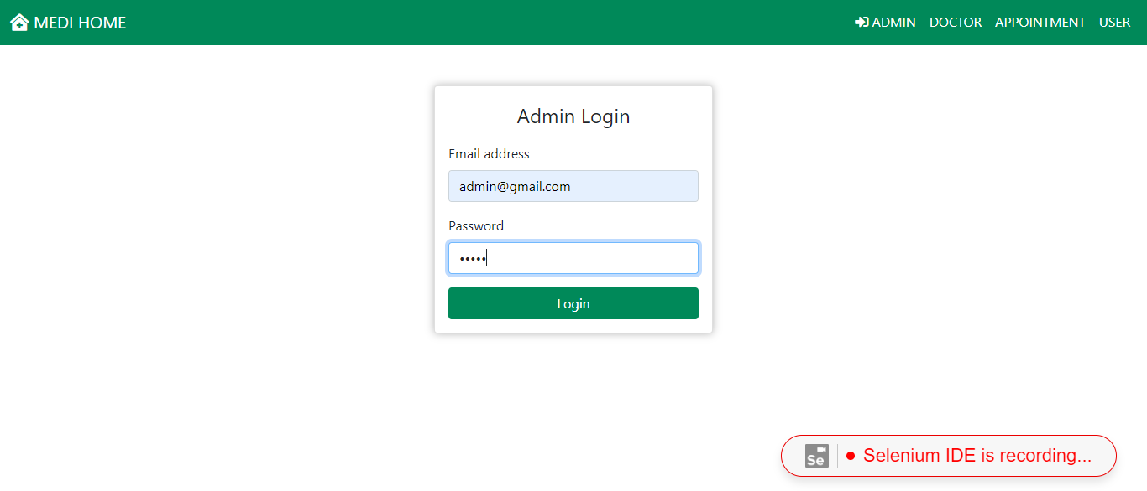
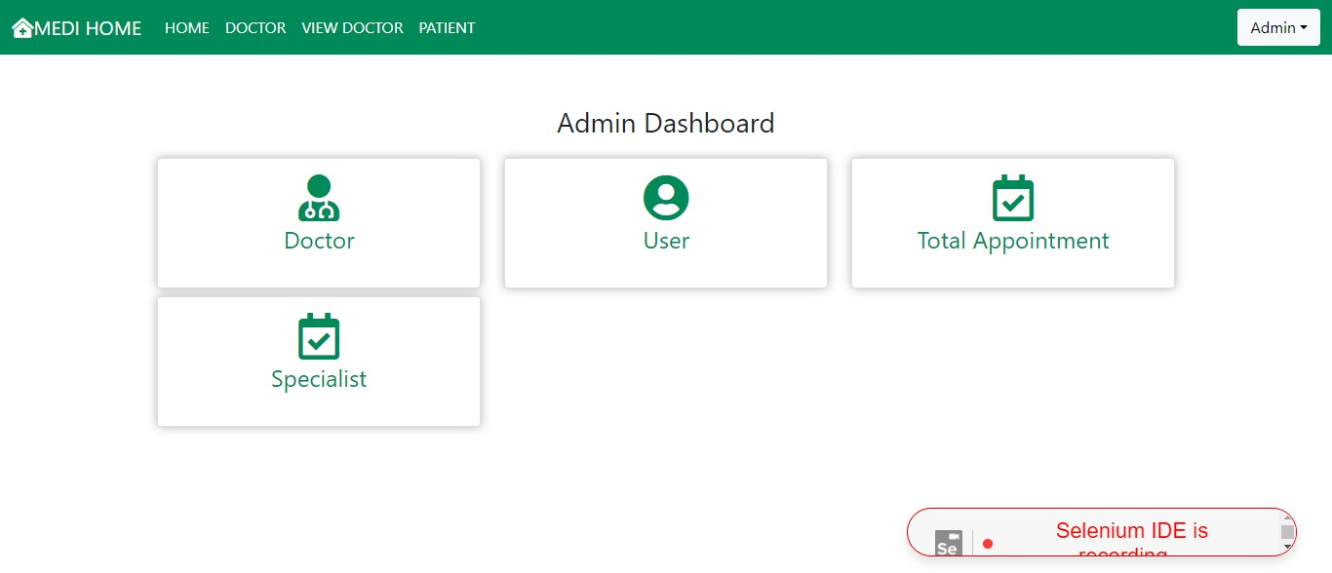

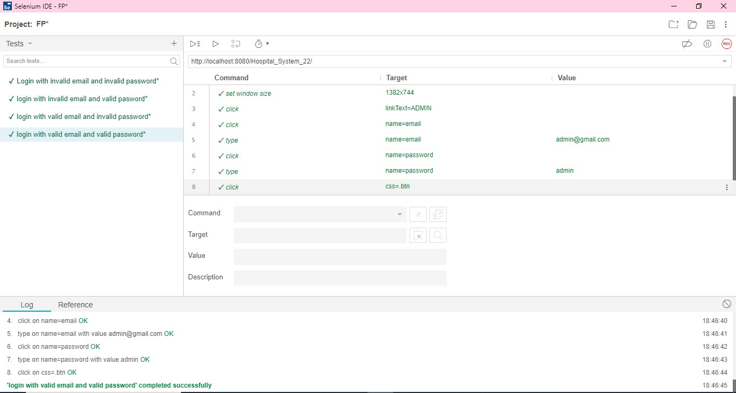

Scenario 2: Login invalid email invalid password.
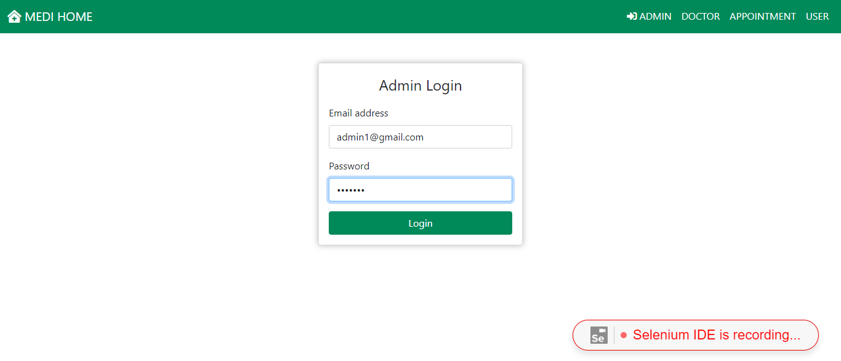

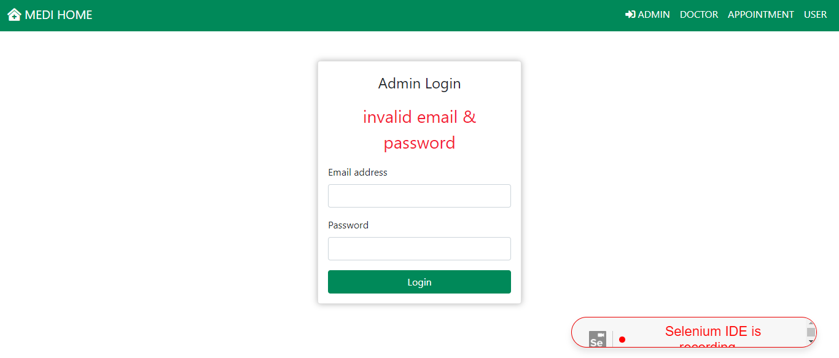
Scenario 3: Login with invalid id and valid password
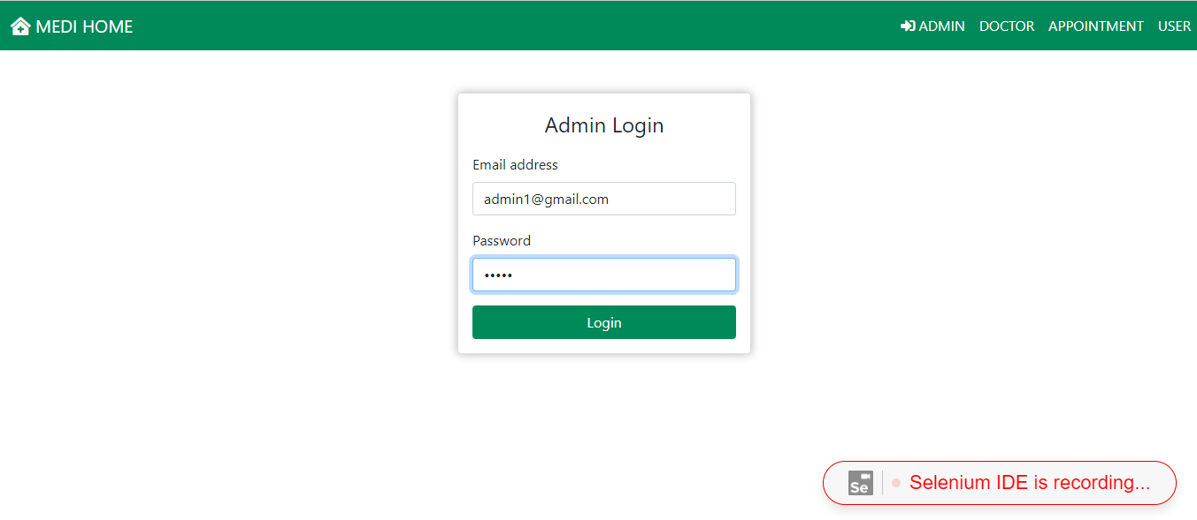
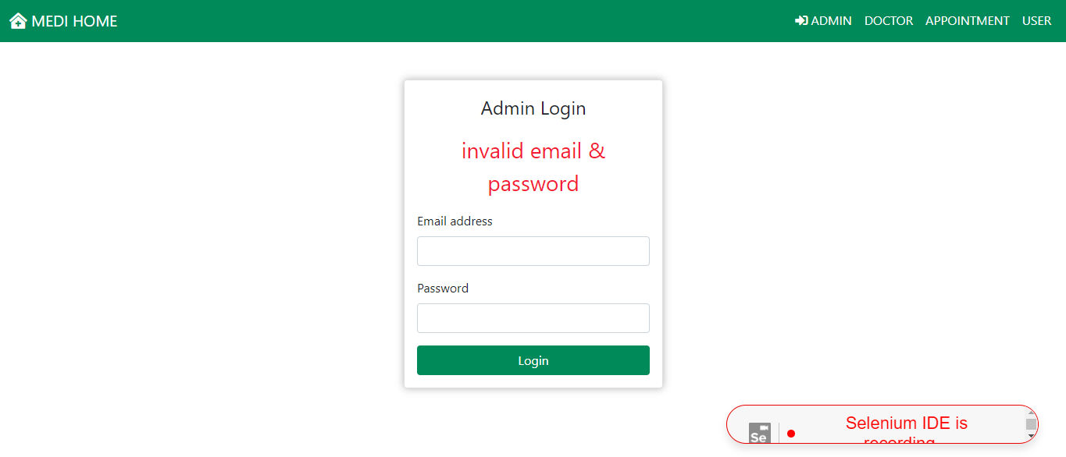

Scenario 4: Login with valid id and invalid password.

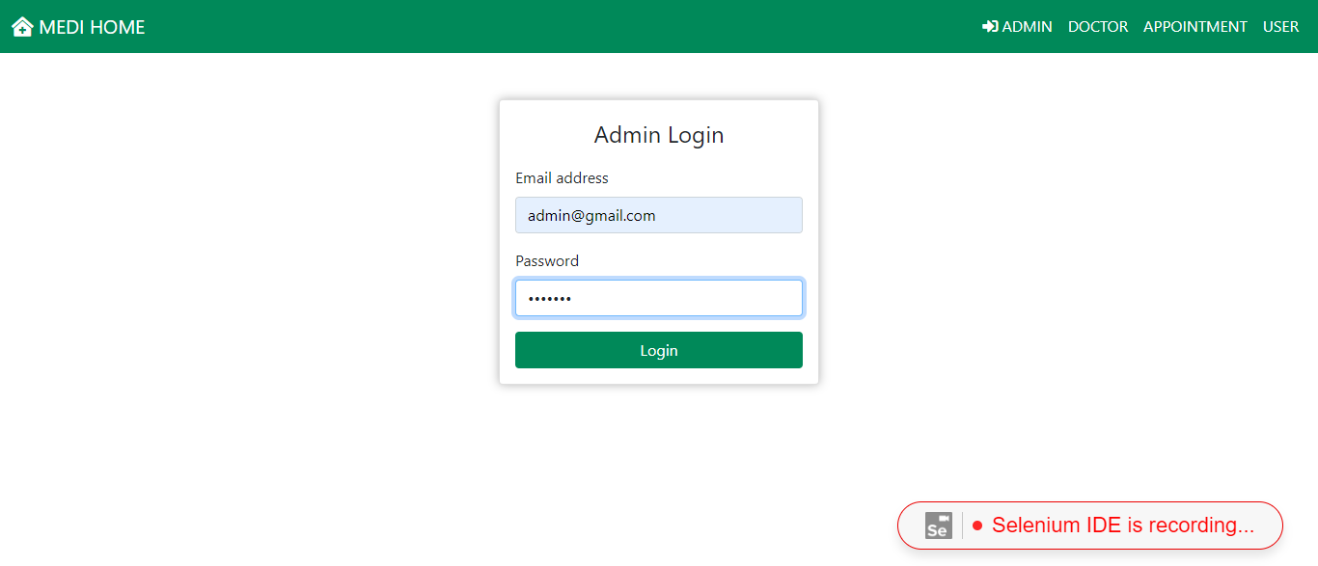
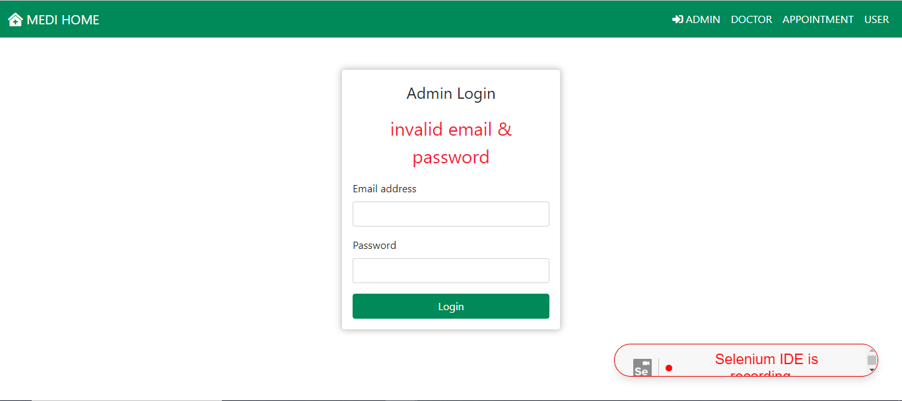

User side
Scenario 1: Login with valid id and valid password
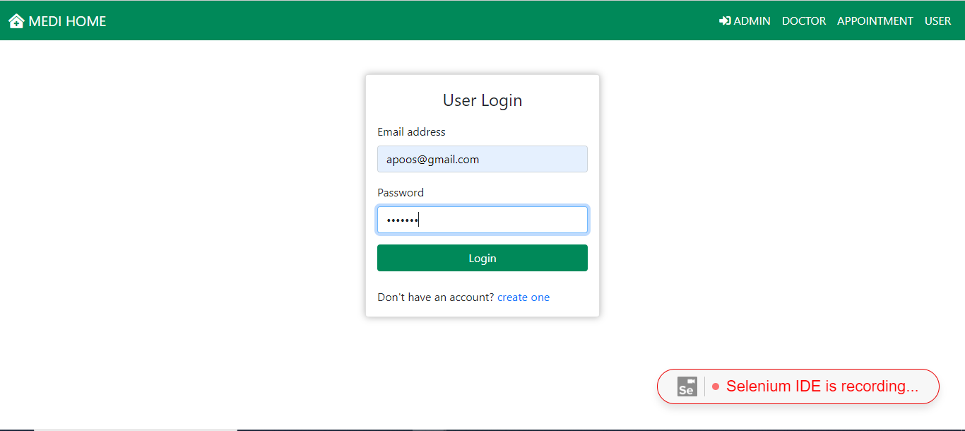


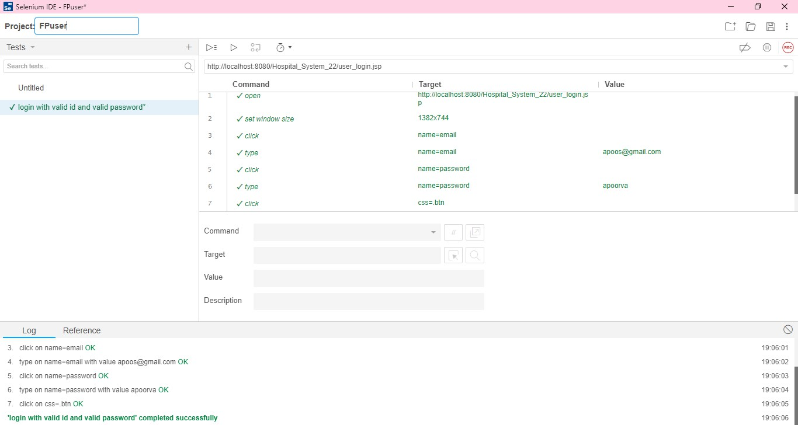
Scenario 2: Login with invalid id and valid password
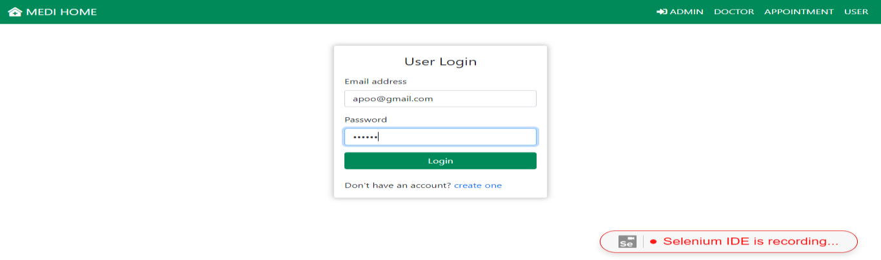
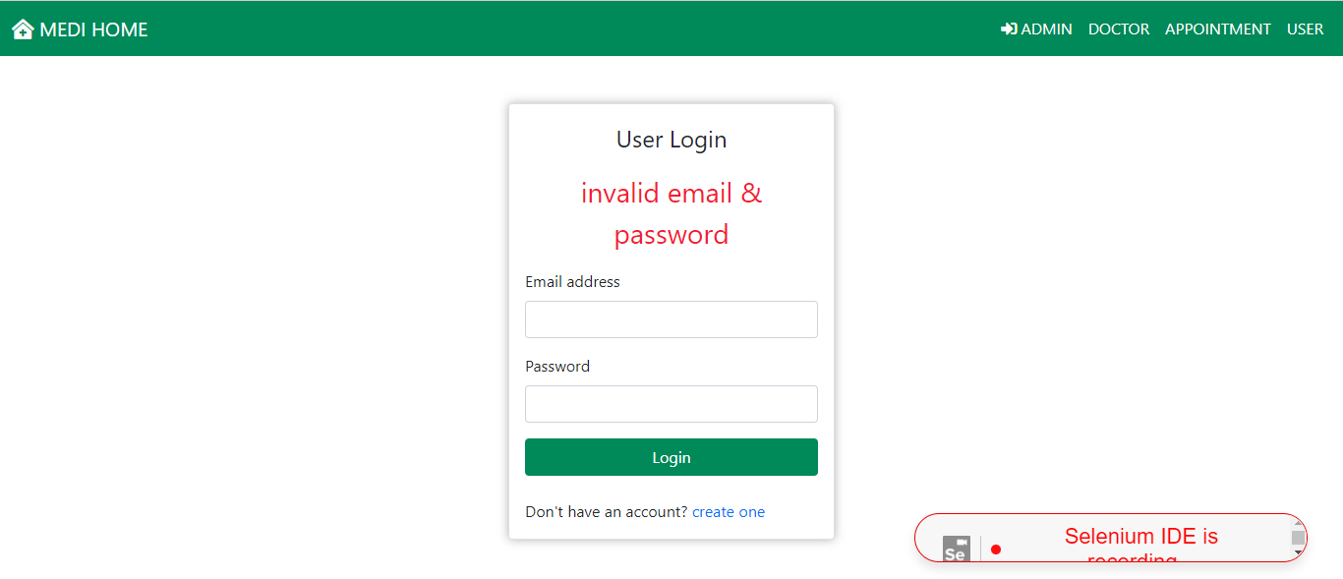

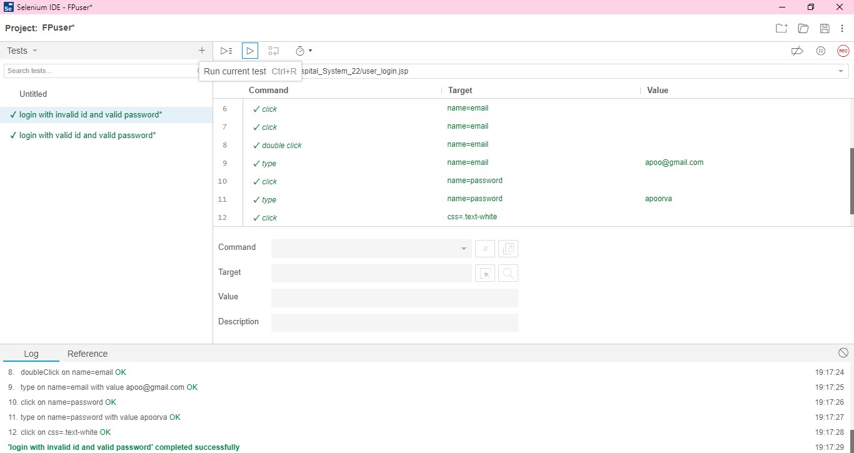

Scenario 3: Login with valid and invalid password
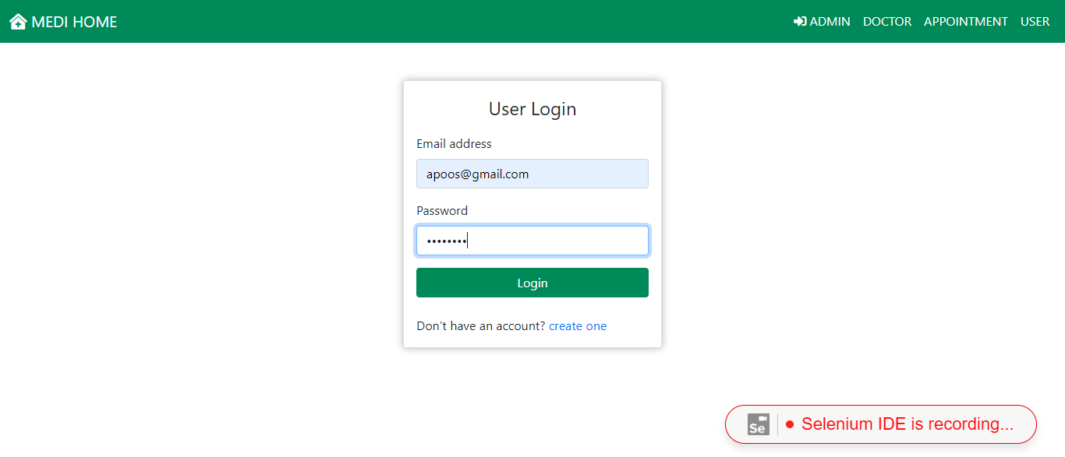

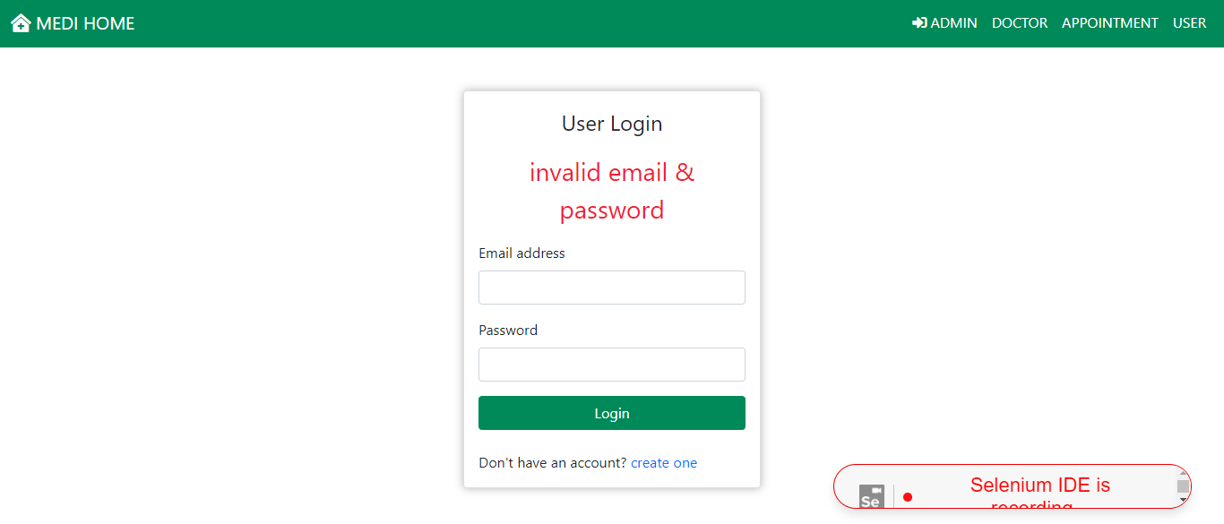
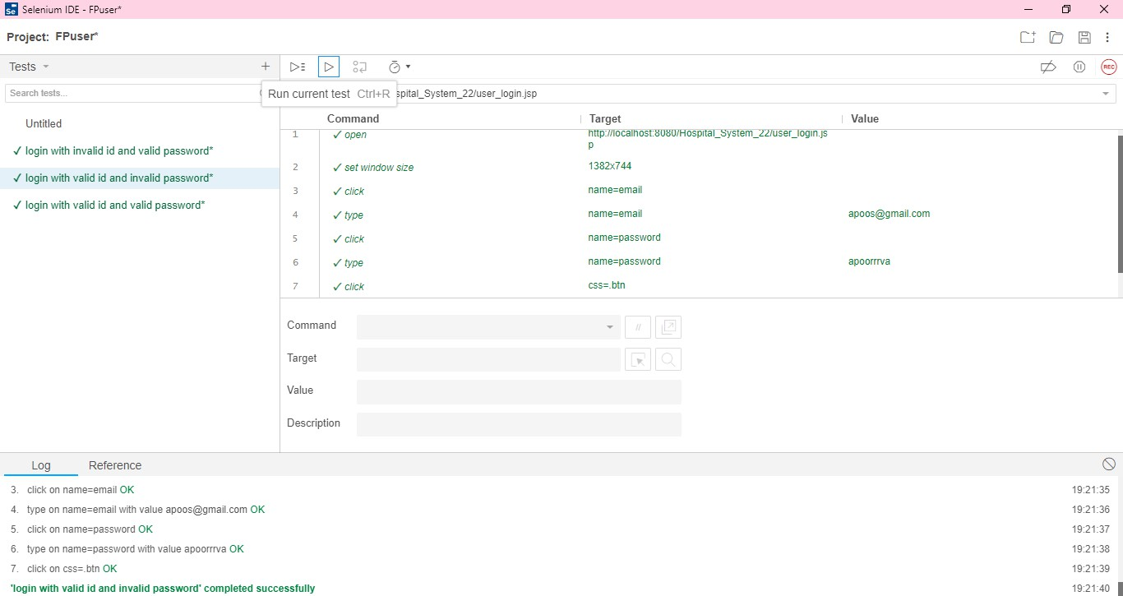

Scenario 4: Login with invalid id and invalid password
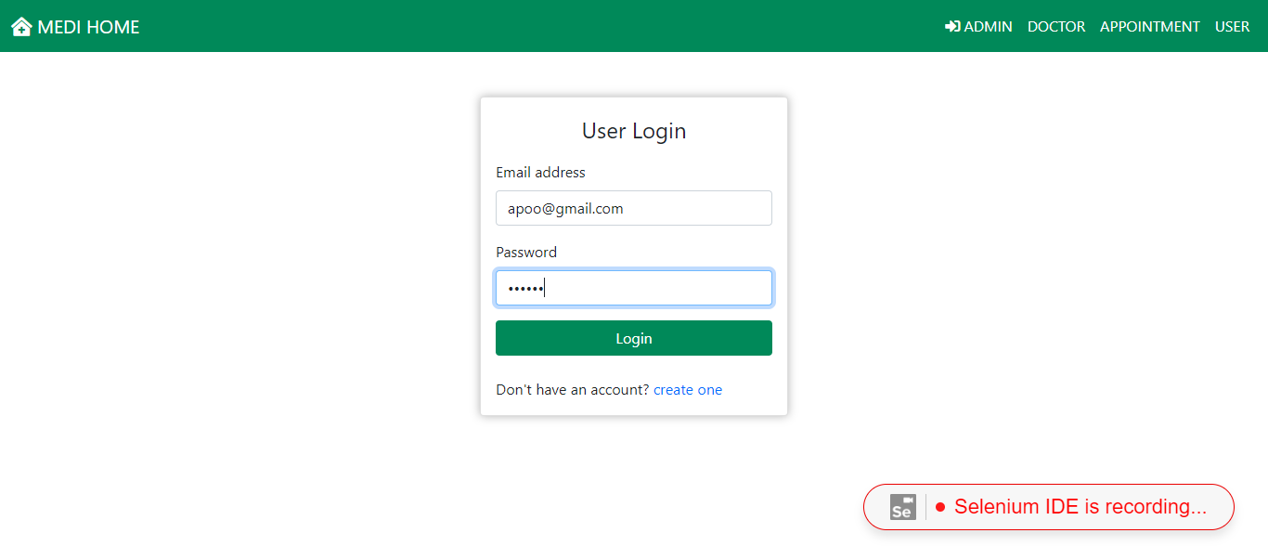

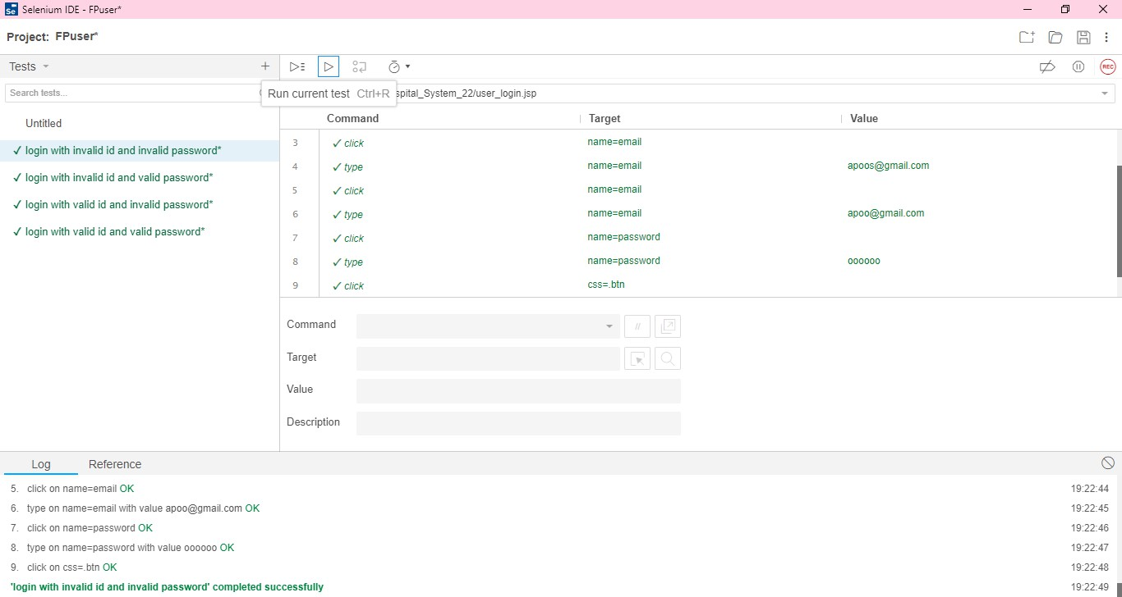

TESTING APPROACH

UNIT TESTING

Unit testing deals with testing a unit or module as a whole. This would test the interaction of many functions but do confine the test within one module.
In our application we tested each module particularly, to see whether there are any bugs or error while executing the module. Changes were made if any error was found. We went through a pattern of testing which was defined in the system testing chapter.

INTEGRATED TESTING

Integrated Testing brings all the modules together into a special testing environment, then checks for errors, bugs and interoperability. It deals with tests for the entire application. After completing unit testing, we combined all the modules together to test the entire application.
Through this technique we came to know about the application limits and features that are tested here.

MODIFICATIONS AND IMPROVEMENTS
- Easy access to the HOSPITAL MANAGEMENT SYSTEM
- Admin can check the Doctors and patients’ users.
- Make it easier for users to access the system.

CHAPTER 6

CONCLUSION AND FUTURE SCOPE
This hospital management system is a vital tool for modern healthcare facilities, streamlining administrative tasks, improving patient care, and enhancing overall operational efficiency. With ongoing advancements in technology and healthcare practices, the future scope for such systems is promising. Integration with IoT devices, AI and machine learning, telemedicine, blockchain, mobile applications, data analytics, interoperability, RPA, user experience enhancements, and regulatory compliance are key areas for future development. By embracing these innovations, hospital management systems can adapt to evolving healthcare needs, ensuring better patient outcomes and optimizing healthcare delivery.

REFERENCES

- YOUTUBE

  - https://www.youtube.com/watch?v=Sony3reF5w8&list=PLQTY Npk8jwk0Zywj8BG C-r4e9l2pwZbYB
  - https://www.youtube.com/@BeCoder

GOOGLE

  - https://chat.openai.com/c/719490a2-d502-4a4f-a12b-dc7854852177
  - https://mocdoc.in/blog/6-reasons-why-you-need-a-hospital- management-system

