ASSIGNMENT NO 5
QUESTION NO 1:
HTML CODE:
<html>
<head>
<meta charset="utf-8">
<meta name="viewport">
<link rel="stylesheet" href="https://maxcdn.bootstrapcdn.com/bootstrap/4.4.1/css/bootstrap.min.css">
<!-- jQuery library -->
<script src="https://ajax.googleapis.com/ajax/libs/jquery/3.4.1/jquery.min.js"></script>
<!-- Popper JS -->
<script src="https://cdnjs.cloudflare.com/ajax/libs/popper.js/1.16.0/umd/popper.min.js"></script>
<!-- Latest compiled JavaScript -->
<script src="https://maxcdn.bootstrapcdn.com/bootstrap/3.4.1/js/bootstrap.min.js"></script>
<style type="text/css">
body
{
background-color: rgba(84,84,84,0.95);
}
#mybrand
{
color: #ffffff;
font-size: 40px;
}
h1
{
color: #ffffff;
font-family: arial, Helvetica, sans-serif;
}
#ref-style a
{
color: #ffffff;
font-family: arial, Helvetica, sans-serif;
}
#firstsection
{
background-color: #545454;
}
#secondsection
{
height: auto;
width: auto;
background-color: #ffffff;
}
#img-style
{
margin-top: 10px;
}
#caption-style
{
background-color: rgba(139,139,139,0.2);
border-radius: 2px;
}
.shift-style
{
padding-left: 18px;
font-family: arial, Helvetica, sans-serif;
font-size: medium;
color: white;
}
.shift-style1
{
padding-left: 310px;
font-family: arial, Helvetica, sans-serif;
font-size: medium;
color: white;
}
#footer-style
{
background-color: black;
}
#footer-style p
{
color: #ffffff;
}

</style>
</head>
<body>
<div class="container">
<div class="row" id="firstsection">
<div class="col-md-12">
<a id="mybrand" href="">TO THE NEW</a>
<nav id="ref-style" class="navbar navbar-expand-lg navbar-light bg-dark">
<button class="navbar-toggler" type="button" data-toggle="collapse" data-target="#navbarNavAltMarkup" aria-controls=" navbarNavAltMarkup" aria-expanded="false" aria-label="Toggle navigation">
<span class="navbar-toggler-icon"></span>
</button>
<div class="collapse navbar-collapse" id="navbarNavAltMarkup">
<div class="navbar-nav">
<a class="nav-item nav-link " href="#">Text Link </a>
<a class="nav-item nav-link" href="#">Text Link</a>
<a class="nav-item nav-link" href="#">Text Link</a>
<a class="nav-item nav-link" href="#">Text Link</a>
<a class="nav-item nav-link" href="#">Text Link</a>
<!--
<a class="nav-item nav-link disabled" href="#" tabindex="-1" aria-disabled="true">Disabled</a> -->
</div>
</div>
</nav>
</div>
</div>
</div>
<section>
<div class="container">
<div id="secondsection" class="row">
<div class="col-md-12">

<div id="img-style" class="col-md-12 col-sm-8 mb-3">
<img src="images/dd.jpg" class="card-img-top" alt="..." height="360" width="960">
</div>
<div id="caption-style" class="col-md-12 col-sm-8 mb-3">
<p class="card-text">Some quick example text to build on the card title and make up the bulk of the card's content.</p>
</div>
<div class="row col-md-12 col-sm-8 mb-3">
<p >Latest from the gallery</p>

</div>
<div class="row col-md-12 col-sm-8 mb-3">

<!-- sgdjfks -->
<div class="card-group">
<div class="card">
<img src="images/dd.jpg" class="card-img-top" alt="..." height="315" width="215">
<div class="card-body">
<p class="card-text">Image caption here</p>
</div>
</div>

<div class="card">
<img src="images/dd.jpg" class="card-img-top" alt="..." height="315" width="215">
<div class="card-body">
<p class="card-text">Image caption here</p>
</div>
</div>
<div class="card">
<img src="images/dd.jpg" class="card-img-top" alt="..." height="315" width="215">
<div class="card-body">
<p class="card-text">Image caption here</p>
</div>
</div>
<div class="card">
<img src="images/dd.jpg" class="card-img-top" alt="..." height="315" width="215">
<div class="card-body">
<p class="card-text">Image caption here</p>
</div>
</div>
</div>
</div>
<!-- sfsdfdsf -->
</div>

</div>
<div id="footer-style" class="row">
<div class="col-sm-12 col-md-12 mb-3">
<span class="shift-style" >Copyright © 2019-2020 ALL RIGHTS RESERVED-"TO THE NEW"</span> <span class="shift-style1">WEB LAYOUT BY TO THE NEW</span>
</div>
</div>

</div>

</div>
</section>

</body>
</html>
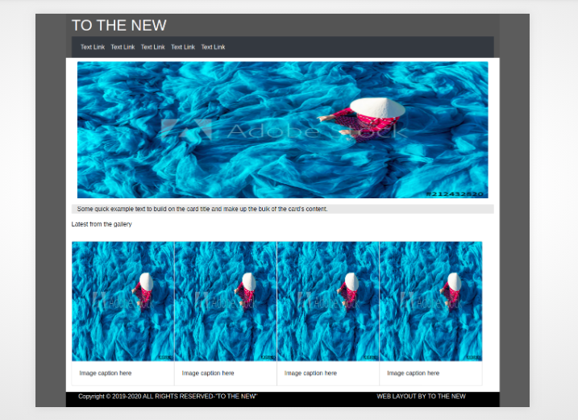
QUESTION NO 2:
HTML CODE:
<!DOCTYPE html>
<html>
<head>
<link rel="stylesheet" href="https://maxcdn.bootstrapcdn.com/bootstrap/3.4.1/css/bootstrap.min.css">
<!-- jQuery library -->
<script src="https://ajax.googleapis.com/ajax/libs/jquery/3.4.1/jquery.min.js"></script>
<!-- Popper JS -->
<script src="https://cdnjs.cloudflare.com/ajax/libs/popper.js/1.16.0/umd/popper.min.js"></script>
<!-- Latest compiled JavaScript -->
<script src="https://maxcdn.bootstrapcdn.com/bootstrap/3.4.1/js/bootstrap.min.js"></script>
<title>BOOTSTRAP FORM</title>
<style type="text/css">
#y
{
width: 300px;
}
</style>
</head>
<!-- ............................Header Start ................... -->
<header>
<nav class="navbar">
<div class="container-fluid">
<div class="navbar-header">
<a class="navbar-brand" href="#">TO THE NEW</a>
</div>

<ul class="nav navbar-nav navbar-right">
<li><a href="#"><span class="glyphicon glyphicon-home"></span> Home</a></li>
<li><a href="#"> QuickHelp</a></li>
</ul>
</div>
<hr>
</nav>
</header>
<!-- ............................Header End ................... -->
<body>
<div class="container">
<div class="row">
<div class="col-md-2"></div>
<div class="col-md-8">

<div class="panel panel-default">
<div class="panel-heading" style="background-color: #d3d3d3"><b><font color="white"><h2>Bug Report</h2></font></b></div>
<div class="panel-body">

<!-- ............................Form Start ................... -->
<form>
<div class="form-group">
<label for="title">TITLE*:</label>
<input type="text" class="form-control" required="true">
<label for="description">DESCRIPTION*:</label>
<textarea class="form-control" required="true"></textarea>
<div class="form-group"> <!-- ............... DropDown ................-->
<label for="sel1">Operating System:</label>
<select class="form-control" style="background-color: lightgreen">

<option>Windows</option>
<option>Ubuntu</option>
<option>MAC</option>
<option>Android</option>
</select>
</div>

<div class="form-group"> <!-- ............... DropDown ................-->
<label for="sel2">Product:</label>
<select class="form-control" style="background-color: lightgreen">

<option>Windows 10</option>
<option>Ubuntu 16.04</option>
<option>Ubuntu 18.04</option>
<option>Android 10</option>
</select>
</div>

<label for="ver">VERSION:*</label>
<input type="text" class="form-control" required="true" id="y">
<label for="lic">License</label><br> <!-- ............... RadioButtons ................-->
<label class="radio-inline"><input type="radio" name="optradio" checked>Free</label>
<label class="radio-inline"><input type="radio" name="optradio">Business</label><br><br>
<div class="form-group"> <!-- ............... DropDown ................-->
<label for="sel3">Severity</label>
<select class="form-control" style="background-color: lightgreen">

<option>Critical</option>
<option>Normal</option>
</select>
</div>

<div class="form-group">
<label for="ControlFile">Attachements: </label>
<input type="file" class="form-control-file">
</div>
</div>
</form>
<!-- ............................Form End ................... -->
</div>
<div class="panel-footer clearfix" style="background-color: #d3d3d3">
<a href="#" class="btn btn-success" role="button" type="submit" style="float: right;">Send</a>

</div>
</div>
</div>
</div>
</body>
</html>
